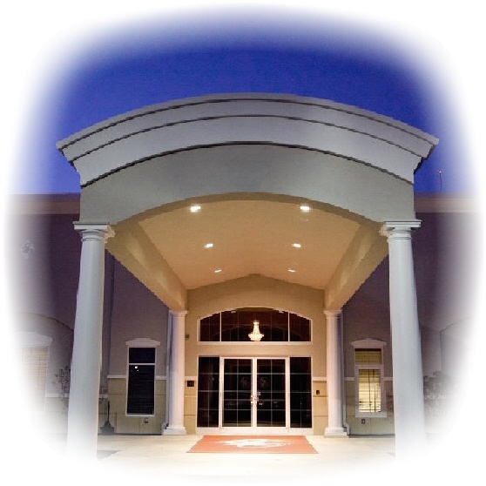

Aladdin Shriners

Petition for **Associate Membership - 2016**

1801 Gateway Circle, Grove City, Ohio 43123

(614) 475-2609 (800) 475-3850

www.aladdinshrine.org

TO THE ILLUSTRIOUS POTENTATE, OFFICERS AND MEMBERS OF Office Use Only:

ALADDIN SHRINE SITUATED IN COLUMBUS, OHIO: Member Number: _____________

I, the undersigned, a Noble of the Mystic Shrine, initiated in _________________________________________ Shrine located at ___________________________________ and a member of ________________ Shrine located at __________________________, respectfully pray that I may be admitted as an Associate member of your Shrine. I furthermore declare that I am a member in good standing of: _____________________________ Lodge No. ____________________ F. & A.M., at ___________________________,

which is a lodge by or in amity with the Conference of Grand Masters of North America. Furthermore, I have resided at my current address for not less than 6 months, as required by the Bylaws of the Imperial Council. I respectfully pray that I may be made a Noble of the Mystic Shrine and become a member of your temple.

Print Full Name: _____________________________________________________ Lady’s Name: ____________________________

Residence Address: ___________________________________________________ Phone: (_______)________________________

City: ______________________________________________ State: _____________________ Zip: _______________-_________

Birthplace: __________________________________________________________ Date of Birth: ___________________________

Profession or Occupation: ______________________________________________________________________________________

(If retired, what did you do before you retired?)

Nickname: __________________________________________ County of Residence: _____________________________________

Email Address: ________________________________________________________ Fez Size: ______________________________

Employed By: _______________________________________ Business Phone Number: (_______)__________________________

Business Address: _____________________________________________________________________________________________

SIGNATURE: ___________________________________________________________ Date: ________________________________

Name in full, no initials.

Recommended and vouched for on the honor of:

Noble’s Name (Print) _______________________________________ Unit/Club: __________________________________  
Noble’s Signature: _________________________________________ Member Number: ___________________________

Noble’s Name (Print) _______________________________________ Unit/Club: __________________________________  
Noble’s Signature: _________________________________________ Member Number: ___________________________

**Fee’s to Associate with Aladdin Shriners:**

**January – March: $54 April – June: $40.50 July – September: $27 October – December: $67.50**

Payment Information: [ ] Check Enclosed [ ] Visa [ ] MasterCard [ ] Discover [ ] American Express

Credit Card Number: ________________________________________ Exp: _____________ Amount To Charge: _______________

Revised 01/16