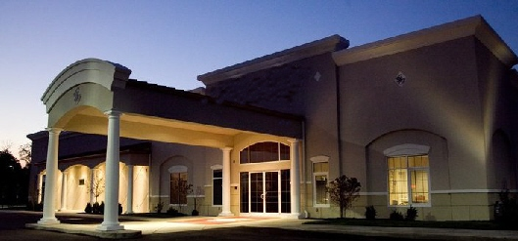

Aladdin Shriners

Petition for **Initiation and Membership - 2016**

1801 Gateway Circle, Grove City, Ohio 43123

(614) 475-2609 (800) 475-3850

[www.aladdinshrine.org](http://www.aladdinshrine.org)

TO THE ILLUSTRIOUS POTENTATE, OFFICERS AND MEMBERS OF Office Use Only:

ALADDIN SHRINE SITUATED IN COLUMBUS, OHIO: Member Number: __________

I hereby declare that I am a Master Mason in good standing of

______________________________ Lodge No. ________________ F. & A.M., at ______________________________,

which is a lodge by or in amity with the Conference of Grand Masters of North America. Furthermore, I have resided at my current address for not less than 6 months, as required by the Bylaws of the Imperial Council. I respectfully pray that I may be made a Noble of the Mystic Shrine and become a member of your temple.

Have you previously applied for admission to any Shrine of the Order?_ _______________________________________

If so, to what Shrine? ____________________________________ When? ____________________________________

Print Full Name: ____________________________________________________________________________________

Nickname: _____________________________________ Spouse: ___________________________________________

Residence Address: _________________________________________________________________________________

City: ________________________________________ State: __________________ Zip: _______________-_________

Phone: (Home) _______________________________________ (Cell) ___________________________ ____________

Email: ______________________________________________________________ Fez Size: _____________________

Date of Birth: ____________________________________ Birthplace: ________________________________________

Employed By: ________________________________ Business Phone Number: ________________________________

Profession or Occupation: _____________________________________________________________________________

(If retired, what did you do before you retired?)

**SIGNATURE: __________________________________________________________ Date_______________________**

Name in full, no initials.

Recommended and vouched for on the honor of:

Noble’s Name (Print) __________________________________ Unit/Club: ________________________________  
Noble’s Signature: ____________________________________ Member Number:___ _______________________

Noble’s Name (Print) ___________________________________ Unit/Club: ________________________________  
Noble’s Signature: ____________________________________ Member Number: __________________________

**Ceremonial Fee: $209 Fez Fee: Embroidered - $70, Jeweled - $137**

Payment Information: [ ] Check Enclosed [ ] Visa [ ] MasterCard [ ] Discover [ ] American Express

Ceremonial Fee of $_______________ + Fez Fee of $_______________ = Total Due $________________________________

Credit Card Number: __________________________________________________________ Exp: _____________________

Amount To Charge: _______________________ Signature: ___________________________________________________

Revised 1/16