|  |  |
| --- | --- |
|  | **FB3 User Manual** |
|  |  |

**2012**

|  |
| --- |
| **Clientcard-FB3** |
|  |
| Client intake tracking software for food banks/pantries |
|  |
| Craig Software Development Group - CSDG  Release: August 2012 |



Contents

Overview 1

Frequently Asked Questions 2

How much does ClientcardFB3 cost? 2

Who/What is CSDG? 2

What are the requirements to run ClientcardFB3? 2

Minimum System Requirements: 2

Getting Started 3

Starting ClientcardFB3 and Logging In 3

Manipulating ClientcardFB3 Windows 3

Navigating Fields 4

Fields 4

Text Box 4

Dropdown Menu 4

Checkbox 4

Radio Button 5

Calendar Field 5

Client Intake Operators Sections of Interest 5

Reports 5

Tools 5

Admin 6

The Main Screen 7

The Main Menu 8

Client 8

Transactions 8

Reports 8

Tools 8

Admin 9

Home Delivery 9

Help 9

Find Client 10

Performing a Client Search 10

Sorting the Client List 11

The Service Date 11

Refresh List 11

Adding a New Client 12

Client Name and Address 12

Entering a Client’s Birthdate 12

ID Number 12

Race 12

Zip Code and City 12

Client Category 12

Verify Method 12

Additional Client Information 13

Editing a Client 14

Family Members and Groups 14

Moving a Family Member 15

ID/Phone 15

Income 15

Food Services Log 15

Client Notes 15

Client Alerts 15

Adding a Family Member 16

Family Member Information Form 16

Adding a New Family Member 16

Deleting a Family Member 17

Inactive Family members 17

Adding a New Service 18

Non-Food Items 18

Baby Services 18

CSFP 18

House Hold Information 19

Food Services 19

Picked Up By 19

Notes 19

Manual Entry 19

Custom Demographics 19

Viewing the Food Services Log 20

Selecting a Service Record 20

Editing a Service 21

Deleting a Service 21

Configuring the Service Calendar 22

Setting the Service Period 22

Adjusting the Calendar View 22

Setting Repeating Service Days 22

Setting Single or Special Service Days 23

Setting Days in the Single Day Window 23

Setting Days in the Multiple Days by Period Window 23

Commodity Supplemental Food Program 25

Adding a CSFP Service to an Existing Client 25

Deleting a CSFP Service on an Existing Client 25

Adding a New CSFP Client 25

Finding Additional Information About CSFP 26

Printing CSFP Client Information 26

Adding Donors 27

Adding a New Donor 27

Editing a Donor 27

Recording Donations 28

Creating a New Donation 28

Editing Donations 29

Food Receipts for Donations 30

Adding Donors 30

Adding Food Receipts 30

Adding Pounds of Food 30

Generating Reports 30

The Search and Barcode Tool 32

Finding a Client Manually 32

Refining the Search 33

Searching by Barcode 33

Adding and Managing Volunteers 35

Adding a New Volunteer 35

Additional Volunteer Information 36

Contact Info 36

User Fields 36

Groups 36

Jobs 36

Notes 36

Recording Volunteer Hours 36

Deleting an Existing Volunteer 36

Volunteer Hours 37

Viewing Hours by Date 37

Editing Volunteer Hours 37

Adding and Deleting a Date 38

Creating Monthly Reports 39

Loading Monthly Data for Reports 39

Creating and Printing Reports 39

Viewing Monthly Data 40

Creating a King County Report 40

Managing Monthly Reports 41

Adding and Removing Monthly Reports 41

Adding New Recipients 41

Deleting Recipients 41

Including Recipients to a Monthly Report 41

Access Reports 42

Report Category 42

Clients 42

Codes 43

Commodities 43

Donations – Cash 43

Donors 43

Food Receipts 43

Services – Baby 43

Services – Food 43

Services – Food w/Teens 44

Services – Non-Food 44

Volunteers 44

Database Statistics 45

Home Delivery 46

Adding a New Route 46

Adding a Driver to a Route 46

Route Time and Distance 47

Deleting a Route 47

ClientcardFB3 Administration 48

Edit Service Items 48

Creating a New Service Item 48

Backing up the ClientcardFB3 Database 49

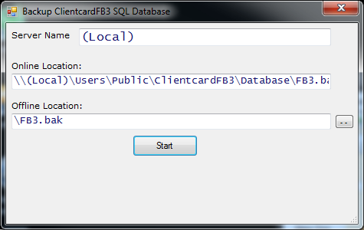 49

Toggle User Information 49

Configuring Preferences 51

My Food Bank 51

Additional Options 52

Features 52

Household Client Data Tab Control 52

Family Members Data Tab Control 52

Add Client Options 53

Use Family List 53

Form Options 53

Monthly Reports 53

Donor Percent List 53

User Defined Fields 54

Adding a New Category Type 55

Editing an Existing Category Type 56

Deleting a Category Type 56

Editing the User List 56

Adding a New User 56

Changing an Existing Password 57

Deleting an Existing User 57

Updating the Income Matrix 57

Adding a New Income 57

Editing an Existing Income Matrix Group 57

Creating and Editing Food Bank Jobs 58

Adding a New Job 58

Assigning Volunteers to a Job 58

Removing Volunteers from a Job 58

Editing a Job 59

Resetting Flags 60

# Overview

ClientcardFB3 accomplishes the tasks needed to meet the reporting requirements of a typical food bank. This includes tracking family demographics, daily services in pounds, meals, or bags, client data (including duplicate and un-duplicate), food donations by donor, cash donations by donor, and volunteer hours. However, ClientcardFB3 is not an accounting or inventory control system.

The first version of the program was designed in January 2000 for the Snohomish County 4-H Teen Ambassador Club’s “Feed The Hungry” project. It was donated to the Sky Valley Food Bank in Monroe, Washington. Julie Morris, Director of the Sky Valley Food Bank, states that with this software they are able to do client intake with one volunteer instead of two and their month end reporting is reduced from four hours to less than thirty minutes.

ClientcardFB Version 2 (Spring 2001) was expanded to meet the needs of numerous food banks within Snohomish County and through-out the state of Washington. ClientcardFB was written in Visual Basic 6 and uses the Microsoft Access® database to store data and generate many of the reports. The VB program uses Microsoft Word® to automatically create the EFAP, Northwest Harvest, Food Lifeline, Second Harvest Inland Northwest and your Food Bank Coalition’s monthly reports.

Version 3 of the software called ClientcardFB3 was written during the fall 2010 and spring 2011 by Ken Craig and Steve Staley with the help of a grant from United Way of King County and fiscal support through the Washington Food Coalition.

ClientcardFB3 (FB3) is written in Microsoft Dot Net C# with Microsoft SQL Server (Express) 2008 R2 as the database engine, Microsoft Office 2007/2010 Professional for reporting. Month end reports are created using MS Word and Excel. Ad-hoc reports are generated by MS Access.

Besides the features of ClientcardFB, FB3 tracks CSFP services, Baby Services, and Grocery Rescue. FB3 supports a barcode scanner to scan a barcode by household or family member for quick intake processing. FB3 has a voucher module for tracking other types of services and Home Delivery module with route sheets. Additional family member demographics have been added to meet the needs of United Way King County and HUD race categories. Backpack services and electronic signature tracking will be available by September 2012.

FB3 will run on an IBM compatible PC with Microsoft Windows XP® or newer operating system and Microsoft Office 2007/2010 Professional®.

Ken Craig, the developer of ClientcardFB3, is making the software available through his company CSDG. Ken has more than thirty years of experience in software development. His clients have included Budget Rent A Car Corporation of Lisle, Illinois; a Puget Sound based plastics converting company, Exxon/Mobil of Houston, Texas; Air Products of Allentown, Pennsylvania, and Lateral Data of Houston, Texas..

Contact: Kenneth A. Craig

16060 NE 165th Street

Woodinville, WA 98072

Email: KenCraig8@Comcast.net

Phone: 425-485-2079 or 206-979-7777

# Frequently Asked Questions

## How much does ClientcardFB3 cost?

The ClientcardFB3 software is completely free to use for as long as you like, including updates. We do, however, accept donations to keep the program running and help cover our operating expenses.

## Who/What is CSDG?

CSDG is the Craig Software Development Group owned by Ken Craig. CSDG is being converted to a non-profit organization to provide a structure to continue providing software for food banks/pantries.

## What are the requirements to run ClientcardFB3?

The physical requirements for ClientcardFB3 are a computer and printer. It is not necessary to buy any special equipment.

## Minimum System Requirements:

Memory: 1 Gigabyte

Hard Disk Space: 10 Gigabytes

Operating System: Windows XP, Vista or 7.

Software: Microsoft Office 2007/2010 Professional

# Getting Started

ClientcardFB3 utilizes the functions as other windows applications for opening and closing windows, navigation, inputting data, deleting data, and selecting fields. If you are already an advanced windows user, feel free to skim over this section. However, if you are new or still learning how to operate computer systems, read this section completely before moving on. If you experience any problems while using ClientcardFB3, please contact us for assistance.

## Starting ClientcardFB3 and Logging In

To start ClientcardFB3, double-click the ClientcardFB3 icon on your desktop. This will launch the ClientcardFB3 Login window:

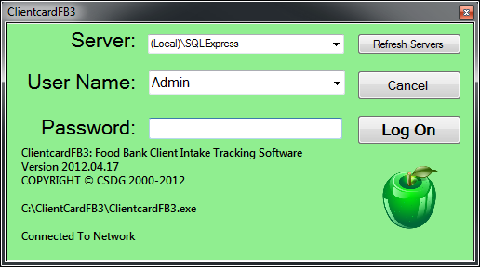

Click this icon on your desktop to launch Clientcard FB3

By default, the **User Name** is *Admin* and the **Password** is *master*. You can select a different account by selecting it in the **User Name** dropdown menu (see the **Forms** section of **Getting Started** for more information). Once you have typed the password, click **Log On** to start the ClientcardFB3 software.

The Server drop down menu can be used to select a different SQL database. This is only for advanced users. Please contact us for assistance if you believe there is a problem with the server.

## Manipulating ClientcardFB3 Windows

Most of the tools in ClientcardFB3 require opening a “window.” A window is simply an extension of ClientcardFB3 that contains additional information and forms. When ClientcardFB3 first opens, you see the **Main Window**, which will remain open for as long as the program is in use. Any additional windows that open may cover or hide the **Main Window**, but it will still be there when you close the additional window. There are a few things you must remember when working with ClientcardFB3 windows:

* When another window is opened, the **Main Window** is locked. This means you cannot click on it or change any information in it until you close the additional window.
* You can move any window by clicking the left mouse button and holding the top bar (where the name is) while moving. Release the mouse button to leave the window in place.
* Any window can be closed by clicking the universal close button  in the upper right corner or clicking the ClientcardFB3 close button .
* Clicking on the Cancel button  will delete changes and return to the **Main Screen** or exit **Edit Mode**.

Unless otherwise specified, closing a window before you have saved any changes will erase those changes. We recommend that you save your work often and before leaving your workstation for an extended period of time.

## Navigating Fields

There are two methods of form navigation in ClientcardFB3. The first is to use the mouse and left click on the field. You can then type in the necessary information or select additional options from within the field. However, you can also use a keyboard to more quickly switch between the different fields as you type. This will allow you to keep your hands on the keyboard for rapid data entry. To move between fields on the same form, press the Tab key on the keyboard. To move to the previous field, hold the Alt key and press the Tab key. Some fields have special attributes that require a different key to activate. See below for a list of fields and their keys.

## Fields

All information in ClientcardFB3 is entered through fields. A field is simply a small white rectangle that holds information. This can be words, numbers, dates, or a selection. Each form type handles information in a different way. The important thing to remember is that a field needs to have the proper information inserted – it cannot tell if the data is correct, misspelled, or the wrong information entirely. To help you enter the correct data, each form has a label. The label is always next to the form, and specifies exactly what information should be entered into the field.

## Text Box

The text box allows for a certain amount of text to be typed in. This includes addresses, names, and notes. Typically you can enter both words and numbers. However, there are some instances where you can only add one or the other.



## Dropdown Menu

These forms already have the information you are allowed to select. To see your choices, click anywhere on the field. The list of options will appear below the form in a list. You can simply **left-click** on the appropriate option in the list to select it. The list will disappear and the option you chose will be displayed in the form.

Keyboard Usage: Press the **Up** and **Down Arrow** keys to select an item and the **Enter** or **Tab** key to confirm.



## Checkbox

The checkbox works exactly the same way you would expect on a sheet of paper. If you want to use or activate the item attached to the checkbox, left-click in the empty box next to the item’s name. It will then display a small check to let you know that it has been selected. To deactivate the item you must **left-click** the checkbox so that the check disappears. You may select as few or as many items as you need.

Keyboard Usage: Press the **Space Bar** to check or uncheck an item.

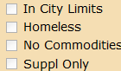

## Radio Button

At first glance, the radio button looks a lot like a checkbox. However, unlike the checkbox that allows every option to be selected, radio buttons only allow you to select one option. There will always be two or more options whenever a radio button is present. You may only select a single choice from the list. A small blue dot will mark the currently selected item.

Keyboard Usage: Press the Space Bar to select the item.

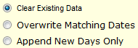

## Calendar Field

The calendar is unique in that you can either type a date into it or click on the down triangle to open an actual calendar. To navigate the calendar, you can press the left or right arrows to move a single step left or right. You may also click on the date at the top of the calendar to see a list of months, click on the year to see a list of years, and click on the decade to see a list of decades. Each time you click you will see a broader spectrum of dates.



## Client Intake Operators Sections of Interest

* Client Household Form (Page XX)
* Find Client
* Adding a New Client
* Editing a Client
* Maintain Family Members
* New Service
* Bar Code Searches

## Reports

* Access Statistics

## Tools

* Volunteers and Hours
* Donors and Food Receipts
* Vouchers
* CSFP
* Backpack - Incomplete
* Cash Donations

# The Main Screen

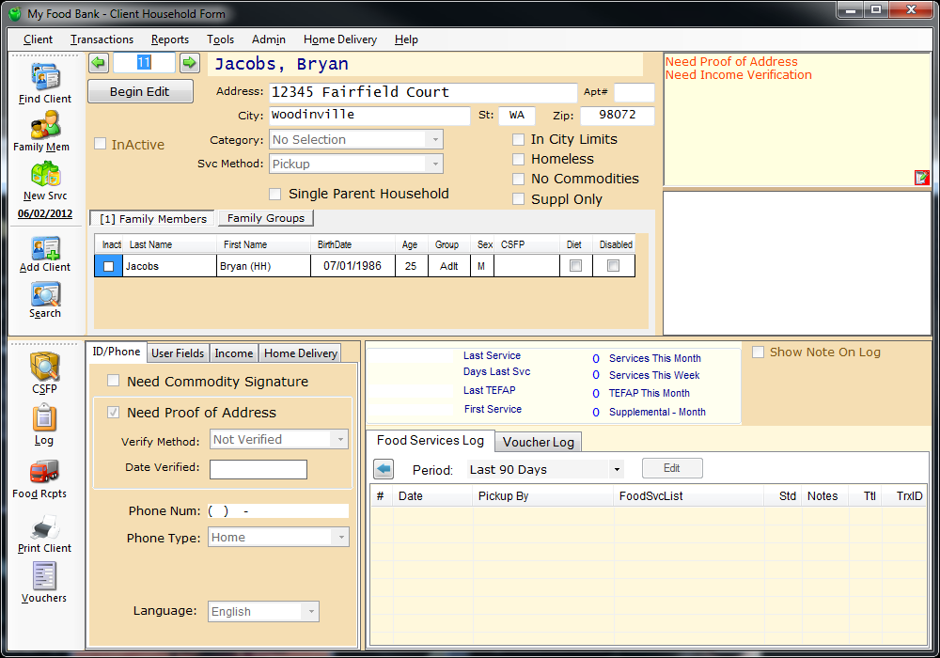

The Main Form is the default screen when Clientcard-FB3 opens. It displays the information of a specific client that has been entered into the FB3 database and provides navigation to all functionality of FB3, along with any additional information, such as their status, address, family members, recent visits, alert box, and notes.

Navigation is accomplished through the main menu bar: Client, Transactions, Reports, Tools, Admin, Home Delivery and Shortcut items on the side toolbar are listed below

These are the **Intake Shortcuts**: These are **Additional Shortcuts**:





Removed from main form. Now on Find Client form.

**New Service** – Creates a new service for the selected client.

**Add Client** - Opens a form to add new clients.

**Family Members** - Opens a window to maintain family members from a household.



**Find Client** - Opens a search window for an advanced client search.



**Log** - Opens a form listing food services by day of service.

**Vouchers** -

**Print Client** – Prints the currently selected client family card using the selected language.

**Food Receipts** - Opens a window that tracks food donations and donors.

**Commodity Supplemental Food Program** - Allows viewing of clients using CSFP.



## The Main Menu

This toolbar is at the top of the main screen and contains the entire list of tools that you can access in ClientcardFB3. Each tool is placed in a category to keep the toolbar clean and efficient. To access a tool, simply click on its appropriate group in the toolbar, then select it from the list that appears:

### Client

The **Client** category allows you to add, edit, and delete client entries. For more information on clients, see page XX. In addition, you can logout or exit ClientcardFB3.

* Find Client or Household Member
* Add Client
* Begin Editing a Client
* Cancel Edit
* Save Changes to Client Record
* Delete Client
* Print Client Card
* Print Client Household Form
* Logout
* Exit

### Transactions

All service related functions are stored in the **Transactions** category. See page XX for more information.

* New Service
* Edit Transaction
* Delete Service Transactions
* CSFP Services

### Reports

All report types can be generated from the **Reports** category, including Database Statistics. See page XX for more information.

* Monthly Reports
* Access Reports
* Database Statistics
* King County Report

### Tools

The **Tools** category is used for maintaining volunteers, donors, and vouchers. See the appropriate page for additional information.

* **Enter Volunteer Hours** – See page XX
* **Enter Food Receipts** – See page XX
* **Enter Grocery Rescue** – See Page XX
* **Maintain Volunteers** – See page XX
* **Maintain Donors**  - See Page XX
* **Maintain Voucher Items** – See Page XX

### Admin

The **Admin** category is the largest and most complex assortment in the toolbar. Each tool is explained on the page listed:

* **Edit Service Items** – See Page XX
* **Yearly Calendar** - See Page XX
* **Allow New Service** - See Page XX
* **Backup Database** - See Page XX
* **Toggle User Info** - See Page XX
* **Preferences** - See Page XX
* **User Defined Fields** - See Page XX
* **Type Codes** - See Page XX
* **User List** - See Page XX
* **Manage Monthly Reports** - See Page XX
* **Update Income Matrix** - See Page XX
* **Edit Jobs Plan** - See Page XX
* **Reset Proof of Address Flag** - See Page XX
* **Reset Need Commodity Signature Flag** - See Page XX
* **Reset Inactive Flag** - See Page XX
* **Create United Way Export** - See Page XX

### Home Delivery

Under **Home Delivery** you will find the tools necessary to create and maintain delivery routes and assign volunteers. See page XX for more information.

* Planner
* Route Maintenance
* Funding Programs
* Buildings

### Help

The **Help** category contains hints and guides to assist you if you’re stuck or don’t understand a specific section of ClientcardFB3.

* Contents
* Index
* About

# Find Client

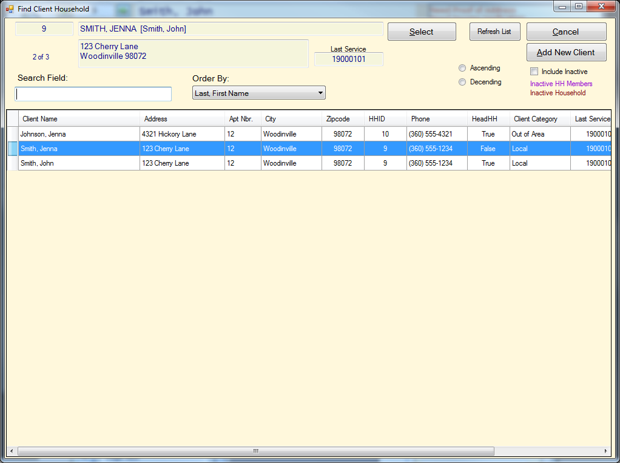

To initiate a client search, click the **Find Client** button in the intake shortcuts. Client searches dramatically reduce the amount of time it takes to find clients by searching for several parameters. If the client is not found, you can add them by clicking the **Add New Client** button. We recommend that you use the **Find Client** tool to find existing clients instead of the **Add Client** tool, incase their information has changed.

## Performing a Client Search

To find a client, type your search parameters into the Search Field. As you type, the list should automatically narrow itself down to the closest matches. Use the up and down arrows to highlight the desired client and press the **Enter** key to select them. You may also double-click on the client’s name in the grid to select them. If a client has not visited the food bank in the last year, you may need to select the **Include Inactive** checkbox for them to appear in the list.

* First Name

Order By: To the right of the **Search Field** is a drop down menu that changes how the list is organized. It is important to set this so that it matches the information you are searching with. For example, if you are searching by phone number, make certain to set **Order By** to **Phone**. Failing to do this can cause errors to be displayed.

* Last Name
* Address
* Apartment Number
* City
* Zip Code
* Household ID
* Phone
* Head of Household
* Client Category
* Last Service

When you have found the proper client, click the **Select** button to return to the **Main Screen**. Their account information will be automatically loaded for you.

## Sorting the Client List

You can choose to sort the client list by **Ascending** (the list beings with the lowest letter or number and increases) or **Descending** (the list begins with the highest letter or number and decreases). You may also decide to include all clients that have been marked **Inactive** in your search. This allows you to reactivate previous clients if necessary.

## The Service Date

The **Last Service** date is displayed in yyyymmdd format. By default, it is set to 19000101. Once the client has received their first service, the **Last Service** date will automatically change to that date.

## Refresh List

Food banks that use a central database and multiple computers for client intake may need to refresh the client list. This is to make certain that they have the most recent information in the database. A volunteer may also want to clear all previous search parameters and start fresh. To do this, simply click the **Refresh List** button. Note that opening the **Find Client** screen will automatically begin a fresh search with the most recent database information. It is not necessary to use **Refresh List** when the **Find Client** screen first opens.

# Adding a New Client

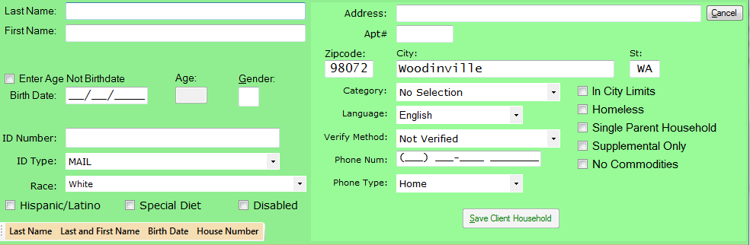

When a new client visits your food bank, you can enter them into your database by clicking the **Add Client** button on the intake shortcuts. This will launch the **Add Client Window**. We recommend that you as much of the client’s information as possible to prevent duplicate entries in the database and to allow for easier searches later on. As you enter the customer’s information, ClientcardFB3 will attempt to find an existing match in the database. If a match is found, the duplicate entry will be displayed in a list below the green **Client Fields**.

## Client Name and Address

A client’s name and address does not need to be unique but is required to record the client. However, at least one name and the client’s general location should be entered to prevent accidental duplicate entries and to make client searches easier.

## Entering a Client’s Birthdate

You can elect to enter the exact birthdate of your client, or check the Enter **Age Not Birthdate** checkbox and manually enter the client’s age. Entering the client’s birthdate will automatically calculate their age. The client’s age or birthdate is required to record the client successfully.

## ID Number

Clientcard-FB3 supports **ID Number** creation using **mail**, **utility bill**, **lease agreement**, **rent receipt**, **DSHS letter**, **school record** and **prescription bottles**. Food banks that do not need or want **ID Numbers** may select not verified to bypass this step. If barcoding and the option for **search family member ID** field is on, then the ID number is used for the barcode search.

## Race

Food banks that are required to track client race can select the appropriate race from the **Race** drop down menu. If the client is Hispanic or Latino, first select **Undisclosed/Other** from the **Race** dropdown menu and then check the **Hispanic/Latino** option.

## Zip Code and City

If you enter the client’s zip code, their city will be automatically filled in. If you enter their city, the zip code will be automatically filled in.

## Client Category

The Client Category records the client’s living category as a **local**, **transient**, or **out of area**. If your food bank does not track this information, you may select **Not Verified** instead.

## Verify Method

This is method for verifying the client’s proof of address.

## Additional Client Information

The following information can be added by selecting the appropriate check box:

**Hispanic/Latino:** The client is considered Hispanic or Latino

**Special Diet:** The client has special dietary needs, such as non-meat or non-dairy.

**Disabled:** The client is currently disabled.

**In City Limits:** The client lives within the city limits.

**Homeless:** The client is homeless or does not have a legal address.

**Single Parent Household:** The client is the only provider for one or more dependents.

**Supplemental Only:** This client is only allowed to receive supplements.

**No Commodities:** The client is not allowed to receive commodities.

# Editing a Client

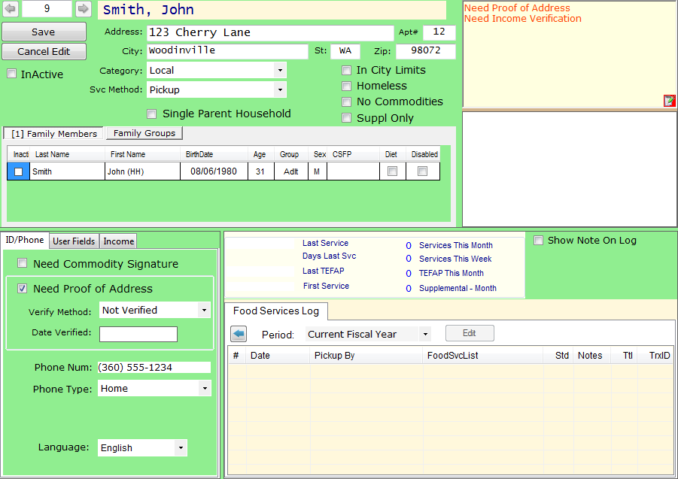

Clientcard-FB3 allows client information to be changed as necessary to keep up with the changes in your clients’ lives. You can access the **Client Edit** window by selecting the client you wish to edit (see Find Client on page XX) and clicking **Begin Edit** on the main window. Alternatively, you can use the left and right arrows by the Client Number. You can cancel the changes at any time without saving by clicking the **Cancel Edit** button. When you are satisfied with the change, click the **Save** button. For more details on client information, please see page XX.

## Family Members and Groups

The **Family Members** tab is enabled by default when you first enter the **Client Edit** window. It displays a list of family members that belongs in the same house hold, and a brief amount of information about them. There are three check boxes that you may enable or disable:

**Inactive:** The family member is inactive.

**Diet**: The family member is on a special diet (such as non-meat or non-dairy).

**Disabled:** The family member is disabled.

**Family Groups** can be accessed by clicking on the **Family Groups Tab**. It contains general information about the family in two ways: You may either use the Member List to automatically insert the correct information or manually enter the information. If you want to manually enter the family group information, simply uncheck the **Use Member List** check box.

## Moving a Family Member

You can move a family member to a different client household.

**Procedure to move a family member to a different household.**

Step 1: Click on the Last Name field of the person that you want to move.

Step 2: Right mouse click and select “Move ‘that person’s name’ to different household”.

Step 3: Press the “Yes” button on the dialog box asking to confirm that you want to move this person.

Step 4: Find the household that you want to add this person and press the “ENTER” key or click the “Select” button.

Step 5: Press the “Yes” button on the dialog box asking to confirm that you want to transfer this person to the selected household.

Step 6: Press the ‘Yes’ to show the household that the family member is transferred, or ‘No’ to stay on the original household.

Step 2:

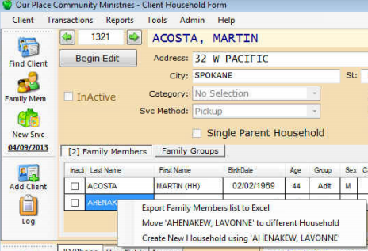

Step 3:

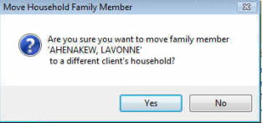

Step 4:

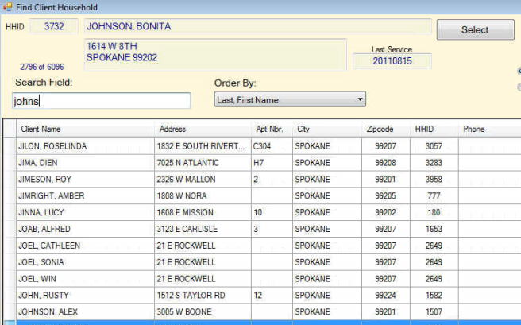

Step 5:

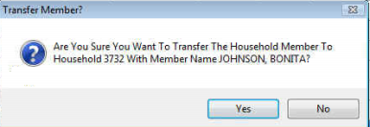

Step 6:

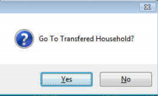

## ID/Phone

The client’s ID and Phone contact information can be changed with the same options during client account creation. You may also require a commodity signature by checking the **Need Commodity Signature** check box.

## Income

The client’s income can be entered by selecting the Income tab. You may enter either the client’s monthly or annual income. Entering the monthly income will automatically calculate the annual income. The HUD Income Category will always be automatically calculated and displayed.

## Food Services Log

The food services log records each service that the client participates in. You can change the information displayed by change service dropdown menu from Last 90 Days to current month, current calendar year, current fiscal year, previous calendar year, previous fiscal year and all. The service log lists the following information:

**Date:** The date of the service.

**Pickup By:** The family member who received the service.

**FoodSvcList:** Description of the service items.

**Std:** Pounds of items by type (Standard, other, commodity, supplemental, baby, and non-food).

**Notes:** Any notes recorded about the client by a volunteer or staff member.

**Ttl:** Total Family members used for the service.

**TrxID:** Internal database row (part of the ClientcardFB3 program).

In addition, you may display client notes in the log by clicking the **Show Note on Log** checkbox. When checked, this allows specific notes to be entered on the day of service if necessary.

## Client Notes

Volunteers may add notes about specific clients or client households using the **Client Note** field. These notes will remain in place until deleted and will be visible to other volunteers. This is useful for recording allergies, previous behavior, reminders, and other useful information about clients.

## Client Alerts

The field in the upper left corner contains current client alerts in red font. This warns volunteers that clients have already received a service and may not be eligible for another. You may edit these alerts by clicking the red **Edit** button in the lower right corner of the Client Warning form.

# Adding a Family Member

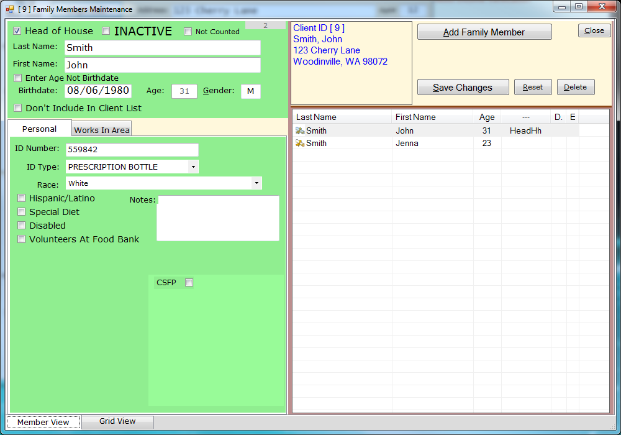

Family members can be added to a household by selecting an existing client from the main screen and clicking the **Family Mem** button in the intake shortcuts. Each household may only have one **Head of House** selected. Once a Head of House is set, additional family members may be added without using the **Add Client** tool, but each family member added this way will be automatically included in the same family.

## Family Member Information Form

The Family Member Information Form is similar to the information found in the **Add Client** tool (see page xx). There are several unique options however:

**Head of House:** Marks this family member as the head of the household.

**Inactive:** Marks the family member as **Inactive**.

**Not Counted:** Marks the family member **Not Counted**.

**Don’t Include in Client List:** Excludes the family member from the client list.

**CSFP:** This client is eligible for the Commodity Supplemental Food Program.

## Adding a New Family Member

To add a new family member, click the **Add Family Member** button. The family surname will automatically be placed in the **Last Name** field, but may be changed if necessary. Additional information may be added as per the **Add Client** tool (see page xx). When changes have been complete, you click **Save New Family Member** to apply the changes or **Cancel Add** to delete the changes and return to the **Family Member** screen.

## Deleting a Family Member

Family members can be removed by selecting the proper family member from the list and clicking the Delete button. Once the family member is deleted, it is permanently removed from the database and will not appear in the **Client List**, so use caution when removing family members.

## Inactive Family members

You may also check the **Inactive** box to flag a family member as inactive. They will not appear in the new service count or demographics until you uncheck the **Inactive** box.

**Procedure to change the head of household:**

Step 1: Select/Open the Family Member Maintenance form.

Step 2: Select the new head of household from the family member list on the right half of the maintenance form.

Step 3a: Click the Head of House checkbox on the top left of the maintenance form.  A confirmation dialog will appear.

Step 3b: Press the “Yes” button to confirm the change.

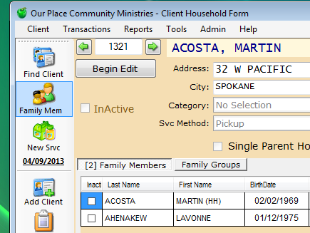Step 1:

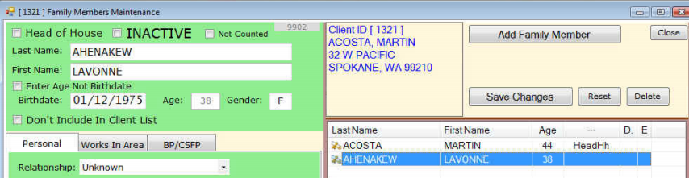Step 2:

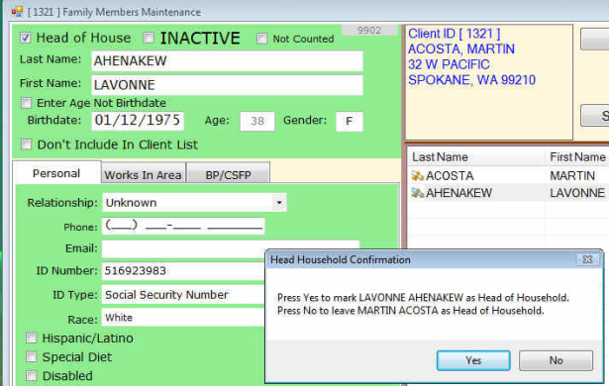Step 3:

# Adding a New Service

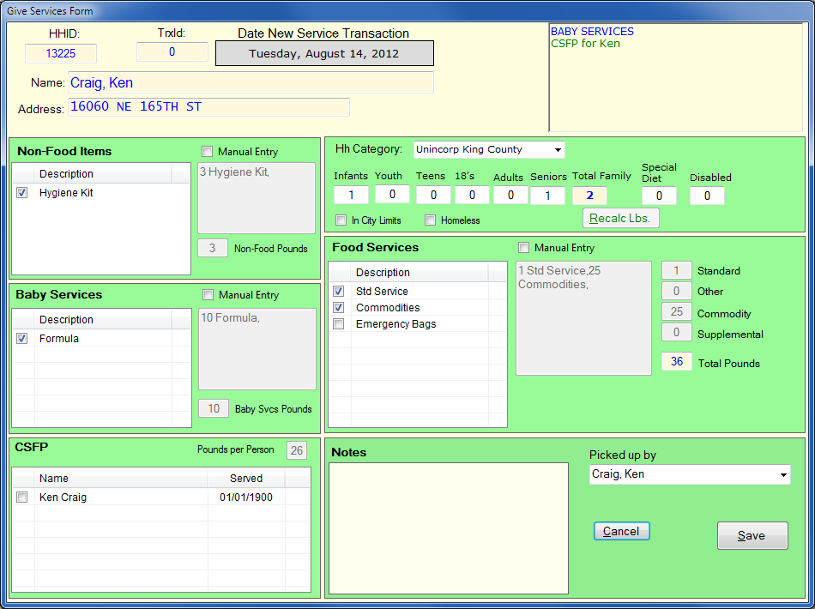

To add a new service, select the proper client (see Find Client on page xx) and click the **New Srvc** button in the intake shortcuts to launch the **Give Services Form**. You will notice that the client’s information is automatically loaded into the window, along with the family size and estimated pounds of food. When you are satisfied with the service entry, click the **Save** button. Otherwise you can click the **Cancel** button to ignore all changes and return to the **Main Menu**.

## Non-Food Items

By default, you may manually add non-food items and the number of pounds they weigh. This can be disabled by un-checking the **Manual Entry** checkbox.

## Baby Services

These services only show if **baby services** is selected in preferences, you have a baby service entered into a service item and the house hold has **baby services** enabled.

## CSFP

If enable CSFP is enabled in preferences, show CSFP on new service form is checked, at least 1 member of the household has CSFP enabled in the family member form and it is not past their CSFP expiration date.

## House Hold Information

Though the household information is automatically added, volunteers may manually change the category, family member quantity, and the living status as needed. When These changes are complete, click the **Recalc Lbs** button to update the Food Service estimate.

## Food Services

The service types that the client can participate in are listed in the **Food Services** section automatically. You may add or remove services by checking or un-checking the checkbox next to each service respectively. If you need to override the current food services and enter a custom service, click the **Manual Entry** checkbox and type in the service name.

Finally, you may manually change **Total Pounds** of services received by clicking the number to the left of **Total Pounds** and typing in the desired number.

## Picked Up By

By default, the Head of Household or the family member selected in the find client screen is displayed in this drop down. You may change this by clicking the drop down arrow and selecting the proper family member or typing over the name that is displayed.

## Notes

To insert notes about this service, type them into the Notes field.

## Manual Entry

When the Manual Entry checkbox is selected, you may enter the pounds and service description as desired.

## Custom Demographics

You may overwrite or customize each one of the demographics for each service. You must click recalculate to refresh the pounds served.

# Viewing the Food Services Log

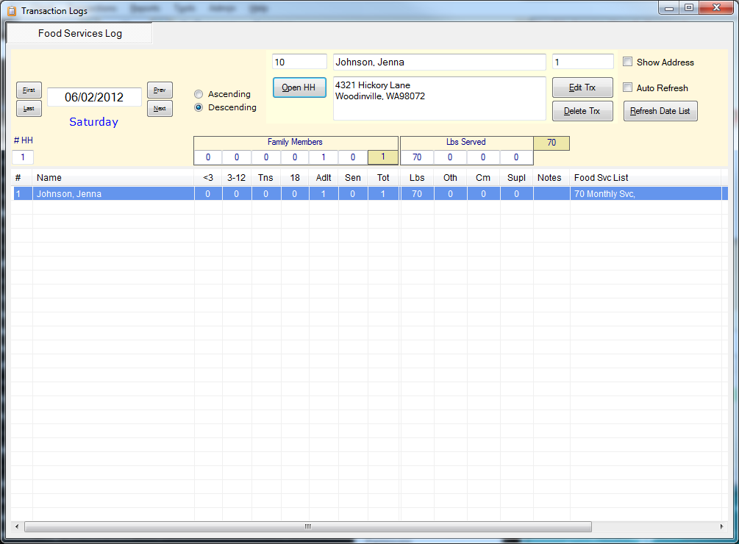

Each time a client participates in a service at your food bank, the information is recorded in the **Food Services Log**. This long tracks the quantity of goods the client has received, the number of family members on the date of the service, and a breakdown of family member and service type (see page XX for more information). When you are finished viewing the log, you can click the red X in the upper right portion of the window to return to the **Main Screen**.

## Selecting a Service Record

Each unique service is linked to the day that it occurred. Before you can view the service, you must select the correct date in the Date field. You can do this in one of three ways:

* **Enter the Date** – The date field displays the current date in MM/DD/YYYY format. To change the date, simply delete it from the form, type in the desired date, and press the Enter key.
* **First and Last** – You can view the first and last service by clicking the **First** or **Las**t button respectively.
* **Prev and Next** – To walk the date backwards or forwards by a single day, click the **Prev** or **Next** button respectively.

Once the correct date has been entered, click the **Refresh Date List** button. A list of all of the services will appear. Click the desired house hold to select it. The records are listed in descending order by house hold name. List them in ascending order, click the **Ascending** radio button. The default sort order is by order of entry into the computer. You can the sort order to name by clicking on the name heading. When the record is highlighted, the house hold information will be displayed in name and address forms at the top of the window.

To edit the house hold, click the **Open HH** button. This will launch the **Family Member** window.

**Show Address** – This check box will display all house hold addresses in the record list.

**Auto Refresh** – This checkbox will automatically refresh the client list every time a new service is entered.

### Editing a Service

You may edit a service by selecting it and clicking the **Edit Trx** button. This will launch the Give Service window. See page XX for more information on services.

### Deleting a Service

To delete a service, select it in the service list and click the **Delete Trx** button. This will permanently delete the selected record, so use with caution.

# Configuring the Service Calendar

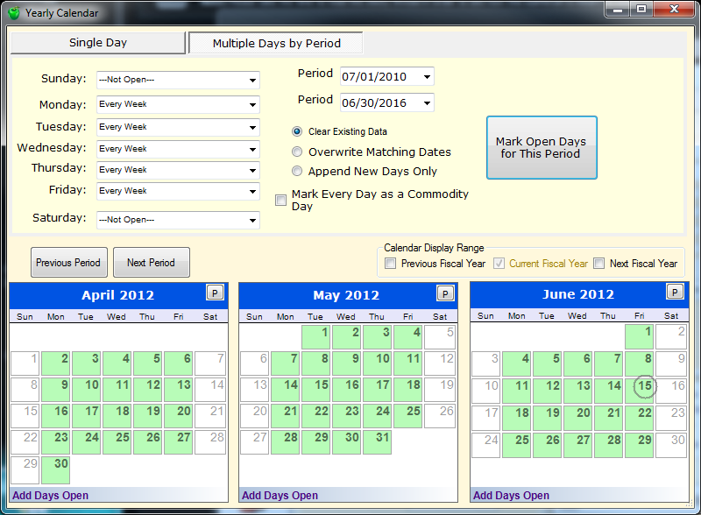

Before configuring new services, you must configure the standard service days. These are the days each week that your food bank is expected to be open. These service days are set in the **Yearly Calendar** in the **Tool Bar** under **Admin**. When the Yearly Calendar window opens, click the **Multiple Days by Period** button to set your standard service days. You may also allow commodities to be given out every day by clicking the **Mark Every Day as a Commodity Day button**.

## Setting the Service Period

Service Period: The service period is the length of time you expect to maintain service dates. In some circumstances, food banks are open different days on different months or seasons. There are two drop down menus lists named Period. The top **Period** is the **Beginning Date** and the bottom **Period** is the **Ending Date**. Any changes you make on this screen will only be applied to days in between and including those two dates.

### Adjusting the Calendar View

You may view the period in 3 month increments by clicking the **Previous Period** and **Next Period** buttons. The previous and next fiscal years can be displayed by clicking on the **Previous Fiscal Year** and/or **Next Fiscal Year** respectively.

## Setting Repeating Service Days

You may set the normal business days of your food bank by selecting the correct day from the list and changing its corresponding drop down menu to one of the following choices:

* Every Week
* Second and Fourth Week of the Month
* First Week of the Month
* Second Week of the Month
* Third Week of the Month
* Fourth Week of the Month
* Not Open

Once you are satisfied with the schedule, press the **Mark Open Days for this Period** to apply the changes.

## Setting Single or Special Service Days

If your food bank is open for special occasions, you can mark these using the **Yearly Calendar**.

### Setting Days in the Single Day Window

This is the preferred method of adding single days. From the bullet list, select the type of service day you would like to add:

**Add Days Open:** This adds a standard day with no special events.

**Toggle Commodity Day:** This marks standard service days where commodities will be available.

**Toggle Special Food Day:** This marks Thanksgiving and Christmas days where unique or themed food items are available.

**Left Click** the day in the calendar (note that the day turns green). To unselect it, **Double Left Click** on the service day. Note that the day must already be marked open (green) to add a **Commodity Day** or **Special Food Day**.

### Setting Days in the Multiple Days by Period Window

Single days may be added as above, but single **Commodity Days** and **Special Food Days** may not be marked in this window.

# Commodity Supplemental Food Program

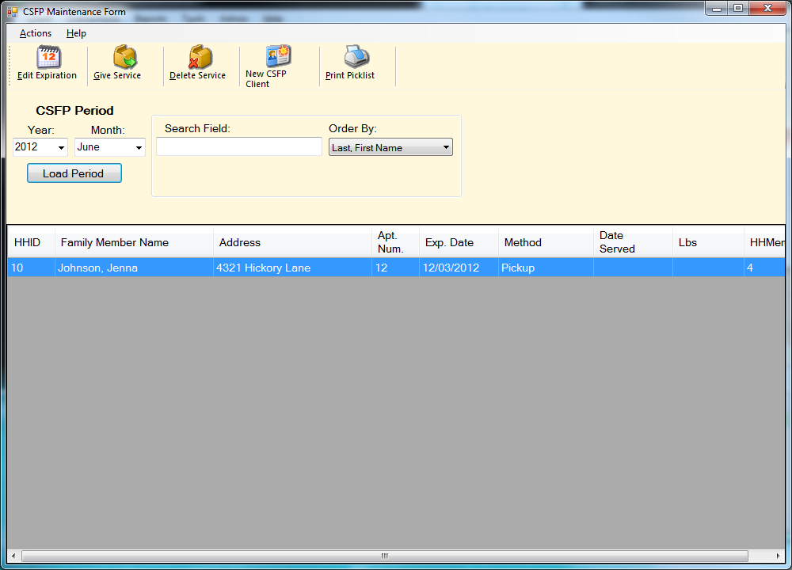

CSFP enrolled clients and services can be tracked in the **CSFP Maintenance Form** by clicking the **CSFP** button in the left tool pain of the **Main Window**. Before you can view or edit any information, you must select a year and month under **CSFP Period** and click the Load Period button.

## Adding a CSFP Service to an Existing Client

Select the client you wish to add the CSFP service to and then click the Give Service button. This will create a **Date of Service** form that allows you to select the date and quantity of CSFP aid in pounds. If the client already has a CSFP service for this period, only the most recent service will be recorded.

To complete the service, click the **Save** button or click the **Cancel** button to erase the changes and return to the **CSFP Maintenance Form**.

## Deleting a CSFP Service on an Existing Client

Select the desired client from the list and click the Delete Service button. This will permanently remove the CSFP service from the client’s record without changing the regular service.

## Adding a New CSFP Client

To add an existing client to the CSFP client list, click the **New CSFP Client button**. This will launch the **Find Client** window. From here you can search for the client you would like to add. Click the **Select** button to confirm the client and return to the **CSFP Maintenance Form**. For additional help using the **Find Client** tool, see page XX. When the **New CSFPS Selection Form** appears, check the box next to each qualified family member and select the **Distribution Method**. This can be local pickup or a route used for delivery. Finally, select the date that the CSFP service will expire. When you are satisfied with the changes, click the **Save** button.

## Finding Additional Information About CSFP

Links are provided in the case that you need more information about CSFP that is not related to the ClientcardFB3 software. In the CSFP Maintenance Window toolbar, click on Help and then the link of your choice:

* FNS – Food and Nutrition Services Website
* Federal CSFP Information
* State CSFP Information (Washington State Only)

This will open the specified website in a separate window. When you are finished reviewing the information, simple click the red X in the upper right hand corner of the window to close it.

## Printing CSFP Client Information

To print CSFP Client information, click the **Print Picklist** button.

# Adding Donors

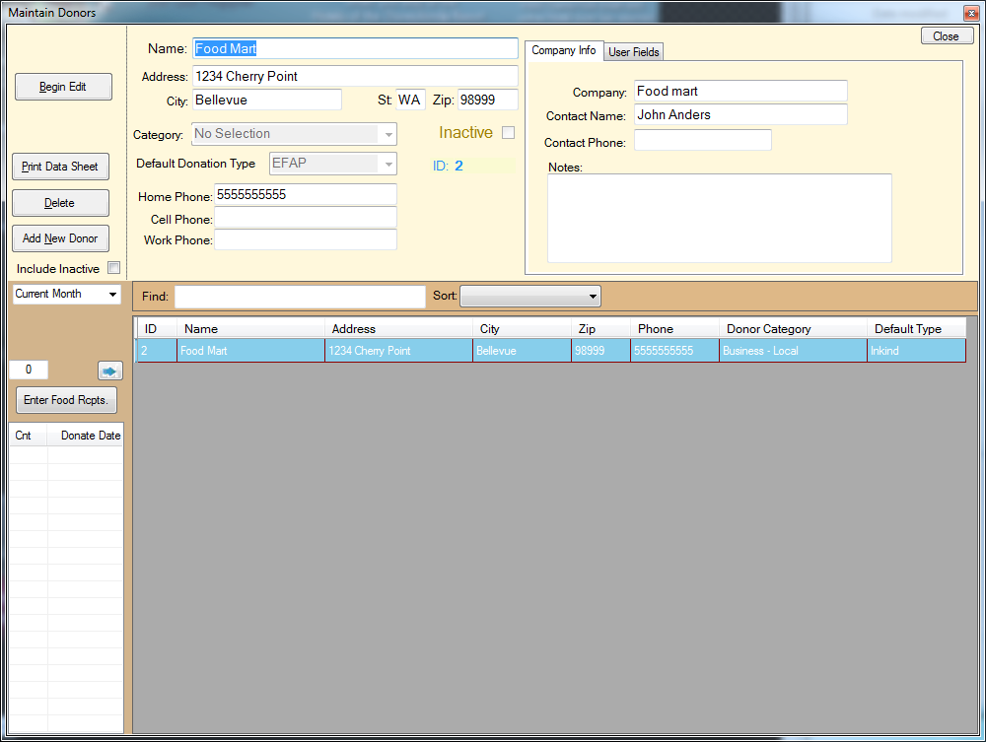 To add donors, select Tools > Maintain Donors from the top toolbar in the Main Window to launch the Maintain Donor window. Donors that++

## Adding a New Donor

Click the **Add New Donor** button to enter edit mode. If the donor is not related to a group, organization, or company, you can record their information and select **Individual** from the Category drop down menu. Otherwise, you can fill out the Company Info tab with additional information and select the proper category. When you are satisfied with the donor information, click the Save button. Clicking the **Cancel Add** button erases all changes and exits edit mode.

You may also select the default donation type. This can be changed at the time of donation if necessary.

## Editing a Donor

To edit an existing donor, you can click the desired donor in the list and click the **Begin Edit** button. If your food bank has a large number of donors, you will need to use the **Find** field. First, set the **Sort** drop down menu to the search parameter you will use (generally Donor Name) and begin typing into the **Find** field. As you type the name, ClientcardFB3 will automatically try to locate the donor. By the time you are finished typing, the correct donor should be highlighted.

Editing a donor is similar to adding one. Click **Save Updates** to save the changes and **Cancel Update** to erase all changes and leave donor edit mode.

# Recording Donations

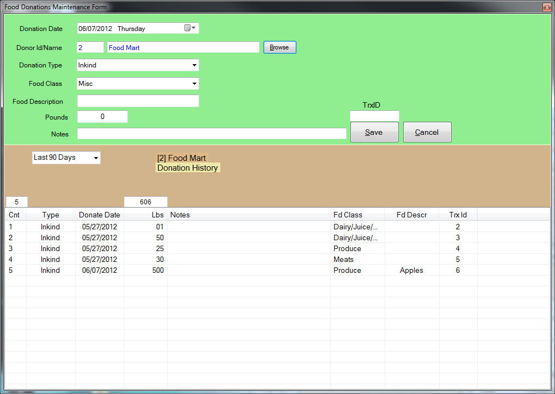ClientcardFB3 allows you to record donations by date and company. All donations are automatically recorded for food donation receipts to reduce the amount of paperwork required. However, donation receipts can still be manually created using the Food Donations Maintenance form (see page XX for more information).

## Creating a New Donation

In the **Food Donations Maintenance** window, select the date of the donation. By default, the current day is selected. Click the **Add New Donation** button to enter edit mode. Click the **Browse** button to open the **Maintain Donor** window. Select the company or individual who is making the donation and press the **Select** button. If this is a new donor, or you want to edit a donor, **see Adding Donors** on page XX.

The **Maintain Donor** window will close once a donor has been selected. The **Food Donations Maintenance** window should now display the donor name and history for the past 90 days. You can now fill out the rest of the donation form to complete the donation record. When you are satisfied with the information, click the Save button to save the record and exit edit mode. To exit without saving changes click the **Cancel** button.

**Donation Type** - Drop down menu for the proper donation type:

* EFAP
* TEFAP
* Other Purchased
* Inkind
* CSFP
* Grocery Rescue
* EFSP

**Food Type** – Sets one of 10 food categories:

* Dairy/Juice/Alternative Dairy
* Produce
* Meats
* Bread/Pastry
* Canned/Dry Goods
* Frozen
* Other/Non-Food Items
* Non-Meat Protein (Eggs, Tofu)
* Prepared Food
* Misc

**Food Description** - An optional field to list the exact contents of the donation, such as apples, baby formula, ham, etc. We recommend you use this field to help track your inventory and to offer more precise donation receipts.

**Pounds**- The quantity of food or product donated in total pounds.

**Notes** - Optional field to add anything not covered by the donation type. This could be the quality of the donation or special storage instructions.

**TrxID** – Unique database ID. This will be automatically generated and should generally be left blank.

Navigating Donations

In the Food Donations Maintenance window, you can view specific donations by selecting them in the donation list. To view a certain day, click on the calendar icon in the Date drop down menu. Select the day on the calendar that you would like to view. Alternatively, you can view the first and last donations by clicking the First or Last button. Finally, you can cycle through the donations by clicking the Prev or Next button. This will move through the donations in the order they were recorded.

## Editing Donations

To edit a donation, click on the desired donation in the donation list to select it. Three buttons will become available:

* **Edit Donation [TrxID] [Donor Name][Donation Pounds]** – This will enter edit mode with the selected donation.
* **Show Donor [Donation ID] History [Donor Name]** – This opens the donor’s entire history. Click **Hide Donor History** to exit.
* **Delete Donation [TrxID]** – This permanently deletes the donation. This cannot be undone.

# Food Receipts for Donations

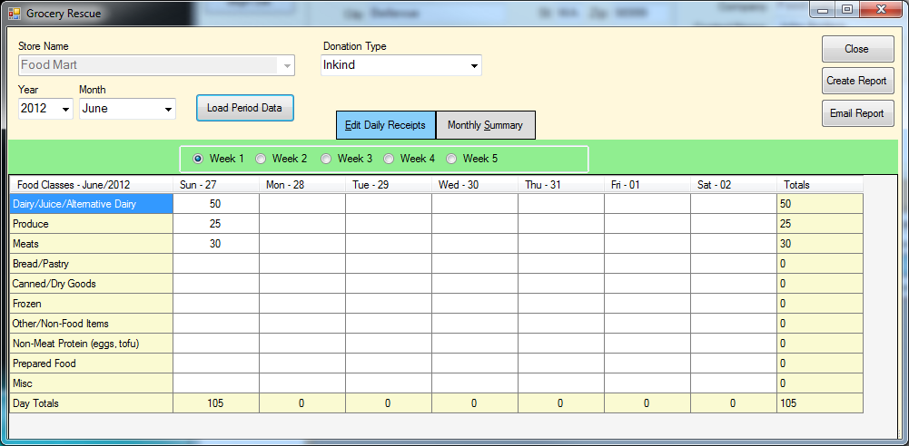

ClientcardFB3 allows you to manually track donations and donators to your food bank through the Food Donations Maintenance form. You can access this by clicking the Food Rcpts button on the intake shortcuts in the Main Window.

## Adding Donors

Before creating a donation entry, you must add donors. To do this, select **Tools** > **Maintain Donors** from the top toolbar in the **Main Window** to launch the **Maintain Donors** window. See **Adding Donors** on page XX for more information.

## Adding Food Receipts

Select the donating company from the **Maintain Donors** window and click **the Enter Food Rcpts** button. This will launch the Food Receipts window. Select the donation type in the **Donation Type** drop down menu, then select the date in the **Year** and **Month** drop down menus and click **Load Period Data**. This generates the Food Receipt spreadsheet.

### Adding Pounds of Food

To add the pounds of food donated, double-click the appropriate day and food type cell. Enter the quantity of pounds and press the **Enter** key on your keyboard. Continue until you are satisfied with the entries. Note that the daily and weekly totals are automatically calculated for you. All entries are automatically saved when you press the **Enter** key.

You can change to different weeks inside the same period by selecting the Week radio button and view the full month by clicking **Monthly Summary**. Return to the spreadsheet by clicking on **Edit Daily Receipts**.

When you are finished with receipts for this company, click the Close button to return to the Maintain Donors window.

### Generating Reports

There are two methods of quickly generating reports from the Food Receipts window. The first is to save a copy to your computer for future use, and the other is to directly email a recipient.

**Create Report** – Clicking the **Create Report** button will open Microsoft Excel with all data from the current period automatically loaded into a spreadsheet. From here, you may edit the spreadsheet or save it for future use. See page XX on using Microsoft Office.

Email Report – If you want to send the report directly to a recipient, click the **Email Report** button. This will launch Outlook with the report automatically attached. You will still need to enter the recipient’s email. See page XX on using Microsoft Office.

# The Search and Barcode Tool

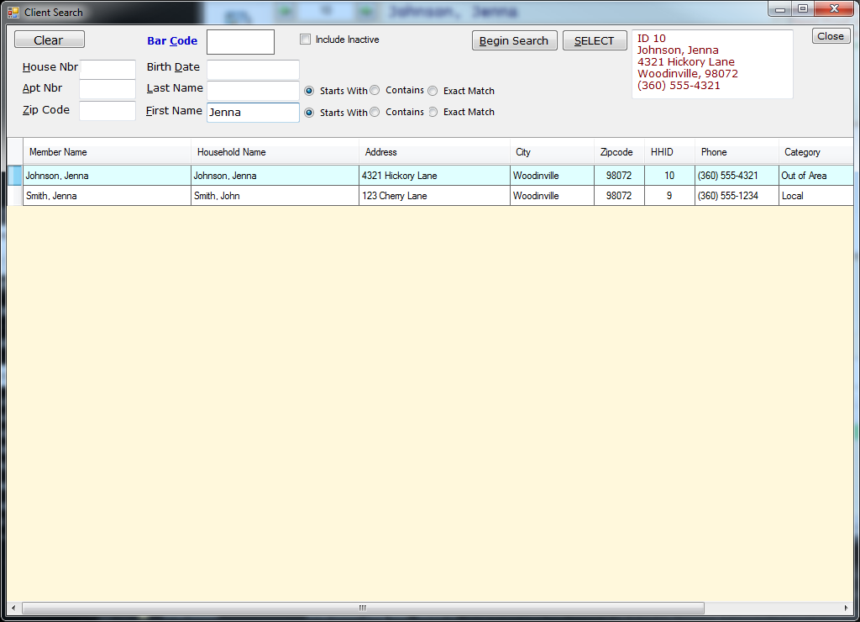

The **Search and Barcode** tool allows for more complex client searches and/or barcodes and barcode devices to increase client processing speed. While it functions similar to the **Client Search** tool, it does not refresh the client list as you type. Once you select a client, however, it returns to the Main Window with the selected client’s information. Click the **Clear** button to erase all search fields and results to start over.

## Finding a Client Manually

To find the client without using a barcode and scanner, type the search parameters into one of the search forms:

* House Nbr
* Apt Nbr
* Zip Code
* Birth Date
* Last Name
* First Name

Once you have the desired client information entered, click the Begin Search button to find any matching clients in the database. Highlight the client in the client list and click the Select button to return to the **Main Window**.

### Refining the Search

You can refine a search based on the client’s name by selecting one of the three radio buttons next to the first and/or last name:

**Starts With** – Matches the first letters in the name until no more matches are found.

**Contains** – Matches any names with a similar name, even if the first or last name is different.

**Exact Match** – Will only match names that match the search parameters exactly. This means they must have the same spelling.

## Searching by Barcode

ClientcardFB3 has the ability to search by barcode. To do this, click on the empty field next to Bar Code and scan the barcode with your scanner (see the instructions that came with your barcode scanner for proper usage). Press the Enter button to confirm the scanned number. You should now see the client if it exists in the database.

Note: The client must have a barcode attached to their account for a barcode search to work correctly. If they do not have a barcode, an error window will appear saying “This Barcode is not in the Database.”

# Adding and Managing Volunteers

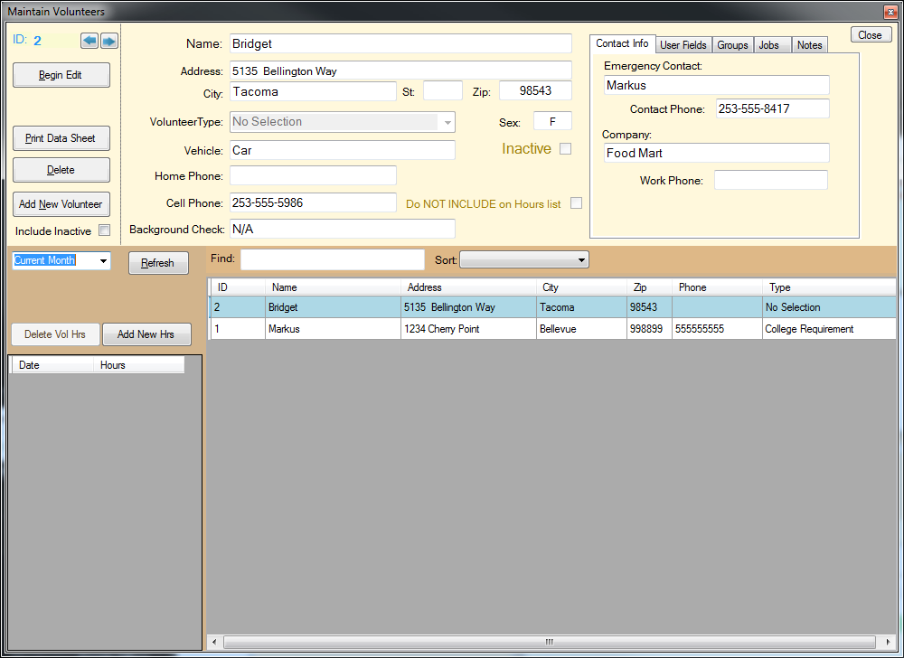

ClientcardFB3 has a robust volunteer tracking system. This allows you to manage volunteers, record hours, and assign tasks. You can access the Maintain Volunteer tool by selecting **Tools** > **Maintain Volunteers** from the **Main Toolbar**. You will notice that this window is very similar to the food donor window. To simply view a volunteer’s information, click the volunteer’s name in the volunteer list. This will load the recorded information into read only forms. When you are finished adding, editing, or viewing volunteers, click the **Close** button in the upper right portion of the screen.

# Adding a New Volunteer

Click the Add New Volunteer button to enter edit mode. If you have an existing volunteer selected, this will unselect them and clear the fields.

Enter the volunteers name, address, city, state, zip code, and gender. Optionally, you may add their vehicle type, home and cell phone numbers, and whether they have completed a background check. Finally, you can select the type of volunteer they are in the **Volunteer Type drop down menu**:

* Board Member
* College Requirement
* General Volunteer
* General Volunteer - CS
* General Volunteer – Corp.
* General Volunteer – Youth
* Internship
* Tuesday’s Table
* Tuesday’s Table – CS
* Tuesday’s Table – Youth
* No Selection

**Do NOT INCLUDE on Hours list** – this checkbox will prevent the volunteer from appear on the hours list, and also preventing them from gaining or losing any hours.

When you are satisfied with the information you have entered, click the **Save** button. To quit and delete all changes, click the **Cancel Add** button.

## Additional Volunteer Information

To add more detailed information, such as emergency contact and job types, use the tab field in the upper right.

### Contact Info

This tab stores additional contact information in case of an emergency:

* **Emergency Contact** – The name of the volunteer’s emergency contact.
* **Contact Phone** – The volunteer’s emergency contact’s number.
* **Company** – The name of the volunteer’s company (if any).
* **Work Phone** – The volunteer’s work phone number.

### User Fields

This allows you to enter the Food Bank ID number.

### Groups

This specifies the group that the volunteer belongs to. Multiple groups may be selected if necessary:

* **Community Service** – The volunteer is completing a community service program.
* **Harvest For Hunger** – The volunteer is a member of Harvest for Hunger.
* **Church Group** – The volunteer belongs to a church group.

### Jobs

The volunteer’s job at the food bank can be set by clicking each checkbox that applies. See page XX for information about jobs.

### Notes

The Notes tab allows you to enter any additional information about the employee, such as days they cannot work, when they will start, or any other information you feel is necessary.

## Recording Volunteer Hours

Once a volunteer’s profile has been created, you can add hours to their record by selecting their name in the volunteer list and clicking the **Add New Hrs button**. This will create a new entry with two fields for date and hours. Enter the date in **mm/dd/yyyy** format (including the slashes) and press the **Tab** button on the keyboard. Enter the number of hours the volunteer completed and press **Tab** again to save the entry. The records will be automatically ordered by date.

Note: You do not need to be in **Edit Mode** to add hours.

## Deleting an Existing Volunteer

To delete an existing volunteer, simply select the record from the volunteer list and click the Delete button. The volunteer’s record, including any hours they have worked, will be permanently deleted.

# Volunteer Hours

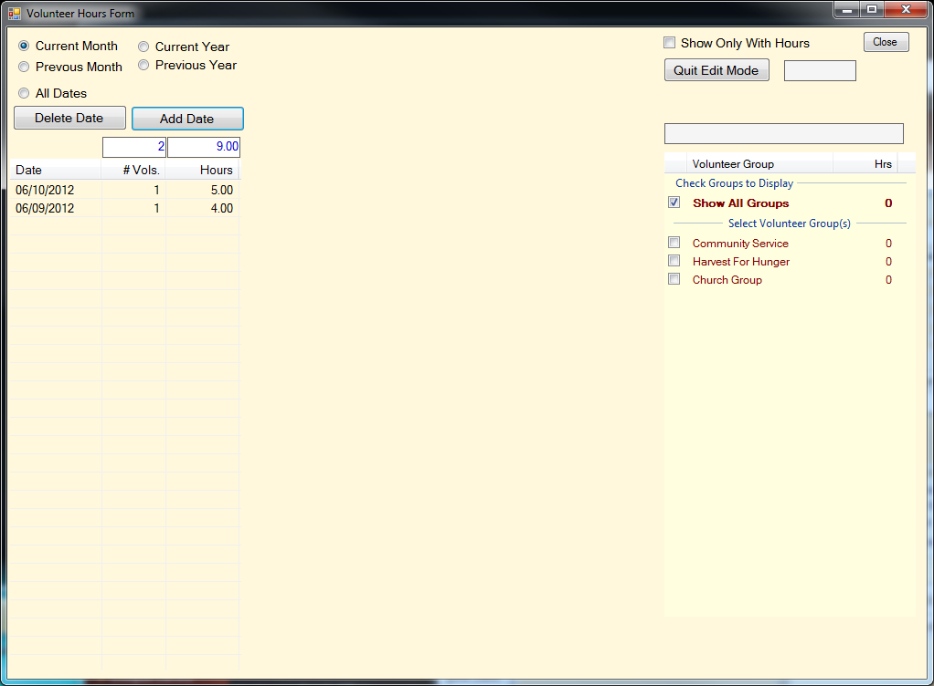

The Volunteer Hours form allows you to track the total volunteer hours, view them by date, or modify them. Using the **Volunteer Hours** form, you can add or delete entire dates. You may also view hours contributed by specific groups and add or delete them. When you are fin

## Viewing Hours by Date

To change the period of dates you are viewing, select one of the radio buttons in the upper left corner of the Volunteer Hours window:

* Current Month
* Previous Month
* Current Year
* Previous Year
* All Dates

## Editing Volunteer Hours

To add, remove, or edit volunteer hours, select the date you would like to change. This will open the date in Edit Mode. You may then alter the hours in two ways. The first is by setting the Time In and Time Out fields. This will automatically calculate the number of hours. Alternatively, you can enter the number of hours in the **Hours** field. The fields are automatically saved as you enter them, so there is no need to manually the form. The volunteer profiles are also updated to reflect the new information. When you are satisfied with the changes, click the **Quit Exit Mode** button.

To view only volunteers with hours, check the **Show Only With Hours** checkbox. You may also view volunteers by group by checking the boxes next to the desired volunteer groups.

## Adding and Deleting a Date

You can add a new date clicking the **Add Date** button. This opens the New TrxDate window. Click on the calendar icon, select the date you wish to add and click the **Save** button. You may erase all changes and quit using the **Cancel** button.

To delete a date, simply click on the date in the list and click the **Delete Date** button. To exit without saving changes, click the **Quit Edit Mode** button.

# Creating Monthly Reports

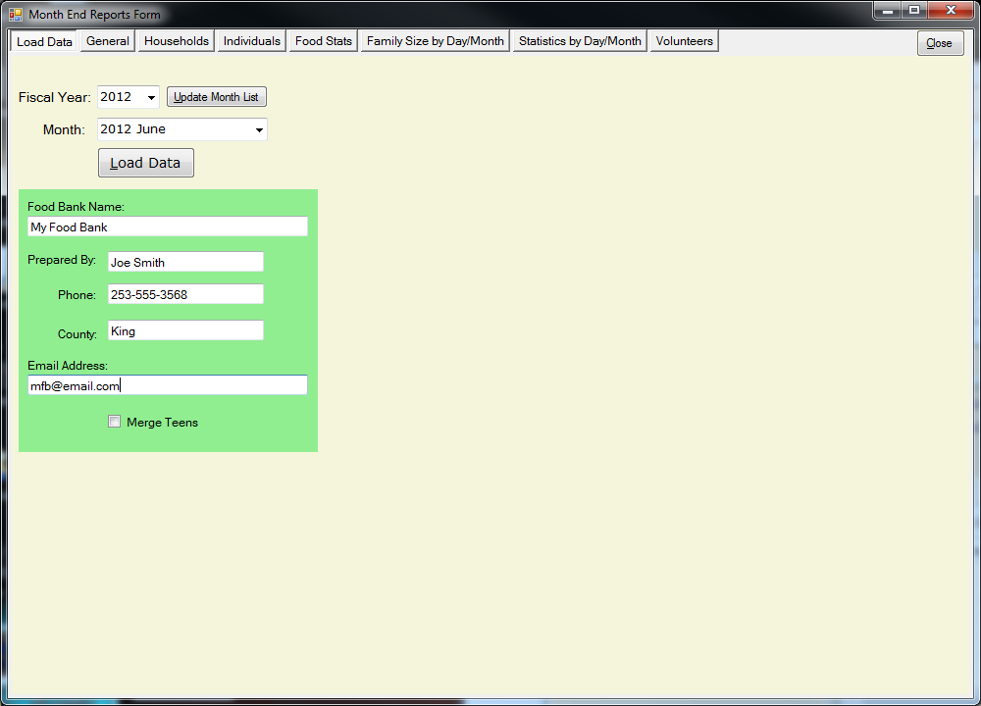

The Month End Reports window can be accessed from **Reports** > **Monthly Reports** in the toolbar of the **Main Window**. From here, you can load all the information for any month that your food bank was in operation. Before creating a monthly report, fill out the food bank name, preparer, contact number, county, and food bank email. This information will be automatically placed in the report. When you are finished with report creation, click the **Close** button to return to the **Main Screen**.

## Loading Monthly Data for Reports

By default, the current month and year will automatically be selected in the Fiscal Year and Month drop down menu. You may select another year and month if necessary. Only the months in which there are service records will be available for selection. If the service records have been updated, click the Update Month List button to add the new months to the list. When you have selected the month that you want to create a report for, click the **Load Data** button.

## Creating and Printing Reports

Once the data has been loaded, a new form will appear inside the **Month End Reports** window. Check the box next to the report type that you would like to create. You may selected multiple reports if necessary:

* All
* EFAP Monthly Activity
* Monthly Summary
* Northwest Harvest
* Second Harvest Inland NW Pantry
* Second Harvest Inland NW Activity

**Auto Print**: If you are printing copies of the reports, check the **Auto Print** checkbox. When this option is selected, whenever you create a report it will be automatically printed.

* EFN Monthly Report

When you are satisfied with your choices, you can choose one of the following options:

* **Create Reports** – Creates the reports with all necessary data and information.
* **Display Existing** – Displays any reports that have already been created.
* **Email Reports**- Generates an email with created reports automatically attached.
* **Export Data** – Exports all information for backup purposes.

## Viewing Monthly Data

Though the Month End Reports window is used primarily for creating monthly reports, it also has a full suite of graphs and compiled data. This information may be viewed at any time to gauge the amount, type, and demographic of goods being distributed. This information is stored in seven separate pages within the **Month End Report** window:

* **General** – A broad list of data for the month and fiscal year.
* **Households** – A breakdown of household composition, type, and needs.
* **Individuals** – A comprehensive chart of individual services.
* **Food Stats** – A list that compares the total amount of food received compared the amount served.
* **Family Size by Day/Month** – Family sizes served by date.
* **Statistics by Day/Month** – Family and food service statistics by date.
* **Volunteers** – List of volunteers and daily/monthly hours.

## Creating a King County Report

To create a report specifically for King County, Washington, select the **KC Report** form on the toolbar in the **Main Window** (**Reports** > **King County**). When the **KC Report** form opens, select the year and quarter of the report in the **Year** and **Quarter** drop down menus and click Create Report.

If you do not wish to create a report, click the **Cancel** button to return to the **Main Screen**.

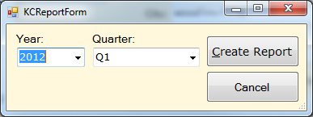

# Managing Monthly Reports

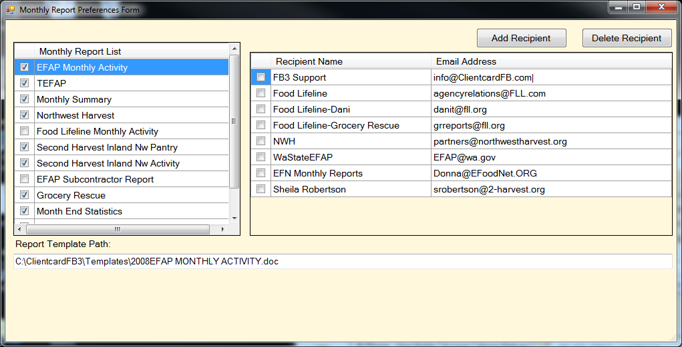The types of monthly reports created and their recipients can be modified in the Monthly Report Preferences form. You can access this form in **Admin** > **Manage Monthly Reports** in the **Main Window** toolbar. This includes adding and deleting additional recipients.

## Adding and Removing Monthly Reports

Find the desired monthly report in the **Monthly Report List** and select the checkbox. To remove it, simply click the checkbox to unselect it.

## Adding New Recipients

Click the **Add Recipient** button. When the **Add New Email Recipient** form opens, enter their name and email address in the **New Recipient Name** and **New Recipient Email Address** respectively. Click the Insert button to save the information and return to the **Monthly Report Preferences** window. Clicking cancel will remove all changes and return to the **Monthly Report Preferences** window.

## Deleting Recipients

Select the recipient by clicking their name in the **Recipient List**. Click the **Delete Recipient** button. Click the **Yes** button in the **Delete Recipient** confirmation window to permanently delete the recipient. Click the **No** button to cancel the delete and keep the recipient.

## Including Recipients to a Monthly Report

Select a monthly report from the **Monthly Report** List to include recipients on by clicking it. In the **Recipient List**, click the checkbox next to each recipient you would like to add. To remove recipients, simply click on a checked box to uncheck it.

These changes are applied instantly and do not require saving.

# Access Reports

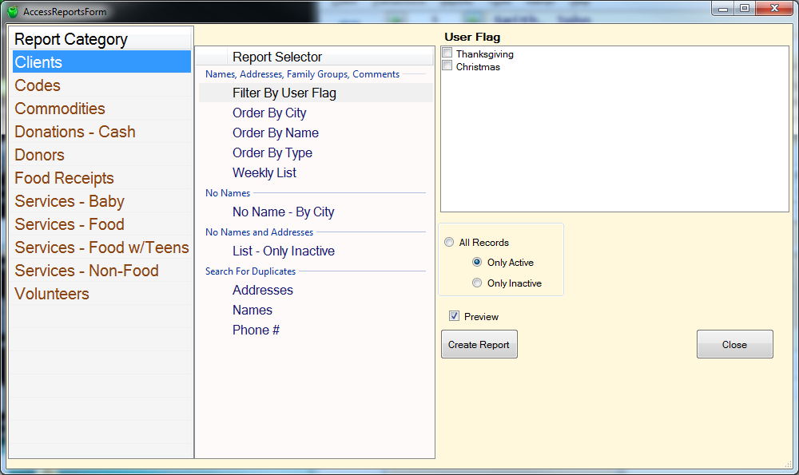

To create more specific reports, you can use the **Access Reports** form. This can be launched from **Reports** > **Access Reports** in the toolbar on the **Main Screen**. When you are finished creating reports, click the Close button to return to the Main Screen. None of these reports are essential for maintaining your food bank. However, you may find them useful in configuring ClientcardFB3 or viewing specific client and service data without generating a full report.

Some reports require a specific date or period to be set. To do this, click on the calendars in the **Enter Date Range** field and select the desired dates.

## Report Category

Inside the Report Category is a list of the basic report types. Clicking on the Report Category will display the list items it is capable of generating in the Report Selector. Click on the desired report and click the **Create Report** button.

### Clients

* **Filter By User Flag** – Lists all clients that participate in Thanksgiving or Christmas services.
* **Order By City** – Lists all clients in the selected cities.

**Only Active** records are displayed by default. You may choose to view **Only Inactive** or **All Records** by selecting the appropriate radio button.

* **Order By Name** – Lists all clients by name.
* **Order By Type** – Lists all clients by their type.
* **Weekly List** – Lists all clients that participated in services by week.
* **No Name – By City** – Lists unnamed clients by city.
* **List – Only Inactive** – Lists unnamed and unaddressed clients who are marked Inactive.
* **Addresses** – Lists all duplicate addresses.
* **Names** – Lists all duplicate names.
* **Phone #** - Lists all duplicate phone numbers.

### Codes

Codes generate a report of all the client data types. This content does not include client information, but metadata used in ClientcardFB3 forms. These fields are sorted by:

* **Client Types**
* **Language Types**
* **Phone Types**
* **Verify ID Method**
* **Donor Types**
* **CSFP Route**
* **Discharge Status**
* **Employment Level**
* **Employment Status**
* **Military Service**
* **Food Classes**
* **Receipt Type**
* **Volunteer Groups**
* **Volunteer Types**
* **Voucher Types**

### Commodities

* **Daily Totals** – The total commodities served over the range of days specified.
* **Totals By City** – The total commodities served each month to each city.
* **Totals By Client Type** – The total commodities served each month to each client type.

### Donations – Cash

* **By Donor** – All cash donations by donors over the specified period.
* **Daily Log** – The day by day donations and their totals over the specified period.
* **Daily Totals** – The total value of all donations over the specified period.
* **Monthly Totals** – The total value of each donations and the grand total of all donation over the specified period.

### Donors

* **Food Donations** – Total food donations by selected donors over the specified period.
* **Food Donations By Donor Type** – Total food donations by donor type over the specified period.
* **By Type** – Lists every donor by the selected type.
* **Master List** – Lists all donors recorded in ClientcardFB3.

### Food Receipts

* **Daily Log** – Record of each donation with quantity, type, and food code by donor over the specified days.
* **Daily Totals** – The total pounds of food donated by day over the specified period.
* **Monthly Totals** – The total pounds of food donated by month over the specified period.

### Services – Baby

* **Daily Log with Notes** – List of baby services on a specific day.
* **Daily Log with Notes** – List of baby services by day over a specific period.

### Services – Food

* **Monthly Totals** – Monthly totals for the specified year.
* **Yearly Totals** – Yearly totals for the specified period.
* **Daily Log with Address** – List of client’s served on the specified day.
* **Daily Log with Notes** – List of client’s served on the specified day with notes.
* **Daily Log with Service List** – List of families and quantity of goods served to them on the specified day.
* **Daily Summary** – Total family member members served plus commodities on the specified day.
* **Monthly Totals by Fiscal Year** – All monthly totals for the specified period.
* **Quarterly Human Services** – Households served by quarter for the specified period.
* **Yearly Totals by Fiscal Year** – Total services by year for the specified period.
* **Daily Totals** – The total household services and quantity of goods served one each day for the specified period.

### Services – Food w/Teens

* **Monthly Totals** – Total monthly services that include teenagers for the given period.
* **Daily Log with Notes** – Services that included teenagers on a specific day (with notes).
* **Daily Totals** – Total services that included teenagers on each day of the specified period.

### Services – Non-Food

* **Daily Log with Service List** – Total household non-food services for each day of a specified period.
* **Daily Summary** – Total household non-food services for a specific day.

### Volunteers

**Hours By Day** – Total volunteer hours on each day of a specified period.

**Hours By Month** – Total volunteer hours on each month of a specified period.

**By Day** – Total hours of the selected volunteers for the specified period.

**By Name** – Total hours of the selected volunteers of each day for the specified period.

**By Classification** – List of all volunteers within the selected classifications.

**Master List – Active** – List of all active volunteers.

**Master List – Inactive** – List of all inactive volunteers.

## Database Statistics

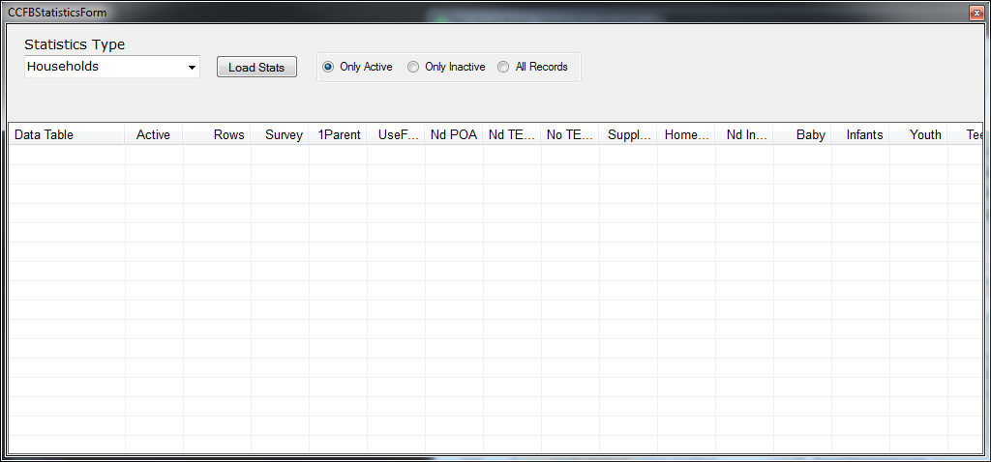

To review raw database statistics, launch the **CCFB Statistics** form form **Reports** > **Database** Statistics on the **Main Screen**. This will allow you to view raw database content without any kind of filters. To access the information, select the desired data type from the **Statistics Type** drop down menu and click **the Load Stats** button. The data types you can choose from are:

* Households
* Households By Category
* Household Members
* Donors
* Donations – Cash
* Food Receipts
* Food Services
* Volunteers
* Volunteer Hours

To close the **CCFB Statistics** window and return to the Main Screen, click the red X in the upper right hand corner.

# Home Delivery

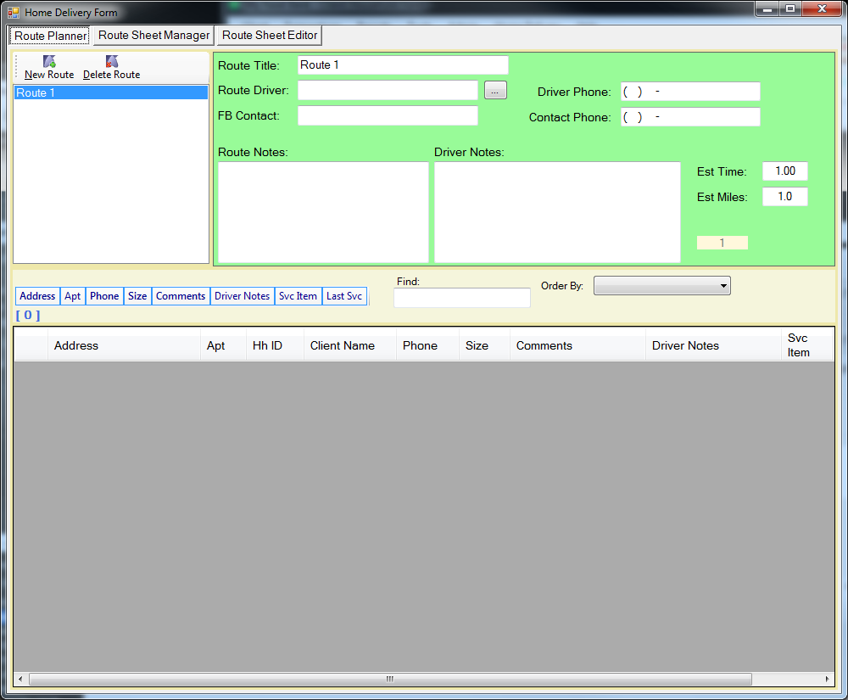

ClientcardFB3 supports home deliveries, including route and driver information. By assigning volunteers as drivers and setting time and mileage estimations, you can make your deliveries more efficient.

## Adding a New Route

Select **Home Delivery** > **Route Maintenance** to open the **Home Delivery Route Maintenance** window. Click the **New Route** button to create a new route and enter its name in the **Route Title** field. When you are finished, click the **Save** button.

### Adding a Driver to a Route

With the **Home Delivery Route** **Maintenance** window open, click the … button next to **Route Driver**. This will open the list of available volunteers. You may either select an existing volunteer by clicking the Select button, or create a new volunteer. The driver’s name and phone number will be automatically loaded when you click the **Select** button.

Enter any notes or information you consider necessary into **Route Notes** or **Driver Notes** for other volunteers to view. When you are finished, click the **Save** button.

### Route Time and Distance

You can enter the estimated time and distance into the **Est Time** and **Est Miles** fields respectively. Note that time is in percentage of an hour, so .25 is equal to 15 minutes and 1.0 is equal to 1 hour. We recommend that you use a website such as Google Maps to plot the intended route for an accurate estimate of time and distance. Click the **Save** button when you are finished.

## Deleting a Route

To delete a route, select it in the route list and click the **Delete Route** button. This will permanently delete all route information from the database.

# ClientcardFB3 Administration

ClientcardFB3 allows many data fields and items to be customized to a food bank’s specific needs. The tools to allow customization can be found in the Admin tab in the toolbar on the **Main Screen**. Changes can be made at any time, and will be immediately reflected in the ClientcardFB3 software.

## Edit Service Items

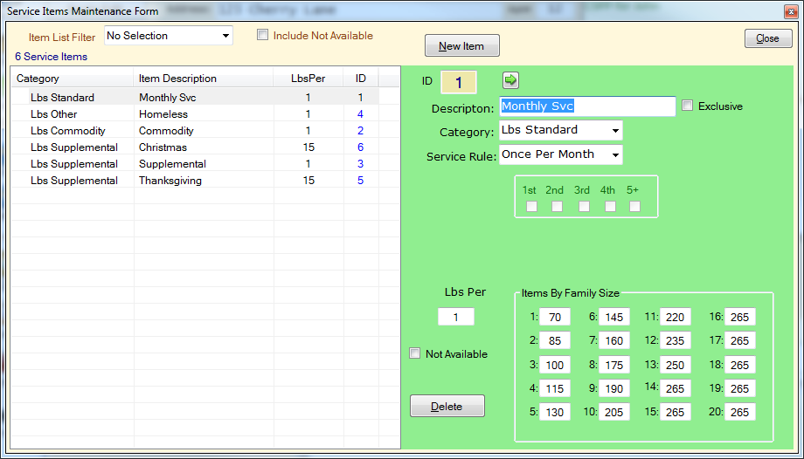

Service items, as well as the default pounds of service per family size, can be modified using the **Service Items Maintenance** form. You can access this form in **Admin** > **Edit Service Items** in the **Main Window**. This allows you to customize the types of services you offer and record.

## Creating a New Service Item

Click the **New Item** button to launch the **Add New Service Item** window. Enter a description of the service and a **Category** from the drop down menu:

* Lbs Standard
* Lbs Other
* Lbs Commodity
* Lbs Supplemental
* Non-Food Items
* Baby Services
* No Selection

To determine when the service is available select the **Service Rule** from the drop down menu:

* Always
* Once Per Month
* Second Service
* Manual Selection
* Special Service
* Once Per Week
* Homeless/Transient
* Mask Array

Click the **Add Item** button to save the service item. To quit without saving, click the **Cancel** button.

Editing a Service Item

Click the desired **Service Item** in the list. This will show the **Service Item’s** configuration in the edit form. The Description, Category, and Service Rule can be altered in the same way as created a new Service Item. In addition, the service may be set as exclusive by selecting the **Exclusive** check box and the **Mask Array** can be set to **1st**, **2nd**, **3rd**, **4th** and **5+**.

The quantity of food allowed per family member is adjusted in the **Items By Family Size** form. The default item weight can be set for up to 20 family members. Each of the numbers preceding the colon is the total number of family members in the family. The number to the right of the colon is the total pounds of items that family size can receive in a single service. This quantity can be changed by deleting the original number, typing your own, and pressing the **Tab** key.

Setting Availability

All services are available by default. You make a specific service unavailable by selecting the **Not Available** checkbox. This will remove the service without deleting it, in case you want to enable it again in the future.

Deleting a Service

To delete a service, click the **Delete** button. This will permanently delete the service from the database.

## Backing up the ClientcardFB3 Database

## 

On the **Main Screen**, select **Admin** > **Backup Database**. When the **Backup ClientcardFB3 SQL Database** window opens, click the **Select Location** button and choose the location you would like to store your database backup. Click the **Start** button to begin the backup.

## Toggle User Information

Toggle user info allows you to view the user who created or modified the client entry. In the Main Window, select Admin > Toggle User Info. The information will appear above the Food Service Log.

# Configuring Preferences

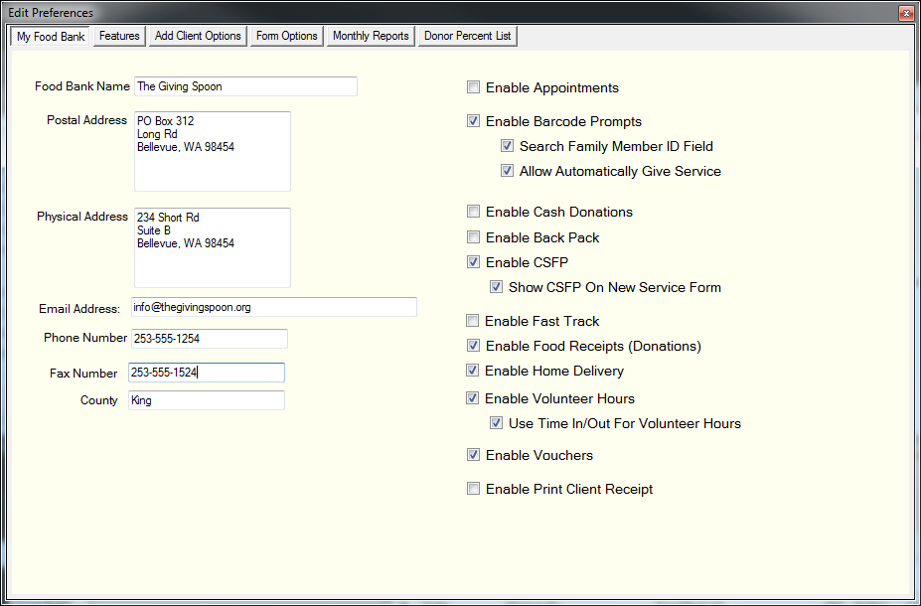  
The Preferences tool allows you to modify the behavior of ClientcardFB3, such as setting default contact information, toggling food services, and when to use certain information. We highly recommend setting all of your preferences before using ClientcardFB3 to save time and prevent problems further down the road. Preferences are divided into 6 categories, detailed below. You can switch between each section by clicking on its name.

## My Food Bank

This section allows you to alter your food bank’s contact information and basic settings.

* **Food Bank Name** – The name of your food bank.
* **Postal Address** – A PO box or other mailing address.
* **Physical Address** – Your physical location.
* **Email Address** – Default contact email for your food bank.
* **Phone Number** – Default contact phone number for your food bank.
* **Fax Number** – Default fax number for your food bank.
* **County** – The county your food bank is registered in.

### Additional Options

These options can be enabled by clicking their check box.

* **Enable Appointments** – Allow appointments to be scheduled.
* **Enable Barcode Prompts** – Enable barcode prompts when scanning barcodes.
  + **Search Family Member ID Field** – Use Family Member ID field when scanning barcodes.
  + **Allow Automatically Give Service** – Automatically assign service when scanning barcodes.
* **Enable Cash Donations** – Allow cash donations to be recorded.
* **Enable Back Pack** – Allow clients to use back packs.
* **Enable CSFP** – Allow Community Service Food Program records.
  + **Show CSFP On New Service Form** – Show Communuty Service Food Program when creating a new service.
* **Enable Fast Track** – allow Fast Track
* **Enable Food Receipts (Donations)** – Allow food donation records.
* **Enable Home Delivery** – Allow home delivery records.
* **Enable Volunteer Hours** – Allow volunteer hour records.
  + **Use Time In/Out For Volunteer Hours** – Allow time in/out to calculate total volunteer hours and track volunteer work days.
* **Enable Vouchers** – Allow voucher records.
* **Enable Print Client Receipt** – Allow receipts to be printed for client use.

## Features

* **Enable Food Services** – Allow food services to be recorded.
  + **Enable Supplemental Food Service** – Enable supplements to be recorded.
  + **Enable Commodities (TEFAP)** – Enable commodities to be recorded.
    - **Serve Commodity ONLY on a Commodity Day** – Only allow commodities on marked days.
    - **Months Comm. Signature Valid** – Months before a commodity signature expires.
* **Enable Print Client Card** – Allow client cards to be printed.
* **Enable Baby Services** – Allow baby services to be recorded.
* **Alert after this number of services in a month** – Alert volunteers after this number of services by one household in one month.
* **Alert after this number of services in a week** – Alert after this number of services by one household in one week.
* **Warn For weekly Services By Person** – Warn after set number of services in one week per person instead of per household.

### Household Client Data Tab Control

* **Track Client Phone Number** – Enable the phone number field in client records.
* **Enable Verify Address** – Enable address verification in client records.
  + **Enable User Defined Fields Tab** – Enable user defined fields in client record.
  + **Enable Household Income** – Enable household income in client records.
  + **Enable HUD Income Category** – Enable HUD income categories in client records.

### Family Members Data Tab Control

**Enable Works In Area** – Enable works in area field in client records.

**Enable Additional HH Member Data Tab** – Enables additional HH member data tab in client records.

**Enable Ethnicity Tab** – Enables ethnicity tab in client records.

**Enable ID Fields** – Enables ID fields in client data.

## Add Client Options

* **Default City** – Default city for clients records.
* **Default State** – Default state for client records.
* **Default Zip Code** – Default zip code for client records.
* **Allow Duplicate Names for Households (not recommended)** – Allow two or more family households to share the same name.
* **Allow Duplicate Names for Family Members** – Allow two or more families members to share the same name.

### Use Family List

* Normally
* Sometimes
* Always
* Never

## Form Options

Each item in Form Options allows you to change default settings on the forms, and is explained next to the item. It is unlikely that any of these settings will need to be changed. In the event that they must be modified, simply change the item to the desired value and press the Tab key.

## Monthly Reports

Like Form Options, Monthly Reports explains each item, though you will want to review each field and make certain they match your food bank’s protocol. This is especially true for **Prepared By**, **NWH Donor ID**, and **Start Month for Fiscal Year**. Whenever a new volunteer begins to complete your monthly reports, make certain to check the **Prepared By** field to reflect this.

## Donor Percent List

You can view the contributions of up to 20 donors to see what their overall donation percentage is. This will give you an idea of the largest or most active donators to your food banks. To add a donor to the Donor Percent List, click on the donor number button (Donor 01, Donor 02, etc). You can then add an existing donor or create a new donor.

## User Defined Fields

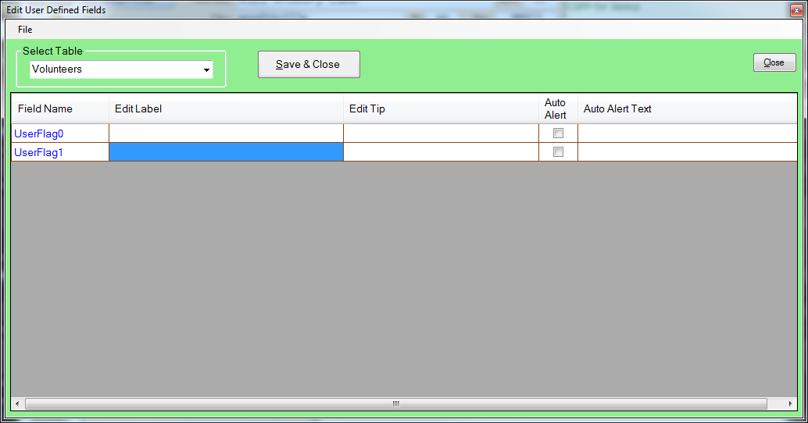

Working with Type Codes

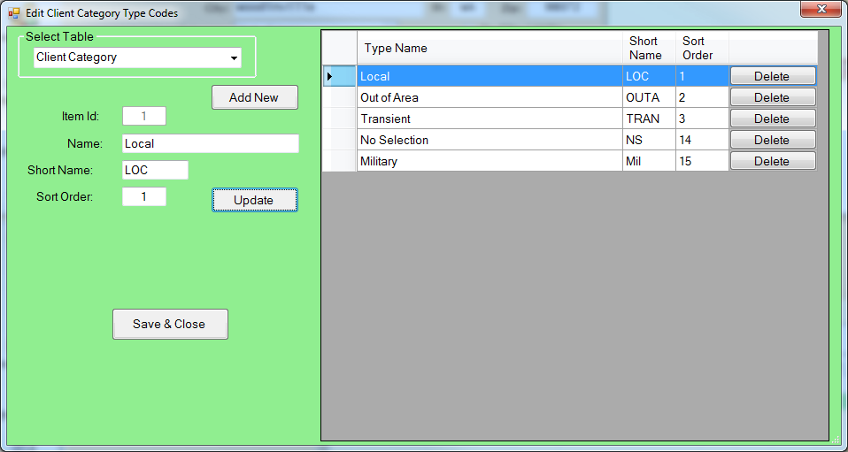

ClientcardFB3 allows food banks to define their own category types. These can be clients, food or service types, languages and more. This allows your food bank to keep better records on its services and identify services needed by the community. The **Edit Client Category Type Codes** window can be accessed from **Admin** > **Type Codes** from the toolbar in the **Main Window**. Each category type is assigned to a specific table in the database. For example, **Special Languages** will allow you to add additional languages to choose from when creating a client. The category tables are:

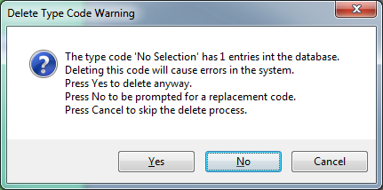

* Client Category
* Donor Category
* Donation Type
* Food Class
* ID Verification
* Phone Type
* Special Language
* Volunteer Category
* Volunteer Groups
* Education Level
* Employment Status
* Military Discharge
* Military Service
* Food Bank Programs

When deleting **Category Types** that are in use, they are deleted the instant **Yes** is selected in the confirmation window and will not be recoverable, causing errors. Make certain a **Type Code** is no longer in use before deleting it!

* Food Bank Jobs

### Adding a New Category Type

Select the click the **Add New** button. The **Item Id** is automatically generated. Complete the rest of the forms:

* **Name:** The name of the type. This should be easy to understand.
* **Short Name:** Unique abbreviation of the type.
* **Sort Order:** This is the order that the type will appear in the list. **Sort Order 1** will appear first on list, **Sort Order 2** will be second, etc.

### Editing an Existing Category Type

Select the table with the type in the **Select Table** dropdown menu and then select the desired type from the **Type List** on the right. Make the desired changes to **Name** ,**Short Name**, **Sort Order** and click the **Update** button.

### Deleting a Category Type

Select the table with the type in the **Select Table** dropdown menu and then click the **Delete Button** on the right of the desired type. When the **Delete Type Code** confirmation window appears, click **OK** to permanently delete the type. Click **Cancel** to keep the type.

## Editing the User List

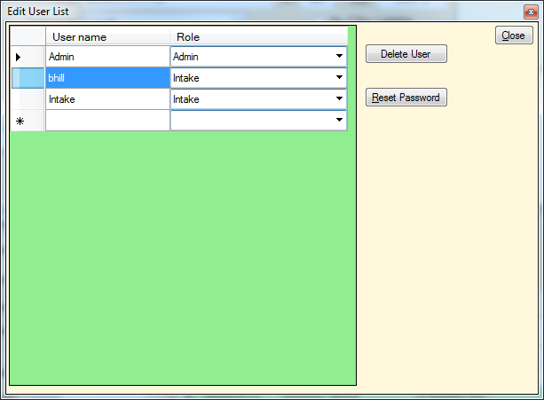

Adding user logins for volunteers will allow the food bank to track changes that are made and prevent unauthorized changes to the ClientcardFB3 software or database. This also allows a volunteer’s access to be removed if they leave the food bank or no longer need access to the software. The Edit User List window can be accessed from Admin > User List from the toolbar in the Main Window.

We highly recommend that you only use the Admin account when absolutely necessary. This will prevent accidental changes to the Clientcard FB3 software or database.

### Adding a New User

Select the blank form at the bottom of the list (it has a * to the left). Enter the desired User Name and press the Tab key. Select the Role from the dropdown menu:

* **Admin** – Full control over the entire program with unlimited access.
* **Intake Admin** -
* **Intake** – Can only add clients and services.

After selecting the roll, you must create the users password. We recommend that you allow the owner of the new account to type in their own password. Click the **Set Pwd** button to confirm the password.

### Changing an Existing Password

Select the user from the user list and click the Reset Button. Type in the new password and click the Set Pwd button to confirm.

### Deleting an Existing User

Select the user from the user list and click the Delete User button. This will permanently delete the user from the database and prevent them from logging with this user name.

## Updating the Income Matrix

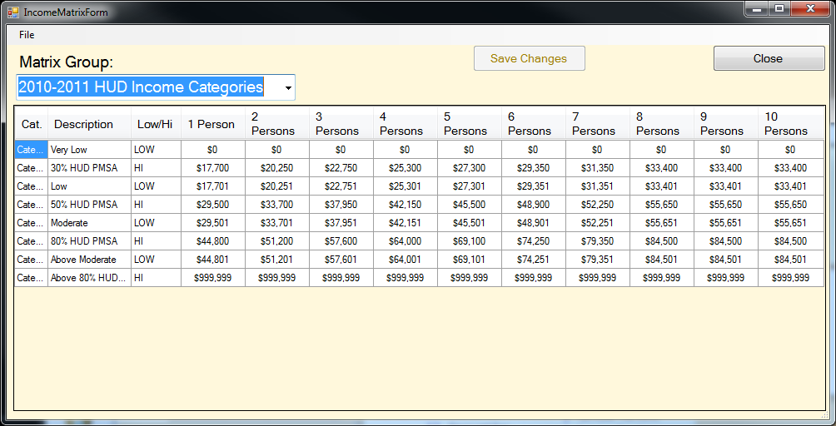

The Income Matrix allows income categories to be updated with changes in the economy. It also allows food banks to adjust the poverty level and average incomes to reflect their region. The **Income Matrix** window can be accessed from **Admin** > **Update Income Matrix** from the toolbar in the **Main Window**.

### Adding a New Income

Click **File** > **Add New Matrix** in the **Income Matrix** window to open the **New Matrix Group** window. Enter the desired information into the form fields:

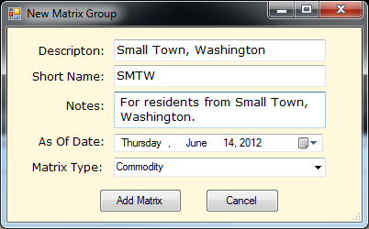

* **Description** – A brief description of the income class.
* **Short Name** – Short tag to reference the matrix.
* **Notes** – Additional notes or description of the matrix.
* **As Of Date** – Date that the income matrix will go into effect.
* **Matrix Type** – The type of matrix.

Click the **Add Matrix** button when you are satisfied with the information. Otherwise, click the **Cancel** button to delete all changes and return to the **Income Matrix** window.

New Matrix Group Window

### Editing an Existing Income Matrix Group

Each **Income Matrix** has a maximum of eight income categories. Four of these categories are pre-marked as **Very Low**, **Low**, **Moderate**, and **Hi**. However, all eight descriptions, along with the income ranges for each family size, can be edited by selecting the correct cell and typing in the desired information. Once you are finished with the changes, click the **Save Changes** button.

# Creating and Editing Food Bank Jobs

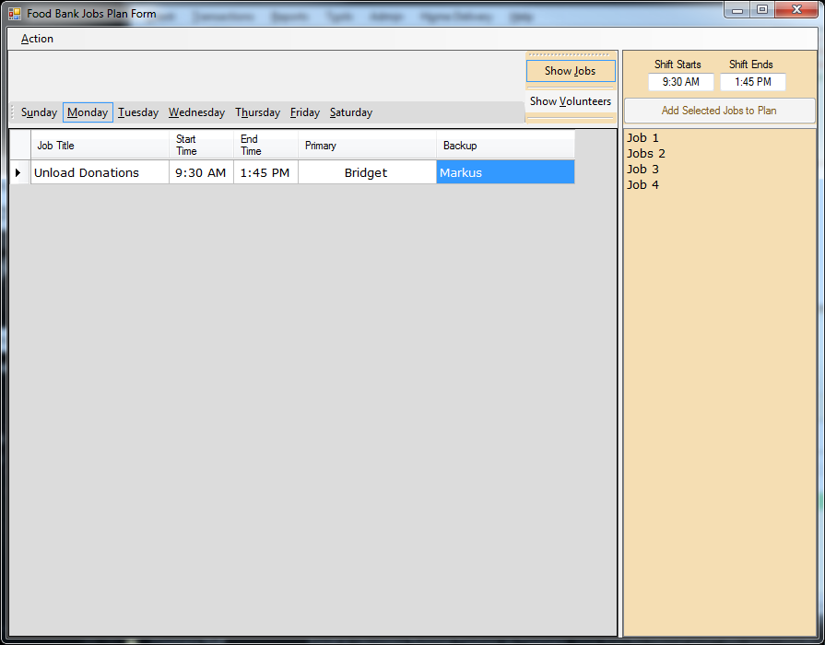

Specific jobs can be created and volunteers assigned to them using the **Food Bank Jobs Plan** form, accessed from **Admin** > **Edit Jobs Plan** from the toolbar in the **Main Window**. Each job can have a **Primary** volunteer and a **Backup** volunteer in case the primary is unable to complete the job.

## Adding a New Job

Select the day of the week that the job will occur by clicking on the day and then select the job group in the right hand column. Both the job group and day will be surrounded by a blue box when selected. Next, enter the time that the job begins and ends in the Shift Starts and Shifts Ends fields respectively. Finally, click the Add Selected Jobs to Plan button to insert the job.

## Assigning Volunteers to a Job

Select the day that the job takes place and then the desired job. Click the Show Volunteers button to list all available volunteers that can be assigned. You can then click and drag the desired volunteer to the Primary or Backup field of the job. Alternatively, you can click on the volunteer’s name and then select Action > Add Selected Volunteer as Primary or Add Selected Volunteer as Backup.

## Removing Volunteers from a Job

Select the volunteer you wish to remove and select Action > Delete Primary or Delete Backup. The changes are saved automatically.

## Editing a Job

To change the Job Title, Start Time, or End Time, click on or highlight the item you would like to change. You can then type in the correct information and press the Enter or Tab key to confirm the change.

# Resetting Flags