**LAPORAN TUGAS KECIL I**

**IF2211 STRATEGI ALGORITMA**

Penyelesaian Permainan Kartu 24 dengan Algoritma Brute Force



Disusun oleh:

Kenneth Ezekiel Suprantoni 13521089

**Program Studi Teknik Informatika**

**Sekolah Teknik Elektro dan Informatika**

**Institut Teknologi Bandung**

**2022**

**Daftar Isi**

**BAGIAN I ALGORITMA BRUTE FORCE 3**

**BAB II SOURCE PROGRAM 4**

**BAGIAN III SCREENSHOT HASIL TEST 25**

**LINK REPOSITORY 30**

**CHECKLIST 30**

# BAGIAN I ALGORITMA BRUTE FORCE

Algoritma *Brute Force*, adalah algoritma dengan pendekatan yang *straightforward* untuk memecahkan suatu masalah. Algoritma ini biasanya bergantung pada kekuatan komputasi yang tinggi untuk mendapatkan semua solusi yang tepat daripada menggunakan teknik yang canggih. Dalam penyelesaian permainan kartu 24 dengan pendekatan *brute force*, algoritma yang digunakan adalah sebagai berikut:

* misalkan a b c d sebagai 4 kartu/angka yang dipilih
* lakukan permutasi dari 4 kartu jika dipilih 2 kartu, sehingga didapatkan 3 angka (mis: (a .. b), sudah menjadi 1 angka), lalu operasikan (4 operasi)
* untuk semua permutasi * operasi tersebut, lakukan permutasi kembali dari 3 angka jika dipilih 2 angka, lalu operasikan (4 operasi) kembali (mis: ((a .. b) .. c) atau (c .. d))
* sisa 2 angka yang terakhir akan menentukan hasil akhir adalah 24 atau tidak jika dioperasikan (4 operasi)

Setelah algoritma menemukan hasil yang berjumlah 24, urutan pemilihan angka dan operasi yang dilakukan untuk mendapatkan angka 24 tersebut dicatat, sampai semua kemungkinan kombinasi sudah dicoba, dan jika ada suatu kombinasi yang sudah tercatat, tidak perlu dicatat kembali untuk meminimalisasi duplikat.

Secara algoritma, kompleksitas waktu yang ditawarkan bertumbuh dengan cepat (O(n3)), tetapi karena n = 4, jumlah pengulangan dapat diperkirakan sebanyak 4*3*((4*2*(3)*4*4) + (2*4*(2)*4*(2)*4)) = 10752 pengulangan/kombinasi (sudah termasuk permutasi dari angka dan operator).

Algoritma yang digunakan mencoba semua kemungkinan solusi, sehingga semua solusi komutatif seperti a + b dan b + a akan dianggap dua solusi berbeda jika a != b, demikian pula untuk a * b dan b * a, dan juga a * (b .. c) dan (b .. c) * a.

# BAB II SOURCE PROGRAM

Projek ini ditulis dalam Bahasa C++, menggunakan *library*:

1. iostream (c++)
2. vector (c++)
3. string (c++)
4. fstream (c++)
5. sstream (c++)
6. cstdlib (c++)
7. ctime (c++)
8. chrono (c++)

Di dalam file *main.cpp*, modul-modul fungsi dibagi menjadi dua kategori, *miscellaneous modules* dan *algorithm*. *Miscellaneous modules* meliputi:

* checkCard
* translateCards
* printCards
* printList
* generateRandom
* getInput

*Algorithm* meliputi:

* op
* stringbuilder
* stringbuilderfromstring (2 overload)
* stringbuilderfromtwostring
* stringChecker
* solver

Berikut *source code*-nya:

*// Miscellaneous*

bool checkCard(string card)

{

    vector<string> listofcard = {"A", "2", "3", "4", "5", "6", "7", "8", "9", "10", "J", "Q", "K"};

*for* (auto &x : listofcard)

    {

*if* (card == x)

        {

*return* true;

        }

    }

*return* false;

}

void translateCards(vector<double> *input, const vector<string> cards)

{

*// LOCAL DICTIONARY*

*// ALGORITHM*

*for* (auto &x : cards)

    {

*if* (x == "2")

        {

            input->push_back(2);

        }

*else* *if* (x == "3")

        {

            input->push_back(3);

        }

*else* *if* (x == "4")

        {

            input->push_back(4);

        }

*else* *if* (x == "5")

        {

            input->push_back(5);

        }

*else* *if* (x == "6")

        {

            input->push_back(6);

        }

*else* *if* (x == "7")

        {

            input->push_back(7);

        }

*else* *if* (x == "8")

        {

            input->push_back(8);

        }

*else* *if* (x == "9")

        {

            input->push_back(9);

        }

*else* *if* (x == "10")

        {

            input->push_back(10);

        }

*else* *if* (x == "J")

        {

            input->push_back(11);

        }

*else* *if* (x == "Q")

        {

            input->push_back(12);

        }

*else* *if* (x == "K")

        {

            input->push_back(13);

        }

*else* *if* (x == "A")

        {

            input->push_back(1);

        }

    }

}

void printCards(const vector<string> cards)

{

*// LOCAL DICTIONARY*

    int i;

*// ALGORITHM*

    cout << "Cards: ";

*for* (auto &x : cards)

    {

        std::cout << x << " ";

    }

    std::cout << endl;

}

void printList(const vector<double> list)

{

*// LOCAL DICTIONARY*

    int i;

*// ALGORITHM*

    cout << "List: ";

*for* (i = 0; i < list.size(); i++)

    {

        std::cout << list.at(i) << " ";

    }

    std::cout << endl;

}

vector<double> generateRandom()

{

*// LOCAL DICTIONARY*

    vector<double> output;

    double d;

    srand(time(NULL));

*// ALGORITHM*

*for* (int i = 0; i < 4; i++)

    {

        d = (rand() % 13) + 1;

        output.push_back(d);

    }

*return* output;

}

void getInput(vector<double> *input)

{

*// LOCAL DICTIONARY*

    char ans;

    string c1, c2, c3, c4;

    vector<string> cards;

    ifstream fin;

    string line;

    string temp;

    bool condition = true;

    int count;

*// ALGORITHM*

*// input selection*

    std::cout << "k : keyboard f : file r : random" << endl;

    std::cout << "Input? (k/f/r) (default: r) " << endl;

    cin >> ans;

*// from keyboard*

*if* (ans == 'k')

    {

*// loop until valid*

*while* (condition)

        {

            std::cout << "Enter 4 cards: ";

            cin >> c1;

            cin >> c2;

            cin >> c3;

            cin >> c4;

*if* (checkCard(c1) && checkCard(c2) && checkCard(c3) && checkCard(c4))

            {

                condition = false;

            }

*else*

            {

                std::cout << "Masukan tidak valid, harap diulangi!" << endl;

            }

        }

*// std::cout << c1 << " " << c2 << " " << c3 << " " << c4 << endl;*

*// input is put to a vector*

        cards.push_back(c1);

        cards.push_back(c2);

        cards.push_back(c3);

        cards.push_back(c4);

        printCards(cards);

*// translate cards to integer*

        translateCards(input, cards);

    }

*// from file*

*else* *if* (ans == 'f')

    {

*// open file*

        fin.open("src/input.txt");

*// get line*

        getline(fin, line);

*// std::cout << "here's the line: " << line << endl;*

        fin.close();

        stringstream ss(line);

        count = 0;

*// check if the input is valid, if valid continue to put the input inside a vector, if not, exit, and only takes 4 input*

*while* (ss >> temp && condition && count <= 3)

        {

*if* (!checkCard(temp))

            {

                std::cout << "Masukan tidak valid, ganti isi file!" << endl;

                condition = false;

            }

            cards.push_back(temp);

            count++;

        }

*if* (condition)

        {

            printCards(cards);

*// translates card*

            translateCards(input, cards);

        }

    }

*else*

    {

        *input = generateRandom();

        printList(*input);

    }

}

*// Algorithms*

double op(double num1, double num2, int opcode)

{

*if* (opcode == 0)

    {

*return* num1 + num2;

    }

*else* *if* (opcode == 1)

    {

*return* num1 - num2;

    }

*else* *if* (opcode == 2)

    {

*return* num1 * num2;

    }

*else* *if* (opcode == 3)

    {

*if* (num2 != 0)

        {

*return* num1 / num2;

        }

*else*

        {

*return* -999;

        }

    }

*else*

    {

*return* -999;

    }

}

string stringbuilder(double num1, double num2, int opcode)

{

*// LOCAL DICTIONARY*

    string solution = "(";

    int numtemp1 = num1;

    int numtemp2 = num2;

*// ALGORITHM*

    solution += to_string(numtemp1);

*switch* (opcode)

    {

*case* 0:

        solution += " + ";

*break*;

*case* 1:

        solution += " - ";

*break*;

*case* 2:

        solution += " * ";

*break*;

*case* 3:

        solution += " / ";

*break*;

    }

    solution += to_string(numtemp2);

    solution += ")";

*return* solution;

}

string stringbuilderfromstring(string str1, double num2, int opcode)

{

*// LOCAL DICTIONARY*

    string solution = "(";

*// int numtemp1 = num1;*

    int numtemp2 = num2;

*// ALGORITHM*

    solution += str1;

*switch* (opcode)

    {

*case* 0:

        solution += " + ";

*break*;

*case* 1:

        solution += " - ";

*break*;

*case* 2:

        solution += " * ";

*break*;

*case* 3:

        solution += " / ";

*break*;

    }

    solution += to_string(numtemp2);

    solution += ")";

*return* solution;

}

string stringbuilderfromstring(double num1, string str2, int opcode)

{

*// LOCAL DICTIONARY*

    string solution = "(";

    int numtemp1 = num1;

*// int numtemp2 = num2;*

*// ALGORITHM*

    solution += to_string(numtemp1);

*switch* (opcode)

    {

*case* 0:

        solution += " + ";

*break*;

*case* 1:

        solution += " - ";

*break*;

*case* 2:

        solution += " * ";

*break*;

*case* 3:

        solution += " / ";

*break*;

    }

    solution += str2;

    solution += ")";

*return* solution;

}

string stringbuilderfromtwostring(string str1, string str2, int opcode)

{

*// LOCAL DICTIONARY*

    string solution = "(";

*// ALGORITHM*

    solution += str1;

*switch* (opcode)

    {

*case* 0:

        solution += " + ";

*break*;

*case* 1:

        solution += " - ";

*break*;

*case* 2:

        solution += " * ";

*break*;

*case* 3:

        solution += " / ";

*break*;

    }

    solution += str2;

    solution += ")";

*return* solution;

}

bool stringChecker(vector<string> list, string str)

{

*// LOCAL DICTIONARY*

*// ALGORITHM*

*// if (find(list.begin(), list.end(), str) != list.end()) {*

*// }*

*for* (auto &x : list)

    {

*if* (x == str)

        {

*return* false;

        }

    }

*return* true;

}

void solver(vector<double> list)

{

*// LOCAL DICTIONARY*

    bool condition = true;

    int i, j, k, l, m, n, o, p, q, r, s, t, u;

    vector<string> solutions;

    vector<double> temp1, temp2, local;

    double num1, num2, num3, num4;

    double hasil1, hasil2, done;

    string solution;

    char save;

    string filename;

*// const clock_t begintime = clock();*

*// ALGORITHM*

    local = list;

    auto t_start = chrono::high_resolution_clock::now();

*// pick card 1 from the list*

*for* (i = 0; i < 4; i++)

    {

*// std::cout << "i: " << i << endl;*

        num1 = local.front();

        local.erase(local.begin());

        temp1 = local;

*// pick card 2 from the list*

*for* (j = 0; j < 3; j++)

        {

*// std::cout << "j: " << j << endl;*

            num2 = temp1.front();

            temp1.erase(temp1.begin());

            temp2 = temp1;

*// operation on card 1 and card 2*

*for* (k = 0; k < 4; k++)

            {

*// std::cout << "k: " << k << endl;*

                hasil1 = op(num1, num2, k);

*// std::cout << num1 << " " << k << " " << num2 << " = " << hasil1 << endl;*

*// pick card 3 from the list*

*for* (l = 0; l < 2; l++)

                {

*// std::cout << "l: " << l << endl;*

                    num3 = temp2.front();

                    temp2.erase(temp2.begin());

*// operation on (card 1 card 2) and card 3*

*for* (m = 0; m < 4; m++)

                    {

*// std::cout << "m: " << m << endl;*

                        hasil2 = op(hasil1, num3, m);

*// pick card 4 (last card on list)*

                        num4 = temp2.front();

*// operation on ((card 1 card 2) card 3) and card 4*

*for* (n = 0; n < 4; n++)

                        {

*// std::cout << "n: " << n << endl;*

                            done = op(hasil2, num4, n);

*if* (done == 24)

                            {

                                solution = stringbuilder(num1, num2, k);

                                solution = stringbuilderfromstring(solution, num3, m);

                                solution = stringbuilderfromstring(solution, num4, n);

*if* (stringChecker(solutions, solution))

                                {

*// solution += " = ";*

*// solution += to_string(done);*

                                    solutions.push_back(solution);

                                }

                            }

                        }

*// can be commented out*

*// operation on card 4 and ((card 1 card 2) card 3)*

*for* (n = 0; n < 4; n++)

                        {

*// std::cout << "n: " << n << endl;*

                            done = op(num4, hasil2, n);

*if* (done == 24)

                            {

                                solution = stringbuilder(num1, num2, k);

                                solution = stringbuilderfromstring(solution, num3, m);

                                solution = stringbuilderfromstring(num4, solution, n);

*if* (stringChecker(solutions, solution))

                                {

*// solution += " = ";*

*// solution += to_string(done);*

                                    solutions.push_back(solution);

                                }

                            }

                        }

                    }

*// operation on card 3 and (card 1 card 2)*

*for* (m = 0; m < 4; m++)

                    {

*// std::cout << "m: " << m << endl;*

                        hasil2 = op(num3, hasil1, m);

*// pick card 4 (last card on list)*

                        num4 = temp2.front();

*// operation on (card 3 (card 1 card 2)) and card 4*

*for* (n = 0; n < 4; n++)

                        {

*// std::cout << "n: " << n << endl;*

                            done = op(hasil2, num4, n);

*if* (done == 24)

                            {

                                solution = stringbuilder(num1, num2, k);

                                solution = stringbuilderfromstring(num3, solution, m);

                                solution = stringbuilderfromstring(solution, num4, n);

*if* (stringChecker(solutions, solution))

                                {

*// solution += " = ";*

*// solution += to_string(done);*

                                    solutions.push_back(solution);

                                }

                            }

                        }

*// can be commented out*

*// operation on card 4 and (card 3 (card 1 card 2))*

*for* (n = 0; n < 4; n++)

                        {

*// std::cout << "n: " << n << endl;*

                            done = op(num4, hasil2, n);

*if* (done == 24)

                            {

                                solution = stringbuilder(num1, num2, k);

                                solution = stringbuilderfromstring(num3, solution, m);

                                solution = stringbuilderfromstring(num4, solution, n);

*if* (stringChecker(solutions, solution))

                                {

*// solution += " = ";*

*// solution += to_string(done);*

*// std::cout << num4 << " " << n << " " << hasil2 << " " << num1 << k << num2 << m << num3 << endl;*

*// std::cout << solution << endl;*

                                    solutions.push_back(solution);

                                }

                            }

                        }

                    }

*// pick card 4 (last card in list)*

                    num4 = temp2.front();

*// operation on card 3 and card 4 first*

*for* (o = 0; o < 4; o++)

                    {

*// std::cout << "m: " << m << endl;*

                        hasil2 = op(num3, num4, o);

*// operation on (card 1 card 2) and (card 3 card 4)*

*for* (p = 0; p < 4; p++)

                        {

*// std::cout << "n: " << n << endl;*

                            done = op(hasil1, hasil2, p);

*if* (done == -999)

                            {

*continue*;

                            }

*if* (done == 24)

                            {

                                solution = stringbuilder(num1, num2, k);

*// std::cout << "solution temp: " << solution << endl;*

                                string solutiontemp = stringbuilder(num3, num4, o);

                                solution = stringbuilderfromtwostring(solution, solutiontemp, p);

*if* (stringChecker(solutions, solution))

                                {

*// solution += " = ";*

*// solution += to_string(done);*

                                    solutions.push_back(solution);

                                }

                            }

                        }

                    }

                    temp2.push_back(num3);

                }

            }

*// pick card 3 first before operation*

*for* (q = 0; q < 2; q++)

            {

                num3 = temp2.front();

                temp2.erase(temp2.begin());

*// card 4 is the last card on the list*

                num4 = temp2.front();

*// operation on card 2 and card 3*

*for* (r = 0; r < 4; r++)

                {

                    hasil1 = op(num2, num3, r);

*// operation on card 1 and (card 2 card 3)*

*for* (s = 0; s < 4; s++)

                    {

                        hasil2 = op(num1, hasil1, s);

*// operation on (card 1 (card 2 card 3)) and card 4*

*for* (t = 0; t < 4; t++)

                        {

                            done = op(hasil2, num4, t);

*if* (done == -999)

                            {

*continue*;

                            }

*if* (done == 24)

                            {

                                solution = stringbuilder(num2, num3, r);

*// std::cout << "solution temp: " << solution << endl;*

                                solution = stringbuilderfromstring(num1, solution, s);

                                solution = stringbuilderfromstring(solution, num4, t);

*if* (stringChecker(solutions, solution))

                                {

*// solution += " = ";*

*// solution += to_string(done);*

                                    solutions.push_back(solution);

                                } *// (num1 .. num2) .. (num3 .. num4)*

                            }

                        }

*// can be commented out*

*// operation on card 4 and (card 1 (card 2 card 3))*

*for* (t = 0; t < 4; t++)

                        {

                            done = op(num4, hasil2, t);

*if* (done == -999)

                            {

*continue*;

                            }

*if* (done == 24)

                            {

                                solution = stringbuilder(num2, num3, r);

*// std::cout << "solution temp: " << solution << endl;*

                                solution = stringbuilderfromstring(num1, solution, s);

                                solution = stringbuilderfromstring(num4, solution, t);

*if* (stringChecker(solutions, solution))

                                {

*// solution += " = ";*

*// solution += to_string(done);*

                                    solutions.push_back(solution);

                                }

                            }

                        }

                    }

*// operation on (card 2 card 3) and card 4*

*for* (s = 0; s < 4; s++)

                    {

                        hasil2 = op(hasil1, num4, s);

*// operation on card 1 and ((card 2 card 3) card 4)*

*for* (t = 0; t < 4; t++)

                        {

                            done = op(num1, hasil2, t);

*if* (done == -999)

                            {

*continue*;

                            }

*if* (done == 24)

                            {

                                solution = stringbuilder(num2, num3, r);

*// std::cout << "solution temp: " << solution << endl;*

                                solution = stringbuilderfromstring(solution, num4, s);

                                solution = stringbuilderfromstring(num1, solution, t);

*if* (stringChecker(solutions, solution))

                                {

*// solution += " = ";*

*// solution += to_string(done);*

                                    solutions.push_back(solution);

                                }

                            }

                        }

*// can be commented out*

*// operation on ((card 2 card 3) card 4) and card 1*

*for* (t = 0; t < 4; t++)

                        {

                            done = op(hasil2, num1, t);

*if* (done == -999)

                            {

*continue*;

                            }

*if* (done == 24)

                            {

                                solution = stringbuilder(num2, num3, r);

*// std::cout << "solution temp: " << solution << endl;*

                                solution = stringbuilderfromstring(solution, num4, s);

                                solution = stringbuilderfromstring(solution, num1, t);

*if* (stringChecker(solutions, solution))

                                {

*// solution += " = ";*

*// solution += to_string(done);*

                                    solutions.push_back(solution);

                                }

                            }

                        }

                    }

                }

                temp2.push_back(num3);

            }

            temp1.push_back(num2);

        }

        local.push_back(num1);

    }

*// std::cout << "executed in " << float(clock() - begintime) << endl;*

    auto t_end = chrono::high_resolution_clock::now();

    double elapsed_time_ms = chrono::duration<double, milli>(t_end - t_start).count();

    std::cout << "executed in " << elapsed_time_ms << " ms" << endl;

    std::cout << solutions.size() << " solutions found" << endl;

*for* (auto &x : solutions)

    {

        std::cout << x << endl;

    }

    std::cout << "save it to a file? (y/n) " << endl;

    cin >> save;

*if* (save == 'y')

    {

        std::cout << "rename file? (y/n) " << endl;

        cin >> name;

        filename += "test/";

*if* (name == 'y')

        {

            std::cout << "filename: ";

            cin >> nameoffile;

            filename += nameoffile;

        }

*else*

        {

*for* (auto &x : list)

            {

*if* (x == 1)

                {

                    filename += "A ";

                }

*else* *if* (x == 11)

                {

                    filename += "J ";

                }

*else* *if* (x == 12)

                {

                    filename += "Q ";

                }

*else* *if* (x == 13)

                {

                    filename += "K ";

                }

*else*

                {

                    int num = x;

                    filename += to_string(num);

                    filename += " ";

                }

            }

        }

        filename += ".txt";

        ofstream fileout(filename);

*for* (auto &x : solutions)

        {

            fileout << x;

            fileout << "\n";

        }

*for* (auto &x : list)

        {

*if* (x == 1)

            {

                fileout << "A ";

            }

*else* *if* (x == 11)

            {

                fileout << "J ";

            }

*else* *if* (x == 12)

            {

                fileout << "Q ";

            }

*else* *if* (x == 13)

            {

                fileout << "K ";

            }

*else*

            {

                int num = x;

                fileout << to_string(num);

                fileout << " ";

            }

        }

        fileout << "\n";

        fileout << solutions.size();

        fileout << " solutions";

        fileout.close();

    }

}

int main()

{

    vector<double> ans;

    getInput(&ans);

*// printList(ans);*

    solver(ans);

*return* 0;

}

Selain itu, diimplementasikan juga sebuah script python sebagai *checker* dari hasil yang dikeluarkan oleh program dalam *script.py*:

*import* os

*from* pathlib *import* Path

print("--------------------------- CHECKER ---------------------------\n")

cwd = os.getcwd()

folder = 'test'

directory = os.path.join(cwd, folder)

*for* filename *in* os.listdir(directory):

    f = os.path.join(directory, filename)

*if* os.path.isfile(f):

        print("file:", f)

        string = Path(f).read_text()

        arr = string.split("\n")

*del* arr[-1]

*del* arr[-1]

        cnt = 0

        err = []

*for* line *in* arr:

            n = eval(line) == 24

*# print(n)*

*if* not n:

                cnt += 1

                err.append(line)

        set_arr = set(arr)

        print("length of unique strings:", len(set_arr))

        print("length of array of solutions:", len(arr))

        print("number of errors:", cnt, "\n")

*for* i *in* err:

            print(i)

# BAGIAN III SCREENSHOT HASIL TEST

Input: A 4 6 9 (dari Keyboard)

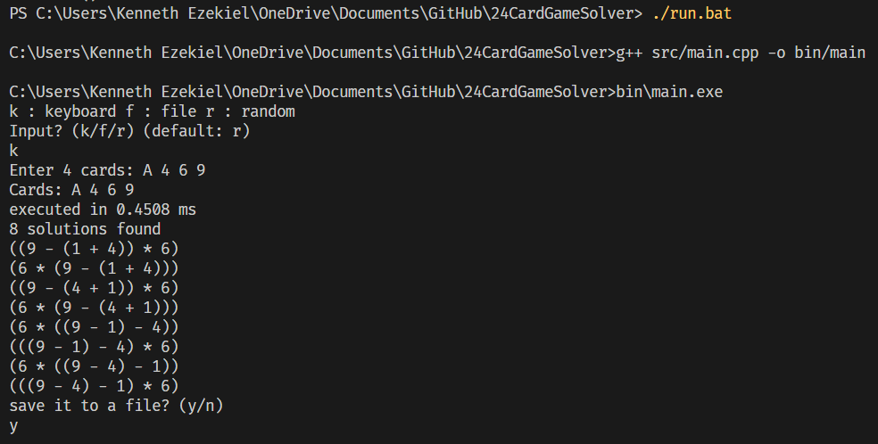

Input: J 2 3 4 (dari File)

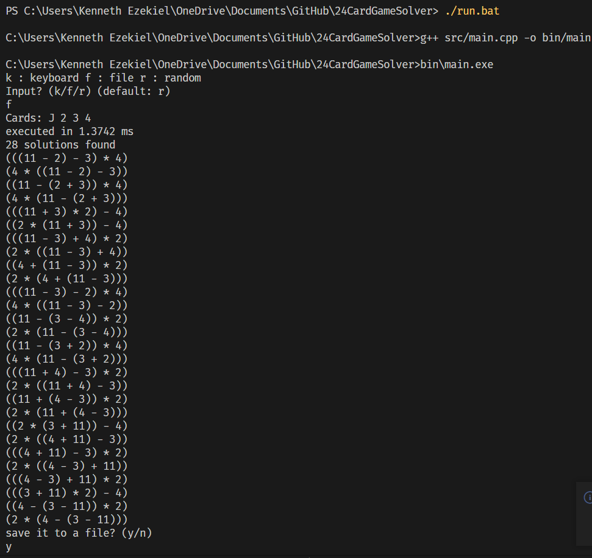

Input: 7 6 J K (Random)

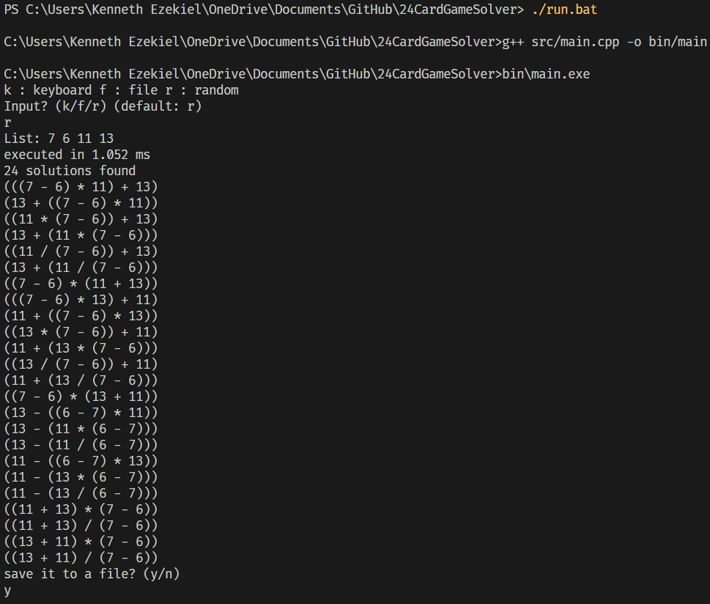

Input: J 3 1 4 (Random)

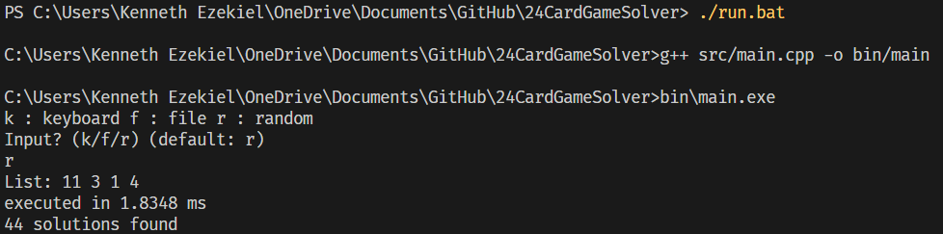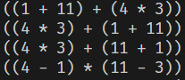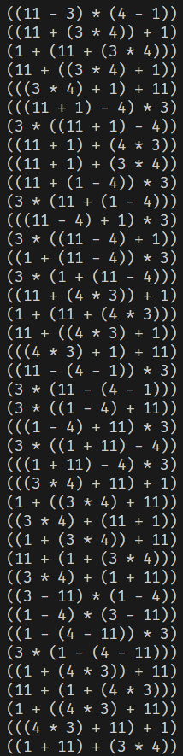

Input: A J Q K (dari Keyboard)

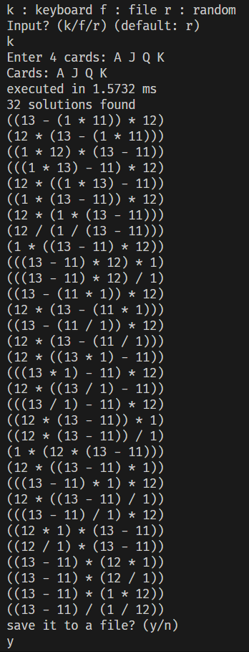

Input: test B 2 3 4, 11 3 5 9, valid J Q K A (test sama atau tidak jumlah solusinya dengan sebelumnya)

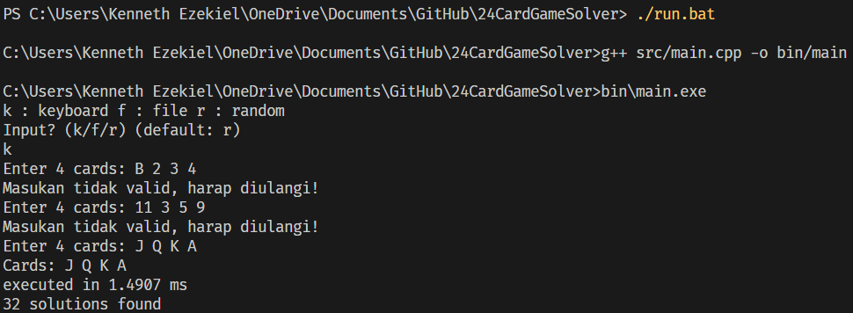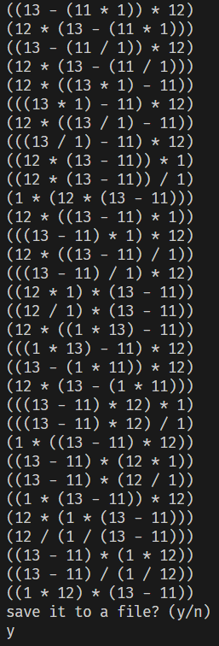

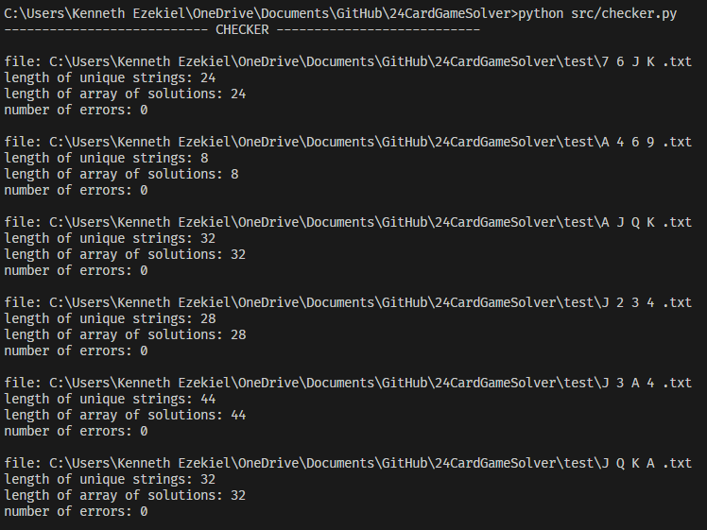

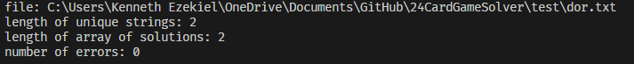

# LINK REPOSITORY

<https://github.com/KenEzekiel/Tucil1_13521089>

# CHECKLIST

|  |  |  |
| --- | --- | --- |
| Poin | Ya | Tidak |
| Program dapat dikompilasi tanpa kesalahan | ✓ |  |
| Program berhasil *running* | ✓ |  |
| Program dapat membaca input / generate sendiri dan memberikan luaran | ✓ |  |
| Solusi yang diberikan program memenuhi (berhasil mencapai 24) | ✓ |  |
| Program dapat menyimpan solusi dalam file teks | ✓ |  |

+ Program dapat menerima input dari sebuah file teks