Laser Data Transfer (LDT Project)

**Members:**

1. Derek Clark majoring in Photonics Science Engineering

2. Joshua Jordan majoring in Photonics Science Engineering

3. Kenneth Figueiredo majoring in Computer Engineering

**Project Description:**

As technology continues to advance the demand for hardware and technologies that support higher bandwidths is at an all-time high. The US Federal Communications Commission has stated that Wi-Fi, which utilizes radio frequencies, is close to maximum bandwidth usage. By using optical frequencies much more data can be transmitted. With this in mind, the Light Data Transfer (LDT) Project was designed. Inspiration for this project came from the emerging market of Li-Fi communication, as well as NASA’s LLCD, and OPALS projects. The LDT Project will take a modulated digital signal, via laser, through a lens system to a sensor. The digital signal will then be demodulated and displayed on an output screen. For the demonstration the laser will have a wavelength of 650 nm to avoid eye injuries and attempts in the near infrared spectral region, 700 nm - 1400 nm, will be used to achieve bit rate speeds of at least 1Mbps download speeds. The distance between laser setups will be 10 feet and we will push the distance farther as we achieve our data speed. The LDT Project can be another means of providing users with a more secure and reliable option of sending and receiving information. With this technology exploited the future of bandwidth demanding applications will continue to provide users with their services around the world, and beyond.

**Specifications and Requirements:**

· 2x Microcontroller

· 2x Red Dot Laser Diode Module

· 2x MOSFET transistor

· 2x PIN Photodiodes

· 2x 50 mm Reflector

· 2x USB to Serial Converter

· 2x 5V battery

· 2x Self owned computers

**Block Diagram:**

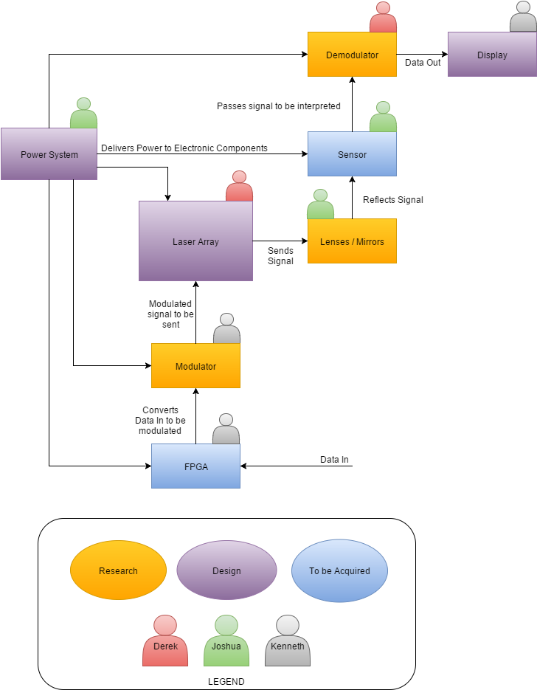

Figure 1: Block Diagram

**Budget:**

|  |  |
| --- | --- |
| ITEM | PRICE |
| 2x Microcontroller | ~ $6.25+ |
| 2x Red Dot Laser Diode Module | ~ $10.95 |
| 2x MOSFET transistor | ~ $4.20 |
| 2x PIN Photodiodes | ~ $2.50 |
| 2x 50 mm Reflector | ~ $3.85 |
| 2x USB to Serial Converter | ~ $19.50 |
| 2x 5V battery | ~ $10.00 |
| TOTAL | ~58.00 |

Prices do not include shipping and handling and could change within time. The project will be financed by potential sponsors and/or group members.

**Milestones:**

Senior Design I milestone: Build a rough first prototype to begin testing by 1 December 2015.

Senior Design II milestone: Final prototype available for testing by 01 March 2016.