Kenny Vo

PSS1

PSS 1 - Choose a good function to graph it in java. Submit screenshots, code, and a write up showing how you experimented with the parameters of your program.

The chosen function to display is **y = m * x + b**, and this is used as a base graph plot. This function is interchangeable within the code shown here:

For this given function, the "m"," b", and "x" variables were needed to be created. The **"m" and "b" variables are randomly selected from a range of integers from 1 to 3**. While **"x" was set with a range of 100, lower bound of 0, and upper bound of 50**.

The **Plotter** plots the generic graph

These variables ranges and bounds are default values that I have placed in the current code but are interchangeable within the code shown here:



The **Salter** functionality plays off the base graph that was chosen to use, this is because it requires the y value from the original graph. The salt component uses a strength range of -2 to 2. This was emplaced specifically to ensure the graph remained within specified bounds. The salter does not provide a constant value uniformly to each point, rather salt strength is randomly distributed individually to every point from any value from -2 to 2. It is not recommended to change this range due to it being specifically picked to keep the graph neatly presented however it is possible to change value if desired within the code shown here:

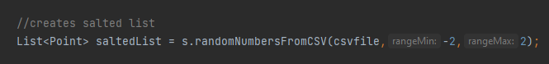

The **Smoother** functionality plays off the Salter graph, where it takes in the Salted Y value, and the window size. The window size determines the number of points grouped together to achieve a more rounded appearance from the salted graph. A default value for Window Value of 9, has been placed current code but it is interchangeable within the code shown here:

The **Results** from the code output the Plotter, Salter, and Smoother into their own CSV file.

It outputs 3 separate CSV files

