This application is supported from devices that are from api 23 – present.

To install the app, navigate to where ever you put in on your device. Once you tap the apk file. It should start the install.

If your device is not set to allow 3rd party apps, you will be asked to set this at the time. A screen similar to this should be shown. It may vary from device to device. (Screenshots are from a Samsung galaxy S6).

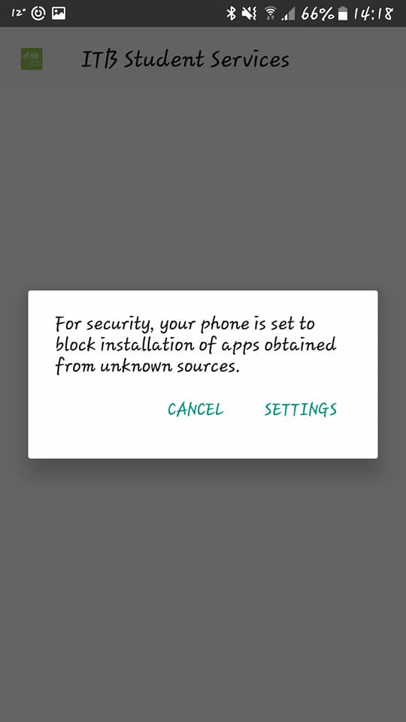

From there you click settings. This brings you to your device security settings. You need to look for an option that says “unknown sources”. Flick this switch which allows you to install 3rd party applications.

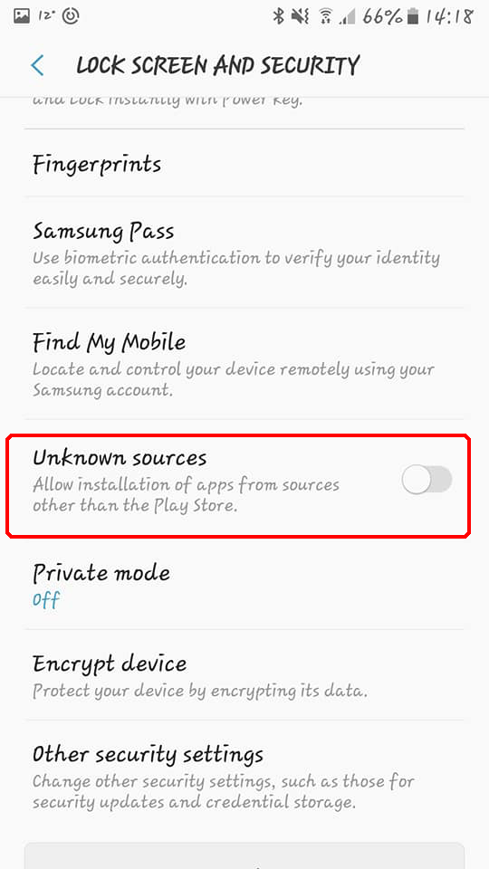

Once you have done this a warning comes up to warning you that you are approving apps not on the play store. Hit ok on this.

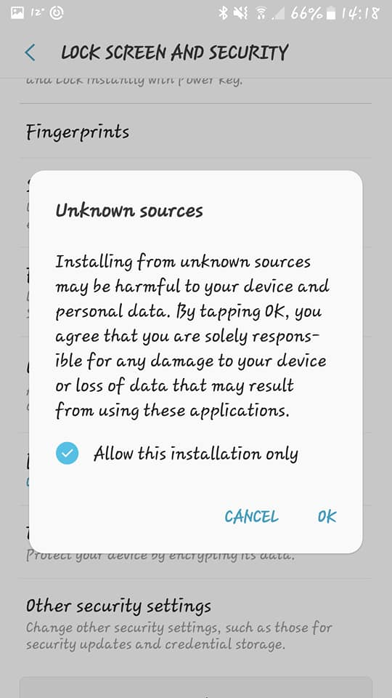

After all these steps are done, you will be greeted with a screen that asks you want to do with this application. From there, you just hit install and its done. From there you can create an account by going to register or use the accounts provided.

