Employees’ Equipment Repair Request and Management
Ken Lorenz Sendaydiego
BSCS3-2

Description

- A special feature that embraces technology as one of the main factors for Human performance maintenance and blending in the HRM as a feedback feature specifically for maintaining equipments. With its goal of minimizing the effects of technological predicaments on mental health and performance, it consists of a quick-access web-based interface for requesting for either repair or upgrade of a company’s property as well as including another interface for quick response and management, and inquiry.

-- Request Form Page --

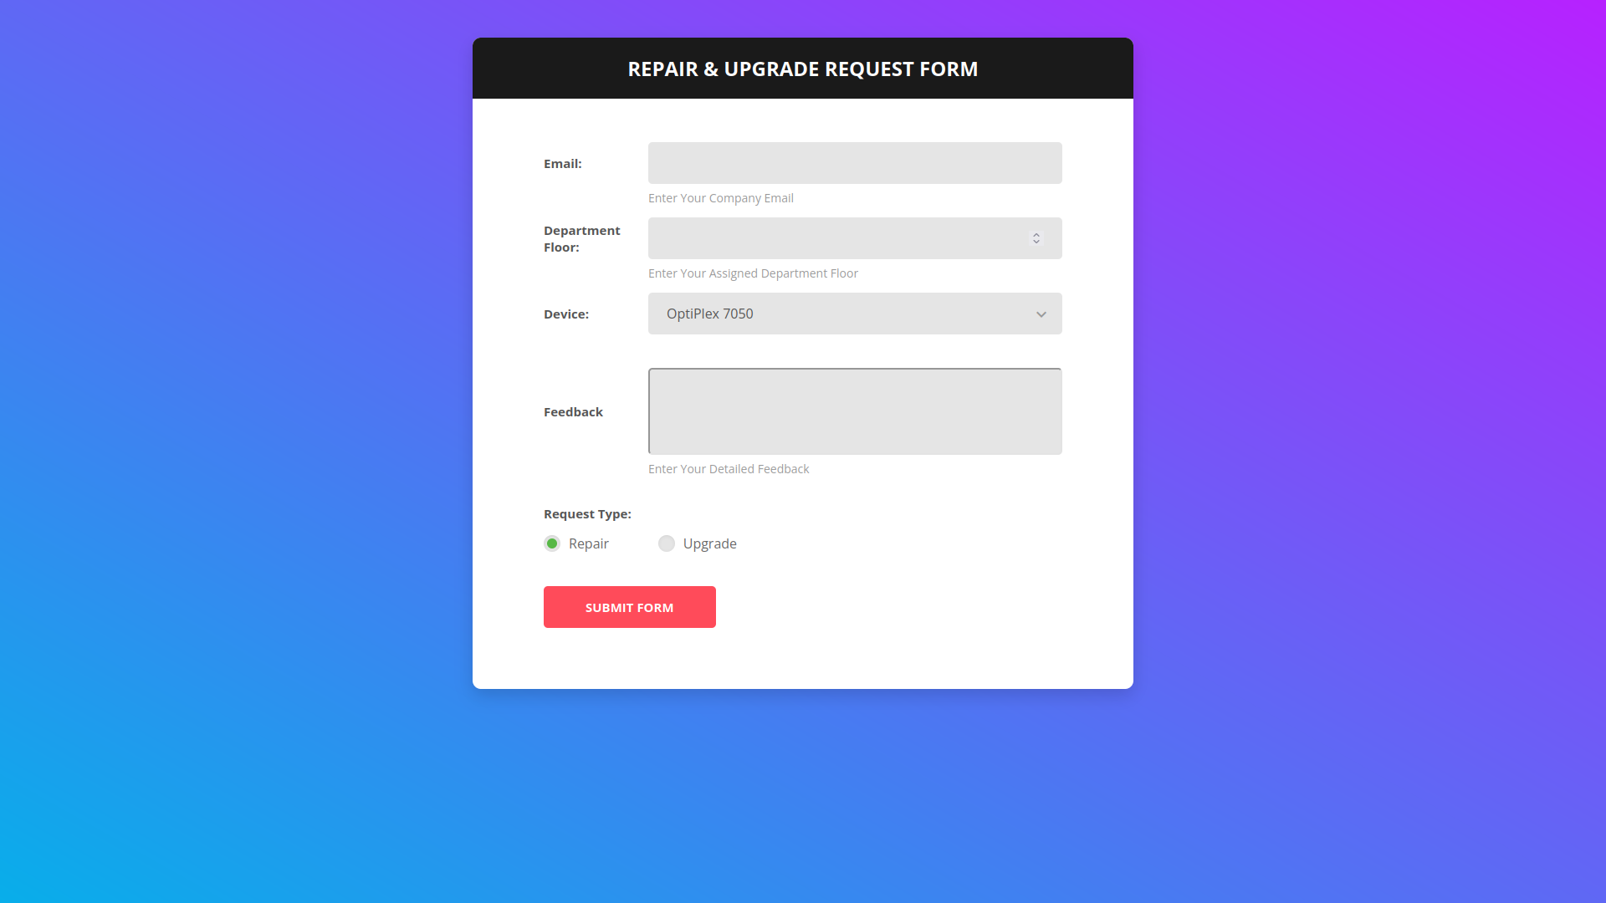

-- Feedback & Requests Page --
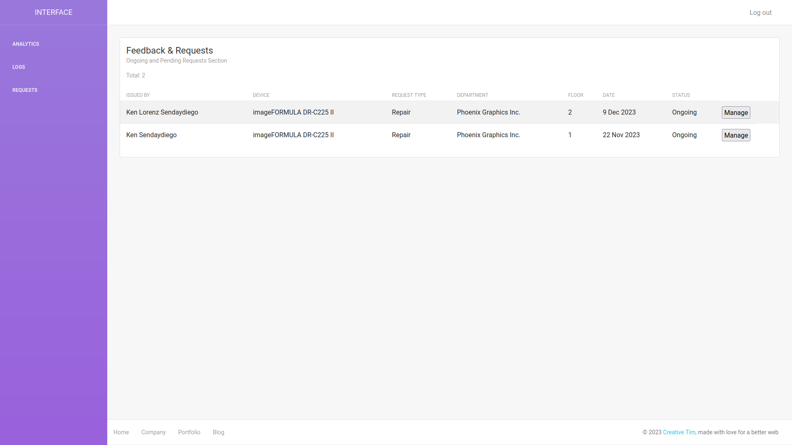

-- History Logs --
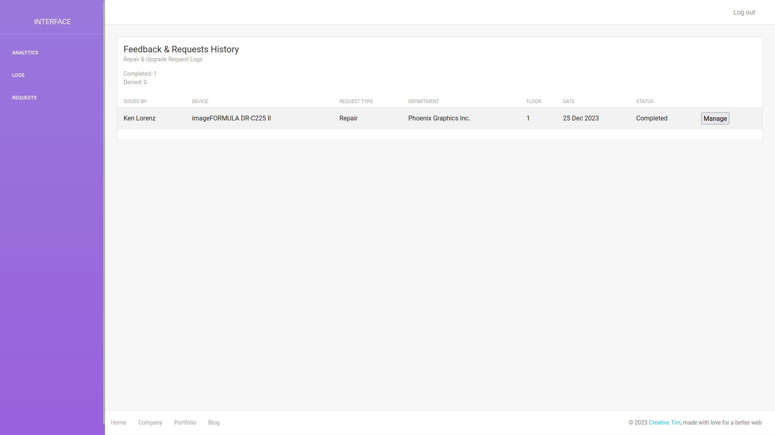

-- Manage Page --
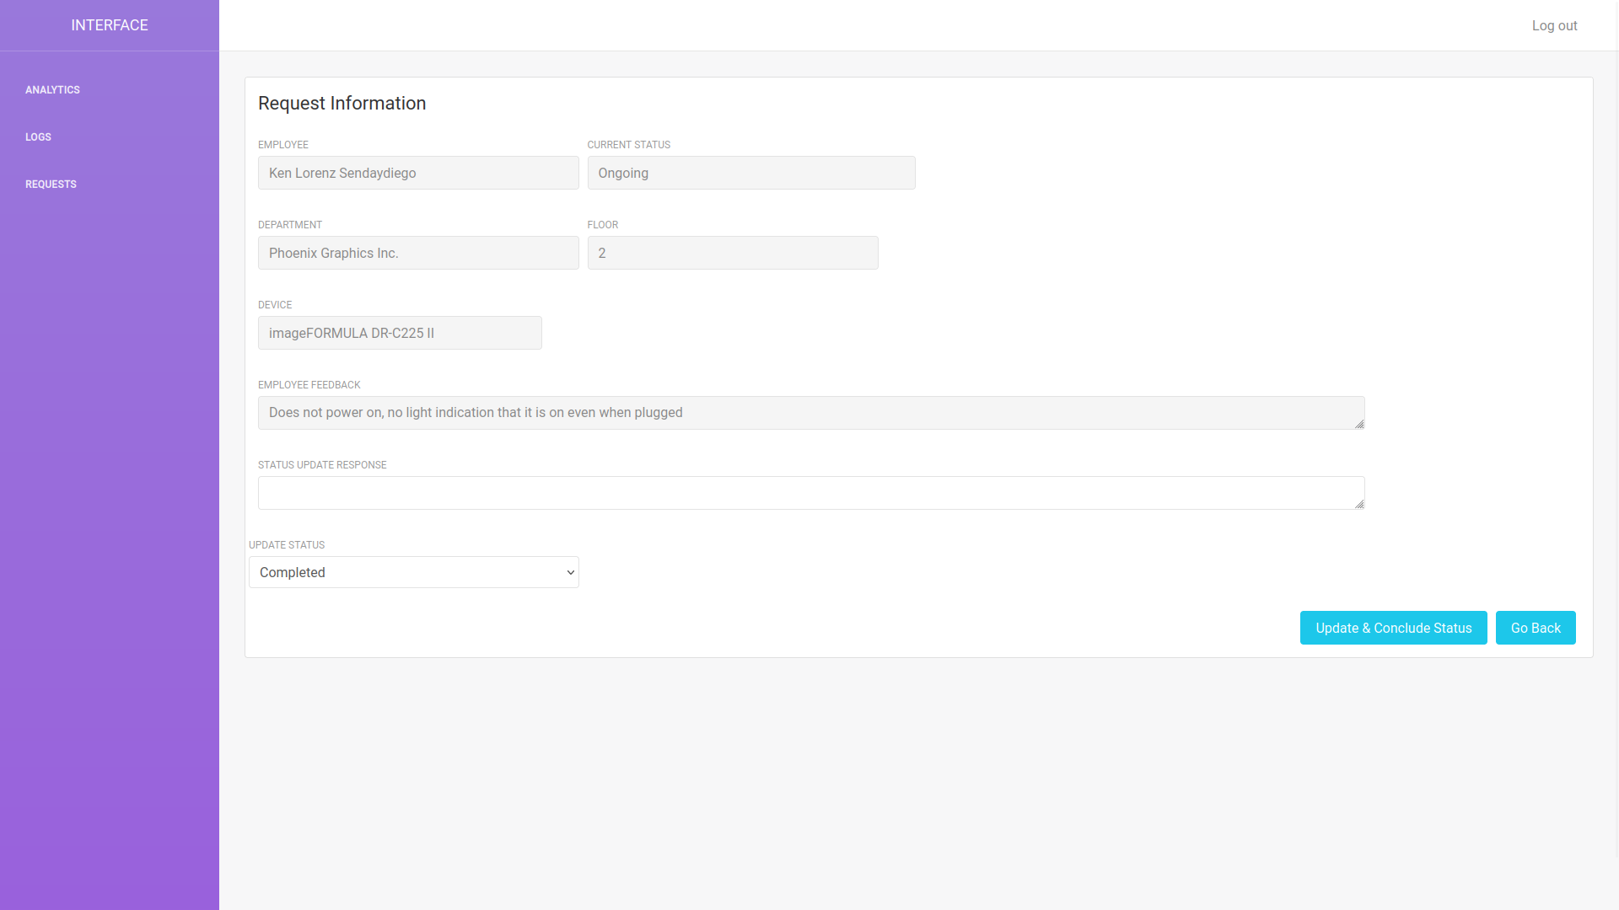

-- Chart Page (Part 1) --
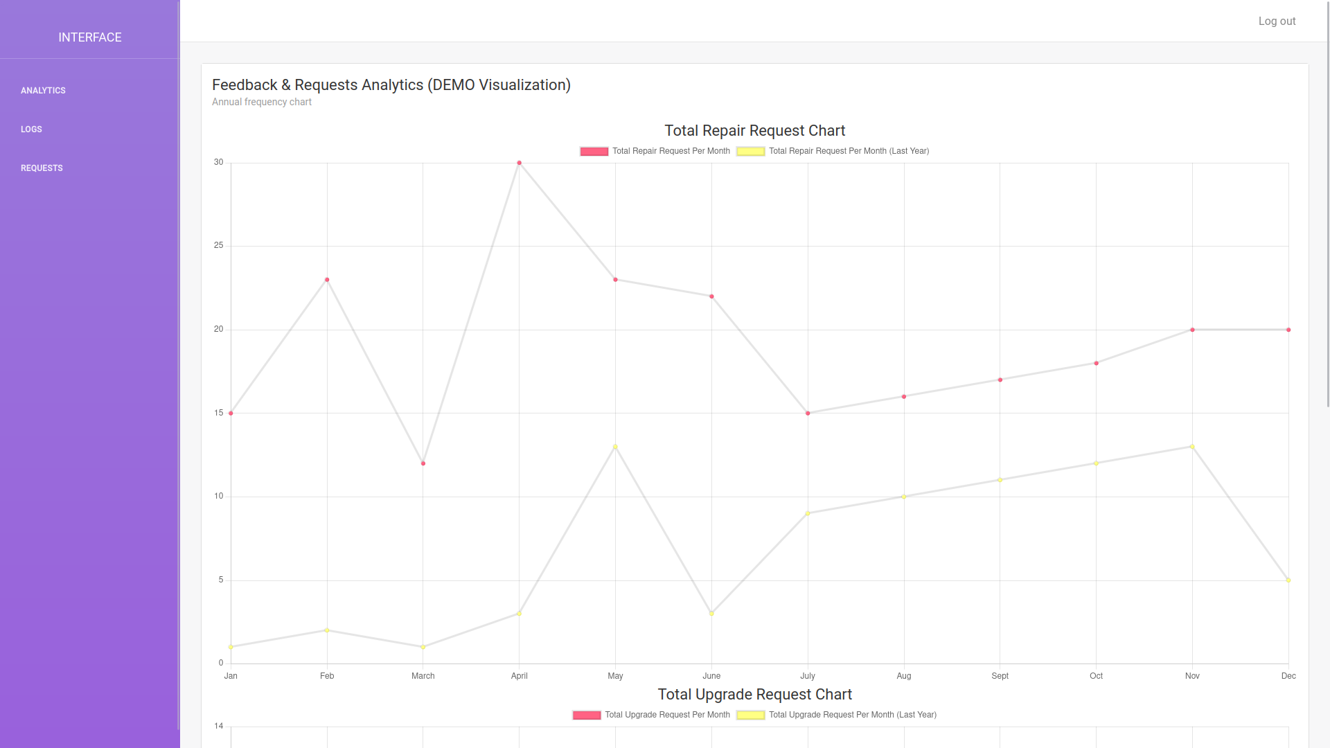

-- Chart Page (Page 2) --
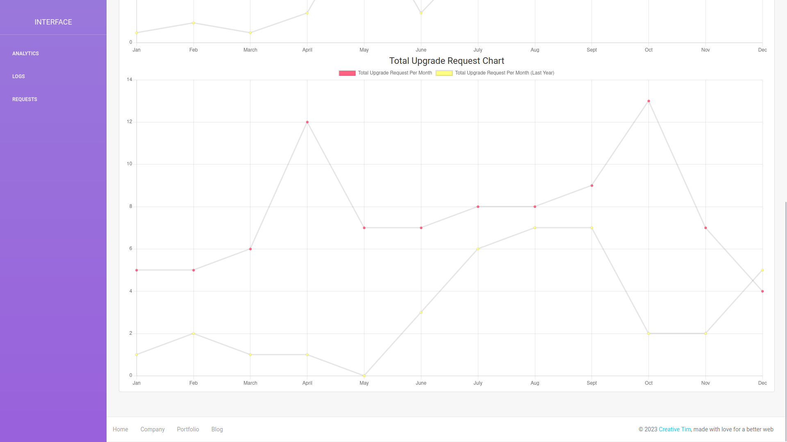

-- ERD Modification --

