*Github Assignment*

CS 611

Programming Languages

Student:

Kenneth Mann

Submitted to:

Dr. Christelle Scharff

Professor and Chair, Department of Computer Science

Kenneth Mann

CS 611 – Github Assignment

**Part 1:**

GitHub Username: KenMannDevSpace

GitHub Email: kmann@pace.edu

**Part 2:**

Install Git bash to local laptop (Done)

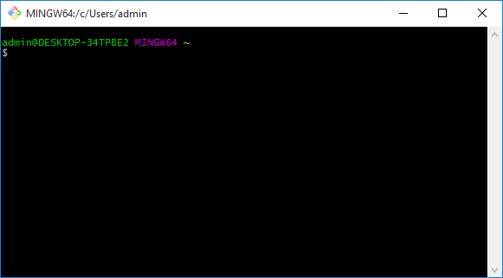

**Part 3 - Questions to answer:**

**What is GitHub?**

Github is software that can be used for version control. Version control refers to the process whereby software versions are kept in an orderly fashion and can be referred back to or ‘rolled back’ if software of a previous version is needed. Github has the added feature that it runs on a remote web platform and so does not need to run as a local network application (Ref: #1).

**When was it created?**

Github was founded in February 2008. (Ref: #2).

**Why?**

From reading one of the founders, it seems that Github was written in order to make a centralized place where people could use “Git”, version control software, yet then to be able to, quoting the founder blog “securely share private code”. (Ref: #3).

**By who?**

PJ Hyett, Chris Wanstrath, Tom Preston-Werner (Ref: #4).

**What similar platforms exist?**

GitHub, Google Code, Bitbucket, CodePlex and SourceForge are examples of other version control systems (found by looking up “cloud based version control systems on Google (Ref: #5).

**Why would you use such a platform?**

In general, a version control system is something like if you had a folder on your thumb drive where you saved numbered and dated versions of a piece of software that you were periodically updating. If you ever needed to go back to an older version of the software, then you could use the backup disk copy to do so. (Ref: #6).

**Part 4 – Git tutorial:**

Go through the Git tutorial here: <https://try.github.io>. While doing the tutorial, save your work the *LastnameFirstnameGitTutorial-mm-dd-yyyy.docx* file.

I registered with CodeSchool and received this merit badge for completing the tutorial. I did not see a way to save the material.



**Part 5 - Define the following terms in the context of Git:**

**Repository:**

A Github repository allows you to organize the particular software you are creating. Anything that can be saved as a file will be organized under the related repository name. (Ref: #1).

**Commit:**

On Github a commit is simply a name for saving changes. However, recall that a version control system tracks changes, so there can be multiple versions of the file (Ref: #1).

**Push:**

Pushing is the act of sending along changes to a document to a repository which is not on the local machine (I would imagine usually GitHub itself?). (Ref: #7).

**Branch:**

A branch is a copy of the “master” version of the repository and is stored within that master repository. Branches can be used to try code prior to master-branch commission. (Ref: #7).

**Fork:**

A fork is a copy of another user’s repository that is then connected to your personal Github account. One can pull updated data from the original repository and vice versa. (Ref: #7).

**Merge:**

A merge operation will apply the changes from one branch into a destination branch. (Ref: #7).

**Clone:**

A clone is a copy of a remote repository (remote meaning the Github web cloud) that has been copied to the local machine. (Ref: #7).

**Pull:**

A pull operation refers to the actual, in progress, act of downloading change requests that have been made and merging the changes into…(repositories, branches, etc.). (Ref: #7).

**Pull request:**

A pull-request is the pre-approval aspect of a pull. When one wishes to conduct a pull, one will send a pull-request to those in charge of the repository for approval. (Ref: #7).

**Part 6:**

Push the Word file in YOUR GitHub account in a repository called CSXXX2016. Please respect the naming conventions! You will use this repository this semester. Your repository will be accessible at: <https://github.com/yourpseudo/CSXXX2016>.

The following commands will be tested in this draft:

At the Bash shell…

First, to add the remote:

git remote add origin <https://github.com/KenMannDevSpace/CS6112016.git>

**apparently this remote I had already added as it errored and said the remote existed…

Then I ran the **git remote –v** command to check on the remotes:

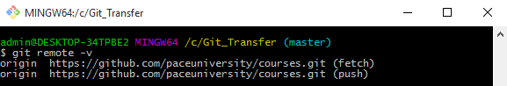

Then add the Word document to my Github repository:

git add .

git commit –m “Add existing file”

git push origin

(Ref: #10, 11)

Part 7:

Retreival and push of class Readme file:

**I **retrieved** and **edited** the specified Readme file from github.com/paceuniversity/courses

Yet I have not ***yet*** succeeded in pushing it back… (please see below)

**Task Done**: cloned Dr. Scharff’s folder using the following command:

git clone <https://github.com/paceuniversity/courses.git>

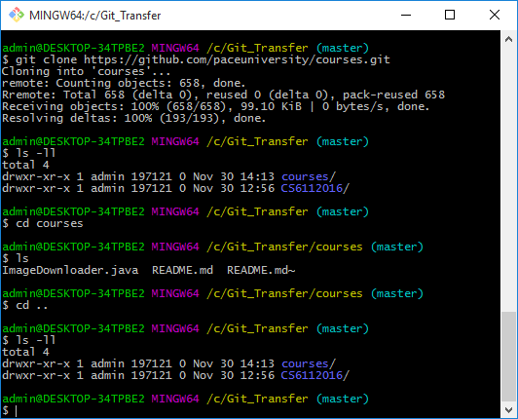

**Task Done**:

Issued the git pull, merge and commit commands towards:

<https://github.com/paceuniversity/courses.git>

Please see following Git command window…

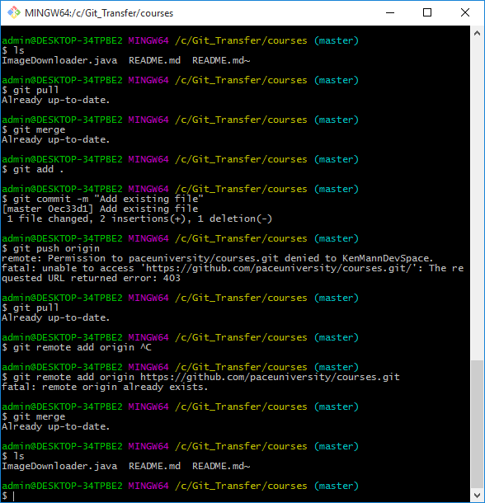

(Ref: #8, 10, 11).

**Part 8:**

Add an issue with title “GitHub training” in your repository called CSXXX2016. Issues will be used for tasks and bug reports. (Ref: #9)

**(DONE)**

**Part 9:**

Edit the main page of the wiki in your repository called CSXXX2016. Add the title “CS XXX 2016” to the page. The wiki will be used for documenting your work.

**(DONE)**

**References**

1) https://guides.github.com/activities/hello-world/

2) https://en.wikipedia.org/wiki/GitHub

3) http://tom.preston-werner.com/2011/03/29/ten-lessons-from-githubs-first-year.html

4) https://www.crunchbase.com/organization/github#/entity

5) https://blog.idrsolutions.com/2014/03/top-5-free-hosted-version-control-sites-compared/

6) http://mikemcquaid.com/2014/01/18/why-use-version-control/

7) https://help.github.com/articles/github-glossary/

8) https://help.github.com/articles/adding-an-existing-project-to-github-using-the-command-line/

9) https://help.github.com/articles/creating-an-issue/

10) https://help.github.com/articles/adding-a-file-to-a-repository-using-the-command-line/

11) https://help.github.com/articles/adding-a-remote/