**How to Use this Template**

1. Make a copy [ File → Make a copy... ]
2. Rename this file: “**Capstone_Stage1**”
3. Replace the text in green

**Submission Instructions**

1. After you’ve completed all the sections, download this document as a PDF [ File → Download as PDF ]
2. Create a new GitHub repo for the capstone. Name it “**Capstone Project**”
3. Add this document to your repo. Make sure it’s named “**Capstone_Stage1.pdf**”

Description

Intended User

Features

User Interface Mocks

Screen 1

Screen 2

Key Considerations

How will your app handle data persistence?

Describe any corner cases in the UX.

Describe any libraries you’ll be using and share your reasoning for including them.

Next Steps: Required Tasks

Task 1: Project Setup

Task 2: Implement UI for Each Activity and Fragment

Task 3: Your Next Task

Task 4: Your Next Task

Task 5: Your Next Task

**GitHub Username**: ken.mills@comcast.net

Pathfinder

# Description

Pathfinder assists users using public transportation in planning routes to their destinations. It provides maps, directions, and transit informtion.

Routes can be saved for future use and can be shared with friends to help them find their way.

# Intended User

Pathfinder is intended for use by anyone looking to get from “point A” to “point B” using public transportation.

# Features

* Provides user with point to point directions to their destination.
* Up to date maps with routes and transition points marked.
* Saves up to five recent routes
* Allows users to share routes with friends

# User Interface Mocks

## Home screen

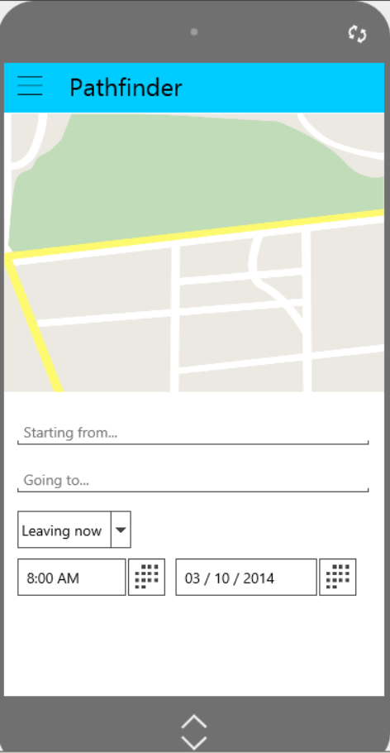

The Home screen will contain:

* A map of the users current location
* Text input fields for the start location and the destination
* A dropdown box that is used to specify when the user wishes to depart or arrive. Options include:
  + Leaving now
  + Leaving at…
  + Arriving at…
* If “Leaving at…” or “Arriving at…” are selected, then the time/date selectors will become visible and accept user input.

## Menu Drawer

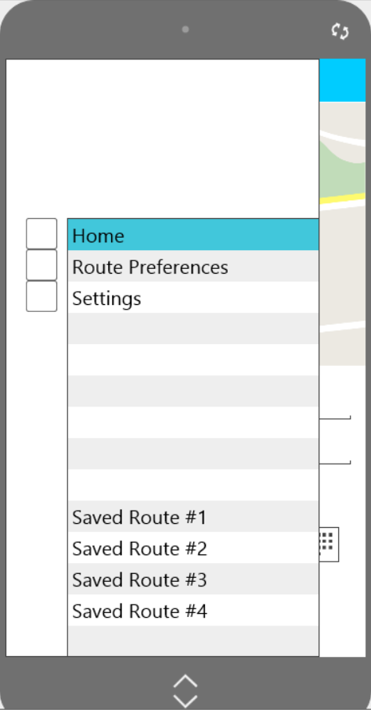

The Menu Drawer allows the user to quickly navigate to the Home screen or display the Route Preferences or Settings dialogs.

The user may also select from up to five previous searches. Pressing on a saved route will take the user to the Search Results page which will display the search results and map information.

## Route Preferences

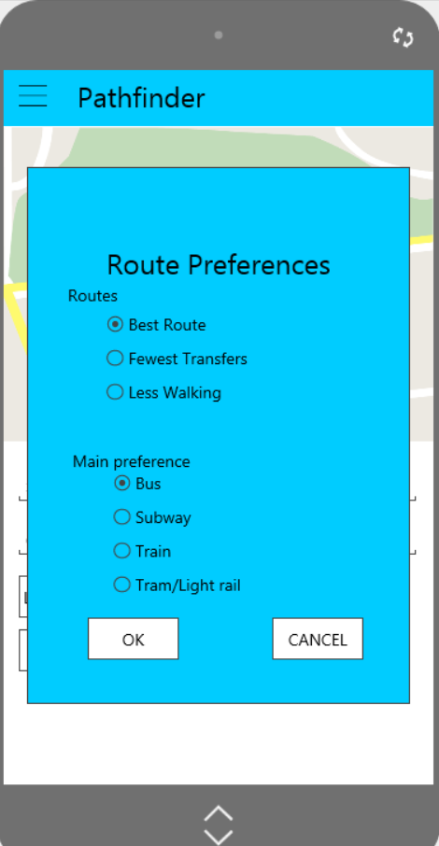

The Route Preferences dialog allows the user to save their preferences for the type of route they would like to search for.

## Settings

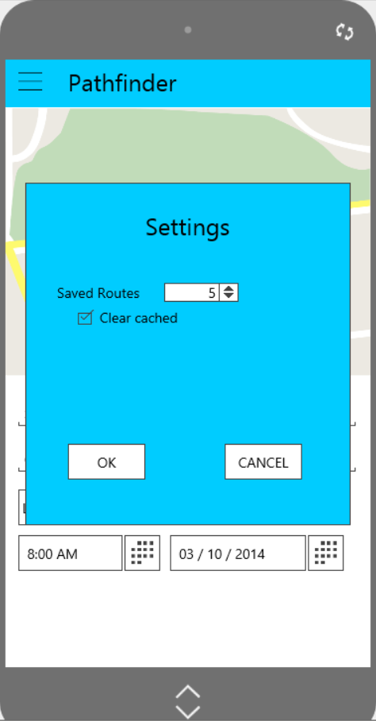

The Settings dialog allows the user to set the number of saved routes that will be displayed. It also allows the user the option to clear saved results

## Search Results

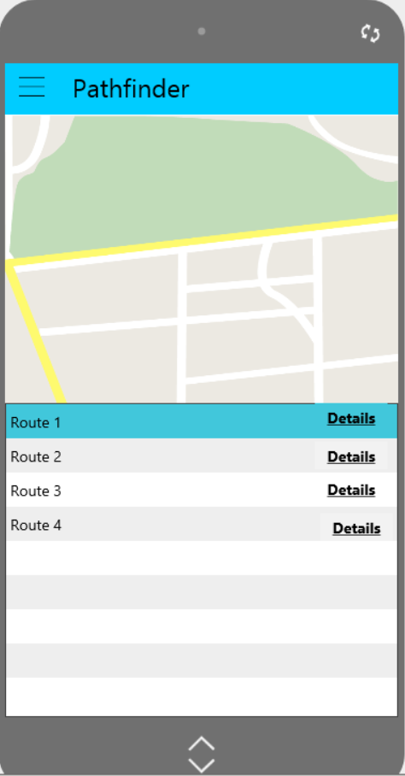

The Search Results page will contain a map which will have route #1 information highlighted when first displayed. Selecting a different route from the list below the map will cause the map to update with the information from the selected route highlighted.

Highlighted routes will have “pins” denoting the start location, the destination, and a line representing the route to be traveled.

Each route will have a “Details” button which will take the user to the Route Details screen.

The Map area will be sensitive to several gestures from the user:

* A Tap on a non-route point will expand the map to full screen
* A Tap on a route point will take the user to the Route Details screen
* A Pinch will zoom in
* A Spread will zoom out

## Route Details

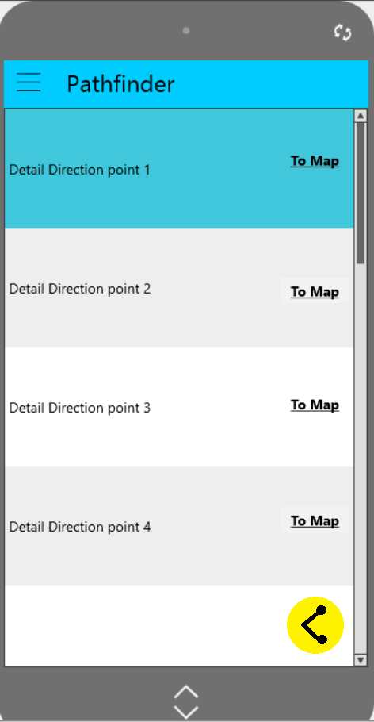

The Route Details screen will show each transition point the user will encounter along their route with detailed information about each point. A button is also provided for each transition to take the user to the Map screen.

There is also a Share button at the button of the screen that will allow the user to share this route with friends.

## Full Screen Map

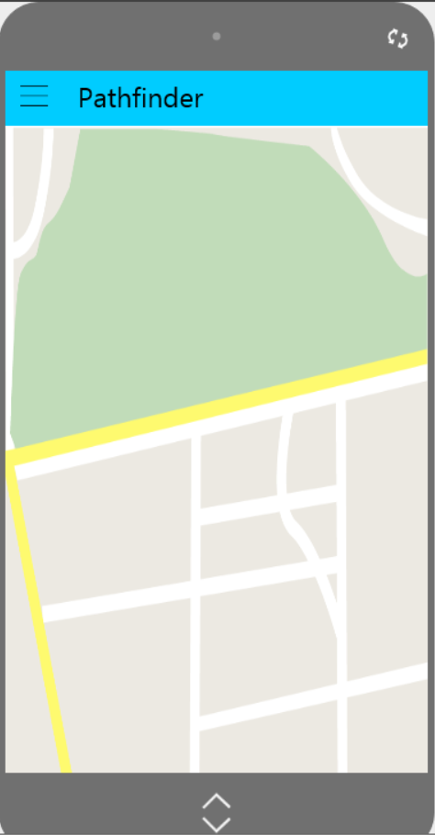

The Map screen will have the same functionality as it did when it was part of the Search Results screen, just more will be displayed.

# Key Considerations

### How will your app handle data persistence?

The information needing to be persisted is:

* User preferences
* User settings
* Saved Routes

A custom content provider will be created.

### Describe any corner cases in the UX.

I’m not sure about corner cases at the moment…

I may need a button on the Menu Drawer to allow the user to quickly get back to the Search Results screen (if search results exist). Otherwise they will need to press the “back” button one or more times.

### Describe any libraries you’ll be using and share your reasoning for including them.

I’m be using the Google Maps Android API. It will provide the maps, route highlighting, public transportation routes, custom markers, and more.

# Next Steps: Required Tasks

This is the section where you can take the main features of your app (declared above) and decompose them into tangible technical tasks that you can complete incrementally until you have a finished app.

## Task 1: Library familiarization

In order to become more familiar with the Google Maps Android API I’ll need to:

* Create a sample project that uses the Google Maps Android API
* Determine how to perform location searches
* Determine how to display maps with current location as well as highlighted routes

## Task 2: Project Setup

Create Pathfinder project and configure it based on what worked in the sample Google Maps project.

## Task 3: Implement UI for Each Activity, Fragment, and Dialog

* Build UI for Search screen
* Build UI for Search Results screen
* Build UI for Route Details screen
* Build UI for Map screen
* Build UI for Menu Drawer
* Build UI for Preferences dialog
* Build UI for Settings dialog
* Build UI for Tablet Search screen
* Build UI for Tablet Routes screen
* Build UI for Tablet Details screen
* Build UI for Tablet Map screen

## Task 4: Implement Content Provider

Build a content provider that retrieves data from the Google Maps Android API and provides the data to the UI.

## Task 5: Implement Data Persistence

Implement data persistence for:

* User preferences
* User settings
* Saved routes

## Task 6: Test Application (Phone)

Test the application:

* All UI screens.
* Content provider
* Data persistence

## Task 7: Implement Tablet UI

Implement tablet UI.

## Task 8: Test Application (Tablet)

Test tablet functionality.

Tablet UI:

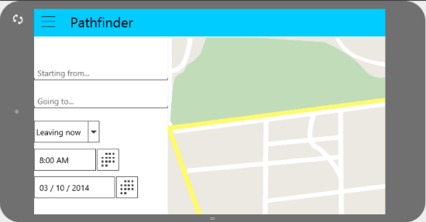

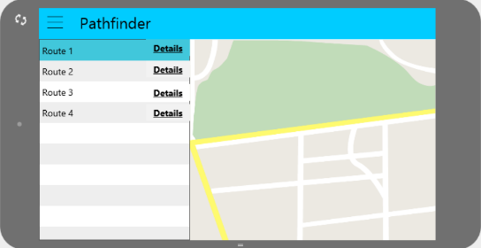

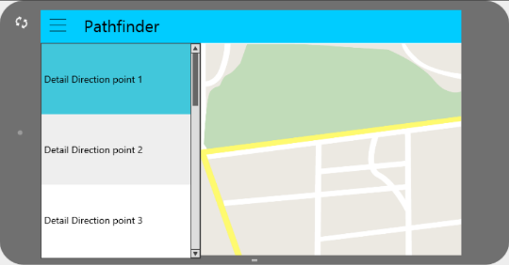

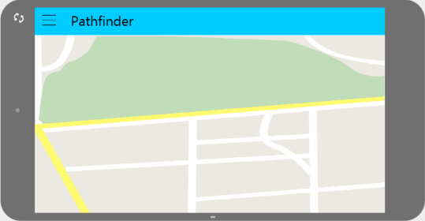

Add as many tasks as you need to complete your app.

**Submission Instructions**

1. After you’ve completed all the sections, download this document as a PDF [ File → Download as PDF ]
2. Create a new GitHub repo for the capstone. Name it “**Capstone Project**”
3. Add this document to your repo. Make sure it’s named “**Capstone_Stage1.pdf**”