Kenneth Munk

CSC155 – Section 02

Scott Gordon

A2

# Disclaimers:

The key listener has been found to have a glitch during some app launch instances where the key listener would not work. The current work-around is to re-launch the app.

All key inputs for the key listener are configured for key-hold states rather than key-type states. To move the camera, you will need to hold the keys down.

# Screenshot(s) of running program

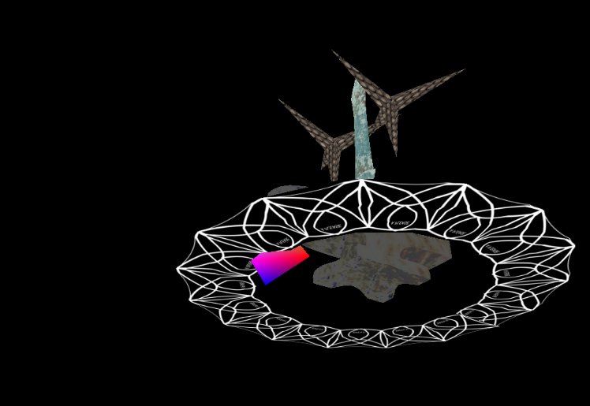

# Description of the object that was created by hand

The object that I created by hand was a triangular pyramid. I wanted to attempt to model the caltrops by hand but ran out of time.

# A description of which object(s) are moving, which object(s) are rotating and which ones are using tiling

The object that is moving is the rainbow triangle pyramid.

The objects that are rotating are the rainbow triangle pyramid and the caltrop stars.

# A list of which requirements were NOT fully working

Camera pitch rotation was not 100% implemented due to how the look-at matrix was implemented. I couldn’t get the system to have the camera pitch up and down on its own.

# Source information for each texture and model that you used

## Anvil_Laptop_Sleeve.png

Sourced via taking a picture of my laptop sleeve then adjusting the color values to make it look more metallic

## Castleroof.jpg

Sourced from book files

## RunicRingSegment.png

Texture drawn by hand for tiling

## metal_bare_0012_01_s.jpg

Sourced via texturelib.com

<http://texturelib.com/texture/?path=/Textures/metal/bare/metal_bare_0012>

<http://texturelib.com/license/>

* In compliance with the license since the assignment isn’t considered as a third party texture pack. No other restrictions on usage indicated in license.

## Models that were made with Blender

Glaidius Sword Model – Original .blend file lost

Caltrop Model – Hyper-simple model .blend file not saved

Anvil Model – File not on hand at time of resubmission

Rune torus – Original .blend file not saved

# Indicate on which RVR-5029 (remote) machine you tested your program

RVR-5029 – Myst – (in-person)

# All of the research to complete the project

Done in tandem with book

## Additional noodling

<https://www.geeksforgeeks.org/java-todegrees-method-example/>

<https://www.tutorialspoint.com/java/number_abs.htm>

<https://docs.oracle.com/javase/7/docs/api/java/awt/event/KeyAdapter.html>

<https://docs.oracle.com/javase/8/javafx/api/javafx/scene/input/KeyCode.html>

<https://docs.oracle.com/javase/7/docs/api/java/awt/AWTKeyStroke.html>

<https://docs.oracle.com/javase/7/docs/api/javax/swing/KeyStroke.html#getKeyStroke(char,%20boolean)>

<https://jogamp.org/deployment/jogamp-current/javadoc/jogl/javadoc_jogl_spec/com/jogamp/opengl/GL2ES2.html#glVertexAttribPointer(int,int,int,boolean,int,long)>