# Disclaimer

Yes, this socket lab was loaded into github as a private repository. This is a standard procedure on my part to make it easy to bounce between systems and backup my work.

<https://github.com/KenMunk/CSC138--Socket1>

I can grant access to this repository upon request but unless a request is made, it will remain private in order to prevent code leakage.

# TCP

## Source Code

### Images

### Description

The TCP client and server were adapted from the code generated when attempting to create the UDP client and server. The syntax is a little bit different because I intentionally used Python 3 because I wanted to know how to setup these sorts of sockets with the newer codebase of python 3 rather than python 2 since python 2 is deprecated now. The difference between doing this lab in python 2 vs python 3 was the inability to use raw_input and the need to explicitly encode and decode the strings into byte arrays. If messages were not encoded and decoded, the byte indicator would appear in all of the responses that were printed out which would have ruined the responses.

## Operations

In the above two snips, the launch commands of the code is being demonstrated to show that the code launches without error.

In this snip, the code operation is being demonstrated including the server also printing messages indicating the type of operations being done to show that the operations are taking the message indicated at client side and performing manipulations on them.

# UDP

## Source Code

## Operations

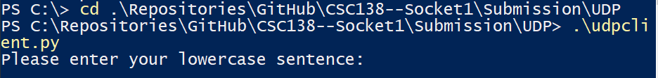

In the above two snips, the launch commands of the code is being demonstrated to show that the code launches without error.

In this snip, the code operation is being demonstrated including the server also printing messages indicating the type of operations being done to show that the operations are taking the message indicated at client side and performing manipulations on them. I intentionally neglected the act of decoding the messages before proceeding to send them since there was no explicit need to clean up the printouts on the server side.