

Technical Safety Concept Lane Assistance

**Document Version: 1.1**

**Template Version 1.0, Released on 2017-06-21**



# Document history

|  |  |  |  |
| --- | --- | --- | --- |
| Date | Version | Editor | Description |
| 3/2/18 | 0.1 | Ken Overholt | Initial draft |
| 3/8/18 | 0.2 | Ken Overholt | Candidate for final release |
| 3/8/18 | 1.0 | Ken Overholt | Final Release |
| 3/8/18 | 1.1 | Ken Overholt | Updated LKA requirements |
|  |  |  |  |

# 

# Table of Contents

Table of Contents

Document history 2

Table of Contents 2

Purpose of the Technical Safety Concept 2

Inputs to the Technical Safety Concept 3

Functional Safety Requirements 3

Refined System Architecture from Functional Safety Concept 4

Functional overview of architecture elements 4

Technical Safety Concept 6

Technical Safety Requirements 6

Refinement of the System Architecture 10

Allocation of Technical Safety Requirements to Architecture Elements 10

Warning and Degradation Concept 10

# Purpose of the Technical Safety Concept

The technical Safety Concept defines how the subsystems interact at the message level and describes how the ECUs communicate with each other. It turns functional safety requirements into technical safety requirements and allocates technical safety requirements to the system architecture.

# Inputs to the Technical Safety Concept

## Functional Safety Requirements

|  |  |  |  |  |
| --- | --- | --- | --- | --- |
| **ID** | **Functional Safety Requirement** | **ASIL** | **Fault Tolerant Time Interval** | **Safe State** |
| Functional  Safety  Requirement  01-01 | The electronic power steering ECU shall ensure that the lane departure warning oscillating torque amplitude is below Max_Torque_Amplitude | C | 50 ms | No torque is being applied |
| Functional  Safety  Requirement  01-02 | The electronic power steering ECU shall ensure that the lane departure warning oscillating torque frequency is below Max_Torque_Frequency | C | 50 ms | No torque is being applied |
| Functional  Safety  Requirement  02-01 | The electronic power steering ECU shall ensure that the lane keeping assistance torque is applied for only Max_Duration. | B | 500 ms | No torque is being applied |

## Refined System Architecture from Functional Safety Concept

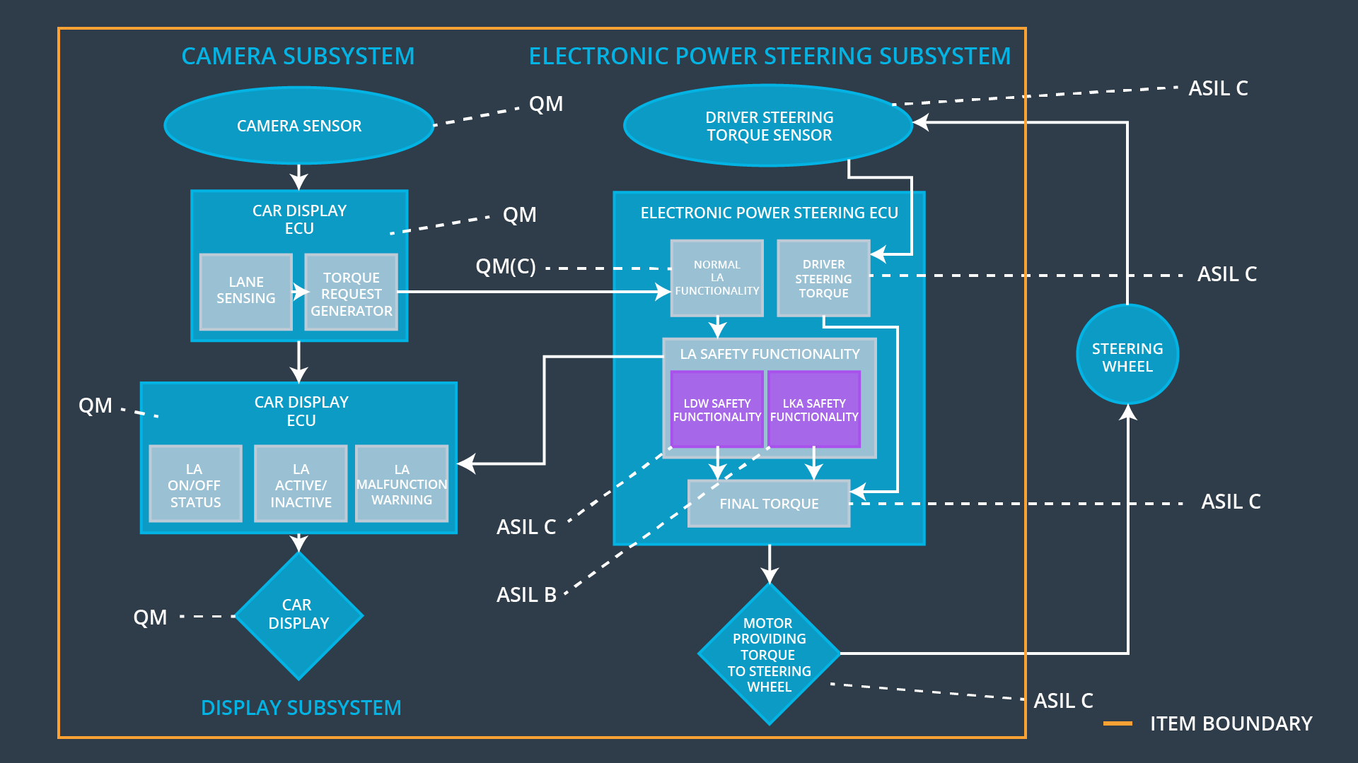

### 

### Functional overview of architecture elements

|  |  |
| --- | --- |
| **Element** | **Description** |
| Camera Sensor | The Camera Sensor reads in images from the road. |
| Camera Sensor ECU - Lane Sensing | The Camera Sensor ECU identifies when the vehicle has accidentally departed its lane and sends the appropriate torque request to the Electronic Power Steering ECU as well as sending a message to the Car Display ECU. |
| Camera Sensor ECU - Torque request generator | The Camera Sensor ECU - Torque request generator determines the amount of torque necessary to keep the car in the lane and sends this value to the EPS ECU - Normal Lane Assistance Functionality |
| Car Display | The Car Display shows a sign in indicating the car has veered from its lane. |
| Car Display ECU - Lane Assistance On/Off Status | The Car Display ECU controls a light that tells the driver if the Lane Keeping system is on or off. It also controls a light that tells the driver that the Lane Departure Warning is activated. |
| Car Display ECU - Lane Assistant Active/Inactive | Car Display ECU - Lane Assistant Active/Inactive turns on the light when the Lane Assistant is active and turns it off when the Lane Assistance is inactive |
| Car Display ECU - Lane Assistance malfunction warning | The Car Display ECU - Lane Assistance malfunction warning turns on a light when the Lane Assistance feature is malfunctioning and off when not |
| Driver Steering Torque Sensor | The Driver Steering Torque Sensor senses the current torque value and sends it to the EPS ECU |
| Electronic Power Steering (EPS) ECU - Driver Steering Torque | The Electronic Power Steering (EPS) ECU - Driver Steering Torque sends the actual torque value to the Final Torque block. |
| EPS ECU - Normal Lane Assistance Functionality | Sends the vibrational torque request to the LDW Safety Functionality |
| EPS ECU - Lane Departure Warning Safety Functionality | Checks to make sure that the torque request is below the maximum amplitude and frequency. If either maximum value is crossed, the LDW Safety Functionality deactivates the functionality and sets the LDW_Torque_Request to zero. Sends its torque request to the Final EPS ECU - Final Torque block. It sends a status signal to the Car Display |
| EPS ECU - Lane Keeping Assistant Safety Functionality | Checks to make sure that the torque request duration is below the maximum duration. If the value is crossed, the EPS ECU - Lane Keeping Assistant Safety Functionality deactivates the functionality and sets the LDW_Torque_Request to zero. Sends its torque request to the Final EPS ECU - Final Torque block. It sends a status signal to the Car Display |
| EPS ECU - Final Torque | The EPS ECU – Final Torque combines torques and sends the resulting torque to the motor. |
| Motor | The motor receives the torque request from the Driver Steering Torque Sensor and moves the steering wheel. |

# Technical Safety Concept

## Technical Safety Requirements

**Lane Departure Warning (LDW) Requirements:**

Functional Safety Requirement 01-01 with its associated system elements

(derived in the functional safety concept)

|  |  |  |  |  |
| --- | --- | --- | --- | --- |
| **ID** | **Functional Safety Requirement** | **Electronic Power Steering ECU** | **Camera ECU** | **Car Display ECU** |
| Functional  Safety  Requirement  01-01 | The lane keeping item shall ensure that the lane departure oscillating torque amplitude is below Max_Torque_Amplitude | X |  |  |

Technical Safety Requirements related to Functional Safety Requirement 01-01 are:

|  |  |  |  |  |  |
| --- | --- | --- | --- | --- | --- |
| **ID** | **Technical Safety Requirement** | **ASIL** | **Fault Tolerant Time Interval** | **Architecture Allocation** | **Safe State** |
| Technical  Safety  Requirement  01 | The LDW safety component shall ensure that the amplitude of the 'LDW_Torque_Request' sent to the 'Final electronic power steering Torque' component is below 'Max_Torque_Amplitude. | C | 50 ms | LDW Safety software component | Lane Departure Warning Torque Request Amplitude shall be set to zero |
| Technical  Safety  Requirement  02 | As soon as a failure is detected by the LDW function, it shall deactivate the LDW feature and the 'LDW_Torque_Request' shall be set to zero. | C | 50 ms | LDW Safety software component | Lane Departure Warning Torque Request Amplitude shall be set to zero |
| Technical  Safety  Requirement  03 | As soon as the LDW function deactivates the LDW feature, the 'LDW Safety' software block shall send a signal to the car display ECU to turn on a warning light. | C | 50 ms | LDW Safety software component | Lane Departure Warning Torque Request Amplitude shall be set to zero |
| Technical  Safety  Requirement  04 | The validity and integrity of the data transmission for 'LDW_Torque_Request' signal shall be ensured. | C | 50 ms | Data Transmission Integrity Check block | Lane Departure Warning Torque Request Amplitude shall be set to zero |
| Technical  Safety  Requirement  05 | Memory test shall be conducted at startup of the EPS ECU to check for any faults in memory. | A | Ignition cycle | Safety Startup Memory Test block | Lane Departure Warning Torque Request Amplitude shall be set to zero |

Functional Safety Requirement 01-2 with its associated system elements

(derived in the functional safety concept)

|  |  |  |  |  |
| --- | --- | --- | --- | --- |
| **ID** | **Functional Safety Requirement** | **Electronic Power Steering ECU** | **Camera ECU** | **Car Display ECU** |
| Functional  Safety  Requirement  01-02 | The lane keeping item shall ensure that the lane departure oscillating torque frequency is below Max_Torque_Frequency | X |  |  |

Technical Safety Requirements related to Functional Safety Requirement 01-02 are:

|  |  |  |  |  |  |
| --- | --- | --- | --- | --- | --- |
| **ID** | **Technical Safety Requirement** | **ASIL** | **Fault Tolerant Time Interval** | **Architecture Allocation** | **Safe State** |
| Technical  Safety  Requirement  01 | The LDW safety component shall ensure that the frequency of the 'LDW_Torque_Request' sent to the 'Final electronic power steering Torque' component is below ' Max_Torque_Frequency. | C | 50 ms | LDW Safety software component | Lane Departure Warning Torque Request Frequency shall be set to zero |
| Technical  Safety  Requirement  02 | As soon as a failure is detected by the LDW function, it shall deactivate the LDW feature and the Max_Torque_Frequency shall be set to zero. | C | 50 ms | LDW Safety software component | Lane Departure Warning Torque Request Frequency shall be set to zero |
| Technical  Safety  Requirement  03 | As soon as the LDW function deactivates the LDW feature, the 'LDW Safety' software block shall send a signal to the Car Display ECU to turn on a warning light. | C | 50 ms | LDW Safety software component | Lane Departure Warning Torque Request Frequency shall be set to zero |
| Technical  Safety  Requirement  04 | The validity and integrity of the data transmission for Max_Torque_Frequency signal shall be ensured. | C | 50 ms | Data Transmission Integrity Check block | Lane Departure Warning Torque Request Frequency shall be set to zero |
| Technical  Safety  Requirement  05 | Memory test shall be conducted at startup of the EPS ECU to check for any faults in memory. | A | Ignition cycle | Safety Startup Memory Test block | Lane Departure Warning Torque Request Frequency shall be set to zero |

**Lane Keeping Assistance (LKA) Requirements:**

Functional Safety Requirement 02-1 with its associated system elements

(derived in the functional safety concept)

|  |  |  |  |  |
| --- | --- | --- | --- | --- |
| **ID** | **Functional Safety Requirement** | **Electronic Power Steering ECU** | **Camera ECU** | **Car Display ECU** |
| Functional  Safety  Requirement  02-01 | The lane keeping item shall ensure that the lane keeping assistance torque is applied for only Max_Duration | X |  |  |

Technical Safety Requirements related to Functional Safety Requirement 02-01 are:

|  |  |  |  |  |  |
| --- | --- | --- | --- | --- | --- |
| **ID** | **Technical Safety Requirement** | **ASIL** | **Fault Tolerant Time Interval** | **Allocation to Architecture** | **Safe State** |
| Technical  Safety  Requirement  01 | The LKA safety component shall ensure that a timer is started when the ‘LKA_Torque_Request' is sent to the 'Final electronic power steering Torque' component. | B | 500 ms | LKA Safety software component | LKA Torque Request shall be set to zero |
| Technical  Safety  Requirement  02 | As soon as the LKA function’s timer reaches Max_Duration, it shall deactivate the LKA feature and the 'LKA_Torque_Request' shall be set to zero. | B | 500 ms | LKA Safety software component | LKA Torque Request shall be set to zero |
| Technical  Safety  Requirement  03 | As soon as the LKA function deactivates the LKA feature, the 'LKA Safety' software block shall send a signal to the car display ECU to turn on a warning light. | B | 500 ms | LKA Safety software component | LKA Torque Request shall be set to zero |
| Technical  Safety  Requirement  04 | The validity and integrity of the data transmission for 'LKA_Torque_Request' signal shall be ensured. | B | 500 ms | Data Transmission Integrity Check block | LKA Torque Request shall be set to zero |
| Technical  Safety  Requirement  05 | Memory test shall be conducted at startup of the EPS ECU to check for any faults in memory. | A | Ignition cycle | Safety Startup Memory Test block | LKA Torque Request shall be set to zero |

## Refinement of the System Architecture

**A screenshot of a video game

Description generated with high confidence**

## Allocation of Technical Safety Requirements to Architecture Elements

For this item, all technical safety requirements are allocated to the Electronic Power Steering ECU

## Warning and Degradation Concept

|  |  |  |  |  |
| --- | --- | --- | --- | --- |
| **ID** | **Degradation Mode** | **Trigger for Degradation Mode** | **Safe State invoked?** | **Driver Warning** |
| WDC-01 | Turn off the functionality | lane departure warning function applies an oscillating torque with very high torque frequency and amplitude | Yes | The owner’s manual will state that the feature will be turned off if it becomes too forceful. The driver will see a warning light on the dashboard when the system malfunctions. |
| WDC-02 | Turn off the functionality | Oscillating torque has reached the max_duration value | Yes | The owner’s manual will state that the vehicle is not to be used for autonomous driving and that this feature will only be active for a short period before turning off. The driver will see a warning light on the dashboard when the lane keeping assistance is activated and it will disappear when not activated. |