Prepared by: Vlanchy Baleda BSIT-2C

1. **IPv4 versus IPv6**

The main difference between IPv4 and IPv6 is the address size of IP addresses. The IPv4 is a 32-bit address, whereas IPv6 is a 128-bit hexadecimal address. IPv6 provides a large address space, and it contains a simple header as compared to IPv4.

Retrieve from: https://community.fs.com/blog/ipv4-vs-ipv6-whats-the-difference.html#:~:text=The%20main%20difference%20between%20IPv4,header%20as%20compared%20to%20IPv4.

2. **What is IP Address?**

An IP address is a string of numbers assigned to an internet-connected device, much like an address on a house. Your computer network uses the IP address to communicate with other computers, websites, and all parts of cyberspace.

Essentially, IP addresses are how computers on the internet recognize one another. Your internet service provider (ISP) assigns IP addresses to your internet-connected devices, and every IP address is unique. Considering every single internet-connected device has an IP address, billions of IP addresses exist.

Retrieve from: https://us.norton.com/internetsecurity-privacy-what-does-an-ip-address-tell-you.html

3. **What is Subnet Mask, and Gateway?** -Purpose of Subnetting?

A subnet mask defines the range of IP addresses that can be used within a network or subnet. It also separates an IP address into two parts: network bits and host bits.

Subnet mask is required for TCP/IP to work. The subnet mask is used by the TCP/IP protocol to determine whether a host is on the local subnet or on a remote network. They are also used when subnetting, which is when you break a network up into smaller networks. By adjusting the subnet mask, you can set the number of available IP addresses within a network. And through subnetting, network traffic can travel a shorter distance without passing through unnecessary routers to reach its destination that makes computer network more fast, efficient, and resilient.

Also, if a TCP/IP computer needs to communicate with a host on another network, it will usually communicate through a device called a router. In TCP/IP terms, a router that is specified on a host, which links the host's subnet to other networks, is called a default gateway.

Retrieve from: https://www.freecodecamp.org/news/subnet-mask-definition/

https://docs.microsoft.com/en-us/troubleshoot/windows-client/networking/tcpip-addressing-and-subnetting

https://www.cloudflare.com/learning/network-layer/what-is-a-subnet/

https://www.fieldengineer.com/skills/subnetting

4. **Characteristics of IPv4**

* IPv4 could be a 32-Bit IP Address.
* IPv4 could be a numeric address, and its bits are separated by a dot.
* The number of header fields is twelve and the length of the header field is twenty.
* It has Unicast, broadcast, and multicast style of addresses.
* IPv4 supports VLSM (Virtual Length Subnet Mask).
* IPv4 uses the Post Address Resolution Protocol to map to the MAC address.
* RIP may be a routing protocol supported by the routed daemon.
* Networks ought to be designed either manually or with DHCP.
* Packet fragmentation permits from routers and causing host.

Retrieve from: https://www.geeksforgeeks.org/what-is-ipv4/#:~:text=Characteristics%20of%20IPv4&text=IPv4%20could%20be%20a%20numeric,(Virtual%20Length%20Subnet%20Mask).

5. **Classes of IPv4**

In the IPv4 IP address space, there are five classes: A, B, C, D and E. Each class has a specific range of IP addresses (and ultimately dictates the number of devices you can have on your network). Primarily, class A, B, and C are used by the majority of devices on the Internet. Class D and class E are for special uses.

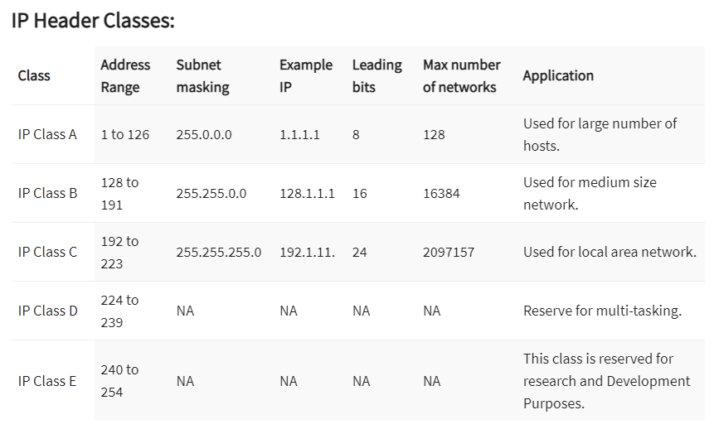

Retrieve from: https://www.guru99.com/ip-address-classes.html

https://www.meridianoutpost.com/resources/articles/IP-classes.php#:~:text=In%20the%20IPv4%20IP%20address,of%20devices%20on%20the%20Internet.