Design
CMPT 275: Assignment 5
Written By:
GROUP 14 – Bonnie Ha, Clayton Jian, Riku Kenju, Yixuan Li, James Voong

April 13, 2015

Table of Contents

Revision History ii
1. Guidelines 1
2. System Design 2
2.1. Navigation 3
2.2. Transit 3
2.3. Calendar 4
2.4. SFU Canvas and SFU Connect 5
2.5. Other Campus Services 6
2.6. Loyalty 10
2.7. Social Media 11
2.8. Feedback 11
3. Data Requirements 12
3.1. User Input 12
3.2. Data Input 12
3.3. Data Output 13
4. Feature Priority 13
4.1. Navigation 14
4.2. Transit 15
4.3. Calendar 15
4.4. SFU Canvas and SFU Connect 16
4.5. Other Campus Services 16
4.6. Loyalty 17
4.7. Social Media 18
4.8. Feedback 18
5. References 19

Revision History
Revision | Status | Publication/Revision Date | By
1.0 | Created | February 3, 2015 | Bonnie Ha, Clayton Jian,  Riku Kenju, Yixuan Li, James Voong
1.1 | Revised:  4. Feature Priority – added notes | February 3, 2015 | Bonnie Ha, Clayton Jian, Riku Kenju, Yixuan Li, James Voong
1.2 | Revised:  1. Technical Guidelines – added notes | February 7, 2015 | Bonnie Ha, Clayton Jian, Riku Kenju, Yixuan Li, James Voong
1.3 | Revised:  3. Data Requirements – added notes | February 13, 2015 | Bonnie Ha, Clayton Jian, Riku Kenju, Yixuan Li, James Voong
2.0 | Draft | February 16, 2015 | Bonnie Ha, Clayton Jian, Riku Kenju, Yixuan Li, James Voong
2.1 | Revision | February 19, 2015 | Bonnie Ha, Clayton Jian, Riku Kenju, Yixuan Li, James Voong
3.0 | Published | February 20, 2015 | Bonnie Ha, Clayton Jian, Riku Kenju, Yixuan Li, James Voong
4.0 | Revised  1. Technical Guidelines – changed Xcode version  2.3 Calendar – edited UML diagram  4. Feature Priority – updated version requirements | March 7, 2015 | Bonnie Ha, Clayton Jian, Riku Kenju, Yixuan Li, James Voong
5.0 | Revised  4. Feature Priority – updated version requirements | March 23, 2015 | Bonnie Ha, Clayton Jian, Riku Kenju, Yixuan Li, James Voong
6.0 | Revised  2. System Design – removed SFU Alerts, changed News Feed to Social Media  2.6 SFU Alerts – removed  2.8 News Feed – changed to Social Media  4. Feature Priority – updated version requirements  4.6 SFU Alerts – removed  4.8 News Feed – changed to Social Media | April 10, 2015 | Bonnie Ha, Clayton Jian, Riku Kenju, Yixuan Li, James Voong
6.1 | Revised diagrams in:  2.2 Transit  2.3 Calendar  2.5 Other Campus Services  2.7 Social Media  2.8 Feedback | April 13, 2015 | Bonnie Ha, Riku Kenju, Yixuan Li, James Voong

Guidelines

The following guidelines will enable the technical implementation of the SFUdiscover application:
- Development will be done using the IDE from Xcode version 5.1.1 for iOS7+. [1]
- The application will be programmed in Objective C.
- Both iPhone and iPad emulators will be used for initial testing and physical iPhones and iPads for the later stages.
- We will be using the version/source control host Bitbucket.
- We will be using Instruments of Xcode version 5.1.1 to monitor and analyze the code while it is running. [2]
- We will be using CLOC 1.62 in to analyze our code sizes. [3]
- A SQL database will be used to store necessary information.
- The app will be able to function without an internet connection, but not all features will be available.
- The application will require an internet connection and user login to access all features’ functionality of the application.
- The UI tool myBalsamiq will be used for initial UI planning and designing.

During implementation, the following ethical and legal issues should be followed for the application:
- We are in agreement with the Atlassian Customer Agreement terms and conditions in our usage of Bitbucket. [4]
- Our application will be eligible for a 4+ application rating on the Apple App store as it will not contain any adult material. [5]
- The personal information of users will not be made available to the public.
- We will not be held responsible for false or inappropriate uploaded data by users (eg. Lost and Found reports).
- We will not be held responsible for damage, injury or accidents the user may face in usage of our application.

System Design
The system will be structured as a Model-View-Controller model. Figure 1 showcases how the components of the MVC model interact with each other.
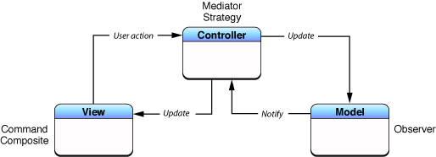
Figure 1: A general MVC model [6]

For our application, there will be a model to represent each feature. As shown in Figure 2, the central controller will send requests to the appropriate model. The model will then be responsible for updating their corresponding appropriate views. [6] Figure 2 is a rough illustration of the 9 feature models. The system of the 9 feature models are further discussed in the following sections. For each feature, its system model was adapted from discussed model. [7]
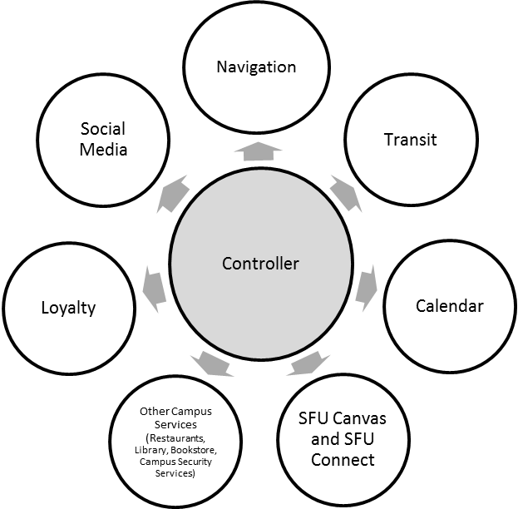
Figure 2: Model layout

Navigation
Figure 3 details the process model of the Navigation feature. It highlights how the map is presented to the user upon opening the feature, user will choose their locations according to their current location, favorite locations, or manually searching. Once the locations are chosen, the application will list out the detailed instructions, such as the detailed route and any relevant data.

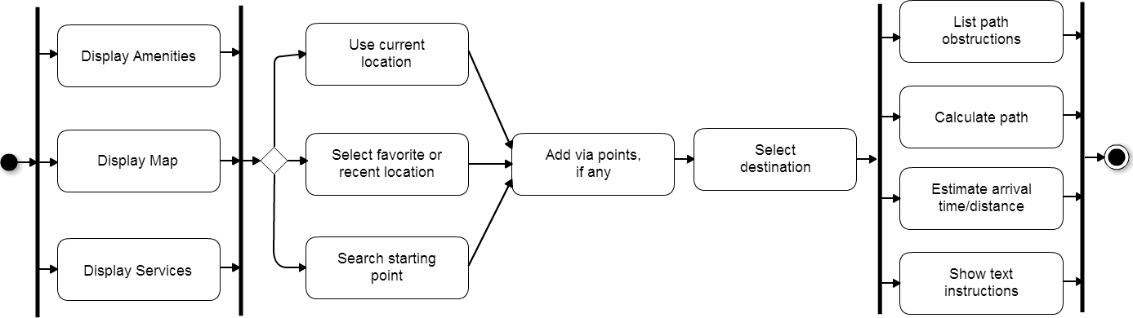
Figure 3: Process Model for Navigation

Transit
Figure 4 details the state diagram for the Transit feature. This figure details the process of a potential user trying to use the app to look up the arrival time of a particular bus at a selected station by using the state diagram.
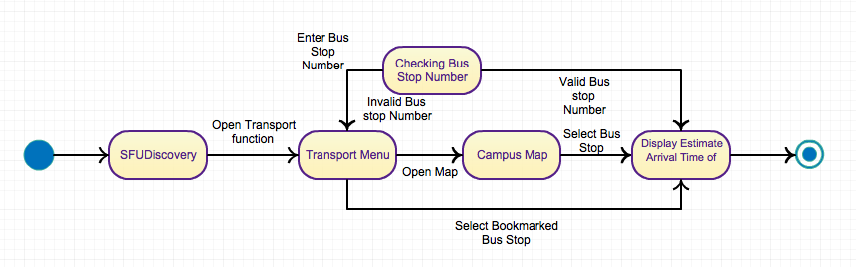
Figure 4: State Diagram for Transit

Calendar
Figure 5 showcases the UML class diagrams of the Calendar feature. There will be only 1 Event Manager object, which will maintain the Calendars and Event. Calendar objects contain Event objects. Event objects contain numerous attributes, such as name, date, time, etc.

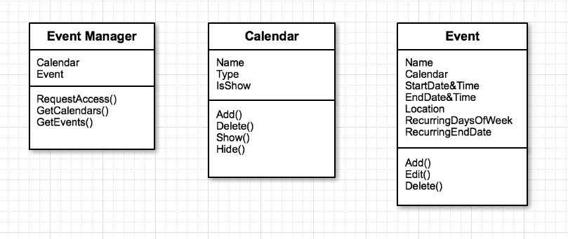
Figure 5: UML Class Diagram of Calendar feature

SFU Canvas and SFU Connect
Figure 6 details the sequence diagram for the SFU Canvas and SFU Connect feature. This figure details the process of what happens when the user request the use of SFU Canvas or SFU Connect.
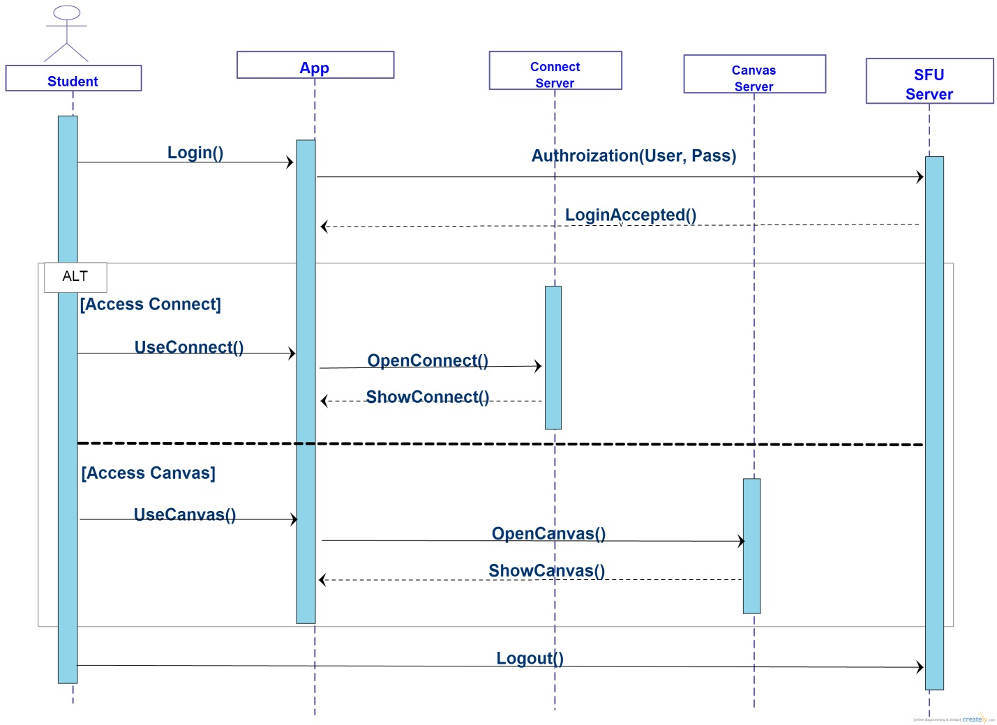
Figure 6: Sequence Diagram of the SFU Connect and Canvas feature

Other Campus Services
Figure 7 details the UML class diagram for other Campus Services. Campus Services will consist of Restaurant, Library, Bookstore, and Security Services. However, only the restaurant's features require a function and class to perform the necessary tasks. The necessary information of each item is listed in the second boxes as seen below.
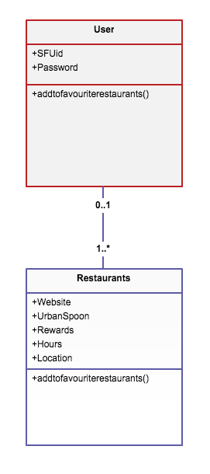
Figure 7: UML Class Diagram for Restaurant/ Bookstore/ Library features

Figure 8 details the state diagram for Restaurant feature. The Restaurant state diagram will start at the services Home screen and navigate to the restaurants Home page. From there, the user may navigate restaurants through cuisine, location or added favorites. On specific restaurant pages, the user will be able to view hours, location, website, UrbanSpoon page and rewards if they are available.
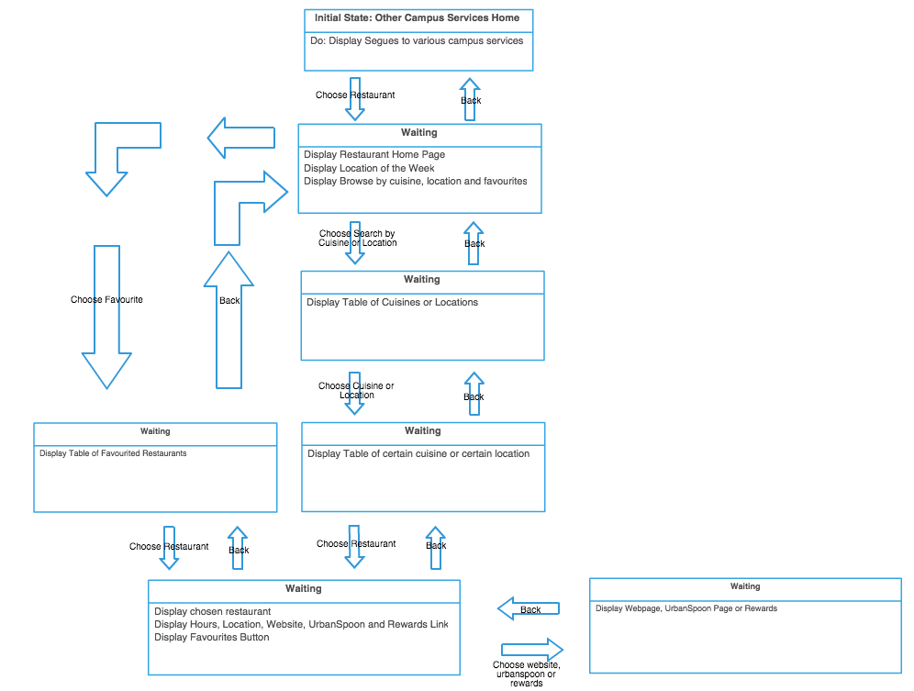

Figure 8: State Diagram for Restaurant and Pubs features

Figure 9 details the state diagram for SFU Library feature. The SFU Library feature will use a webpage view that links to the SFU library mobile link for user familiarity.
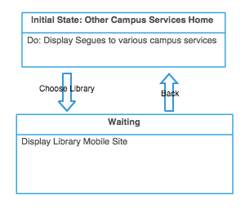
Figure 9: State Diagram for SFU Library feature

Figure 10 details the state diagram for SFU Bookstore feature. The SFU Bookstore feature will use a webpage view that links to the SFU bookstore mobile link for user familiarity.
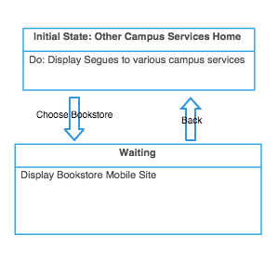
Figure 10: State Diagram for SFU Bookstore feature

Figure 11 details the state diagram for the Lost and Found feature. The Lost and Found feature consists of 3 options from the Home page. The first option is a report form, which leads to a submission. The second option is to search the catalogue. In the third case, a user may view all items of the lost and found catalogue.
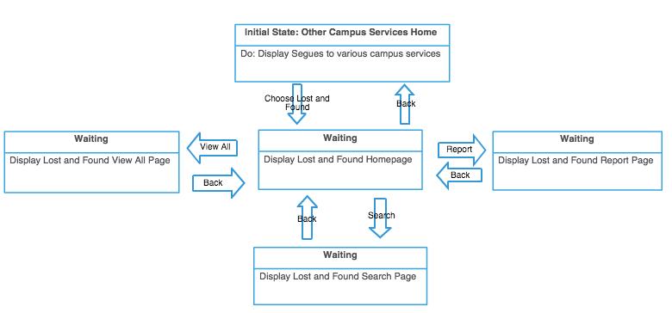
Figure 11: State Diagram for the Lost and Found feature

Figure 12 details the state diagram for the Traffic and Conditions feature. The state diagram for the Traffic and Conditions feature will have a Home screen with two options. One option will be to display the current conditions of the SFU campus. The second option will allow the user to choose one of the SFU webcams and then, will display the webcam. This webcam view will then constantly refresh to bring the latest feed.
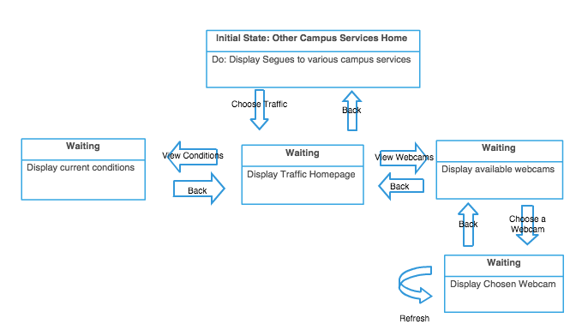
Figure 12: State Diagram for the Traffic and Conditions feature

Loyalty
Figure 13 shows the state diagram for the Loyalty feature. User will be able to scan QR codes scattered around the campus and accumulate points, use the points to redeem various rewards, and view a history of their own redeemed rewards. Database for the history of redeem rewards will be updated accordingly, when the user acquires or deletes a reward.
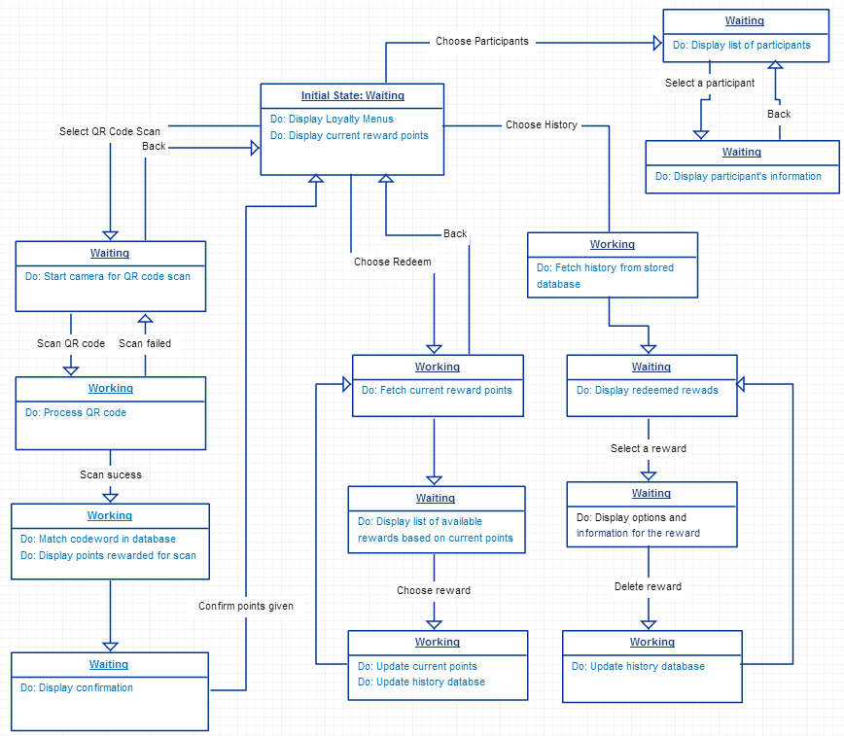
Figure 13: State Diagram for Loyalty feature.

Social Media
Figure 14 illustrates the state diagram of the Social Media feature. The feature will begin in the Waiting state. During the Waiting state, a list of SFU-registered Facebook accounts will be displayed. Upon tapping on an account name, the feature enters the Busy state, where users will be directed to the news feed of the desired account name.
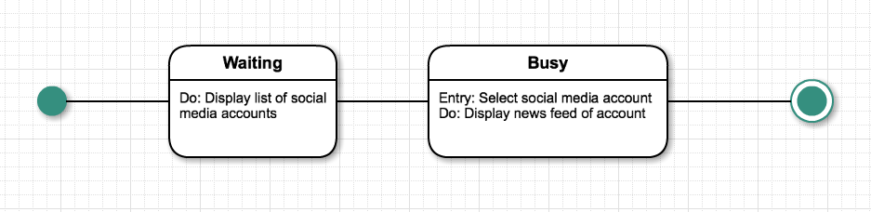
Figure 14: State Diagram of Social Media feature

Feedback
Figure 15 shows the state diagram for the Feedback feature. The top page of this feature shows the user options to send a feedback to a one of the destination to send feedback. The app will open iOS mail composer as per Apple's requirements and the recipients and subject of feedback is pre-loaded.
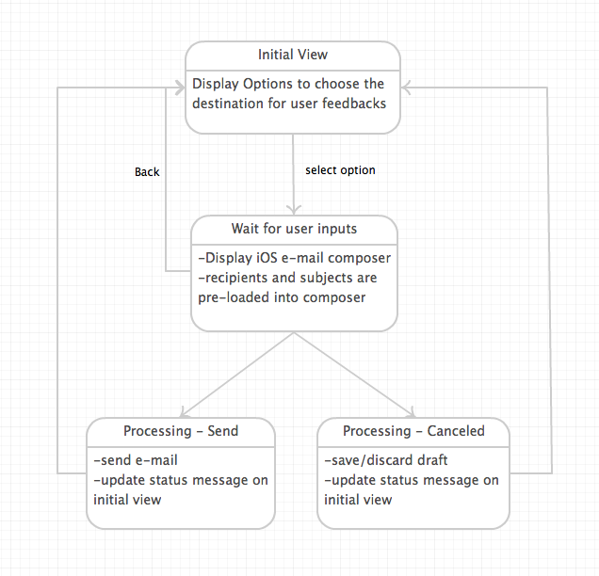
Figure 15: State Diagram for Feedback feature

Data Requirements
The application will use various data to support its operation. The following section details the data input, output, and user input that are necessary for each of the features implemented. Data structure and file types will also be specified for each feature where necessary. Device refers to an Apple iPhone or iPad running iOS 7.0. However, the application may not function properly on older iOS versions

User Input
- Main source for user input is the device’s touchscreen:
  - Tapping buttons to manipulate item on-screen
  - Text input using on-screen keyboards
  - Dragging to scroll through various menus and utilize different features, such as panning and zooming on the map
- Camera will also be used to scan QR codes for loyalty program

Data Input
- Most common form of input into system will be from string input
- Assortment of databases
  - Student’s academic schedule from SFU’s Student Information System
  - List of SFU-registered social media accounts
  - SFU Library catalogue database
  - SFU Bookstore catalogue database
  - Lost and Found catalogue database
  - A look up table will be accessed to convert reward points depending on the code word stored on the QR code. Table 1 is a sample table using the query QRLookup(Codeword, Points). The table will be updated for additional Codeword or changes in points.

Table 1: Sample Lookup table for Reward Points
Codeword | Points
3gfe45h | 2
Djdf83j | 3
Sdf3f | 2
Sdfjh34o | 1
... | ...
... | ...

- Reward redeem history will be stored in Ordered Linked List sorted by date from most recent to oldest. This file will store up to 10 items and older items will be deleted if new item are to be added.

  - File format will be as follows to indicate if the reward has been used:
--------
Starbucks coupon : 0
Blenz coupon: 1
--------
0 indicates not yet used but redeemed, 1 indicates used and will be shown in history.
- Predefined text messages for Feedback will be stored in text file. This text file will be accessed to load the predefined text when user opens the Feedback service.
- Device settings, such as the location of the device, will be used by the map to help the user navigate

Data Output
- Text files for displaying information
  - Lost and found form
  - Information about user preferences, like locations, restaurants, books, etc
  - Redeem points and rewards
  - UML file for Calendar view
  - HTML file of social media channel’s news feed

Feature Priority
The application will go through 3 iterations of implementation. Table 2 lists the owners of each feature. Each owner will be responsible for implementing the feature’s functionality to completion. A complete list of functionalities can be found in Section 3 of the Requirements document. [8] The following sections list the functionalities that will be completed for each version of the application.
Table 2: Owners of Features
Feature | Person Responsible
Navigation | Clayton
Transit | Yixuan
Calendar | Bonnie
SFU Canvas & SFU Connect | Yixuan
Other Campus Services | James
Loyalty | Riku
Social Media | Bonnie
Feedback | Riku

Navigation
Table 3: Functional Requirements for Navigation
Functional Requirements | Version 1 | Version 2 | Version 3
The application shall display a map of the campus. | ✓
The application shall be able to process entries into the search bar and provide the most relevant location results back to the user. | ✓
The application shall be able to pinpoint the user’s location on campus using Wi-Fi signals and display the user’s location on a map. |  |  | ✓
The user shall be able to add a location to a list of preferences. |  | ✓
The application shall store records of recent location search results. |  | ✓
The application shall determine the path with the shortest distance from one location to another. |  |  | ✓
The application shall be able to give a time and distance estimate on how far the user is from their destination. |  |  | ✓
The map shall display important campus services (ex. library, security, bus loops, etc) with an appropriate icon. | ✓
The map shall display campus amenities (ex. washrooms, food, elevators, ATMs, etc) with an appropriate icon. | ✓
The application shall provide the user with text instructions on how to get from their starting point to their destination. |  |  | ✓
The application shall find any obstructions on the map (ex. construction, events, etc) and list them out to the user. |  |  | ✓
The application shall be able to find a detour in the case that the current path is not desirable. |  |  | ✓
The application shall be able to accept different transportation methods (ex. walking, bike, car, bus, etc) and calculate a path accordingly. |  |  | ✓
The map shall be upgradable to receive new available versions. |  |  | ✓
The application shall display floor plans upon selecting a building. | ✓

Transit
Table 4: Functional Requirements for Transit
Functional Requirements | Version 1 | Version 2 | Version 3
The application shall have a visual map with bus stops that could be selected. | ✓
The application shall display bus table upon searching by bus number for all SFU busses. | ✓
The application shall have real-time estimation of how long until the next bus arrives at the specified bus stop. |  | ✓
The application shall have interactive bus stop icons that display the next arrival time when selected. |  | ✓
The application shall have the ability to add and remove bookmark bus stops for easier viewing. |  |  | ✓
The application shall include an alert that will appear if bus time is disrupted (eg. bus broke down, road accident, alternative route). |  |  | ✓
The application shall display the Translink route given a starting and ending point. |  |  | ✓

Calendar
Table 5: Functional Requirements for Calendar
Functional Requirements | Version 1 | Version 2 | Version 3
In the Agenda view, the application shall display events in a list. The list shall be organized first by date and then, by starting time. |  | ✓
The application shall be able to create and delete schedules. Each schedule shall be able to contain multiple events. |  | ✓
Each schedule can be shown or hidden from displaying any of the calendar views. |  |  | ✓
The application shall be able to create and delete events. The events shall belong to only 1 schedule. Each event shall contain the following information: name, date, starting time, and ending time. | ✓
In addition, each event shall have the option of containing additional information, such as location and recurring information. |  |  | ✓
The application shall be able to download the user’s academic schedule from SFU’s Student Information System (SIS). For each course in the user’s academic schedule, the application shall create a Course Schedule with the appropriate information. |  |  | ✓

SFU Canvas and SFU Connect
Table 6: Functional Requirements for SFU Canvas and SFU Connect
Functional Requirements | Version 1 | Version 2 | Version 3
The application shall require only one-time login for initial use. | ✓
The application shall maintain the user’s login credentials for subsequent uses. |  | ✓
The application shall have the ability to allow the user to log off of their SFU account. |  | ✓

Other Campus Services
Table 7: Functional Requirements for Other Campus Services
Functional Requirements | Version 1 | Version 2 | Version 3
Restaurant
The application shall be able to browse restaurants by various locations. | ✓
The application shall display each restaurant’s address. |  |  | ✓
The application shall have the hours, website, Urbanspoon link and loyalty rewards of some restaurants. |  |  | ✓
SFU Library
The application shall display the hours for the SFU Burnaby library. | ✓
The application shall be able to search for books, articles, and additional resources in the library’s database. |  | ✓
The application shall display the number of available computers on each floor of the library. |  | ✓
The application shall be able to reserve available study rooms in the library. |  | ✓
The application shall display contact information of librarians. | ✓
The application shall display links to citation guides. | ✓
SFU Bookstore
The application shall provide the location and store hours of the SFU Bookstore. | ✓
The application shall be able to browse through the merchandise of the SFU Bookstore. |  | ✓
The application shall be able to browse the books of the bookstore. |  | ✓
Safe Walk
The application shall provide the hours of operation and contact information of the Safe Walk program. | ✓
The application shall provide a short description of the Safe Walk program. | ✓
The application shall provide contact information for additional questions. | ✓
Lost and Found
The application shall provide the location and hours of operation of the Lost and Found. | ✓
The application shall provide a short description of the Lost and Found. | ✓
The application shall be able to search and browse the catalogue of the Lost and Found. |  | ✓
The application shall be able to allow users to report lost items to the Lost and Found. |  | ✓
Emergency
The application shall provide the emergency contact methods and campus security location. | ✓
The application shall give a short description of the zone liaison program. | ✓
The application shall provide the zone liaison contact information. | ✓
Traffic
The application shall display if the school is open or closed. | ✓
The application shall display the current conditions of the Burnaby road and provide a refresh button. |  | ✓
The application shall display if the classes, exams and Translink buses are currently on schedule and provide a refresh button. | ✓
The application shall provide contact information of the SFU traffic reports. | ✓
The application shall provide options for webcam feeds from University Drive North, Gaglardi Intersection, Convocation Mall, AQ North and AQ South West. |  |  | ✓

Loyalty
Table 8: Functional Requirements for Loyalty
Functional Requirements | Version 1 | Version 2 | Version 3
The application shall be able to use the QR scan camera to correctly scan information contained in a QR code. | ✓
The application shall be able to process reward points contained in the QR codes correctly and automatically accumulate scanned points. |  | ✓
The application shall be ready to use reward points to redeem rewards and update redeemed history data structure correctly. |  |  | ✓
The data structure for the history page shall be ready to use by the application. |  | ✓

Social Media
Table 9: Functional Requirements for Social Media
Functional Requirements | Version 1 | Version 2 | Version 3
The application shall display a list of all SFU-registered Facebook accounts. |  | ✓
Upon tapping on an account name, the application shall direct to its Facebook page. |  |  | ✓
The application shall be able to redirect from the Facebook page to the account list. |  |  | ✓

Feedback
Table 10: Functional Requirements for Feedback
Functional Requirements | Version 1 | Version 2 | Version 3
The application shall present available email addresses to send messages. | ✓
The application shall be able to send messages to the selected email addresses. |  | ✓

References

[1] | H. Tsang, "Project Related Questions and Dicussion," SFU Canvas, 23 January 2015. [Online]. Available: https://canvas.sfu.ca/courses/19002/discussion_topics/303577. [Accessed 3 February 2015].
[2] | A. Danial. [Online]. Available: http://cloc.sourceforge.net/. [Accessed 10 February 2015].
[3] | "About Instruments," 20 10 2014. [Online]. Available: https://developer.apple.com/library/mac/documentation/DeveloperTools/Conceptual/InstrumentsUserGuide/Introduction/Introduction.html. [Accessed 10 February 2015].
[4] | Atlassian, "Atlassian End User Agreement," [Online]. Available: https://www.atlassian.com/end-user-agreement/. [Accessed 10 February 2015].
[5] | D. Nations, "http://ipad.about.com/od/iPad_Games/a/iPad-Parental-Ratings-Explained.htm," [Online]. Available: http://ipad.about.com/od/iPad_Games/a/iPad-Parental-Ratings-Explained.htm. [Accessed 10 February 2015].
[6] | "Model-View-Controller," iOS Developer Library, [Online]. Available: https://developer.apple.com/library/ios/documentation/General/Conceptual/CocoaEncyclopedia/Model-View-Controller/Model-View-Controller.html. [Accessed 20 February 2015].
[7] | I. Sommerville, "System Modeling," in Software Engineering, Boston, Addison-Wesley, 2011, pp. 118-138.
[8] | B. Ha, C. Jian, R. Kenju, Y. Li and J. Voong, "Requirements," Vancouver, 2015.

