Requirements
CMPT 275: Assignment 5
Written By:
GROUP 14 – Bonnie Ha, Clayton Jian, Riku Kenju, Yixuan Li, James Voong

April 13, 2015

Table of Contents
Revision History ii
1. Introduction 1
2. Intended Audience 1
3. Functional Requirements 1
3.1. Navigation 1
3.2. Transit 2
3.3. Calendar 2
3.4. SFU Canvas and SFU Connect 3
3.5. Other Campus Services 3
3.6. Loyalty 4
3.7. Social Media 4
3.8. Feedback 4
4. Non-Functional Requirements 5
5. Example Tutorials 6
5.1. Navigation 7
5.2. Transit 9
5.3. Calendar 11
5.4. SFU Canvas and SFU Connect 13
5.5. Library Services 14
6. Glossary 16
7. References 18

Revision History
Revision | Status | Publication/Revision Date | By
1.0 | Created | January 30, 2015 | Bonnie Ha, Clayton Jian, Riku Kenju, Yixuan Li, James Voong
1.1 | Revised:  3. Functional Requirements – added notes | February 2, 2015 | Bonnie Ha, Clayton Jian, Riku Kenju, Yixuan Li, James Voong
1.2 | Revised:  4. Non-functional Requirements – added notes  5. Example Tutorial – notes | February 3, 2015 | Bonnie Ha, Clayton Jian, Riku Kenju, Yixuan Li, James Voong
1.3 | Revised:  4. Non-functional Requirements – added notes | February 7, 2015 | Bonnie Ha, Clayton Jian, Riku Kenju, Yixuan Li, James Voong
1.4 | Revised:  6. Glossary – added notes | February 10, 2015 | Bonnie Ha, Riku Kenju, Yixuan Li, James Voong
2.0 | Draft | February 13, 2015 | Bonnie Ha, Clayton Jian, Riku Kenju, Yixuan Li, James Voong
2.1 | Revision | February 16, 2015 | Bonnie Ha, Clayton Jian, Riku Kenju, Yixuan Li, James Voong
3.0 | Final Revision | February 17, 2015 | Bonnie Ha, Riku Kenju, James Voong
4.0 | Published | February 18, 2015 | Bonnie Ha, Clayton Jian, Riku Kenju, Yixuan Li, James Voong
5.0 | Revised:  3. Functional Requirements – revised requirements | March 7, 2015 | Bonnie Ha, Clayton Jian, Riku Kenju, Yixuan Li, James Voong
6.0 | Revised:  3. Functional Requirements – revised requirements | March 23, 2015 | Bonnie Ha, Clayton Jian, Riku Kenju, Yixuan Li, James Voong
7.0 | Revised:  1. Introduction – updated number of features  3. Functional Requirements –revised requirements  3.6 SFU Alert – removed  3.8 News Feed – changed to Social Media | April 10, 2015 | Bonnie Ha, Clayton Jian, Riku Kenju, Yixuan Li, James Voong

Introduction
SFUdiscover is an application that aims to ease students’ day-to-day lives by providing a one-stop portal to all campus services. With 8 features, the application will allow students to navigate on and off campus, connect to student accounts, manage their academic schedule, find food locations, access emergency assistance, interact with the SFU community through social media, and much more. The following details the intended audience, the functional and non-functional requirements, and several example tutorials.

Intended Audience
The main intended audience for our application is the undergraduate student body. Other focuses include people ages 18 – 30 and anyone with a mobile device, more specifically in the case of our application, an iOS device. No real technical background is required, but some experience with mobile devices is recommended. The purpose that this application serves is to make campus life easier. There is a long list of features that will appeal to many students. Some might use this application to find classrooms without getting lost, or look up specific bus stop schedules, or even details about the many food options and services that are available on campus.

Functional Requirements
The application aims to be a portal to SFU services to better engage the population on campus. As result, the application will feature 8 prominent features: Navigation, Transit, Calendar, SFU Canvas and SFU Connect, other Campus Services, Loyalty, Social Media, and Feedback. The following section lists the functions of each feature.

Navigation
- The application shall display a map of the campus.
- The application shall be able to process entries into the search bar and provide the most relevant location results back to the user.
- The application shall be able to pinpoint the user’s location on campus using Wi-Fi signals and display the user’s location on a map.
- The user shall be able to add a location to a list of preferences.
- The application shall store records of recent location search results.
- The application shall determine the path with the shortest distance from one location to another.
- The application shall be able to give a time and distance estimate on how far the user is from their destination.
- The map shall display important campus services (ex. library, security, bus loops, etc) with an appropriate icon.
- The map shall display campus amenities (ex. washrooms, food, elevators, ATMs, etc) with an appropriate icon.
- The application shall provide the user with text instructions on how to get from their starting point to their destination.
- The application shall find any obstructions on the map (ex. construction, events, etc) and list them out to the user.
- The application shall be able to find a detour in the case that the current path is not desirable.
- The application shall be able to accept different transportation methods (ex. walking, bike, car, bus, etc) and calculate a path accordingly.
- The map shall be upgradable to receive new available versions.
- The application shall display floor plans upon selecting a building.

Transit
- The application shall have a visual map with bus stops that could be selected.
- The application shall display bus table upon searching by bus number for all SFU busses.
- The application shall have real-time estimation of how long until the next bus arrives at the specified bus stop.
- The application shall have interactive bus stop icons that display the next arrival time when selected.
- The application shall have the ability to add and remove bookmark bus stops for easier viewing.
- The application shall include an alert that will appear if bus time is disrupted (eg. bus broke down, road accident, alternative route).
- The application shall display the Translink route given a starting and ending point.

Calendar
- In the Agenda view, the application shall display events in a list. The list shall be organized first by date and then, by starting time.
- The application shall be able to create and delete schedules. Each schedule shall be able to contain multiple events.
- Each schedule can be shown or hidden from displaying any of the calendar views.
- The application shall be able to create and delete events. The events shall belong to only 1 schedule. Each event shall contain the following information: name, date, starting time, and ending time.
- In addition, each event shall have the option of containing additional information, such as location and recurring information.
- The application shall be able to download the user’s academic schedule from SFU’s Student Information System (SIS). For each course in the user’s academic schedule, the application shall create a Course Schedule with the appropriate information.

SFU Canvas and SFU Connect
- The application shall require only one-time login for initial use.
- The application shall maintain the user’s login credentials for subsequent uses.
- The application shall have the ability to turn off some or all alerts.

Other Campus Services
- The application shall provide information about restaurants located on SFU.
  - The application shall be able to browse restaurants by various locations.
  - The application shall display each restaurant’s address.
  - The application shall have the hours, website, Urbanspoon link and loyalty rewards of some restaurants
- The application shall provide information about library services.
  - The application shall display the hours for the SFU Burnaby library.
  - The application shall be able to search for books, articles, and additional resources in the library’s database.
  - The application shall display the number of available computers on each floor of the library.
  - The application shall reserve available study rooms in the library.
  - The application shall display contact information of librarians.
  - The application shall display links to citation guides.
- The application shall provide the location and store hours of the SFU Bookstore.
  - The application shall be able to browse through the merchandise of the SFU Bookstore.
  - The application shall be able to browse the books of the bookstore.
- The application shall provide the hours of operation and contact information of the Safe Walk program.
  - The application shall provide a short description of the Safe Walk program.
  - The application shall provide contact information for additional questions.
- The application shall provide the location and hours of operation of the Lost and Found.
  - The application shall provide a short description of the Lost and Found.
  - The application shall be able to search and browse the catalogue of the Lost and Found.
  - The application shall be able to allow users to report lost items to the Lost and Found.
- The application shall provide the emergency contact methods and campus security location.
  - The application shall give a short description of the zone liaison program.
  - The application shall provide the zone liaison contact information.
- The application shall display if the school is open or closed.
  - The application shall display the current conditions of the Burnaby road and provide a refresh button.
  - The application shall display if the classes, exams and Translink buses are currently on schedule and provide a refresh button.
  - The application shall provide contact information of the SFU traffic reports.
  - The application shall provide options for webcam feeds from University Drive North, Gaglardi Intersection, Convocation Mall, AQ North and AQ South West.

Loyalty
- The application shall be able to use the QR scan camera to correctly scan information contained in a QR code.
- The application shall be able to process reward points contained in the QR codes correctly and automatically accumulate scanned points.
- The application shall be ready to use reward points to redeem rewards and update redeemed history data structure correctly.
- The data structure for the history page shall be ready to use by the application.

Social Media
- The application shall display a list of all SFU-registered Facebook accounts.
- Upon tapping on an account name, the application shall direct to its Facebook page.
- The application shall be able to redirect from the Facebook page to the account list.

Feedback
- The application shall present available email addresses to send messages.
- The application shall be able to send messages to the selected email addresses.

Non-Functional Requirements
Non-functional requirements are requirements that the application must adhere to. This set of requirements act as a foundation for the application’s features. By ensuring the foundation is performing at optimal speeds, the features will be more usable for our intended audience. Thus, the application must not violate the following system requirements:
- The application must be available 99.9% of the time. In other words, the application must be unavailable for less than 1 hour every 6 weeks. [1]
- The application must load within 10 seconds.
- The application must respond to input within 3 seconds.
- The application must withstand a break into the system for 5 minutes by an experienced hacker.
- The application alone must not exceed 30MB.
- The application must be compatible with iOS versions 5 and above.
- The application must be free to download from the app store.
- The application must uphold privacy policies by not sharing confidential information.
- The application must be visually intuitive upon initial usage. A feature of the application must be learned within 15 minutes of usage.
- The application must be easy to navigate by experienced users.
- The application must be organized in such a way that experienced users make no errors.
- The application must be able to connect to the internet for certain features’ functionality.
- The application’s interface must be in English as it’s the most commonly used language at the university.
- The handling of login credentials must be completed by SFU’s system for security purposes.

Example Tutorials
When the application is started, the home screen will be displayed. Figure 1 shows the design and important functionalities of the home screen. The home screen gives access to all 9 features. The following tutorials details some of the typical usage scenarios of the application’s major features. During any step in the tutorial, users may tap on the top banner to return to the home screen.
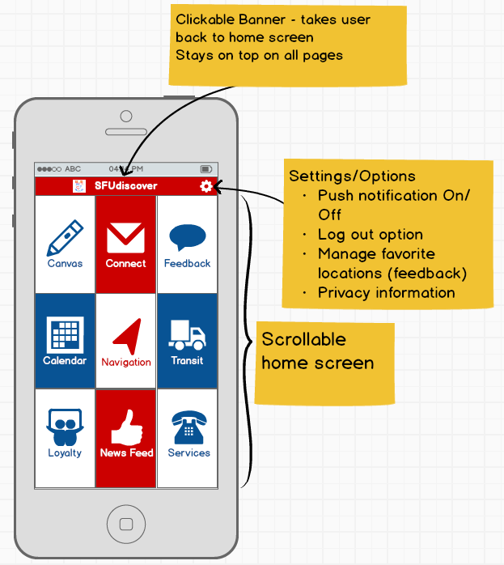
Figure 1: Home screen design and important functionalities

Navigation
One of the main features of the application is to assist users to easily navigate on campus. This function can be accomplished, as shown in Figure 2 through Figure 4:
- Tap on the "Navigation" button on Home screen.
- You will be presented the map view. Here you can search a location you wish by tapping the search bar.
- Once you tap on the search bar you will be presented with some default options. For this tutorial type in "ASB9838" manually to find this room.
- Once you have typed in your destination, hit "return" on the on screen keyboard.
- Your selected location will be shown in the blue box below the search bar. Tap on the search bar again to enter another location.
- Here, we will use one of the default options, select "My Location" option. The GPS will automatically determine your approximate location on the map and enter the location as your choice.
- Once you have entered 2 (or more) locations, you will be shown a menu to set your choices as way points. Since we used "My Location" as our latest choice, select "Start" in the menu to set this location as a starting point for your navigation.
- You will be shown the route on the map to your destination. Press "GO" to display turn by turn text instructions. Press "Stop" to cancel current navigation.
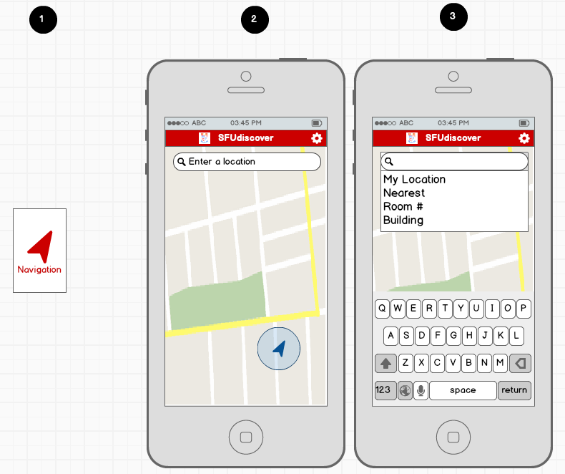
Figure 2: Screenshot of the first 3 steps for Navigation tutorial
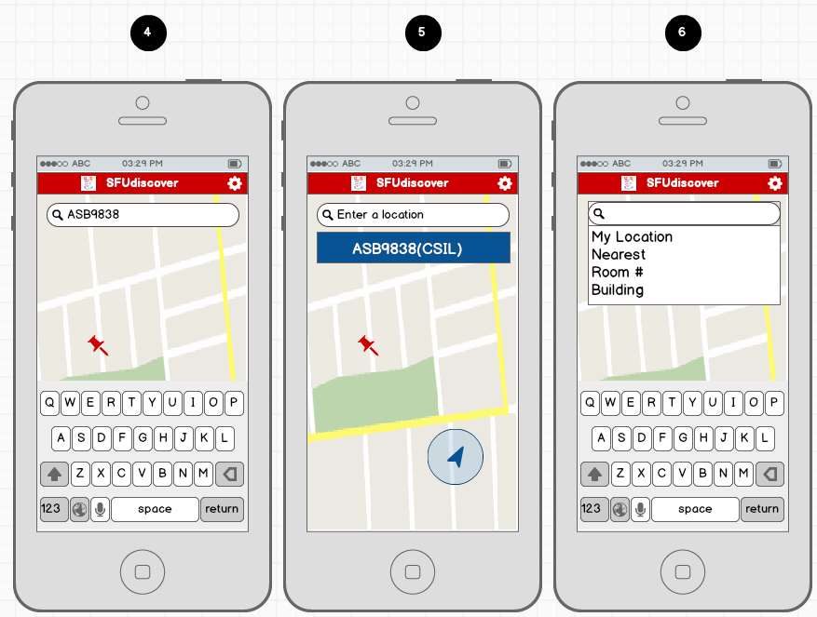
Figure 3: Screenshot of the next 3steps for Navigation tutorial
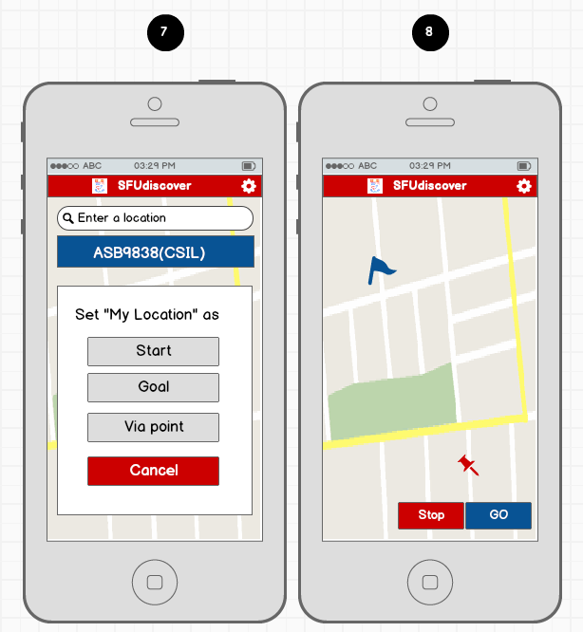
Figure 4: Screenshot of the last 2 steps for Navigation tutorial

Transit
A major function of the Transit feature is to display real-time estimation of the bus arrives. If this information is not available, the application shall display the bus schedules. To display approximate bus arrival times, the following steps, as shown in Figure 5 and Figure 6, need to be performed:
- Tap on the "Transit" button on your Home screen.
- At default you will be shown this screen. Tap on "Choose your location".
- A map view with bus stops will be shown. Choose a bus stop from the map, or enter the bus stop number in the search box.
- Confirm your choice by selecting "Yes", or "Cancel" if this is not the bus stop you wished and choose again in the previous screen.
- You will be brought back to Transit top page and your location will be set. You can see the upcoming buses with their approximate arriving time in the box below the location.
- If you would like to check the bus schedule, select "Look up bus schedule" button.
- You will be shown in a browser the bus schedule at your selected bus stop.
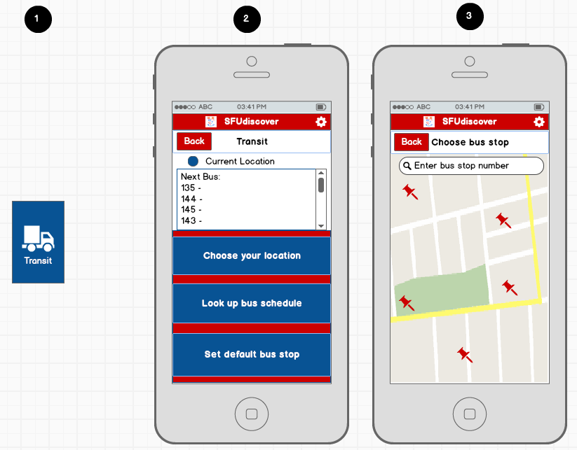
Figure 5: Screenshot of the first 3 steps for the Transit tutorial
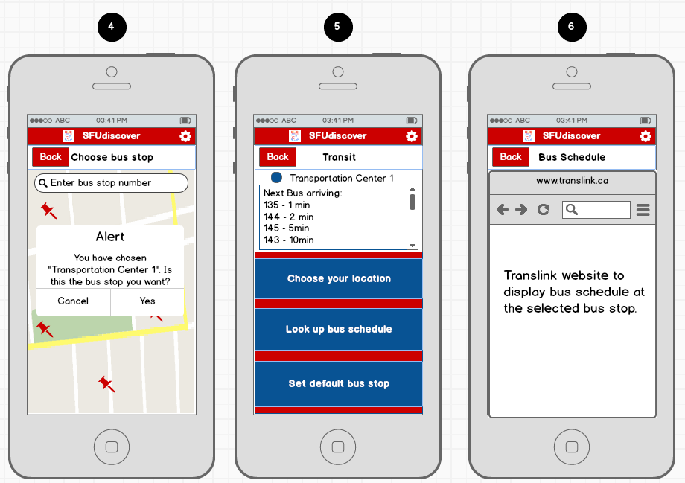
Figure 6: Screenshot of the last 3 steps for the Transit tutorial

Calendar
The major function of the Calendar feature is to download the user’s academic schedule from SFU’s Student Information System (SIS). This function can be accomplished in the following steps, as shown in Figure 7 and Figure 8:
- Tap on the "Calendar" button on your Home screen.
- If this is your first time using the app, you will be asked to enter your SFU computing ID and password. You have the option to save this information to skip this screen next time.
- You will be back at your Home screen after log in. Click on the "Calendar" button again.
- You will be shown your calendar view now. Press the blue arrow button near the top right to sync your SFU calendar.
- Your phone will now download and sync your SFU schedule.
- You will be taken back to the calendar view after sync. Now your calendar view will show your schedule in colors. The color may change depending on the types of event.
- Swipe left on calendar view to show your course details.
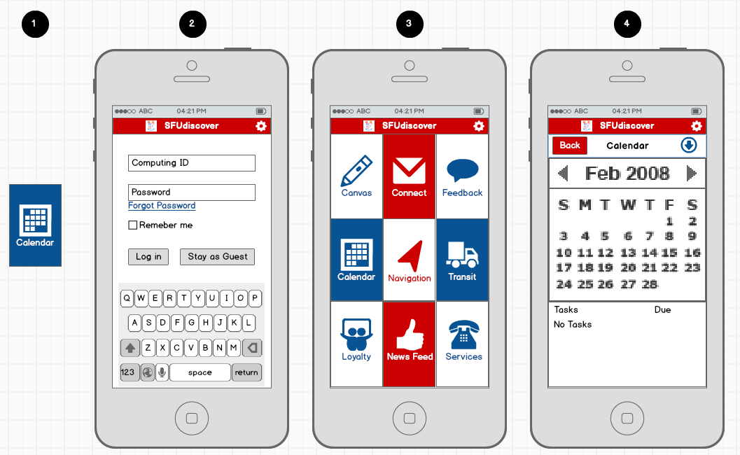
Figure 7: Screenshot of the first 4 steps for the Calendar tutorial

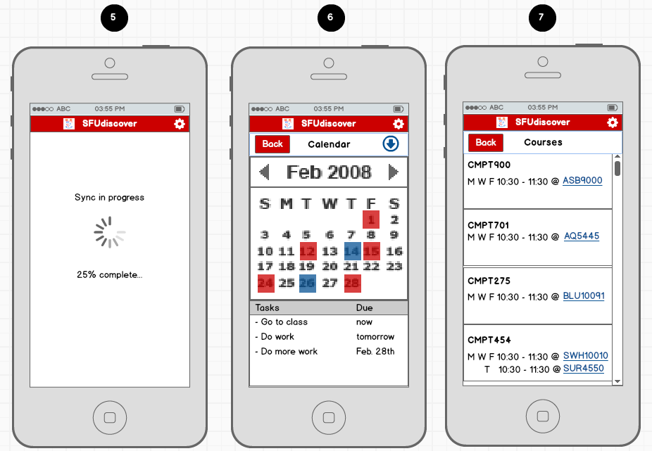
Figure 8: Screenshot of the last 3 steps for the Calendar tutorial

SFU Canvas and SFU Connect
For our intended audience, it is highly important to have quick access to SFU Canvas and SFU Connect. This function can be accomplished in the following steps, as shown in Figure 9:
- Tap on the "Canvas" or "Connect" button on Home screen depending on what you would like to access.
- If this is your first time using the app, you will be asked to enter your SFU computing ID and password. You have the option to save this information to skip this screen next time.
- You will be back at your Home screen after log in.
- Click on the "Canvas" or "Connect" button again.
- You will be taken to the corresponding website to access Canvas or SFU connect.

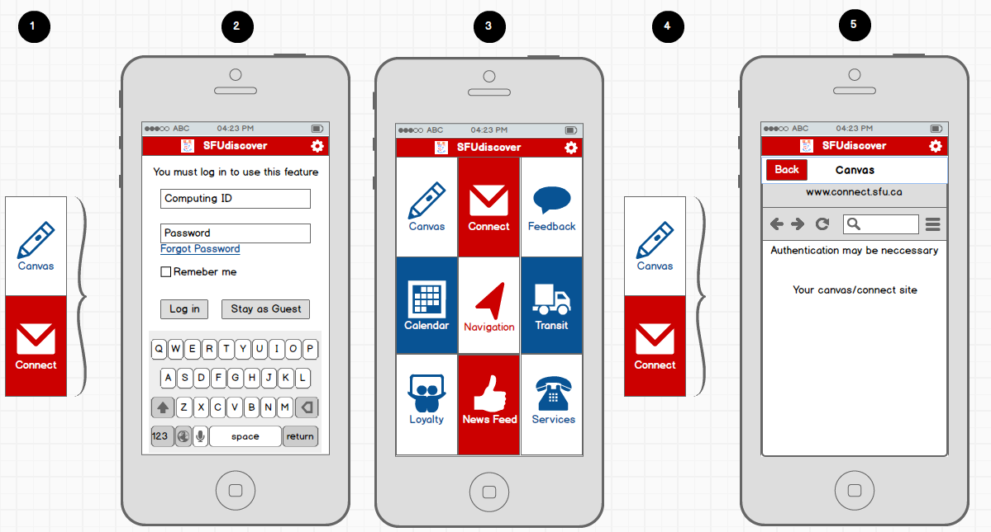
Figure 9: Screenshots for Canvas/Connect tutorial

Library Services
Our intended audience uses the campus library’s service of booking study rooms. This function can be performed in the following steps, as show in Figure 10 and Figure 11:
- Scroll up at the Home screen to reveal more buttons.
- Tap on the "Library" button.
- At the Library page, select "Book a Study Room".
- You will be shown a calendar view. Select a date on the calendar which you want to book a room.
- You will be shown availability of the rooms on that date. Tap on one of the white stars to book the room at the particular time.
- You will be asked to enter your information to confirm your bookings. After you are done entering information, select "Confirm Booking". *you may be asked to enter additional information when booking.

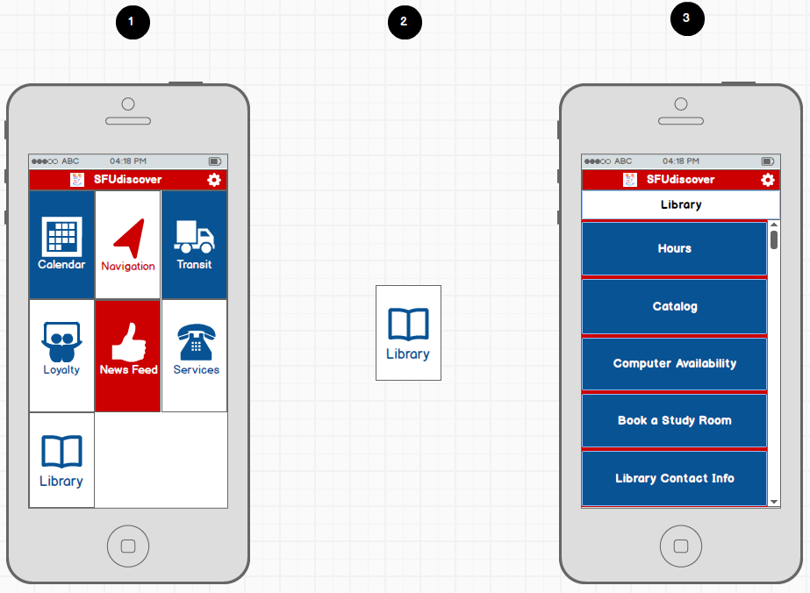
Figure 10: Screenshot of the first 3 steps for the Library service tutorial

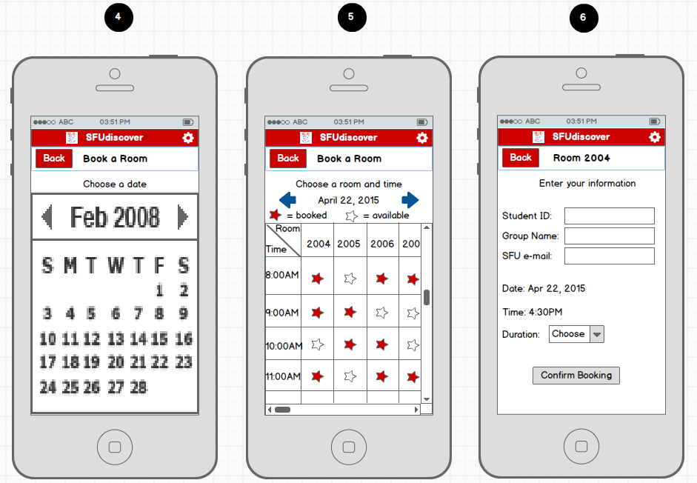
Figure 11: Screenshot of the last 3 steps for the Library service tutorial

Glossary
Word | Definition
Amenity | A resource that can provide convenience
AQ North | The northern part of the Academic Quadrangle
AQ South West | The south western part of the Academic Quadrangle
Arrival Details | The time and distance estimate as to how far you are from your destination/via point(s)
Bus Table | A schedule of all departure and arrival time from one terminal station to another within the period of one day
Calendar | Provides an overview of user’s academic and personal events
Computing ID | User’s unique ID for all SFU online access given at the time of enrolment
Convocation Mall | The undercover area of the Burnaby campus of Simon Fraser University between West Mall Center and the Academic Quadrangle
Course Schedule | A category of events related to a unique academic course
Directions | Instructions on how to get to a location
Emergency | Services in at Simon Fraser University that provide security and help in the case and anticipation of dangerous/serious situations
Emergency Screen | A notification that reminds the user of any urgent matters
Event | An activity that is planned for a specific date and time
Favorite Place | Location that an user can store in the program so that it can recall the location in the future
Gaglardi Intersection | The intersection that must be crossed by anyone going to Simon Fraser University. It is intersected by Gaglardi Way and University Drive East.
General Schedule | A category of events
Location | Point on the map that the user can navigate to
Location History | List of the most recent locations that the user has searched up
Login | Use the user information given to authorize access to server
Lost And Found | The location on campus where items lost are deposited and returned to the owners
Map | A diagram shows different features, and in our case, buildings and rooms, of SFU
News Feed | A complied list of updates from different sources
Password | The personal pin code for access User’s computing ID
Path | Route that connects the starting point and the destination together, as well as any via points along the way
Restaurant | A business on the SFU campus whose main purpose is to sell food that is cooked and served at their location
Safe Walk | The safe walk program is a safety initiative in which someone on the Simon Fraser University campus may ask to be escorted from one area on campus to another
Schedule | A category of events. There are 2 types of schedules: General Schedules and Course Schedules. See General Schedule and Course Schedule
SFU Bookstore | The bookstore at the SFU Burnaby campus that contains textbooks and merchandise for sale. It is located in the Maggie Benson center in the convocation mall.
SFU Library | The library at the SFU Burnaby campus that contains computers, books and many other resources. It is located between west mall center and the academic quadrangle in the convocation mall.
SFU-Registered Facebook Accounts | Official networking accounts [2]
Subscribe | To continue to receive news and updates
Sync With SIS | Function that extracts the user’s academic schedule from SFU’s student information system (SIS) and copies the schedule into Calendar
Traffic | The current state of vehicles moving on the road
Transit | Public transportation system which include bus, SkyTrain, and SeaBus
Transportation Method | A means of getting from one place to another
University Drive North | The road between west mall centre and the convocation mall in the Simon Fraser University Burnaby campus. All buses must go through university drive north and typically drop passengers off at this area before heading to the upper bus loop.
Unsubscribe | To discontinue to receive news and updates
Via Point | A location on the map that in between the starting point and the destination
Zone Liaisons | Zone Liaisons provide guidance on crime prevention tips, personal security pointers, the Safe Walk, and Lone Worker initiatives, and issues regarding the physical security of your work area. [3]

References

[1] | H. H. Tsang, Requirements Engineering, 2015.
[2] | Simon Fraser University, "SFU Social Media Channels," [Online]. Available: http://www.sfu.ca/dashboard/media/social-media-channels.html . [Accessed 13 February 2015].
[3] | Simon Fraser University, "Simon Fraser University," [Online]. Available: http://www.sfu.ca/srs/security/patrol-operations/programs/zone-liaison.html. [Accessed 2 February 2015].

