GUI Manual Test
Step 1: Run the Controller class, and you'll be prompted for Player 1's name and Player 2's name.
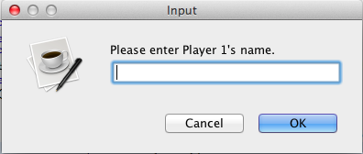
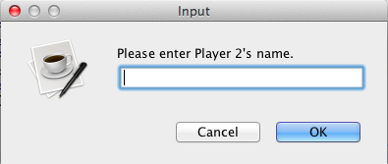

Step 2: After entering both player's names, this window should pop up. Note that if you press cancel for any of the name prompts, it will default to Player 1 and Player 2 respectively.
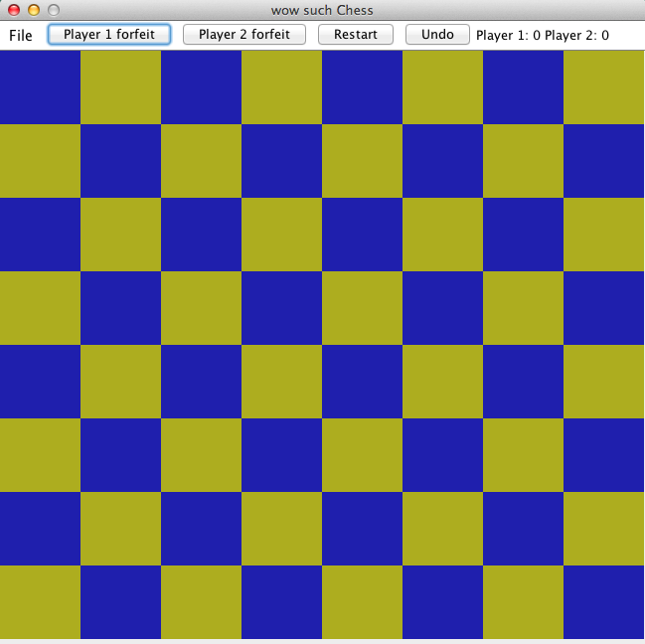
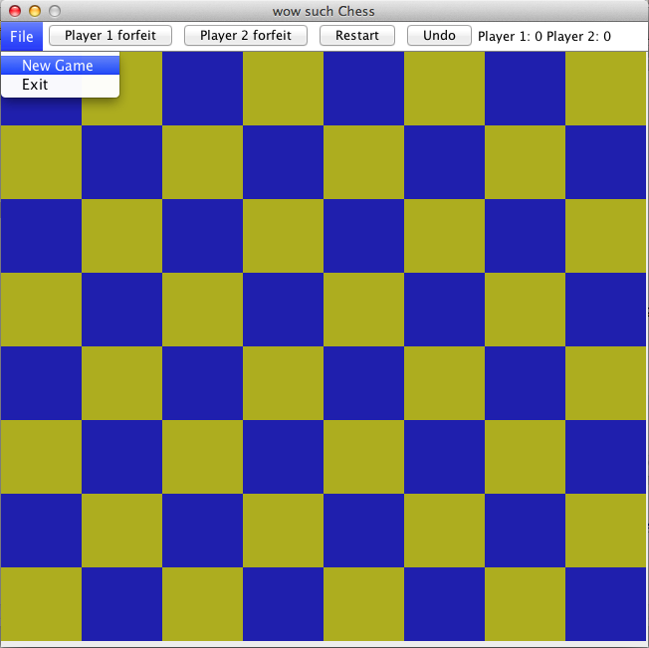
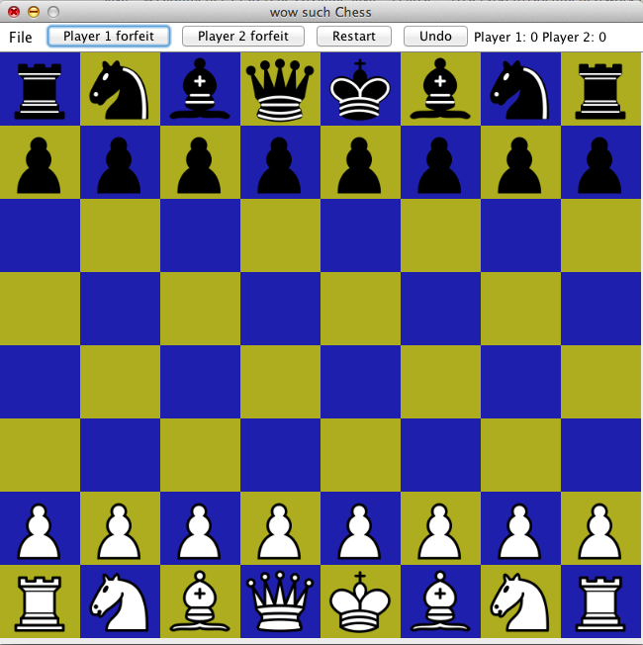
Step 3: Click File->New Game to start a new Game. The board should now be populated with pieces.

Step 5: Click on a piece to select that piece, then click on a valid square to move that piece to that spot.
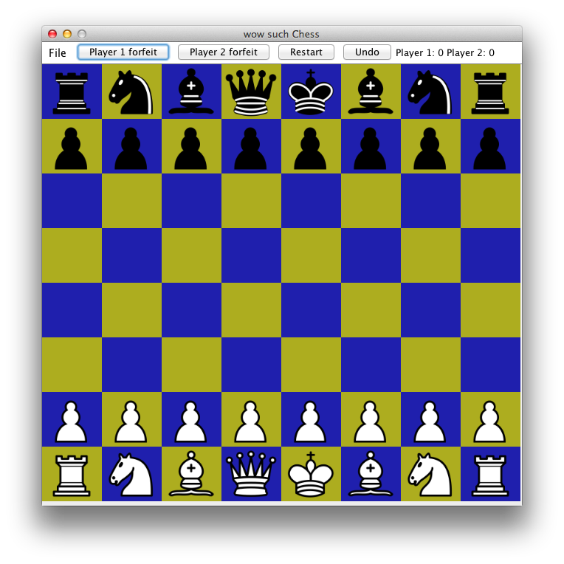
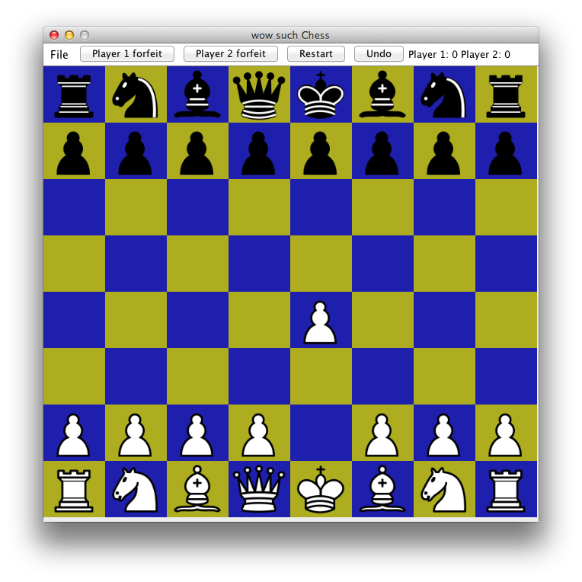
Step 6: Try moving a piece to an invalid location. You should be unable to move the piece to that location, and a yellow border should appear around the window as a warning.
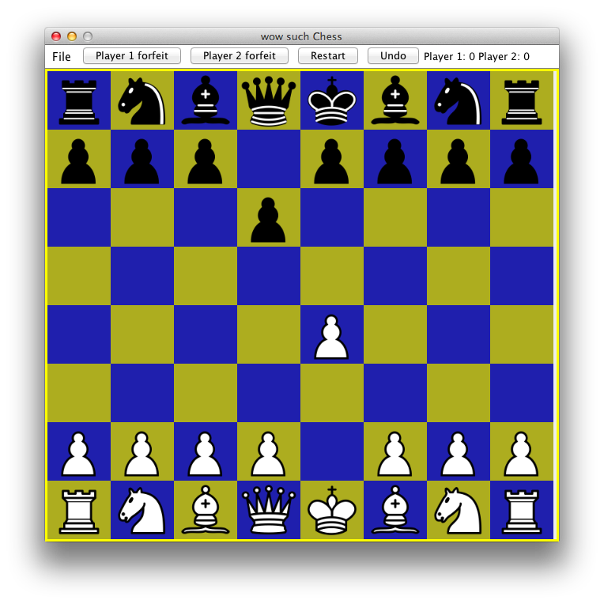

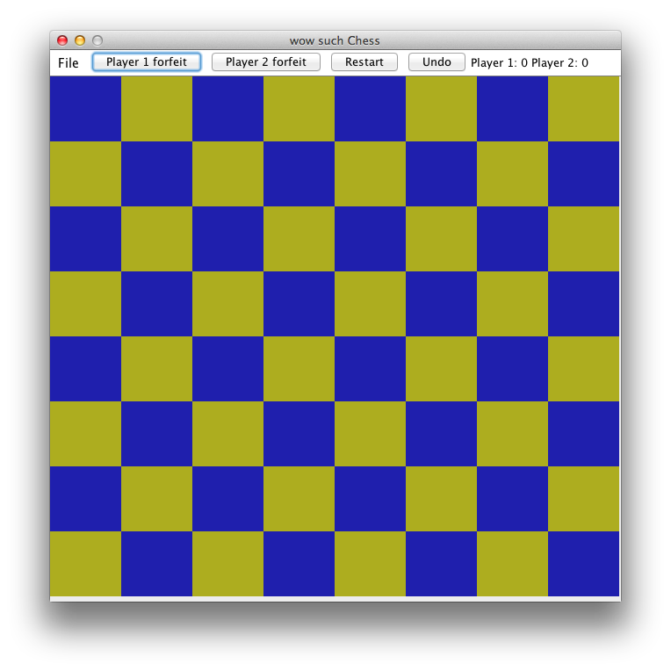
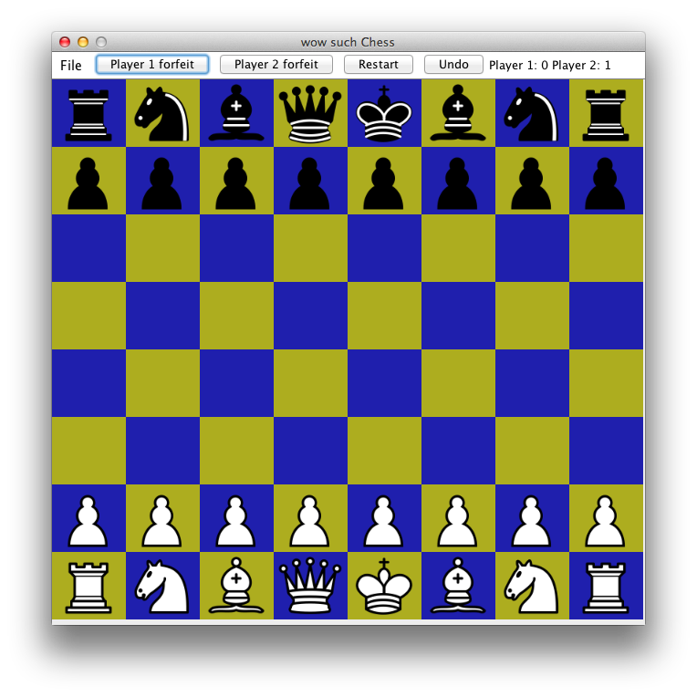
Step 7: When you click on “Player 1 Forfeit”, the game should reset, and Player 2's score should increment by 1.
Step 8: This is also true for “Player 2 Forfeit”.
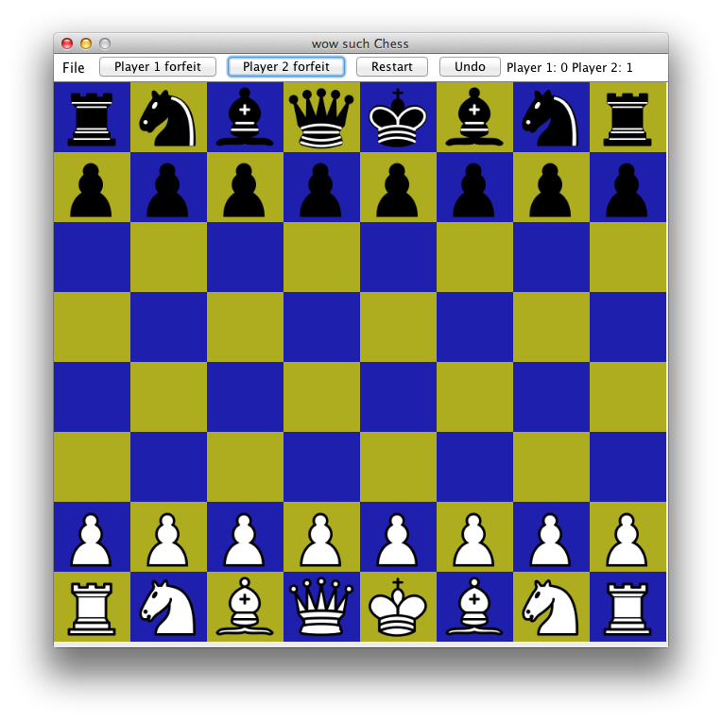
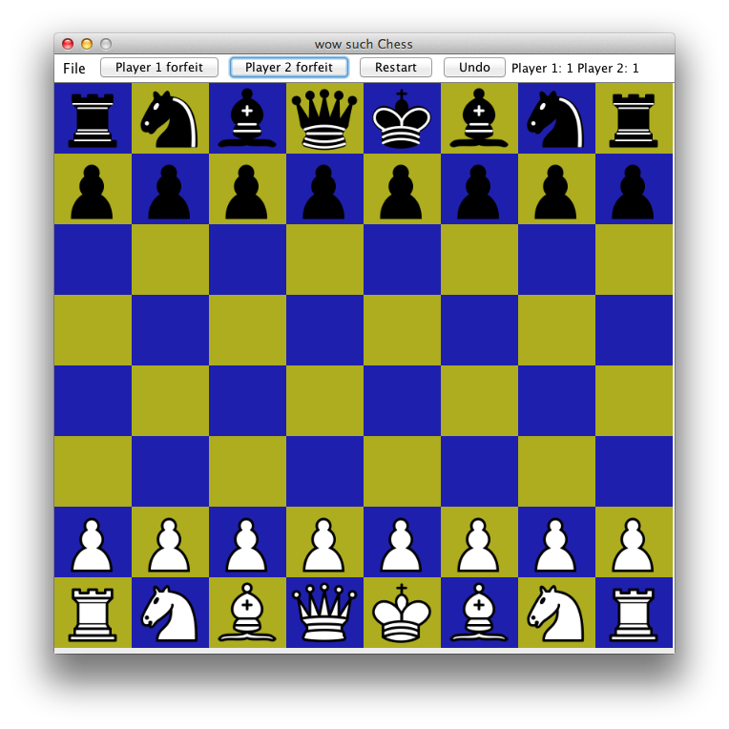

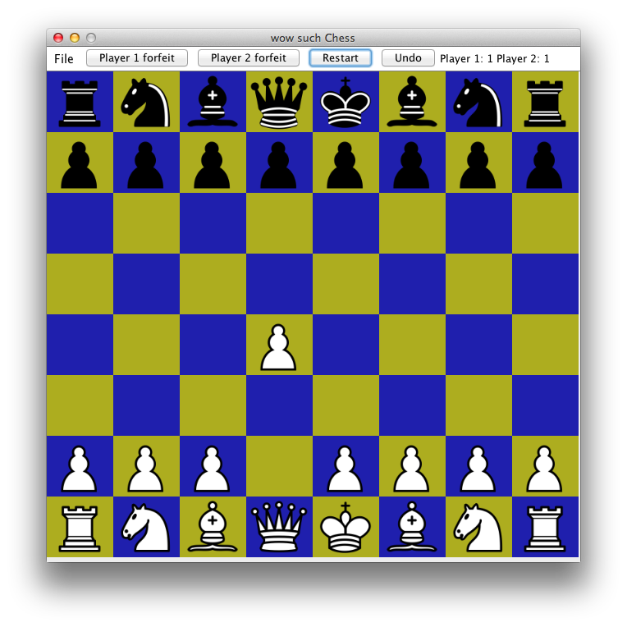
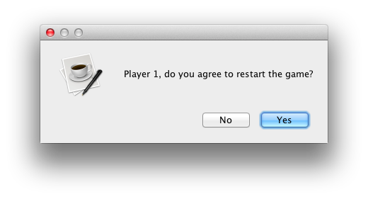
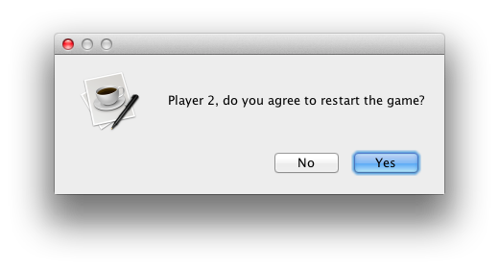
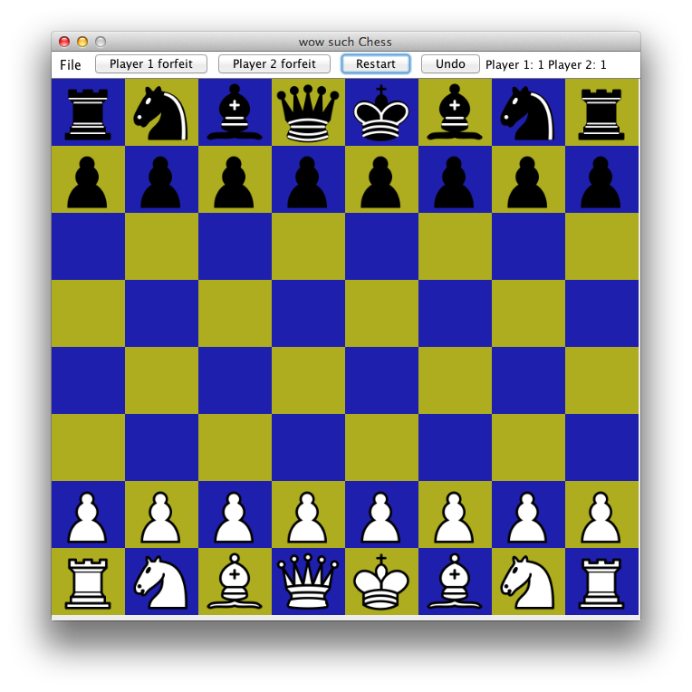
Step 9: When you click “Restart”, both players will be asked if they want to restart. If they both say “yes”, then the game should reset with no points added to either player.

Step 10: After moving a piece, clicking “Undo” will undo the move and move the piece back to its previous position.
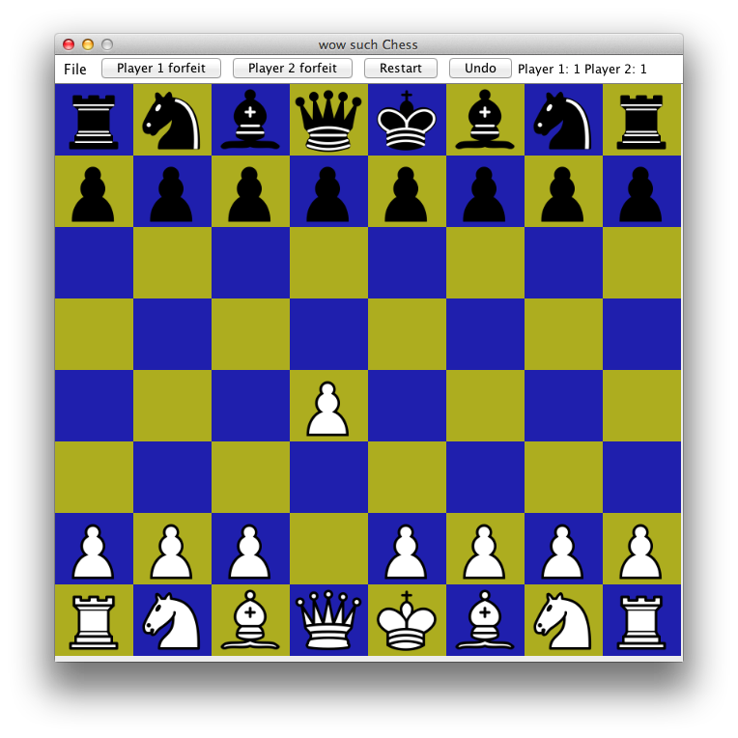
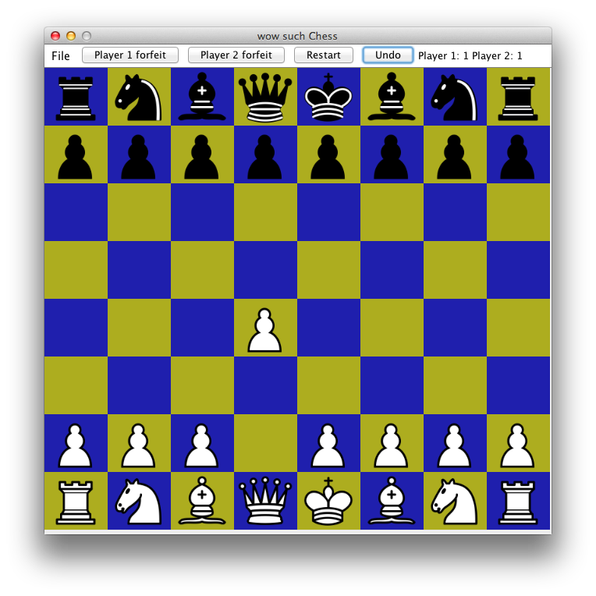
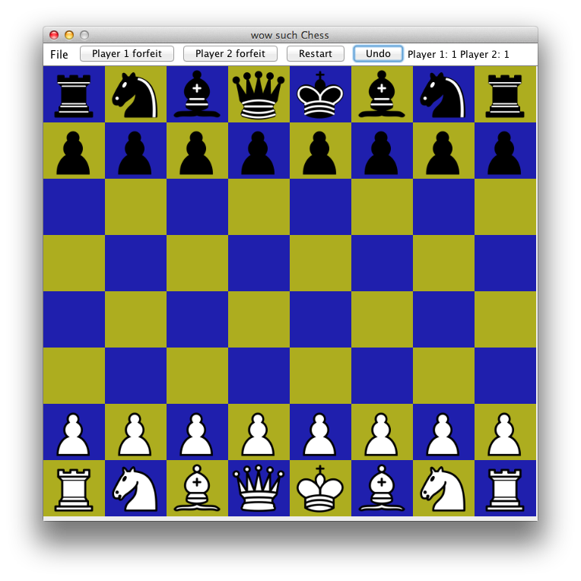

Step 10: Go to File->Exit, and the game window will close. Clicking the x on the top left corner works too.
