Assignment02: Arm Inverse Kinematics

Guided by Professor Rachel McDonell

Implemented by: Yuzhou Shao

Student id: 19322035

Youtube Demo: <https://youtu.be/qUMkEFlkiPc>

Mainly thank Professor Rachel McDonell who provides us this opportunity to study and guided us patiently. Also thank my peer, Mr. Shijun Zhang, who selflessly helped me debugging the code related to Complex inverse kinematics algorithms.

I know I submitted late, but I have never given up the struggling of fighting to the bugs. I have tried my best and daily working for 15 hours to study and implement each required functions and specifications which I could. I appreciate your patiently reviewing in advance.

Create an arm and torso, where the arm should be constructed from a lower and upper arm, and attached to the torso.

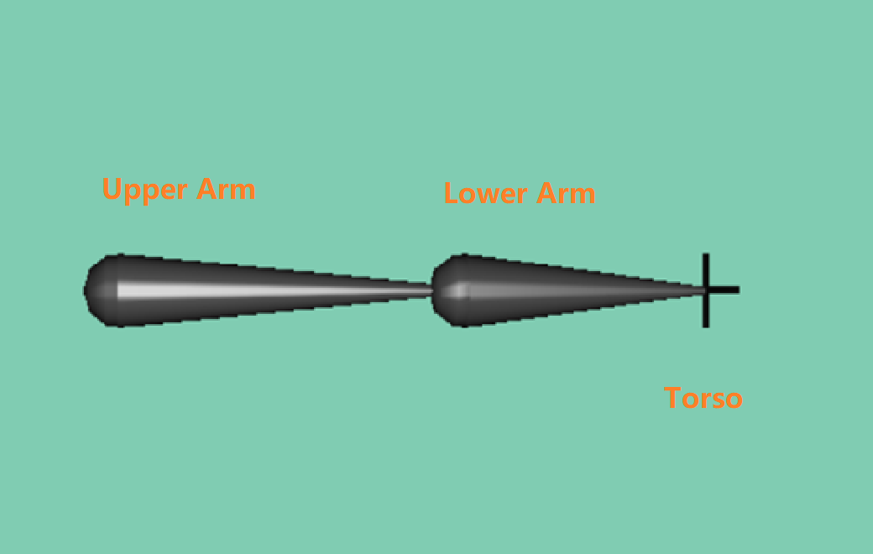

I have work out appropriate orientations for the lower and upper arm, given the desired position of the end effector.

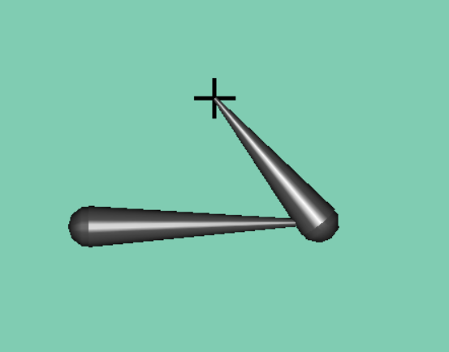

Reaching the desired position by adjusting the length of the first arm.

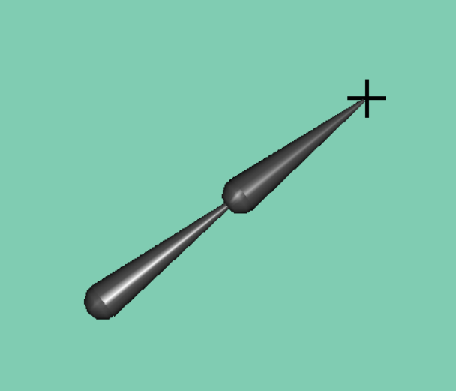 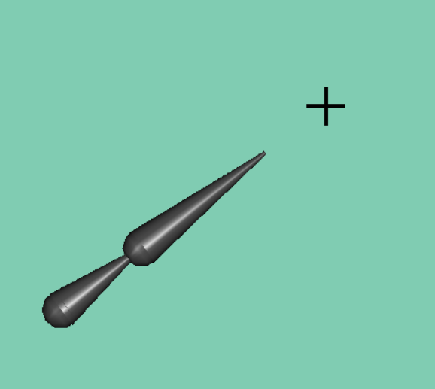

Reaching the desired position by adjusting the length of the second arm.

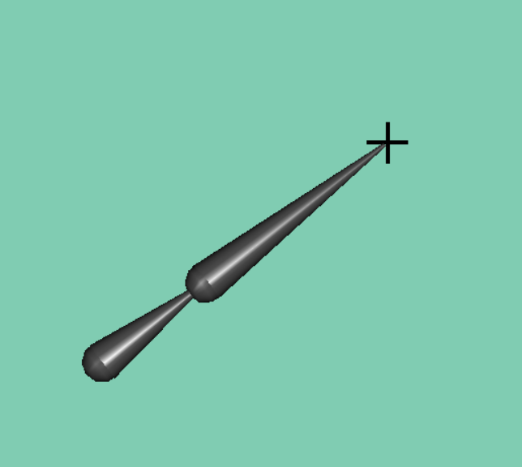 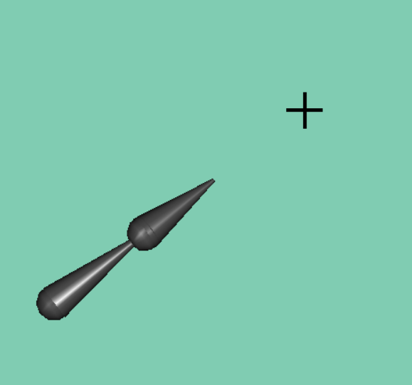

Reaching the desired position by rotating up and down

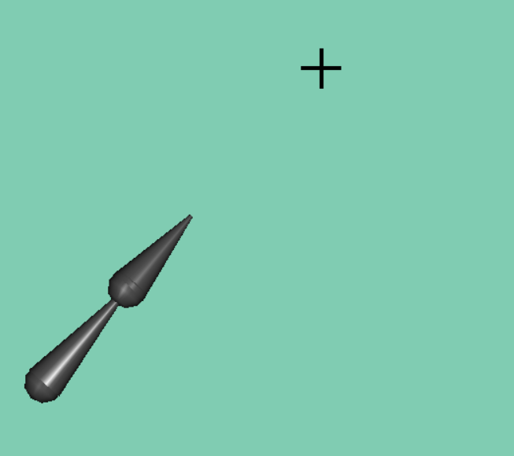 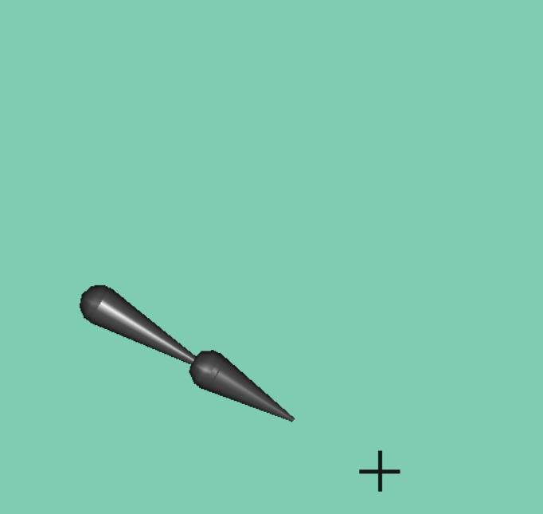

Reaching the desired position by moving left and right.

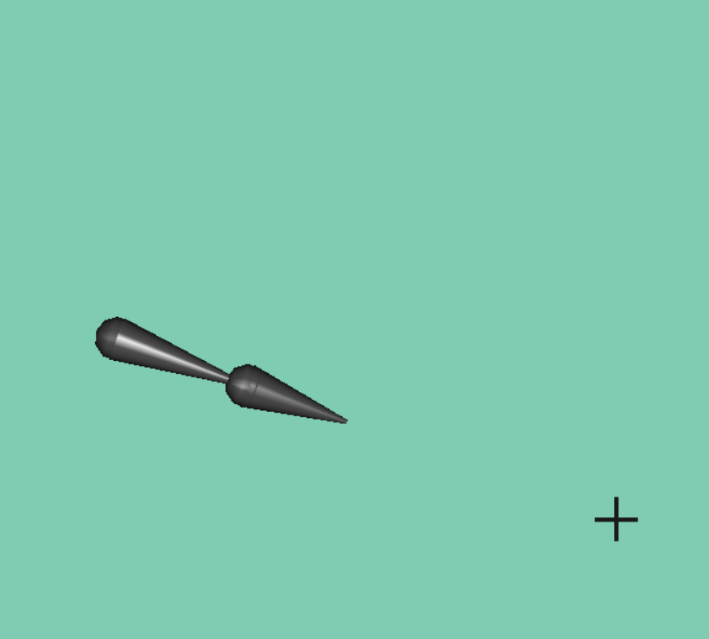 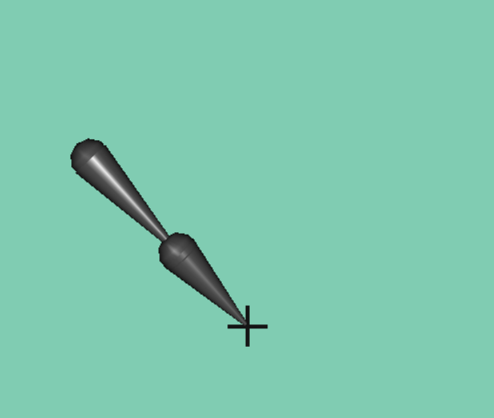

Show the alternative Inverse Kinematics approach.

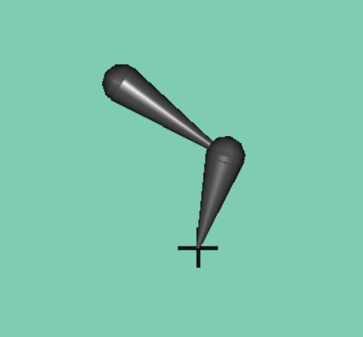 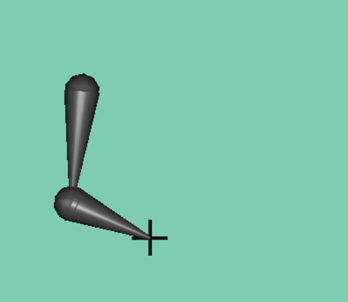

Shifting between polygon and wireframe appearances.

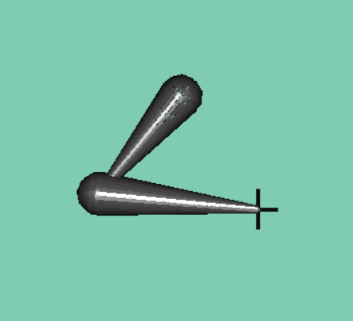 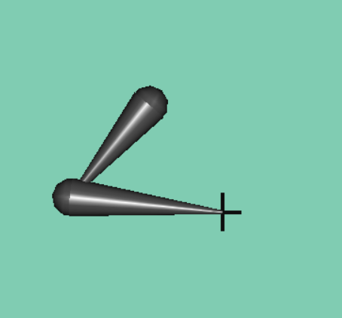

Added Constraints for reality movement.

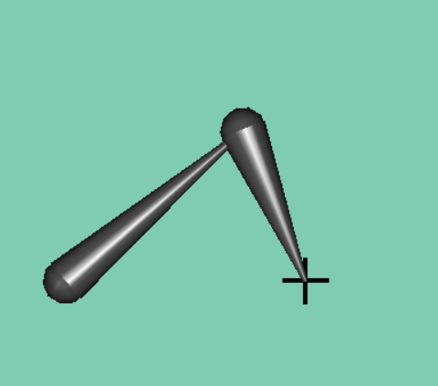 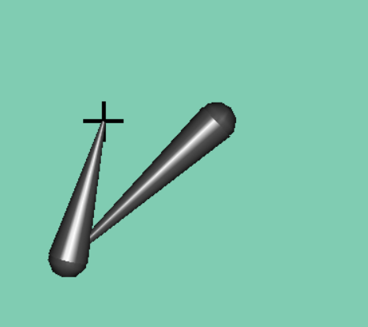

I have also extended to more complex chains, other approaches like CCD.

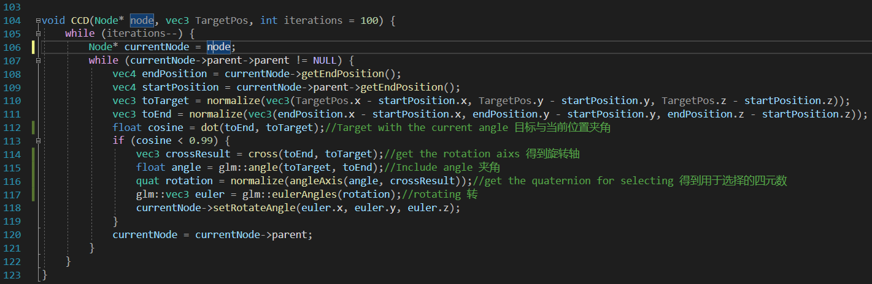

References:

IK Demo by Dr. Ludovic Hoyet

Inverse Kinematics with OpenGL/Eigen3 : unstable Jacobian pseudoinverse <https://stackoverflow.com/questions/10115354/inverse-kinematics-with-opengl-eigen3-unstable-jacobian-pseudoinverse>

Game Creation with XNA/Mathematics Physics/Inverse Kinematics <https://en.wikibooks.org/wiki/Game_Creation_with_XNA/Mathematics_Physics/Inverse_Kinematics#Jacobian_transpose_method>

Cyclic Coordinate Descent in 2D <https://www.ryanjuckett.com/cyclic-coordinate-descent-in-2d/>

Mathematics for Inverse Kinematics <http://graphics.cs.cmu.edu/nsp/course/15-464/Fall09/handouts/IK.pdf>

傅老师游戏大师课(Mr. Fu's OpenGL tutorial, this is really helpful for Chinese Speakers.) <https://www.youtube.com/channel/UCPpDrebzulufI3G1TTeNu-g>

OpenGL + C++: Modern Graphics for Groundbreaking Games | Udemy <https://www.udemy.com/course/graphics-with-modern-opengl/>