Deep Learning for Computer Vision (2021 Fall) HW1
R10942152 Ken Yu(游家權)
Problem 1 : Image Classification
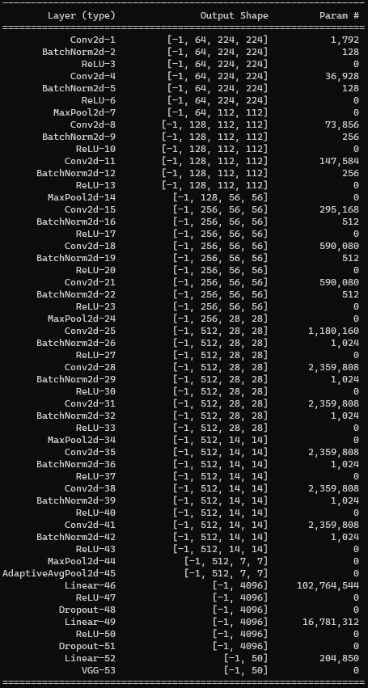
1. (2%) Print the network architecture of your model.

2. (2%) Report accuracy of model on the validation set. (TA will reproduce your results, error ±0.5%)
Ans: Accuracy on validation set is 0.8356
3. (6%) Visualize the classification result on validation set by implementing t-SNE on output features of the second last layer. Briefly explain your result of the tSNE visualization.
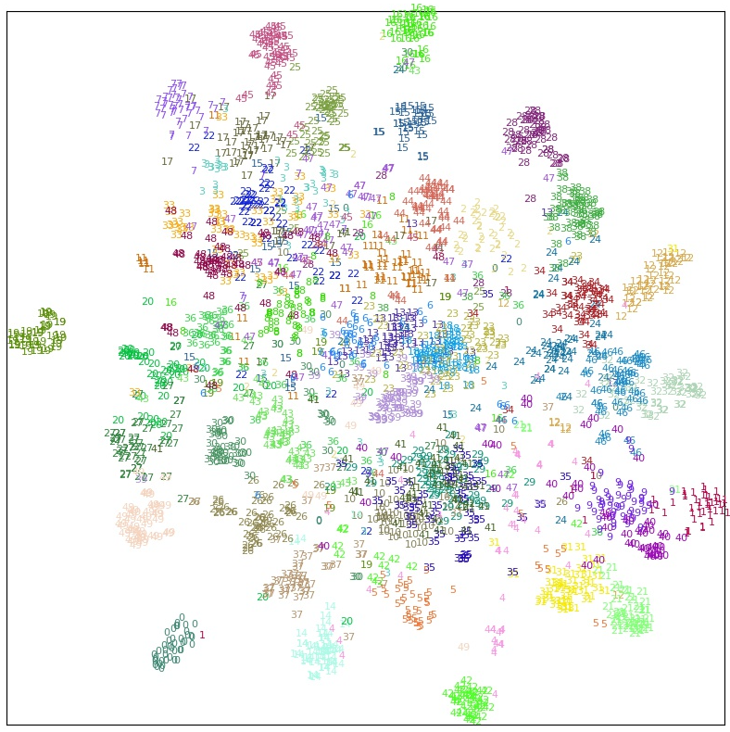
Ans: We can tell from tSNE plot that some classes are far from others, while some overlap with other classes. If the class is far from others, it means it has some distinct feature that make it easier to classify. If the class is overlapped with others, it means their features can easily confuse detector, hence harder to classify.
For instance, class 0 is bicycle which has lots of features to recognize, making it stay far from other classes on tSNE plot. On the other hand, class 29 and class 35 are adult and child; due to the similarity of these features, these two classes are almost inseparable on tSNE plot.

Problem 2: Segmentation
1. (5%) Print the network architecture of your VGG16-FCN32s model.
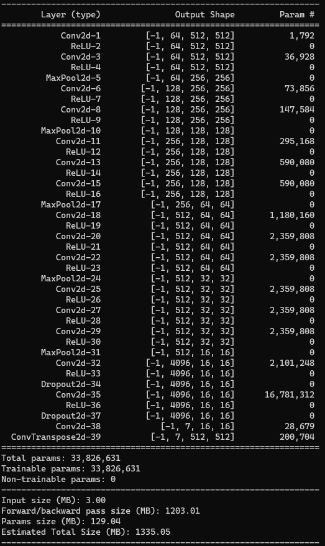
2. (5%) Implement an improved model which performs better than your baseline model. Print the network architecture of this model.
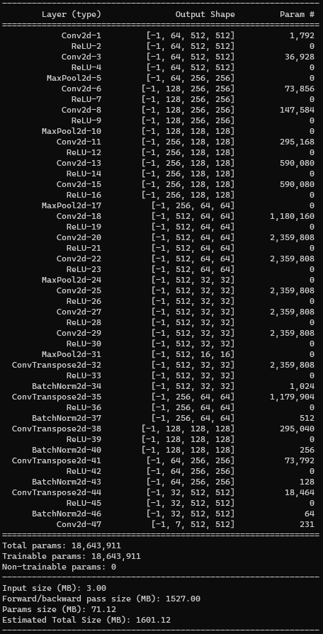

3. (5%) Report mIoU of the improved model on the validation set. (TA will reproduce your results, error ±0.5%)
Ans: My improved model is FCN8s, which produce 0.7247 mean_iou on validation dataset. By the way, my baseline model only produce 0.68 mean_iou in the same experiment.

4. (5%) Show the predicted segmentation mask of “validation/0010_sat.jpg”, “validation/0097_sat.jpg”, “validation/0107_sat.jpg” during the early, middle, and the final stage during the training process of this improved model
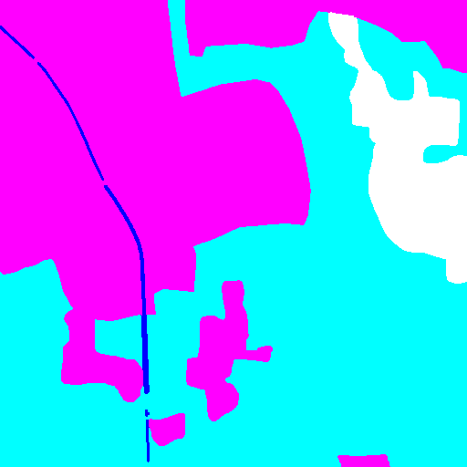  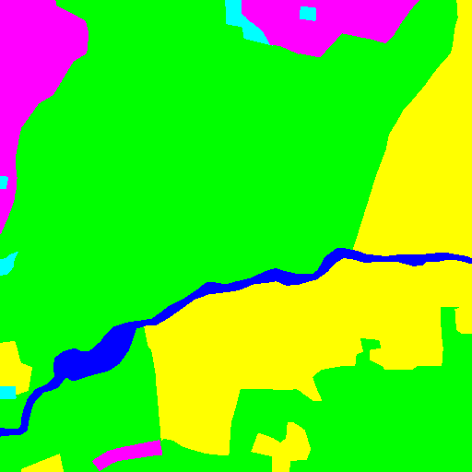  Early Stage  (5 epoch) | Middle Stage  (20 epoch) | Final Stage  (40 epoch) | Label
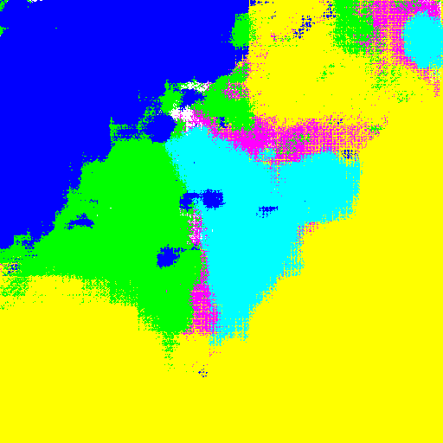 | 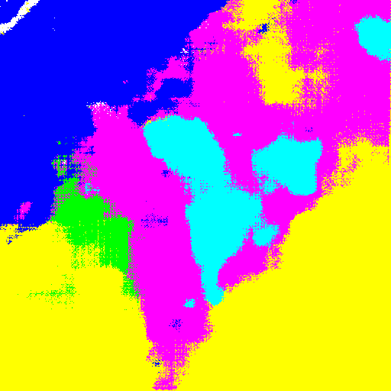 | 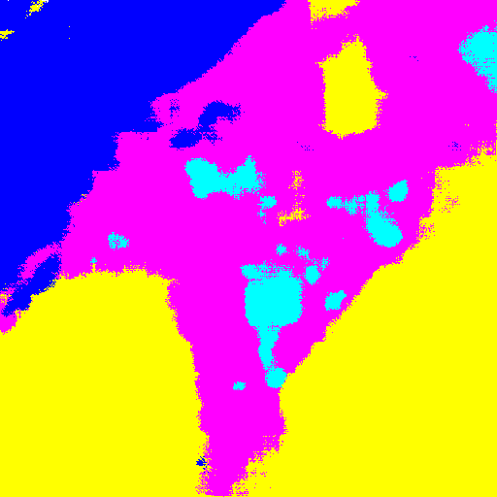 | 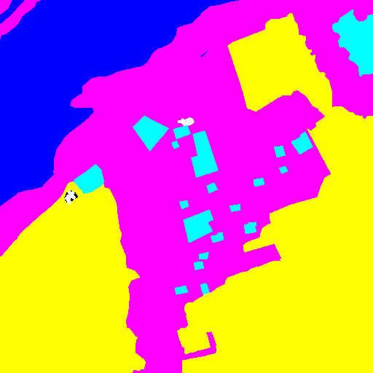
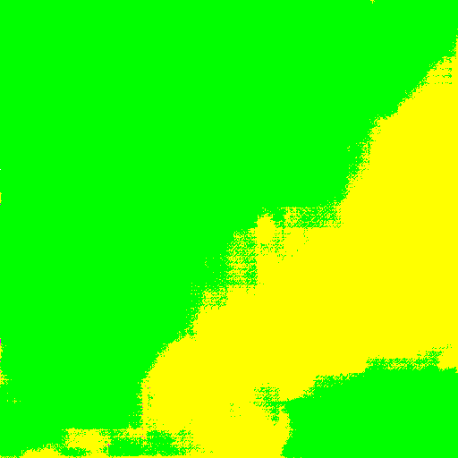 | 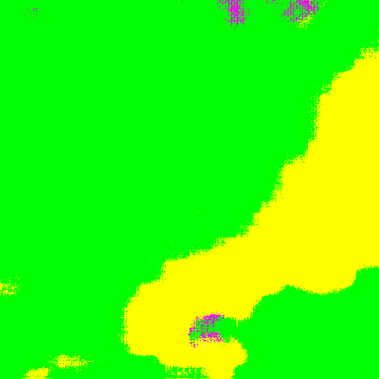 | 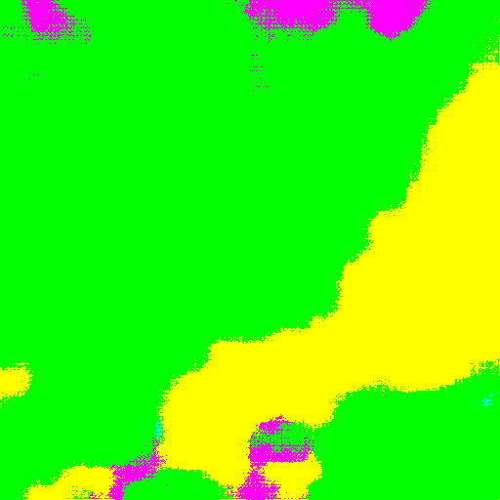
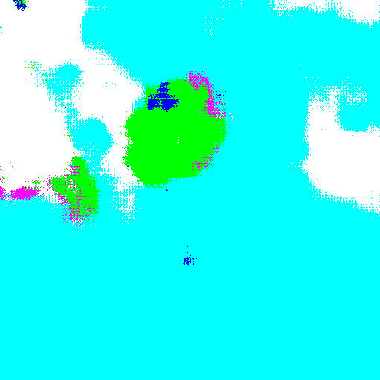 |  | 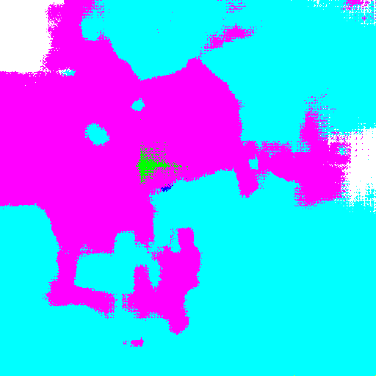

Reference
[1] How to get intermediate layer’s output.
https://discuss.pytorch.org/t/how-can-l-load-my-best-model-as-a-feature-extractor-evaluator/17254/6
[2] FNC8s
https://zhuanlan.zhihu.com/p/73965733
[3] Adam Optimizer
https://zhuanlan.zhihu.com/p/32626442
[4] UNet
https://github.com/milesial/Pytorch-UNet

