Signal-Adaptive Retrieval for Domain QA: Design, Deployment, and Evaluation
— Traditional Chinese Bible QA as an Example
Ko-Han Chung, Yoke-Hou Tan*
Intelligent Computing and Big Data, Chung Yuan Christian University, Taoyuan City, Taiwan
Abstract
Domain-specific question answering with large language models (LLMs) incurs high API costs and raises data-privacy concerns. We design, deploy, and evaluate signal-adaptive retrieval system architecture for Traditional Chinese Bible QA, integrating PostgreSQL, Qdrant, and Neo4j with a 6-route signal-adaptive retrieval system that selects optimal engine combinations based on query signal features. On a 100-question benchmark spanning five question types, a locally-deployed Gemma 3 4B model achieves comparable performance to Claude Haiku 4.5, with 6 of 7 generation metrics differing by less than 4 percentage points and neither model dominating overall. Claude leads on faithfulness (0.887 vs. 0.849) while Gemma leads on answer relevancy (0.658 vs. 0.592). These results show that a well-designed retrieval could reduce the impact of model scale, enabling cost-free, privacy-preserving deployment with competitive quality.

I. Introduction
While large language models (LLMs) demonstrate impressive performance on general question answering, their deployment for domain-specific tasks faces two critical challenges: (1) commercial API costs that scale linearly with query volume, creating barriers for resource-constrained organizations, and (2) limited coverage of specialized domain knowledge during pre-training, resulting in factual gaps that persist across model sizes. This raises a fundamental research question: can a well-designed retrieval pipeline decouple answer quality from model scale?
We investigate this question in the context of Traditional Chinese biblical question answering—a domain where factual accuracy and theological faithfulness are paramount. Recent evaluations show that even state-of-the-art LLMs score poorly on faith-related dimension [1], highlighting the Christian community's legitimate concerns about whether LLM can provide answers grounded in Scripture rather than hallucinated content.
Retrieval-Augmented Generation (RAG) [2] supplements LLM generation with retrieved evidence, reducing hallucination and enabling domain adaptation without fine-tuning. Knowledge graph-enhanced RAG [3] further captures entity relationships, offering complementary signals to dense passage retrieval [4] and lexical methods [5]. Recent surveys [6] catalogue diverse RAG architectures, yet most evaluations compare retrieval strategies under a single model. A critical gap remains: when the retrieval component is held constant, how much does model scale affect answer quality?
Our contributions are threefold:
1) A signal-driven 6-route Graph RAG architecture integrating PostgreSQL, Qdrant, and Neo4j, where a decision-tree router selects optimal engine combinations based on six query signal features.
2) Empirical evidence shows that Gemma 3 4B [7] (locally deployed, zero API cost) achieves comparable performance to Claude Haiku 4.5 [8], with complementary strengths across generation metrics.
3) A 19-metric evaluation framework spanning retrieval, semantic similarity to ground truth, and LLM-judged-generation dimensions [9] over 100 curated questions in 5 types.
II. System Architecture
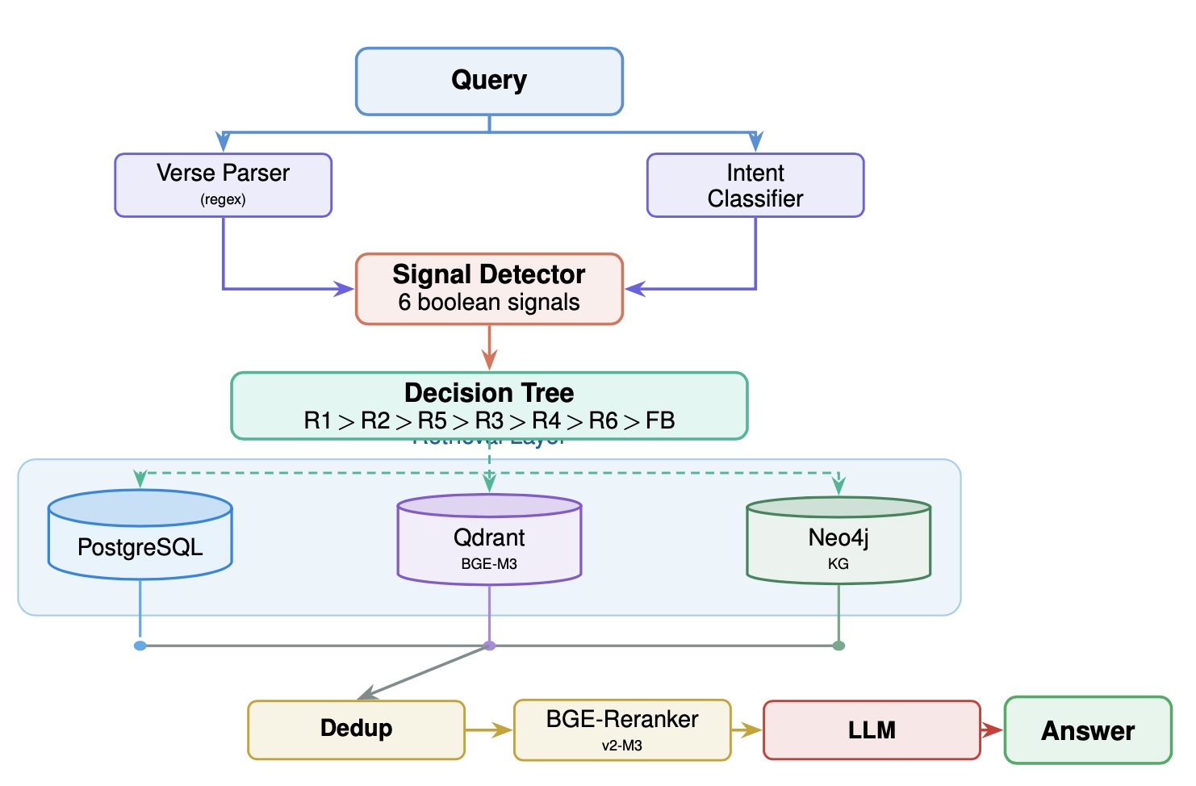
Fig. 1. Signal-driven 6-route RAG pipeline.
A. Data Processing Pipeline
The 66 books of the Traditional Chinese Bible are processed through hierarchical chunking: Book (66) → Chapter (1,189) → Pericope (2,779) → Chunk (438), with token-aware splitting (512–1024 tokens) respecting verse boundaries. CKIP Transformers [10] perform Chinese NER with LLM validation, extracting 14,845 entities across 6 types (Person, Place, Event, Theme, Object, Group) linked to text via 49,668 MENTIONS edges. BGE-M3 [11] generates 1024-dim embeddings for 3,041 vectors stored in Qdrant.
B. Triple-Database Architecture
PostgreSQL stores structured verse/chapter/book data (100,222 records) for exact lookup. Qdrant provides dense vector search via cosine similarity over 3,041 embedding points. Neo4j maintains a knowledge graph with 19,317 nodes and 58,031 relationships across 5 edge types: MENTIONS (49,668), CONTAINS (4,406), NEXT (2,980), CROSS_REFERENCES (912), and NEXT_BOOK (65).
C. Signal-Adaptive 6-Route Retrieval
Each query first undergoes verse reference parsing (regex) and LLM intent classification to extract entity names and keywords. A signal detector then analyzes the query for six boolean features: (1) book+chapter:verse reference, (2) book+chapter-only reference, (3) ≥2 book names, (4) ≥2 person entities, (5) event keyword, and (6) place name—detected via regex patterns and dictionary substring matching against person, place, and event entity lists derived from the knowledge graph.
A priority-ordered decision tree (Table I) selects among six routes, each combining a specific subset of four engines—SQL (PostgreSQL), Semantic (Qdrant), Graph (Neo4j entity traversal), and Cross-Reference (Neo4j CROSS_REFERENCES) — with configurable weights. R1 handles exact verse lookups via SQL direct match, bypassing reranking. R2 adds semantic search to chapter-filtered SQL results. R3–R6 leverage Neo4j graph traversal for person, event, cross-reference, and place queries respectively, combined with semantic search and SQL supplements. After retrieval, results undergo ID-based deduplication (highest-weight retention) and BGE-Reranker-v2-M3 [11] reranking.
TABLE I
Signal-Driven Route Overview
Route | Signal Trigger | Engines (weights)
R1 | book+chapter:verse | SQL (1.0)
R2 | book+chapter | SQL(.9)+Sem(.6)
R3 | ≥2 persons | Grp(.9)+Sem(.7)+SQL(.5)
R4 | event keyword | XRef(.85)∥Grp(.75)+Sem(.65)+SQL(.4)
R5 | ≥2 books | Grp(.85)+Sem(.7)+SQL(.5)
R6 | place name | Grp(.85)+Sem(.7)+SQL(.5)
FB | (else) | Sem (1.0)
D. Pluggable LLM Generation
A factory pattern supports multiple providers (Claude, Gemini, OpenAI, Ollama). An identical evidence-first system prompt enforces strict citation. Note that the LLM also performs intent classification (1st step in Fig.1), so switching models can introduce minor routing differences for complex query types—a design trade-off we analyze in Section IV.
III. Experiments
Setup: We evaluate on 100 Traditional Chinese questions (20 per category) with ground truth approved by annotators with biblical expertise: VERSE_LOOKUP (explicit references), TOPIC (thematic concepts), PERSON (biblical figures), EVENT (narratives), and GENERAL (open-ended synthesis). This taxonomy systematically tests exact matching, semantic search, entity retrieval, and knowledge integration capabilities.
We compare Claude Haiku 4.5 (commercial API) [8] against Gemma 3 4B (local Ollama) [7] sharing the same retrieval codebase (temperature=0.1, top_k=5). We employ metrics in 3 categories: retrieval, generation (LLM-judged via RAGAS [9]) and RAGAS semantic similarity to ground truth.
TABLE II
Overall Performance Comparison (Selected Metrics)
Category | Metric | Claude | Gemma | Δ
Retrieval | Hit Rate | 0.790 | 0.820 | +0.030
 | Recall@5 | 0.746 | 0.761 | +0.015
 | MRR | 0.753 | 0.782 | +0.029
Generation | Faithfulness | 0.887 | 0.849 | −0.039
 | Relevancy | 0.592 | 0.658 | +0.066
 | Context Recall | 0.678 | 0.712 | +0.034
Semantic | Similarity | 0.738 | 0.729 | −0.009
TABLE III
Answer Correctness by Question Type (RAGAS)
Type | Claude | Gemma | Δ
VERSE | 0.841 | 0.886 | +0.044
TOPIC | 0.657 | 0.622 | −0.036
PERSON | 0.440 | 0.418 | −0.022
EVENT | 0.457 | 0.440 | −0.017
GENERAL | 0.416 | 0.370 | −0.047
IV. Results and Discussion
Finding 1: Complementary Model Strengths
Table II shows that 6 of 7 metrics differ by less than 4 percentage points (pp). Relevancy differs by 6.6pp. The models exhibit complementary strengths: Claude achieves higher faithfulness (0.887 vs. 0.849), indicating stricter citation behavior, while Gemma leads on answer relevancy (0.658 vs. 0.592), suggesting more comprehensive responses. Retrieval metrics are identical for signal-deterministic routes (R1, R2) but diverge slightly for R3–R5, where LLM-dependent intent classification affects entity extraction and thus graph traversal inputs. This confirms that when high-quality context is provided, model differences manifest as generation style rather than fundamental quality gaps.
Finding 2: Question Type Analysis
Table III reveals clear route-dependent patterns. VERSE scores highest (0.841/0.886) because SQL direct match provides exact evidence; GENERAL scores lowest (0.416/0.370) as the cross-reference path—the most complex 4-engine route—faces sparser CROSS_REFERENCES edges (912 total). EVENT also challenges both models (0.457/0.440) since multi-chapter narratives strain fixed-window chunking. Claude leads on TOPIC and GENERAL; Gemma leads on VERSE, indicating complementary biases tied to route complexity.
Finding 3: Cost-Quality Tradeoff
Gemma 3 4B runs locally via Ollama with zero API cost and full data privacy—critical for sensitive corpora. Despite moderate per-metric gaps, neither model dominates overall, making the local option viable. The key investment shifts from model selection to retrieval infrastructure: the signal-adaptive router ensures each query type receives an optimized engine combination rather than a one-size-fits-all strategy.
V. Conclusion
We designed, deployed, and evaluated a signal-driven Graph RAG architecture for Traditional Chinese Bible QA, featuring a 6-route decision tree router that selects optimal engine combinations from PostgreSQL, Qdrant, and Neo4j based on query signal features. A locally-deployed Gemma 3 4B achieves comparable performance to Claude Haiku 4.5, with 6 of 7 generation metrics within 4 percentage points and complementary model strengths. These results confirm that retrieval design—not model scale—is the primary determinant of domain QA quality. Future work will explore agentic LLM-driven sequential routing to complement the current decision-tree approach, balancing retrieval quality against query latency.
References
[1] E. Hilliard, A. Jagadeesh, A. Cook, S. Billings, N. Skytland, A. Llewellyn, J. Paull, N. Paull, N. Kurylo, K. Nesbitt, R. Gruenewald, A. Jantzi, and O. Chavez, "Measuring AI alignment with human flourishing," arXiv preprint arXiv:2507.07787, Jul. 2025. [Online]. Available: https://arxiv.org/abs/2507.07787
[2] P. Lewis et al., "Retrieval-augmented generation for knowledge-intensive NLP tasks," NeurIPS, 2020.
[3] D. Edge et al., "From local to global: A graph RAG approach to query-focused summarization," arXiv:2404.16130, 2024.
[4] V. Karpukhin et al., "Dense passage retrieval for open-domain question answering," in Proc. EMNLP, pp. 6769–6781, Nov. 2020..
[5] S. Robertson and H. Zaragoza, "The probabilistic relevance framework: BM25 and beyond," Found. Trends Inf. Retr., 2009.
[6] Y. Gao et al., "Retrieval-augmented generation for large language models: A survey," arXiv:2312.10997, Dec. 2023 (rev. Mar. 2024).
[7] Gemma Team, "Gemma 3 technical report," arXiv:2503.19786, 2025.
[8] Anthropic, "Introducing the next generation of Claude," Mar. 4, 2024. [Online]. Available: https://www.anthropic.com/news/claude-3-family.
[9] S. Es et al., "Ragas: Automated Evaluation of Retrieval Augmented Generation," arXiv:2309.15217, Sep. 2023 (rev. Apr. 2025).
[10] CKIP Lab, "CKIP Transformers” [Software]. Dec. 2020. [Online]. Available: https://github.com/ckiplab/ckip-transformers
[11] J. Chen et al., "M3-embedding: Multi-Linguality, Multi-functionality, Multi-Granularity text embeddings through self-knowledge distillation," arXiv:2402.03216, 2024.

