Project Overview

The Healthcare Monitoring AI Agent follows a multi-layered architecture consisting of frontend interaction, backend processing, AI agent workflow, healthcare API integration, and secure data management. The system enables real-time health monitoring and intelligent medical assistance while ensuring patient data privacy.

High-level System Diagram

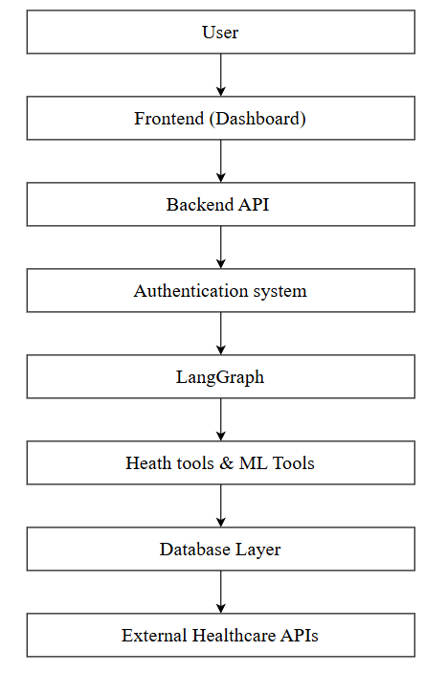

Core Components

1) Frontend:

Name: Patient Health Dashboard
Provides an interactive interface allowing users to monitor health metrics, manage medications,
submit health queries, and visualize analytics reports.

2) Backend services:

2.1 Health Management Service
Name: Health Data Processing API
Handles user health data collection, validation, storage, and communication between frontend and AI agents.
2.2 AI Agent Service
Name: Healthcare AI Agent System
Implements intelligent multi-agent workflows using LangGraph to process health queries, medication tracking, nutrition analysis, and medical information retrieval.
2.3 Notification Service
Name: Medication Reminder Service
Generates medication alerts, adherence reminders, and emergency health notifications.

Data Stores

1) Primary Health Database:

Name: Patient Health Database
stores patient profiles, medication schedules, fitness records, and historical health data.

2) Cache & Session Store:

Name: Redis Cache
Used for session management, real-time alerts, and frequently accessed health data caching

External Integration
- Language : Python
- Backend : FastAPI
- AI : OpenAI API
- Advanced AI : Langchain
- Database : PostgreSQL
- ORM : SQL Alchemy
- Frontend : React/ HTML-CSS-JS
- Authentication : JWT
- Version Control : Git + GitHub
- Deployment : Render/ Railway/ AWS

Deployment & Infrastructure

Cloud Provider:
AWS / Render / Vercel

Key Services Used:
Vercel (Frontend Hosting) Render/Railway (Backend) PostgreSQL Cloud Database Redis Cloud

CI/CD Pipeline:
GitHub Actions

Monitoring & Logging:
Application logs + Health analytics dashboard

Security Considerations

Authentication:
JWT-based authentication / Firebase Auth

Authorization:
Role-Based Access Control (Patient, Doctor, Caregiver)

Data Encryption:
HTTPS/TLS in transit Encrypted database storage

Security Practices:
API key protection Input validation Health data anonymization

Development & Testing Environment

Local Setup:
Python virtual environment Node.js frontend setup Docker containers

Testing Frameworks:
Pytest Jest

Code Quality Tools:
ESLint Black Formatter

Future Considerations

Predictive health risk assessment Voice-based health assistant Image-based pill identification Real-time wearable device integration Advanced healthcare analytics

Project Identification

Project Name:
Healthcare Monitoring AI Agent

Repository URL:

Primary Team:
AI Healthcare Development Team
1) Kena Rathod
2) Jiya Tandel
3) Heer Patel

