Benjamin Meyer 3/15/2021

ben@kenaiwateshed.org

**Note on data download files from** [**https://www.waterqualitydata.us/**](https://www.waterqualitydata.us/)

The script “baseline_data_KRBWQM.Rmd” employs .csv files downloaded from the WQX water quality database. The resultant csv files are too large to sync through GitHub, so they are designated to kept only on the local desktop via the “.gitignore” file.

To acquire WQX data in order to be able to run this script independently, one must download data from [**https://www.waterqualitydata.us/**](https://www.waterqualitydata.us/)

The web query functionality is buggy. I contacted their tech support, who confirmed that they are working on improving query as of spring 2021. The reliable query format is to use the “bounding box”, pictured below:

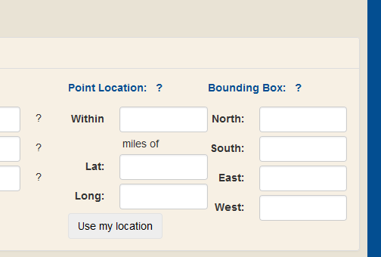

I used the following coordinates:

* West: -151.322501
* East: -149.216144
* South: 60.274310
* North: 60.738915

I chose water as our sample media, which has two designations in the database, pictured below:

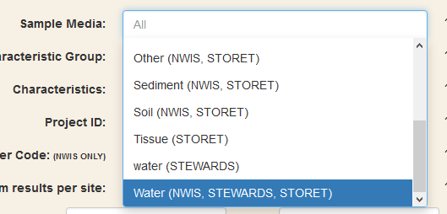

* Sample media: water (STEWARDS), Water (NWIS, STEWARDS, STORET)

Separate queries must be made for the physical results (“Sample results (narrow)”) and the site data (“Site data only”), using the “Select data download” option, pictured below:

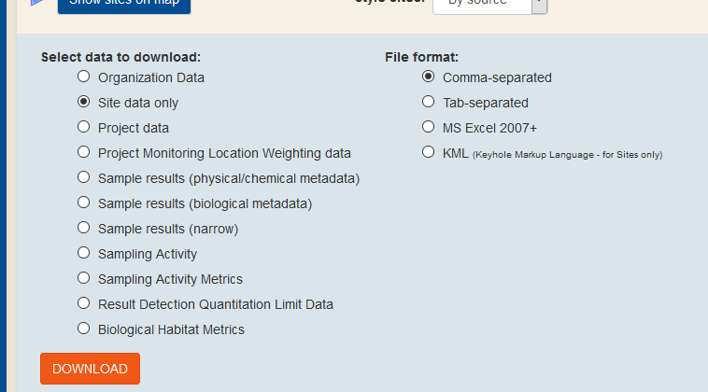

This query approach may be able to be automated in the future using USGS R packages:

https://owi.usgs.gov/R/training-curriculum/usgs-packages/.