|  |  |  |
| --- | --- | --- |
|  | Status of Copper and Zinc Levels Throughout the Kenai River Watershed    *Z:\Company  Policy\Marketing Branding\Logos\KWF Logos\NEW - 2015\KWF.newlogo.blue copy.png* | |
| 11/23/2019 | | Prepared by the Kenai Watershed Forum for the Alaska Department of Environmental Conservation under ACWA grant 19-02, FAIN: 00J84604 |

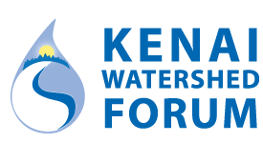

**Prepared by:**

Benjamin Meyer

Environmental Scientist

Kenai Watershed Forum

(907) 260-5449 x1207

www.kenaiwatershed.org

The Kenai Watershed Forum (KWF) is a 501(c)(3) non-profit and is recognized as the regional watershed organization of the Kenai Peninsula, successfully identifying and addressing the environmental needs of the region by providing high quality education, restoration and research programs. KWF is a dynamic organization dedicated to protecting the streams, rivers, and surrounding communities on the Kenai Peninsula.

Contents

list of figures iii

list of Tables iii

Purpose 4

Introduction 5

Methods 5

Copper and zinc sampling* 5

Kenai River Baseline Water Quality Monitoring (KRBWQM) 5

Copper and zinc-specific sampling events 6

Mapping potential sources of copper and zinc 7

Potential sources on the Kenai River 7

Potential sources throughout the Kenai River watershed 7

RESULTS 7

Copper and zinc sampling 7

Kenai River Baseline Water Quality Monitoring (KRBWQM) 7

Copper and zinc-specific sampling events 8

Mapping potential sources of copper and zinc 8

Potential sources on the Kenai River 8

Potential sources throughout the Kenai River watershed 9

DISCUSSION 9

Copper and zinc sampling 9

Kenai River Baseline Water Quality Monitoring (KRBWQM) 9

Copper and zinc-specific sampling events 9

General discussion: zinc exceedances 10

Mapping potential sources of copper and zinc 11

Potential sources on the Kenai River 11

Potential sources throughout the Kenai River watershed 11

CONCLUSION 11

References 13

appendix a: Maps 14

appendix B: Tables 17

# list of figures

Figure 1. Division of the Kenai River watershed (lower, middle, and upper Kenai River) 15

Figure 2. 2019 - 2020 sampling locations. at sites 15 through 18 on may 22, 2019 AND JULY 24, 2019, calcium and magnesium data was not available and data from the nearest downstream site was applied to calculate ccc values. points 7 (Lower Slikok creek) and 12 (slikok confluence) are superimposed at this scale 16

Figure 3. 2019-2020 kenai river mainstem sites copper concentrations and criterion values. 17

Figure 4. 2019-2020 kenai river tributary sites copper concentrations and criterion values. 18

Figure 5. Kenai River mainstem sites zinc concentrations and criterion values. 19

Figure 6. Kenai river tributary sites zinc concentrations and criterion values. 20

# list of Tables

Table 1. Alaska Department of Environmental Conservation water quality standards and pertaining calculations. 21

Table 2. Copper and zinc levels and hardness-dependent standards. 22

# Purpose

This field report serves as a draft under the Alaska Clean Water Actions (ACWA) grant 19-02, FAIN: 00J84604 for the Alaska Department of Environmental Conservation (ADEC). Its purpose is to highlight fieldwork and mapping efforts conducted to assess levels of copper and zinc, as well as to their potential sources throughout the Kenai River watershed. These efforts are intended to complement and respond to the literature review submitted to ADEC in 2017 by the Kenai Watershed Forum under ACWA grant 17-06 (KWF, 2017). This review will answer the following questions:

1. What are the copper and zinc levels at specific locations throughout the Kenai River watershed during spring and summer sampling events?
2. Where are copper and zinc exceedances occurring throughout the Kenai River watershed during spring and summer sampling events?
3. What is the status of mapping efforts of potential copper and zinc sources on the Kenai River and throughout its watershed?

# **Introduction**

The Kenai River is a glacially-fed system located on the Kenai Peninsula. This 82-mile river begins at the outlet of Kenai Lake and flows into a branch of the Gulf of Alaska commonly known as Cook Inlet. Due to its size, the Kenai River is generally divided into three sections: the upper river (Cooper Landing at river mile [RM] 82 to Skilak Lake at RM 65), middle river (RM 50 at the outlet of Skilak Lake to RM 21 in Soldotna at the Sterling Highway bridge), and lower river (RM 21 to RM 0 at the mouth in Kenai). Several major, non-glacial tributaries flow into the Kenai River (Figure 1).

The Kenai River watershed plays host to millions of Pacific salmon that utilize its waters for rearing and spawning habitat. These salmon are critical to Alaskan economy, recreation, and culture. As a result, the Kenai River watershed is a priority for conservation efforts, as it experiences significant anthropogenic pressures throughout the year. Over 20 years ago the Kenai Watershed Forum (KWF) identified a need for monitoring several water quality parameters often influenced by development, impervious surfaces, boat use, and others. KWF established the Kenai River Baseline Water Quality Monitoring (KRBWQM) program in 2000 to track water quality changes over time. Thirteen sites were chosen along the Kenai River mainstem and in its major tributaries with the intention of providing information on overall watershed conditions twice per year (Figure 1), and since inception a suite of water quality parameters have been measured biannually. Analyses performed on twice-yearly water quality samples include copper, zinc, calcium, and magnesium. Exceedances of copper and zinc are identified when their levels are compared to a hardness-dependent freshwater criterion continuous concentration (CCC) whose calculation requires the input of calcium and magnesium levels (Table 1; ADEC 2008).

A notable increase in dissolved copper and zinc concentrations from 2010 through 2014 as compared with previous sampling years (KWF, 2015 and 2017). These heavy metals can have harmful effects on Pacific salmon and their habitat. Elevated levels of copper can lead to toxic effects on a salmon’s olfactory nervous system, which is critical for survival and migratory success (Baldwin et al, 2003). Chinook salmon (*Oncorhynchus tshawytscha*) have shown increased susceptibility to elevated zinc levels during early life stages-a critical period of time in development (Chapman, 1978).

These elevated levels of copper and zinc warranted further investigation and, through ACWA grant 19-02/FAIN: 00J84604, KWF identified four tributary and three mainstem sites throughout the Kenai River watershed for further testing in the springs and summers of 2019-2020 (Figure 2). Five river trips were also conducted in order to photograph all potential zinc and copper sources visible from the Kenai River mainstem. These photos were incorporated into a GIS shapefile that was established to document other adjacent sources of these heavy metals including impervious surfaces, boat landings, and wastewater discharge.

# **Methods**

## Copper and zinc sampling

Water sampling efforts in 2019-2020 targeted sites that have been monitored biannually since the year 2000 as part of the Kenai River Baseline Water Quality Monitoring (KRBWQM) project, as well as new additional sites targeted to explore spatial trends in copper and zinc concentrations (referred to here on as “Copper and zinc-specific sampling events”. In total, water samples were taken from ten sites on the Kenai River mainstem and nine tributary sites (Figure 1).

Note: that all river miles listed throughout document are in reference to the Kenai River mainstem. River miles listed for tributaries reference their confluence river mile on the mainstem of the Kenai River. Sampling site names were chosen based on sampling location; their corresponding river miles can be found in Table 2.

### Kenai River Baseline Water Quality Monitoring (KRBWQM)

KWF conducted biannual KRBWQM events in 2019 and 2020. These were cooperative events that required the participation and/or financial contributions of several agencies and organizations including:

* Alaska Department of Fish and Game
* City of Kenai
* City of Soldotna
* Cook Inlet Aquaculture Association
* Alaska Department of Environmental Conservation
* Alaska Department of Natural Resources
* Kenai Peninsula Borough
* Kenai Watershed Forum
* United States Fish and Wildlife Service
* United States Forest Service
* Local Kenai Peninsula volunteers

Sites in the KRBWQM sampling program were originally selected to represent the Kenai River watershed's ambient water quality conditions (Ashton, 1998). Samples in 2019-2020 were analyzed for zinc, copper, calcium, and magnesium concentrations. Sampling events included

Working here: regenerate results using 2019 and 2020 aqms files

samples were taken and analyzed at five tributaries and seven mainstem Kenai River sites in April, and four tributaries and seven mainstem Kenai River sites in July.

After a training session, sampling participants were split into small groups and sampled 2-5 sites by foot or boat on April 30 and July 30th 2019, and July 21, 2020. All samples were collected on the same day and the timing of sample collection coincided with an outgoing tide to reduce potential saltwater contamination of samples. Individuals collecting samples by foot waded into the water until the water depth was around two feet and the participant was offshore in flowing water. For sites accessed by boats, water samples were taken from the bow while the boat faced upstream. Prior to sampling, all bottles were labeled with site and river mile; sampling team name; date and time; and parameter. Samples were collected by facing upstream, putting on clean gloves, removing the bottle seal, inverting the bottle and plunging it roughly one foot below the water surface. The bottle was then turned 90 degrees to allow water to fill at that depth. All bottles were stored and shipped in insulated coolers with ice packs via Grant Aviation. They were retrieved and analyzed by SGS North American, Inc (Anchorage) within the holding time of each sample. These procedures follow the protocols established in a Quality Assurance Project Plan (QAPP) originally approved by ADEC in 2001, later revised and approved by ADEC again in 2013 and 2019 (KWF, 2019). Results were reported digitally; data entry and management was done in Microsoft Excel and R Studio. Hardness and hardness-dependent freshwater CCC criteria were calculated using ADEC-provided equations located in Table 1.

### Copper and zinc-specific sampling events

In addition to the long-running biannual KRBWQM sampling events, in 2019 and 2020 KWF staff and volunteers also conducted sampling specifically focused on copper and zinc on May 22 and July 24, 2019, as well as May 20 and July 22, 2020. Sample sites for these events included four sites in the upper reaches of tributaries and three mainstem Kenai River locations (Figure 2).

Tributary sites were selected based on their historically-elevated levels of copper and/or zinc (KWF, 2015) as well as their location above most anthropogenic influence. On the Kenai mainstem, the Slikok Creek confluence site was chosen in order to compare the levels of copper and zinc found within the Slikok Creek tributary. The Skilak Lake outlet and Jim's Landing sites were chosen as control sites as they are located upstream of the majority of development along the Kenai river and would provide relative background levels away from anthropogenic influence Uniquely, Jim's Landing is a designated, popular boat launch utilized by recreationists using drift-only (non-motorized) boats. All sampling procedures aligned with the ADEC-approved 2019 QAPP and are discussed in further detail throughout the "Copper and zinc sampling: Kenai River Baseline Water Quality Monitoring (KRBWQM)" section of this document.

Results were reported digitally; data entry and management was done so in Microsoft Excel and R Studio. Hardness and freshwater CCC criteria were calculated using ADEC-provided equations located in Table 1.

Duplicates and rdl calculations…

## Mapping potential sources of copper and zinc

### Potential sources on the Kenai River

Throughout the summer of 2019, five photography trips were conducted by raft or motorboat along all sections of the Kenai River mainstem to document parcels containing potential copper and zinc sources. This task was completed using Ricoh WG-6 digital cameras, which were equipped with GPS and aspect functionality. Two photographers took photos of each parcel with a potential metal source; one photographer was assigned the river-right (RL) bank while the other was assigned the river-left (RL) bank. Photos were taken directly out from the potential source, perpendicular to the bank of the river. Side channels diverting from the mainstem of the Kenai River were floated or boated as well.

### Potential sources throughout the Kenai River watershed

Following the literature review conducted by KWF in 2017, potential sources of copper and zinc were identified throughout the Kenai River watershed. Copper sources included brake pads/vehicles, pesticides/herbicides, roofing/metal plating, mining activity, boat hull coatings/anti-fouling agents, municipal wastewater discharge, natural mineral deposits, forest fires, air emissions, and decking/pilings (KWF, 2017). Similarly, zinc sources included galvanized metals, tire wear, motor oil/hydraulic fluid, fertilizer/pesticides/fungicides, natural mineral depots, mining activity, forest fires, and brakes (KWF, 2017). Using these results from the literature review, KWF identified potential local sources of copper and zinc through a mapping exercise.

# **RESULTS**

## Copper and zinc sampling

***Copper***

Copper levels ranged from undetected to values that were notably high yet still below CCC criterion values. A of high of 3.91 µg/L was observed at the Beaver Creek upper-reach tributary site on April 30, 2019, with other notably high observations also made at the City of Kenai Docks (July 21, 2020) and No Name Creek upper-reach tributary sites (May 22, 2019). Hardness-dependent freshwater CCC criteria for copper ranged from a low of 2.31 µg/L (various sites) to a high of 121.31 µg/L at No Name Creek (July 21, 2020) (Table 2). No copper exceedances were observed during any of the sampling events in 2019-2020

For both tributary and mainstem sites the highest copper values were observed in the lower Kenai River region, closer to the developed Kenai/Soldotna area. Copper values > 2.5 µg/L were observed solely at the City of Kenai Docks mainstem site, No Name Creek tributary site, and Beaver Creek tributary site. All other copper values in the dataset were below this arbitrary threshold.

During the May sampling event, freshwater CCC criteria for copper ranged from 4.4 µg/L-7.3 µg/L (Table 4). Calcium and magnesium samples were not taken at the Slikok Creek confluence and therefore a freshwater CCC criteria could not be calculated. The highest level of copper was noted at No Name Creek (duplicate), 3.27 µg/L, while several sites reported no detection, including Beaver Creek, Slikok Creek, Soldotna Creek, and Jim's Landing (Table 4). When compared to the freshwater CCC criteria, no exceedances were noted during the May sampling event.

Throughout the July sampling event, the freshwater CCC criteria for copper ranged from 4.47 µg/L-9.62 µg/L (Table 4). Calcium and magnesium samples were not taken at the Slikok Creek confluence and therefore a freshwater CCC criteria could not be calculated. The highest level of copper was noted at the Slikok Creek confluence, 8.16 µg/L, while the lowest level was estimated at 0.39 µg/L at No Name Creek (Table 4). When compared to the freshwater CCC criteria, no exceedances were noted. However, an exceedance cannot not be determined at Slikok Creek because a freshwater CCC criterion could not be calculated, calcium and magnesium sampling was not conducted at this site.

***Zinc***

Zinc values ranged from…

Throughout the April sampling event, zinc levels ranged from undetected at three sites to 137 µg/L at Soldotna Creek (Table 3) and freshwater CCC criteria ranged from 39.92 µg/L at No Name Creek to 628.18 µg/L at Kenai City Docks (Table 3). Exceedances occurred at mainstem sites including Cunningham Park, Kenai River, Pillars, Soldotna Bridge, and Swiftwater Park; tributary exceedances occurred at Beaver Creek, Slikok Creek, and Soldotna Creek.

In contrast, zinc exceedances were not reported during the July KRBWQM sampling event. Zinc levels ranged from undetected at four locations to 69.9 µg/L at Beaver Creek and freshwater CCC criteria ranged from 40.69 µg/L at Swiftwater Park to 86.7 µg/L (Table 3). While the zinc level at Beaver Creek did result in an exceedance, its corresponding freshwater CCC criterion was 79.66 µg/L (Table 3).

Zinc samples taken during the May sampling event resulted in zinc levels that ranged from undetected at all three mainstem sites to 159 µg/L at No Name Creek (duplicate) (Table 5). The second highest zinc level was also recorded from another sample taken at No Name Creek, 98.1µg/L (Table 5). Freshwater CCC criteria ranged from 32.59 µg/L at No Name Creek (both samples) to 86.7 µg/L at Soldotna Creek (Table 5). Freshwater CCC criteria could not be calculated at Slikok Creek confluence because calcium and magnesium samples were not taken at this site during the April KRBWQM sampling event. This spring sampling event resulted in exceedances from samples taken at No Name Creek (both samples), Beaver Creek, and Slikok Creek-all of which are tributaries to the mainstem Kenai River.

The July sampling event resulted in zinc levels that varied from undetected at four locations to 64.4 µg/L at Beaver Creek. Freshwater CCC criteria ranged from 40.56 µg/L at Skilak Lake outlet to 86.7 µg/L at Soldotna Creek (Table 5). The CCC value could not be calculated for Slikok Creek confluence because a calcium and magnesium sample was not taken at this site during the July KRBWQM sampling event. While the July sampling event did not result in any exceedances, the sample analyzed from Beaver Creek resulted in a zinc level of 64.4 µg/L and a freshwater CCC criterion of 79.66 µg/L (Table 5).

Present RDL data

## Mapping potential sources of copper and zinc

### Potential sources on the Kenai River

In total, 932 photos were taken of river-right parcels and 899 photos of river-left parcels with potential copper and zinc sources. These photos have been imported into ESRI’s ArcMap GIS program. An attribute table will be created for all photos and will contain information such as parcel ID, the number of potential metal sources, and the type of potential source observed on the property. To date, potential sources documented included elevated, light-penetrating walkways; building roofs; impervious surfaces such as roads and parking lots; significant bank erosion; boat launches; bridges; and RV parks. This is an ongoing process and the resulting shapefile will be incorporated with the data included in the mapping described below. Findings will be summarized in the 2020 final draft submitted to ADEC under this grant.

### Potential sources throughout the Kenai River watershed

While these mapping efforts are ongoing, potential sources of these metals include road construction, gravel pits, stormwater discharge, stormwater treatment structure/outfall, boat launches, impervious surfaces, densely populated areas, golf courses, wastewater treatment plants, and airports. A shapefile has been created to visually document these sources and will be used to as a powerful mapping tool to identify areas of high-concentration potential sources of copper and zinc. Findings will be summarized in the 2020 final draft submitted to ADEC under this grant.

# **DISCUSSION**

## Copper and zinc sampling

### Kenai River Baseline Water Quality Monitoring (KRBWQM)

Copper exceedances were not observed during the 2019 KRBWQM April and July sampling events. Beaver Creek and No Name Creek (duplicate) samples did result in copper levels that approached their freshwater CCC criteria in April and July, respectively. In addition, copper levels detected at the Kenai City Dock resulted in levels roughly 1 µg/L and 2 µg/L (duplicate) higher than those collected throughout the watershed, though the freshwater CCC criteria at this site were significantly higher than those calculated for other sites in the watershed as well (70.9 µg/L and 35.43 µg/L, respectively) (Table 2). Kenai City Dock (duplicate) and Beaver Creek results both showed decreases in copper levels from spring to summer. This could be a result of increased snowmelt and rain events (see "General discussion: zinc exceedances" for further detail). Sample analysis for copper will continue at these sites in order to monitor them for any future exceedances or trending changes over time.

While zinc exceedances were not observed during the July sampling event, eight exceedances were identified during the April sampling event. Mainstem exceedances occurred at Cunningham Park, Kenai river, Pillars, Soldotna Bridge, and Swiftwater Park sampling sites; tributary exceedances occurred at Beaver Creek, Slikok Creek, and Soldotna Creek. Notably, the duplicate sample taken at Slikok Creek reported an undetectable level of zinc, warranting further investigation at this site in future years. Exceedances noted in April were taken during a period of snowmelt and at sites located within highly-developed areas of the Kenai Peninsula and are all located throughout the general City of Soldotna and City of Kenai area (see "General discussion: zinc exceedances" for further detail).

### 

### Note on asynchronous CCC values in 2019 data

In nearly all cases, zinc and copper data is synchronous in space and time with paired calcium and magnesium data used to generate associated CCC values. However it is critical to note that the freshwater CCC criteria applied for both May 22, 2019 and July 24, 2019 sampling events were calculated using calcium and magnesium levels obtained from other sampling events on April 30, 2019 and July 30, 2019, respectively For the four upper-reach tributary sites sampled on these dates (No Name Creek, Beaver Creek, Slikok Creek, and Soldotna Creek), differences in location also exist for copper and zinc data vs. calcium and magnesium data. Where calcium and magnesium data was unavailable, data from the nearest downstream site was applied to generate CCC values.

In order to evaluate this application, an average of spring and summer calcium and magnesium levels were calculated using data collected from 2000-2014 (Table X). These averages are intended to be used as reference to which hardness values calculated using asynchronous calcium and magnesium levels can be compared. All significant outliers were removed prior to calculating averages.

At one site (Slikok Creek confluence)

A calcium and magnesium sample was not taken at the during KRBWQM because this is not a site typically included during this biannual sampling program.

Moving forward, calcium and magnesium samples will be taken at all sites within the copper and zinc-specific sampling plan and will therefore result in hardness and freshwater CCC criteria that directly correspond to each copper and zinc sample take at each site.

While copper exceedances were not observed during May and July sampling events, there were two notably elevated observations of copper levels. In May, the No Name Creek (duplicate) sample resulted in a copper level of 3.27 µg/L and the corresponding freshwater CCC criterion was 4.4 µg/L (Table 4).

In July 2019, a copper lever of 8.16 µg/L was recorded at the Slikok Creek confluence site, though a freshwater CCC criterion could not be calculated, as calcium and magnesium samples were not taken at that site (Table 4). Because of the small sample size at the No Name Creek and Slikok Creek confluence sites (n=2 and n=1, respectively), it is highly advised that further sampling is conducted more thoroughly at these locations.

With the exception of No Name Creek and No Name Creek (duplicate) samples, all copper sampling conducted in July resulted in higher copper levels than in May. However, the freshwater CCC criterion were also higher in July, with the exception of those corresponding to Beaver Creek and Jim's Landing.

All zinc exceedances were observed during the spring sampling event in May. Slikok Creek, Beaver Creek, and both samples taken at No Name Creek resulted in zinc levels that exceeded their freshwater CCC criteria. Similarly, exceedances occurred during the KRBWQM April sampling event at Beaver Creek and Slikok Creek, when samples were collected near the mouth of these tributaries. These tributaries flow through significant development before reaching the Kenai River, and therefore are adjacent to several potential sources of zinc. In addition, they are both designated as anadromous streams by the state of Alaska and are known to provide rearing habitat for juvenile salmon (ADFG, 2019). Longitudinal transect of samples collected during the spring would provide further insight into the exact locations of copper and zinc exceedances throughout these anadromous tributaries critical to salmon development.

### General discussion: zinc exceedances

It is critical to note that springtime exceedances in the tributaries and mainstem Kenai River were observed from mainstem RM 0 to RM 23. This stretch of river, primarily located within a section known as the "lower river", flows through the highest concentrations of development within the Kenai River watershed. Located throughout these developed areas are several potential sources of copper and zinc, including thousands of homes, daily tire wear and brake use, motor oil, fertilizer and pesticides (KWF, 2017).

Over several months throughout the winter, these sources of zinc contribute fine particles that can accumulate on surfaces adjacent to these tributaries and mainstem Kenai River. As the season changes, the western Kenai Peninsula experiences increased rainfall and snowmelt events, particularly throughout April when KRBWQM sampling occurs. During a rain or snowmelt event, this build-up is likely flushed into these waterbodies as small particles, likely affecting their water quality and spiking zinc levels. Once suspended in the water column, dissolved metals can be transported further downstream, affecting water quality (Lewis and Clark, n.d.). Metals taken up by aquatic life often prove most toxic when they are in the dissolved phase (Gerhardt, 1993). Because of this toxicity, it remains critical that zinc monitoring continue throughout the Kenai River watershed- an area central to Alaska's economy, recreational opportunities, and culture that will likely continue to see increased development in coming years.

In order to identify the typical duration of zinc exceedances throughout the Kenai River watershed, it is advisable that zinc is monitored throughout an expanded one-year period under average rainfall and snowmelt conditions for the area. This would provide further insight into when exceedances occur, which could then be related to the timing of significant events such as rainfall, snowmelt, and glacial melt, in addition to the timing of biological events like salmon smolt outmigration-a period of time when salmon are undergoing several critical physiological changes. Additionally, further literature review is required in order to identify the detrimental effects zinc exceedances can have on the juvenile salmon species that remain in the tributaries for another year or two.

Finally, this study helped identify areas experiencing spring exceedances and will result in a significant mapping tool that will help identify potential sources of copper and zinc. All efforts are ongoing and will be concluded in 2020 with a final report further detailing area-specific sources of copper and zinc, advisable study expansions, and potential area-specific repercussions of elevated heavy metal levels. However, expanding the number of samples taken by way of longitudinal transects within each transect would identify specific areas of metal exceedances, thereby aiding managers in narrowing down potential point sources of copper and zinc in the area. Once specific areas of zinc exceedances are identified, managers could work with members of area partnerships to develop site-specific mitigation plans involving strategic solutions such as phytoremediation tactics, riparian restoration efforts, strategic development, wetland preservation, and watershed user and landowner education.

### Mapping potential sources of copper and zinc

All mapping of potential sources of copper and zinc throughout the Kenai Watershed is an ongoing effort and will be completed in 2020.

### Potential sources on the Kenai River

The current shapefile that has been created includes photos taken of parcels with potential sources of copper and zinc along river-right and river-left. The attribute table corresponding to these photos will be further developed to include attributes such as the number of potential sources, types of potential sources, and parcel ID. This mapping tool could be used to identify areas experiencing significant change over time. It is advisable that these photography trips are conducted every 5-10 years in order to update this tool over time.

### Potential sources throughout the Kenai River watershed

Identifying potential sources of copper and zinc throughout the Kenai River watershed is an ongoing process. Current methods being employed to identify these potential sources include local knowledge, local contacts, and online searches. Additions to this map could also include critical rearing and/or spawning habitat for salmon, areas of copper and zinc exceedances, and geologic data. Once completed, this shapefile will be integrated with the photo shapefile described above. This will result in a powerful mapping tool that will be used to identify areas such as those that contain highly-concentrated potential copper and zinc sources. In order to maintain relevancy, though, KWF highly recommends that the data contained within this mapping tool is updated on an annual basis in order to track changes in development over time.

# **CONCLUSION**

This document is intended as a draft report addressing the findings from compiled copper and zinc data gathered during April, May, and July sampling events in 2019. While the data collected throughout this study will provide further insight into the current sources and levels of copper and zinc throughout the Kenai River watershed during the spring and summer, much remains to be known about temporal variation and point sources of these heavy metals. As a result, the following preliminary study expansions are advised:

1. **Complete copper and zinc sampling as well as mapping of potential sources through 2020**
   1. Collect additional calcium and magnesium samples at each copper and zinc-specific sampling site
   2. Identify critical areas of copper and zinc exceedances
   3. Identify critical areas of highly-concentrated potential sources of copper and zinc using mapping tool
2. **Expand copper and zinc sampling study through increased sampling of Kenai River mainstem and tributary sites**
   1. Assess fluctuations in copper and zinc levels over the period of one year, particularly at sites that saw spring zinc exceedances:
      1. Tributaries: No Name Creek, Beaver Creek, Slikok Creek, Soldotna Creek
      2. Mainstem: from Cunningham Park (RM 6.5) to Swiftwater Park (RM 23)
   2. Expand sampling efforts along longitudinal transects in tributaries experiencing exceedances in order to identify areas of concern within each tributary
   3. Implement restoration and other mitigation efforts in tandem with local partnerships
3. **Track changes in development throughout the Kenai River watershed to address anthropogenic impact over time**
   1. Conduct Kenai River photography trips every 5-10 years
   2. Monitor new development over time in order to conduct annual updates of mapping tool
4. **Develop an educational program for local landowners and watershed user groups including topics such as responsible river use and effective property restoration projects**

It would be a resource-intensive process to attempt to identify all point sources at each sampling site reporting metal exceedances, as these are location-dependent. However, the Kenai River watershed boasts one of the largest water quality datasets in the state of Alaska-an invaluable resource showing a concerning history of heavy metal exceedances throughout the watershed. Expanding this study would aid in a more detailed delineation of spatial and temporal variations of these exceedances in the Kenai River watershed. As adjacent development and subsequent riparian de-vegetation increase along the Kenai River mainstem and its tributaries, study expansion remains a critical step that would lead to effective, strategic mitigation efforts throughout this highly-revered watershed in Alaska.

# **References**

Alaska Department of Environmental Conservation (ADEC). (2008). Alaska Water Quality Criteria Manual for Toxic and Other Deleterious Organic and Inorganic Substances.

Alaska Department of Fish and Game (ADFG). (2019). Anadromous Fish Resource Monitor. Alaska Department of Fish and Game. Retrieved from https://adfg.maps.arcgis.com/apps/MapSeries

/index.html?appid=a05883caa7ef4f7ba17c99274f2c198f

Ashton, W., 1998, Framework for Water Quality Monitoring of the Kenai River.

Baldwin, D. H., Sandahl, J. F., Labenia, J. S., & Scholz, N. L. (2003). Sublethal Effects of Copper on Coho Salmon: Impacts on Nonoverlapping Receptor Pathways in the Peripheral Olfactory Nervous System. Environmental Toxicology and Chemistry, 22(10), 2266–2274. doi: 10.1897/02-428

Chapman, G. A. (1978). Toxicities of Cadmium, Copper, and Zinc to Four Juvenile Stages of Chinook Salmon and Steelhead. Transactions of the American Fisheries Society, 107(6), 841–847.

Clesceri, L.S., Greenberg, A.E., Eaton, A.D. (Eds.). (1998). Standard Methods for the Examination of Water and Wastewater (20th ed.), Washington D.C. American Public Health Association, American Water Works Association, and Water Environment Federation.

Gerhardt, A. 1993. Review of Impact of Heavy Metals on Stream Invertebrates with Special Emphasis on Acidic Conditions: Water, Air, and Soil Pollution, v. 66, 345-364.

Kenai Watershed Forum (KWF). (2015) Water Quality Assessment of the Kenai River Watershed from July 2000 to July 2014.

Kenai Watershed Forum (KWF). (2017). Kenai River Watershed Zinc and Copper Pollution: A Summary of Data Analysis, Literature Review Results, and Suggested Actions.

Kenai Watershed Forum (KWF). (2019). Quality Assurance Project Plan: Kenai River Watershed Monitoring Program (3rd ed.). Alaska Department of Environmental Conservation.

Lewis, E. L. and Clark, M.L. (N.d.). How Does Streamflow Affect Metals in the Upper Arkansas River?. U.S. Department of the Interior-U.S. Geological Survey.

# **appendix a: Maps**

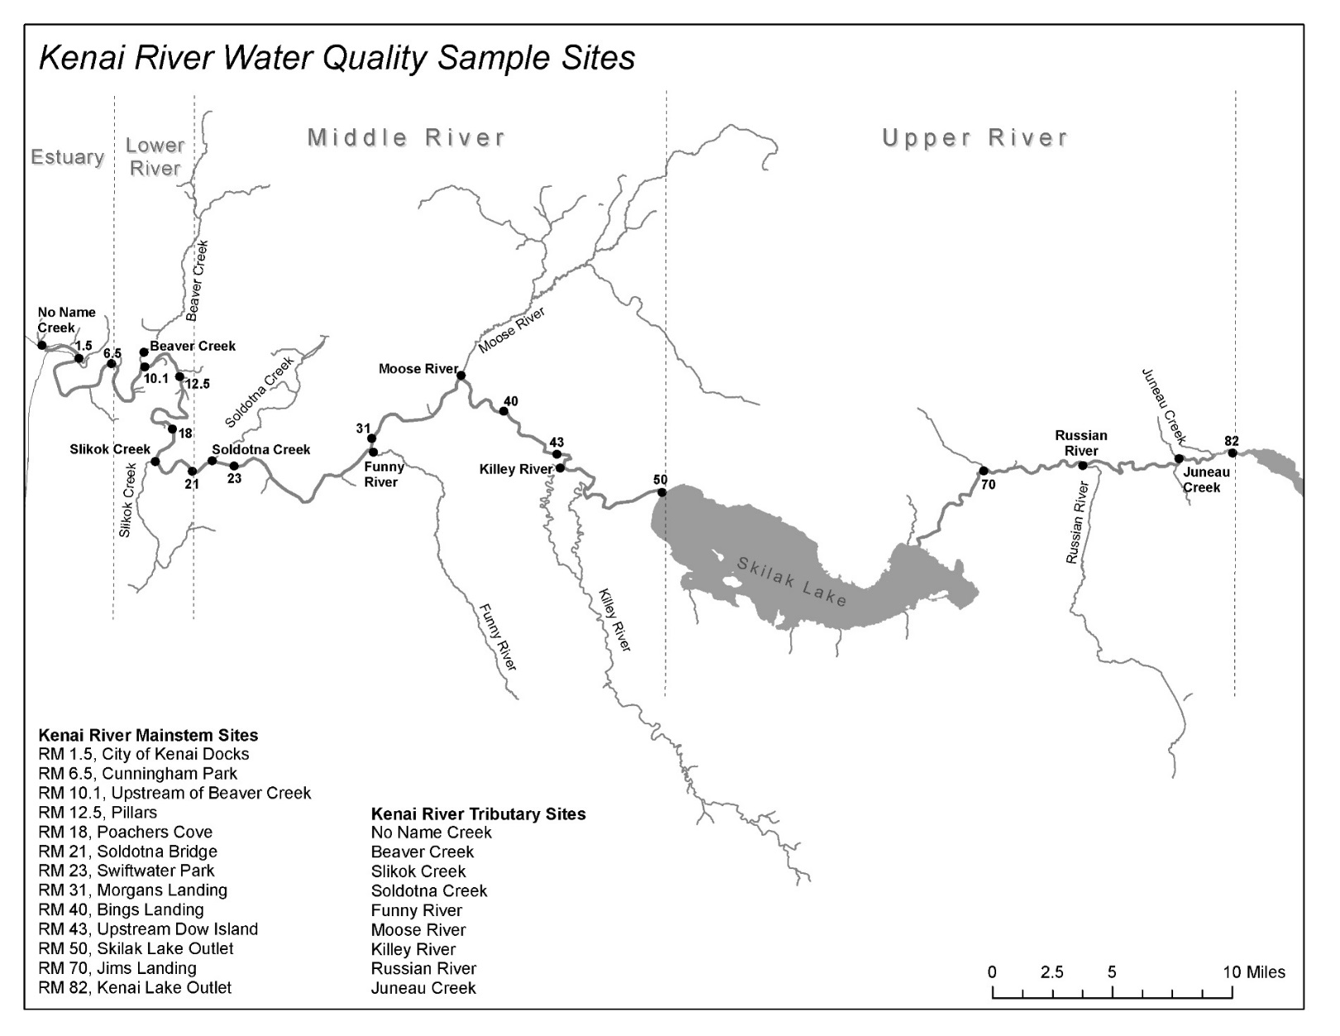

Figure 1. Division of the Kenai River watershed (lower, middle, and upper Kenai River)

and water quality monitoring site locations during biannual (2000 – present) KRBWQM sampling events.

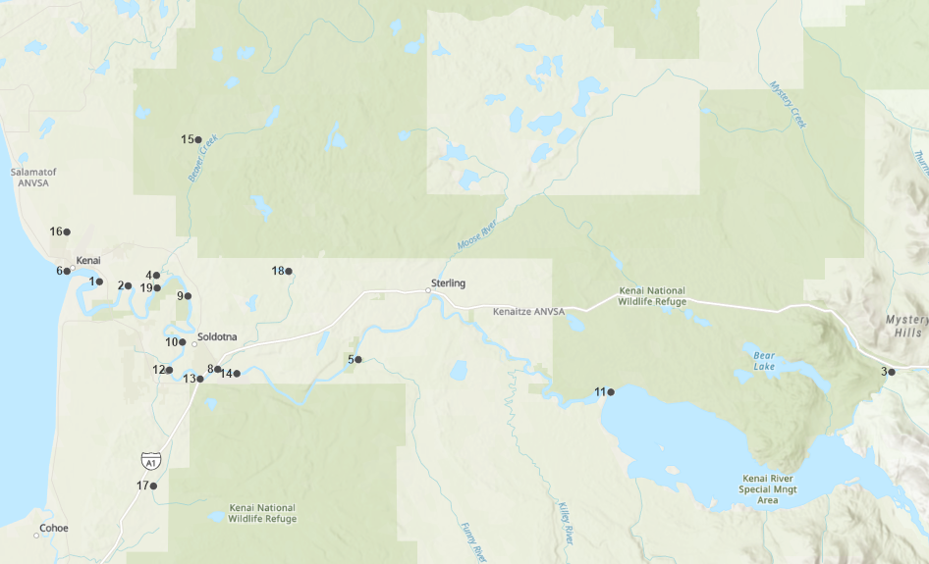 



Figure 2. 2019 - 2020 sampling locations. at sites 15 through 18 on may 22, 2019 AND JULY 24, 2019, calcium and magnesium data was not available and data from the nearest downstream site was applied to calculate ccc values. points 7 (Lower Slikok creek) and 12 (slikok confluence) are superimposed at this scale

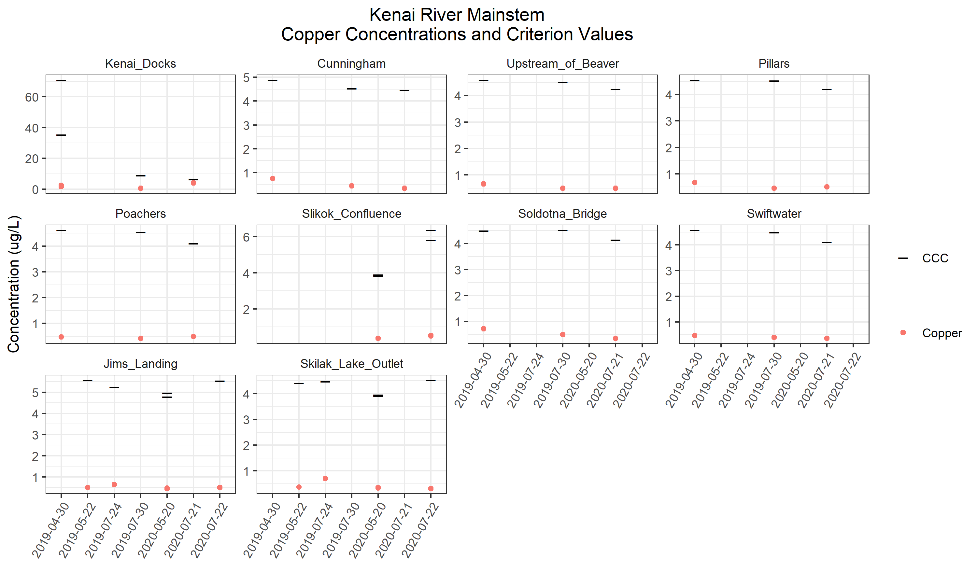

Figure 3. 2019-2020 kenai river mainstem sites copper concentrations and criterion values.

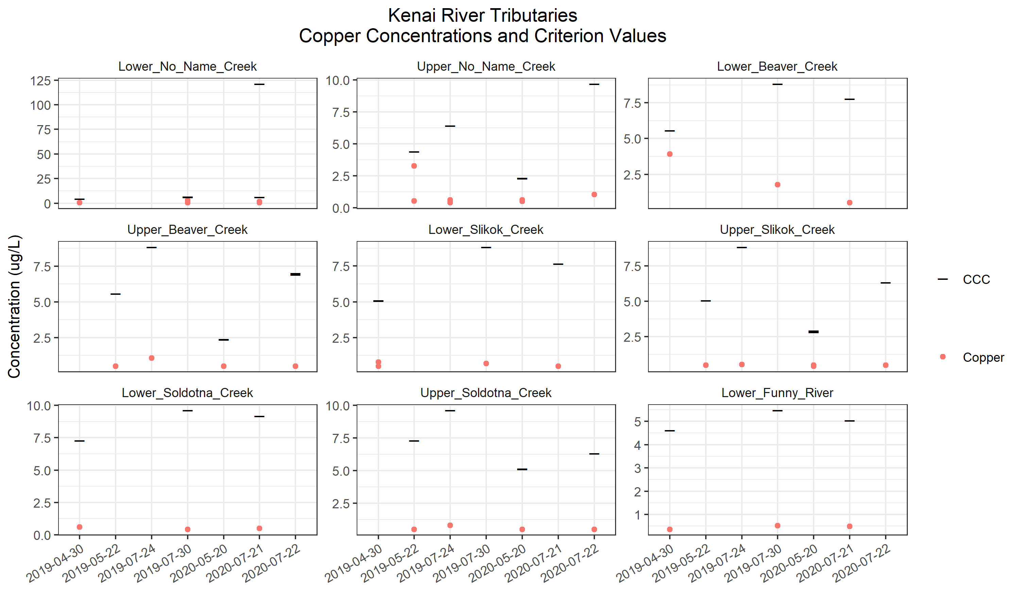

Figure 4. 2019-2020 kenai river tributary sites copper concentrations and criterion values.

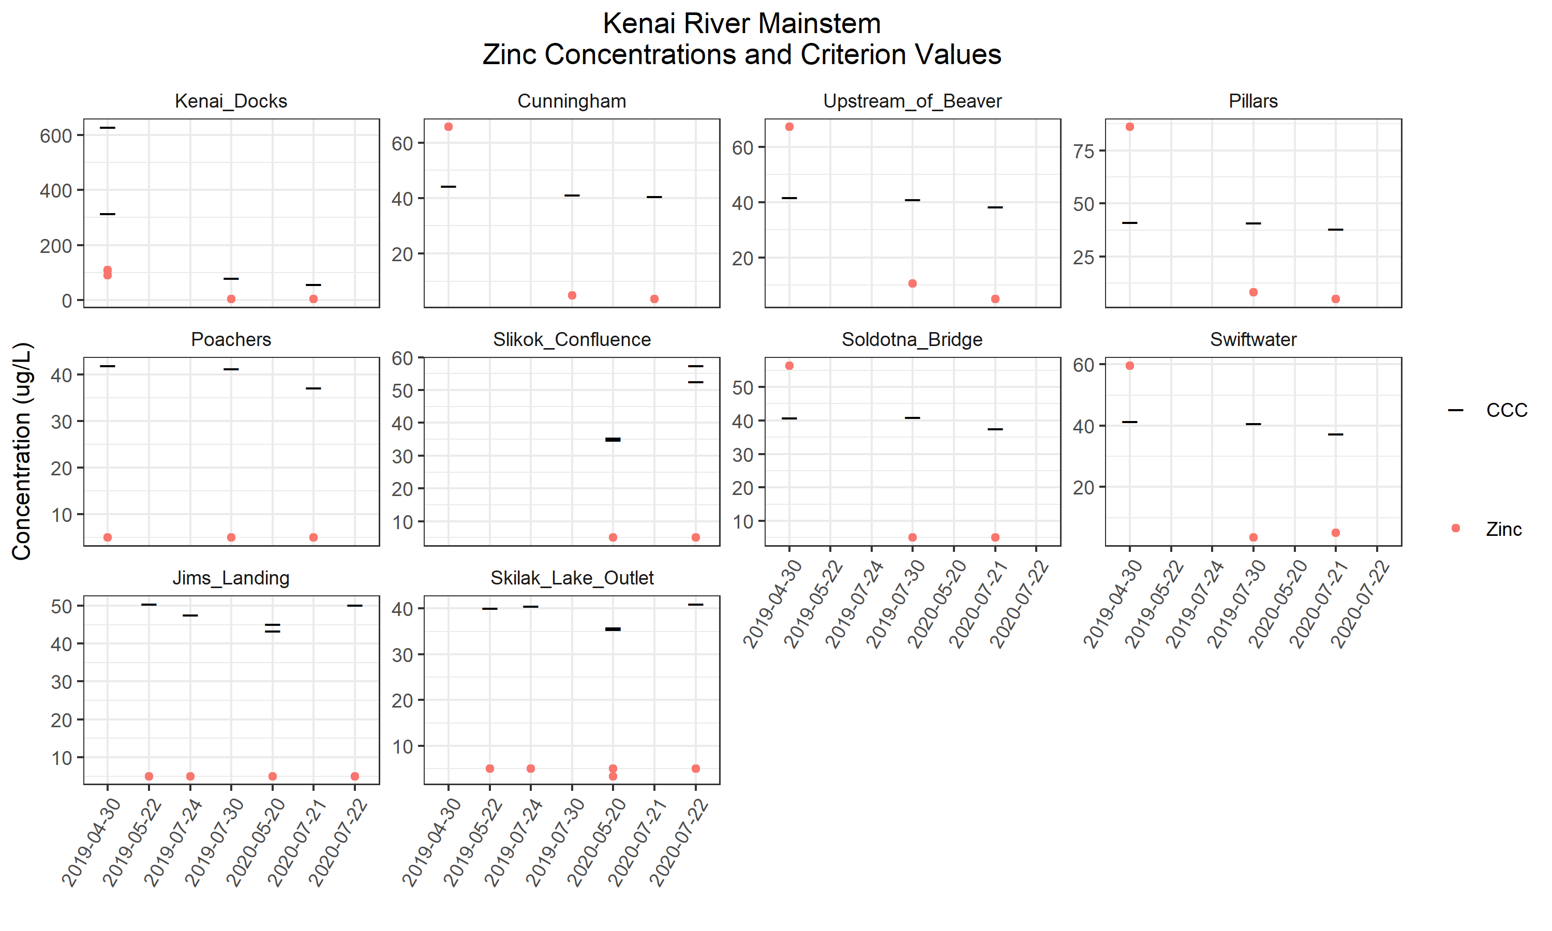

Figure 5. Kenai River mainstem sites zinc concentrations and criterion values.

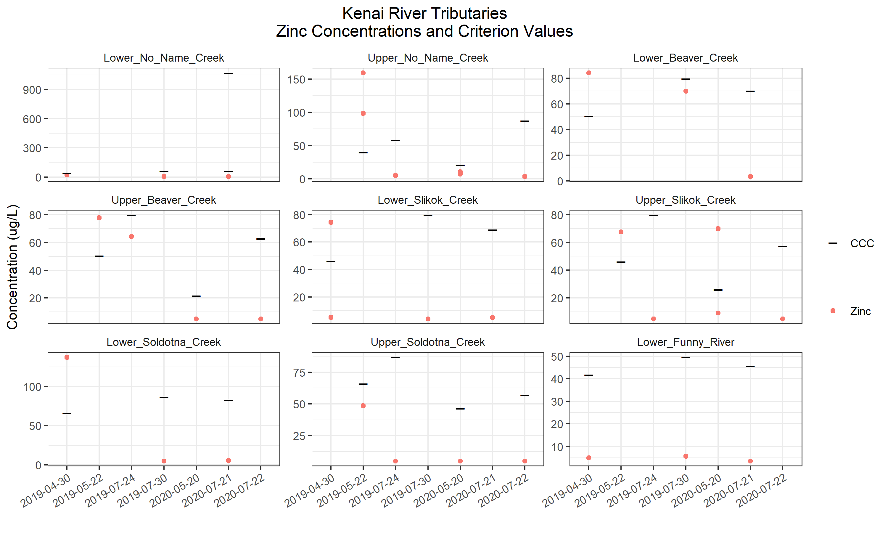

Figure 6. Kenai river tributary sites zinc concentrations and criterion values.

# **appendix B: Tables**

Table 1. Alaska Department of Environmental Conservation water quality standards and pertaining calculations.

|  |  |  |
| --- | --- | --- |
| **Parameter** | **ADEC Standard** | **Reference** |
| **Copper** | (e0.8545(ln hardness*)-1.702)*0.96  for aquatic life, fresh water, and chronic exposure. | ADEC. (2008). Alaska Water Quality Criteria Manual for Toxic and Other Deleterious Organic and Inorganic Substances. |
| **Zinc** | (e0.8473(ln hardness*)+0.884)*0.986  for aquatic life, fresh water, and chronic exposure. | ADEC. (2008). Alaska Water Quality Criteria Manual for Toxic and Other Deleterious Organic and Inorganic Substances. |
| **Hardness\*** | 2.497(Ca mg/L) + 4.119(Mg mg/L) | Clesceri, L.S., Greenberg, A.E., Eaton, A.D. (Eds.). 1998. Standard Methods for the Examination of Water and Wastewater (20th ed.), Washington D.C. American Public Health Association, American Water Works Association, and Water Environment Federation. |

Table 2 (page 1 of 3). Copper and zinc levels and hardness-dependent standards for sampling events on the kenai river mainstem and tributaries.

|  |  |  |  |  |  |  |  |  |
| --- | --- | --- | --- | --- | --- | --- | --- | --- |
|  |  |  |  |  | **Copper** | | **Zinc** | |
| **Site name** | **River mile** | **Date** | **Location on Kenai River** | **Hardness (mg/L)** | **Result (ug/L)** | **Standard: CCC (ug/L)** | **Result (ug/L)** | **Standard: CCC (ug/L)** |
| Lower No Name Creek |  | 4/30/2019 | Tributary | 32.59 | 0.668 J | 4.40 | 21.3 | 39.92 |
| 7/30/2019 | Tributary | 51.22 (50.85) | 0.451 J (3.04 ) | 6.48 (6.44) | 5.53 J (5.31 J) | 58.56 (58.2) |
| 7/21/2020 | Tributary | 49.86 (1579.89) | 0.5 U (1.79 ) | 6.33 (121.31) | 5 U (3.75 J) | 57.24 (1069.95) |
| Upper No Name Creek |  | 5/22/2019 | Tributary | 32.59 | 0.53 J (3.27) | 4.40 | 98.1 (159) | 39.92 |
| 7/24/2019 | Tributary | 50.85 | 0.39 J (0.61 J) | 6.44 | 5.12J (5.77J) | 58.20 |
| 5/20/2020 | Tributary | 15.58 (15.33) | 0.606 J (0.497 J) | 2.34 (2.31) | 10.9 (7.05 J) | 21.36 (21.07) |
| 7/22/2020 | Tributary | 82.32 | 1.04 | 9.71 | 3.46 J | 87.53 |
| Lower Beaver Creek |  | 4/30/2019 | Tributary | 43.06 | 3.91 | 5.58 | 84.1 | 50.55 |
| 7/30/2019 | Tributary | 73.65 | 1.77 | 8.83 | 69.9 | 79.66 |
| 7/21/2020 | Tributary | 63.36 | 0.509 J | 7.77 | 3.27 J | 70.12 |
| Upper Beaver Creek |  | 5/22/2019 | Tributary | 43.06 | 0.5 U | 5.58 | 77.80 | 50.55 |
| 7/24/2019 | Tributary | 73.65 | 1.07 | 8.83 | 64.40 | 79.66 |
| 5/20/2020 | Tributary | 15.7 (15.87) | 0.5 U (0.5 U) | 2.36 (2.38) | 5 U (5 U) | 21.5 (21.7) |
| 7/22/2020 | Tributary | 56.16 (55.17) | 0.5 U (0.5 U) | 7.01 (6.9) | 5 U (5 U) | 63.31 (62.36) |
| Lower Slikok Creek |  | 4/30/2019 | Tributary | 38.45 (38.74) | 0.783 J (0.5 U) | 5.07 (5.1) | 74.4 (5 U) | 45.93 (46.22) |
| 7/30/2019 | Tributary | 73.58 | 0.684 J | 8.83 | 4.01 J | 79.60 |
| 7/21/2020 | Tributary | 62.29 | 0.5 J | 7.66 | 5 U | 69.12 |
| Upper Slikok Creek |  | 5/22/2019 | Tributary | 38.45 | 0.5 U | 5.07 | 67.60 | 46.22 |
| 7/24/2019 | Tributary | 73.58 | 0.53 J | 8.83 | 5U | 79.60 |
| 5/20/2020 | Tributary | 20.19 (19.47) | 0.431 J (0.5 U) | 2.92 (2.83) | 69.9 (9.09 J) | 26.61 (25.8) |
| 7/22/2020 | Tributary | 49.82 | 0.5 U | 6.33 | 5 U | 57.20 |
| Lower Soldotna Creek |  | 4/30/2019 | Tributary | 58.94 | 0.597 J | 7.30 | 137 | 65.96 |
| 7/30/2019 | Tributary | 81.39 | 0.424 J | 9.62 | 5 U | 86.70 |
| 7/21/2020 | Tributary | 77.10 | 0.5 U | 9.19 | 5.52 J | 82.81 |
| Upper Soldotna Creek |  | 5/22/2019 | Tributary | 58.94 | 0.5 U | 7.30 | 48.50 | 65.96 |
| 7/24/2019 | Tributary | 81.39 | 0.81 J | 9.62 | 5U | 86.70 |
| 5/20/2020 | Tributary | 38.91 (39.08) | 0.5 U (0.5 U) | 5.12 (5.14) | 5 U (5 U) | 46.39 (46.56) |
| 7/22/2020 | Tributary | 49.78 | 0.5 U | 6.32 | 5 U | 57.16 |
| **Copper, zinc exceedances based on water quality criteria for aquatic life for fresh water (chronic exposure) established by Alaska Department of Environmental Conservation** | | | | | | | | |
| CCC = criterion continuous concentration (freshwater) () = duplicate sample J = quantitation is an estimate U = analyte was analyzed for but not detected  Values in parentheses are duplicate samples | | | | | | | | |

Table 2 (page 2 of 3). copper and zinc leevls and hardness-dependent standards for sampling events on the kenai river mainstem and tributaries.

|  |  |  |  |  |  |  |  |  |
| --- | --- | --- | --- | --- | --- | --- | --- | --- |
|  | | | | | **Copper** | | **Zinc** | |
| **Site name** | **River mile** | **Date** | **Location on Kenai River** | **Hardness (mg/L)** | **Result (ug/L)** | **Standard: CCC (ug/L)** | **Result (ug/L)** | **Standard: CCC (ug/L)** |
| Lower Funny River |  | 4/30/2019 | Tributary | 34.41 | 0.363 J | 4.61 | 5 U | 41.80 |
| 7/30/2019 | Tributary | 42.01 | 0.514 J | 5.47 | 5.63 J | 49.50 |
| 7/21/2020 | Tributary | 38.13 | 0.495 J | 5.03 | 3.53 J | 45.60 |
| City of Kenai Docks | 1.5 | 4/30/2019 | Mainstem | 842.68 (374.19) | 2.49 (1.68) | 70.9 (35.43) | 89.9 (110) | 628.18 (315.75) |
| 7/30/2019 | Mainstem | 74.98 | 0.562 J | 8.97 | 5 U | 80.87 |
| 7/21/2020 | Mainstem | 50.23 | 3.88 | 6.37 | 4.16 J | 57.60 |
| Cunningham Park | 6.5 | 4/30/2019 | Mainstem | 36.84 | 0.751 J | 4.89 | 65.6 | 44.29 |
| 7/30/2019 | Mainstem | 33.74 | 0.428 J | 4.53 | 5 U | 41.12 |
| 7/21/2020 | Mainstem | 33.23 | 0.334 J | 4.47 | 3.59 J | 40.58 |
| Upstream of Beaver Creek | 10.1 | 4/30/2019 | Mainstem | 34.23 | 0.66 J | 4.59 | 67.1 | 41.62 |
| 7/30/2019 | Mainstem | 33.62 | 0.497 J | 4.52 | 10.7 | 40.99 |
| 7/21/2020 | Mainstem | 31.16 | 0.5 U | 4.24 | 5 U | 38.43 |
| Pillars | 12.5 | 4/30/2019 | Mainstem | 33.90 | 0.681 J | 4.55 | 86 | 41.28 |
| 7/30/2019 | Mainstem | 33.58 | 0.452 J | 4.52 | 8.14 J | 40.94 |
| 7/21/2020 | Mainstem | 30.83 | 0.5 U | 4.20 | 5 U | 38.08 |
| Poachers Cove | 18 | 4/30/2019 | Mainstem | 34.53 | 0.47 J | 4.62 | 5 U | 41.92 |
| 7/30/2019 | Mainstem | 33.87 | 0.42 J | 4.55 | 5 U | 41.25 |
| 7/21/2020 | Mainstem | 29.96 | 0.5 U | 4.10 | 5 U | 37.17 |
| Slikok Creek-Kenai River Confluence | 19.00 | 5/22/2019 | Mainstem | NA | 0.42 J | NA | 5U | NA |
| 7/24/2019 | Mainstem | NA | 8.16 | NA | 3.55J | NA |
| 5/20/2020 | Mainstem | 28.31 (27.75) | 0.387 J (0.372 J) | 3.9 (3.84) | 5 U (5 U) | 35.43 (34.84) |
| 7/22/2020 | Mainstem | 50.1 (45.09) | 0.515 J (0.5 U) | 6.36 (5.81) | 5 U (5 U) | 57.47 (52.56) |
| Soldotna Bridge | 21 | 4/30/2019 | Mainstem | 33.49 | 0.716 J | 4.50 | 56.4 | 40.85 |
| 7/30/2019 | Mainstem | 33.58 | 0.493 J | 4.52 | 5 U | 40.94 |
| 7/21/2020 | Mainstem | 30.33 | 0.348 J | 4.14 | 5 U | 37.57 |
| Swiftwater Park | 23 | 4/30/2019 | Mainstem | 34.11 | 0.462 J | 4.58 | 59.6 | 41.49 |
| 7/30/2019 | Mainstem | 33.33 | 0.398 J | 4.49 | 3.49 J | 40.69 |
| 7/21/2020 | Mainstem | 30.08 | 0.359 J | 4.11 | 5 U | 37.30 |
| **Copper, zinc exceedances based on water quality criteria for aquatic life for fresh water (chronic exposure) established by Alaska Department of Environmental Conservation** | | | | | | | | |
| CCC = criterion continuous concentration (freshwater) () = duplicate sample J = quantitation is an estimate U = analyte was analyzed for but not detected  Values in parentheses are duplicate samples | | | | | | | | |

Table 2 (page 3 of 3). copper and zinc leevls and hardness-dependent standards for sampling events on the kenai river mainstem and tributaries.

|  |  |  |  |  |  |  |  |  |
| --- | --- | --- | --- | --- | --- | --- | --- | --- |
|  | | | | | **Copper** | | **Zinc** | |
| **Site name** | **River mile** | **Date** | **Location on Kenai River** | **Hardness (mg/L)** | **Result (ug/L)** | **Standard: CCC (ug/L)** | **Result (ug/L)** | **Standard: CCC (ug/L)** |
| Skilak Lake Outlet | 50.00 | 5/22/2019 | Mainstem | 32.72 | 0.37 J | 4.42 | 5U | 40.06 |
| 7/24/2019 | Mainstem | 33.20 | 0.70 | 4.47 | 5U | 40.56 |
| 5/20/2020 | Mainstem | 28.68 (28.38) | 0.341 J (0.327 J) | 3.95 (3.91) | 3.41 J (5 U) | 35.83 (35.51) |
| 7/22/2020 | Mainstem | 33.59 | 0.313 J | 4.52 | 5 U | 40.95 |
| Jim's Landing | 70.00 | 5/22/2019 | Mainstem | 42.94 | 0.5 U | 5.57 | 5U | 50.43 |
| 7/24/2019 | Mainstem | 40.07 | 0.64 | 5.25 | 5U | 47.56 |
| 5/20/2020 | Mainstem | 37.7 (36) | 0.472 J (0.447 J) | 4.98 (4.79) | 5 U (5 U) | 45.16 (43.43) |
| 7/22/2020 | Mainstem | 42.77 | 0.496 J | 5.55 | 5 U | 50.26 |
| **Copper, zinc exceedances based on water quality criteria for aquatic life for fresh water (chronic exposure) established by Alaska Department of Environmental Conservation** | | | | | | | | |
| CCC = criterion continuous concentration (freshwater) () = duplicate sample J = quantitation is an estimate U = analyte was analyzed for but not detected  Values in parentheses are duplicate samples | | | | | | | | |

Table X. Hardness averages for sampling events on Kenai River mainstem and tributaries during spring and summer biannual KRBWQM sampling events from 2000-2014.

|  |  |  |  |
| --- | --- | --- | --- |
|  | **River mile** | **Site name** | **Average hardness** |
| **Spring 2000-2014** | 0 | Lower No Name Creek | 33.22 |
| 10 | Beaver Creek | 42.96 |
| 19 | Slikok Creek Confluence | NA |
| 19 | Slikok Creek | 28.38 |
| 22.5 | Soldotna Creek | 41.00 |
| 50 | Skilak Lake Outlet | 28.56 |
| 70 | Jim's Landing | 40.12 |
| **Summer 2000-2014** | 0 | No Name Creek | 52.60 |
| 10 | Beaver Creek | 62.75 |
| 19 | Slikok Creek Confluence | NA |
| 19 | Slikok Creek | 50.84 |
| 22.5 | Soldotna Creek | 68.73 |
| 50 | Skilak Lake Outlet | 30.42 |
| 70 | Jim's Landing | 36.79 |