|  |  |  |
| --- | --- | --- |
|  | Status of Copper and Zinc Levels Throughout the Kenai River Watershed    *Z:\Company  Policy\Marketing Branding\Logos\KWF Logos\NEW - 2015\KWF.newlogo.blue copy.png* | |
| 12/14/2020 | | Prepared by the Kenai Watershed Forum for the Alaska Department of Environmental Conservation under ACWA grant 19-02, FAIN: 00J84604 |

*Note: This project has been funded wholly or in part by the United States EPA under assistance agreement number (00J84604) to the Department of Environmental Conservation through the Alaska Clean Water Actions (ACWA) program. The contents of this document do not necessarily reflect the views and policies of the EPA, nor does the EPA endorse trade names or recommend the use of commercial product mentioned in this document.*

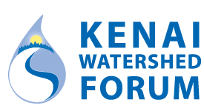

**Prepared by:**

Benjamin Meyer

Environmental Scientist

Kenai Watershed Forum

(907) 260-5449 x1207

www.kenaiwatershed.org

The Kenai Watershed Forum (KWF) is a 501(c)(3) non-profit and is recognized as the regional watershed organization of the Kenai Peninsula, successfully identifying and addressing the environmental needs of the region by providing high quality education, restoration and research programs. KWF is a dynamic organization dedicated to protecting the streams, rivers, and surrounding communities on the Kenai Peninsula.

Contents

list of figures iii

list of Tables iii

Purpose 4

Acronyms & Abbreviations 5

Introduction 6

Methods 7

Copper and zinc sampling 7

Kenai River Baseline Water Quality Monitoring (KRBWQM) 7

Copper and zinc-specific sampling events 8

Sample Accuracy and Precision 8

2019 Hardness values 8

Mapping potential sources of copper and zinc 9

Potential sources on the Kenai River 9

Potential sources throughout the Kenai River watershed 9

RESULTS 9

Copper and zinc sampling 9

Copper 9

Zinc 10

Variation among replicate samples 10

Mapping potential sources of copper and zinc 10

Potential sources on the Kenai River mainstem 10

Potential sources throughout the Kenai River watershed 10

DISCUSSION 11

Copper and zinc sampling 11

Copper 11

Zinc 11

Variation among replicate samples 12

Potential Drivers of copper and zinc exceedances 12

Mapping potential sources of copper and zinc 13

Potential sources on the Kenai River 13

Potential sources throughout the Kenai River watershed 14

CONCLUSION 14

From information to action 15

Data availability 15

References 16

appendix a: figures 17

appendix B: Tables 23

# list of figures

Figure 1. Division of the Kenai River watershed (lower, middle, and upper Kenai River) 15

Figure 2. 2019-2020 sampling locations 16

Figure 3. Kenai River mainstem sites copper concentrations and criterion values. 17

Figure 4. Kenai River tributary sites copper concentrations and criterion values. 18

Figure 5. Kenai River mainstem sites zinc concentrations and criterion values. 19

Figure 6. Kenai River tributary sites zinc concentrations and criterion values. 20

# list of Tables

Table 1. ADEC water quality standards and calculations.. 22

Table 2. Sampling site coordinates 23

Table 3. Instances where zinc and copper data differs from paired calcium and magnesium data. 24

Table 4. Copper and zinc levels and hardness-dependent criterion standards. 25

Table 5. Relative difference levels of duplicate samples by site and date 28

Table 6. Average hardness values for 2000 – 2014 29

# list of acronyms

**ADF&G** - Alaska Department of Fish & Game

**ADEC** - Alaska Department of Environmental Conservation

**CWA** - Clean Water Act

**EPA -** United States Environmental Protection Agency

**KPB** - Kenai Peninsula Borough

**KPFHP** - Kenai Peninsula Fish Habitat Partnership

**KRBWQM** - Kenai River Baseline Water Quality Monitoring

**KRCMP** - Kenai River Comprehensive Management Plan

**KRSMA** - Kenai River Special Management Area

**KWF** - Kenai Watershed Forum

**QAPP** - Quality Assurance Project Plan

**RPD** – Relative Percent Difference

**USFS -** United States Forest Service

**USGS** - United States Geological Survey

# Purpose

This field report highlights efforts conducted to assess levels of copper and zinc, as well as to their potential sources in surface water throughout the Kenai River watershed. These efforts are intended to complement and respond to the literature review submitted to ADEC in 2017 by the Kenai Watershed Forum under ACWA grant 17-06 ([KWF, 2017](https://dec.alaska.gov/media/16761/kenai-river-zinc-and-copper-pollution-study.pdf)). This field report will address the following questions:

1. What are the copper and zinc levels at specific water monitoring locations throughout the Kenai River watershed during spring and summer 2019-2020 sampling events?
2. Where are elevated levels copper and zinc occurring throughout the Kenai River watershed during spring and summer 2019-2020 sampling events?
3. What is the status of mapping efforts of potential copper and zinc sources on the Kenai River and throughout its watershed?

# **Introduction**

The Kenai River is a glacially-fed system located on the Kenai Peninsula. This 82-mile river begins at the outlet of Kenai Lake and flows into the Cook Inlet, a branch of the Gulf of Alaska. Due to its size, the Kenai River is generally divided into three sections: the upper river (Cooper Landing at river mile [RM] 82 to Skilak Lake at RM 65), middle river (RM 50 at the outlet of Skilak Lake to RM 21 in Soldotna at the Sterling Highway bridge), and lower river (RM 21 to RM 0 at the mouth in the city of Kenai). Several major glacial and non-glacial tributaries flow into the Kenai River (Figure 1).

The Kenai River watershed plays host to millions of Pacific salmon that utilize its waters for rearing and spawning habitat. These salmon are critical to Alaskan economy, recreation, and culture. As a result, the Kenai River watershed is a priority for conservation efforts, as it experiences significant anthropogenic pressures throughout the year. Over 20 years ago the Kenai Watershed Forum (KWF) identified a need for monitoring water quality parameters often influenced by development, impervious surfaces, boat use, and other sources. KWF established the Kenai River Baseline Water Quality Monitoring (KRBWQM) program in 2000 to track water quality changes over time. Thirteen sites were chosen along the Kenai River mainstem and in its major tributaries with the intention of providing information on overall watershed conditions twice per year (Figure 1). Since inception a broad suite water quality parameters have been measured biannually including the metals copper, zinc, lead, arsenic, and others; nutrients such as phosphorus and nitrogen; hydrocarbon pollutants; fecal coliform bacteria; and intrinsic parameters such as pH, turbidity, conductance, and temperature. An increase in copper and zinc concentrations was identified from 2010 through 2014 relative to previous sampling years (KWF, 2015 and 2017), warranting further investigation and more intensive monitoring for these metals.

Metals interacting with aquatic organisms often exhibit greatest toxicity when in the dissolved phase (Gerhardt, 1993), and can have harmful effects on Pacific salmon and their habitat. Elevated levels of copper can lead to toxic effects on a salmon’s olfactory function, which is critical for survival and migratory success (Baldwin et al, 2003). Chinook salmon (*Oncorhynchus tshawytscha*) have shown increased susceptibility to mortality from elevated zinc levels during early life stages-a critical period of time in development (Chapman, 1978). Copper and zinc exceedances are identified when their levels are compared to a hardness-dependent freshwater criterion chronic concentration (CCC), which varies with calcium and magnesium concentration (Table 1; ADEC 2008). Hardness is used to calculate aquatic toxicity criteria for many dissolved metals because magnesium and calcium compete for metals binding sites on the fish gill (Galvez et al., 1998).

Through grant funds provided through the Alaska Department of Environmental Conservation (ADEC) and matching funds from KWF, KWF identified four tributary and three mainstem sites in addition to the standard biannual KRBWQM sampling sites throughout the Kenai River watershed for supplemental sampling in the springs and summers of 2019-2020 (Figure 2). This report presents results from both biannual KRBWQM events in 2019-2020 as well as the supplemental sampling events. Additional efforts to identify potential sources of metals throughout the Kenai River watershed were initiated in 2019-2020 and are reported here. As part of an ongoing mapping effort, five river trips were conducted in order to photograph potential zinc and copper sources visible from the Kenai River mainstem. Remote sensing techniques are being applied to identify potential sources not visible from the mainstem. These photos and data are being incorporated into a GIS shapefile established to document other adjacent potential sources of these heavy metals including impervious surfaces, boat landings, and wastewater discharge. Mapping efforts are ongoing and will be completed in early 2021.

# **Methods**

## Copper and zinc sampling

Water sampling efforts in 2019-2020 targeted sites that have been monitored biannually since the year 2000 as part of the Kenai River Baseline Water Quality Monitoring (KRBWQM) project, as well as new additional sites targeted to explore spatial trends in copper and zinc concentrations (referred to here on as “Copper and zinc-specific sampling events.” In total, water samples were taken from ten ~~additional~~ sites on the Kenai River mainstem and nine tributary sites (Figure 1).

Note: all river miles listed throughout document are in reference to the Kenai River mainstem. River miles listed for tributaries reference their confluence river mile on the mainstem of the Kenai River. Sampling site names were chosen based on sampling location; their corresponding river miles can be found in Table 2.

### Kenai River Baseline Water Quality Monitoring (KRBWQM)

Kenai Watershed Forum conducted biannual KRBWQM events in 2019 and 2020. Sampling events are of a cooperative nature and require the participation and/or financial contributions of several agencies and organizations including:

* Alaska Department of Fish and Game
* City of Kenai
* City of Soldotna
* Cook Inlet Aquaculture Association
* Alaska Department of Environmental Conservation
* Alaska Department of Natural Resources
* Kenai Peninsula Borough
* Kenai Watershed Forum
* United States Fish and Wildlife Service
* United States Forest Service
* Local Kenai Peninsula volunteers

Due to logistical and safety constraints as a result of the COVID-19 pandemic, spring sampling did not occur in 2020.

Sites in the KRBWQM sampling program were originally selected to represent the Kenai River watershed's ambient water quality conditions. Samples from 2019-2020 presented in this report were analyzed for zinc, copper, calcium, and magnesium concentrations. Sample locations are reported in Table 2, and sample dates are included in Table 3.

After a training session, sampling participants were split into small groups and sampled 2-5 sites by foot or boat. Sample collection timing coincided with an outgoing tide to reduce potential saltwater contamination of samples in the lower river. Individuals collecting samples by foot waded into the water until the water depth was approximately two feet and the participant was offshore in flowing water while still maintaining personal safety. For sites accessed by boats, water samples were taken from the bow while the boat faced upstream. Prior to sampling, all bottles were labeled with site and river mile; sampling team name; date and time; and parameter. Samples were collected by facing upstream, wearing clean gloves, removing the bottle seal, inverting the bottle and plunging it approximately one foot below the water surface. The bottle was then turned 90 degrees to allow water to fill at that depth All bottles were stored in insulated coolers with ice packs to keep at 4ºC and shipped via Grant Aviation to Anchorage. They were retrieved and analyzed by SGS North American, Inc (Anchorage, AK) within the holding time of each sample. Copper and zinc analyses were performed by SGS in Anchorage, while calcium and magnesium analyses were performed by ALS Environmental of Kelso, WA. These procedures follow the protocols established in a Quality Assurance Project Plan (QAPP) originally approved by ADEC in 2001, later revised and approved by ADEC again in 2013 and 2019 (KWF, 2019). Results for copper, zinc, calcium, and magnesium concentrations were reported digitally; data entry and management was done in Microsoft Excel and R Studio. Hardness and hardness-dependent freshwater CCC criteria were calculated using ADEC-provided equations shown in Table 1(ADEC, 2008).

### Copper and zinc-specific sampling events

In addition to the long-running biannual KRBWQM sampling events, in 2019 and 2020 KWF staff and volunteers also conducted sampling specifically focused on copper and zinc. Sample sites for these events included four sites in the upper reaches of tributaries and three mainstem Kenai River locations not regularly targeted in previous years (Figure 2).

Tributary sites were selected based on their historically-elevated levels of copper and/or zinc (KWF, 2015) as well as their location above most potential anthropogenic influence. On the Kenai River mainstem, the Slikok Creek confluence site was chosen in order to compare the levels of copper and zinc found in the mainstem to those within the Slikok Creek tributary. The Skilak Lake outlet and Jim's Landing sites were chosen as control sites as they are located upstream of the majority of development along the Kenai River and would provide relative background levels away from most anthropogenic influence. Jim's Landing is a designated boat launch utilized solely by recreationists using drift-only (non-motorized) boats. All sampling procedures aligned with the ADEC-approved 2019 Quality Assurance Project Plan (KWF, 2019). Results for copper, zinc, calcium, and magnesium concentrations were reported digitally; data entry and management was done in Microsoft Excel and R Studio. Hardness and freshwater CCC values were calculated using ADEC-provided equations shown in Table 1(ADEC, 2008).

### Sample Accuracy and Precision

To explore the degree to which an individual grab sample is representative of copper and zinc concentrations, a total of fifteen replicate samples were collected and analyzed from sampling events in 2019-2020. Replicate samples were collected by the same personnel, with identical technique, within five minutes of each other. Relative percent difference (RPD) between replicates was calculated from the resulting values of each metal analyzed and described in the QAPP data quality objectives.

### 2019 Hardness values

As standard practice, zinc and copper data is synchronous in space and time with paired calcium and magnesium data used to generate hardness and associated CCC values. However, for a total of four sites in two sampling events (May 22, 2019 and July 24, 2019), calcium and magnesium data was not available. Thus for these events CCC criteria were instead calculated using calcium and magnesium results obtained from other sampling events on April 30, 2019 and July 30, 2019, respectively (see Table 3 for details). At sites where no calcium and magnesium data was available, data from the nearest downstream site was applied to generate CCC values (Figure 2, Table 3).

In order to evaluate the relevance of spatially asynchronous hardness values in some instances, an average of spring and summer hardness levels were calculated using data collected from 2000-2014 (Table 6). These averages are intended to be used as reference to which hardness values calculated that used asynchronous data can be compared. At one site (Slikok Creek – Kenai River confluence) that lacked calcium and magnesium data on May 22, 2019 and July 24, 2019, long-term calcium and magnesium values were not available because the site is typically not included during the biannual sampling program, thus 2019 hardness data from other sampling events were not applied this site.

## Mapping potential sources of copper and zinc

### Potential sources on the Kenai River

Throughout the summer of 2019, five photography trips were conducted by raft or motorboat along all sections of the Kenai River mainstem to document parcels containing potential copper and zinc sources. This task was completed using Ricoh WG-6 digital cameras, which were equipped with GPS and aspect functionality. Two photographers took photos of each parcel with a potential metal source; one photographer was assigned the river-right (RL) bank while the other was assigned the river-left (RL) bank. Photos were taken directly out from the potential source, perpendicular to the bank of the river. Side channels diverting from the mainstem of the Kenai River were floated or boated as well. The geotagged photos can serve as a reference for future work beyond the scope of this report to identify locations and assess potential sources of copper and zinc in greater detail, and also serve as an archival set of observations to compare future photo transects.

### Potential sources throughout the Kenai River watershed

A literature review conducted by KWF in 2017 identified potential sources of copper and zinc throughout the Kenai River watershed. General copper sources included brake pads/vehicles, pesticides/herbicides, roofing/metal plating, mining activity, boat hull coatings/anti-fouling agents, municipal wastewater discharge, natural mineral deposits, forest fires, air emissions, and decking/pilings (KWF, 2017). Similarly, general zinc sources included galvanized metals, tire wear, motor oil/hydraulic fluid, fertilizer/pesticides/fungicides, natural mineral deposits, mining activity, forest fires, and brakes (KWF, 2017). Using results from the literature review, KWF contracted with St. Mary’s University Geospatial (Winona, MN) to curate and prepare all available regional geospatial data potentially related to nonpoint sources of copper and zinc. All layers found were converted to a consistent projection and geodatabase format. Gaps in geospatial data availability that would likely be needed to fully assess copper and zinc sources were also identified in the report from St. Mary’s University Geospatial Services.

# **RESULTS**

## Copper and zinc sampling

Note: all metals results are reported as dissolved metal concentrations.

### Copper

Copper levels ranged from a low of undetected to values that were elevated yet still below CCC criterion values. A high of 8.16 ug/L was observed in the Kenai River mainstem at the Slikok Creek Confluence on July 24, 2019. CCC values were not available for this sampling event, but based on CCC values from other nearby 2019 sampling events on the main stem Kenai River, the observation could be indicated as a potential, but unconfirmed, exceedance (see “Copper” in the discussion section for further consideration and discussion).

The second greatest copper concentration in the data set, 3.91 µg/L, was observed at Upper Beaver Creek tributary on April 30, 2019, with other notably elevated observations also made at the City of Kenai Docks (July 21, 2020) and Upper No Name Creek sites (May 22, 2019). Hardness-dependent freshwater CCC criteria for copper ranged from a low of 2.31 µg/L (various sites) to a high of 121.31 µg/L at No Name Creek (July 21, 2020) (Table 2). No confirmed copper exceedances were observed during any of the sampling events in 2019-2020 (Figure 3 and Figure 4).

For both tributary and mainstem sites, the highest copper values observed were in the lower Kenai River region, closer to the developed Kenai/Soldotna area. Copper values > 2.5 µg/L were observed at the City of Kenai Docks mainstem site, in No Name Creek, and in Beaver Creek. All other copper values in the 2019-2020 dataset were below 2.5 µg/L.

### Zinc

Zinc values ranged from a low of undetected to a high of 159.0 µg/L in Upper No Name creek on May 22, 2019. Hardness-dependent CCC values for zinc ranged from a low of 21.1 µg/L in Upper No Name Creek on May 20, 2020 to a high of 315.8 µg/L on April 20, 2019 at the City of Kenai Docks. Additionally, two observed zinc CCC values were several multiples above the range of typical data and are presumed unlikely to be representative of actual conditions:

* Zinc CCC = 1069 µg/L at Lower No Name on July 21, 2020 (Zinc CCC range at this site, 2014 – 2018, is 6.64 – 69.22 µg/L)
* Zinc CCC = 628 µg/L at City of Kenai Docks on April 30, 2019 (Zinc CCC range at this site, 2014 – 2018, is 11.09 – 105.76 µg/L).

Zinc exceedances of CCC criterion values were observed for a total of twelve samples. Zinc exceedances were observed at tributary sites including Upper No Name Creek, Lower Beaver Creek, Upper Beaver Creek, Lower Slikok Creek, Upper Slikok Creek, and Lower Soldotna Creek (Figure 5). Zinc exceedances in mainstem sites were observed at Cunningham Park, Upstream of Beaver Creek, Pillars, Soldotna Bridge, and Swiftwater Park (Figure 6).

As with copper, elevated zinc values were observed solely in closer proximity to the developed Kenai/Soldotna area. Zinc exceedances were not observed at the minimally anthropogenically-influenced sites of Jim’s Landing, Skilak Lake Outlet, or Lower Funny River.

In the mainstem Kenai River sites, all zinc exceedances observed occurred during the April 30, 2019 sampling event, whereas timing of zinc exceedances in the tributary sites were variable and do not follow a visibly evident pattern.

### Variation among replicate samples

A total of fifteen unique samples had associated copper and zinc replicate values, from ten unique sites and seven unique dates. A relative percent difference of > 20% among replicate samples was observed in eleven out of thirty instances, ranging from 0% - 175% (Table 5), with a mean difference of 38.9 ±13.6% (mean ± standard error) for copper and 34.8 ± 14.3% for zinc. The QAPP set a relative percent difference for replicate samples of 20%, indicating that these eleven samples did not meet data quality objectives and the results should be flagged, interpreted conservatively, or not used to calculate long-term summary values.

## Mapping potential sources of copper and zinc

### Potential sources on the Kenai River mainstem

In total, 932 photos were taken of river-right parcels and 899 photos of river-left parcels with potential copper and zinc sources. These photos have been imported into ESRI’s ArcMap GIS program and converted to a point layer shape file. Photos included locations with elevated, light-penetrating walkways; building roofs; impervious surfaces such as roads and parking lots; significant bank erosion; boat launches; bridges; and RV parks. The photos shape file of geotagged photos is intended to serve as an archival document of potential point sources of copper and zinc pollution, and may be useful to compare to similar transects in future years. The photos shape file may be particularly useful in the context of the additional GIS products described below.2

### Potential sources throughout the Kenai River watershed

The final report from St. Mary’s University Geospatial Services describes a collection of fourteen data sources useful for identifying potential sources of zinc and copper pollution. Listed below are all relevant datasets included:

* Traffic Counts
* Bridges, Gates, Culverts
* Digital Raster Graphics
* Facilities
* Fire Locations
* Fire Perimeters
* Land Cover
* Material Sites
* Mining Claims
* Oil and Gas leases
* Parcel Boundaries
* Railroads
* Waterways
* Wells

The above datasets were compiled into ArcGIS file geodatabases and contain potentially relevant information about heavy metal pollution nonpoint sources. Each geodatabase’s download metadata was recorded in an Excel spreadsheet table identifying a link, date of creation, type of potential pollution source, and if the source covers the entire study area. Datasets were maintained in their native extent in order to encompass all tributaries transporting water into the Kenai River main stem.

Data gaps were also identified and included the following:

* Impervious surfaces
* Galvanized metal surfaces
* Natural mineral deposits
* Snow storage locations
* Stormwater systems

# **DISCUSSION**

## Copper and zinc sampling

### Copper

No copper exceedances of hardness-dependent toxicity criteria were observed throughout the 2019-2020 sampling events. The most elevated copper value (8.16 ug/L) was observed on July 24, 2019 in the Kenai River mainstem at the Slikok Creek confluence. While a CCC value was not available for this sampling event, a comparison to copper CCC values at the two nearest mainstem sites downstream on July 21, 2019 (Poacher’s Cove, CCC = 4.55 ug/L) and upstream (Soldotna Bridge, CCC = 4.52 ug/L) (Table 2) suggests that copper may have exceeded the toxicity criterion for this sampling event. Copper results at this site in 2020 (0.372 – 0.515 ug/L) were substantially lower. Due to the range of data observed in Slikok Creek and its proximity to potential anthropogenic sources, more intensive monitoring is warranted, including longitudinal survey(s) and/or more frequent sampling along with examination of potential point sources within the watershed.

Other elevated copper samples include those from Upper No Name creek and Lower Beaver Creek during spring 2019, likely the product of the rapid flush of nutrients and sediment associated with the spring snow melt freshet. Data to identify the seasonal patterns within 2020 was unavailable, as spring sampling did not occur that year. Notably elevated copper samples were also observed at the City of Kenai Docks sites on July 24, 2019 and July 21, 2020, which could potentially be associated with precipitation trends leading up to that date, although this mechanism has not yet been studied for this dataset.

Annual sampling for copper will continue at these and other sites in order to monitor for future exceedances or trending changes over time.

### Zinc

Zinc exceedances of hardness-dependent toxicity criteria in 2019-2020 were observed throughout the sampling area in 2019-2020, including six of nine tributary sites and five of ten mainstem sites. Zinc exceedances suggested clear spatial trend.. Exceedances were observed primarily in the lower and estuary sections of the Kenai River (river mile 0 to 23, Figure 1), the segment of river that flows through the highest concentration of development within the Kenai River watershed. Located throughout these developed areas are numerous potential anthropogenic sources of copper and zinc, including impervious surfaces, tire and break dust, motor oil, fertilizer and pesticides (KWF, 2017). No exceedances were observed at Jim’s Landing, Skilak Lake Outlet, or Lower Funny River, sites which have minimal potential for anthropogenic influence.

(Temporal trends…) The sampling event on April 30, 2019, where zinc exceedances were simultaneously observed at three tributary and five mainstem sites, suggests a region-wide meteorological process such as snowmelt or precipitation helped to drive the elevated concentrations and warrants further investigation.

Annual sampling for zinc will continue at these and other sites in order to monitor for future exceedances or trending changes over time.

### Variation among replicate samples

The project QAPP requires data verification by examining variation among replicate samples compared to the actual samples and calculating the relative percent difference. In 2019-2020, outcomes revealed that data from instantaneous grab samples should be interpreted with some moderation. The average difference between replicates for both copper and zinc was in the range of ±35% (Table 5). In two of the fifteen replicate pairs (Lower Slikok Creek April 30, 2019 and Upper Slikok Creek May 20, 2020), one replicate was above the zinc CCC threshold while the other was below (Figure 6).

The issue of sample precision could be addressed with several approaches, some which would involve modifying field and lab protocol and others that would not. One suggestion is to interpret and present CCC thresholds in future analyses in such a way that accounts for the inherent variation of instantaneous grab samples, assigning an error range to each copper and zinc result based on all replicate data available from 2000 – 2020. Additionally or alternatively, future field efforts may modify field and lab protocol to increase accuracy and precision. Further literature review and consultation with other local experts may yield additional solutions and resulting modifications to the quality assurance plan.

### Potential Drivers of copper and zinc exceedances

Some examination of trends in metals concentrations in the Kenai River watershed (KWF, 2015) and their probable sources (KWF, 2017) has been previously conducted, revealing more frequent exceedances in the lower river region. However, a conclusive analysis including both spatial and temporal factors driving likelihood of toxicity criteria exceedance has yet to be performed. Such an analysis could leverage the uniquely robust twenty-year biannual Kenai River Baseline Water Quality Monitoring data set, along with other detailed meteorological, geographical, and biological data available for the region (e.g. Alaska EPSCoR, 2020). Decisively identifying the spatial and temporal factors driving metals concentrations would be of significant aid in prioritizing mitigation actions to reduce future exceedances.

A variety of both anthropogenic and natural factors drive likelihood of toxicity criteria. Spatial factors may include characteristics such as watershed size, percent of watershed impermeable area, quantity of known point sources in watershed, watershed slope, local geological characteristics, and others. Temporal predictors may include factors such as precipitation prior to sample date, average stream flow volume, annual winter precipitation, and velocity of spring melt conditions. Results of a multivariate regression approach to conclusively identify predictors of exceedances would allow conservation-minded land owners and managers to most effectively identify locations and/or time periods where mitigation actions will be most effective. Once specific drivers of metals exceedances are identified, managers could work with members of area partnerships to develop site-specific mitigation plans involving strategic solutions such as phytoremediation tactics, riparian restoration efforts, strategic development, wetland preservation, and watershed user and landowner education.

Examination of the long-term dataset could also potentially reveal if interventions already applied have successfully mitigated some copper and zinc runoff, as recommended in recent Alaska Department of Environmental Conservation strategy documents (ADEC, 2020b; section 2.4). A variety of restoration interventions have been applied throughout the lower Kenai River basin to reduce the impact of urban runoff, including sedimentation basins, diffuser outfalls, and rain gardens (City of Soldotna, 2016). An examination of the location(s) and installation dates of these interventions and water quality downstream could reveal if they have been effective in reducing copper and zinc concentrations, both in the past and future years.

Some drivers of exceedances are evident in 2019-2020 data without the more detailed approach discussed above. For example, the annual spring melt event likely represents the most important driver of timing of elevated metals concentrations in spring, because the meltwater contains months of particulate accumulation collected throughout the winter months. Additionally, a period of precipitation following a long drought in summer is also a likely driver of spikes in metals concentrations, as accumulated particles are flushed into the watershed.

In addition to the need to identify intra-annual spatial and temporal drivers of exceedances, a need exists to examine duration of identified exceedances. It is unclear if the grab samples measured during typical sampling procedures represent concentrations that persist for hours, days, or weeks. In order to identify the typical duration of exceedances in watersheds where they are known to occur, it is advisable that metals are monitored throughout an expanded one-year period on a more frequent basis. For example, weekly or bi-weekly monitoring at select sites in the lower watershed region would help to pinpoint temporal drivers of exceedances. Opportunistic samples could also be collected leading up to, during, and after major precipitation and snow melt events. New field sampling techniques could offer substantial improvements in data quantity, quality, and project cost. For example, some recent evidence suggests conductance (total dissolved ions), which may be continuously monitored with sondes (e.g. Hydrolab), might serve as a proxy for metals concentrations (Morel et al., 2020). A field sampling program employing both traditional grab samples and continuously deployed sondes would provide insight as to which method is most economical and appropriate for long term monitoring efforts. In tandem with this field effort, longitudinal transects collected during the rising limb of the spring freshet in select tributaries could provide valuable insight into the geographic sources of copper and zinc. Insights gained from these efforts to characterize in-situ spatial and temporal trends would allow an enhanced interpretation of predicted biological effects of concern.

Additionally, further literature review is required in order to identify the predicted detrimental effects elevated copper or zinc can have on the juvenile salmon species that remain in lotic rearing habitat for multiple years, potentially presenting enhanced opportunity for bioaccumulation. New knowledge of the characteristics and effects of urban runoff pollution on freshwater aquatic communities are continuously being discovered (e.g., Tian et al. 2020), thus regular assessment of water quality monitoring priorities based on updated knowledge is critical.

### Mapping potential sources of copper and zinc

Mapping of potential sources of copper and zinc throughout the Kenai Watershed is an ongoing effort and will be completed in 2021. The final product will include a robust GIS mapping tool that will help identify potential sources of copper and zinc. This portion of the study will be concluded in 2021 with a final report further detailing area-specific sources of copper and zinc, advisable study expansions, and potential area-specific repercussions of elevated heavy metal levels.

### Potential sources on the Kenai River

The current shapefile that has been created includes photos taken of parcels with potential sources of copper and zinc along river-right and river-left. The attribute table corresponding to these photos will be further developed to include attributes such as the number of potential sources, types of potential sources, and parcel ID. This mapping tool could be used to identify areas experiencing significant change over time. It is advisable that these photography trips are conducted every 5-10 years in order to update this tool over time.

### Potential sources throughout the Kenai River watershed

Identifying potential sources of copper and zinc throughout the Kenai River watershed is an ongoing process. Current methods being employed to identify these potential sources include local knowledge, local contacts, and online searches. Additions to this map could also include critical rearing and/or spawning habitat for salmon, areas of copper and zinc exceedances, and geologic data. Once completed, this shapefile will be integrated with the photo shapefile described above. The final product may be used to identify areas that contain high concentrations of potential copper and zinc sources. In order to maintain relevance, Kenai Watershed Forum recommends that the data contained within this mapping tool is updated on an annual basis in order to track changes in development over time.

# **CONCLUSION**

This document is intended as a draft report addressing the findings from compiled copper and zinc data gathered during April, May, and July sampling events in 2019-2020. While the data collected throughout this study will provide further insight into the current sources and levels of copper and zinc throughout the Kenai River watershed, much of the temporal variation and point sources of these heavy metals remains to be characterized. As a result, the following preliminary study expansions are advised:

1. **Perform a basic exploratory data analysis to summarize all available water quality data from 2000 – 2020 and apply results**
   1. Ensure all data 2000 - 2020 is archived and available for public access through the EPA water quality portal
   2. Examine site-specific trends from 2000 – 2020 to identify spatial and temporal predictors of copper and zinc exceedance
   3. Using the identified predictors, choose a subset of watersheds where mitigation actions may be potentially feasible and appropriate
   4. Implement restoration and other mitigation efforts in tandem with local partnerships
2. **Expand copper and zinc sampling study through increased sampling of Kenai River mainstem and tributary sites**
   1. Assess fluctuations in copper and zinc levels over the period of one year, particularly at sites that saw exceedances:
      1. Tributaries: No Name Creek, Beaver Creek, Slikok Creek, Soldotna Creek
      2. Mainstem: from Cunningham Park (RM 6.5) to Swiftwater Park (RM 23)
   2. Expand sampling efforts along longitudinal transects in tributaries experiencing exceedances in order to identify areas of concern within each tributary
   3. Perform opportunistic sampling at known and suspected discrete sources before, during, and after select precipitation and melt events, at locations that may include storm water outfalls, road crossings, and outlets draining large impervious surfaces.
   4. Perform literature review on the topics of sample precision, monitoring for predicted effects of runoff pollution on aquatic organisms, and bioaccumulation of copper and zinc in salmonids and other fishes.
3. **Track changes in development throughout the Kenai River watershed to address anthropogenic impact over time**
   1. Conduct Kenai River photography trips every 5-10 years
   2. Monitor new development over time in order to conduct annual updates of mapping tool
4. **Expand awareness of educational programs for local landowners and watershed user groups including topics such as responsible river use and effective property restoration projects**

The Kenai River watershed boasts one of the longest term water quality datasets in the state of Alaska; an invaluable resource showing varying levels of copper and zinc that warrant further investigation in order to apply effective solutions.

### From information to action

As stream-adjacent development and subsequent development pressures increase along the Kenai River mainstem and its tributaries (Schoen et al, 2017), study expansion remains a critical step that would lead to effective, strategic mitigation efforts throughout this highly-revered watershed in Alaska. However, the knowledge gained from the study expansion will have utility only if successful, feasible mitigation strategies can also be demonstrated. The recommended post-hoc analysis discussed in the, “Drivers of copper and zinc exceedances,” section could be an important and achievable step towards this goal.

Additionally, a pilot project to install proven green infrastructure that filters many pollutants of concern would be a substantive step towards more widespread community adoption. Visible, proven success stories will encourage land managers and property owners to adopt green infrastructure practices both in mitigation actions and in new designs (e.g. ADEC, 2011). Such actions are in alignment with goals outlined in section 4.1in the City of Soldotna 2015 Soldotna Drainage Master Plan:

*“Use public facility development and operations to model sustainable design techniques, such as using green areas along roads for stormwater detention and treatment, maximizing retention of native vegetation, reducing the impermeable footprint of new development…” (City of Soldotna, 2016).*

Specifically, opportunistic monitoring could be performed below known sources or sources of untreated storm water outfall (ADEC, 2011) before, during, and after installation of mitigating infrastructure such as sedimentation basins, diffuser outfalls, rain gardens, bio-swales, or stream bank revegetation. While the study expansions described will help better define the most ecologically significant metals pollution exceedances, even prior to having its results and conclusions, streams may be targeted for mitigation wherever cooperative landowners are willing.

# **Data availability**

All data and analysis used to generate this report is available at <https://github.com/Kenai-Watershed-Forum/KWF_Metals_2019_2020>.

# **References**

Alaska Department of Environmental Conservation (ADEC). (2008). Alaska Water Quality Criteria Manual for Toxic and Other Deleterious Organic and Inorganic Substance. <https://dec.alaska.gov/water/water-quality/standards/>

Alaska Department of Environmental Conservation (ADEC). (2011). CWA Section 604(b) ARRA Project Highlight, Alaska: Green Infrastructure Alternatives Assessment and Planning.

Alaska Department of Environmental Conservation (ADEC). (2020a). 18 AAC 70 Water Quality Standards. <https://dec.alaska.gov/media/1046/18-aac-70.pdf>

Alaska Department of Environmental Conservation (ADEC). (2020b). Alaska Nonpoint Source Water Pollution Prevention and Restoration Strategy.

Baldwin, D. H., Sandahl, J. F., Labenia, J. S., & Scholz, N. L. (2003). Sublethal Effects of Copper on Coho Salmon: Impacts on Nonoverlapping Receptor Pathways in the Peripheral Olfactory Nervous System. Environmental Toxicology and Chemistry, 22(10), 2266–2274. doi: 10.1897/02-428

Chapman, G. A. (1978). Toxicities of Cadmium, Copper, and Zinc to Four Juvenile Stages of Chinook Salmon and Steelhead. Transactions of the American Fisheries Society, 107(6), 841–847.

Clesceri, L.S., Greenberg, A.E., Eaton, A.D. (Eds.). (1998). Standard Methods for the Examination of Water and Wastewater (20th ed.), Washington D.C. American Public Health Association, American Water Works Association, and Water Environment Federation.

Alaska EPSCoR (Established Program to Stimulate Competitive Research) Data Portal. (2020). <https://catalog.epscor.alaska.edu/dataset>. Accessed December 4, 2020.

Galvez, F., Webb, N., Hogstrand, C., Wood, C.M. (1998). Zinc binding to the gills of rainbow trout: the effect of long-term exposure to sublethal zinc. Journal of Fish Biology, 52(6), 1089 – 1104.

Gerhardt, A. 1993. Review of Impact of Heavy Metals on Stream Invertebrates with Special Emphasis on Acidic Conditions: Water, Air, and Soil Pollution, v. 66, 345-364.

Kenai Watershed Forum (KWF). (2015) Water Quality Assessment of the Kenai River Watershed from July 2000 to July 2014.

Kenai Watershed Forum (KWF). (2017). Kenai River Watershed Zinc and Copper Pollution: A Summary of Data Analysis, Literature Review Results, and Suggested Actions. <https://dec.alaska.gov/media/16761/kenai-river-zinc-and-copper-pollution-study.pdf>

Kenai Watershed Forum (KWF). (2019). Quality Assurance Project Plan: Kenai River Watershed Monitoring Program (3rd ed.). Alaska Department of Environmental Conservation.

Lewis, E. L. and Clark, M.L. (1997). How Does Streamflow Affect Metals in the Upper Arkansas River? U.S. Department of the Interior-U.S. Geological Survey.

Morel, C.J., Kaushal, S.S., Tan, M.L., Belt, K.T. (2020). Developing Sensor Proxies for “Chemical Cocktails”

of Trace Metals in Urban Streams. Water, 12, 2864, doi:10.3390/w12102864.

Schoen, E.R. and 15 others. (2017). Future of Pacific Salmon in the face of environmental change: lessons from one of the world's remaining productive salmon regions. Fisheries 42(10), 538–553. doi: 10.1080/03632415.2017.1374251.

Tian, T. and 26 others. (2020) A ubiquitous tire rubber–derived chemical induces acute mortality in coho salmon. Science. Published online Dec. 3, 2020. DOI: 10.1126/science.abd6951

# **appendix a: figures**

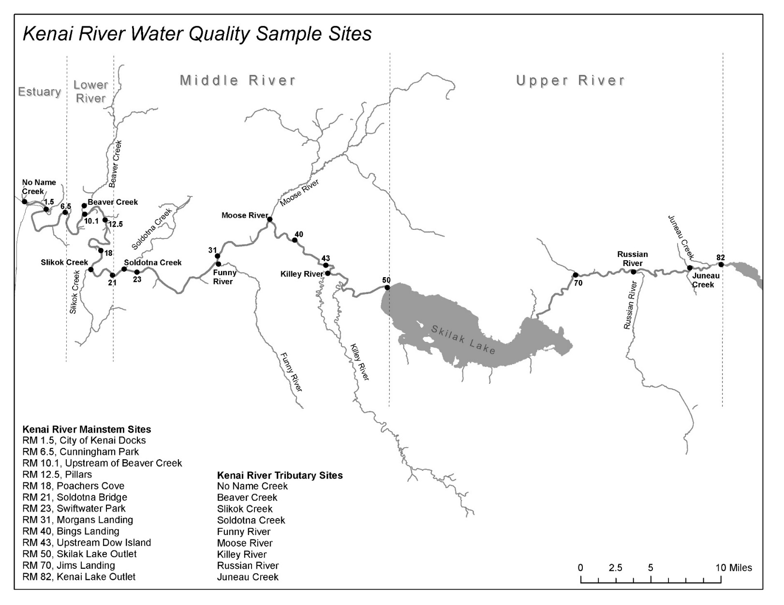

Figure 1. Division of the Kenai River watershed (lower, middle, and upper Kenai River) and water quality monitoring site locations during biannual (2000 – present) KRBWQM sampling events.

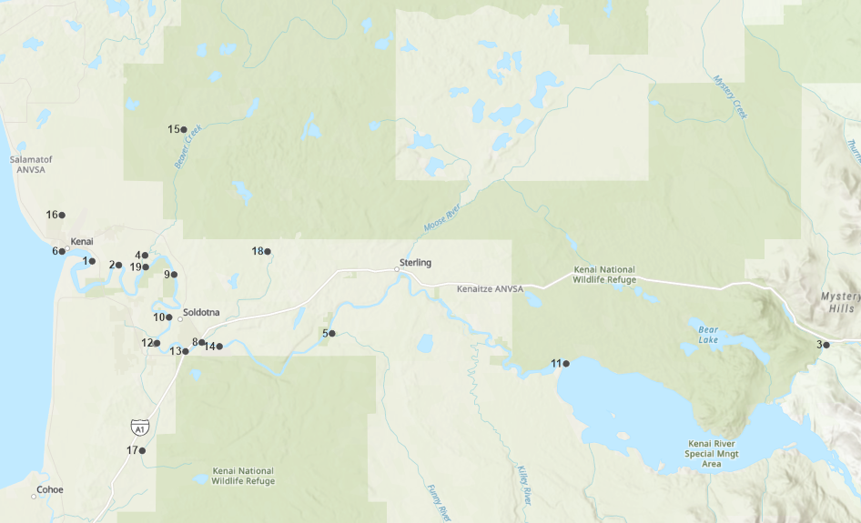 



Figure 2. 2019 - 2020 sampling locations. Sites newly included in 2019 – 2020 field sampling are noted with an asterisk (*). points 7 (Lower Slikok creek) and 12 (slikok confluence) are superimposed at this map scale.

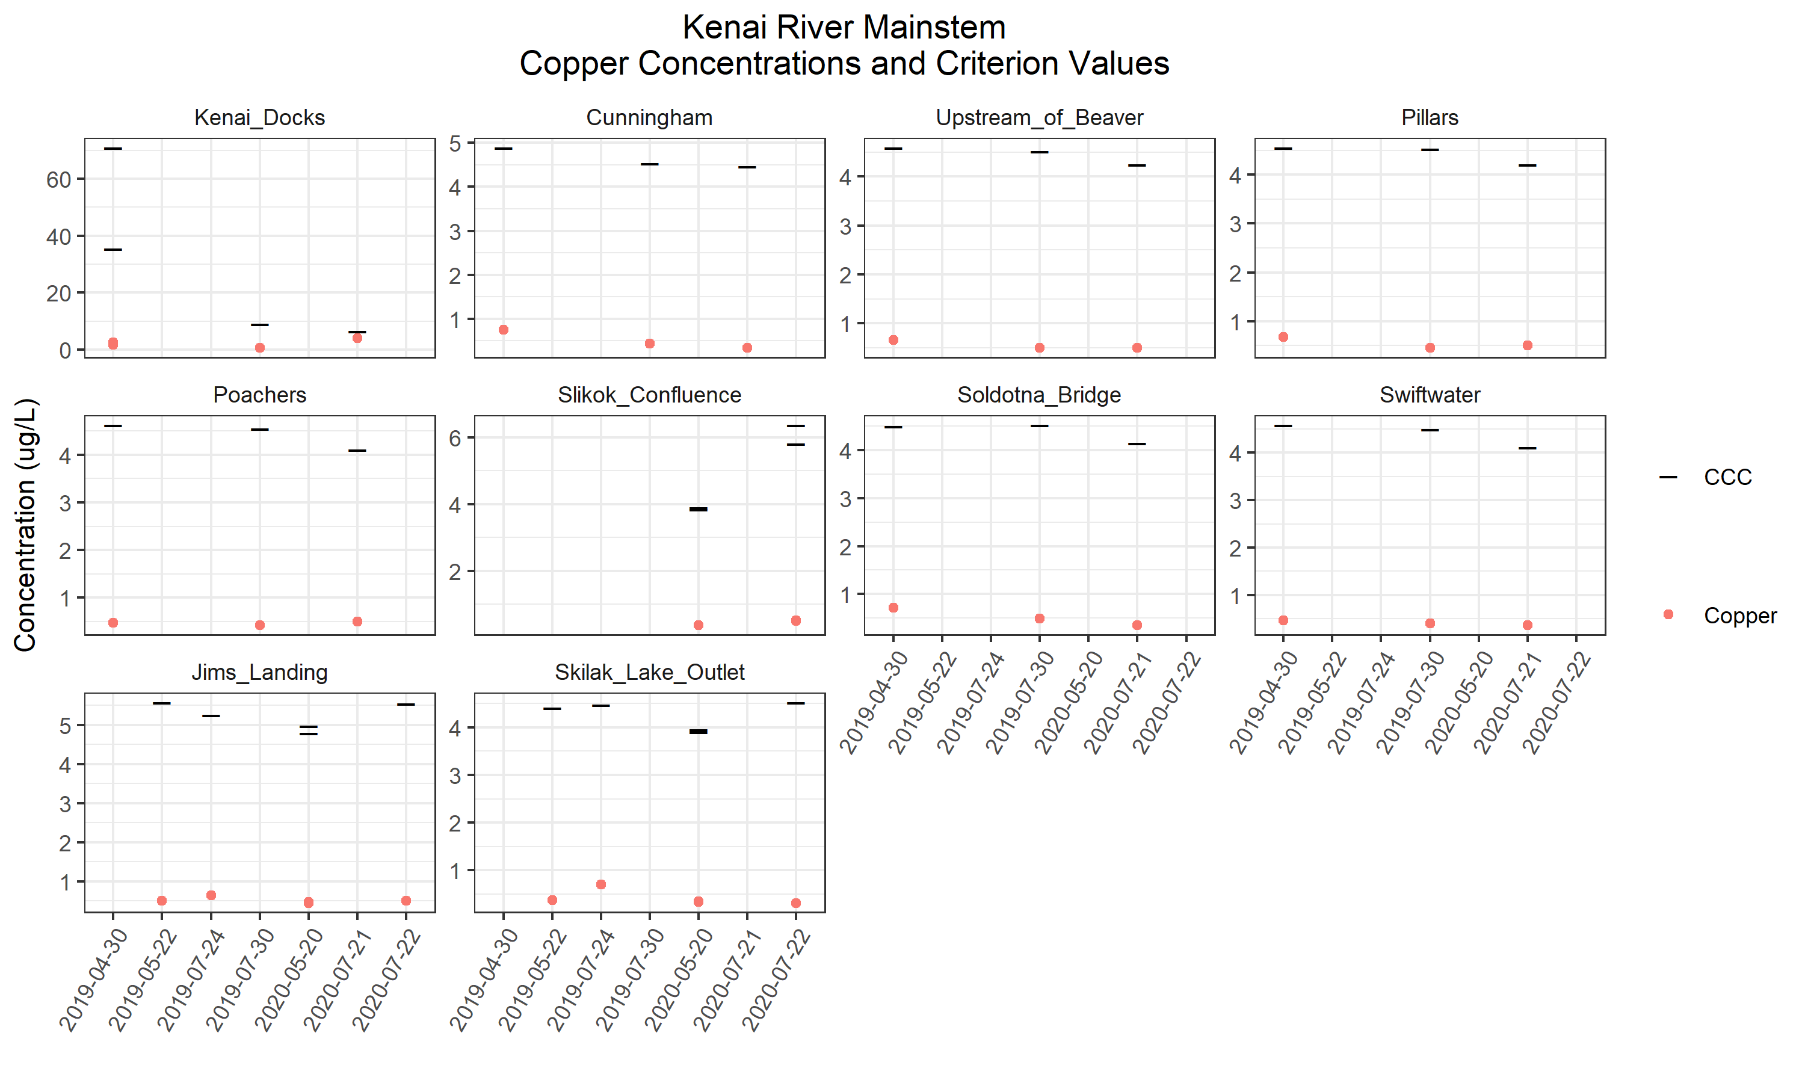

Figure 3. 2019-2020 Kenai River mainstem sites copper concentrations and criterion (CCC) values.

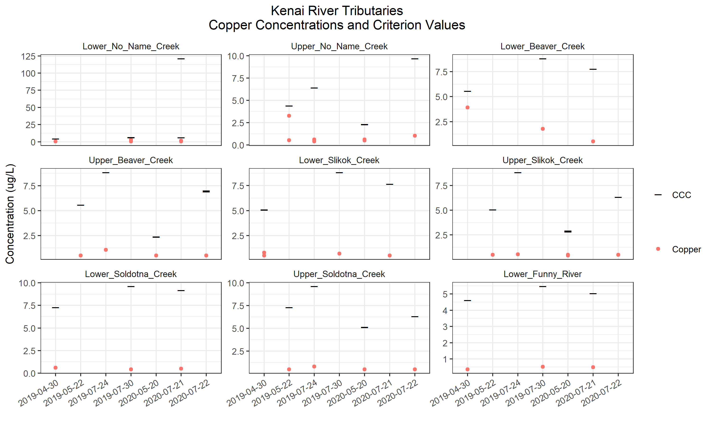

Figure 4. 2019-2020 Kenai River tributary sites copper concentrations and criterion (CCC) values.

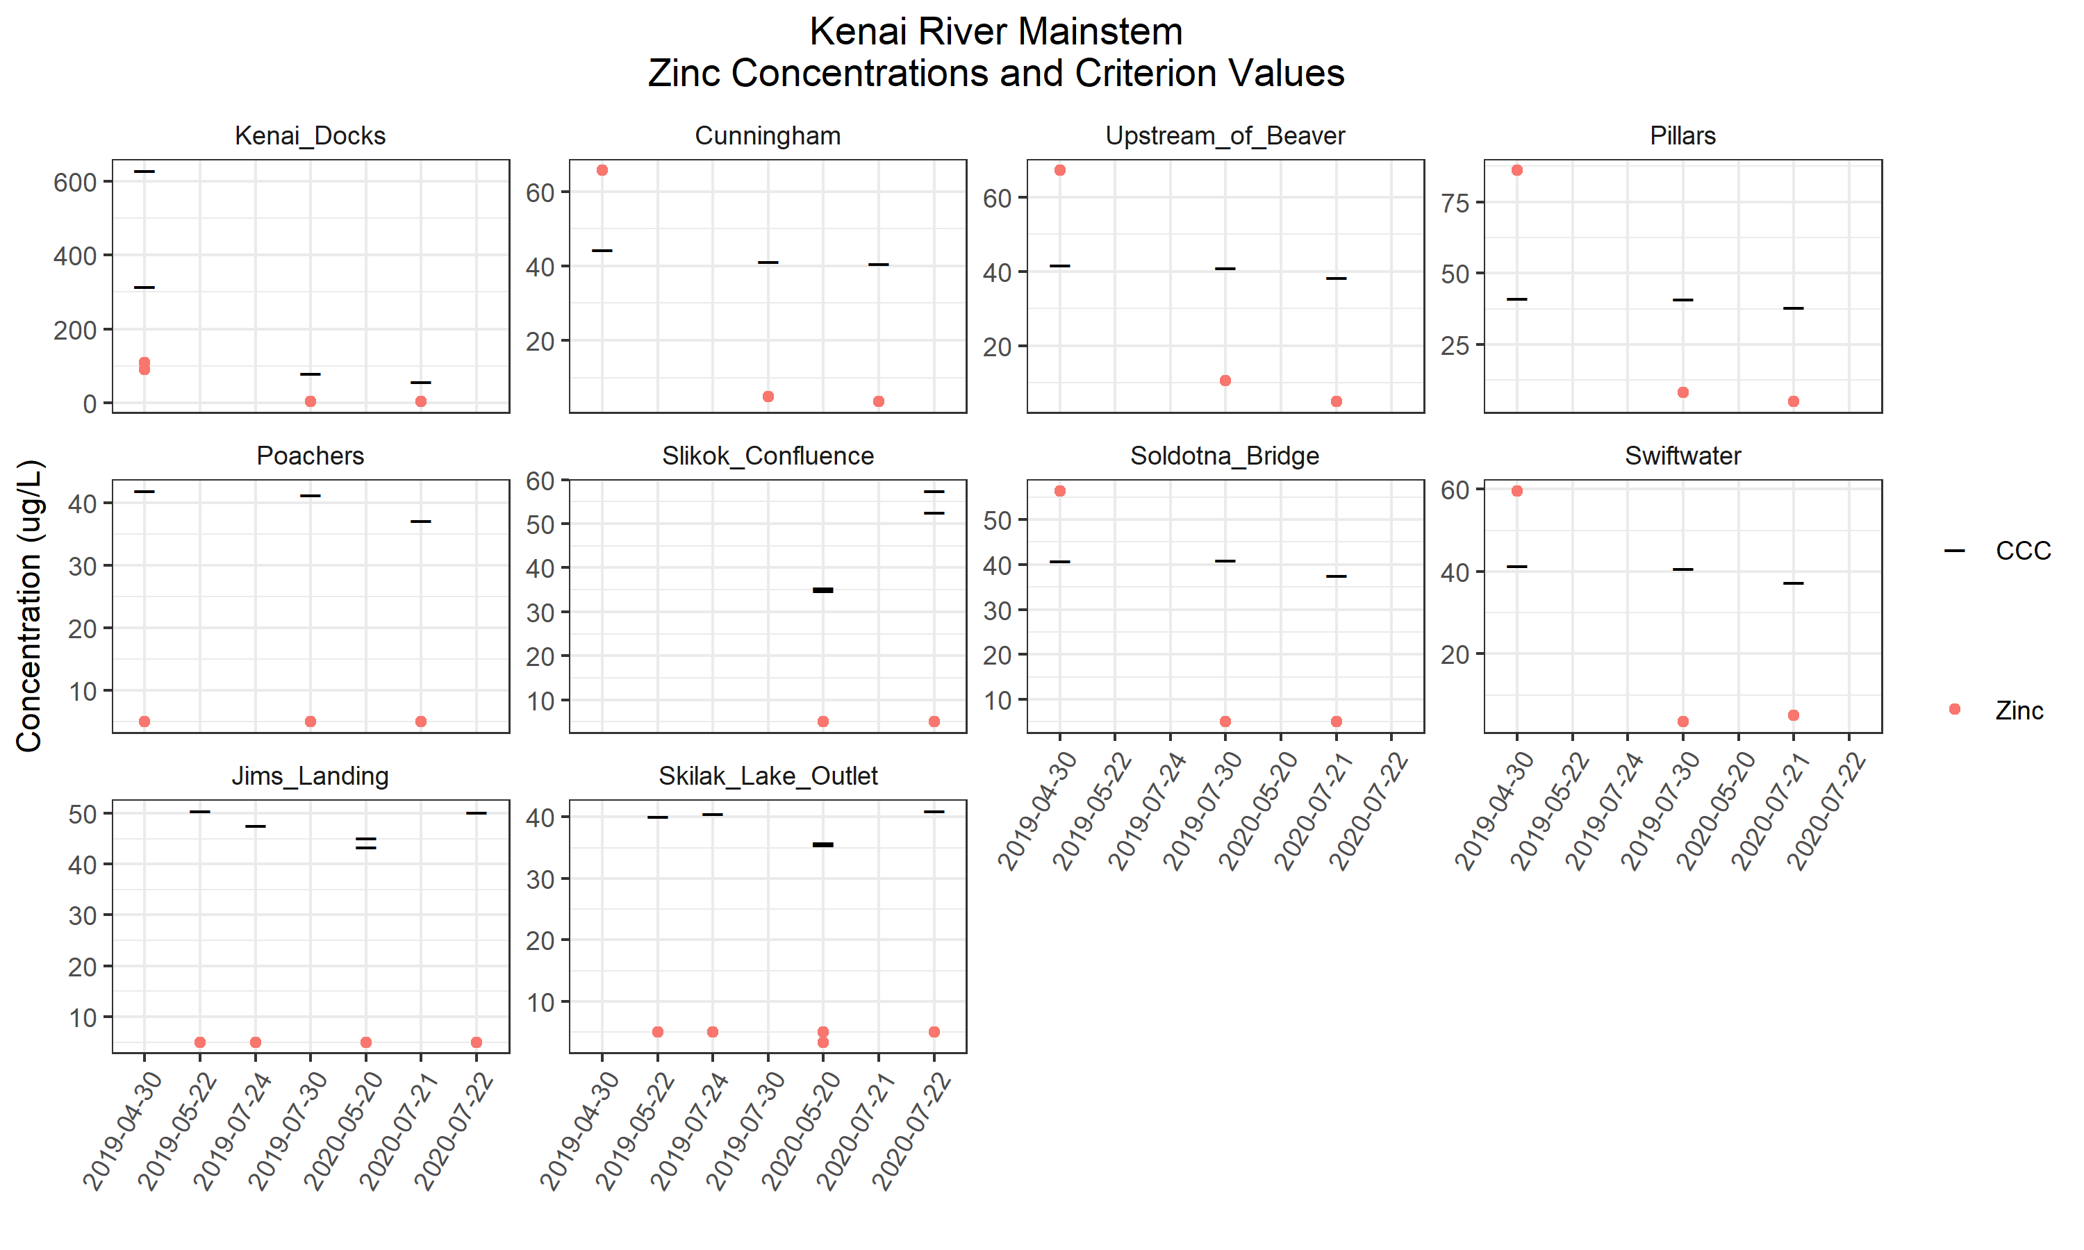

Figure 5. Kenai River mainstem sites zinc concentrations and criterion (CCC) values.

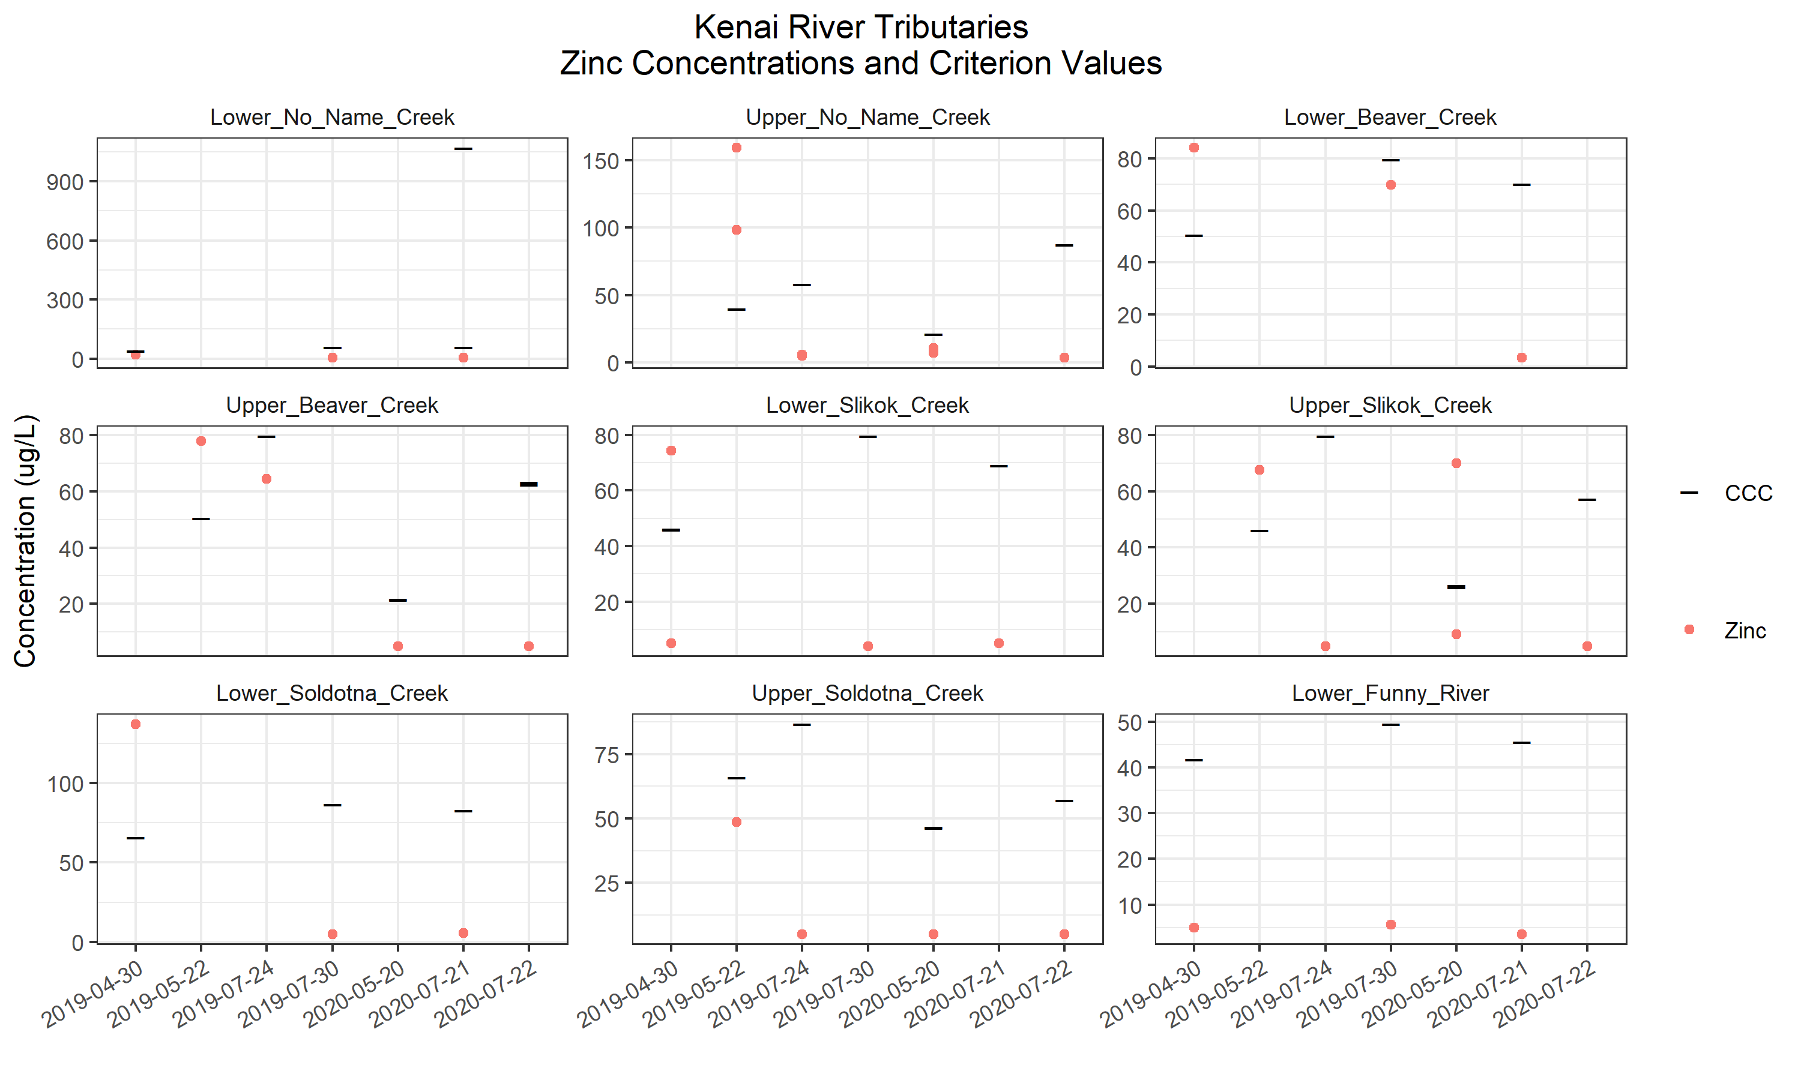

Figure 6. Kenai River tributary sites zinc concentrations and criterion (CCC) values.

# **appendix B: Tables**

Table 1. Alaska Department of Environmental Conservation water quality standards and pertaining calculations. (CCC = Criterion chronic concentration).

|  |  |  |
| --- | --- | --- |
| **Parameter** | **ADEC Standard** | **Reference** |
| **Copper** | CCC = (e0.8545(ln hardness*)-1.702)*0.96  for aquatic life, fresh water, and chronic exposure. | ADEC. (2008). Alaska Water Quality Criteria Manual for Toxic and Other Deleterious Organic and Inorganic Substances. |
| **Zinc** | CCC = (e0.8473(ln hardness*)+0.884)*0.986  for aquatic life, fresh water, and chronic exposure. | ADEC. (2008). Alaska Water Quality Criteria Manual for Toxic and Other Deleterious Organic and Inorganic Substances. |
| **Hardness\*** | Hardness = 2.497(Ca mg/L) + 4.119(Mg mg/L) | Clesceri, L.S., Greenberg, A.E., Eaton, A.D. (Eds.). 1998. Standard Methods for the Examination of Water and Wastewater (20th ed.), Washington D.C. American Public Health Association, American Water Works Association, and Water Environment Federation. |

Table 2. Sampling site coordinates.

|  |  |  |  |
| --- | --- | --- | --- |
| **Site** | **Habitat** | **Latitude** | **Longitude** |
| Lower No Name Creek | Tributary | 60.550888 | -151.26842 |
| Upper No Name Creek | Tributary | 60.577846 | -151.26859 |
| Lower Soldotna Creek | Tributary | 60.483364 | -151.05766 |
| Upper Soldotna Creek | Tributary | 60.550828 | -150.95833 |
| Lower Beaver Creek | Tributary | 60.548029 | -151.14324 |
| Upper Beaver Creek | Tributary | 60.641201 | -151.08472 |
| Lower Slikok Creek | Tributary | 60.482318 | -151.12705 |
| Upper Slikok Creek | Tributary | 60.402664 | -151.14739 |
| Lower Funny River | Tributary | 60.489963 | -150.86098 |
| City of Kenai Docks | Mainstem | 60.54368 | -151.22294 |
| Cunningham Park | Mainstem | 60.54081 | -151.18278 |
| Upstream of Beaver Creek | Mainstem | 60.539279 | -151.14226 |
| Pillars | Mainstem | 60.533743 | -151.09926 |
| Poacher's Cove | Mainstem | 60.502005 | -151.10697 |
| Soldotna Bridge | Mainstem | 60.476634 | -151.0821 |
| Slikok Creek Kenai River Confluence | Mainstem | 60.482752 | -151.12512 |
| Swiftwater Park | Mainstem | 60.480338 | -151.03085 |
| Jim's Landing | Mainstem | 60.481392 | -150.11502 |
| Skilak Lake Outlet | Mainstem | 60.467517 | -150.50779 |

Table 3. Instances where zinc and copper data differs from Paired calcium and magnesium data.

|  |  |  |  |
| --- | --- | --- | --- |
| **Copper/Zinc Sample Date** | **Copper/Zinc Sample Location** | **Calcium/Magnesium Sample Date** | **Calcium/Magnesium Sample Location** |
| May 22, 2019 | Upper No Name Creek | April 30, 2019 | Lower No Name Creek |
| May 22, 2019 | Upper Beaver Creek | April 30, 2019 | Lower Beaver Creek |
| May 22, 2019 | Upper Slikok Creek | April 30, 2019 | Lower Slikok Creek |
| May 22, 2019 | Upper Soldotna Creek | April 30, 2019 | Lower Soldotna Creek |
| July 30, 2019 | Upper No Name Creek | July 24, 2019 | Upper No Name Creek |
| July 30, 2019 | Upper Beaver Creek | July 24, 2019 | Upper Beaver Creek |
| July 30, 2019 | Upper Slikok Creek | July 24, 2019 | Upper Slikok Creek |
| July 30, 2019 | Upper Soldotna Creek | July 24, 2019 | Upper Soldotna Creek |
| May 22, 2019 | Slikok Creek – Kenai River Confluence | NA | NA |
| July 24, 2019 | Slikok Creek – Kenai River Confluence | NA | NA |

Table 4. (Page 1 of 3) Copper and zinc levels and hardness-dependent criterion standards.

|  |  |  |  |  |  |  |  |  |
| --- | --- | --- | --- | --- | --- | --- | --- | --- |
|  |  |  |  |  | **Copper** | | **Zinc** | |
| **Site name** | **River mile** | **Date** | **Location on Kenai River** | **Hardness (mg/L)** | **Result (ug/L)** | **Standard: CCC (ug/L)** | **Result (ug/L)** | **Standard: CCC (ug/L)** |
| Lower No Name Creek |  | 4/30/2019 | Tributary | 32.59 | 0.668 J | 4.40 | 21.3 | 39.92 |
| 7/30/2019 | Tributary | 51.22 | 0.451 J | 6.48 | 5.53 J | 58.56 |
| 7/21/2020 | Tributary | 49.86 | 0.5 U | 6.33 | 5 U | 57.24 |
| Upper No Name Creek |  | 5/22/2019 | Tributary | 32.59 | 0.53 J | 4.40 | 98.1 | 39.92 |
| 7/24/2019 | Tributary | 50.85 | 0.39 J | 6.44 | 5.12 J | 58.20 |
| 5/20/2020 | Tributary | 15.58 | 0.606 J | 2.34 | 10.9 | 21.36 |
| 7/22/2020 | Tributary | 82.32 | 1.04 | 9.71 | 3.46 J | 87.53 |
| Lower Beaver Creek |  | 4/30/2019 | Tributary | 43.06 | 3.91 | 5.58 | 84.1 | 50.55 |
| 7/30/2019 | Tributary | 73.65 | 1.77 | 8.83 | 69.9 | 79.66 |
| 7/21/2020 | Tributary | 63.36 | 0.509 J | 7.77 | 3.27 J | 70.12 |
| Upper Beaver Creek |  | 5/22/2019 | Tributary | 43.06 | 0.5 U | 5.58 | 77.80 | 50.55 |
| 7/24/2019 | Tributary | 73.65 | 1.07 | 8.83 | 64.40 | 79.66 |
| 5/20/2020 | Tributary | 15.7 | 0.5 U | 2.36 | 5 U | 21.5 |
| 7/22/2020 | Tributary | 56.16 | 0.5 U | 7.01 | 5 U | 63.31 |
| Lower Slikok Creek |  | 4/30/2019 | Tributary | 38.45 | 0.783 J | 5.07 | 74.4 | 45.93 |
| 7/30/2019 | Tributary | 73.58 | 0.684 J | 8.83 | 4.01 J | 79.60 |
| 7/21/2020 | Tributary | 62.29 | 0.5 J | 7.66 | 5 U | 69.12 |
| Upper Slikok Creek |  | 5/22/2019 | Tributary | 38.45 | 0.5 U | 5.07 | 67.60 | 46.22 |
| 7/24/2019 | Tributary | 73.58 | 0.53 J | 8.83 | 5U | 79.60 |
| 5/20/2020 | Tributary | 20.19 | 0.431 J | 2.92 | 69.9 | 26.61 |
| 7/22/2020 | Tributary | 49.82 | 0.5 U | 6.33 | 5 U | 57.20 |
| Lower Soldotna Creek |  | 4/30/2019 | Tributary | 58.94 | 0.597 J | 7.30 | 137 | 65.96 |
| 7/30/2019 | Tributary | 81.39 | 0.424 J | 9.62 | 5 U | 86.70 |
| 7/21/2020 | Tributary | 77.10 | 0.5 U | 9.19 | 5.52 J | 82.81 |
| Upper Soldotna Creek |  | 5/22/2019 | Tributary | 58.94 | 0.5 U | 7.30 | 48.50 | 65.96 |
| 7/24/2019 | Tributary | 81.39 | 0.81 J | 9.62 | 5U | 86.70 |
| 5/20/2020 | Tributary | 38.91 | 0.5 U | 5.12 | 5 U | 46.39 |
| 7/22/2020 | Tributary | 49.78 | 0.5 U | 6.32 | 5 U | 57.16 |
| **Copper, zinc exceedances based on water quality criteria for aquatic life for fresh water (chronic exposure) established by Alaska Department of Environmental Conservation** | | | | | | | | |
| CCC = criterion chronic concentration (freshwater) () = duplicate sample J = quantitation is an estimate U = analyzed but not detected  Values in parentheses are duplicate samples | | | | | | | | |

Table 4 (page 2 of 3). copper and zinc leevls and hardness-dependent standards for sampling events on the kenai river mainstem and tributaries.

|  |  |  |  |  |  |  |  |  |
| --- | --- | --- | --- | --- | --- | --- | --- | --- |
|  | | | | | **Copper** | | **Zinc** | |
| **Site name** | **River mile** | **Date** | **Location on Kenai River** | **Hardness (mg/L)** | **Result (ug/L)** | **Standard: CCC (ug/L)** | **Result (ug/L)** | **Standard: CCC (ug/L)** |
| Lower Funny River |  | 4/30/2019 | Tributary | 34.41 | 0.363 J | 4.61 | 5 U | 41.80 |
| 7/30/2019 | Tributary | 42.01 | 0.514 J | 5.47 | 5.63 J | 49.50 |
| 7/21/2020 | Tributary | 38.13 | 0.495 J | 5.03 | 3.53 J | 45.60 |
| City of Kenai Docks | 1.5 | 4/30/2019 | Mainstem | 842.68 | 2.49 | 70.9 | 89.9 | 628.18 |
| 7/30/2019 | Mainstem | 74.98 | 0.562 J | 8.97 | 5 U | 80.87 |
| 7/21/2020 | Mainstem | 50.23 | 3.88 | 6.37 | 4.16 J | 57.60 |
| Cunningham Park | 6.5 | 4/30/2019 | Mainstem | 36.84 | 0.751 J | 4.89 | 65.6 | 44.29 |
| 7/30/2019 | Mainstem | 33.74 | 0.428 J | 4.53 | 5 U | 41.12 |
| 7/21/2020 | Mainstem | 33.23 | 0.334 J | 4.47 | 3.59 J | 40.58 |
| Upstream of Beaver Creek | 10.1 | 4/30/2019 | Mainstem | 34.23 | 0.66 J | 4.59 | 67.1 | 41.62 |
| 7/30/2019 | Mainstem | 33.62 | 0.497 J | 4.52 | 10.7 | 40.99 |
| 7/21/2020 | Mainstem | 31.16 | 0.5 U | 4.24 | 5 U | 38.43 |
| Pillars | 12.5 | 4/30/2019 | Mainstem | 33.90 | 0.681 J | 4.55 | 86 | 41.28 |
| 7/30/2019 | Mainstem | 33.58 | 0.452 J | 4.52 | 8.14 J | 40.94 |
| 7/21/2020 | Mainstem | 30.83 | 0.5 U | 4.20 | 5 U | 38.08 |
| Poachers Cove | 18 | 4/30/2019 | Mainstem | 34.53 | 0.47 J | 4.62 | 5 U | 41.92 |
| 7/30/2019 | Mainstem | 33.87 | 0.42 J | 4.55 | 5 U | 41.25 |
| 7/21/2020 | Mainstem | 29.96 | 0.5 U | 4.10 | 5 U | 37.17 |
| Slikok Creek-Kenai River Confluence | 19.00 | 5/22/2019 | Mainstem | NA | 0.42 J | NA | 5U | NA |
| 7/24/2019 | Mainstem | NA | 8.16 | NA | 3.55J | NA |
| 5/20/2020 | Mainstem | 28.31 | 0.387 J | 3.9 | 5 U | 35.43 |
| 7/22/2020 | Mainstem | 50.1 | 0.515 J | 6.36 | 5 U | 57.47 |
| Soldotna Bridge | 21 | 4/30/2019 | Mainstem | 33.49 | 0.716 J | 4.50 | 56.4 | 40.85 |
| 7/30/2019 | Mainstem | 33.58 | 0.493 J | 4.52 | 5 U | 40.94 |
| 7/21/2020 | Mainstem | 30.33 | 0.348 J | 4.14 | 5 U | 37.57 |
| Swiftwater Park | 23 | 4/30/2019 | Mainstem | 34.11 | 0.462 J | 4.58 | 59.6 | 41.49 |
| 7/30/2019 | Mainstem | 33.33 | 0.398 J | 4.49 | 3.49 J | 40.69 |
| 7/21/2020 | Mainstem | 30.08 | 0.359 J | 4.11 | 5 U | 37.30 |
| **Copper, zinc exceedances based on water quality criteria for aquatic life for fresh water (chronic exposure) established by Alaska Department of Environmental Conservation** | | | | | | | | |
| CCC = criterion chronic concentration (freshwater) () = duplicate sample J = quantitation is an estimate U = analyzed but not detected  Values in parentheses are duplicate samples | | | | | | | | |

Table 4 (page 3 of 3). copper and zinc leevls and hardness-dependent standards for sampling events on the kenai river mainstem and tributaries.

|  |  |  |  |  |  |  |  |  |
| --- | --- | --- | --- | --- | --- | --- | --- | --- |
|  | | | | | **Copper** | | **Zinc** | |
| **Site name** | **River mile** | **Date** | **Location on Kenai River** | **Hardness (mg/L)** | **Result (ug/L)** | **Standard: CCC (ug/L)** | **Result (ug/L)** | **Standard: CCC (ug/L)** |
| Skilak Lake Outlet | 50.00 | 5/22/2019 | Mainstem | 32.72 | 0.37 J | 4.42 | 5U | 40.06 |
| 7/24/2019 | Mainstem | 33.20 | 0.70 | 4.47 | 5U | 40.56 |
| 5/20/2020 | Mainstem | 28.68 | 0.341 J | 3.95 | 3.41 J | 35.83 |
| 7/22/2020 | Mainstem | 33.59 | 0.313 J | 4.52 | 5 U | 40.95 |
| Jim's Landing | 70.00 | 5/22/2019 | Mainstem | 42.94 | 0.5 U | 5.57 | 5U | 50.43 |
| 7/24/2019 | Mainstem | 40.07 | 0.64 | 5.25 | 5U | 47.56 |
| 5/20/2020 | Mainstem | 37.7 | 0.472 J | 4.98 | 5 U | 45.16 |
| 7/22/2020 | Mainstem | 42.77 | 0.496 J | 5.55 | 5 U | 50.26 |
| **Copper, zinc exceedances based on water quality criteria for aquatic life for fresh water (chronic exposure) established by Alaska Department of Environmental Conservation** | | | | | | | | |
| CCC = criterion chronic concentration (freshwater) () = duplicate sample J = quantitation is an estimate U = analyzed but not detected  Values in parentheses are duplicate samples | | | | | | | | |

Table 5. Relative difference levels (RPD) of duplicate samples by site and date.

|  |  |  |  |  |  |  |  |  |  |  |  |  |  |  |  |  |  |  |  |  |  |  |  |  |  |  |  |  |  |  |  |  |  |  |  |  |  |  |  |  |  |  |  |  |  |  |  |  |  |  |  |  |  |  |  |  |  |  |  |  |  |  |  |  |  |  |  |  |  |  |  |  |  |  |  |  |  |  |  |  |  |  |  |  |  |  |  |  |  |  |  |  |  |  |  |  |  |  |  |  |  |  |  |  |  |  |  |  |  |  |  |  |  |  |  |  |  |  |  |  |  |  |  |  |  |  |  |  |  |  |  |  |  |  |  |  |  |  |  |  |  |  |  |  |  |  |  |  |  |  |  |  |  |  |  |  |  |  |  |  |  |  |  |  |  |  |  |  |  |  |  |  |  |  |  |  |  |  |  |  |  |  |  |  |  |  |  |
| --- | --- | --- | --- | --- | --- | --- | --- | --- | --- | --- | --- | --- | --- | --- | --- | --- | --- | --- | --- | --- | --- | --- | --- | --- | --- | --- | --- | --- | --- | --- | --- | --- | --- | --- | --- | --- | --- | --- | --- | --- | --- | --- | --- | --- | --- | --- | --- | --- | --- | --- | --- | --- | --- | --- | --- | --- | --- | --- | --- | --- | --- | --- | --- | --- | --- | --- | --- | --- | --- | --- | --- | --- | --- | --- | --- | --- | --- | --- | --- | --- | --- | --- | --- | --- | --- | --- | --- | --- | --- | --- | --- | --- | --- | --- | --- | --- | --- | --- | --- | --- | --- | --- | --- | --- | --- | --- | --- | --- | --- | --- | --- | --- | --- | --- | --- | --- | --- | --- | --- | --- | --- | --- | --- | --- | --- | --- | --- | --- | --- | --- | --- | --- | --- | --- | --- | --- | --- | --- | --- | --- | --- | --- | --- | --- | --- | --- | --- | --- | --- | --- | --- | --- | --- | --- | --- | --- | --- | --- | --- | --- | --- | --- | --- | --- | --- | --- | --- | --- | --- | --- | --- | --- | --- | --- | --- | --- | --- | --- | --- | --- | --- | --- | --- | --- | --- | --- | --- |
| |  |  |  |  |  |  | | --- | --- | --- | --- | --- | --- | | **River Mile** | **Site** | **Date** | **Parameter** | **RPD (%)** | **>20%** | | Trib | Lower_No_Name_Creek | 7/30/2019 | Copper | 148.32% | Y | | Trib | Lower_No_Name_Creek | 7/21/2020 | Copper | 112.66% | Y | | 1.5 | City_of_Kenai_Docks | 4/30/2019 | Copper | 38.85% | Y | | 19 | Lower_Slikok_Creek | 4/30/2019 | Copper | 44.12% | Y | | 19 | Slikok_Creek_Kenai_River_Confluence | 5/20/2020 | Copper | 3.95% |  | | 19 | Slikok_Creek_Kenai_River_Confluence | 7/22/2020 | Copper | 2.96% |  | | 50 | Skilak_Lake_Outlet | 5/20/2020 | Copper | 4.19% |  | | 70 | Jims_Landing | 5/20/2020 | Copper | 5.44% |  | | Trib | Upper_No_Name_Creek | 5/22/2019 | Copper | 144.21% | Y | | Trib | Upper_No_Name_Creek | 7/24/2019 | Copper | 44.00% | Y | | Trib | Upper_Beaver_Creek | 5/20/2020 | Copper | 0.00% |  | | Trib | Upper_No_Name_Creek | 5/20/2020 | Copper | 19.76% |  | | Trib | Upper_Slikok_Creek | 5/20/2020 | Copper | 14.82% |  | | Trib | Upper_Soldotna_Creek | 5/20/2020 | Copper | 0.00% |  | | Trib | Upper_Beaver_Creek | 7/22/2020 | Copper | 0.00% |  | | Trib | Lower_No_Name_Creek | 7/30/2019 | Zinc | 4.06% |  | | Trib | Lower_No_Name_Creek | 7/21/2020 | Zinc | 28.57% | Y | | 1.5 | City_of_Kenai_Docks | 4/30/2019 | Zinc | 20.11% | Y | | 19 | Lower_Slikok_Creek | 4/30/2019 | Zinc | 174.81% | Y | | 19 | Slikok_Creek_Kenai_River_Confluence | 5/20/2020 | Zinc | 0.00% |  | | 19 | Slikok_Creek_Kenai_River_Confluence | 7/22/2020 | Zinc | 0.00% |  | | 50 | Skilak_Lake_Outlet | 5/20/2020 | Zinc | 37.81% |  | | 70 | Jims_Landing | 5/20/2020 | Zinc | 0.00% |  | | Trib | Upper_No_Name_Creek | 5/22/2019 | Zinc | 47.37% |  | | Trib | Upper_No_Name_Creek | 7/24/2019 | Zinc | 11.94% |  | | Trib | Upper_Beaver_Creek | 5/20/2020 | Zinc | 0.00% |  | | Trib | Upper_No_Name_Creek | 5/20/2020 | Zinc | 42.90% | Y | | Trib | Upper_Slikok_Creek | 5/20/2020 | Zinc | 153.97% | Y | | Trib | Upper_Soldotna_Creek | 5/20/2020 | Zinc | 0.00% |  | | Trib | Upper_Beaver_Creek | 7/22/2020 | Zinc | 0.00% |  |   Overall mean difference (mean ± standard error):   * Copper: 38.9 ±13.6% * Zinc : 34.8 ± 14.3% |  |

Table 6. Average hardness values for spring and summer biannual spring and summer krbwqm sampling events 2000 – 2014. Significant outliers were removed prior to calculating averages.

|  |  |  |  |
| --- | --- | --- | --- |
|  | **River mile** | **Site name** | **Average hardness** |
| **Spring 2000-2014** | 0 | Lower No Name Creek | 33.22 |
| 10 | Lower Beaver Creek | 42.96 |
| 19 | Slikok Creek Confluence | NA |
| 19 | Lower Slikok Creek | 28.38 |
| 22.5 | Lower Soldotna Creek | 41.00 |
| 50 | Skilak Lake Outlet | 28.56 |
| 70 | Jim's Landing | 40.12 |
| **Summer 2000-2014** | 0 | Lower No Name Creek | 52.60 |
| 10 | Lower Beaver Creek | 62.75 |
| 19 | Slikok Creek Confluence | NA |
| 19 | Lower Slikok Creek | 50.84 |
| 22.5 | Lower Soldotna Creek | 68.73 |
| 50 | Skilak Lake Outlet | 30.42 |
| 70 | Jim's Landing | 36.79 |