

Kenai River Baseline Water Quality Monitoring

PRELIMINARY
Results subject to change pending QA/QC review and EPA WQX submission

Prepared by:
Kenai Watershed Forum
44129 Sterling Highway, Soldotna, AK 99669
www.kenaiwatershed.org

Contents

AI disclosure: This document was drafted with assistance from Posit Assistant, an AI tool developed by Posit PBC. Posit Assistant was used to help write data processing code, interpret preliminary results, and draft text. All analytical decisions, data quality judgments, and factual content were reviewed and approved by KWF staff. The preliminary findings and regulatory comparisons in this document reflect KWF’s own evaluation of unreviewed data.

Acronyms
Table 1: Acronyms used in this report.
Acronym | Definition
ADEC | Alaska Department of Environmental Conservation
BTEX | Benzene, Toluene, Ethylbenzene, and Xylenes (petroleum hydrocarbons)
CDX | EPA Central Data Exchange (data submission portal)
EPA | U.S. Environmental Protection Agency
FC | Fecal Coliform
J (flag) | Qualified detection; value is between the LOD and the LOQ
KWF | Kenai Watershed Forum
LOD | Laboratory Detection Limit; the lowest concentration at which a compound can be reliably detected
LOQ | Laboratory Quantitation Limit; the lowest concentration that can be reliably measured and reported
QAPP | Quality Assurance Project Plan
QC | Quality Control
RM | River Mile
RPD | Relative Percent Difference; a measure of agreement between two measurements of the same sample
SGS | SGS North America (environmental laboratory)
SWWTP | Soldotna Wastewater Treatment Plant
TSS | Total Suspended Solids
U (flag) | Non-detect; the compound was not detected at or above the LOD
WQP | EPA Water Quality Portal (public data repository)
WQX | Water Quality Exchange (EPA data standard and submission system)

Overview
The Kenai Watershed Forum (KWF) has conducted baseline water quality monitoring on the Kenai River and its major tributaries since 2000. More information about the project and access to data and reports are available at the links below.
Resource | Link
Project website | kenaiwatershed.org/kenai-river-baseline-water-quality-monitoring
2025 raw data files | kenaiwatershed.org/news-media/summer-2025-kenai-river-water-quality-monitoring-data-preliminary-results-available
Media coverage (KDLL, August 2025) | kdll.org: “Peninsula water monitoring project aims to improve salmon habitat”
Full report (in progress) | kenai-watershed-forum.github.io/kenai-river-wqx
Sampling occurs twice each year, in spring (April/May) and summer (July/Aug) at up to 22 established monitoring sites spanning the river from Kenai Lake (River Mile 82) to the river mouth (River Mile 1.5). Laboratory analysis is performed by SGS North America; fecal coliform (FC) and total suspended solids (TSS) analysis is performed by the City of Soldotna Wastewater Treatment Plant (SWWTP).
In 2026 and in years going forward, TSS samples will be processed by the City of Kenai Wastewater Treatment Plant.
Results are submitted to the U.S. EPA Water Quality Portal, where they are accessible to the public and used by the Alaska Department of Environmental Conservation (ADEC) in its Integrated Report on water quality conditions in Alaska.

Study Area
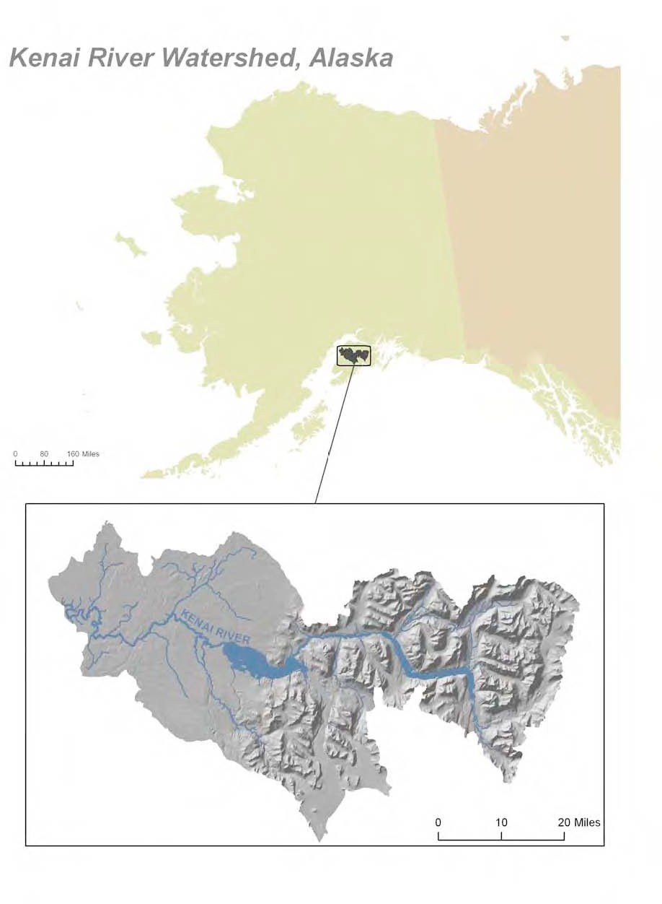
Figure 1: Location of the Kenai River Watershed within Alaska.

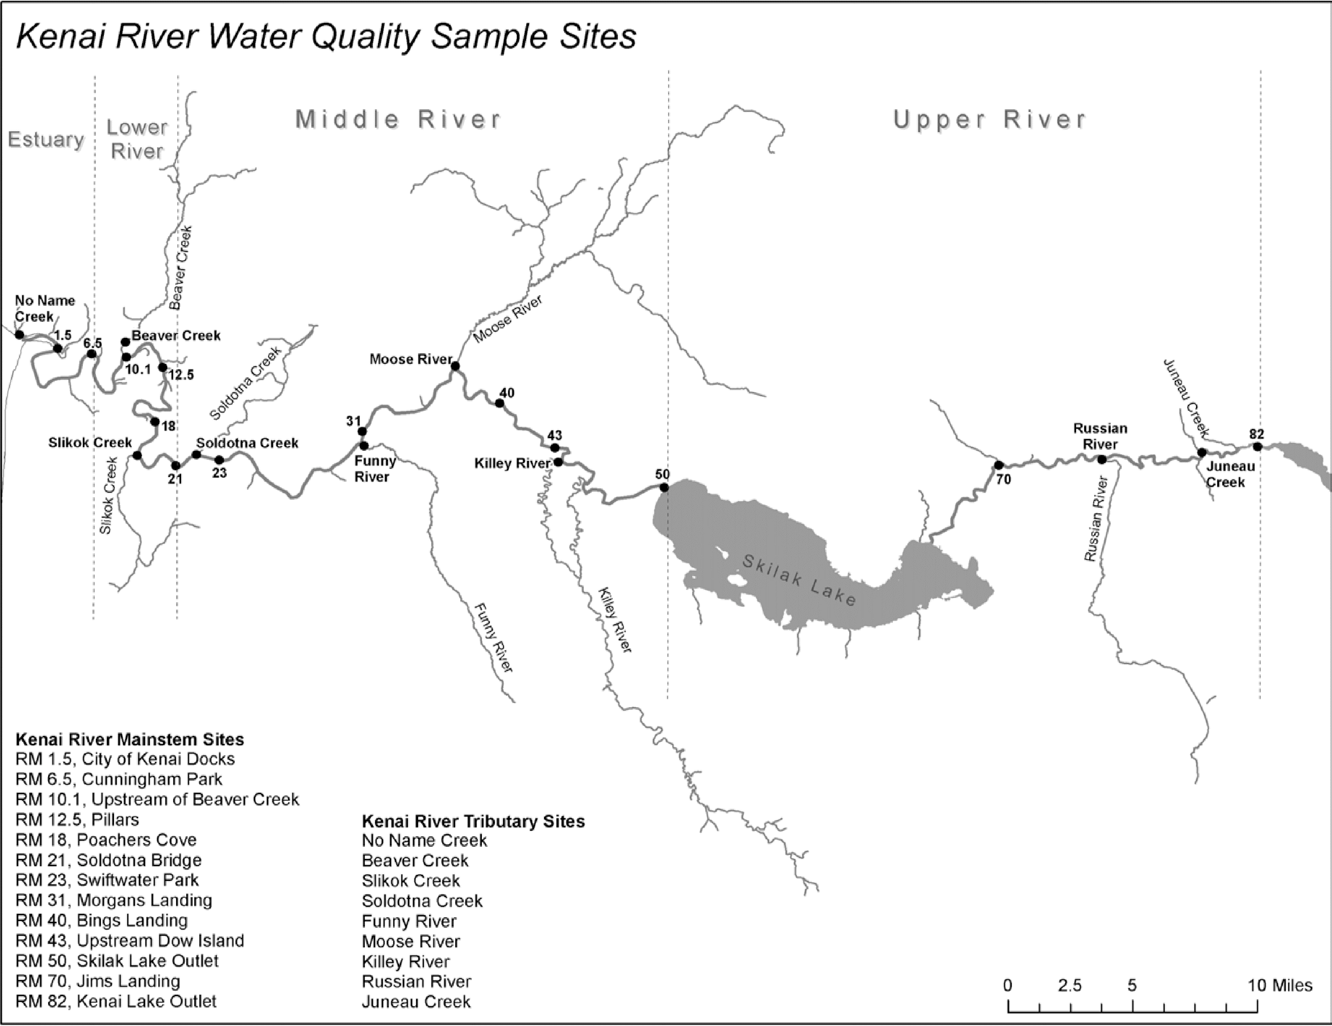
Figure 2: Location of water quality sampling sites on the Kenai River and its major tributaries.

2025 Sampling Events
Table 2: 2025 sampling events.
Season | Date | Monitoring sites | Notes
Spring | April 30, 2025 | 20 | Metals and nutrients; TSS and FC at 6 mainstem sites
Summer | July 23, 2025 | 22 | Metals, nutrients, and hydrocarbons (BTEX); TSS and FC at mainstem sites
Hydrocarbon (BTEX) analysis is not conducted in spring by design: boat activity on the river is minimal in April and May, and the risk of petroleum-related contamination from vessel traffic is negligible during that period.

Parameters Analyzed
Table 3: Parameters analyzed by season and analytical fraction. “Dissolved” metals were filtered through a 0.45 µm membrane prior to analysis; “Total” metals were unfiltered. FC and TSS were analyzed by SWWTP.
Parameter group | Parameter | Fraction | Seasons sampled
Dissolved metals | Arsenic | Dissolved | Spring and Summer
Dissolved metals | Cadmium | Dissolved | Spring and Summer
Dissolved metals | Chromium | Dissolved | Spring and Summer
Dissolved metals | Lead | Dissolved | Spring and Summer
Metals | Copper | Dissolved | Spring and Summer
Metals | Copper | Total | Spring and Summer
Metals | Zinc | Dissolved | Spring and Summer
Metals | Zinc | Total | Spring and Summer
Total metals | Calcium | Total | Spring and Summer
Total metals | Iron | Total | Spring and Summer
Total metals | Magnesium | Total | Spring and Summer
Nutrients | Nitrate + Nitrite (as N) | Total | Spring and Summer
Nutrients | Total Phosphorus | Total | Spring and Summer
Hydrocarbons (BTEX) | Benzene | Volatile | Summer
Hydrocarbons (BTEX) | Ethylbenzene | Volatile | Summer
Hydrocarbons (BTEX) | Toluene | Volatile | Summer
Hydrocarbons (BTEX) | Total Xylenes | Volatile | Summer
Hydrocarbons (BTEX) | o-Xylene | Volatile | Summer
Hydrocarbons (BTEX) | p/m-Xylene | Volatile | Summer
Field parameters | Fecal Coliform | None | Spring and Summer
Field parameters | Total Suspended Solids | Suspended | Spring and Summer

Preliminary Results
The tables below summarize measured concentrations across all primary sampling sites. Ranges show the minimum and maximum detected values; non-detected parameters show the laboratory LOD. Some parameters were analyzed at a subset of sites. “J” indicates a qualified detection between the LOD and LOQ.

Spring 2025 (April 30, 2025)
Table 4: Spring 2025 preliminary results summary.
Parameter group | Parameter | Fraction | Unit | n sites | Result range
Dissolved metals | Arsenic | Dissolved | ug/L | 11 | 1.54 - 5.24 (6/11 detected)
Dissolved metals | Cadmium | Dissolved | ug/L | 11 | Non-detect (LOD: 0.375)
Dissolved metals | Chromium | Dissolved | ug/L | 11 | Non-detect (LOD: 3.75)
Dissolved metals | Lead | Dissolved | ug/L | 11 | Non-detect (LOD: 1.50)
Metals | Copper | Dissolved | ug/L | 11 | 19.0 - 19.0 (1/11 detected)
Metals | Copper | Total | ug/L | 11 | 1.42 - 48.1 (3/11 detected)
Metals | Zinc | Dissolved | ug/L | 11 | 5.20 - 22.9
Metals | Zinc | Total | ug/L | 11 | 3.84 - 54.6 (7/11 detected)
Total metals | Calcium | Total | mg/L | 19 | 9.05 - 158.
Total metals | Iron | Total | mg/L | 19 | 0.0845 - 17.8 (16/19 detected)
Total metals | Magnesium | Total | mg/L | 19 | 1.00 - 396.
Nutrients | Nitrate + Nitrite (as N) | Total | mg/L | 20 | 0.0566 - 1.11
Nutrients | Total Phosphorus | Total | mg/L | 20 | 0.0151 - 0.473 (8/20 detected)
Field parameters | Fecal Coliform | None | CFU/100mL | 20 | 1.00 - 164. (12/20 detected)
Field parameters | Total Suspended Solids | Suspended | mg/L | 22 | 0.200 - 493. (20/22 detected)

Summer 2025 (July 23, 2025)
Table 5: Summer 2025 preliminary results summary.
Parameter group | Parameter | Fraction | Unit | n sites | Result range
Dissolved metals | Arsenic | Dissolved | ug/L | 13 | 1.50 - 7.57 (6/13 detected)
Dissolved metals | Cadmium | Dissolved | ug/L | 13 | Non-detect (LOD: 0.375)
Dissolved metals | Chromium | Dissolved | ug/L | 13 | Non-detect (LOD: 3.75)
Dissolved metals | Lead | Dissolved | ug/L | 13 | 7.36 - 7.36 (1/13 detected)
Metals | Copper | Dissolved | ug/L | 13 | Non-detect (LOD: 2.25)
Metals | Copper | Total | ug/L | 13 | 1.25 - 36.0 (3/13 detected)
Metals | Zinc | Dissolved | ug/L | 13 | 17.1 - 17.1 (1/13 detected)
Metals | Zinc | Total | ug/L | 13 | 3.36 - 87.2 (8/13 detected)
Total metals | Calcium | Total | mg/L | 22 | 6.54 - 24.9
Total metals | Iron | Total | mg/L | 22 | 0.215 - 26.4 (17/22 detected)
Total metals | Magnesium | Total | mg/L | 22 | 0.920 - 13.9
Nutrients | Nitrate + Nitrite (as N) | Total | mg/L | 22 | 0.0532 - 1.02
Nutrients | Total Phosphorus | Total | mg/L | 22 | 0.0156 - 0.662 (9/22 detected)
Hydrocarbons (BTEX) | Benzene | Volatile | ug/L | 4 | Non-detect (LOD: 0.300)
Hydrocarbons (BTEX) | Ethylbenzene | Volatile | ug/L | 4 | Non-detect (LOD: 0.750)
Hydrocarbons (BTEX) | Toluene | Volatile | ug/L | 4 | Non-detect (LOD: 0.750)
Hydrocarbons (BTEX) | Total Xylenes | Volatile | ug/L | 4 | Non-detect (LOD: 2.25)
Hydrocarbons (BTEX) | o-Xylene | Volatile | ug/L | 4 | Non-detect (LOD: 0.750)
Hydrocarbons (BTEX) | p/m-Xylene | Volatile | ug/L | 4 | Non-detect (LOD: 1.50)
Field parameters | Fecal Coliform | None | CFU/100mL | 22 | 1.00 - 400. (15/22 detected)
Field parameters | Total Suspended Solids | Suspended | mg/L | 22 | 1.00 - 763.
BTEX compounds were analyzed at 4 sites: RM 1.5 (Kenai City Dock), RM 6.5 (Cunningham Park), RM 40 (Bing’s Landing), and RM 43 (Upstream of Dow Island). All BTEX compounds were below laboratory detection limits at all four sites.

Fecal Coliform and TSS
FC and TSS results from SWWTP are included in the spring and summer results tables above under the “Field parameters” group. Site-level detail will be available in the full QA/QC report.

Preliminary Threshold Comparison
The table below identifies measurements that preliminarily exceed applicable water quality standards. Two categories of standards are referenced:
- Aquatic life chronic standards (Alaska Department of Environmental Conservation 2023b; U.S. Environmental Protection Agency 2024): protect aquatic organisms and salmon habitat; these are the primary regulatory standards for the Kenai River.
- Drinking water standards (Alaska Department of Environmental Conservation 2023a): included for context; the Kenai River is not a designated drinking water source.
Thresholds for hardness-dependent metals (Cadmium, Chromium, Copper, Lead, Zinc) are computed per site using measured calcium and magnesium concentrations, following ADEC criteria formulas (Alaska Department of Environmental Conservation 2023b). Those input values are themselves preliminary and may change after QA/QC. No regulatory determination can be made from these data.

Table 6: Preliminary threshold comparisons for values with flagged potential exceedances. “Ratio” = measured value divided by the applicable threshold. PRELIMINARY: values have not been fully QA/QC reviewed. Hardness-dependent thresholds are computed per site from preliminary Ca/Mg values using ADEC 18 AAC 70 chronic aquatic life criteria formulas and may change after QA/QC review.
Season | Site | Parameter | Measured | Threshold | Unit | Ratio | Standard
Spring | RM 0-No Name Creek | Iron | 4.47 | 1.00 | mg/L | 4.5 | Aquatic life chronic (ADEC 18 AAC 70 / USEPA 1976)
Spring | RM 1.5 -Kenai City Dock | Iron | 17.80 | 1.00 | mg/L | 17.8 | Aquatic life chronic (ADEC 18 AAC 70 / USEPA 1976)
Spring | RM 10-Beaver Creek | Iron | 3.46 | 1.00 | mg/L | 3.5 | Aquatic life chronic (ADEC 18 AAC 70 / USEPA 1976)
Spring | RM 19-Slikok Creek | Iron | 1.47 | 1.00 | mg/L | 1.5 | Aquatic life chronic (ADEC 18 AAC 70 / USEPA 1976)
Spring | RM 22-Soldotna Creek | Iron | 1.13 | 1.00 | mg/L | 1.1 | Aquatic life chronic (ADEC 18 AAC 70 / USEPA 1976)
Spring | RM 30-Funny River | Iron | 1.04 | 1.00 | mg/L | 1.0 | Aquatic life chronic (ADEC 18 AAC 70 / USEPA 1976)
Summer | RM0-No Name Creek | Iron | 3.61 | 1.00 | mg/L | 3.6 | Aquatic life chronic (ADEC 18 AAC 70 / USEPA 1976)
Summer | RM1.5-Kenai City Dock | Iron | 26.40 | 1.00 | mg/L | 26.4 | Aquatic life chronic (ADEC 18 AAC 70 / USEPA 1976)
Summer | RM10-Beaver Creek | Iron | 2.76 | 1.00 | mg/L | 2.8 | Aquatic life chronic (ADEC 18 AAC 70 / USEPA 1976)
Summer | RM19-Slikok Creek | Iron | 1.87 | 1.00 | mg/L | 1.9 | Aquatic life chronic (ADEC 18 AAC 70 / USEPA 1976)
Summer | RM6.5-Cunningham Park | Iron | 1.24 | 1.00 | mg/L | 1.2 | Aquatic life chronic (ADEC 18 AAC 70 / USEPA 1976)
Summer | RM10-Beaver Creek | Lead | 7.36 | 1.72 | ug/L | 4.3 | Aquatic life chronic (ADEC 18 AAC 70)

Iron (11 site-events): Iron exceeds the 1 mg/L aquatic life chronic criterion (U.S. Environmental Protection Agency 1976; Alaska Department of Environmental Conservation 2023b) at several tributary and lower-river sites in both seasons. Elevated iron is common in glacially influenced and wetland-draining streams in the Kenai River watershed and is consistent with historical monitoring results. The most elevated values occur at RM 1.5 (Kenai City Dock), where tidal mixing substantially increases dissolved mineral content. These results will be evaluated in context of the full dataset during QA/QC review.
Lead (1 site-event): A dissolved lead concentration of 7.36 µg/L was measured at Beaver Creek (RM 10) during the summer sampling event. The hardness-adjusted aquatic life chronic threshold at that site is 1.72 µg/L, placing the measured value at 4.3× the threshold. This detection was confirmed by the laboratory above the reporting limit. However, the corresponding field duplicate was non-detect for lead (see Field QC section below), which raises a question about the validity of this result. It will receive additional scrutiny during the full QA/QC review.
No exceedances were identified for Arsenic, Cadmium, Chromium, Copper, Zinc, Nitrate + Nitrite (as N), or BTEX compounds.

Field Quality Control
Field QC samples are collected alongside environmental samples to detect potential contamination introduced during collection, preservation, or transport, and to assess measurement precision. All results below are preliminary.

Field Blanks (Metals)
Field blanks were collected at two sites per season and analyzed for the same suite of metals as primary samples. All results should ideally be non-detect; any detection in a field blank may indicate contamination introduced during sampling.
Table 7: Field blank detections (non-detect results not shown). “J” indicates a qualified trace detection between the LOD and LOQ.
Season | Site | Parameter | Result
Spring | RM 1.5-Kenai City Dock | Zinc | J: 9.2 ug/L (below LOQ)
Spring | RM 19-Slikok Creek | Zinc | J: 6.74 ug/L (below LOQ)
Spring | RM 19-Slikok Creek | Zinc | J: 5.43 ug/L (below LOQ)
Summer | RM22-Soldotna Creek | Zinc | J: 3.61 ug/L (below LOQ)
All field blank detections were for Zinc at trace levels below the reporting LOQ (J-flag). These low-level detections do not necessarily indicate problematic contamination, but they are noted for transparency and will be considered during QA/QC review of primary Zinc results.

Trip Blanks (BTEX)
Trip blanks for hydrocarbon (BTEX) analysis were collected for the summer sampling event. A trip blank travels with the sample containers throughout collection and is used to detect contamination from the sampling process or transport. Two trip blanks covered the four BTEX sampling sites.
Table 8: Summer 2025 BTEX trip blank results. All compounds were non-detect in both trip blanks, indicating no contamination was introduced during sample collection or transport.
Trip blank | Compound | Result
RM1.5&6.5 trip blank | Benzene | Non-detect (LOD: 0.3 ug/L)
RM1.5&6.5 trip blank | Ethylbenzene | Non-detect (LOD: 0.75 ug/L)
RM1.5&6.5 trip blank | P & M -Xylene | Non-detect (LOD: 1.5 ug/L)
RM1.5&6.5 trip blank | Toluene | Non-detect (LOD: 0.75 ug/L)
RM1.5&6.5 trip blank | Xylenes (total) | Non-detect (LOD: 2.25 ug/L)
RM1.5&6.5 trip blank | o-Xylene | Non-detect (LOD: 0.75 ug/L)
RM40&43 trip blank | Benzene | Non-detect (LOD: 0.3 ug/L)
RM40&43 trip blank | Ethylbenzene | Non-detect (LOD: 0.75 ug/L)
RM40&43 trip blank | P & M -Xylene | Non-detect (LOD: 1.5 ug/L)
RM40&43 trip blank | Toluene | Non-detect (LOD: 0.75 ug/L)
RM40&43 trip blank | Xylenes (total) | Non-detect (LOD: 2.25 ug/L)
RM40&43 trip blank | o-Xylene | Non-detect (LOD: 0.75 ug/L)

Field Duplicates
Field duplicate samples were collected at two sites per season. The RPD between a primary sample and its duplicate indicates measurement precision. Values below 10–20% RPD are generally considered acceptable. Only pairs where both the primary and duplicate produced detectable results are shown; non-detect pairs are excluded from RPD calculation.
Table 9: Field duplicate RPD results. Only pairs where both primary and duplicate were detected are shown. All RPDs are below 10%, indicating good field and laboratory precision.
Season | Site | Parameter | Unit | Primary | Duplicate | RPD (%)
Spring | RM 18-Poacher's Cove | Calcium | mg/L | 15.500 | 15.400 | 0.6
Spring | RM 18-Poacher's Cove | Iron | mg/L | 0.248 | 0.260 | 4.7
Spring | RM 18-Poacher's Cove | Magnesium | mg/L | 1.800 | 1.840 | 2.2
Spring | RM 18-Poacher's Cove | Zinc (dissolved) | ug/L | 13.100 | 11.900 | 9.6
Spring | RM 22-Soldotna Creek | Arsenic | ug/L | 5.240 | 5.510 | 5.0
Spring | RM 22-Soldotna Creek | Zinc (dissolved) | ug/L | 9.710 | 10.300 | 5.9
Summer | RM10-Beaver Creek | Arsenic | ug/L | 6.350 | 6.000 | 5.7
Summer | RM10-Beaver Creek | Calcium | mg/L | 21.200 | 20.800 | 1.9
Summer | RM10-Beaver Creek | Iron | mg/L | 2.760 | 2.740 | 0.7
Summer | RM10-Beaver Creek | Magnesium | mg/L | 4.270 | 4.190 | 1.9
Summer | RM10-Beaver Creek | Total Phosphorus | mg/L | 0.066 | 0.064 | 2.0
Note: The dissolved Lead result at Beaver Creek (RM 10, summer), flagged as a potential exceedance in Table 6, was detected at 7.36 µg/L in the primary sample but was non-detect in the field duplicate. This discrepancy does not appear in Table 9 (since non-detect duplicates are excluded from RPD calculation), but it is an important QC flag that will receive additional scrutiny during QA/QC review.

Next Steps
The following steps remain before 2025 data are finalized:
- Full QA/QC review in accordance with the KWF QAPP, including holding time verification, matrix spike recovery assessment, and resolution of the Lead field duplicate discrepancy at Beaver Creek.
- Data submission to EPA WQX via the EPA Central Data Exchange (CDX). Upon successful upload, 2025 results will be publicly accessible through the EPA Water Quality Portal and How’s My Waterway.
- Integration into the KWF baseline water quality report, covering the full period of record (2000–present).
Questions about this summary may be directed to Kenai Watershed Forum at kenaiwatershed.org.

Appendix: Project Collaborators
The following organizations provided in-kind and/or financial support for baseline water quality sampling in 2025. This project is also supported by a Memorandum of Understanding renewed in 2025 by sixteen participating organizations. For the current partner list and MOU, see kenaiwatershed.org/kenai-river-baseline-water-quality-monitoring.
Current Entities Contributing In-kind and/or Financial Support
- Alaska Department of Environmental Conservation
- Alaska Department of Fish and Game
- Alaska Department of Natural Resources
- City of Kenai
- City of Soldotna
- Cook Inlet Aquaculture Association
- Defenders of Wildlife
- Kenai National Wildlife Refuge
- Kenai Peninsula Borough
- Kenai Peninsula Fish Habitat Partnership
- Kenai Peninsula Trout Unlimited
- Kenaitze Indian Tribe
- Mister Kenai Sportfishing
- Salamatof Tribe
- SGS North America, Inc.
- Tyonek Tribal Conservation District
- U.S. Fish and Wildlife Service
- U.S. Forest Service
Alaska Department of Environmental Conservation. 2023a. “Alaska Drinking Water Regulations: 18 AAC 80.” Juneau, AK: Alaska Department of Environmental Conservation. https://dec.alaska.gov/eh/dw/.
———. 2023b. “Alaska Water Quality Standards: 18 AAC 70.” Juneau, AK: Alaska Department of Environmental Conservation. https://dec.alaska.gov/water/water-quality/standards/.
U.S. Environmental Protection Agency. 1976. Quality Criteria for Water. Washington, D.C.: U.S. Environmental Protection Agency, Office of Water Planning; Standards.
———. 2024. “National Recommended Water Quality Criteria: Aquatic Life Criteria Table.” Washington, D.C.: U.S. Environmental Protection Agency, Office of Water. https://www.epa.gov/wqc/national-recommended-water-quality-criteria-aquatic-life-criteria-table.

