Jan 4th 2024
CSV files in this folder are manually-edited for final preparation.

- Write up summary for KC, create open-time zoom meeting link, suggest times

Preparing three separate csv files for upload to WQP. Each as failed in some way. Preparing questions for meeting w/ EPA:
- Project file
  - Issues
    - General Validation Error: “A submission file referencing an attachment, must include that attachment.”
      - Attachment file name: “KenaiWatershedForum_QAPP_v3_2023.zip”, is included.
        - Unclear what is generating error

- Monitoring Location file
  - Import Successful on 1/16/2024

- Results & Activities
  - Issues
    - All rows: “Value for Analysis Start Date ('5/15/2021') does not match its specified format”
      - Unclear what is generating error. Date format matches import configuration, “MM/DD/YYYY”
    - All rows: “Invalid value for Monitoring Location ID
      - Unclear how to resolve error
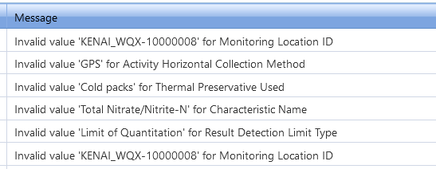
Address one by one …
- Monitoring Location ID
  - TBD
- Horizontal Collection Method
  - Made all “GPS-Unspecified”
- Thermal Preservative Used
  - All “Cold Packs (4 deg C)”
- Total Nitrate/Nitrite-N' for Characteristic Name
  - Changed all instances to “Nitrate + Nitrite” per available domain values
  - Added method speciation column, all Nitrate+Nitrite instances include “as NO2+NO3”
- Limit of Quantitation' for Result Detection Limit Type
  - Changed all instances of “Limit of Quantitation” to “Lower Quantitation Limit” per available domain values in CDX

1/11/2024
In the process of matching import config to data structure. Have been manually manipulating csv
Just learned that we submit/upload results as “rejected” – so we want to include those. See below.
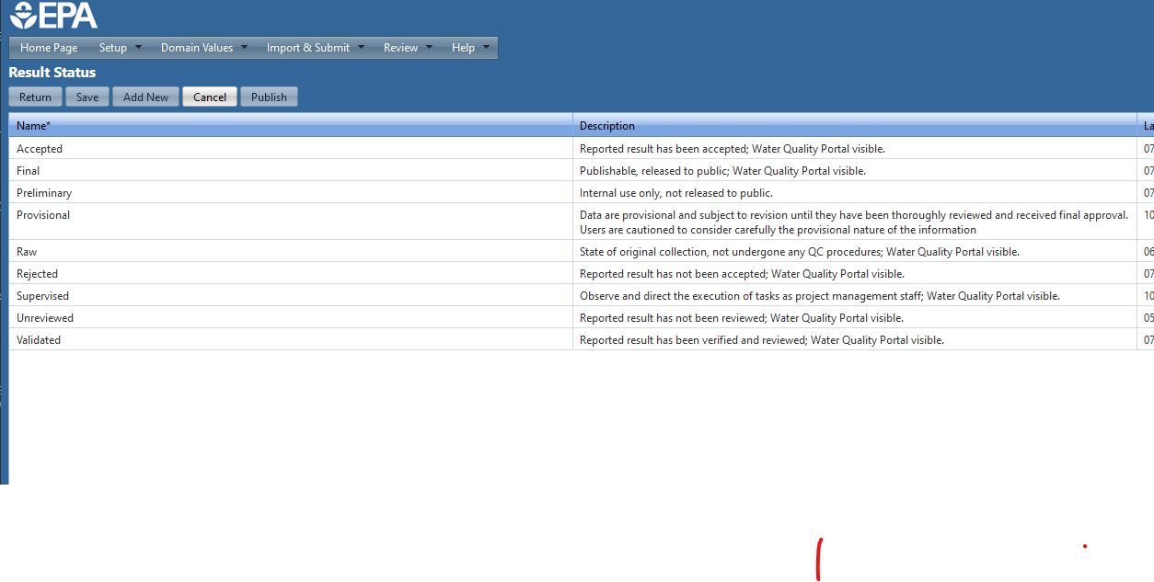
So – we need to re-produce results csv, correct weird negative signs, and ensure column structure matches import config (e.g. remove all cloumns where all rows are NA.
Emailed to wqx@epa.gov and Christian.kevin@epa.gov on 1/16/2024
Hello Kevin,
I would like to request assistance in resolving a few minor errors in importing a new dataset to CDX. I will outline the details here in an attachment and will greatly appreciate EPA’s advice.
If it will be easiest to address these in a Zoom meeting, I have set up a link we can use at any time. I am available at the following times:
- Jan 17th 7:30 – 11:00 AKST
- Jan 18th 7:30 – 11:00 AKST
- Jan 19th All Day
- Jan 22nd All Day
- Jan 23rd 11:00 – 5:00 AKST
Kenai Watershed Forum Zoom Room link: https://zoom.us/j/7031694675?pwd=MWc4empJR1Nrd21WUDgvR0tGV09Hdz09
The issues I am working to address are outlined below. Thank you in advance for your help!
Sincerely,
Benjamin Meyer
***
In progress: preparing three separate csv files for upload to EPA CDX. The three files and their status of their import is as follows:
- Monitoring Location file (IMPORTED)
  - Import Successful on 1/16/2024

- Projects file (IMPORT FAILED)
  - Issue
    - General Validation Error: “A submission file referencing an attachment, must include that attachment.”
      - Attachment file name: “KenaiWatershedForum_QAPP_v3_2023.zip”, is included.
        - Unclear what is generating error. File name matches file name in imported csv file
- Results & Activities file (IMPORT FAILED)
  - Issues
    - All rows: “Value for Analysis Start Date ('5/15/2021') does not match its specified format”
      - Unclear what is generating this error. Date format matches import configuration, “MM/DD/YYYY”
    - All rows: “Invalid value for Monitoring Location ID
      - Unclear how to resolve error. Monitoring location IDs are same as downloaded from WQP

