Kenai River Water Quality Monitoring Quality Assurance Project Plan (QAPP)

**Multi-Agency Baseline**

***V. 2. Updated April 2012*  
*V.3. Updated March 2023***

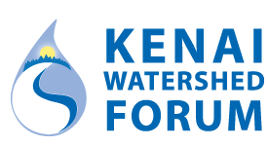

***Original Version Prepared by:***

**Kenai Watershed Forum**

**44129 Sterling Highway**

**Soldotna, AK 99669** [**www.kenaiwatershed.org**](http://www.kenaiwatershed.org/)

# Al. Title and Approval Page

Title: Kenai River Water Quality Monitoring: Multi-Agency Baseline

**Name and Title:** Benjamin Meyer, Project QA, Project Manager

Affiliation: Kenai Watershed Forum  
**Email:** [hydrology@kenaiwatershed.org](mailto:hydrology@kenaiwatershed.org)  
Phone: (907) 260-5449

**Signature: Date:**

**Name and Title:** Mitch Michaud, Executive Director  
**Affiliation:** Kenai Watershed Forum  
**Email:** [executivedirector@kenaiwatershed.org](mailto:executivedirector@kenaiwatershed.org)   
Phone: (907) 260-5449

Signature: Date:

**Name and Title:** Cindy Fields, EPA Region 10 Quality Assurance Manager (or designee)

**Affiliation:** U.S. Environmental Protection Agency, Region 10

**Email:** fields.cindy@epa.gov

Phone: (206) 553-7263

Signature:  **Date:**

# Contents

Al. Title and Approval Page 2

Contents 3

A2. Acknowledgements 6

A3. Distribution List 7

A4. Project/Task Organization. 8

A5. Problem Definition/Background and Project Objectives 11

A6. Project / Task Description 11

A7. Quality Objectives and Criteria for Measurement of Data 14

A8.Training Requirements 24

A9. Documentation and Records 24

B1. Sampling Process Design 25

B2. Sampling Methods Requirements 28

B3. Sample Handling and Custody Requirements 29

B4. Analytical Methods Requirements 31

B5. Quality Control Requirements 31

B.5.1 Field Quality Control (QC) Measures 31

B6. Instrument / Equipment Testing, Inspection and Maintenance 36

B7. Instrument Calibration Procedures 36

Standard Calibration Procedures for Hydrolab Minisonde MS 5 are included 36

B8. Inspection and Acceptance Requirements for Supplies 36

B9. Data Acquisition Requirements for Non-Direct Measurements 36

B10. Data Management 37

C1. Assessments and Response Actions 40

C2. QA Reports to Management 41

D1. Data Review, Validation, and Verification Requirements 42

D2. Validation and Verification Methods 43

D3. Reconciliation with Data Quality Objectives 43

References 45

**Tables**

Table 2. Annual, biannual, and five-year project logistics tasks and responsible parties 10

Table 3. Data Quality Objectives for Electronic Instruments 15

Table 4. Data Quality Objectives for Hydrocarbons Collected for Agency Baseline 16

Table 5. Data Quality Objectives for Metals Collected for Agency Baseline 18

Table 6. Data Quality Objectives for Nutrients, Fecal Coliform, and Total Suspended Solids 19

Table 7. Data Quality Objectives for Stream Temperature Monitoring 20

Table 8. Data Qualifiers 23

Table 10. Sampling Locations for Agency Baseline Monitoring 26

Table 11. Preservation and Holding Times for Sample Analysis 29

Table 12. Field Quality Control Samples. 33

**Figures**

Figure 1. Project management organization 8

Figure 2. Map of sample locations and the Kenai River watershed 27

Figure 3. Sample Container Label 30

Figure 4. Data management and evaluation flowchart 39

**Appendices**

Appendix A: Technical Advisory Committee…………………………………………………...46

Appendix B: Fieldwork Sampling SOP………………………………………………………….47

Appendix B1: “Clean Hands, Dirty Hands” Sampling Technique………………………………54

Appendix C: Kenai River Watershed Water Quality Monitoring Field Data Form……………..55

Appendix D: Kenai River Watershed Water Quality Monitoring Chain of Custody Forms…….56

Appendix E: Agency Baseline Lab Test Results………………………………………………...60

Appendix F: Hydrolab Downloads………………………………………………………………61

Appendix F: Minisonde Calibration Record……………………………………………………..62

Appendix G: Stream Temperature Monitoring Field Data Sheet………………………………..63

Appendix H: Standard Calibration Procedure for Hydrolab Minisonde MS 5…………………..65

Appendix I: YSI Temperature Meter QA………………………………………………………..70

Appendix J: Calibration Standards Record Form………………………………………………..71

Appendix K: Laboratory Certificates of Analysis……………………………………………….72

Appendix L: Data Evaluation Checklist…………………………………………………………73

## Acronyms

* ADEC – Alaska Department of Environmental Conservation
* ADEC DOW – ADEC Division of Water
* ADEC WQS – Water Quality Standards
* AWQMS – Ambient Water Quality Monitoring System
* BTEX – Benzene, Toluene, Ethylbenzene, Xylene
* COC – Chain of Custody
* CWA – Clean Water Act
* DL – Detection Limit
* EPA – Environmental Protection Agency
* EPA WQP – EPA Water Quality Portal
* EPA WQX – EPA Water Quality Exchange
* IDL – Instrument Detection Limit
* KWF – Kenai Watershed Forum
* LCS – Laboratory Control Sample
* LFB – Laboratory Fortified Blank
* LOQ – Level ofQuantitation
* MS – Matrix Spike
* MSD – Matrix Spike Duplicate
* MQO – Measurement Quality Objective
* ND – Non-detect
* NMFS – National Marine Fisheries Service
* QAPP – Quality Assurance Project Plan
* QA/QC – Quality Assurance / Quality Check
* RL – Reporting Limit
* RPD – Relative Percent Difference
* SOP – Standard Operating Procedure
* TSS – Total Suspended Solids
* USGS – United States Geological Survey

## A2. Acknowledgements

This document was originally developed by the Kenai Watershed Forum and was modeled and adapted, with permission, from Quality Assurance Project Plans (QAPP) produced by the Cook Inletkeeper of Homer, Alaska. Portions of the Cook Inletkeeper QAPP were adapted from similar plans developed by The Friends of Casco Bay (Maine) and Texas Watch. The United States Environmental Protection Agency (EPA), the Alaska Department of Environmental Conservation (ADEC), the United States Geological Survey (USGS), and the National Marine Fisheries Service / Auke Bay Laboratory (NMFS / ABL) also provided guidance and cooperation in helping both the Cook Inlet Keeper and the Kenai Watershed Forum develop and refine their QAPP. Some sections are also adapted from the 2021 ADEC Watershed Health and Data Analysis Project QAPP.

# A3. Distribution List

Signees (Project Manager, Project QA Officer, ADEC Project Manager and ADEC QA Officer) shall receive a copy of the QAPP and subsequent revisions. Offers for official copies of this QAPP and any subsequent revisions will be extended to individuals on the Distribution List.

|  |  |  |  |  |
| --- | --- | --- | --- | --- |
| **NAME** | **POSITION** | **AGENCY** | | **CONTACT INFORMATION** |
| Benjamin Meyer | Project Manager, QA Officer | KWF | | (907) 260-5449  [hydrology@kenaiwatershed.org](mailto:hydrology@kenaiwatershed.org) |
| Mitch Michaud | Executive Director | KWF | | (907) 260-5449 ext. 1206 [executivedirector@kenaiwatershed.org](mailto:executivedirector@kenaiwatershed.org) |
| Sue Mauger | Science Director | Cook Inletkeeper | | (907) 235-4068 ext. 24  [sue@cookinletkeeper.org](mailto:sue@cookinletkeeper.org) |
| Justin Nelson | Client Service Manager | SGS  Environmental Laboratory Services | | (800) 873-8707  [justin.nelson@sgs.com](mailto:justin.nelson@sgs.com) |
| Moses Jordan | Environmental Program Manager | Kenaitze  Indian Tribe | | (907) 545-1444  mjordan@kenaitze.org |
| Eric Morrison | Tribal Executive Officer | Salamatof Tribe | | (907) 283-2700  [emorrison@salamatoftribe.org](mailto:emorrison@salamatoftribe.org) |
| Amber Bethe | Data Manager, Water Quality Section | ADEC | | (907) 269-7955  [amber.bethe@alaska.gov](mailto:amber.bethe@alaska.gov) |

Copies of this Quality Assurance Project Plan will be made available online at [https://www.kenaiwatershed.org/science-in-action/research-information/water-quality](https://www.kenaiwatershed.org/science-in-action/research-information/water-quality/)/. Interested parties may request a digital copy from KWF, or purchase a copy for the cost of production and shipping by writing the Kenai Watershed Forum, 44129 Sterling Highway, Soldotna, AK 99669, or calling (907) 260-5449, or emailing [hydrology@kenaiwatershed.org](mailto:hydrology@kenaiwatershed.org).

**A4.** **Project / Task Organization**

**KWF Project Technicians**

Determined Annually

**KWF Director**

Mitch Michaud

**KWF Project Manager/ Project QA Officer**

Benjamin Meyer

**Multi-Agency Baseline Sampling Teams**

Determined Annually

**Figure** 1. Project management organization

**Key Contacts and Responsibilities**

Mitch Michaud – Kenai Watershed Forum – Executive Director – Oversees all employees and operations at Kenai Watershed Forum.

Benjamin Meyer - Kenai Watershed Forum - Project Manager- Oversees the water quality monitoring efforts and projects conducted by the Kenai Watershed Forum. Provides and/or ensures adequate training is completed for each of the team members conducting water quality monitoring throughout the project. Has completed training in each of the monitoring elements outlined in the plan. Project Quality Assurance Officer - Supervises and trains water quality monitors. They are trained in Agency Baseline Sampling protocols. They are responsible for overall supervision of quality assurance and data entry.

Justin Nelson **-** SGS Environmental Laboratory Services (SGS) - Subcontractor for Kenai River Water Quality Assessment element of the project. Oversees all analyses to be performed at SGS. This contract will be used to ensure proper sampling and analysis of water for 22 Kenai River Watershed sites to determine the water quality within the Kenai River Watershed.

John Essert - City of Soldotna Wastewater Treatment Plant operator plays a significant role in the Kenai River Water Quality Assessment. Will work cooperatively with the Project QA Officer and will perform a variety of water quality analysis for the Kenai Watershed Forum.

Technical Advisory Committee - The technical advisory committee will review results obtained from the monitoring effort on an annual basis. The committee may at any time ask for additional information on any aspect of the project. If monitoring data raises a particular concern, the advisory committee will be asked to suggest and review any changes to the monitoring plan. KWF will not be bound to implement any changes, but will give serious consideration to their input and will follow the committee’s wishes if feasible.

Field Monitoring Staff - Monitoring staff collect samples for the Kenai River Watershed Monitoring program. Monitoring staff are or have been provided by the following Agencies/Organizations:

* Alaska Department of Fish and Game
* Alaska Department of Natural Resources
* Alaska Department of Environmental Conservation
* Cook Inlet Aquaculture Association
* City of Kenai
* City of Soldotna
* Kenai Peninsula Borough
* Kenaitze Indian Tribe
* KWF and any volunteers under direct supervision of KWF monitoring staff
* Kenai Soil and Water Conservation District
* Salamatof Tribe
* Tyonek Tribal Conservation District
* U.S. Fish and Wildlife Service
* U.S. Forest Service

Project managers are outlined in Figure 1, and annual, biannual, and five-year responsibilities are outlined in Table 1.

**Table 1. Annual, biannual, and five-year project logistics tasks and responsible parties**

|  |  |  |  |  |  |
| --- | --- | --- | --- | --- | --- |
| **Frequency** | **Month** | **Responsible Party** | **Responsible Person** | **Task** | **Page** |
| Annual | February | Technical Advisory Committee | Committee Members | Review annual results from previous year | 10 |
| Annual | March | Kenai Watershed Forum | Project Manager / Project QA Officer | Uplift previous year's data that passed QA review to the EPA Water Quality Exchange | 39, 40 |
| Annual | March | Kenai Watershed Forum | Project Manager / Project QA Officer | Review previous year's data for five-year trends in the context of regulatory values | 40 |
| Annual | December | Kenai Watershed Forum | Project Manager / Project QA Officer | Produce a data trends and QA summary report; submit to the KWF Executive Director | 32, 42 |
| Semiannual | January | Kenai Watershed Forum | Project Manager / Project QA Officer | Submit data to the ADEC Integrated Report call for data. | 39 |
| Semiannual | March | Technical Advisory Committee | Committee Members | Review QAPP, address QA issues, and overall project design | 42 |
| Semiannual | March/May | Kenai Watershed Forum | Project Manager | Confirm sampling teams | 29 |
| Semiannual | April/May | Kenai Watershed Forum | Project Manager | Transfer field samples to laboratories | 30 |
| Semiannual | July/August | Kenai Watershed Forum | Project Manager | Receive data from laboratories | 40 |
| Semiannual | March/May | Kenai Watershed Forum | Project Manager / Project QA Officer | Confirm laboratory schedules and capabilities | 29 |
| Five years | - | Kenai Watershed Forum | Project Manager / Project QA Officer | Produce comprehensive data review, contingent on funding | 42 |

## A5. Problem Definition/Background and Project Objectives

The Kenai Watershed Forum's (KWF) water quality program is designed to document the existing and changing conditions of water quality within the Kenai River Watershed by developing and maintaining baseline information. It is the intent of the program to first identify and then address a wide range of activities that may contribute to nonpoint source pollution in the Kenai River Watershed. The baseline water-quality monitoring program is consistent with the recommendation 4.5.10.2.2 in the ***Kenai River Comprehensive Management Plan***, which today is overseen by the Kenai River Special management Area (KRSMA) Advisory Board (AKDNR 1997)*.*This recommendation was developed for Alaska State Parks and the ***Upper Kenai River Cooperative Plan*** (USFWS 1997) as a partnership between Alaska State Parks, U.S. Fish and Wildlife Service and the U.S. Forest Service, Chugach National Forest. Since the project’s inception in 2000, agencies represented by the KRSMA Advisory Board have provided financial and personnel support to carry out fieldwork and laboratory analyses.

The State of Alaska conducts ambient water quality monitoring only in select areas due to the high operating costs to maintain such a system over large undeveloped areas. Historically, on the Kenai Peninsula There have been several water quality analyses conducted by state agencies in the early 1990's (Litchfield and Kyle 1992; ADEC 2022b, 2022a). Although these studies indicated that measured water quality parameters were within state and federal compliance standards, *impacts of development and recreational use were evident.* Litchfield and Kyle (1992) analyzed water quality at 17 sites located between the outlet of Kenai Lake and Cook Inlet, and recommended the continued sampling of critical water quality parameters (fecal coliform, hydrocarbon, metals, and nutrients) for the purpose of monitoring future impacts on the Kenai River. They selected representative sites with the suggestion that they be monitored at least twice a year. It was also suggested that more intensive sampling be conducted in the Lower Kenai River, where concentrations of water quality contaminants were the highest priority and of greatest concern.

The baseline-monitoring program is needed to link water quality trends to an understanding of the natural and human factors that affect the water quality. The program is also necessary since many of the enforceable parameters rely on background or natural conditions. Without long-term data collection, it is impossible to know what the appropriate standards of enforcement are. This program must be integrated among many agencies that have differing objectives and must be long-term. The unique hydrologic features of the Kenai River, such as its glacier origin and two large lake systems, require an investigation that is designed to assess the whole of the watershed. The monitoring program must also be consistent with standard sampling and analysis protocols. The monitoring program addresses these needs and implements methods to monitor changes to the Kenai River as the local population and recreational use increase. For more detailed information on historical results, see the two previous Kenai River Water Quality Assessments published by Kenai Watershed Forum (Guerron Orejuela 2016; McCard 2007).

It should be noted that the temporal structure of this sampling program has not intended to represent water quality conditions of a full calendar year. Rather, the intention is to capture a snapshot of two annual conditions:

1. Prior to a period of higher potential for impact from human activities (boating activity, impervious surface runoff, etc.) in early summer; and
2. At the peak of human activity on/near the river in mid-summer.

## A6. Project / Task Description

There are three project elements of the Kenai River Watershed Forum’s Water Quality Monitoring Program described in this QAPP:

1. Agency Baseline Monitoring Partnership
2. Collection of specified interval data with programmable Electronic Instruments
3. Stream Temperature Monitoring

Continuous monitoring of intrinsic parameters with electronic instruments was conducted by KWF in 2008 through 2012 on the lower Kenai River, which was summarized in a technical report by KWF (Martin et al. 2011). These activities are not currently active, but QA/QC methods are included here in Appendix H for future reference.

Water temperature monitoring was conducted in tributaries of the Kenai River by Cook Inletkeeper (CIK) 2008 through 2012, and continues in a selected subset of these streams today, led by KWF. Monitoring results were synthesized (Mauger 2013) and later applied in peer-reviewed research (Mauger et al. 2017). Currently active stream temperature monitoring will continue indefinitely as funding permits. (See further details on stream temperature monitoring under “Task C” of this section, and Appendix H for field form).

In 2018, a zinc and copper monitoring project was added to the KWF Water Quality Monitoring Program. This Alaska Clean Waters Action (ACWA) grant funded project was designed to monitor copper and zinc levels in key locations on the Kenai River and its tributaries. This element was added in response to an observed increase in zinc and copper levels between 2014 and 2016 (Sires 2017b, 2017a; Guerron Orejuela 2016). A final report on this project was completed in 2021 (Meyer 2021). ADEC conducted a subsequent monitoring effort focused on dissolved metals in the main stem Kenai River in 2021-2022, which highlighted the value of incorporating additional sample QA/QC metrics to ensure accuracy (Apsens and Petitt 2022).

## 

## ***Task A) Agency Monitoring Partnership to conduct baseline monitoring*** for Nutrients, Dissolved Metals, Hydrocarbons, and Fecal Coliforms (Referred to as Agency Baseline hereafter)

Narrative Task Description

Work with the Kenai River Special Management Area Advisory Board and the agencies represented on that board to conduct sampling with the help of a professional environmental contractor[1].

Objectives:

* Develop a baseline data set to include, at a minimum, dissolved metals, hydrocarbons, and fecal coliforms
* Work with the City of Soldotna to supplement this data with parameters that Soldotna’s wastewater treatment plant can analyze. (i.e. – total suspended solids, pH, fecal coliforms, turbidity and specific conductance, etc.)
* Near concurrent sample collection at 22 sites located on the Kenai River main stem and tributaries throughout the Kenai River Watershed using federal, state and local agency personnel (See Table 8 for a narrative description of the 22 sample sites)
* Attain high quality data by collecting samples in a manner that minimizes potential sample contamination and by using a professional lab certified by ADEC for drinking water analysis
* Sample each of the 22 sites at least 2 times per year as financial resources allow.

Data Collection

* + Surface water quality parameters include; total metals (Cu, Fe, Hardness, and Zn), dissolved metals, petroleum hydrocarbons, fecal coliform, turbidity, specific conductance, temperature, nutrients
* Physical parameters include; weather conditions, boat traffic, and water temperature.

Schedule

* + Data collection will occur in spring (April/May) and summer (July/August)

### ***Task B) Collection of specified interval data with programmable Electronic Instruments***

Narrative Task Description

Maintain and deploy as needed instruments capable of recording time series of water quality parameters, e.g. water quality sondes. Work with partners to identify projects where such monitoring is beneficial. Continuous monitoring with sondes is not currently part of the baseline water quality monitoring project, but will be conducted opportunistically as future needs are identified by stakeholders represented in the KRSMA advisory board and the project technical advisory committee.

Objectives

* Maintain a collection of 8-10 water quality sondes capable of recording continuous parameters
* Work with agencies, NGOs, and citizens to identify locations where continuous monitoring of water quality parameters may be valuable. E.g.; invasive species treatments; developing areas, impacted water bodies.

Data Collection

* Parameters monitored by sondes include pH, turbidity, conductivity, temperature, and dissolved oxygen
* Sondes will be subject to pre and post deployment calibrations and checks for all parameters

Schedule

* Fieldwork will be executed based on funding opportunities and local need
* Sondes will be returned to the manufacturer for bench calibration as needed depending on annual usage

See Appendix H for further details on Hydrolab Calibration

### ***Task C) Stream Temperature Monitoring***

Narrative Task Description

Maintain stream temperature monitoring sites in perpetuity at six sites in the lower Kenai River and Kasilof River areas, and at other sites as needed by new projects

Objectives

* Perform site visits at the six long-term stream temperature monitoring sites a minimum of twice annually
  + Moose River
  + Funny River
  + Soldotna Creek
  + Slikok Creek
  + Beaver Creek
  + Crooked Creek
* Apply the highest available standards for field site management and data curation (as outlined in Mauger et al. (2015))

Data Collection

* Record year-round continuous time series of water temperature using programmed electronic instruments

Schedule

* Site visits to locations with water temperature loggers will be visited a minimum of biannually, typically once in early summer (May/June) and once in Fall (September/ October)

See Appendix G and Mauger et al. (2015) for further details on stream temperature monitoring methods in southcentral Alaska. Standard operating procedure for water temperature data QA/QC, management, and storage are detailed in the AKTEMP Water Temperature Database user Guide at <https://aktemp.uaa.alaska.edu/> from the University of Alaska Anchorage’s Alaska Center for Conservation Sciences (ACCS 2023).

## A7. Quality Objectives and Criteria for Measurement of Data

Data Quality Objectives (DQOs) for this program have been established to ensure that the data meets its overall objectives as described in A6, above – establishing a basic water quality inventory and detecting significant changes and trends. Table 2 through Table 6 show objectives for detectability, precision and accuracy for each parameter tested by all possible methods used by the Agency Baseline. DQOs are also included for automated multiprobes. In each case the sampling matrix is the water body of interest. Table 6 shows the objectives for the Stream Temperature monitoring. Objectives for precision, accuracy, representativeness, comparability, and completeness are also summarized in the following tables. Project DQOs may be revised in the future if funding becomes available for additional training and equipment or if the project manager determines that different objectives would be more effective in meeting program objectives. Any changes in DQOs will be submitted to USEPA for approval and reviewed by ADEC and the Technical Advisory Committee before implementation.

**Table 2. Data Quality Objectives for Electronic Instruments**

|  |  |  |  |  |  |
| --- | --- | --- | --- | --- | --- |
| PARAMETER | METHOD/RANGE | UNITS | SENSITIVITY | PRECISION | ACCURACY |
|  |  |  |  |  |  |
| pH | SM H+ B-2000, Hydrolab pH probe on Minisonde  0-14 | Standard pH units | 0.01 units | +0.2 units | +0.2 units |
| Turbidity | ISO 7027, Self Cleaning Turbidity Hydrolab Minisonde 5  0-3000 NTU | Nephelometric Turbidity Units (NTU) | 0.1 0-400 NTU  1.0 400-3000 NTU | +5 NTU | +5% 0-100 NTU  +5% 100-400 NTU  +5% 400-3000 NTU |
| Turbidity (Soldotna Lab) | EPA 180.1 Rev 2.0, Hach 2100 P  0-1000 NTU | Nephelometric Turbidity Units | 0.010-9.99 NTU  0.1 10-100 NTU  1 100-1000 NTU | +5 NTU | +5% 0-500 NTU  +5% 500-1000 NTU |
| Water Temperature | SM 2550 B-2000, YSI Model 30, 55, and  95  -5 to 95, -5 to +45, and -5 to +45 | Degrees Celsius (C) | 0.1, 0.2,  and 0.1 | ±0.1, ±0.2, and  ±0.2 | ±0.1, ±0.2, and ±0.2 C |
| Conductance | EPA 120.1, Hydrolab probe on Minesonde 0-100 mS/cm | Micro-Siemens/cm (µS/cm)  (converted to 25 C) | 4 digits | +0.001 units | 2% full Scale |
| Dissolved Oxygen | SM 4500 O C-2000, Micro Winkler Titration  0 to 20 mg/L | Milligrams per liter (mg/L) | 0.1 mg/L | ±0.9 mg/L | ±0.3 mg/L |
| Dissolved Oxygen (Winkler used for calibration) | ASTM D888-09 (A), Hydrolab LDO  probe on Minisonde 0 to 50 mg/L | Milligrams per liter (mg/L) | 0.01 mg/L | NA | ±0.2 mg/L |

**Table 3. Data Quality Objectives for Hydrocarbons Collected for Agency Baseline (Supplied by SGS)**

|  |  |  |  |  |  |
| --- | --- | --- | --- | --- | --- |
| **PARAMETER** | **METHOD / RANGE** | **Sensitivity**  **(DL)** | **LOQ** | **OVERALL PROJECT PRECISION[2]** | **ACCURACY** |
|  |  |  |  |  |  |
| Gasoline Range Organics (GRO) | AK101 by GCFID: 25- 1,000,000,000 | 3.0 µg/L | 5x DL | 20% | Calibration: ±25%  Recovery: 60-120% |
| Diesel Range Organics (DRO) | AK102 by GCFID: 50- 1,000,000 | 0.0065 mg/L | 0.11 mg/L | 20% | Calibration: ±25%  Recovery: ±25% |
| Residual Range Organics (RRO) | AK103 by GCFID: 500- 1,000,000 | 0.22 mg/L | 0.54 mg/L | 20% | Calibration: 75-105%  Recovery: 60-120% |
| Benzene | EPA 602 by GC/PID: 1-  1,000,000,000 | 0.074 µg/L | 1.0 µg/L | 20% | Calibration: ±15%  Recovery: ±30% |
| Ethylbenzene | EPA 602 by GC/PID: 1-  1,000,000,000 | 0..088 µg/L | 1.0 µg/L | 20% | Calibration: ±15%  Recovery: ±30% |
| Toluene | EPA 602 by GC/PID: 1-  1,000,000,000 | 0.078 µg/L | 1.0 µg/L | 20% | Calibration: ±15%  Recovery: ±30% |
| m,p-Xylene (total) | EPA 602 by GC/PID: 1-  1,000,000,000 | 0.20 µg/L | 2.0 µg/L | 20% | Calibration: ±15%  Recovery: ±30% |
| o-Xylene | EPA 602 by GC/PID: 1-  1,000,000,000 | 0.20 µg/L | 1.0 µg/L | 20% | Calibration: ±15%  Recovery: ±30% |
| Xylenes (total) | EPA 602 by GC/PID: 1-  1,000,000,000 | 0.82 µg/L | 3.0 µg/L | 20% | Calibration: ±15%  Recovery: ±30% |

GCFID, gas chromatograph flame ionization detector

GCPID, gas chromatograph photo ionization detector

LOQ, limit of quantitation

**Table 3.** **Continued**

|  |  |  |  |  |  |
| --- | --- | --- | --- | --- | --- |
| **PARAMETER** | **METHOD / RANGE** | **Sensitivity (DL)** | **LOQ** | **OVERALL PROJECT PRECISION[3]** | **ACCURACY** |
| Bromofluorobenzene (surrogate) | EPA 602 by GCPID | 0.12 µg/L | 0.50 µg/L | 20% | Calibration: ±15%  Recovery: ±30% |
| Benzene | EPA 624 | 0.12 µg/L | 0.40 µg/L | 20% | ±20.5% |
| Ethylbenzene | EPA 624 | 0.31 µg/L | 1.0 µg/L | 20% | ±21% |
| Toluene | EPA 624 | 0.31 µg/L | 1.0 µg/L | 20% | ±20.5% |
| m,p-Xylene (total) | EPA 624 | 0.620 µg/L | 2.0 µg/L | 20% | ±20.5% |
| o-Xylene | EPA 624 | 0.31 µg/L | 1.0 µg/L | 20% | ±22% |
| 1,2-Dichloroethane-D4 (surrogate) | EPA 624 |  |  |  | ±18.5% |
| 4-Bromofluorobenzene (surrogate) | EPA 624 |  |  |  | ±14.4% |
| Toluene D-8  (surrogate) | EPA 624 |  |  |  | ±11.5% |

**Table 4. Data Quality Objectives for Metals Collected for Agency Baseline (Supplied by SGS Laboratories, Anchorage, AK; and ALS Laboratories, Kelso, WA)**

|  |  |  |  |  |  |
| --- | --- | --- | --- | --- | --- |
| **PARAMETER** | **METHOD** | **SENSITIVITY (DL)** | **LOQ** | **OVERALL PROJECT PRECISION[4]** | **ACCURACY** |
| Hardness | Calculated from Ca, total and Mg, total as CaCO3 + MgCO3 |  |  |  |  |
| Calcium, total | EPA 200.7 | 0.9 µg/L | 4.0 mg/L | ≤ 20 RPD | 85 – 115 %LCS |
| Iron, total | EPA 200.7 | 3.0 µg/L | 8.0 mg/L | ≤ 20 RPD | 85 – 115 %LCS |
| Magnesium, total | EPA 200.7 | 0.3 µg/L | 2.0 mg/L | ≤ 20 RPD | 85 – 115 %LCS |
| Arsenic, dissolved | EPA 200.8 | 1.5 µg/L | 5.0 µg/L | ≤ 20 RPD | ±15 % LFB |
| Cadmium, dissolved | EPA 200.8 | 0.15 µg/L | 0.50 µg/L | ≤ 20 RPD | ±15 % LFB |
| Chromium, dissolved | EPA 200.8 | 0.78 µg/L | 2.0 µg/L | ≤ 20 RPD | ±15 % LFB |
| Copper, dissolved | EPA 200.8 | 0.031µg/L | 1.0 µg/L | ≤ 20 RPD | ±15 % LFB |
| Lead, dissolved | EPA 200.8 | 0.06 µg/L | 0.2 µg/L | ≤ 20 RPD | ±15 % LFB |
| Zinc, dissolved | EPA 200.8 | 3.1 µg/L | 10.0 µg/L | ≤ 20 RPD | ±15 % LFB |

DL, detection limit µg/L, micrograms per liter (ppb)

LOQ, limit of quantitation RPD, relative percent difference LCS, laboratory control sample

LFB, laboratory fortified blank mg/L, milligrams per liter (ppm)

**Table 5. Data Quality Objectives for Nutrients, Fecal Coliform, and Total Suspended Solids (Supplied by Analytica Group F.C., and SGS)**

|  |  |  |  |  |  |
| --- | --- | --- | --- | --- | --- |
| **PARAMETER** | **METHOD** | **SENSITIVITY (DL)** | **LOQ** | **OVERALL PROJECT PRECISION[5]** | **ACCURACY** |
| Phosphorous, total | SM21 4500-P-B,E | 0.01 mg/L | 0.02 mg/L | ≤ 25 RPD | ±25 % LFB |
| Nitrates (NO2 + NO3) | SM21 4500-NO3-F | 0.05 mg/L | 0.20 mg/L | ≤ 25 RPD | ±10 % LCS |
| Suspended solids,  total | SM21-2540-+D | 0.31 mg/L | 1.0 mg/L | ≤5 RPD | ±25 % |
| Fecal coliform | SM 9222D-1997 – membrane filtration | 1.0 cfu/100 ml | 1.0 cfu/100 ml | ** | ** |

DL, detection limit

LOQ, limit of quantitation

mg/L, milligrams per liter (ppm)

cfu/100 ml, colony forming units per 100 milliliters RPD, relative percent difference

LFB, laboratory fortified blank LCS, laboratory control sample

* depends on dilution: filter 100 ml, <1/0; filter 50 ml, <2

** control checks of sterility, temperature

**Table 6. Data Quality Objectives for Stream Temperature Monitoring (From Cook Inletkeeper)**

|  |  |  |  |  |  |  |
| --- | --- | --- | --- | --- | --- | --- |
| **PARAMETER** | **METHOD** | **RESOLUTION/LIMIT (°C)** | **EXPECTED RANGE(°C)** | **ACCURACY** | **PRECISION** | **COMPLETENESS** |
| AIR TEMPERATURE | SM 2550 B-2000, HOBO TIDBIT V2 | 0.16 | -5 TO 37 | ± 0.2°C | ±0.4C | 90% |
| WATER TEMPERATURE | HOBO WATER TEMP PROV2 | 0.02 | 0 TO 50 | ±0.2 @  0 TO 50°C | ±0.4C | 90% |

**Detectability** is the ability of the method to reliably measure a pollutant concentration above background. ADEC DOW uses two components to define detectability: detection limit (DL) and limit of quantitation (LOQ) or reporting limit (RL).

* + - The DL is the minimum value which the instrument can discern above background but no certainty to the accuracy of the measured value. For field measurements the manufacturer’s listed instrument detection limit (IDL) can be used.
    - The LOQ or RL is the minimum value that can be reported with confidence (usually some multiple of the DL).

**Note:** The measurement method of choice should at a minimum have a practical quantification limit or reporting limit 3 times more sensitive than the respective ADEC WQS and/or permitted pollutant level (for permitted facilities).

Sample data measured below the DL is reported as ND or non-detect. Sample data measured ≥ DL but ≤ LOQ or RL is reported as estimated data. Sample data measured above the LOQ or RL is reported as reliable data unless otherwise qualified per the specific sample analysis.

**Precision**

Precision is the degree of agreement among repeated measurements of the same characteristic, or parameter, and gives information about the consistency of methods. It applies to analytical lab techniques and field replicates. Precision is expressed in terms of the relative percent difference (RPD) between two measurements (A and B). To use measurements for RPD calculations: one or both of the measurements must be above the parameters limit of quantitation (LOQ) and/or reporting limit (RL), and one or both of the measurements must be at least two times the LOQ.

For field measurements, precision is assessed by measuring replicate (paired) samples at the same locations and as soon as possible to limit temporal variance in sample results. Field and laboratory precision is measured by collecting blind (to the laboratory) field replicate or duplicate samples. For paired and small data sets project precision is calculated using the following formula:

For larger sets of paired precision data sets (e.g. overall project precision) or multiple replicate precision data, use the following formula:

Replicate samples will be taken as described in section B5. Goals for precision are described for each element of the monitoring effort in Tables 1 through 5.

**Accuracy**

Accuracy is a measure of confidence that describes how close a measurement is to its “true” value. Methods to determine and assess accuracy of field and laboratory measurements include, instrument calibrations, various types of QC checks (e.g., sample split measurements, sample spike recoveries, matrix spike duplicates, continuing calibration verification checks, internal standards, sample blank measurements (field and lab blanks), external standards), performance audit samples (Discharge Monitoring Report Quality Assurance reports, blind Water Supply or Water Pollution PE samples from American Association for Laboratory Accreditation certified, etc). Accuracy is usually assessed using the following formula:

**Representativeness**

Representativeness is the extent to which measurements represent the true environmental condition. Representativeness will not be routinely monitored throughout the project, but is incorporated when necessary, in interpreting the data. It is obvious that water flowing past a given location on land or in the water column, particularly in the Kenai River, is constantly changing in response to dynamic inflow, tidal cycle, weather, etc. Regular periodic collection of data from any given location can help develop a better understanding of the variance associated with time series measurements of selected environmental variables. Representativeness for any given location, area, and region within the Kenai River Watershed will be more defined as historical water data is collected and compared at each site over time.

**Comparability**

Comparability is the degree to which data can be compared directly to similar studies. Using standardized sampling, analytical methods and units of reporting with comparable sensitivity helps ensure comparability. The Kenai Watershed Forum has selected testing methods that are EPA-approved and/or currently being employed by other water quality monitoring programs throughout the country. All monitors are trained to follow the same standard protocol for each parameter within the respective monitoring elements described in this document. As the program expands, site selection will favor locations where previous water quality monitoring has taken place. Efforts will be made to duplicate the effort of past studies where possible.

**Completeness**

Completeness is the comparison between the amounts of usable data collected versus the amount of data called for in the sampling plan. Completeness is measured as the percentage of total samples collected and analyzed as a whole and for individual parameters and sites as compared to the goals set out by the project design. We can measure completeness by two mechanisms: 1) the primary number of samples collected divided by the useable number of samples submitted to ADEC with a goal of 85% completeness and, 2) a secondary completeness measured by the planned number of samples divided by the useable samples with a goal of 60%.

Where T = Total number of expected measurements I = Number of invalid results

NC = Number of results not produced (e.g., spilled sample, etc.) or rejected during data validation.

**Qualifiers**

Qualifiers refer data points with additional information about a particular analytical condition. This information is useful for a condition handler to determine what corrective actions to take. In this project, the qualifiers applied will be from those outlined by SGS Laboratories America, which are provided as part of a standard annual results report (Table 7).

**Table 7. Data Qualifiers (from SGS North America)**

|  |  |
| --- | --- |
| * | The analyte has exceeded allowable regulatory or control limits. |
| ! | Surrogate out of control limits. |
| B | Indicates the analyte is found in a blank associated with the sample. |
| CCV/CVA/CVB | Continuing Calibration Verification |
| CCCV/CVC/CVCA/CVCB | Closing Continuing Calibration Verification |
| CL | Control Limit |
| DF | Analytical Dilution Factor |
| DL | Detection Limit (i.e., maximum method detection limit) |
| E | Detection Limit (i.e., maximum method detection limit) |
| GT | Greater Than |
| IB | Instrument Blank |
| ICV | Initial Calibration Verification |
| J | The quantitation is an estimation. |
| LCS(D) | Laboratory Control Spike (Duplicate) |
| LLQC/LLIQC | Low Level Quantitation Check |
| LOD Limit of Detection | (i.e., 1/2 of the LOQ) |
| LOQ Limit of Quantitation | (i.e., reporting or practical quantitation limit) |
| LT | Less Than |
| MB | Method Blank |
| MS(D) | Matrix Spike (Duplicate) |
| ND | Indicates the analyte is not detected |
| RPD | Relative Percent Difference |
| TNTC | Too Numerous To Count |
| U | Indicates the analyte was analyzed for but not detected |

# A8. Training Requirements

Training workshops are held for all monitors from the various agencies on how to collect water samples and secure them for transportation to the drop-off location. Training sessions occur the day preceding each sampling event (See Appendix B, Agency Baseline Monitoring Procedures). Monitors are also instructed on how to complete the Agency Baseline Field Data Sheet (Appendix C***)*** to provide added information on sample conditions at the site. Training is performed by SGS staff and/or the KWF QA Officer. The KWF QA Officer will conduct an audit of 10% of the agency monitors to ensure they are following proper sampling procedures and data sheets are completed correctly. Both the KWF QA Officer and SGS staff will be available to aid by cell phone during the sampling period. The ADEC QA Officer may be available to provide support through pre and post sampling consultation.. When samples are brought to the receiving location, we will review their sampling procedure and data collection to ensure completeness and accuracy. A standard chain of custody (COC) form supplied by SGS is used to track the samples from the field to the lab. All training workshops are documented by the KWF QA Officer and stored in digital and hardcopy versions at the KWF office for no less than 10 years.

## 

## A9. Documentation and Records

The field logbook will be a 3-ring binder containing individual field forms and chain-of- custody forms. Please see Appendix C and Appendix D for examples of these documents.

All field activities and observations will be noted during fieldwork. The descriptions will be clearly written with enough detail so that participants can reconstruct events later if necessary. Field logs and data sheets will describe any changes that occur at the site, in particular, personnel and responsibilities or deviations from the QAPP as well as the reasons for the changes. Requirements for entries will include the following:

Entries will be made legibly with black (or dark) waterproof ink.

* Corrections will be made by drawing a single line through the original entry allowing the original entry to be read. The corrected entry will be written alongside the original.
* Corrections will be initialed and dated and may require a footnote for explanation.
* Unbiased, accurate language will be used.
* Entries will be made while activities are in progress or as soon afterward as possible (the date and time that the notation is made should be noted, as well as the time of the observation itself). Each consecutive day's first entry will be made on a new, blank page.
* The date and time will appear on each page.
* Names of person(s) conducting the monitoring will be recorded on each data sheet.

All data gathered in the field will be recorded on site at the time sampling occurs using the Agency Baseline Field Data Sheet (Appendix C). This form is then returned to the drop-off location, along with the water samples collected in the field, where the Project QA Officer and the Project Manager check the data as described in sections B9 & B10 of this plan. The Project Manager enters data into a computer database after the Project QA officer has approved them for entry. Original copies of all data sheets are kept on file at the Kenai Watershed Forum office indefinitely.

Results for parameters analyzed at the Soldotna Wastewater Treatment Plant on the sampling event day will be recorded on the Agency Baseline Lab Test Results form (Appendix E). SGS will provide results from their analyses on their data sheets. Sample analytical results will include all method, SOP and QAPP required quality control sample results including their acceptance criteria limits in order for project staff and ADEC to perform tertiary data validation/verification of analytical results. All data will be entered into the KWF database which is accessible in-house.

Hard copies of all data sheets will be kept at the KWF office for 10 years and at SGS lab for 5 years.

## B1. Sampling Process Design

In order to obtain useful baseline inventory and monitoring information as described in Section A5 (Problem Definition/Background), it is critical to select sampling sites that are representative of the various hydrologic, geographic, biologic, land use, and other conditions within the watershed. Because of the variability and distribution of human population densities in the Kenai River Watershed, site selection should ensure a balance between more impacted and less impacted areas. Finally, to maintain agency involvement, it is important to select monitoring sites in which agency monitors can work and fund the project within the area that is managed by their particular agency

Applying the above criteria, the Kenai Watershed Forum has established 22 sites along the Kenai River and several of its tributaries. Sites were also selected based on a previous water- quality monitoring project performed by the Alaska Department of Fish and Game in 1990.

Each site is given a name and identified by river mile and a location description, as well as by its latitude, longitude and elevation as determined using USGS 1:63,360 scale topographical maps and on -site GPS readings. See Table 8 for Agency Baseline sampling locations. Site selection for future monitoring within the basin will be based on similar factors.

As described in Section A6 (Project Objectives/Task Description), testing parameters are selected based on their usefulness in inventorying water quality and projecting the general "health" of the water bodies in question.

Surface water grab samples will be taken at all 22 stations during July/August when the river is heavily used and is at high flow and then again during April/May breakup when the river is at low flow. Agencies that have received training and are supplying staff to conduct monitoring are outlined in Section A4 (“Key Contacts and Responsibilities”) of this document.

The 22 sampling stations where water samples will be taken were selected by first incorporating the 17 sites used during the ADF&G 1990/91 Water Quality study with the addition of four additional sites in the estuary portion of the river and Juneau Creek. The selected sites with GPS coordinates are listed in Table 8.

**Table 8. Sampling Locations for Agency Baseline Monitoring**

|  |  |  |  |
| --- | --- | --- | --- |
| **KENAI RIVER STATIONS** | **RIVER MILE** | **LATITUDE** | **LONGITUDE** |
|  |  |  |  |
| City of Kenai Boat Dock | 1.5 | 60.543680 | -151.222940 |
| Cunningham Park | 6.5 | 60.540810 | -151.182780 |
| Upstream of Beaver Creek  Mouth | 10.1 | 60.539279 | -151.142263 |
| The Pillars Park | 12.5 | 60.533743 | -151.099258 |
| Poacher's Cove | 18 | 60.502005 | -151.106973 |
| Soldotna Bridge | 21 | 60.476634 | -151.082099 |
| Swiftwater Park | 23 | 60.480338 | -151.030847 |
| Morgan's Landing | 31 | 60.498284 | -150.863121 |
| Bing's Landing | 40 | 60.515441 | -150.702069 |
| Upstream of Dow Island | 43 | 60.489844 | -150.636905 |
| Skilak Lake Outflow | 50 | 60.467517 | -150.507789 |
| Jim's Landing | 70 | 60.481392 | -150.115020 |
| Kenai Lake Bridge | 82 | 60.49200 | -149.81087 |
| **TRIBUTARY STATIONS** |  |  |  |
| "No Name" Creek | 0 | 60.550888 | -151.268417 |
| Beaver Creek | 10 | 60.548029 | -151.143240 |
| Slikok Creek | 19 | 60.482318 | -151.127053 |
| Soldotna Creek | 22 | 60.483364 | -151.057656 |
| Funny River | 30 | 60.489963 | -150.860982 |
| Moose River | 36 | 60.536870 | -150.754724 |
| Killey River | 44 | 60.481518 | -150.632498 |
| Russian River | 74 | 60.484622 | -149.993955 |
| Juneau Creek | 79.5 | 60.489 | -149.877 |

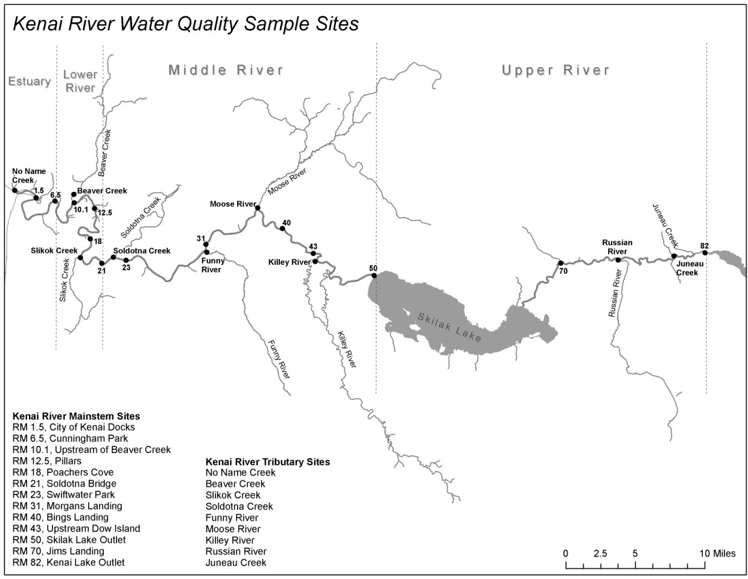

**Figure** 2. **Map of the multi-agency baseline sample locations and the Kenai River watershed.**

The City of Soldotna Wastewater Treatment Plant has the capability and equipment to test the following parameters and will do so as time allows and staff are available and willing to donate time:

* Total Suspended Solids
* Fecal Coliform

SGS Anchorage will be under contract for a more intensive analysis of water quality parameters including:

* Hydrocarbons
* Trace Metals
* Total Phosphorous
* Nitrates

## As needed, Tauriainen Engineering & Testing will be under contract for analysis of water quality parameters including:

* Fecal Coliform (when the City of Soldotna cannot provide this analysis)

Agency representatives receive training on sampling techniques directly from the SGS and the KWF Quality Assurance Officer on the day prior to sampling. Each team receiving training will be assigned from 1 to 5 sites to collect multiple water samples. Total suspended solids samples will be taken directly to the City of Soldotna Wastewater Treatment for analysis within the capacity of the Soldotna Wastewater treatment plant. Remaining samples will be sent to SGS or Tauriainen for the more specific analysis as described above.

## B2. Sampling Methods Requirements

Monitors will face upstream while collecting water samples, wear clean gloves, and ensure that they are not downstream of any boats or other river obstacles that may be adding concentrated products into the water column. Monitors will employ “Clean Hands – Dirty Hands” technique when handling sample vessels and equipment (EPA 1996b) (see Appendix B for detailed protocol). Monitors will remove the bottle lid carefully, making sure not to touch the inside of the bottle cap or bottle rim. Never place bottle caps in pockets, or on surfaces. Monitors will do their best to minimize the amount of time that bottles are open before sample collection. Samples collected in the main stem of the Kenai River, unless otherwise noted on the data collection sheet for safety reasons, will be collected at least 10 feet away from the riverbank. Samples from a tributary stream will be collected upstream of the mixing zone with the Kenai River. The GPS coordinates of the actual sample collection location will be recorded by each monitor.

Each sample bottle will be labeled with a unique sample number, sample site name, analysis to be performed, date and time, and initials of the person collecting the sample. SGS will provide and prepare all uncontaminated testing sample bottles for each. See Section B3, Sampling Handling and Custody Requirements, for details on how the samples will be prepared and handled for transport.

The recommended time for sampling is morning so that samples can be analyzed in the early afternoon at the Soldotna Wastewater Treatment Plant and prepared for travel and subsequent analysis at the SGS in Anchorage. At the sampling stations located in the tidal areas of the Kenai River, samples will be taken during outgoing tide to obtain river water rather than tidally influenced salt water.

**Table 9. Preservation and Holding Times for Sample Analysis**

|  |  |  |  |  |  |
| --- | --- | --- | --- | --- | --- |
| **Analyte** | **Matrix** | **Container** | **Necessary Volume** | **Preservation and Filtration** | **Holding Time** |
| **BTEX** | Water | VOA amber vials w/septa | 3x40mL vials | HCl to pH < 2; 0-≤6°C, do not  freeze; no headspace | 14 days |
| **Phosphorus, total** | Water | HDPE | 125ml | H2SO4 to pH < 2;  0-6°C, do not freeze | 28 days |
| **–Nitrates (NO2 + NO3)** | DW/W | HDPE | 60 ml | H2SO4 to pH < 2;  chill recommended | 28 days |
| **Fecal Coliform** | Water | PA | 125 ml | * 1 ml of 10% sodium thiosulfate, * ≤10°C, do not freeze | <6 hours sample collection to sample incubation. |
| **TSS** | Water | P, FP, G |  | * Cool ≤6°C * do not freeze | 7 days |
| **Dissolved Metals** | Water | HDPE | 250 ml | * lab filtration w/0.45 µm filter within 14 days of collection followed by * HNO3 to pH<2 | 6 months |
| **Total Metals** | Water | HDPE | 250 ml | HNO3 to pH<2 at time of collection | 6 months |
| **Turbidity** | Water | P, FP, G | 250 ml | * Cool ≤6°C * do not freeze | 48 hours |

PA, P, FP, PA is any sterizable (autoclavable) plastic, “P” is polyethylene, “FP” is fluoropolymer, “G” is glass, HDPE is “high-density polyethylene”, VOA is “volatile organic analysis”

## B3. Sample Handling and Custody Requirements

*In-situ field measurements*

* Field sampling crews will use handheld electronic instruments to measure conductivity, pH, temperature, and turbidity on site.

*Sample transport from field to office*

* Samples will be labeled (see Figure 3) and logged on the Agency Baseline Field Data Sheet (Appendix C).
* Sample collection vessels will be stored in double plastic bags, grouped by field site. Sample vessels will be handled only by gloved hands, per description of the “Clean Hands / Dirty Hands” methodology (see Field Sampling SOP in Appendix B).
* In the field, samples will be collected and stored in insulated ice chests containing freezable gel packs to hold samples at 4 degrees C (plus or minus 2 degrees C) until delivered to the lab. Temperature in transit will be monitored with a temperature blank with an objective of maintaining 4 degrees centigrade plus or minus 2 degrees centigrade. Once collected, samples are the responsibility of the monitors, and will stay in their possession until delivered to the drop-off location.
  + - Once samples have been delivered to the drop-off location, the Soldotna Wastewater Treatment Plant lab technicians analyze samples for total suspended solids, and fecal coliform bacteria.
    - A portion of the samples will also be prepared for travel to SGS for further analysis. Samples will be repacked in insulated ice chests and kept in chilled condition with freezable ice packs. Temperature in transit will be monitoring with a temperature blank with an objective of maintaining 4 degrees centigrade plus or minus 2 degrees centigrade.
    - An SGS Chain of Custody Form will be used to record all transport and storage information.
    - Each sample bottle will be labeled with a unique sample number, sample site name, analysis to be performed, date and time, and initials of the person collecting the sample.

Analyst: Signature:

**Lab Information:**

Date: / / Time: AM PM Phone:

Phone: Monitor Signature:

**KENAI WATERSHED FORUM Phone (907) 260-5449**

**Field Information:**

Type of Sample: Sample Number Site #: Location:

Sample of

Preservation Method: Gear: Date:

/ /

Time: AM PM Monitor Name:

**Figure** 3. **Sample Container Label**

*Sample transport from office to laboratory*

Samples and sample containers will be maintained in a secure environment from the time the bottles leave the laboratory until the samples are received at the laboratory. The laboratories will maintain custody of bottles and samples using their normal custody procedures.

Samples must be in the sampler’s possession or in a cooler sealed with signed and dated friable evidence tape on opposing sides of the cooler. When the cooler is sealed, the method of securing the samples must be such that tampering with samples or bottles is not possible. The cooler must be secured so that the lid cannot be removed without breaking the evidence tape or cutting the lock.

Transfer of samples will be accomplished using the laboratory’s Chain-of-Custody (COC) form. When samples are transferred between personnel, such transfer will be indicated on the COC form with signature, date, and time of transfer. The COC will remain with the samples, sealed inside the cooler, until received by the laboratory.

If custody is broken at any time during sample transfer, a note must be made on the COC form accompanying the sample. Upon receipt at the laboratory, the laboratory sample custodian will make note if a breach of custody has occurred (for example, if a custody seal has broken during transport).

*Shipping Requirements*

Packaging, marking, labeling, and shipping of samples will comply with all regulations promulgated by the U. S. Department of Transportation in 49 CFR 171-177. Staff should receive the necessary training for shipping samples or consult with the contracted laboratory for shipping instructions.

Samples collected in plastic bottles may be placed in the cooler with sufficient padding (e.g., bubble wrap, cardboard, etc.) to limit movement of the bottles in the cooler during transport. The plastic sample bottles will be placed into a bag-lined cooler with ice sealed in plastic bags or gel-ice/blue-ice to maintain a temperature of less than four degrees C. A temperature blank, 250 or 500 mL in size, will be placed in the cooler. Temperature will be measured prior to shipment and upon receipt at the lab. The chain of custody (COC) form will be placed in a plastic bag within the cooler. The cooler will be taped closed securely using packing tape at the drop-off location.

The six-hour holding time limitation for the bacteria samples must be met. To accomplish this, this project will use a combination of transportation to get the samples from waterbodies to laboratory within the specified hold time. Water chemistry samples will be delivered to contracted laboratories within 48 hours to meet the hold times.

## B4. Analytical Methods Requirements

Monitoring shall be conducted in accordance with EPA-approved analytical procedures and in compliance with 40 CFR Part 136, *Guidelines Establishing Test Procedures for Analysis of Pollutants* (EPA 1996a). Documentation of methods used, along with precision and accuracy and detectability information is provided in Table 2 through Table 5. For each sample collected, the method used is recorded in the data.

Under direction of the Project Manager, project staff will ensure that all equipment and sampling kits used in the field and laboratories use EPA Clean Water Act (CWA) approved methods. The project’s QA officer will verify that only EPA CWA approved methods (or in specific incidences ADEC DOW pre- approved methods) are used.

Soldotna Wastewater Treatment Lab will analyze samples for Total Suspended Solids, as well as for Fecal Coliforms when resources allow. SGS will perform laboratory analysis of water quality beyond the capacity of the Soldotna Wastewater Treatment Plant. Their Quality Management Plan is on file with Kenai Watershed Forum, and available upon request from either KWF or the Soldotna Wastewater Treatment Plant.

## B5. Quality Control Requirements

Quality Control (QC) is the overall system of technical activities that measures the attributes and performance of a process, item, or service against defined standards to verify that they meet the monitoring project’s data quality objectives. This information is summarized in Table 10.

## B.5.1Field Quality Control (QC) Measures

QC measures in the field include but are not limited to:

* + - Adherence to documented procedures and the comprehensive documentation of sample collection information included in the field data sheets.
    - A rigidly enforced chain-of-custody program will ensure sample integrity and identification. The chain-of-custody procedure documents the handling of each sample from the time the sample was collected to the arrival of the sample at the laboratory.
    - Proper cleaning of sample transport containers (coolers) and sampling equipment.
    - Maintenance, cleaning and calibration of field equipment/kits per the manufacturer’s and/or laboratory’s specification, and field SOPs.
    - Chemical reagents and standard reference materials used prior to expiration dates.
    - Ensuring that field sample collection containers seals remain unbroken until sampling is conducted.
    - Correct sample labeling and data entry.
    - Proper sample handling and shipping/transport techniques.
    - Field replicate samples (blind to the laboratory). A minimum of 10% of the field samples will be duplicated with a replicate sample. Two replicate samples will be collected during the spring Monitoring event and again during the summer Monitoring event. The replicate samples will be randomly rotated among the 7 teams of monitors.
    - Field replicate measurements. At least 10% of the instrument multi-day deployments are duplicated using two instruments side by side. Comparison of the two data sets is to be reported in an annual summary to demonstrate comparability.
* Field blank measurements. A minimum of two field blank samples will be assigned by random rotation to two separate sites for each sample event. The sample will be collected by pouring ultrapure distilled water provided by SGS Laboratories directly into the sample vessel. At minimum, the field blank will be analyzed for total Cu and Zn, and dissolved Cu, Zn, As, Cd, Cr, and Pb (see Table 12).
  + Field blanks will be assigned only to sites below River Mile 30. The rationale is that field blanks are currently intended to measure the influence of field collection procedures as a potential source of sampling contamination for dissolved metals. Dissolved metals samples are collected only at sites including at and downstream of River Mile 30.

**Table 10 (page 1 of 2).** **Field Quality Control Samples. Table contains information for Hydrolabs and stream temperature monitoring for general reference.**

|  |  |  |  |
| --- | --- | --- | --- |
| **Field Quality Control Sample** | **Measurement Parameter** | **Frequency of Occurrence** | **QC Acceptance Criteria Limits** |
| Trip Blank | BTEX | 1/cooler/  shipment | ≤ BTEX DL (see Table 2) |
| Field Blank | Total Cu, Zn; Dissolved Cu, Zn, As, Cd, Cr, Pb | 2 per sample event (i.e., spring/summer), random rotation |  |
| aField Replicate (Blind to Lab) | DRO, GRO, RRO, Benzene, Ethylbenzene, m,p-Xylene, o-xylene, Toluene, Catotal,Fetotal, Mgtotal, Asdissolved, Cddissolved, Crdissolved, Cudissolved,  Pbdissolved, Zndissolved, Ptotal,NO2 + NO3, | 10% | See Section A7, Table 3 through Table 5 for analyte-specific precision criteria. (See section B.5.1 for operational details). |
| Field Replicate Measurement | Hydrolab (pH, Turbidity, Water Temperature, Specific Conductance, DO) | 2/each hydrolab deployment (beginning and end) and at least 10%  sample data collected | See Section A7, Table 2 for analyte-specific precision criteria |
| Field Replicate Measurement (Stream Temperature Monitoring) | Air and Water Temperature | 2/each deployment (beginning and end of ice-free season) | See Mauger et al. (2015) |
| Calibration Verification Check Standards | Hydrolab (pH, Turbidity, Specific Conductance, DO) | 1/deployment after stream  retrieval | See Table 2 analyte- specific accuracy criteria |
| Temperature Blank | BTEX, Phosphorous (Total), NO3+NO2, TSS,  Turbidity | 1/cooler/ship- ment | ≤ 6°C |
| Fecal Coliforms |  | ≤ 10°C |
| Trip Blank | BTEX | 1/cooler/ship-ment | ≤ BTEX DL (see Table 2) |

a Two replicate samples will be collected during the summer Monitoring event. The replicate samples will be rotated among the 7 teams of monitors.

b  One field blank collection for total and dissolved metals will be randomly assigned to two sites per sampling event.

**Table 10. (page 2 of 3).** **Field/Laboratory Quality Control Samples**

|  |  |  |  |
| --- | --- | --- | --- |
| **Field/Lab Quality Control Sample** | **Measurement Parameter** | **Frequency of Occurrence** | **QC Acceptance Criteria Limits** |
| Lab blank | DRO, GRO, RRO, Benzene, Ethylbenzene, m,p-Xylene, o-xylene, Toluene, Catotal,Fetotal, Mgtotal, Asdissolved, Cddissolved, Crdissolved, Cudissolved, Pbdissolved, Zndissolved, Ptotal,NO2 + NO3, TSS,  Turbidity, Fecal Coliforms |  | ≤ DL (See Section A7, Table 3 through Table 5 for analyte-specific precision criteria) |
| Lab Fortified Blank | DRO, GRO, RRO, |  | Calibration: ±25% |
| Benzene, Ethylbenzene, m,p-Xylene, o-xylene,  Toluene |  | Calibration: ±15% |
| Catotal,Fetotal, Mgtotal |  | Calibration: ±15% |
| Asdissolved, Cddissolved, Crdissolved, Cudissolved,  Pbdissolved, Zndissolved, |  | Calibration: ±15% |
| Ptotal |  | Calibration: ±15% |
| NO2 + NO3 |  | Calibration: ±15% |
| Lab Calibration Standard (LCS) and Continuing Lab Calibration Standard (CCS) | DRO, GRO, RRO |  | Calibration: ±25% |
| Benzene, Ethylbenzene,  m,p-Xylene, o-xylene, Toluene, |  | Calibration: ±15% |
| Catotal,Fetotal, Mgtotal |  | Calibration: ±15% |
| Asdissolved, Cddissolved, Crdissolved, Cudissolved,  Pbdissolved, Zndissolved |  | Calibration: ±15% |
| Ptotal |  | Calibration: ±15% |
| NO2 + NO3 |  | Calibration: ±15% |
| Turbidity |  | Calibration: ±15% |

**Table 10. (page 3 of 3). Field/Laboratory Quality Control Samples**

|  |  |  |  |
| --- | --- | --- | --- |
| **Field/Lab Quality Control Sample** | **Measurement Parameter** | **Frequency of Occurrence** | **QC Acceptance Criteria Limits** |
| Matrix Spike | DRO, GRO, RRO, Benzene, Ethylbenzene, m,p-Xylene, o-xylene, Toluene, Catotal,Fetotal, Mgtotal, Asdissolved, Cddissolved, Crdissolved, Cudissolved,  Pbdissolved, Zndissolved, Ptotal,NO2 + NO3, |  | Calibration: ±15% |
| Matrix Spike Duplicate | DRO, GRO, RRO, Benzene, Ethylbenzene, m,p-Xylene, o-xylene, Toluene, Catotal,Fetotal, Mgtotal, Asdissolved, Cddissolved, Crdissolved, Cudissolved,  Pbdissolved, Zndissolved, Ptotal,NO2 + NO3, |  | Calibration: ±15% |
| Lab Duplicate Sample | DRO, GRO, RRO, Benzene, Ethylbenzene, m,p-Xylene, o-xylene, Toluene, Catotal,Fetotal, Mgtotal, Asdissolved, Cddissolved, Crdissolved, Cudissolved, Pbdissolved, Zndissolved, Ptotal,NO2 + NO3, Turbidity,  TSS |  | Calibration: ±15% |
| External QC Check Standard | Turbidity, |  | Calibration: ±15% |
| TSS |  | Calibration: ±15% |
| Internal Standard/Surrogate Standard | BTEX |  | Calibration: ±15% |
| Asdissolved, Cddissolved, Crdissolved, Cudissolved, Pbdissolved, Zndissolved |  | Calibration: ±15% |

If analytical sample results exceed state water quality criteria for a parameter (or multiple parameters), KWF will do the following:

* + - For the semiannual water quality monitoring events in April and July, KWF will collect another sample as soon as possible to confirm the original findings if funding is available. Ideally, samples would be collected at the original sample location and one above and below the original location.
    - Flag the data, validate it, notify ADEC as soon as feasible and summarize it in the annual data report.
    - Flag the data, validate it, and share the information with the technical advisory committee to help determine where and what to sample for in the future.
    - Prior to the public release of any data, KWF will inform ADEC of KWF’s intention to report the data. KWF will work closely with the ADEC project manager to ensure an accurate and consistent message will be delivered. Prior to final release, KWF will also notify partner organizations involved with fieldwork, sample analysis, and data management to ensure consistent messaging.

## B6. Instrument / Equipment Testing, Inspection and Maintenance

Training is conducted by the KWF Program Manager with support from the KWF QA Officer and/or SGS staff. The trainers describe the proper handling and maintenance of sample bottles and, once the water samples were taken, how to handle the samples while in transit to the drop off point. The only field analysis performed by monitors is in-situ temperature. Proper equipment handling and maintenance is also emphasized when each monitor picks up his/her sample kit assembled by SGS. Monitors are asked to contact the Project QA Officer immediately upon receipt if any sample bottles, caps, labeling material, data sheets, etc. are not included in the kit.

All equipment, and kits are checked upon receipt by the Project QA Officer to ensure that all equipment is in working order and the kit was complete. Before each sampling event, Monitors are asked to inspect all kits for completeness. Kits are also inspected when Monitors bring them in with water samples to the drop-off location. SGS will provide extra sampling bottles in case some are missing in the kits.

## B7. Instrument Calibration Procedures

Field instruments will be calibrated or verified within calibration tolerances prior to using the instruments. Calibrations will be in accordance with the respective EPA Clean Water Act (CWA) approved method against standards of known traceability and within stated certification (expiration) dates. Calibrations, etc. will be documented as previously described.

Contracted and sub-contracted laboratories will follow the calibration procedures found in its QAPP and the laboratory’s SOPs. Specific calibration procedures for regulated pollutants will be in agreement with the respective EPA Approved CWA method of analysis. Field and/or laboratory calibration records will be made available to partner agencies upon request.

Standard Calibration Procedures for Hydrolab Minisonde MS 5 are included as Appendix H to this document.

Note: YSI meters are calibrated to the manual specifications for each model listed. YSI meters are only used to collect temperature data. The YSI Temperature Meter QA form is found in Appendix I.

## B8. Inspection and Acceptance Requirements for Supplies

Monitoring supplies are provided by SGS. The lead contact at SGS has the responsibility of ordering equipment and supplies. All sample containers, tubing, filters, etc. provided by SGS will be certified clean for the analyses of interest. The KWF team will take note of the information on the certificate of analysis that accompanies sample containers to ensure that they meet the specifications and guidance for contaminant-free sample containers for the analyses of interest. The project QA Officer has the responsibility to ensure that adequate supplies are available and being used at the time of sampling.

## B9. Data Acquisition Requirements for Non-Direct Measurements

Weather data downloaded or purchased through the National Oceanic and Atmospheric Administration (NOAA) web site (<http://www.ncei.noaa.gov>) also will be used and assumed accurate. Stream discharge data may be obtained from the U.S. Geological Survey (USGS) ([https://maps.waterdata.usgs.gov/mapper/)](https://maps.waterdata.usgs.gov/mapper/)and will be assumed to be accurate.

## B10. Data Management

The success of a monitoring project relies on data and their interpretation. It is critical that data be available to users and that these data are:

* + - Of known quality
    - Reliable
    - Aggregated in a manner consistent with their prime use
    - Accessible to a variety of users

Quality Assurance/Quality Control (QA/QC) of data management begins with the raw data and ends with a defensible report, preferably through the computerized messaging of raw data. See Figure 4 for details.

Data management encompasses and traces the path of the data from their generation to their final use or storage [e.g., from field measurements and sample collection/recording through transfer of data to computers (laptops, data acquisition systems, etc.), laboratory analysis, data validation/verification, QA assessments and reporting of data of known quality to the Project Manager and partner agencies upon request. Data management also includes/discusses the control mechanism for detecting and correcting errors.

Various people are responsible for separate or discrete parts of the data management process:

* The sampling team is responsible for field measurements/sample collection and recording of data and subsequent shipment of samples to laboratories for analyses. They assemble data files, which includes raw data, calibration information and certificates, QC checks (routine checks), data flags, sampler comments and metadata where available. These files are assembled and forwarded for secondary data review by the sampling manager or supervisor.
* Laboratories are responsible for complying with the data quality objectives specified in the QAPP and as specified in the laboratory QAP and method specific SOPs. Validated sample laboratory data results with respective analytical method QA/QC results and acceptance criteria are reported to the sampling manager or project supervisor.
* Secondary reviewers (sampling coordinator/supervisor/project supervisor) are responsible for QA/QC review, verification and validation of field and laboratory data and data reformatting as appropriate for reporting to the EPA Water Quality Exchange, AWQMS (if subscribed), and reporting validated data to the project manager.
* The project QA officer is responsible for performing routine independent reviews of data to ensure the monitoring projects data quality objectives are being met. Findings and recommended corrective actions (as appropriate) are reported directly to project management.
* The project manager is responsible for final data certification
* Prior to uplift to the EPA Water Quality Exchange, a final tertiary review is conducted by a third party, such as the ADEC DOW Water Quality Nonpoint Source Regional Staff/WQAO or another party as recommended by ADEC and technical review board members.
* ADEC staff will perform a biannual assessment of water quality that has been uplifted to the EPA Water Quality Exchange in the context of regulatory limits as part of their Integrated Assessment report.

## B10.1 Data Storage and Retention

Data management files will be stored as described below and in Section A9, Documents and Records. Laboratory records must be retained by the contract laboratory for a minimum of five years.

All data are reviewed by the Project QA Officer and the Project Manager before data are accepted. Data will be converted into a customized template in Microsoft Excel compatible with the data uplift procedure being applied (e.g. the EPA Water Quality Exchange or the Ambient Water Quality Management System (AWQMS)). Data will be reviewed to determine if water quality problems exist and any values exceed water quality standards. Data files are backed up on KWF server, which in turn is backed up at a remote location by the IT service provider North Tech Group (<https://northtechgroup.com/>). See Figure 4 for the data management flowchart.

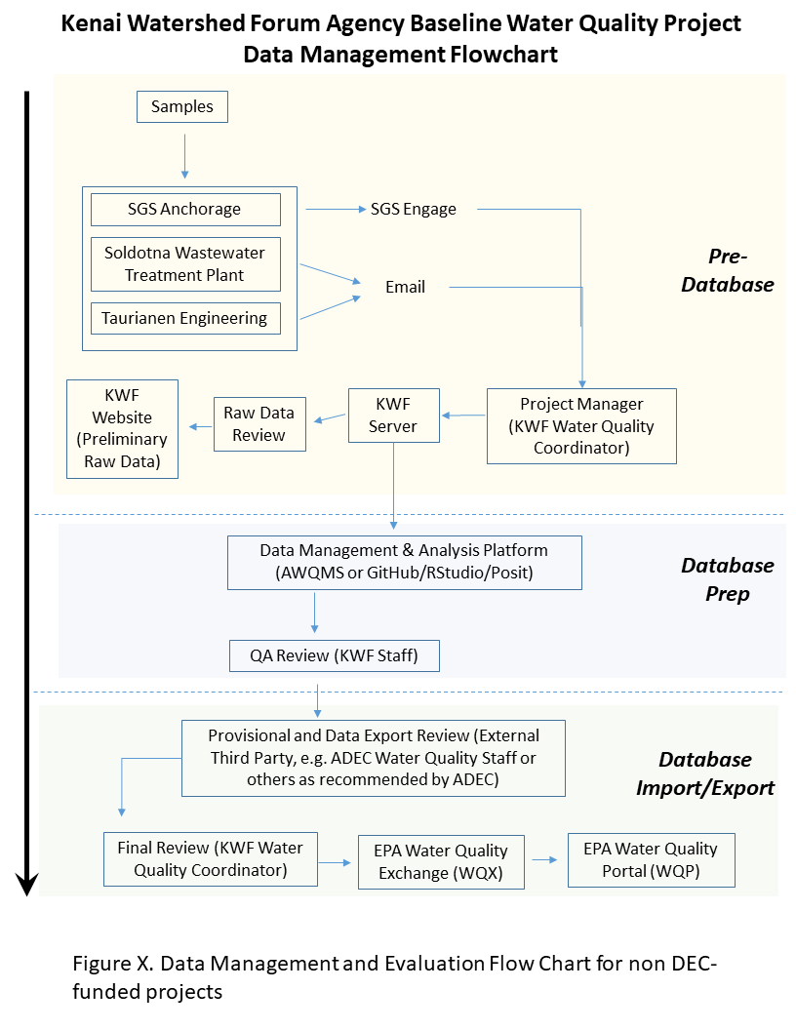

**Figure 5. Data management and evaluation flowchart for Kenai River Agency Baseline Water Quality Monitoring Project.**

## C1. Assessments and Response Actions

Assessments are independent (of management) evaluations of the monitoring project that are performed by the Project’s QA Officer or his/her designee. For this project assessments include the following:

Field Assessments (each pollutant)

* + - * Precision (replicate) sample measurements. Precision criteria are specified in Section A7, Table 2 through Table 6.
      * On-site observation of field monitoring operations. Surveillance - The project QA Officer will spot check monitoring teams at two sampling locations (10%) to observe sample collection. If sampling technique problems are observed, corrective action will be taken immediately to resolve the problem. Observations of problems and corrective actions will be included in a corrective action report (reporting errors observed and actions taken to correct errors).

Field samples collected for subsequent laboratory analysis (each pollutant)

* + - * Blind replicate samples for each pollutant to be measured. Precision criteria are specified in Section A7, Table 2 through Table 6.
      * Matrix spike duplicates (MSD) (assesses total measurement bias for project – both precision and accuracy). Frequency of MSDs is usually specified by the analytical method. Accuracy and precision of criteria for each pollutant and analytical method are specified in the project’s Measurement Quality Objectives (MQO) tables, see section A7.
      * Matrix spike (MS) assess project accuracy are specified in the project’s MQO tables, see section A7.

On-Site Assessments

* + - * Inspection of field monitoring operations for compliance with QAPP requirements - The QA Officer will spot check monitoring teams at two sampling locations (10%) to observe sample collection. If sampling technique problems are observed, corrective action will be taken immediately to resolve the problem. Observations of problems and corrective actions will be included in a corrective action report (reporting errors observed and actions taken to correct errors).
      * Audit of project field measurement data results.

Project Data Assessments

* + - * QA review (verification and validation) of Monitoring Data. Recommended QA coverage is 100% QA for data entered by hand. A 10% QA is recommended for data copy/pasted or downloaded from a database. Data that receives manual QA review will be recorded as such in the spreadsheet being reviewed. The reviewer will record their initials and the date in a column adjacent to each row that has been manually reviewed. If the records are being checked against a paper copy, the reviewer will note their initials and the date in the lower right corner of the paper sheet once complete in the following format: “QA1: AB 10/30/2022.”
      * Calculation of monitoring project’s overall achieved precision, accuracy and data completeness compared to QAPP defined precision, accuracy and data completeness goals.

As described in Section B10, all data are reviewed by the Project QA Officer and the Project Manager before data are accepted and submitted to a database. If problems are discovered with data quality or management, it is the responsibility of both the Project Manager and the Project QA Officer to address them in a timely manner, which may include a corrective action report.

Procedures for inspection, acceptance, calibration and maintenance of equipment and supplies are described in detail in Sections B6, B7, and B8. If problems with data quality are traceable to equipment failure, inspection, calibration and maintenance will be scheduled more frequently.

The Technical Advisory Committee (Appendix A) will review this QAPP and the overall project design bi-annually and may suggest procedural refinements or additional testing procedures. This may include new parameters to be measured or changes to procedures currently in use. Any such changes will be subject to EPA and ADEC approval. The project is open to EPA or ADEC system audits at their discretion.

Data that has been validated and appears not to meet state water quality standards will be flagged and pointed-out both to ADEC and EPA as well as members of the Kenai River Special Management Area Board.

# C2. QA Reports to Management

Annually a QA summary report and field report will be produced and submitted to the KWF Project Manager, ADEC DOW Nonpoint Source Regional Staff, Technical Review Committee, and participating partner agencies. QA summary report to include the following:

* + - * A written summary stating whether the project-specific data quality objectives (and specifically project Measurement Quality Objectives were met, specified in section A7 of each QAPP). If not, what parameters failed, what data was affected and what corrective actions were taken to return the monitoring network to pre-approved project data quality objectives.
      * Precision assessments and Precision Table listing for each analyte—
        + All field replicate sample pairs (even if sample values are qualified).
        + Sample collection date of respective field replicate sample pairs.
        + Calculated individual precision of each paired field replicate where both values ≥ analyte specific limit of quantitation/reporting limit (LOQ or RL). Use algorithm in section A7
        + Calculated overall precision project precision where both values ≥ analyte

specific LOQ or RL. Use algorithm in section A7.

* + - * + QAPP specified Precision Measurement Quality Objective (MQO)
      * Accuracy (Assessment-- Accuracy Table listing for each analyte measured where sample spike recoveries are required by analytical method and project specific QAPP) the following:
        + Sample spiked and unspiked results
        + Date of analysis of sample and spiked sample
        + Per cent (%) sample spike recovery
        + Sample unspiked and spike duplicate results
        + Date of analysis of dup sample and dup spiked sample
        + % sample spike duplicate recovery
        + Sample spiked duplicate RPD
        + QAPP specified Accuracy MQO

Note: Accuracy for spiked sample results is determined by calculation percent (%) spike recovery from sample spikes and duplicate sample spikes using the following algorithm:

% spike recovery = (spike concentration - sample conc.)/spike conc. X 100

* + - * Data Completeness Assessment—Data Completeness Table listing each analyte measured the following: following:
        + Number of samples scheduled to be collected/analyzed as specified in the QAPP.
        + Number of samples collected/analyzed and reported as valid data.
        + QAPP required Data Completeness requirement.
  + Any deviations from the sampling plan with explanation

A comprehensive report will be produced every 5 years, contingent on available funding. An open data report will be produced within one year of data collection. The open data reports will be available online through a link at <http://www.kenaiwatershed.org>. The KWF Program Manager is responsible for report production and distribution. Summaries of all reports, highlighting the assessment results, and project status will be made available to the local public through the Kenai River Center and Kenai Watershed Forum web centers and at the local public libraries.

## D1. Data Review, Validation, and Verification Requirements

The Project Manager and the Quality Assurance Officer will conduct data review and validation. This process for data review is described under Sections B10 and A7. Data that are obtained using equipment that has been stored and calibrated correctly and that meets the accuracy, precision and QC limits will be used. Data that does not meet the accuracy, precision and QC limits may be used if justification is reasonable, data is qualified with data use limitations applied and with ADEC project manager/ADEC Water QA Officer concurrence.

## D2. Validation and Verification Methods

Project QA Officer and Project Manager will conduct data validation and verification. Project QA Officer and Project Manager review data and flag, but not delete, any values which fall outside of the expected range for each parameter. Errors in data entry will be corrected and inconsistencies will be flagged for further review.

The Project QA Officer is responsible for ensuring that maintenance and calibration records show all monitoring equipment in use to be in compliance with the requirements of this QAPP (see Sections B6, B7, & B8). If data quality questions cannot be adequately resolved, data will not be entered into any database without being flagged as questionable. The Project QA Officer will arrange for corrective measures (i.e. monitor re-training, equipment re- calibration, etc.).

## Laboratory Quality Control (QC) Measures

Laboratory QC includes the following:

* + - Laboratory instrumentation calibrated with the analytical procedure.
    - Laboratory instrumentation maintained in accordance with the instrument manufacturer’s specifications, the laboratory’s QAP and Standard Operating Procedures (SOPs).
    - Matrix spike/matrix spike duplicates, sample duplicates, calibration verification checks, surrogate standards, external standards, etc. per the laboratory’s QAP and SOPs.
    - Specific QC activities prescribed in the project’s QAPP.
    - Laboratory data verification and validation prior to sending data results to ADEC and/or permitted facility.

Contracted laboratories will provide analytical results after verification and validation by the laboratory QA Officer. The laboratory must provide all relevant QC information with its summary of data results so that the project manager and project QA officer can perform field data verification and validation and review the laboratory reports. The Project Manager reviews these data to ensure that the required QC measurement criteria have been met. If a QC concern is identified in the review process, the Project Manager and Project QA Officer will seek additional information from the contracted laboratory to resolve the issue/s and take appropriate corrective action.

## D3. Reconciliation with Data Quality Objectives

The Project QA Officer and/or the Project Manager will compare the results and associated variability, accuracy, precision, and completeness with project objectives. If data quality indicators do not meet program specifications (see Table 2 through Table 6) data will flagged as ‘Rejected’ and not be uplifted to the EPA Water Quality Exchange. The cause of failure will be evaluated and documented in the data QA report. If the cause is found to be equipment failure, calibration and maintenance procedures will be reassessed and improved. In some cases, accuracy project criteria may be modified with prior approval by ADEC project management and ADEC Water QA Officer. In this case the justification for modification, problems associated with collecting and analyzing data, as well as potential solutions will be reported to ADEC. If failure to meet program specifications is found to be unrelated to equipment, methods, or monitor error, specifications may be revised. Revisions to this QAPP will be submitted to the designated state ADEC and federal EPA, Region 10 Quality Assurance Officers for approval.

# 

## References

ACCS. 2023. “AKTEMP Water Temperature Database.” AKTEMP. 2023. https://aktemp.uaa.alaska.edu/#/.

ADEC. 2022a. “Kenai River Water Quality Monitoring Activities.” 2022. https://dec.alaska.gov/water/nonpoint-source-control/waters-in-the-spotlight/kenai-river-water-quality-monitoring-activities/.

———. 2022b. “Water Quality Standards and Restoration, Water Quality Reports.” February 15, 2022. https://dec.alaska.gov/water/water-quality/reports.

AKDNR. 1997. “Kenai River Comprehensive Management Plan.” https://www.kenaifishpartnership.org/wp-content/uploads/2021/10/krsma_1997_editable_sm.pdf.

Apsens, S., and J. Petitt. 2022. “Kenai River, Alaska Field Report 2021.” Alaska Department of Environmental Conservation.

EPA. 1996a. “Guidelines Establishing Test Procedures for the Analysis of Pollutants (40 CFR Part 136).” 1996. https://www.ecfr.gov/current/title-40/chapter-I/subchapter-D/part-136?toc=1.

———. 1996b. “Method 1669 - Sampling Ambient Water for Trace Metals at EPA Water Quality Criteria Levels.” 1669. Washington D.C.

Guerron Orejuela, Edgar. 2016. “Water Quality Assessment of the Kenai River Watershed from July 2000 to July 2014.” Kenai Watershed Forum. https://dec.alaska.gov/media/16756/kenai-river-baseline-monitoring-report-final-zncuappendix.pdf.

Litchfield, V. P., and G. B. Kyle. 1992. “Kenai River Water Quality Investigation Completion Report.” 123. Alaska Department of Fish and Game. http://www.adfg.alaska.gov/fedaidpdfs/FRED.123.pdf.

Martin, Michelle, Joe Charbonnet, Elizabeth Jones, Jim Czarnezki, and Robert Ruffner. 2011. “Turbidity Monitoring on the Lower Kenai River, 2008-2010.” Kenai Watershed Forum.

Mauger, Sue. 2013. “Cook Inlet Stream Temp Network Synthesis Report 2008-2012.” Cook Inletekeeper. https://inletkeeper.org/wp-content/uploads/2017/03/Cook-Inlet-Stream-Temp-Network-Synthesis-Report.pdf.

Mauger, Sue, Rebecca Shaftel, Jason C. Leppi, and Daniel J. Rinella. 2017. “Summer Temperature Regimes in Southcentral Alaska Streams: Watershed Drivers of Variation and Potential Implications for Pacific Salmon.” *Canadian Journal of Fisheries and Aquatic Sciences. Journal Canadien Des Sciences Halieutiques et Aquatiques* 74 (5): 702–15.

Mauger, Sue, Rebecca Shaftel, E. Jamie Trammell, Marcus Geist, and Dan Bogan. 2015. “Stream Temperature Data Collection Standards for Alaska: Minimum Standards to Generate Data Useful for Regional-Scale Analyses.” *Journal of Hydrology: Regional Studies* 4, Part B (September): 431–38.

McCard, Jennifer J. 2007. “Water Quality Assessment of the Kenai River Watershed from July 2000 to July 2006.” Kenai Watershed Forum.

Meyer, Benjamin. 2021. “Status of Copper and Zinc Throughout the Kenai River Watershed.” Kenai Watershed Forum. https://dec.alaska.gov/media/22967/copper-zinc-field-report-2019-2020.pdf.

Sires, Jeff. 2017a. “A Review of Potential Zinc and Copper Pollution Sources in the Kenai River Watershed.” DEC. https://dec.alaska.gov/media/5181/zcliteraturereviewfinal.pdf.

———. 2017b. “Kenai River Watershed Zinc and Copper Pollution: A Summary of Data Analysis, Literature Review Results, And Suggested Actions.” DEC. http://www.dec.alaska.gov/media/16761/kenai-river-zinc-and-copper-pollution-study.pdf.

USFWS. 1997. “Upper Kenai River Cooperative Plan.” https://www.fws.gov/uploadedFiles/UpperKenaiRiverCoop_Plan_1997.pdf.

**Appendix** **A: Technical Advisory Committee**

***Sara Apsens***

Alaska Department of Environmental Conservation

Kenai Region Representative, Division of Water Nonpoint Source Program

43335 Kalifornsky Beach Road, Suite 11

Soldotna, AK 99669

Phone: 907- 262-5210

## Scott Curtin

City of Kenai Wastewater Treatment Plant 210 Fidalgo Ave., Suite 200

Kenai, AK 99611

Phone: 907-283-8240

## Jack Blackwell

Alaska State Parks

Kenai River Special Management Area

P.O. Box 1247 Soldotna, AK 99669

Phone: 907-262-5581

***Ruth D’Amico***

U.S. Forest Service Chugach National Forest Seward Ranger District

33599 Ranger Station Spur (mile marker 23.5)

Seward, AK 99664

Phone: 907-288-7730

***Gary Fandrei***

Executive Director, Emeritus

Cook Inlet Aquaculture

40610 Kalifornsky Beach Rd.

Kenai, AK 99611

Phone: 907-283-5761

## 

## Justin Nelson

Client Service Manager

SGS Environmental Laboratory Services

200 W Potter Dr Anchorage, AK 99518

Phone: 907-562-2343

## Jon Essert

Utility Department Manager

City of Soldotna Wastewater Treatment Plant

215 S Kobuk St Soldotna, AK 99669

Phone: 907-262-4205

# Appendix B: Fieldwork Sampling SOP



*“Research, Restoration, Education”*

**Benjamin Meyer | Water Quality Coordinator |** [**ben@kenaiwatershed.org**](mailto:ben@kenaiwatershed.org) **| (907) 232-0280**

**KENAI RIVER BASELINE WATER QUALITY MONITORING**

**SAMPLE COLLECTION PROCEDURES**

1. **Fieldwork Preparation ………………………………………………………………….1**
2. **General Sampling Protocol ……………………………………………………………..2**
3. **Preparing for Sample Collection………………………………………………………..2**
4. **Sample Collection Procedures by Sample Type………………………………………..3**
   1. **Fecal Coliform …………………………………………………………………...3**
   2. **Dissolved Metals …………………………………………………………………4**
   3. **BTEX (Hydrocarbons) ………………………………………………………….5**
   4. **Total metals ……………………………………………………………………...6**
   5. **Nitrogen and Phosphorus ………………………………………………………6**
   6. **Total Suspended Solids …………………………………………………………7**
   7. **Field Blanks …………………………………………………………………….. 7**
5. **Appendix A – Clean Hands, Dirty Hands ……………………………………………..8**
6. **FIELDWORK PREPARATION**
   1. **Six weeks prior to sampling date**
      * The water quality coordinator will contact you by email. Please RSVP as soon as possible if you are participating.
   2. **One week prior to sampling date** 
      * Confirm plans with your fieldwork partners and supervisor.
        1. Know meeting time and place.
      * Review current sampling protocol (this document).
      * Ask the Water Quality Coordinator if you have questions (see top of this form for contact info).
   3. **One day prior to sampling date**
      * At least one team member will pick up water quality sampling equipment from the Water Quality Coordinator. Your confirmation email will describe pick-up time and location.
      * Keep **ice packs** for the sample cooler frozen until the morning of sampling, put reminder note in car.

**______________________________________________________________________________**

1. **GENERAL SAMPLING PROTOCOL**

* **Once you’re at the site, there are some important things to do BEFORE opening the cooler.**
  + **At the site, make a judgment call as to whether the site is representative**
    - Is the river bottom stirred up?
    - Is there something atypical, like a moose carcass just upstream?
    - Are other boats nearby?
      * If site at the coordinates are not representative, either wait until conditions return to normal or slightly modify location.
  + Leave cell phones turned on for project communications
  + **Choose a collection location**
    - Samples collected in the main stem of the river should be collected at least ten feet from the riverbank.
    - Samples collected from tributaries should be collected upstream of the mixing zone with the main stem.
    - **Collect Site information**
    1. Use pre-printed Rite-in-the-Rain field forms to record data with a pencil
    2. Record GPS coordinates on paper at each sampling location
       1. *You can use the Google Maps app on your smart phone to get coordinates even when out of cell reception. Ask the Water Quality Coordinator if you have questions how to do it.*
    3. Collect a photograph at each location with a person holding a sign indicating the sampling location.
    4. Deploy water and air thermometers, take readings before you leave the site
    5. Collect samples only from the assigned creek or river for your group

**______________________________________________________________________________**

1. **PREPARING FOR SAMPLE COLLECTION**

Once you’ve established that your sampling location is ready…

1. **Prepare to use “Clean Hands / Dirty Hands” technique**
   1. ***NEW*:** Designate one person as “Clean Hands” who will only handle sample bottles, and one person as “Dirty Hands” who will perform all other steps. The water quality coordinator will provide training and explanation on clean hands / dirty hands technique on sample kit pick-up day. See Appendix A for further detail.
2. **Prepare sample labels**
   1. Write on bottle label stickers **prior** to applying them to the bottles, and apply them to the bottles **before** they are wet. (Labels are waterproof).
   2. Other sample label notes
      1. Complete the fields on the bottle labels for **TIME and INITIALS.**
      2. **INITIALS** should be those of the team leader **only.**
      3. Use the **IDENTICAL TIME** for all sample containers at a site[6].
      4. Sites are designated with Kenai River main stem River Mile (RM) and site name.
         1. Duplicate samples are indicated by using the abbreviation DUP, as in “RM 10 – Site name - DUP.”
         2. If necessary, write additional information with a black sharpie on plastic HDPE bottles.
         3. ***Do NOT use sharpies on the hydrocarbon (BTEX) samples vials, they will contaminate the sample.***
3. **Other General Sampling Notes**
   1. Put on new clean gloves if you suspect contamination at any point in sampling process.
   2. In general always, ensure that the inside of the bottle caps are not contaminated:
      1. Do not put bottle caps in your pocket.
      2. Do not touch inside of cap or bottle.
   3. Employ “Clean Hands / Dirty Hands” technique throughout sampling process. The water quality coordinator will provide a demonstration on cooler pick-up day. See Appendix A of this document for more details.

**When sample collection is complete at all sites, return to sample drop-off location in Soldotna as quickly as feasible.**

* Some samples cannot be analyzed if they exceed a holding period, thus timely delivery is important!!!
* If your route to the next sampling site passes by the sample drop-off location, please drop them off even if you are not yet done for the day.
* Thank you!!!

**______________________________________________________________________________**

1. **SAMPLE COLLECTION PROCEDURES BY SAMPLE TYPE**

**Fecal coliform** *is a bacteria that exists naturally in the wild that is found in feces of warm-blooded animals. It can reach elevated levels when animals concentrate, like gulls flocking to carcasses, or from human sources, such as a leaking septic tank.*

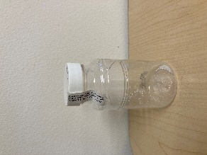

1. **Collect the “Fecal Coliform” sample.** 
   * 1. The fecal coliform bottle is 100 ml clear plastic bottle with white powder (sodium thiosulfate-fixing agent) and may have a *labeled paper seal over the lid.* The lid may be labeled “FC.”
     2. Break the seal, either plastic or paper
     3. **Record sampling time and crew leader initials on the label and apply to bottle.**
     4. Carefully open the container, keeping the lid in one hand and the bottle in the other hand.
        1. ***Do not touch the inside of the bottle or lid.***
     5. Always collect samples facing upstream with the flow of the river coming at you.
     6. Fill the sample bottle with one smooth motion to just over the 100 ml mark. It is necessary to leave some room in the bottle because it will have to be inverted 25 X in the lab.
     7. **Place sealed bottle in cooler with ice.**

**\*\*\*\*\*\*\*\*\*\*\*\*\*\*\*\*\*\*\*\*\*\*\*\*\*\*\*\*\*\*\*\*\*\*\*\*\*\*\*\*\*\*\*\*\*\*\*\*\*\*\*\*\*\*\*\*\*\*\*\*\*\*\*\*\*\*\*\*\*\*\*\*\*\*\*\***

**Dissolved metals** *refers to substances such as zinc, copper, lead, arsenic, and others that exist in a soluble (dissolved) form in water. These elements exist naturally in the environment in rocks and soils, and also have anthropogenic sources such as runoff from roads and agriculture, industrial processes, and fuel combustion.*

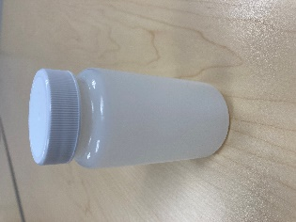

**Not all sites collect dissolved metals samples. Check your kit packing list to see if your sites do.**

* **NEW CHANGES TO DISSOLVED METALS COLLECTION:**
  + **No filtration in the field is required for any samples. The dissolved metals sample will be filtered in the lab. No syringes or filters are provided.**
  + **See note on Field Blank collection below if your site has been randomly assigned a Field Blank**

1. **Collect the “Dissolved Metals” sample (if applicable)**
2. ***Please note, only sites including and downstream of RM 30 will sample for dissolved metals.***
3. ***Proceed to Step 3 if no dissolved metals sample is to be collected.***
4. The dissolved metals sample collection bottle is a 250 ml plastic bottle with no stickers.
5. **Record sampling time and crew leader initials on the label and apply to bottle.**
6. Do not rinse this bottle.
7. Fill the TSS bottle (1 L plastic bottle) using a slow sweeping motion at a depth of six inches.
8. Remove the cap of the dissolved metals bottle. Fill this bottle to the shoulder with sample water from the 1 L TSS bottle, then replace the caps on both bottles.
9. Place dissolved metals bottle in cooler with ice.
10. If your site has been randomly assigned a field blank

**\*\*\*\*\*\*\*\*\*\*\*\*\*\*\*\*\*\*\*\*\*\*\*\*\*\*\*\*\*\*\*\*\*\*\*\*\*\*\*\*\*\*\*\*\*\*\*\*\*\*\*\*\*\*\*\*\*\*\*\*\*\*\*\*\*\*\*\*\*\*\*\*\*\*\*\***

**Hydrocarbons (BTEX)** *are substances found in petroleum products, such as fuel for boats and vehicles. These substances can enter the water from several sources including older or improperly maintained boat engines, fuel leaks from homes or vehicles, and products such as paints and plastics. BTEX stands for benzene, toluene, ethylbenzene, and xylene.*

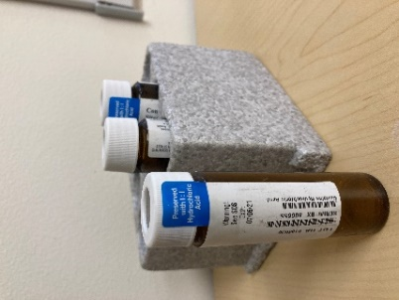

**Hydrocarbon samples are collected in Summer only, not Spring, and not all sites collect these samples. Check to see if your kit does. *This is our most detail-oriented type of sample collection, so proceed carefully.***

1. ***Please note, only RM 1.5, 6.5, 40 and 43 sites will be sampled for BTEX and only during summer (not spring) sampling events!***
2. ***Proceed to Step 4 if no BTEX sample is to be collected***
3. The BTEX sample vials are three 40 ml brown glass vials preserved with hydrochloric acid (HCl)
4. **Record sampling time, crew leader initials, and vial sequence (# of 3) on the label and apply to the vials lengthwise.**
5. Do not rinse these vials.
6. **Fill the 1 L TSS bottle with sample water:**
   1. Face upstream with the flow of the river coming at you.
   2. Remove the lid, turn the bottle upside down, go to a depth of 6”, and allow the bottle to fill, remove the bottle from the water, and discard a small amount so that the fluid level reaches the shoulder of the bottle.
   3. Carefully **fill all three** 40 ml vials until a mound of water (meniscus) is formed on top of the vial.
      1. *Do not overflow the vials excessively as they contain Hydrochloric Acid (HCl) as a preservative.*
7. Cap the vials and place in cooler with ice.
8. **Special notes concerning the collection of BTEX samples.**
   1. **For BTEX-Volatile Organics Compounds (VOC)- it is critically important to NOT have any air bubbles (or headspace) in the vials after sampling.**
   2. Sampling Teams using a boat
      1. Have a designated driver and only the driver handles gas can and drives the motor.
      2. Boat driver does not handle BTEX Bottles.
   3. All teams
      1. If you filled up a vehicle with gas the day of sampling, do not handle the BTEX vials.
      2. Avoid handling or contact with all chemicals and/or solvents.

**\*\*\*\*\*\*\*\*\*\*\*\*\*\*\*\*\*\*\*\*\*\*\*\*\*\*\*\*\*\*\*\*\*\*\*\*\*\*\*\*\*\*\*\*\*\*\*\*\*\*\*\*\*\*\*\*\*\*\*\*\*\*\*\*\*\*\*\*\*\*\*\*\*\*\*\***

**Total metals** *includes all the metals within a water sample, including BOTH dissolved metals AND non-soluble (particulate) metals. These elements, including zinc, copper, lead, arsenic, and others exist naturally in the environment in rocks and soils, and also have anthropogenic sources such as runoff from roads and agriculture, industrial processes, and fuel combustion.*

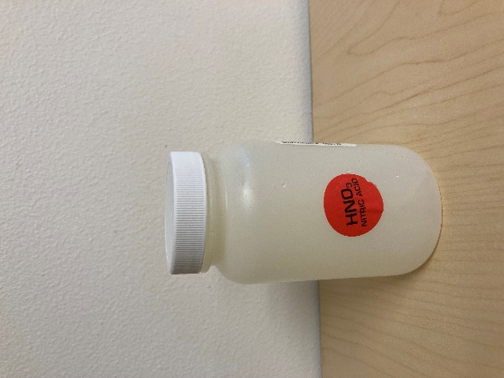

* **NEW CHANGES TO TOTAL METALS COLLECTION:**
  + **See note on Field Blank collection below if your site has been randomly assigned a Total Metals Field Blank**

1. **Collect the unfiltered “Total Metals” sample**
2. The unfiltered total metals sample collection bottle is a 250 ml plastic bottle with a red sticker (denoting HNO3; Nitric acid)
3. **Record sampling time and crew leader initials on the label and apply to bottle.**
4. Do not rinse this bottle.
5. Remove the cap, fill the bottle to the shoulder with sample water from the TSS bottle, and replace the cap.
6. Place bottle in cooler with ice.

**\*\*\*\*\*\*\*\*\*\*\*\*\*\*\*\*\*\*\*\*\*\*\*\*\*\*\*\*\*\*\*\*\*\*\*\*\*\*\*\*\*\*\*\*\*\*\*\*\*\*\*\*\*\*\*\*\*\*\*\*\*\*\*\*\*\*\*\*\*\*\*\*\*\*\*\***

**Nitrogen and phosphorus** *are essential for plant and animal growth and nourishment, but the overabundance in water can cause adverse health and ecological effects. Although nitrogen and phosphorus are abundant naturally in the environment, they are also introduced through sewage and fertilizers.*

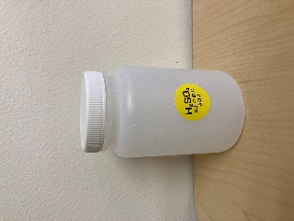

1. **Collect the Nitrate+Nitrite/Total Phosphorus sample**
2. The Nitrate+Nitrite/Total Phosphorus bottle is a 250 ml plastic bottle, with a yellow sticker (denoting H2SO4, sulfuric acid)
3. **Record sampling time and crew leader initials on the label and apply to bottle.**
4. Remove the cap, fill the bottle to the shoulder with sample water from the TSS bottle, and replace the cap.

**\*\*\*\*\*\*\*\*\*\*\*\*\*\*\*\*\*\*\*\*\*\*\*\*\*\*\*\*\*\*\*\*\*\*\*\*\*\*\*\*\*\*\*\*\*\*\*\*\*\*\*\*\*\*\*\*\*\*\*\*\*\*\*\*\*\*\*\*\*\*\*\*\*\*\*\***

**Total Suspended Solids,** *or TSS, stands for total suspended solids, and refers to waterborne particles that exceed 2 microns in size. TSS commonly consists of items like clay, gravel, sand, silt, and vegetation. TSS can increase due to erosion, algae growth, and sediment disruption. TSS levels can affect dissolved oxygen content, which affects aquatic life like fish.*

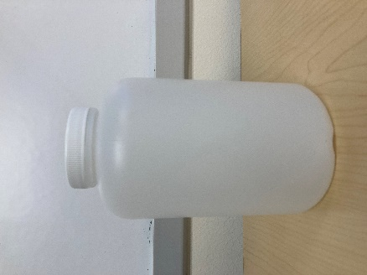

**Collect the “TSS”-Total Suspended Solids**

* + 1. The Total Suspended Solids bottle is a 1 L plastic bottle
    2. **Record sampling time and crew leader initials on the label and apply to bottle.**
    3. Fill the TSS bottle with the same methods outlined in the “Dissolved Metals” Section.
    4. Cap the bottle and place bottle in cooler with ice.

**Field Blanks –** Field blanks are samples of clean water provided by the laboratory that are collected and handled in the same way as normal water quality samples. Field blanks are collected in order to help assess the influence that the field sampling process may have on water quality measurements.

To collect a field blank, use the same, normal method described for the parameter (dissolved metals or total metals). Rather than river water, use ultra-pure distilled water provided by the laboratory. A bottle of ultra-pure distilled water will be provided by the laboratory, and the water quality coordinator will provide training on this collection procedure.

**Appendix B1: “Clean Hands, Dirty Hands” Sampling Technique**

What is ‘Clean Hands, Dirty Hands’ (CHDH)?

The Clean Hands Dirty Hands sampling technique of EPA-1669 was developed for low level mercury testing but is often applied to trace metals sampling. This method minimizes potential sample contamination by designating one person to be ‘clean hands’ (CH) and another as ‘Dirty Hands’ (DH). DH handles all sampling equipment and CH handles all sample bottles.

Field Application

**Clean Hands** – The person designated as Clean Hands (CH) will handle the actual sample bottles. CH will fill and label the bottles. CH is responsible for keeping hands clean during sampling events, and changing gloves if contamination occurs. CH is responsible for communicating with other crew members to open coolers, handle sampling equipment, etc., as CH should not be handling any sampling items except for the sample bottles themselves.

**Field Sampling Crew** – The field sampling crew will be Dirty Hands (DH). DH will open/close the cooler, handle the sealed (in Ziplock) bag of sample bottles, handle the water collection bottle, and record data.

**Boat Crew** – The boat operator will be in contact with motor oil, galvanized metals, etc. and therefore should not be handling the actual sample bottles. The boat operator will be responsible for maintaining the boat in position for sampling and safely transporting the crew from one site to the next. The boat operator may help with data recording and other tasks as needed that do not involve directly handling sample bottles.

Required Preparation

• Practice makes perfect – The field sampling team will practice sample collection using the CHDH technique. At least one practice sample collection will be demonstrated on sample cooler pickup day, and the other on fieldwork day prior to the first sample collection.

• Pre-sampling preparation – Bottles will be carefully handled with gloved hands, labeled, and placed into double layer Ziplock bags. DO NOT open bottles before actual sample collection.

• Supplies – The Project Manager will make sure that the field team has enough nitrile gloves, Ziplocks and other tools required to complete field work.

Sunscreen, jewelry, and galvanized metals

• Many cosmetic products including sunscreen contain zinc. It’s important to protect you skin against UV, however if you wear sunscreen DO NOT touch your face during active sampling. If you do, change gloves, and start over. Alternatively, wear physical sun protection such as a sun hat, face mask/gaiter, long sleeved shirt, etc.

• Avoid wearing jewelry on your hands and/or wrists. Earrings and necklaces are fine, just avoid touching them during active sampling. If you touch metal jewelry, even if it’s not zinc based, change your gloves immediately.

• Galvanized metals are metals coated in zinc oxides. No one actively collecting samples should touch galvanized surfaces during active sample collection. If samplers accidentally touch galvanized metal they should stop, remove the contaminated gloves, and replace contaminated gloves with clean cloves.

*Adapted from Appendix F in Apsens, S., and Petitt, J. 2022. Kenai River, Alaska Field Report 2021. Alaska Department of Environmental Conservation.*

**Appendix C: Kenai River Watershed** **Water Quality Monitoring Field Data Form**

|  |  |  |  |  |  |  |  |  |  |  |  |  |  |
| --- | --- | --- | --- | --- | --- | --- | --- | --- | --- | --- | --- | --- | --- |
|  | Low Tide |  |  | River |  |  | Air temp. | Weather | Boat traffic | Photos | Water Temp | GPS  coord |  |
| Date | Time | Agency | Initials | Mile | Location | Location  of sample | Fahrenheit | S/R/C | L/M/H | Y/N | Centigrade | Latitude  Longitude | Comments |
|  |  |  |  |  |  |  |  |  |  |  |  |  |  |
|  |  |  |  |  |  |  |  |  |  |  |  |  |  |
|  |  |  |  |  |  |  |  |  |  |  |  |  |  |
|  |  |  |  |  |  |  |  |  |  |  |  |  |  |

Take all samples upstream from your position in the river sunny low yes

rainy med no cloudy high

YSI: Handheld Thermometer Serial Number ___________________________________________

Team Members: __________________________________________________________________________________________

Samples Submitted By: ________________Date: ___________Time:

Samples Received By: _______________ Date: ___________Time:

Notes: On sampling day measure water temperature with YSI digital thermometer.

Turn in samples at drop-off point as notified by project coordinator.

River Mile is the location on the main stem of the Kenai River or where the tributary enters the Kenai River

**: Kenai River Watershed Water Quality Monitoring Chain of Custody Forms**

**SGS Laboratories, Anchorage**

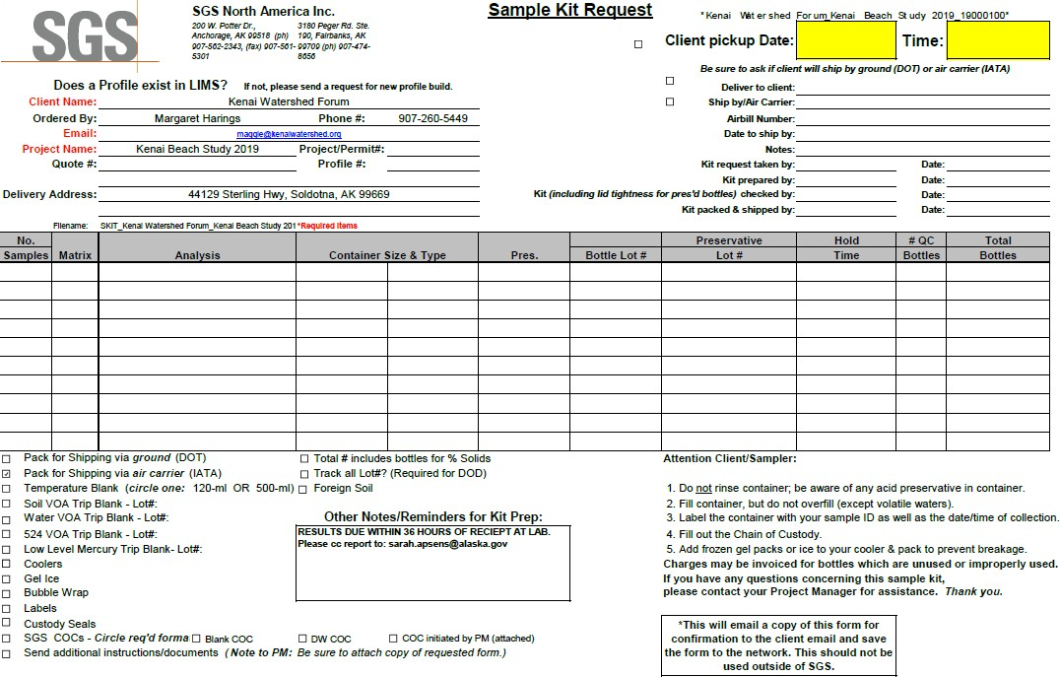

**Appendix D: Kenai River Watershed Water Quality Monitoring Chain of Custody Forms**

**Soldotna Wastewater Treatment Plant**

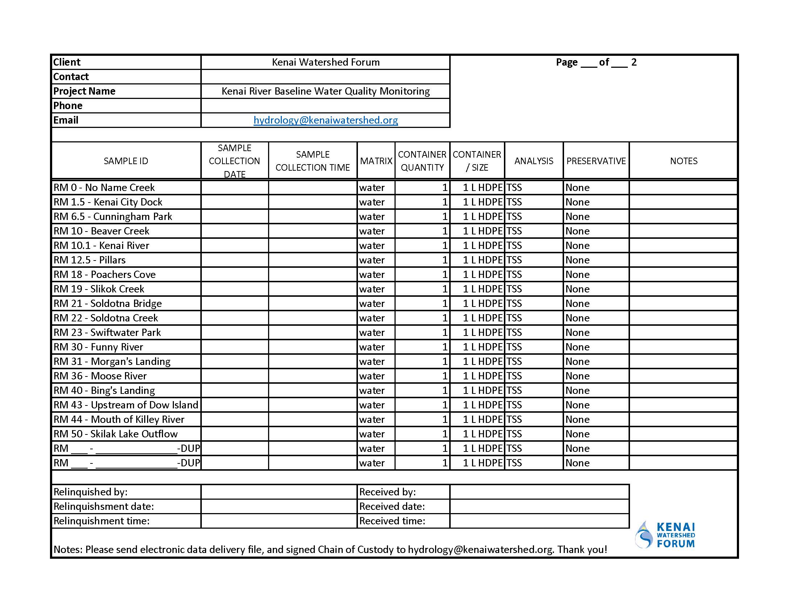

**Appendix D: Kenai River Watershed Water Quality Monitoring Chain of Custody Forms**

**Tauriainen Engineering and Testing (page 1 of 2)**

__________________________________________________________________________

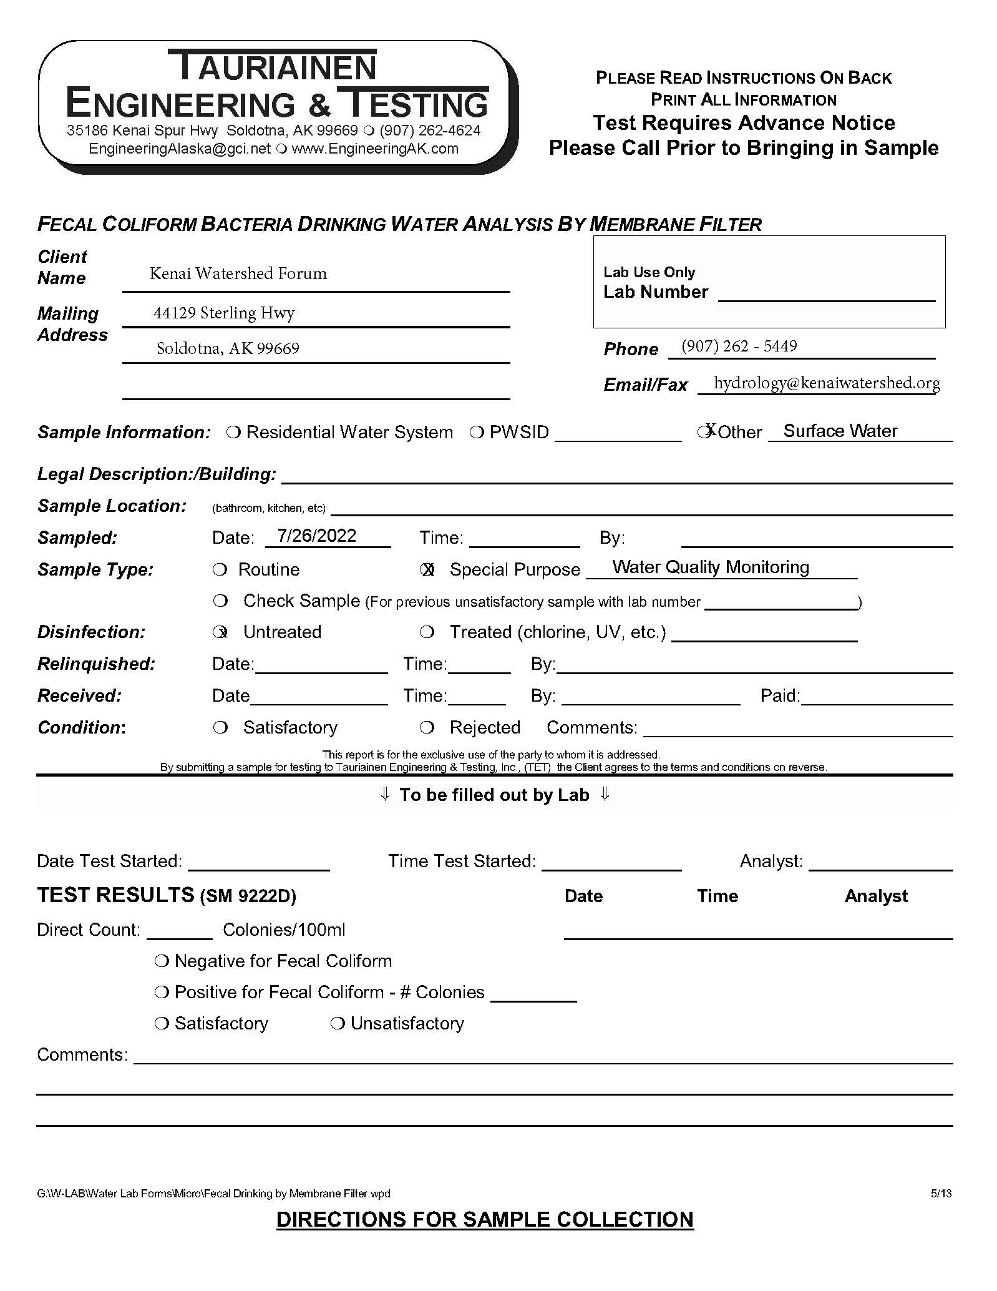

**Appendix D: Kenai River Watershed Water Quality Monitoring Chain of Custody Forms**

Tauriainen Engineering and Testing (page 2 of 2)

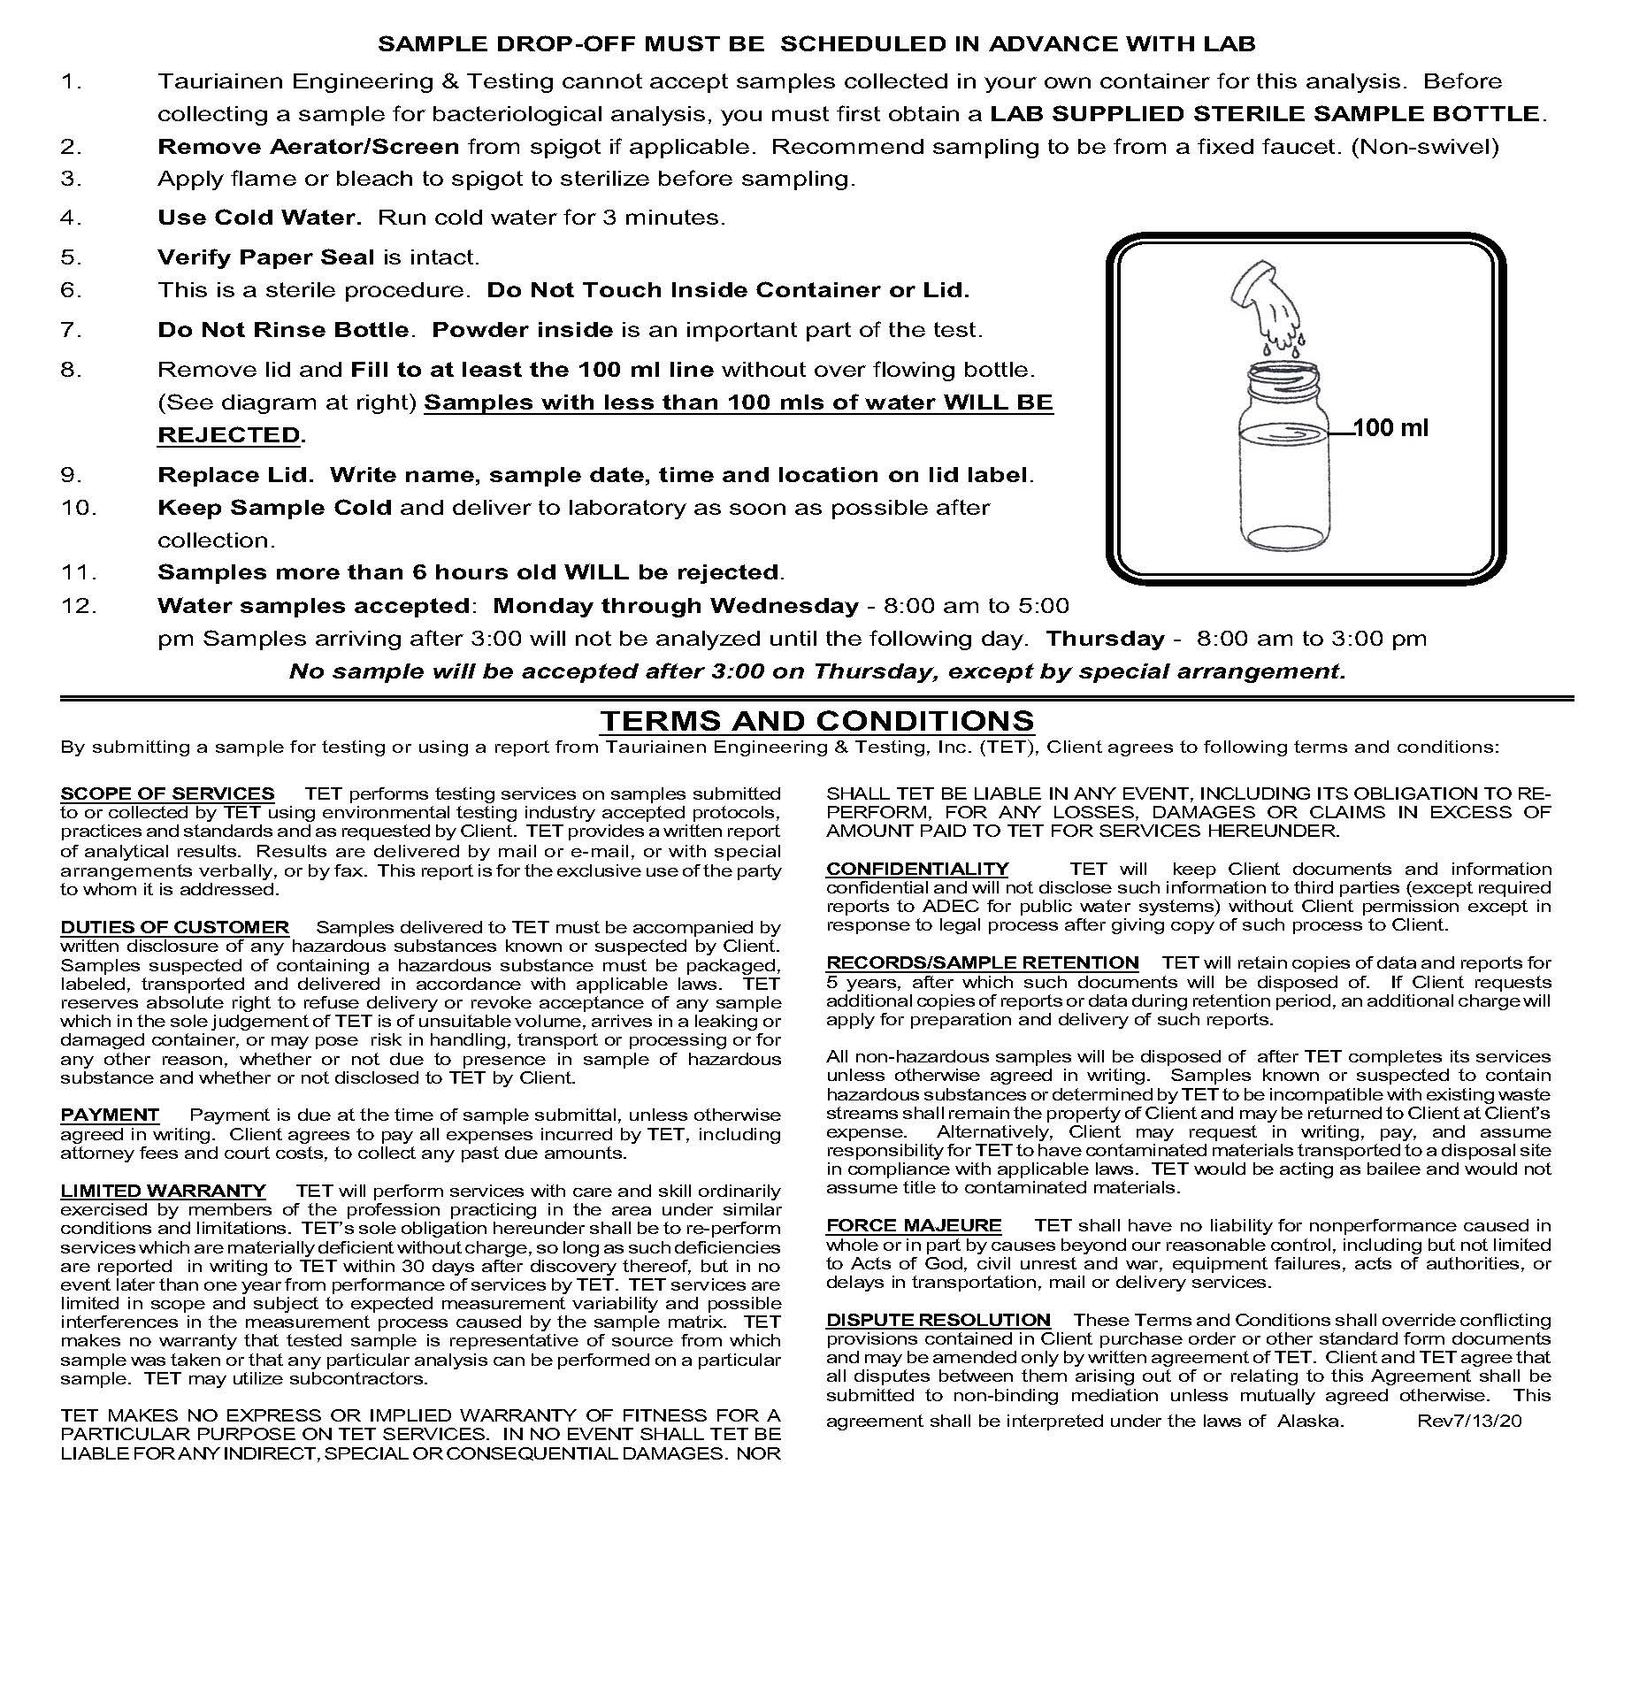

**Appendix E: Agency Baseline Lab Test Results**

DATE:

|  |  |  |  |  |  |  |  |
| --- | --- | --- | --- | --- | --- | --- | --- |
| **River Mile** | **Location** | **Temperature** | **Conductivity us/cm** | **pH** | **Turbidity NTU** | **Turbidity Check NTU** |  |
| 0 | No Name Creek |  |  |  |  |  |  |
| 1.5 | Kenai Dock |  |  |  |  |  |  |
| 6.5 | Cunningham Park |  |  |  |  |  |  |
| 10 | Beaver Creek |  |  |  |  |  |  |
| 10.1 | Kenai River |  |  |  |  |  |  |
| 12.5 | Pillars |  |  |  |  |  |  |
| 18 | Poachers Cove |  |  |  |  |  |  |
| 21 | Soldotna Bridge |  |  |  |  |  |  |
| 23 | Swiftwater Park |  |  |  |  |  |  |
| 19 | Slikok Creek |  |  |  |  |  |  |
| 22 | Soldotna Creek |  |  |  |  |  |  |
| 30 | Funny River |  |  |  |  |  |  |
| 31 | Morgan’s Landing |  |  |  |  |  |  |
| 36 | Moose River |  |  |  |  |  |  |
| 40 | Bing’s Landing |  |  |  |  |  |  |
| 43 | Upstream Dow Island |  |  |  |  |  |  |
| 44 | Mouth of Killey  River |  |  |  |  |  |  |
| 50 | Skilak Lake Outflow |  |  |  |  |  |  |
| 70 | Jim’s Landing |  |  |  |  |  |  |
| 74 | Russian River |  |  |  |  |  |  |
| 79.5 | Juneau Creek |  |  |  |  |  |  |
| 82 | Kenai Lake Bridge |  |  |  |  |  |  |
| DUP |  |  |  |  |  |  |  |
| DUP |  |  |  |  |  |  |  |

ANALYSIS PERFORMED BY : ______________________________________________

**Appendix F: Hydrolab Downloads**

|  |  |  |  |  |
| --- | --- | --- | --- | --- |
| Date | Hydrolab # | File Name | Data Lines | Notes |
|  |  |  |  |  |
|  |  |  |  |  |
|  |  |  |  |  |
|  |  |  |  |  |
|  |  |  |  |  |
|  |  |  |  |  |
|  |  |  |  |  |
|  |  |  |  |  |
|  |  |  |  |  |
|  |  |  |  |  |
|  |  |  |  |  |
|  |  |  |  |  |
|  |  |  |  |  |
|  |  |  |  |  |
|  |  |  |  |  |
|  |  |  |  |  |
|  |  |  |  |  |
|  |  |  |  |  |
|  |  |  |  |  |
|  |  |  |  |  |
|  |  |  |  |  |
|  |  |  |  |  |
|  |  |  |  |  |
|  |  |  |  |  |
|  |  |  |  |  |
|  |  |  |  |  |
|  |  |  |  |  |
|  |  |  |  |  |
|  |  |  |  |  |
|  |  |  |  |  |
|  |  |  |  |  |
|  |  |  |  |  |
|  |  |  |  |  |
|  |  |  |  |  |
|  |  |  |  |  |

**Appendix F: Minisonde Calibration Record**

Serial # Performed By:

|  |  |  |  |  |  |  |  |  |  |
| --- | --- | --- | --- | --- | --- | --- | --- | --- | --- |
| Date | Time | Parameter | Action | Standard | Temp | Reading | Over  Std % | Under  Std % | Correction  % |
|  |  |  |  |  |  |  |  |  |  |
|  |  |  |  |  |  |  |  |  |  |
|  |  |  |  |  |  |  |  |  |  |
|  |  |  |  |  |  |  |  |  |  |
|  |  |  |  |  |  |  |  |  |  |
|  |  |  |  |  |  |  |  |  |  |
|  |  |  |  |  |  |  |  |  |  |
|  |  |  |  |  |  |  |  |  |  |
|  |  |  |  |  |  |  |  |  |  |
|  |  |  |  |  |  |  |  |  |  |
|  |  |  |  |  |  |  |  |  |  |
|  |  |  |  |  |  |  |  |  |  |
|  |  |  |  |  |  |  |  |  |  |
|  |  |  |  |  |  |  |  |  |  |
|  |  |  |  |  |  |  |  |  |  |
|  |  |  |  |  |  |  |  |  |  |
|  |  |  |  |  |  |  |  |  |  |
|  |  |  |  |  |  |  |  |  |  |
|  |  |  |  |  |  |  |  |  |  |
|  |  |  |  |  |  |  |  |  |  |
|  |  |  |  |  |  |  |  |  |  |
|  |  |  |  |  |  |  |  |  |  |
|  |  |  |  |  |  |  |  |  |  |
|  |  |  |  |  |  |  |  |  |  |

**Appendix G: Stream Temperature Monitoring Field Data Sheet**

**Stream Information**

Stream Name:

Field Crew: Partner Organization:

Site Description/Directions:

**Water Logger Information**

Logger Type: Date placed in stream:

Serial #: Time placed in stream:

Instantaneous water temperature:

**Air Logger Information**

Time of measurement:

Logger Type Date placed in riparian zone:

Serial #: Time placed in riparian zone:

Instantaneous air temperature: Time of measurement:

**Site/Reach Information**

Habitat type of water logger placement: (circle) riffle pool run other Tethering/deployment method: (circle) rebar bank-secured cable sandbag other

Verified site is well mixed using: (circle) Hand-held thermometer Probe:

Channel depth (m) at logger Channel width (m) at logger

Extent to which vegetation shades the logger: (circle) 0% 20% 40% 60% 80% 100% Channel flow status: (circle) bank full 90-75% of channel filled 75-50% filled <50% filled GPS Coordinates: N W

Elevation (m)

**Photo Documentation**

Photos taken on which camera?: # of photos taken:

Description of photos:

**Detailed sketch of site should include stream aspect, landmarks like large boulders or other markers to help locate the loggers, trails or other access points.**

**Other Comments and Observations:**

**For additional detail and standardized methods on water temperature QA/QC, data management, and data storage, see Mauger et al. 2015 and visit the AKTEMP Water Temperature Database from the University of Alaska Anchorage’s Alaska Center for Conservation Science at <https://aktemp.uaa.alaska.edu/>**

**Appendix H: Standard Calibration Procedure for Hydrolab Minisonde MS 5**

*(updated June 2021)*

**Hydrolab Calibration**

All calibration readings and solution usage should be recorded in the Hydrolab QA physical folder as well as the individual instrument’s physical folder. Time and temperature must be taken for every measurement (calibrations and checks). Follow these instructions in order.

*Connecting to Hydrolab:*

1. Open HYDRAS3 LT program
2. Remove black tip casing at the top of the Hydrolab and attach cable to it by lining up the single black dot on the cable and the largest prong on the Hydrolab. Secure firmly. Attach COM port to the laptop.
3. Click "Re-scan for Sondes". In the top box titled "Connected Sondes" the serial number for the Hydrolab should appear. Highlight and click "Operate Sonde"
4. Make sure that the "Clock" setting is set to the accurate time a day. If not, click on "Set clock to PC time" to correct.
5. Select "Calibration" on the top of the window.

*Conductivity:*

1. Select tab labeled "SpCond (ųS/cm)"
2. Remove the clear protective cap
3. Gently remove the turbidity wiper using a small allen wrench.
4. Rinse sensors with DI water in a spray bottle. Dry off with a KIMTECH wipe. Finish drying process by using a small air blower to remove drops stuck in between sensors. This is particularly important when performing conductivity calibration because it can dilute the test solution resulting in inaccurate readings.
5. Set standard to "0" and click calibrate with the sensor exposed to the air. Record temperature on data sheet. This creates a baseline of zero for calibration.
6. Attach solution labeled "100 ųS/cm" to the Hydrolab and change SpCond standard on the laptop to "100". Invert Hydrolab **slowly** so the solution does not touch the pH sensor. The pH sensor is the second shortest probe in the Hydrolab and the conductivity sensor is the shortest. Touching the pH solution to the sensor will skew data and result in having to replace the solution and restart.
7. The reading should be less than 10% off of the calibration standard. If not, dispose of solution in conductivity waste receptacle, clean sensor and restart procedure. If reading is within 10%, click on "Calibrate" and record temperature.
8. Remove 100 ųS/cm solution and clean sensor with DI spray bottle, KIMTECH wipes, and air blower again.
9. Attach solution labeled "1500 ųS/cm" to the Hydrolab and change SpCond Standard on the laptop to 1500. Invert Hydrolab **slowly** so the solution does not touch the pH sensor. The pH sensor is the second shortest probe in the Hydrolab and the conductivity sensor is the shortest. Touching the pH solution to the sensor will skew data and result in having to replace the solution and restart.
10. The reading should be less than 10% off of the calibration standard. If not, dispose of solution in conductivity waste receptacle, clean sensor and restart procedure. If reading is within 10%, click on "Calibrate" and record temperature.
11. Remove 1500 ųS/cm solution and clean sensor with DI water, KIMTECH wipes, and air blower.

**Appendix H (continued)**

General Notes:

Conductivity is very sensitive. Be patient with this calibration as it takes the longest and is the one that is most likely to be repeated. Meticulous drying can help increase the accuracy of readings. If repeated 3 times with a fresh solution each time and readings are still unsuccessful, then it may be a problem with the Hydrolab sensor and get in touch with Hach Industries Customer Service.

*pH*

1. Click on the tab labeled "pH (Units)" on the top of the window.
2. Attach the solution labeled "7.00 pH" to the clean Hydrolab sensors.
3. Invert the Hydrolab and let sit/settle for ~5 minutes.
4. Make sure that "Standard" line reads "7.00" on the laptop. If reading is greater than 10% off the standard then replace the solution, clean the sensor and repeat the trial.
5. When reading is within the accepted range click "Calibrate".
6. Clean sensor with DI water, KIMTECH wipes, and air blower.

*Turbidity*

1. Click on the tab labeled "Turbidity (NTU)" at the top of the window.
2. Put on gloves!
3. Attach wiper to the bottom of the sensor. Make sure that the single ridge (the part that looks like a windshield wiper) is on the sensor side and make sure that the screw is flush with the flat side of the fixed piece (DO NOT OVERTIGHTEN!). The wiper should sit approximately 180 degrees opposite of the sensor window. If this step is done incorrectly your NTU readings will be very high because the sensor window will be partially blocked.
4. Change the "Turbidity Point" value to "1" and the "Turbidity standard" value to "0".
5. Perform an air test with no solution or cap on the sensor and the sensor pointing upwards. The NTU value for this should be between 0 and 1. Click "Calibrate".
6. Change the "Turbidity Point" value to "2" and the "Turbidity standard" value to "100".
7. Place 100 NTU solution on a stir plate on medium setting for 2-5 minutes until the solution seems evenly dispersed. Attach the 100 NTU solution to the Hydrolab while keeping it on the stir plate to continue the dispersal of the sediment.
8. Reading should be within 10% of desired standard value. If so, click "Calibrate". If not, allow to stir on a lower setting for 5-10 minutes attached to Hydrolab and try reading again. If still outside of range, replace the solution and repeat.
9. Remove 100 NTU solution and clean with DI water, KIMTECH wipes, and air blower.
10. Place 20 NTU solution on stir plate for 2-5 minutes to evenly disperse particulates. Attach to Hydrolab while still on stir plate and let it continue to stir. This is a check reading, there is no need to calibrate or change any of the values, you are just checking to make sure the NTU reading is within the acceptable range of 20 NTU.
11. Remove 20 NTU solution and repeat Step 10 with 40 NTU solution to perform a second value check.
12. Clean sensors with DI water, KIMTECH wipes, and air blower.

**Appendix H (continued)**

**Potential Problems:** Turbidity can be a pain to calibrate and issues can arise for a number of reasons.

* 1. If readings are odd the first step is to get fresh solution, rinse and dry instrument and try again (up to three times) then move on to the other possible solutions if there is still a problem
  2. Is the wiper blade on correctly?
  3. Is the cap filled high enough to cover the sensor?
  4. Is it possible the stock solution wasn’t mixed correctly and the bottle is now bad? Are there air bubbles in the solution?
  5. Is the magnet stirring at a constant rate? This one I’ve noticed can really cause the readings not to settle. If the magnet doesn’t settle down, turn off for a while and come back later.
  6. Is the magnet stirring fast enough (if not turbidity slowly drops and particles settle out)
  7. If none of these seem wrong try to calibrate again with all new solutions.

*LDO*

1. Click on the lab labeled "LDO% (Sat)" at the top of the window.
2. Search for mmHg pressure at the nearest airport sensor (ours is Kenai Municipal Airport). The reading they will give you will most likely be in inches from the "Altimeter" column on the NOAA website. You will need to convert this to mmHg. (Ex. 29.94 inches = 760.476 mmHg). Enter this value into the "Enter BP mmHg" line on the page.
3. Grab the vial labeled "DI H2O". Shake it lightly 15-20 times.
4. Attach this to the Hydrolab and gently invert. Unscrew the black cap that is now at the top of the vial (originally the black cap that is at the bottom of the vial prior to being inverted). Flip it upside down and rest it gently on the open vial.
5. Allow current value to stabilize and click "Calibrate".
6. Screw cap back on and unscrew vial from the Hydrolab.

**General Calibration Tips**

1. Don’t rush, let readings settle
2. Always change solution first if a reading is odd
3. Avoid touching sensors as much as possible (it is better to wear gloves for the whole calibration)
4. If a calibration isn’t working try more cleaning and thorough drying sessions between standards
5. If batteries are less than 50% reading can become odd

**Programming**

To create a program file:

1. Select: Files>Delete
2. Check to see how many files are already on the instrument, four is the max, three or less are necessary to create a new file
3. Delete a file only after checking to make sure it has been downloaded
4. To delete simply type in the file number and hit ENTER, “Y” for yes, ENTER

**Appendix H (continued)**

1. Go to: Files>Create and fill in the following:
   1. File Name – whatever you want
   2. Start date – MMDDYY
   3. Start time – HHMMSS
   4. Finish date – MMDDYY
   5. Finish time – HHMMSS
      1. 14 days is max, 10 is ideal
   6. Sample frequency – 001500 is typical for turbidity
   7. Sensor warm-up - 000030, fills in the next criteria as 000030 too
   8. Disable audio –“Y” ENTER
2. Go to: Files>Status and check to make sure file you created is there, verify start/end dates ands times
3. Unplug instrument
4. Put in 8 new batteries, should beep if done correctly
5. Plug instrument back in
6. Record the battery % and voltage of the first reading, should be 100% and 13 + volts

**Data Download**

* + - 1. Connect to Hydrolab
      2. Select: Files>Transfer>Sensors Off>Spreadsheet Importable>X Modem 1K
      3. Highlight just the file name (not date and time)
      4. Hit Crtl+C (Copy)
      5. Type the file number (1,2,3 or 4) and hit ENTER
      6. From grey bar select “Transfer”
      7. Click “receive file”
      8. A transfer box should pop up
         1. Browse to “Desktop”
         2. Select “1K X Modem”
         3. Receive
         4. Under File Name hit Crtl+V (Paste)
      9. On the desktop select file and change name to .csv to make it an excel file
      10. Open the file and check to see if the data look good, make a quick graph
      11. Log the number of data lines and file name in the Hydrolab QA folder
      12. Move file to correct folder

**Instrument Retrieval**

1. Clean sensor off as much as possible in the river, remove guard and attach plastic cap
2. In lab scrub sensor gently with a toothbrush and dish soap
3. Rinse with water and dry with AccuWipe
4. Download data immediately
5. Within 24 hr check calibration using calibration techniques above, unless redeploying with 48 hours do not calibrate, just check

**Sensor Reset –**When all else fails and the sensor will not calibrate

1. Select: Login>Level 3, Enter “Hydrolab” as the password, ENTER
2. Select: Setup>System>Reset>Sensor, select the correct sensor and correct units

**Appendix H (continued)**

1. For Turbidity: Select Setup>Parameter>Turbidity>Calibrate>4 pt to get the four point calibration

**Other Useful Knowledge**

Crtl+R refreshes screen

**Appendix I: YSI Temperature Meter QA**

DATE: TIME:

CONDUCTED BY:

|  |  |  |
| --- | --- | --- |
| METER NUMBER | MODEL NUMBER | TEMPERATURE |
|  |  |  |
|  |  |  |
|  |  |  |
|  |  |  |
|  |  |  |
|  |  |  |
|  |  |  |
|  |  |  |
|  |  |  |
|  |  |  |
|  |  |  |
|  |  |  |
|  |  |  |
|  |  |  |
|  |  |  |
|  |  |  |
|  |  |  |

**Appendix J: Calibration Standards Record Form**

|  |  |  |  |  |  |  |
| --- | --- | --- | --- | --- | --- | --- |
| Date | Time | Action | Parameter | Concentration | Lot | Expiration |
|  |  |  |  |  |  |  |
|  |  |  |  |  |  |  |
|  |  |  |  |  |  |  |
|  |  |  |  |  |  |  |
|  |  |  |  |  |  |  |
|  |  |  |  |  |  |  |
|  |  |  |  |  |  |  |
|  |  |  |  |  |  |  |
|  |  |  |  |  |  |  |
|  |  |  |  |  |  |  |
|  |  |  |  |  |  |  |
|  |  |  |  |  |  |  |
|  |  |  |  |  |  |  |
|  |  |  |  |  |  |  |
|  |  |  |  |  |  |  |
|  |  |  |  |  |  |  |
|  |  |  |  |  |  |  |
|  |  |  |  |  |  |  |
|  |  |  |  |  |  |  |
|  |  |  |  |  |  |  |
|  |  |  |  |  |  |  |
|  |  |  |  |  |  |  |
|  |  |  |  |  |  |  |
|  |  |  |  |  |  |  |
|  |  |  |  |  |  |  |
|  |  |  |  |  |  |  |
|  |  |  |  |  |  |  |
|  |  |  |  |  |  |  |
|  |  |  |  |  |  |  |
|  |  |  |  |  |  |  |
|  |  |  |  |  |  |  |

# Appendix K: Laboratory Certificates of Analysis

# Laboratory certificates of analysis are available from the project manager at [hydrology@kenaiwatershed.org](mailto:hydrology@kenaiwatershed.org). The certificates are also available for download online at <https://bit.ly/kwf_lab_certs>.

**Appendix L: Data Evaluation Checklist**

## 

Kenai Watershed Forum developed its data evaluation checklist based on the template provided from the Alaska Department of Environmental Conservation. KWF has translated this template to a spreadsheet format. Both documents are available to download online at https://bit.ly/kwf_wqx_evaluation_checklist.

1. Kenai Watershed Forum has been this contractor from 2000 – present.
2. To use measurements for RPD calculations: one or both of the measurements must be above the parameters limit of quantitation (LOQ) and/or reporting limit (RL), and one or both of the measurements must be at least two times the LOQ.
3. To use measurements for RPD calculations: one or both of the measurements must be above the parameters limit of quantitation (LOQ) and/or reporting limit (RL), and one or both of the measurements must be at least two times the LOQ.
4. To use measurements for RPD calculations: one or both of the measurements must be above the parameters limit of quantitation (LOQ) and/or reporting limit (RL), and one or both of the measurements must be at least two times the LOQ.
5. To use measurements for RPD calculations: one or both of the measurements must be above the parameters limit of quantitation (LOQ) and/or reporting limit (RL), and one or both of the measurements must be at least two times the LOQ.
6. *Duplicate samples at the same site are considered separate sampling events, and each set of duplicate samples will have a unique time associated with it.*