Jan 4th 2024

CSV files in this folder are manually-edited for final preparation.

Preparing three separate csv files for upload to WQP. Each as failed in some way. Preparing questions for meeting w/ EPA:

1. Project file
   1. Issues
      1. General Validation Error: “A submission file referencing an attachment, must include that attachment.”
      2. Corrected yellow highlighted errors
      3. Reproduce example error
2. Monitoring Location file
   1. Import Successful
3. A

1/11/2024

In the process of matching import config to data structure. Have been manually manipulating csv

Just learned that we submit/upload results as “rejected” – so we want to include those. See below.

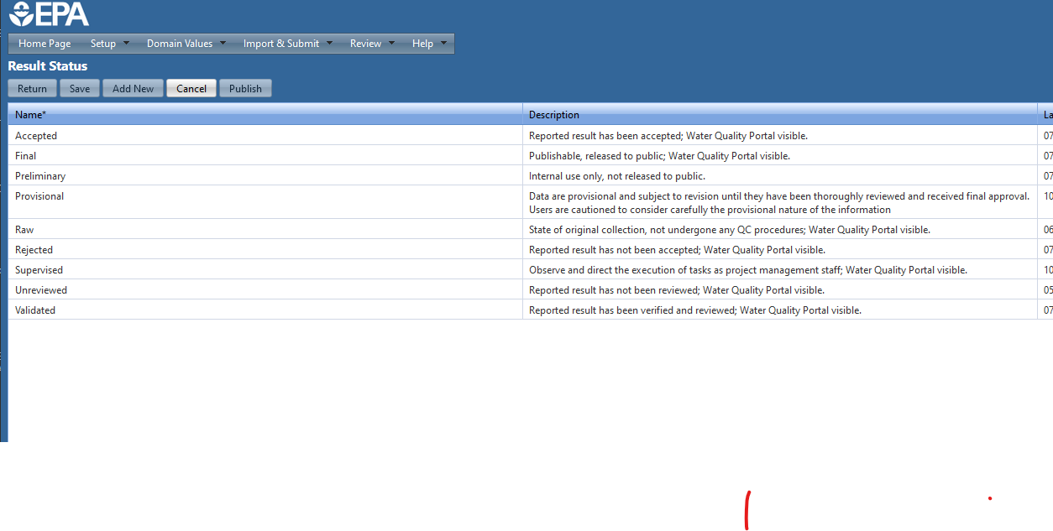

So – we need to re-produce results csv, correct weird negative signs, and ensure column structure matches import config (e.g. remove all cloumns where all rows are NA.

Starting at 5:00 AM!