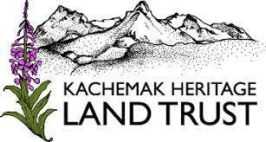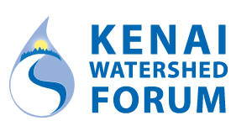

May 27, 2022

Dear Landowner,

Hundreds of small streams run through the Kenai Peninsula — in fact, one runs right through your land. These streams are home to baby salmon — places where adult salmon return from the ocean to spawn and die, creating the next generation. These “nursery” streams need a perfect balance of nutrients and nitrogen, cold water in the summer and warm water in the winter, protection from predators and human development to keep baby salmon thriving. **We are writing to you today because your land may be home to something called cold-water refugia which is critical for salmon survival.**

*Researchers measure water temperature on Beaver Creek near Kenai.*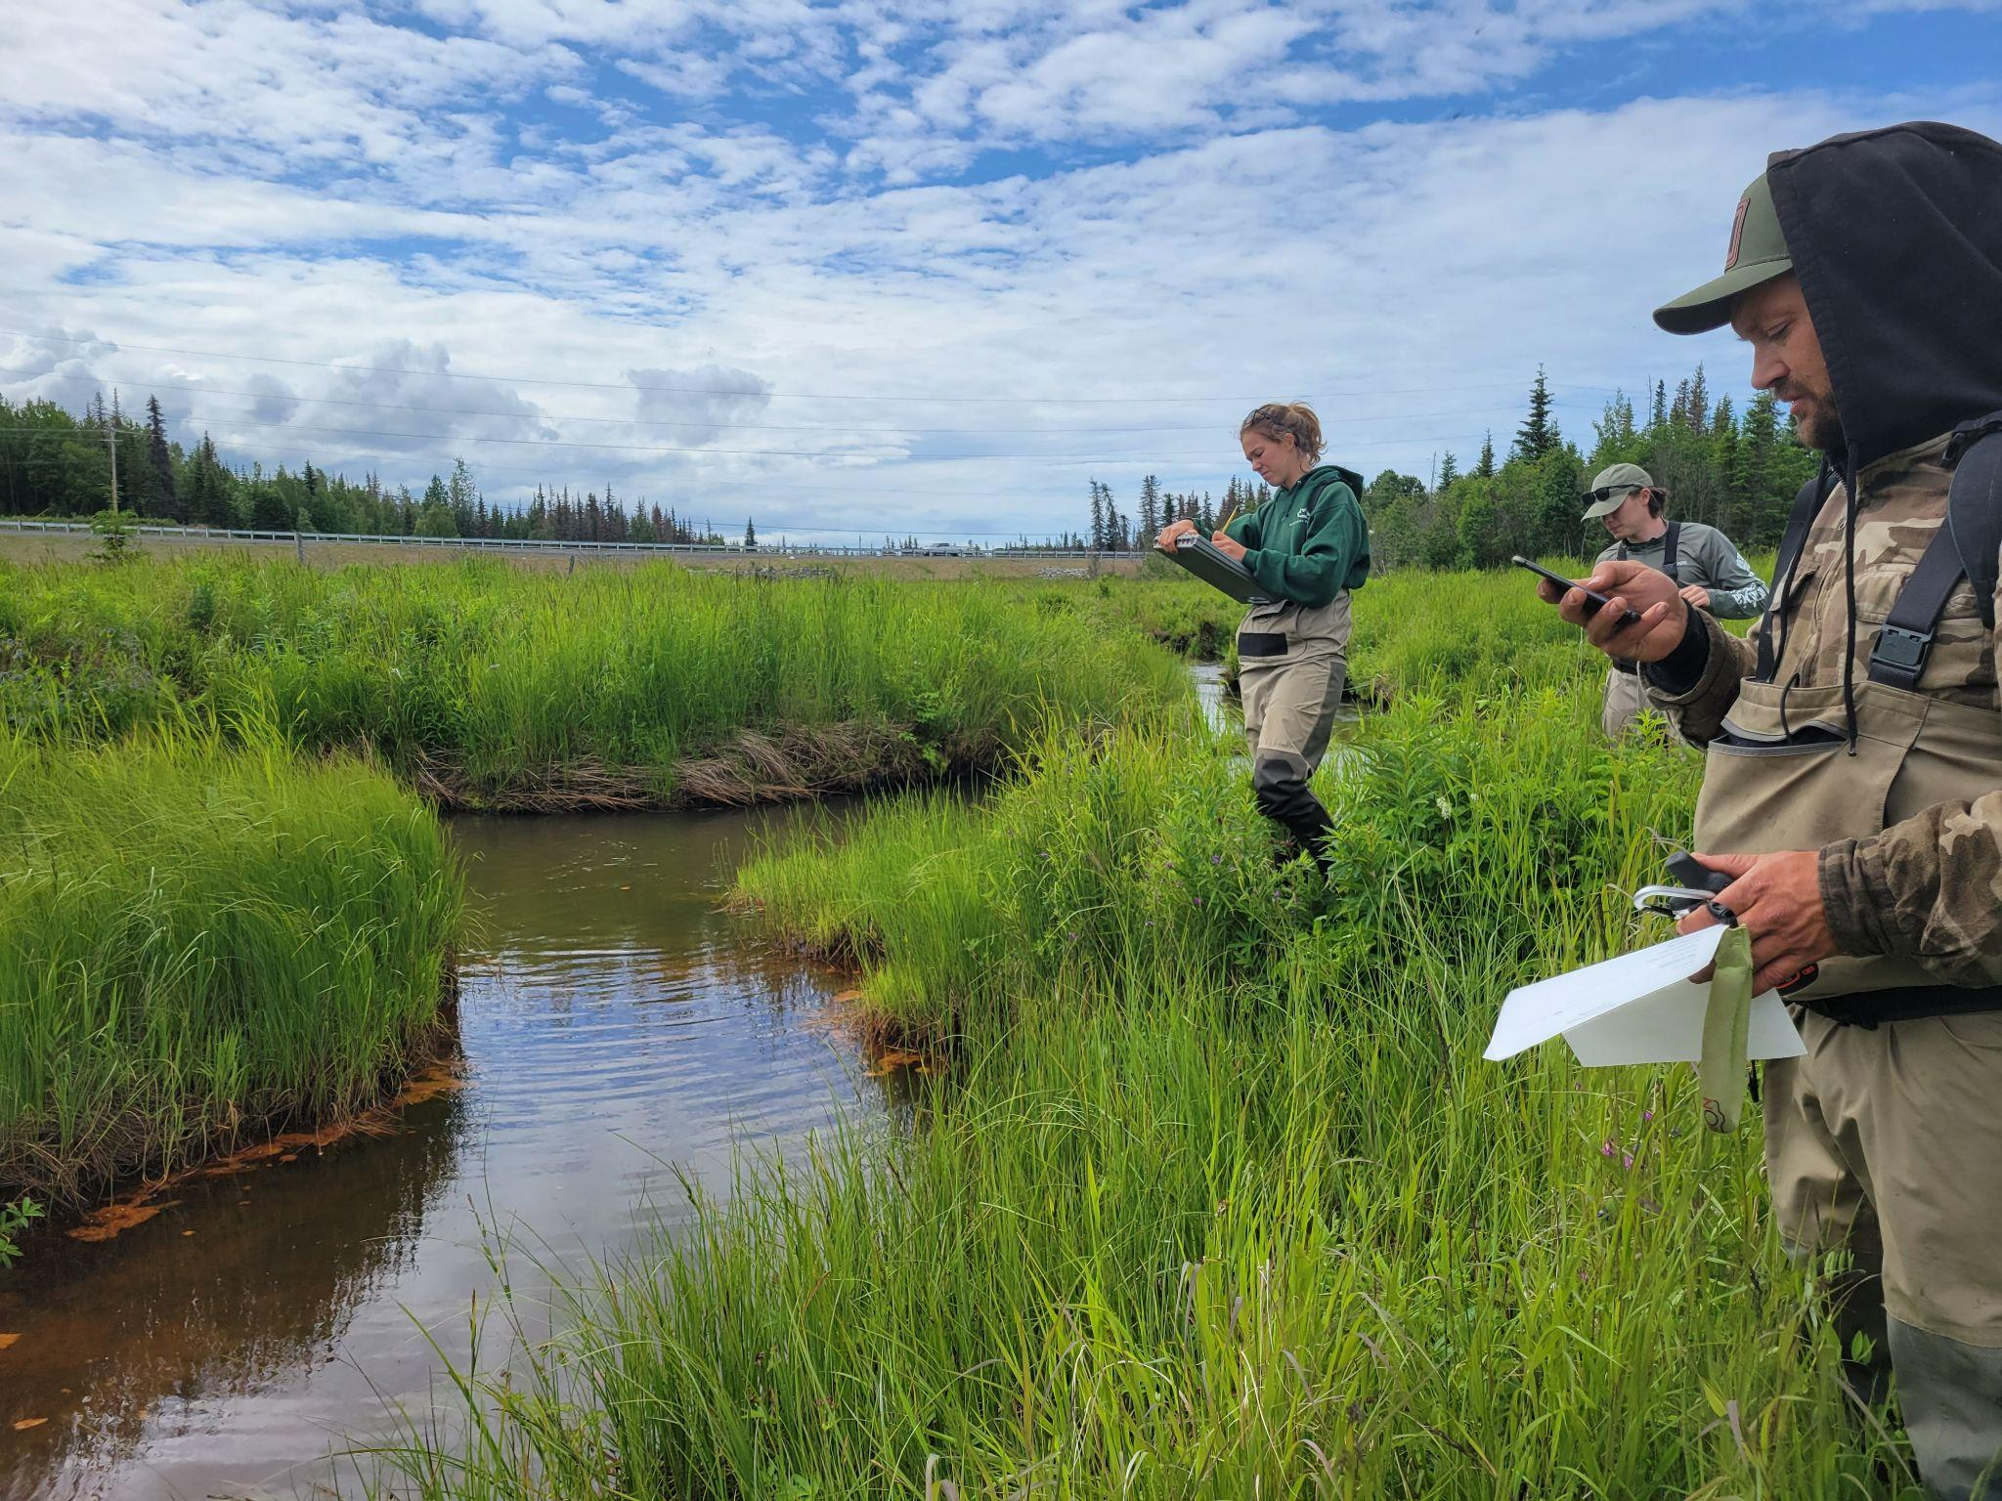

Cold water refugia, or areas with groundwater springs and seeps, are pockets of water along a stream that stay cold in the summer and warm in the winter. They allow adult salmon to avoid stressful warm temperatures during summer months and provide baby salmon warm, flowing water during the winter. These pockets are essential for salmon survival and salmon survival is essential to us as Alaskans.

Local nonprofits including Kachemak Heritage Land Trust, Cook Inletkeeper, and Kenai Watershed Forum have been working with the U.S. Fish and Wildlife Service, Kenai Peninsula Fish Habitat Partnership, and the Alaska Sustainable Salmon Fund to use thermal imagery to map these springs and seeps throughout the Kenai Peninsula.

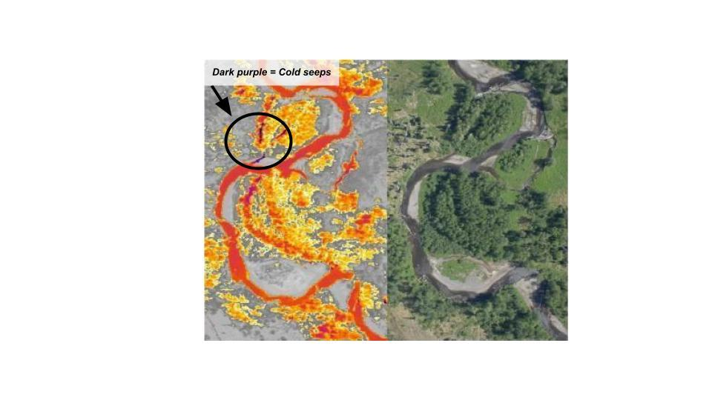

*Researchers measure water temperature on Beaver Creek near Kenai. Thermal infrared imagery (left) showing cold water inputs (purple) to the mainstem of the Anchor river (orange). Corresponding aerial image on the right.*

Our goal is to provide you with information on what you can do, as a landowner, to protect land that is vital to salmon. **By protecting the waterways on your land, you can help safeguard salmon and a healthy, vibrant future for Alaskans. Please contact us to learn more about this thermal imagery project and how you can get involved.** We look forward to building an enduring partnership with you as stewards of your unique and important land.

Sincerely,   
  
  
  
  
  
Marie McCarty, [marie@kachemaklandtrust.org](mailto:marie@kachemaklandtrust.org)  
Kachemak Heritage Land Trust

Branden Bornemann, [branden@kenaiwatershed.org](mailto:branden@kenaiwatershed.org)   
Kenai Watershed Forum   


Sue Mauger, [sue@inletkeeper.org](mailto:sue@inletkeeper.org)  
Cook Inletkeeper

More information can be found here: <https://inletkeeper.org/our-work/healthy-habitat/cold-water-refugia/>