**Upstream barriers to anadromous fish passage – Drafting GIS layer, Methodology  
Ceili Demarais, Kenai Watershed Forum intern  
Contact: Benjamin Meyer (**[**ben@kenaiwatershed.org**](mailto:ben@kenaiwatershed.org)**)**  
August 2024

**Procedures/Steps**

Downloaded IfSAR DTMs

* Found them here: <https://apps.nationalmap.gov/lidar-explorer/#/>
* Added them into one data folder on the computer as tiffs

Access to the National Hydrography dataset

* <https://www.usgs.gov/national-hydrography/access-national-hydrography-products>

AWC Access

* <https://www.adfg.alaska.gov/sf/SARR/AWC/index.cfm?ADFG=maps.dataFiles>

KPB Boundary download

* <https://gis.data.alaska.gov/datasets/da11ff8ce6d64ecf82ef9603ee0215b5_0/explore?location=60.007496%2C-151.797468%2C7.69>

Import DTMs into mosaic dataset

* In the catalog pane on Arcgis pro go to databases and right click on the .gdb for the project
* Select new, mosaic dataset
* You can then find this mosaic dataset under the .gdb
* To add files to it right click and select add rasters. From here you can select the folder with all of your DTM rasters.

Add all the other layers you may want including the AWC, NHD, and borough boundary

Prepare the NHD flowlines by clipping them to your study area and then running “polyline to raster.”

* Set the cell size to that of the DTM.

In the geoprocessing pane use the Slope tool for your DEM

* 1. Output measurement should be % Rise
  2. Z factor 1
  3. Run

1. **If need to run longer than work you can lock the computer with ctrl alt delete + lock and it should run smoothly

In the geoprocessing pane open the Con (Spatial Analyst Tool)

* 1. Input conditional raster : your NHD flowline raster
  2. Input true raster or constant value : your DTM slope raster
  3. Run

Ensure that the conditional slope flowline raster is in Integer form

* 1. If not integers: geoprocessing pane Int(Spatial Analyst tools)
  2. Run

Geoprocessing Raster to Polyline (Conversion Tools)

* 1. Input raster : your conditional slope NHD flowline raster integer form
  2. Background value NoData
  3. 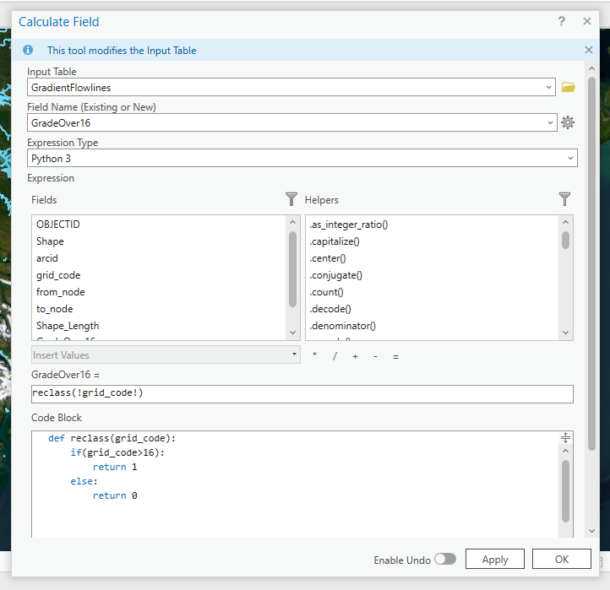Simplify Polylines
  4. Name new polyline “GradientFlowlines”
  5. Run

Open the attribute table GradientFlowlines and create new field labeled GradeOver16

* 1. Calculate field: put in code ->
  2. See image to the right ->>>

Geoprocessing Pane Dissolve (Data Management Tools)

* 1. Input features : Gradient Flowlines
  2. Dissolve Fields : GradeOver16
  3. Check Create Multipart Features AND Unsplit Lines
  4. Run

Open Attribute table of Flowlines dissolved by gradeover16 and create new field for length

Open Calculate geometry attributes

* 1. Input features : Gradient flowlines dissolved polyline
  2. Field : length
  3. 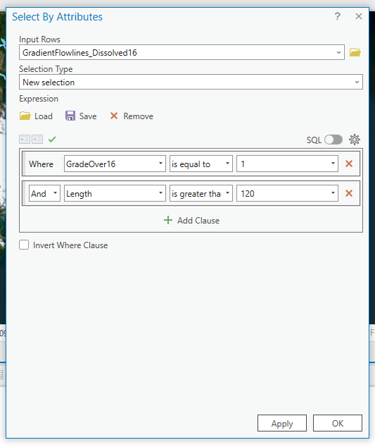Property : length (geodesic)
  4. Length unit : meters
  5. Run

Open select by attributes

* 1. Look right ---->>>>
  2. Select for grade over 16
  3. And desired length (35m?)
  4. Run

Under the data tab click

* 1. Export features
  2. Export the selected attributes
  3. Name new polyline
     1. Grade16Over120m

Edit NHD flowlines of the area by deleting areas upstream of these gradient areas

* 1. I would also recommend also pulling in the culvert and AWC barrier layers. The AWC lines are also helpful in seeing where salmon have been cataloged
  2. Type code:
  3. Ok