CI/CD Performance, Engineering Workflow Dynamics, and Technical Debt in Open-Source DevOps Projects

Innhold
Abstract 5
List of Symbols 6
Introduction 7
1.1 Motivation 7
1.2 Project goals 10
1.3 Thesis structure 11
Chapter 2 – Background 12
2.1 DevOps and Software Delivery 12
2.2 Continuous Integration and Continuous Delivery 14
2.3 CI/CD Pipeline Automation 14
2.4 Pull-Request-Based Development Workflows 16
2.5 Repository Mining in Software Engineering Research 17
2.6 Static Analysis and Code Quality Measurement 18
2.7 Technical Debt in Software Systems 19
2.8 Conceptual Framework of the Study 20
2.9 Summary of the Theoretical Foundation 22
Chapter 3 – Related Work 23
3.1 DevOps and Software Delivery Performance 23
3.2 Engineering Workflow and Pull Request Analytics 24
3.3 CI/CD Pipeline Performance and Reliability 25
3.4 Repository Mining in Software Engineering Research 26
3.5 Code Quality and Technical Debt Indicators 27
3.6 Research Gap 28
Chapter 4 – Methodology 29
4.1 Research Design 29
4.2 Case Study Selection 31
4.3 Case Study Projects 31
4.4 Data Sources 33
4.5 Use of GitHub Repository Data 34
4.6 Metric Definitions and Operationalization 34
4.7 Data Processing and Aggregation 37
4.8 Data Analysis Approach 37
4.9 Validity Considerations 38
Chapter 5 40
5.1 Results for RQ1: Temporal Evolution of Development Workflows and Delivery Activity 40
5.2 Results for RQ2: Cross-Project Comparison of Workflow, CI/CD Behavior, and Code Quality 61
Chapter 6 73
6.1 Synthesis of the Findings 73
6.2 Interpreting Workflow and CI/CD Dynamics (RQ1) 75
6.3 Interpreting the Relationship Between Process and Code Quality (RQ2) 77
6.4 Theoretical Implications 80
6.5 Practical Implications for DevOps Practice 82
6.6 Limitations 83
6.7 Future Research 84
6.8 Conclusion 85
References 87

Figur 1. DevOps lifecycle illustrating the integration of continuous integration (CI) and continuous delivery (CD) processes. 13
Figur 2. Example architecture of a CI/CD pipeline with automated build, testing, and deployment stages. 15
Figur 3. Pull-request-based development workflow integrated with GitHub Actions pipelines. 17
Figur 4. Conceptual research framework of the study. 30
Figur 5. PR cycle time over time across repositories. 41
Figur 6. PR cycle time over time per repository 42
Figur 7. Review latency distribution across repositories. 43
Figur 8. Review latency over time across repositories. 44
Figur 9. Review latency over time per repository. 44
Figur 10. Review duration over time across repositories (4-week median). 45
Figur 11. Review duration over time per repository (weekly median and 4-week median). 46
Figur 12. Merge frequency over time across repositories (4-week average). 47
Figur 13. Merge frequency over time per repository (weekly and 4-week average). 48
Figur 14. CI failure rate over time per repository (weekly values and 4-week smoothed mean). 50
Figur 15. CI duration over time per repository (weekly median and 4-week smoothed median). 51
Figur 16. CI flakiness over time (retry share, weekly values and 4-week smoothed mean). 52
Figur 17. CI flakiness over time per repository (retry share, weekly values and 4-week smoothed mean). 53
Figur 18. CI failure volatility over time (8-week rolling standard deviation, comparison across repositories) 54
Figur 19. CI failure volatility over time per repository (8-week rolling standard deviation) 55
Figur 20. Monthly release frequency per repository. 56
Figur 21. Median monthly Time-to-Release per repository. 58
Figur 22. Median Time-to-Release over time for repositories with available release data.. 58
Figur 23. CD workflow success rate over time (weekly). 59
Figur 24. Distribution of pull request churn across repositories (logarithmic scale). 64
Figur 25. SonarQube-Based Code Quality Comparison. 67

Abstract:
Context:
Goal:
Method:
Result(s):
Conclusion(s):
This study examines pull request, workflow, release, and static analysis data collected from three large-scale open-source DevOps repositories: prometheus/prometheus, docker/cli, and tektoncd/pipeline. The dataset covers about two years observation period and includes 64,798 GitHub Actions workflow runs, comprehensive pull request metadata, release events, and SonarQube-based maintainability and technical debt indicators.
By combining workflow-level CI/CD telemetry with repository mining and static code analysis, the study enables a multi-dimensional analysis of engineering velocity, pipeline stability, delivery cadence, and code-level technical debt.
The empirical dataset consists of pull request metadata (prs.csv), GitHub Actions workflow execution logs (workflow_runs.csv), and release metadata (releases.csv), collected via the GitHub GraphQL and REST APIs. In total, 64,798 workflow executions were analyzed across the three repositories during the observation window.
Static code analysis snapshots were obtained using SonarQube to measure maintainability, code smells, duplication density, reliability, and security issues.
The selected repositories vary in CI/CD maturity and architectural complexity, enabling comparative analysis across heterogeneous DevOps contexts.

List of Symbols
Abbreviation | Description
CI | Continuous Integration
CD | Continuous Delivery
DevOps | Development and Operations
PR | Pull Request
TD | Technical Debt
RQ | Research Question
DORA | DevOps Research and Assessment
MSR | Mining Software Repositories
CNCF | Cloud Native Computing Foundation
API | Application Programming Interface

Introduction

1.1 Motivation

1.1.1 Motivating Use Case
Modern software development increasingly relies on DevOps practices and Continuous Integration and Continuous Delivery (CI/CD) pipelines to support rapid code integration, automated testing, and frequent software releases. These practices aim to shorten development cycles, improve collaboration, and enhance the reliability and speed of software delivery (Forsgren et al., 2018).
As a result, modern software development environments generate large volumes of observable development artefacts, including pull requests, code review activities, CI/CD pipeline executions, and release events. In open-source ecosystems, platforms such as GitHub provide detailed and publicly accessible traces of these activities, enabling empirical analysis of development processes through repository mining techniques (Bird et al., 2009).
While prior research and industry frameworks such as DevOps Research and Assessment (DORA) define key metrics for evaluating software delivery performance—such as deployment frequency and lead time for changes—many of these metrics are not directly observable from repository data alone. In particular, operational metrics such as change failure rate and mean time to restore service typically require production monitoring data, which is often unavailable in open-source environments.
Consequently, repository artefacts such as pull requests, CI/CD workflow executions, and release histories must be used as observable proxies for analyzing software delivery processes. These artefacts provide insights into development workflow efficiency, including integration speed, review latency, and feedback cycles, as well as into delivery cadence. However, a comprehensive understanding of how these indicators relate to each other is essential for accurately interpreting software delivery performance. When considered in isolation, individual metrics capture only specific aspects of development activity, as their meaning depends on context and their interactions with other metrics, limiting their ability to reflect the dynamics of workflows, CI/CD processes, and delivery behavior.
In addition, static analysis tools such as SonarQube provide complementary indicators of code quality, including code smells, duplication, reliability issues, and security vulnerabilities. These indicators are often associated with technical debt and long-term maintainability (Avgeriou et al., 2016).
However, despite the availability of both repository-based metrics and static analysis indicators, existing empirical studies have largely focused on individual dimensions—such as pull request workflows or CI performance—while rarely examining how workflow dynamics, CI/CD pipeline behavior, and code quality characteristics interact in real-world DevOps environments.
To address this gap, this study investigates how repository artefacts and static analysis indicators can be combined to provide a multi-dimensional analysis of engineering workflows, CI/CD pipeline behavior, and software quality in open-source DevOps projects.

1.1.2 Research Objective
The objective of this study is to investigate how development workflow metrics and CI/CD-related indicators derived from GitHub repository data can be used to characterize and analyze software delivery processes in open-source DevOps projects. Modern collaborative development platforms record detailed traces of development activity, including pull request workflows, code review interactions, CI/CD pipeline executions, and software release events. These repository artefacts provide valuable opportunities for empirically studying engineering workflows and delivery processes.
This study examines how observable repository data can be used to capture workflow dynamics and CI/CD pipeline behavior in real-world DevOps environments. In addition, it explores how these indicators relate to delivery performance proxies aligned with the DevOps Research and Assessment (DORA) metrics framework, as well as to code-level maintainability and technical debt indicators derived from static code analysis using SonarQube.
By combining repository mining techniques with workflow, pipeline, and static analysis metrics, this study aims to provide empirical insights into how workflow, pipeline, and code-quality dimensions jointly shape software delivery performance in open-source DevOps projects.

Research Questions
To address the research objective, the study investigates the following research questions:
- RQ1
How do pull request workflow dynamics and CI/CD pipeline performance evolve over time in open-source DevOps projects?
- RQ2
How do differences in workflow structure and CI/CD automation across projects relate to delivery performance proxies and SonarQube-based maintainability and technical debt indicators?

1.1.3 Approach and Design
This study adopts an empirical repository-mining approach to investigate software development and delivery processes in open-source DevOps projects. Repository mining enables the systematic analysis of historical development artefacts recorded in software repositories, providing insights into development workflows, collaboration patterns, and software evolution.
The research follows a structured empirical design consisting of several stages.
First, a literature review was conducted to examine prior research on DevOps delivery performance, pull request workflows, CI/CD pipeline behavior, repository mining techniques, and static-analysis-based indicators of software quality. This review provides the theoretical foundation for the metric framework used in the study.
Second, a set of open-source DevOps-oriented projects hosted on GitHub was selected as case studies. These projects were chosen based on their active development activity, use of pull-request-based collaboration, and adoption of automated CI/CD workflows.
Third, development and pipeline data were collected from the selected repositories. The collected data include pull request metadata, code review events, CI/CD workflow executions from GitHub Actions, and release histories. These repository artefacts provide observable traces of engineering workflow dynamics.
Fourth, a set of analytical metrics was derived from the collected repository data to capture engineering workflow dynamics, CI/CD pipeline behavior, and delivery activity. These metrics include pull request workflow indicators, CI pipeline reliability measures, release cadence indicators, and static analysis–based code quality metrics obtained from SonarQube snapshots.
Finally, the extracted metrics were analyzed to investigate temporal patterns within individual projects and cross-project differences among the selected case studies. The analysis focuses on identifying relationships between development workflows, CI/CD pipeline behavior, and code quality indicators associated with maintainability and technical debt.

1.1.4 Research Contributions
The main contributions of this study are summarized as follows:
- This study provides a multi-dimensional empirical analysis of DevOps workflows and software delivery performance by integrating workflow, CI/CD, and code quality indicators derived from repository-mined data.
- It operationalizes delivery-performance proxies from repository artefacts, demonstrating how pull requests, CI/CD workflow runs, and release histories can be used to study DevOps performance in environments where operational metrics are not directly observable.
- It analyzes temporal dynamics in development workflows and CI/CD pipelines using time-series data, revealing how engineering velocity, pipeline stability, and release behavior evolve over time.
- It conducts a cross-project comparative analysis of open-source DevOps projects, highlighting differences in workflow efficiency, pipeline reliability, and code quality characteristics.
- It provides empirical insights into the relationships between engineering workflows, CI/CD pipeline performance, and technical debt indicators derived from SonarQube-based static analysis.

1.2 Project goals
The main goal of this study is to investigate software engineering workflow dynamics in open-source DevOps projects through the empirical analysis of observable repository artefacts. Modern software development platforms generate extensive development data through version control systems, pull request workflows, automated CI/CD pipelines, and release management processes. These artefacts provide valuable opportunities for analyzing engineering workflows and software delivery behavior.
This thesis aims to explore how development activities recorded in GitHub repositories can be used to analyze engineering workflow dynamics, CI/CD pipeline behavior, and delivery performance indicators in collaborative open-source software projects.
More specifically, the study pursues the following objectives:
- To identify observable repository artefacts that reflect development workflows and delivery processes in DevOps environments.
- To operationalize a set of workflow, CI/CD, and delivery-related metrics derived from GitHub repository data.
- To analyze engineering workflow dynamics, including pull request processing patterns, code review interactions, and integration cycles.
- To evaluate CI/CD pipeline behavior and reliability using workflow execution data and pipeline outcomes.
- To examine how static analysis indicators derived from SonarQube provide complementary insights into codebase characteristics, maintainability, and technical debt indicators.
By combining repository mining techniques with workflow metrics, CI/CD pipeline indicators, and static analysis measures, this study aims to provide an empirical perspective on how development workflows and delivery processes operate in open-source DevOps projects.

1.3 Thesis structure
The remainder of this thesis is organized into six chapters.
Chapter 1 introduces the research context and motivation for the study. It presents the research objectives, research questions, research contributions, and the overall scope of the thesis.
Chapter 2 provides the theoretical background and introduces key concepts relevant to the study. These include DevOps practices, Continuous Integration and Continuous Delivery (CI/CD), pull-request-based development workflows, repository mining techniques, static analysis tools such as SonarQube, and the concept of technical debt.
Chapter 3 reviews relevant prior research related to DevOps development processes, CI/CD pipeline performance, repository mining, pull request analytics, and technical debt indicators. This chapter situates the study within the existing body of literature and identifies research gaps addressed by the thesis.
Chapter 4 describes the research methodology adopted in this study. It explains the research design, case study selection, data sources, metric definitions, data collection procedures, analytical methods, and threats to validity.
Chapter 5 presents the empirical results and analysis of the study. It discusses the observed patterns in development workflows, CI/CD pipeline behavior, delivery performance proxies, and code quality indicators across the analyzed projects.
Finally, Chapter 6 concludes the thesis by summarizing the main findings, discussing the implications of the results, outlining limitations of the study, and suggesting directions for future research.

Chapter 2 – Background
This chapter presents the theoretical foundations that support the empirical analysis conducted in this study. It introduces key concepts related to DevOps practices, Continuous Integration and Continuous Delivery (CI/CD), pull-request-based development workflows, repository mining methods, and static analysis techniques for evaluating software quality.
These concepts directly support the three analytical perspectives of this study: engineering workflow dynamics, CI/CD pipeline performance, and code quality and technical debt indicators. Together, they provide the theoretical basis for analyzing software delivery processes in open-source DevOps projects.
The chapter begins by introducing DevOps as a paradigm for modern software delivery, followed by an overview of CI/CD practices and pipeline automation. It then discusses pull-request-based development workflows and repository mining as approaches for studying collaborative development processes. Finally, it presents static analysis techniques and the concept of technical debt as perspectives for evaluating software quality and maintainability, which are further analyzed in relation to workflow and pipeline metrics in RQ2.

2.1 DevOps and Software Delivery
DevOps represents a set of practices that integrate software development and IT operations to shorten development cycles and improve the reliability and frequency of software delivery. The DevOps paradigm emphasizes collaboration, automation of software delivery processes, and continuous feedback across the software lifecycle (Forsgren et al., 2018; Jha et al., 2023). Rather than treating development and operations as separate phases, DevOps promotes integrated workflows that enable rapid and stable software delivery.
Traditional software development processes relied on sequential handoffs between development and operations teams, often resulting in slow deployment, communication barriers, and difficulties in diagnosing operational issues. DevOps addresses these limitations by integrating development, testing, deployment, and monitoring activities within unified and automated delivery pipelines.
Modern DevOps environments rely on integrated toolchains that combine version control systems, CI/CD pipelines, issue tracking systems, and monitoring platforms. These toolchains improve traceability across development processes by linking code changes to integration, deployment, and operational outcomes (Jha et al., 2023). As a result, DevOps environments generate rich and interconnected data describing how software systems evolve over time.
For this study, DevOps environments are particularly relevant because they produce observable development artefacts—such as commits, pull requests, CI/CD workflow executions, and release events—that can be analyzed using repository mining techniques (Gousios & Spinellis, 2017). These artefacts enable the empirical investigation of engineering workflows and delivery processes, supporting the analysis of temporal workflow dynamics and cross-project differences in delivery performance and code quality.
The DevOps lifecycle integrates development, testing, deployment, and monitoring within a continuous feedback loop. Continuous Integration (CI) and Continuous Delivery (CD) play a central role in this lifecycle by enabling automated integration, validation, and deployment of software changes, forming an iterative process of continuous software delivery as illustrated in Figure 1.

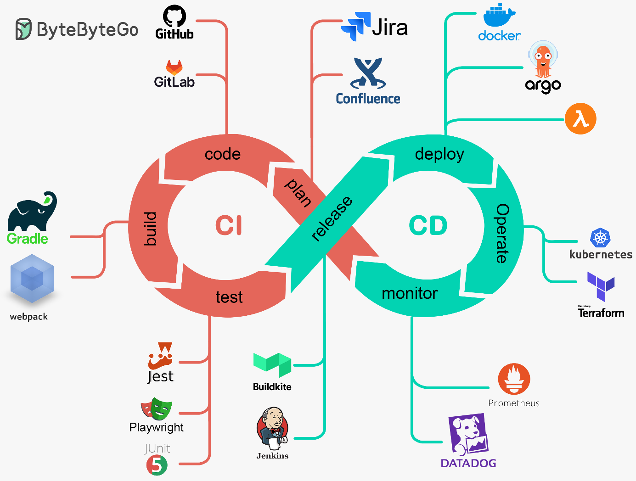
Figur 1. DevOps lifecycle illustrating the integration of continuous integration (CI) and continuous delivery (CD) processes.

2.2 Continuous Integration and Continuous Delivery
Continuous Integration (CI) and Continuous Delivery (CD) are core practices in modern DevOps environments, enabling frequent integration of code changes and automated validation through build, test, and analysis stages (Forsgren et al., 2018). CI focuses on detecting integration issues early by verifying each change through automated builds and tests, thereby maintaining a stable and continuously functioning codebase.
Continuous Delivery extends these principles by ensuring that software systems remain continuously deployable through automated packaging and release processes. In CI/CD environments, automated pipelines execute sequences of stages including compilation, testing, static analysis, and artefact generation, enabling consistent and reliable software delivery.
CI/CD pipelines form the backbone of automated software delivery systems, providing rapid feedback on code quality, integration stability, and system behavior (Forsgren et al., 2018). This continuous feedback loop supports early defect detection and contributes to improved delivery efficiency.
For this study, CI/CD pipelines are particularly relevant because they generate detailed execution metadata—including pipeline durations, execution outcomes, failure events, and retry behavior—that serve as observable indicators of pipeline reliability and integration stability. These execution traces enable empirical analysis of CI/CD performance and support the investigation of temporal dynamics in software delivery processes (Leite et al., 2019).
In addition, pipeline execution data provide a basis for assessing delivery consistency and automation maturity across projects, making CI/CD behavior a central analytical dimension in understanding software delivery performance in open-source DevOps environments.

2.3 CI/CD Pipeline Automation
CI/CD pipelines represent the automated execution infrastructure that operationalizes software build, testing, and deployment processes in modern DevOps environments. Unlike the conceptual principles of Continuous Integration and Continuous Delivery introduced in Section 2.2, pipelines provide a concrete implementation layer where these practices are executed through structured and automated workflows.
A typical CI/CD pipeline consists of a sequence of stages corresponding to different phases of the software delivery lifecycle, including compilation, automated testing, static analysis, artifact generation, and deployment preparation. These stages are defined through configuration files that specify execution conditions, dependencies, and workflow triggers. Pipeline execution is typically initiated by repository events such as commits, branch updates, or pull request activities, enabling continuous and automated validation of software changes (Wessel et al., 2023).
For this study, CI/CD pipelines are analytically important because they generate execution-level telemetry describing how software delivery processes operate in practice. Pipeline runs record detailed information such as execution duration, success and failure outcomes, retry behavior, and resource usage. These execution traces provide observable indicators of pipeline reliability, integration stability, and delivery consistency.
The availability of such pipeline telemetry has made CI/CD behavior a central topic in empirical software engineering research (Santos et al., 2024). In this study, pipeline execution data are used to derive metrics related to failure rates, flakiness, and temporal variation in pipeline performance, supporting the analysis of temporal CI/CD dynamics and cross-project differences in pipeline reliability.
Because CI/CD pipelines produce detailed execution logs, they constitute a form of development telemetry that can be analyzed using repository mining techniques. These logs enable the study of engineering workflow dynamics, integration stability, and delivery performance in collaborative DevOps environments.
As illustrated in Figure 2, CI/CD pipelines integrate automated stages for building, testing, artifact generation, and deployment, forming a structured and repeatable workflow for validating and delivering software changes.

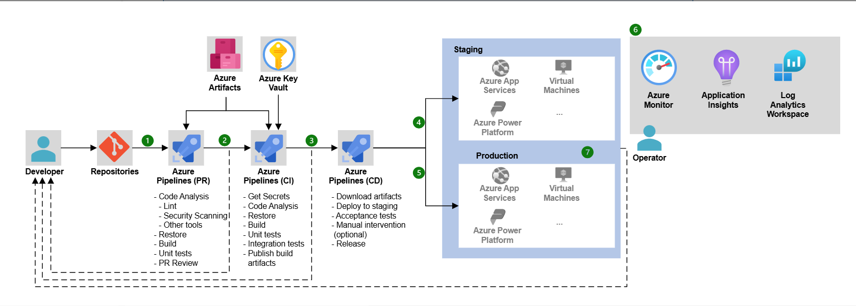
Figur 2. Example architecture of a CI/CD pipeline with automated build, testing, and deployment stages.

2.4 Pull-Request-Based Development Workflows
Pull-request-based workflows have become a dominant collaboration model in modern software development, particularly in open-source projects hosted on platforms such as GitHub and GitLab. In these environments, developers propose code changes through pull requests that must be reviewed and approved before integration into the main codebase, enabling structured collaboration and controlled code integration (Gousios & Spinellis, 2017).
Pull requests serve both technical and social functions within collaborative development processes. Technically, they allow developers to propose and validate changes while preserving the stability of the main branch. From a collaborative perspective, pull requests facilitate communication and knowledge sharing through review comments, feedback, and discussion, supporting defect detection and improving code quality before integration.
Pull-request workflows generate detailed and time-stamped traces of development activities, including review interactions, modification history, contributor participation, and integration timing (Kalliamvakou et al., 2016). These traces enable empirical analysis of how development teams coordinate integration processes and evaluate contributions.
For this study, pull request data are analytically important because they can be operationalized into workflow metrics such as pull request cycle time, review latency, and review duration. These metrics provide measurable indicators of workflow efficiency and collaboration dynamics, supporting the analysis of temporal workflow behavior.
Previous research has examined factors influencing pull request evaluation processes, including review latency, contributor experience, and project activity levels (Yu et al., 2015; Zhang et al., 2022). While these studies provide insights into individual aspects of pull request workflows, they typically do not consider how workflow dynamics interact with CI/CD pipeline behavior and software quality indicators in a unified analytical framework.
Pull request workflows are also closely integrated with CI/CD pipelines in modern DevOps environments. Pipeline executions are often triggered by pull request events, enabling automated validation of proposed code changes before integration. This integration strengthens software delivery reliability and provides additional observable data linking workflow processes with pipeline behavior (Wessel et al., 2023).
Because pull requests capture detailed information about development interactions and integration processes, they represent a key data source for repository mining studies. In this study, pull request data are used to analyze workflow dynamics, collaboration patterns, and integration behavior across projects, forming a central component of the empirical analysis.
As illustrated in Figure 3, pull-request-based workflows integrate collaborative code review with automated CI/CD pipelines, enabling validation of proposed changes before they are merged into the main codebase.

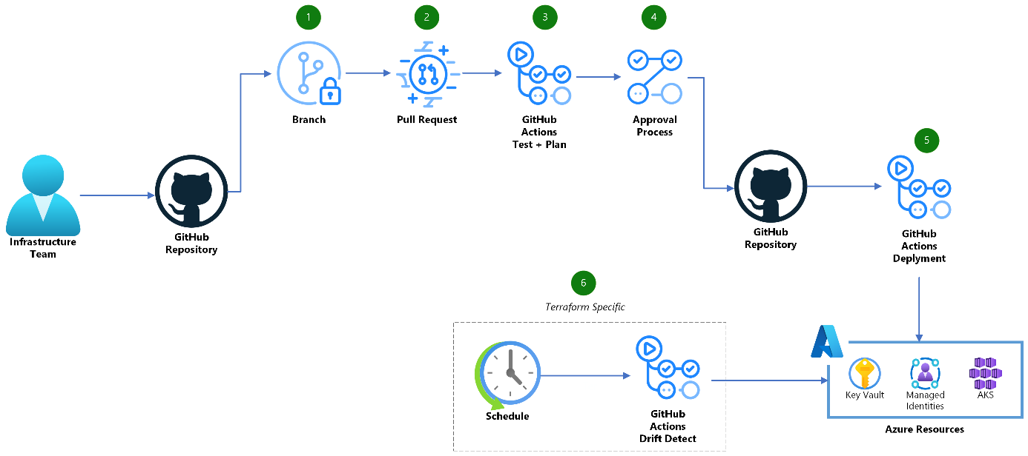
Figur 3. Pull-request-based development workflow integrated with GitHub Actions pipelines.

2.5 Repository Mining in Software Engineering Research
Repository mining, commonly referred to as Mining Software Repositories (MSR), is a research approach that analyzes historical development data stored in software repositories and collaborative development platforms. By examining data generated during software development activities, researchers can investigate software evolution, developer collaboration, and project management practices (Gousios & Spinellis, 2017).
Modern collaborative development platforms such as GitHub provide extensive datasets that capture various aspects of software development processes. These repositories record detailed information about commits, pull requests, issue tracking activities, code review discussions, and release events. Such artefacts represent observable traces of development activities and enable researchers to study how software systems evolve over time (Kalliamvakou et al., 2014).
Repository mining has become a widely used empirical research method in software engineering because it allows researchers to analyze real-world development practices at large scale. In DevOps-oriented projects, where development, integration, and delivery activities are tightly coupled and extensively logged, repository mining provides a uniquely rich empirical basis for studying workflow and pipeline behavior. By analyzing repository artefacts, researchers can investigate patterns in development workflows, collaboration dynamics among developers, code integration processes, and software project evolution. Studies based on repository mining have significantly contributed to understanding software engineering practices in open-source ecosystems (Gousios & Spinellis, 2017).
Despite its advantages, repository mining also presents methodological challenges. Repository data may contain incomplete or misleading representations of development activities, since not all coordination and communication occur within repository platforms. For example, some development discussions may take place through external communication channels such as mailing lists or private messaging systems. Consequently, researchers must carefully interpret repository data when conducting empirical studies of software engineering processes (Kalliamvakou et al., 2016).
Despite these limitations, repository mining remains one of the most powerful methodologies for studying real-world software development practices at scale. The availability of large-scale repository datasets enables researchers to analyze engineering workflows, collaboration patterns, and software delivery processes across diverse software projects. In particular, repository artefacts such as pull requests, workflow executions, and release histories provide valuable data sources for empirical investigations of development workflows and CI/CD-driven software delivery processes.
In this study, repository mining is used to extract and analyze time-stamped workflow, pipeline, and release artefacts, forming the empirical basis for analyzing temporal workflow dynamics and cross-project differences in delivery performance and code quality.

2.6 Static Analysis and Code Quality Measurement
Static analysis tools are widely used in software engineering to evaluate code quality by analyzing source code without executing the program. These tools examine code structures, dependencies, and programming patterns to identify potential issues related to maintainability, reliability, and security. By operating directly on source code, static analysis enables early detection of quality problems and supports continuous quality assurance throughout the development lifecycle.
Modern static analysis techniques automatically detect patterns associated with code quality issues such as code smells, duplicated code, excessive complexity, and potential defects. These issues often indicate maintainability challenges that may increase long-term maintenance costs and negatively affect software evolution. Consequently, static analysis has become an important mechanism for monitoring code quality and identifying maintainability risks in large-scale software systems (Li et al., 2020).
Among the available platforms, SonarQube is one of the most widely adopted tools in DevOps-oriented environments. It performs continuous inspection of source code and generates metrics related to maintainability, reliability, and security vulnerabilities (SonarSource, 2023). These metrics provide quantitative indicators that support decision-making related to refactoring, maintenance, and software evolution.
Static analysis tools are commonly integrated into CI/CD pipelines, enabling automated evaluation of code quality whenever new code changes are introduced. This integration allows development teams to continuously monitor quality evolution and detect issues during the integration process. In DevOps environments, where frequent integration and deployment cycles are central, such automated quality checks play a critical role in maintaining system stability.
While static analysis tools provide measurable indicators of code quality issues, they primarily capture code-level and issue-level concerns and do not fully represent architectural or process-related aspects of software quality (Avgeriou et al., 2021; Li et al., 2020). Nevertheless, such indicators are commonly used as proxies for code-level technical debt in empirical studies.
In addition to SonarQube, other static analysis platforms provide advanced capabilities for analyzing structural dependencies and architectural design. These tools support the identification of architectural weaknesses and structural issues that may contribute to long-term maintainability challenges (Avgeriou et al., 2021).
Overall, static analysis tools provide an automated and scalable mechanism for evaluating software quality. By generating measurable indicators, they enable empirical studies of how code quality evolves alongside development workflows and software delivery processes.

2.7 Technical Debt in Software Systems
Technical debt is a widely used concept in software engineering that describes the long-term consequences of design and implementation decisions that prioritize short-term development speed over long-term maintainability. Originally introduced as a metaphor, it captures how expedient decisions can accumulate additional maintenance effort over time, similar to financial debt that must eventually be repaid. As software systems evolve, unresolved technical debt can increase system complexity, reduce maintainability, and negatively affect software quality (Li et al., 2020).

Technical debt encompasses multiple dimensions of software systems and extends beyond observable code-level issues. Previous research has identified several categories, including code debt, design debt, testing debt, documentation debt, and infrastructure debt (Li et al., 2020). Each category reflects different types of suboptimal decisions that influence software quality and long-term system evolution.
Code debt arises from issues such as poor code structure, excessive complexity, duplication, and violations of coding standards. Design debt originates from architectural decisions that constrain system flexibility or hinder evolution. Testing debt refers to insufficient or inadequate automated testing, increasing the risk of undetected defects and reducing confidence in system reliability. Documentation debt emerges when incomplete or outdated documentation limits system understanding and maintainability.
In modern DevOps environments, technical debt may also manifest in development infrastructure and delivery pipelines. Inefficient build processes, misconfigured CI/CD pipelines, and inadequate monitoring mechanisms can introduce infrastructure-related debt that affects software delivery performance and system reliability (Stochel et al., 2022).
In empirical software engineering, technical debt is often operationalized through observable indicators such as code smells, duplication, and maintainability violations (Avgeriou et al., 2021). Because these indicators can be measured automatically, they provide a practical basis for analyzing code-level technical debt across software projects.
However, such indicators primarily capture code-level and issue-level concerns and do not fully represent architectural, organizational, or process-related dimensions of technical debt (Avgeriou et al., 2021; Li et al., 2020). As a result, empirical studies typically approximate technical debt through measurable proxies rather than capturing the full scope of the concept.
Understanding technical debt therefore requires considering both the structural characteristics of software systems and the development processes through which software evolves. Empirical research increasingly emphasizes the importance of analyzing technical debt in relation to development workflows, DevOps practices, and continuous integration processes (Aldaeej et al., 2023).

2.8 Conceptual Framework of the Study
The concepts discussed in the previous sections provide the theoretical foundation for analyzing development workflows and software delivery processes in DevOps environments. Modern DevOps-oriented development relies on integrated toolchains that connect version control systems, CI/CD pipelines, and automated code quality analysis tools, generating rich development artefacts that capture observable traces of engineering activities.
Within DevOps-oriented development processes, version control systems and pull-request-based workflows serve as key mechanisms for coordinating collaborative software development. Pull requests enable structured code review processes, discussion among contributors, and controlled integration of code changes into the main codebase. These workflows generate detailed metadata describing development interactions, review activities, and integration timing, which can be analyzed to understand engineering workflow dynamics (Gousios & Spinellis, 2017; Yu et al., 2015; Zhang et al., 2022).
CI/CD pipelines extend these workflows by automating build, testing, and deployment processes whenever new code changes are integrated into the repository. Automated pipelines continuously validate software changes and generate execution data describing build outcomes, pipeline durations, and failure events. These pipeline execution traces provide valuable indicators of software delivery performance and integration stability in DevOps environments (Forsgren et al., 2018; Santos et al., 2024).
In addition to workflow and pipeline data, static analysis tools provide quantitative indicators of software quality and maintainability. Platforms such as SonarQube analyze source code to detect issues such as code smells, duplication, and maintainability violations, which are commonly associated with the accumulation of technical debt in evolving software systems (Avgeriou et al., 2021; Li et al., 2020).
Together, repository artefacts generated through collaborative development platforms and automated CI/CD pipelines provide an integrated data source for empirical analysis of software engineering practices. By combining pull request workflow data, CI/CD pipeline execution logs, release information, and static analysis metrics, it becomes possible to analyze how development workflows, delivery processes, and code quality characteristics evolve over time in DevOps-oriented projects.
Based on this theoretical foundation, the present study analyzes development workflows and software delivery performance in open-source DevOps projects using repository mining techniques. The conceptual framework of the study integrates three main analytical perspectives:
- engineering workflow dynamics, derived from pull request activities and code review interactions
- CI/CD pipeline performance, derived from workflow execution data and pipeline outcomes
- code quality and technical debt indicators, derived from static analysis metrics

These perspectives collectively provide a multi-dimensional view of software development processes. Engineering workflow dynamics and CI/CD pipeline performance form the basis for analyzing temporal behavior and evolution of development and delivery processes (RQ1), while their integration with code quality and technical debt indicators enables cross-project comparison of delivery performance and maintainability characteristics (RQ2).
Together, this conceptual framework enables a systematic empirical investigation of how development workflows, CI/CD pipelines, and code quality characteristics interact in modern DevOps environments.

2.9 Summary of the Theoretical Foundation
This chapter presented the theoretical foundations relevant to this study. It introduced DevOps as a paradigm for modern software delivery and examined the role of Continuous Integration and Continuous Delivery in enabling automated and continuous development workflows. The chapter further discussed pull-request-based development workflows and repository mining as mechanisms for analyzing collaborative software development through observable repository artefacts.
In addition, static analysis techniques and the concept of technical debt were presented as perspectives for evaluating software quality and maintainability. Together, these concepts establish a theoretical foundation for analyzing software development processes from multiple complementary perspectives.
Specifically, the chapter outlined how development workflows, CI/CD pipeline behavior, and code quality indicators can be examined as interconnected dimensions of software delivery performance in open-source DevOps environments.

Chapter 3 – Related Work
This chapter reviews prior empirical research related to DevOps-oriented software development and delivery processes. It focuses on studies examining software delivery performance, pull-request-based development workflows, CI/CD pipeline behavior, repository mining approaches, and indicators of code quality and technical debt. The purpose of this review is to position the present study within the empirical software engineering literature and to identify analytical perspectives and methodological approaches relevant to the analysis of engineering workflows and software delivery dynamics in DevOps environments.

3.1 DevOps and Software Delivery Performance
Empirical software engineering research has examined how software delivery performance can be evaluated in DevOps-oriented environments. A central reference point in this work is the DORA framework, whose four indicators—deployment frequency, lead time for changes, change failure rate, and mean time to restore service—are widely used as empirical proxies for organizational delivery capability (Forsgren et al., 2018).
Rather than treating these metrics as purely conceptual constructs, prior studies have investigated how they can be operationalized using observable development artefacts. Sallin et al. (2021), for example, show that repository events, release histories, and integration activity can be used to approximate delivery-related indicators in contexts where production-level data is unavailable. Their work demonstrates the feasibility of repository-based operationalizations of deployment frequency and lead time.
Complementary research has focused on the role of continuous integration and delivery practices in supporting software delivery performance. Hilton et al. (2016) find that continuous integration adoption improves integration efficiency in open-source projects, while Shahin et al. (2017) identify automated pipelines as a key enabler of continuous delivery. Together, these studies indicate that delivery performance is not only reflected in release activity, but also shaped by the efficiency and reliability of underlying integration and automation processes.
Despite these contributions, existing research remains primarily focused on delivery outcomes or their approximations, offering limited insight into the engineering processes that produce them. Outcome-oriented metrics such as deployment frequency and lead time capture observable results, but do not explain how workflow dynamics, review behavior, integration latency, or CI/CD pipeline execution contribute to these outcomes. Consequently, prior work provides only a partial understanding of how delivery performance emerges from the interaction between development workflows and automation systems.
Furthermore, most empirical studies analyze delivery outcomes, workflow activity, and CI/CD behavior as separate dimensions. While studies such as Sallin et al. (2021) demonstrate that delivery indicators can be approximated from repository artefacts, they do not systematically relate these indicators to workflow-level coordination processes or pipeline-level execution characteristics.
This suggests that integrated empirical analyses of workflow behavior, pipeline performance, and delivery outcomes are less frequently examined in combination. Further analysis of the relationship between workflow behavior, pipeline performance, and delivery outcomes may support a better understanding of how software delivery performance arises from the combined effects of coordination practices, automation behavior, and development activity in DevOps-oriented environments.

3.2 Engineering Workflow and Pull Request Analytics
Empirical software engineering research has widely used pull request and merge request artifacts to analyze engineering workflow dynamics in collaborative software development. Prior studies use these artefacts to analyze review processes, integration behavior, and coordination patterns in distributed development environments.
Yu et al. (2015) demonstrate that pull request evaluation latency is influenced by a combination of technical, social, and process-related factors. Their findings show that review delays emerge from interactions between contributor experience, project activity, and characteristics of the proposed change, highlighting the complexity of workflow dynamics in collaborative development.
Zhang et al. (2022) extend this perspective by providing a broader empirical analysis of pull request latency across projects. Their results indicate that review latency is highly context-dependent and shaped by interactions between reviewers and contributors, including discussion activity and change complexity. These findings support the use of pull-request-based metrics—such as review latency, cycle time, and review duration—as indicators of workflow coordination and integration efficiency.
More recent work by Kansab et al. (2025) expands pull request analysis beyond review timing to broader DevOps process behavior. Analyzing merge requests across industrial GitLab projects, they show that PR/MR artefacts can reveal patterns related to collaboration structure, prioritization behavior, and workflow efficiency. This illustrates the applicability of pull-request-based analysis for studying engineering workflows in DevOps-oriented environments.
Taken together, these studies show that pull request artefacts provide a useful empirical basis for analyzing workflow dynamics in modern software development. At the same time, existing research primarily focuses on review processes and coordination patterns within the pull request lifecycle. These studies therefore tend to emphasize workflow-level phenomena without explicitly considering how these processes relate to other aspects of software delivery.
In particular, pull-request-based analyses are often conducted independently of studies on CI/CD pipeline behavior or code-quality-related indicators. While this does not diminish their contribution, it means that they provide a more focused perspective on specific aspects of the development process rather than a broader view of software delivery.
From this perspective, there is an opportunity to further explore how workflow-related metrics may be examined alongside pipeline behavior and code quality indicators. Such combined analyses may help provide a more nuanced understanding of how different dimensions of software delivery relate to one another in DevOps-oriented projects.

3.3 CI/CD Pipeline Performance and Reliability
Another line of research focuses on CI/CD pipeline behavior and the role of automation in software delivery processes. In contrast to studies that emphasize delivery outcomes or workflow coordination, this line of research examines how pipeline execution, build systems, and automated testing contribute to development and delivery performance.
Santos et al. (2024) argue that continuous integration practices themselves require systematic monitoring. Their study shows that developers rely on CI-related signals such as test coverage, build health, and time to fix broken builds to assess the state of the development process. At the same time, they highlight that current CI services often provide limited native support for capturing and analyzing such signals. This indicates that CI behavior represents an observable and analytically relevant component of software development rather than purely as operational infrastructure.
Wessel et al. (2023) further demonstrate the importance of CI/CD automation by examining the impact of GitHub Actions on pull request processes. Their findings indicate that the adoption of automation tools influences workflow dynamics, including communication patterns, rejection rates, and the time required to merge contributions. This illustrates that pipeline behavior is not isolated from development workflows, but interacts with how contributions are evaluated and integrated.
Taken together, these studies show that CI/CD pipelines represent not only technical execution environments, but also observable aspects of development processes. Pipeline-related metrics—such as execution duration, failure rate, and indicators of instability such as flakiness—can therefore serve as empirical signals of integration challenges and process reliability.
At the same time, existing research on CI/CD pipelines is often conducted with a primary focus on pipeline performance or developer interaction with automation tools. These studies typically examine pipeline behavior as a distinct analytical dimension, without systematically relating it to workflow-level metrics or code-quality-related indicators.
From this perspective, pipeline performance metrics may be considered alongside workflow dynamics and structural code properties. Such analyses may contribute to a more comprehensive understanding of how automation behavior relates to software delivery processes in DevOps-oriented environments.

3.4 Repository Mining in Software Engineering Research
Repository mining is commonly used in empirical software engineering research to study development processes based on observable project artefacts. Prior work emphasizes that such artefacts must be interpreted carefully, as they do not provide a complete or direct representation of underlying development activities.
Kalliamvakou et al. (2014) identify several validity threats associated with mining GitHub repositories, including incomplete data, implicit workflows, and differences in how projects use repository platforms. Their findings show that artefacts such as commits and pull requests may reflect project-specific conventions rather than consistent representations of development behavior. This underscores the need to consider how repository data is produced and used in practice.
Gousios and Spinellis (2017) further stress that repository mining requires careful methodological interpretation. They argue that repository artefacts should be analyzed within their contextual and technical constraints, as differences in development practices, tool usage, and workflow configurations can significantly affect the meaning of observed data.
Taken together, these studies suggest that repository-derived metrics can be interpreted as operational proxies for development processes rather than direct measurements. This has implications for how empirical studies define and interpret analytical constructs derived from repository data.
In this context, prior studies use observable artefacts such as pull requests, workflow runs, and release events to approximate aspects of workflow behavior, CI/CD pipeline activity, and software delivery processes. However, their interpretation remains dependent on project-specific practices and platform semantics, and must therefore be considered with attention to construct validity and measurement limitations.

3.5 Code Quality and Technical Debt Indicators
Research on code quality and technical debt provides an additional perspective for interpreting the structural characteristics of software systems in empirical software engineering. Rather than focusing solely on development workflows or delivery processes, this line of research examines how properties of the codebase itself relate to software evolution and maintainability.
Empirical studies operationalize technical debt through observable indicators that capture aspects of code quality and maintainability. Aldaeej et al. (2023), for example, propose a process-oriented approach in which development performance metrics, such as sprint velocity and its variability, are used to identify potential maintainability issues. Their findings suggest that process-level signals may reflect underlying structural challenges in the codebase, particularly in fast-paced development environments.
Extending this perspective, Stochel et al. (2022) argue that technical debt should be analyzed across the broader software delivery ecosystem rather than being limited to source code. Their work highlights that inefficiencies may emerge not only from code-level issues, but also from build pipelines, testing infrastructures, and operational environments. This suggests that technical debt can be understood as a multi-dimensional phenomenon that spans both code and process-related aspects of software development.
Complementing these perspectives, Avgeriou et al. (2021) examine how technical debt is measured in practice and show that empirical studies often rely on static-analysis-based indicators. Tools such as SonarQube provide measurable metrics related to maintainability issues, code smells, and duplication, which are commonly used as proxies for code-level technical debt. These indicators enable systematic and scalable analysis of structural properties across software systems.
Taken together, these studies indicate that technical debt is typically operationalized through a combination of process-related and code-level indicators. While static analysis provides quantifiable measures of structural quality, process-oriented metrics offer complementary insights into how such issues may affect development workflows and productivity.
At the same time, prior research also highlights that these indicators capture only a subset of the broader technical debt concept. Static-analysis-based metrics primarily reflect code-level characteristics and do not fully represent architectural, organizational, or infrastructure-related dimensions of technical debt (Avgeriou et al., 2021). As a result, empirical studies often approximate technical debt through measurable proxies rather than capturing its full scope.
In this context, code quality indicators derived from static analysis can be used as observable signals of structural properties within the codebase. When examined alongside workflow metrics and CI/CD pipeline performance, such indicators may provide additional insight into how structural code characteristics relate to development processes and software delivery behavior in DevOps-oriented environments.

3.6 Research Gap
Existing research has examined several dimensions of software development and delivery in DevOps-oriented environments, including delivery performance, pull-request-based workflows, CI/CD pipeline behavior, and code quality or technical debt. These dimensions have typically been investigated using different empirical approaches, each focusing on specific aspects of the development and delivery process.
As a result, workflow-related metrics, CI/CD pipeline indicators, delivery-oriented measures, and code quality signals are often analyzed within their respective research contexts. While this has provided valuable insights into each dimension, it also means that these aspects are commonly examined separately rather than in relation to one another.
From this perspective, it may be relevant to consider how these different types of repository-derived indicators can be examined together when analyzing software development and delivery processes.
This observation is reflected in the focus of the present study. RQ1 examines how pull request workflow dynamics and CI/CD pipeline performance evolve over time within open-source DevOps projects, while RQ2 explores how cross-project differences in workflow structure and CI/CD automation relate to SonarQube-based maintainability and technical debt indicators.
In this context, the study combines repository-derived workflow metrics, CI/CD pipeline indicators, release-based delivery measures, and static-analysis-based code quality indicators within a single analytical framework. By examining these dimensions in combination, the study aims to provide a more integrated perspective on how workflow behavior, pipeline performance, delivery activity, and structural code properties relate to one another in DevOps-oriented software development environments.

Chapter 4 – Methodology
This chapter presents the methodological approach used to investigate engineering workflow dynamics and CI/CD pipeline behavior in open-source DevOps projects. It outlines the research design, case selection criteria, and data sources, followed by the operationalization of workflow, pipeline, delivery, and code quality metrics. The chapter also describes the procedures used for data extraction, processing, and aggregation, and discusses methodological considerations related to validity and reliability in repository-based empirical research.

4.1 Research Design
This study adopts an empirical software engineering research design based on repository mining and a multi-case study approach. The analysis is grounded in observable development artefacts extracted from collaborative development platforms such as GitHub.
Repository mining enables the examination of time-stamped development data, including pull requests, CI/CD workflow executions, and release events. These artefacts are used as observable proxies for analyzing engineering workflows and software delivery processes in open-source projects (Kalliamvakou et al., 2016; Gousios & Spinellis, 2017).
The study focuses on repositories that follow DevOps-oriented practices, including pull-request-based collaboration and automated CI/CD pipelines. Within this context, development artefacts are analyzed to capture workflow dynamics, pipeline behavior, delivery activity, and structural code quality.
Figure 4 presents the conceptual research framework of the study. The framework shows how repository-derived data are transformed into metric categories and interpreted through analytical dimensions related to workflow efficiency, pipeline behavior, delivery performance, and code quality.
The framework also illustrates how these analytical dimensions relate to the research questions. RQ1 focuses on temporal dynamics in workflow and pipeline behavior, while RQ2 examines how process-related characteristics relate to code quality indicators.

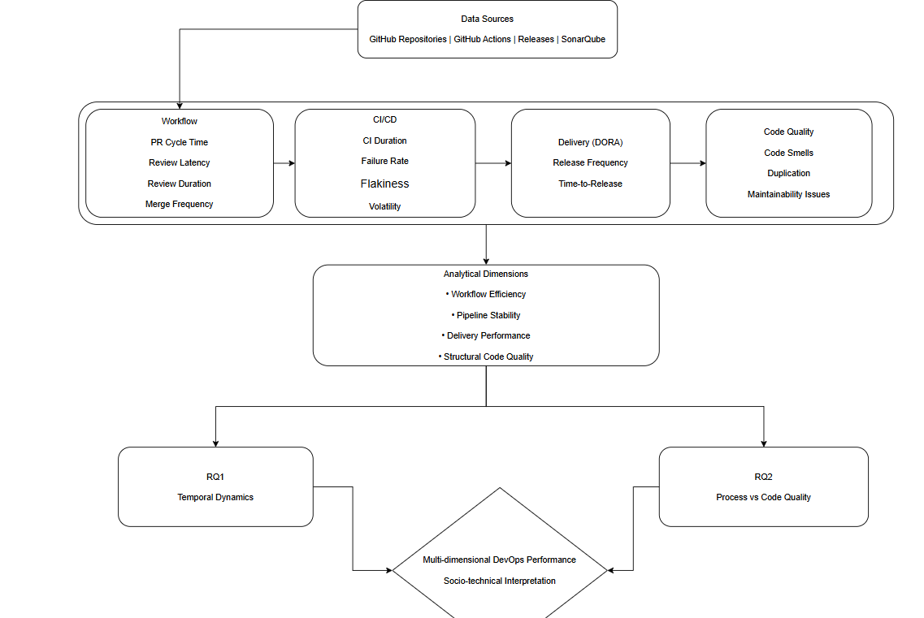
Figure 4. Conceptual research framework of the study.

A multi-case study design is employed to support comparison across projects with different CI/CD configurations and development characteristics. Analyzing multiple repositories enables the examination of variation in workflows, pipeline performance, and delivery practices across heterogeneous DevOps environments, as well as temporal analysis within individual projects.
Through this approach, the study seeks to observe patterns in development workflows, CI/CD pipeline performance, and software delivery activity across open-source DevOps projects.

4.2 Case Study Selection
The projects included in this study were selected from publicly available GitHub repositories using a purposeful sampling strategy. The selection focused on repositories that are well-suited for analyzing development workflows, CI/CD pipeline behavior, and delivery activity in DevOps-oriented environments.
The selection criteria ensured that the chosen repositories exhibit sufficient development activity and provide the necessary data for empirical analysis. Specifically, the repositories were required to demonstrate sustained development activity, use pull-request-based collaboration, employ automated CI pipelines through GitHub Actions, and provide release histories suitable for delivery analysis. In addition, the projects were required to have sufficient scale and community activity to support consistent observation.
To support comparative analysis, variation in CI/CD adoption patterns and pipeline configurations was also considered during the selection process. This allows the study to examine differences in workflow structure, pipeline behavior, and delivery practices across repositories with heterogeneous automation characteristics.
The use of GitHub repositories enables access to development artefacts such as pull requests, CI/CD workflow executions, and release events, which form the empirical basis for the analysis conducted in this study.

4.3 Case Study Projects
This study analyzes three large open-source repositories hosted on GitHub: prometheus/prometheus, docker/cli, and tektoncd/pipeline. The repositories were selected to represent different CI/CD configurations while maintaining comparability in terms of project scale, development activity, and relevance to DevOps practices.
The selected cases were chosen to reflect variation in CI/CD configurations based on observable repository characteristics and project documentation. Specifically, the study includes repositories that differ in their use of CI-based validation workflows, delivery-related automation, and pipeline complexity.
Analyzing multiple repositories with different CI/CD characteristics supports cross-project comparison and reduces the likelihood that observed patterns are specific to a single project context.
Table 1 provides an overview of the repositories included in the study.

Tabell 1. Case Study Repositories
Repository | Organization | Project Domain | CI/CD Characteristics
prometheus/prometheus | Prometheus | Monitoring and observability system | CI + delivery-related automation
docker/cli | Docker | Container management tooling | CI-only workflows
tektoncd/pipeline | TektonCD | Cloud-native CI/CD framework | Infrastructure-heavy CI pipelines

Prometheus
Prometheus is a widely used open-source monitoring and alerting system and a core project within the Cloud Native Computing Foundation (CNCF). The repository is characterized by high development activity, a structured pull-request-based workflow, and extensive use of automated CI/CD pipelines implemented through GitHub Actions.
In addition to pull-request-based validation workflows, the repository includes automation triggered by push events, representing delivery-related processes within the scope of this study. This distinguishes Prometheus as a case that integrates both CI and delivery-oriented automation.
The repository provides data for analyzing workflow-related metrics such as pull request cycle time, review latency, and merge frequency, as well as pipeline-related indicators including execution duration, failure rates, and delivery cadence.
Due to its scale and development activity, Prometheus represents a mature DevOps-oriented project suitable for analyzing interactions between workflow dynamics and CI/CD pipeline behavior.

Docker CLI
Docker CLI is the command-line interface for the Docker platform and represents an application-level repository with sustained development activity and community involvement. The project follows a pull-request-based workflow and employs automated CI pipelines for validation and testing.
In contrast to Prometheus, the observed GitHub Actions workflows are triggered exclusively by pull requests and are limited to pre-merge validation. No post-merge or delivery-oriented automation workflows were identified.
This configuration represents a CI-only environment, enabling analysis of workflow behavior and pipeline performance in the absence of delivery-oriented automation.

TektonCD Pipeline
Tekton Pipelines is an open-source framework for building and managing CI/CD pipelines in Kubernetes environments. The tektoncd/pipeline repository represents the development of CI/CD infrastructure rather than an application system.
The repository is characterized by complex CI workflows, including pull-request-triggered pipelines as well as scheduled and infrastructure-oriented workflows implemented through GitHub Actions. These pipelines typically exhibit longer execution times and higher variability compared to the other cases.
Pipeline failures in this context may be influenced by infrastructure dependencies and interactions with distributed systems, rather than solely by code-level changes.
Including this repository extends the empirical scope to infrastructure-oriented environments and supports analysis of pipeline stability, execution variability, and retry behavior under more complex operational conditions.

4.4 Data Sources
The empirical analysis in this study is based on data extracted from GitHub repositories and associated development tools. The dataset was collected in January 2026 and covers an observation window of approximately 750 days prior to the collection date, corresponding to the period from January 2024 to January 2026. This period provides sufficient development history for analyzing temporal patterns in workflows, pipeline executions, and delivery activity.
The primary data sources include:
- Pull request metadata and review interactions, capturing code integration processes and contributor collaboration. These data are used to compute workflow-related metrics such as pull request cycle time, review latency, and review duration.
- GitHub Actions workflow execution records, providing information about CI/CD pipeline runs, including execution duration, outcomes, and triggering events. These data support analysis of pipeline-related metrics such as execution time, failure rates, and stability.
- Release and tag information, representing observable delivery events and enabling analysis of release frequency and delivery-related metrics.
- Repository activity metadata, including commit activity and contributor participation, providing contextual information about development intensity and project activity.
- Static analysis indicators derived from SonarQube, providing measurements of code quality and maintainability characteristics.
Together, these data sources provide a structured empirical basis for analyzing workflow behavior, pipeline performance, delivery activity, and code quality across the selected repositories.

4.5 Use of GitHub Repository Data
In this study, GitHub repository data are used as observable proxies for analyzing engineering workflows, CI/CD pipeline behavior, and delivery activity in open-source software projects. Rather than relying on proprietary operational telemetry or internal development tools, the study examines publicly accessible repository artefacts that record development and automation events throughout the software lifecycle.
Pull request metadata and review events are used to operationalize workflow-related aspects of development, including code integration activity, review responsiveness, and collaboration patterns among contributors. GitHub Actions workflow records are used to analyze CI pipeline behavior through observable execution traces such as run duration, execution outcomes, and triggering events. Release and tag information are used as repository-based indicators of delivery activity and release cadence across projects.
These artefacts do not represent complete development or operational processes, but provide partial, observable traces of activity within the repository environment. As a result, the constructed metrics should be interpreted as approximations of underlying processes rather than direct measurements.
Through this approach, GitHub repository artefacts function as empirically observable traces of development and delivery processes. Their use enables the construction of workflow, pipeline, and delivery metrics that can be analyzed consistently across repositories within a common repository-mining framework.

4.6 Metric Definitions and Operationalization
The study operationalizes a set of metrics derived from repository artefacts and CI/CD pipeline execution logs. These metrics are used to capture observable aspects of development workflows, pipeline performance, and software delivery processes. For analytical clarity, the metrics are grouped into four categories.

4.6.1 Engineering Workflow Metrics
These metrics describe the dynamics of pull request processing and code review activity.
- Pull Request Cycle Time
The elapsed time between pull request creation and completion, where completion is defined as merge if the pull request is merged and closure otherwise. This metric reflects the overall duration of the integration process.
- Review Latency
The elapsed time between pull request creation and the first recorded review-related event. This metric indicates how quickly feedback is initiated.
- Review Duration
The elapsed time between the first recorded review event and pull request completion. This metric reflects the duration of the review and revision phase following the initiation of reviewer feedback.
- Merge Frequency
The number of pull requests merged within a defined aggregation interval. This metric represents the rate of code integration over time.

4.6.2 Process-Based Development Indicators
These metrics capture characteristics of development activity that may influence workflow efficiency and coordination effort.
- Pull Request Churn
The total number of lines added and deleted within a pull request. This metric represents the magnitude of code changes associated with the proposed contribution.
- Review Overhead
The total number of review-related interactions associated with a pull request, including review events and review comments. This metric serves as an indicator of coordination effort during the review process.

4.6.3 CI Pipeline Metrics
These metrics describe the behavior and performance of CI pipelines based on GitHub Actions workflow execution data.
- CI Duration
The elapsed time between the recorded start and completion of a workflow run. This metric represents the pipeline execution time of CI workflows.
- CI Failure Rate
The proportion of workflow runs within a defined aggregation interval that terminate with a failed outcome relative to the total number of workflow runs in the same interval.
- CI Flakiness
A proxy indicator of pipeline instability based on repeated workflow executions associated with the same code change or commit. Such repeated runs for the same commit are interpreted as potential indicators of unstable or unreliable CI behavior.
- Failure Volatility
The temporal variation in CI failure occurrence across aggregation intervals. This metric captures fluctuations in pipeline stability over time.

4.6.4 Delivery Metrics
These metrics capture observable aspects of software delivery activity.
- Release Frequency
The number of release events observed within a defined aggregation interval. This metric represents delivery cadence over time.
- Time-to-Release
The elapsed time between pull request merge and the subsequent observed release event. This metric indicates how quickly integrated changes become part of an official release.

4.6.5 SonarQube-based Code Quality Indicators
In addition to repository-derived metrics, static code quality indicators are obtained from SonarQube analysis results. These indicators include maintainability-related issues (code smells), code duplication, and remediation-related metrics, which are commonly used as proxies for code-level technical debt.
These metrics capture structural characteristics of the codebase and provide a complementary perspective to workflow and pipeline-related indicators. In this study, SonarQube metrics are interpreted as observable indicators of maintainability and potential technical debt rather than direct measurements of overall software quality.

Each metric is computed from observable timestamps, event records, and metadata extracted from pull request histories, review events, workflow execution logs, and release records. These operational definitions provide a consistent basis for analyzing workflow dynamics, pipeline performance, and delivery activity across the selected repositories.

4.7 Data Processing and Aggregation
The collected data were processed using automated Python scripts developed for this study. Separate scripts handled different stages of the data pipeline, including data extraction, metric computation, and aggregation.
The data processing procedure consisted of four main steps. First, raw repository data were extracted from GitHub repositories and GitHub Actions workflow logs using the GitHub API and locally stored repository datasets. These data included pull request metadata, review events, workflow execution records, and release information.
Second, the collected data were cleaned and filtered to remove incomplete, inconsistent, or irrelevant records. This included handling missing timestamps, excluding cancelled workflow executions, and filtering pull requests that lacked sufficient metadata for metric computation.
Third, derived metrics were calculated according to the operational definitions described in Section 4.6. These metrics were computed from observable timestamps, workflow execution records, and pull request metadata.
Finally, development events and derived metrics were aggregated into time-based intervals to support temporal analysis of development activity, CI/CD pipeline behavior, and release processes. The aggregated datasets were subsequently used for repository-level analysis and cross-project comparison.

4.8 Data Analysis Approach
The analysis focuses on examining development workflows, CI/CD pipeline performance, and software delivery activity across the selected repositories.
The study employs descriptive statistical analysis and exploratory data analysis techniques to examine variations in development metrics and CI pipeline behavior. The analysis is conducted both at the repository level and across repositories to identify similarities and differences in development practices and CI/CD performance.
At the repository level, temporal analysis is used to examine how workflow activity, pipeline execution behavior, and release activity evolve over time. Aggregated metric values are analyzed across time intervals to identify trends and fluctuations in development and pipeline dynamics.
Across repositories, the analysis compares development workflows, CI pipeline characteristics, and delivery activity between projects with different CI/CD configurations. This cross-project comparison enables the study to examine how differences in automation practices and development environments relate to observable variations in workflow and pipeline metrics.
Specifically, the analysis investigates:
- cross-project differences in workflow metrics
- temporal patterns in pipeline execution and release activity
- variations in CI pipeline stability and execution performance
Visualizations and summary statistics are used to support the interpretation of observed patterns and trends in the aggregated datasets.
The objective of the analysis is to identify observable patterns in development processes rather than to establish causal relationships between variables.

4.9 Validity Considerations
This study considers threats related to construct validity, internal validity, external validity, and reliability (Wohlin et al., 2012).
4.9.1 Construct Validity
Construct validity concerns whether the metrics used in the study accurately represent the development processes and concepts under investigation. In this study, several measures are derived from repository artefacts and CI/CD workflow logs and therefore function as observable proxies rather than direct representations of all aspects of software delivery performance. For example, release frequency is used as an indicator of delivery activity, while pull request cycle time, review latency, and review duration represent workflow-related aspects of integration and review processes. Similarly, CI pipeline measures such as execution duration, failure rate, flakiness, and failure volatility capture observable pipeline behavior but do not fully represent the overall operational performance of the system. SonarQube-derived indicators provide structured measurements of maintainability-related code quality but do not capture all dimensions of technical debt or broader software quality characteristics.
To mitigate construct validity threats, the study relies on repository artefacts and metric types that have been widely used in empirical software engineering research and explicitly treats the selected indicators as repository-based operationalizations of broader development and delivery concepts.
4.9.2 Internal Validity
Internal validity concerns whether the observed patterns in the data may be influenced by factors not directly observable in repository data. In repository mining studies, workflow and pipeline metrics may be affected by factors such as project governance structures, contributor experience, team size, or coordination activities occurring outside the repository platform. Likewise, temporal variation in workflow or CI/CD metrics may reflect shifts in release practices, contributor composition, or project activity over time rather than changes in development efficiency alone. In addition, pipeline failures may result from infrastructure instability, dependency issues, or environmental conditions rather than changes in the source code.
To reduce internal validity threats, the study adopts a descriptive and exploratory analytical design and avoids causal claims regarding relationships between workflow metrics, pipeline behavior, delivery activity, and code quality indicators.
4.9.3 External Validity
External validity refers to the extent to which the findings can be generalized beyond the analyzed cases. This study examines three open-source GitHub repositories that represent different DevOps-oriented development contexts, including application-level systems and infrastructure-oriented pipeline software. The inclusion of multiple repositories with different CI/CD configurations strengthens the diversity of the empirical context and supports analytical comparison across heterogeneous projects.
However, the selected repositories represent only a limited subset of open-source DevOps environments. The findings are therefore most directly relevant to active open-source projects that use pull-request-based collaboration and repository-visible automation practices. Generalization to proprietary software projects, alternative CI/CD platforms, or organizations with different development processes should therefore be made with caution. Future studies involving additional repositories or industrial environments could further strengthen the generalizability of the findings.
4.9.4 Reliability
Reliability concerns the reproducibility of the research process and the extent to which the study can be replicated by other researchers. In this study, the underlying repository artefacts and CI/CD workflow records are publicly accessible, and the data extraction and processing procedures are based on automated scripts developed for systematic collection, cleaning, metric computation, and aggregation. In addition, the metric definitions and data processing steps are explicitly documented in the methodology chapter. These practices improve transparency and support replication of the analytical procedure, although exact reproduction may be affected by repository evolution and data availability over time.

Chapter 5
This chapter presents the empirical results of the study, structured around the two research questions. The analysis captures both temporal patterns within repositories and cross-project differences across workflow dynamics, CI pipeline behavior, delivery activity, and code quality indicators.
Rather than representing a single dimension of performance, the results reflect multiple complementary aspects of software delivery processes. The findings highlight how development workflows, automation behavior, and structural code properties vary both over time and across projects, providing an empirical basis for examining their relationships in practice.

5.1 Results for RQ1: Temporal Evolution of Development Workflows and Delivery Activity
This section presents the results related to RQ1, which examines how development workflows, CI pipeline behavior, and delivery-related indicators evolve over time in the analyzed repositories. The results are organized into three groups of metrics: workflow dynamics, CI pipeline behavior, and delivery activity.

5.1.1 Workflow Dynamics Over Time
This subsection presents the temporal evolution of pull-request-based workflow metrics across the selected repositories. The analysis examines integration speed, review responsiveness, review processing time, and merge throughput, providing a multi-dimensional view of how code changes move through the integration process.

Pull Request Cycle Time
Pull request cycle time captures the total time from pull request creation to completion and represents an end-to-end measure of integration speed. As shown in Figures 5 and 6, the repositories exhibit distinct patterns in both magnitude and temporal behavior.
Docker/cli maintains consistently low cycle times with limited fluctuation across the observation period, indicating a stable and predictable integration process. In contrast, prometheus/prometheus displays higher cycle times combined with sustained periods of elevated values, reflecting slower and less consistent pull request completion. Tektoncd/pipeline shows the most irregular pattern, with sharp spikes and rapid shifts between low and high values, indicating unstable integration dynamics.
Taken together, docker/cli exhibits both faster and more temporally stable pull request completion, while prometheus/prometheus—and especially tektoncd/pipeline—exhibit longer and more variable integration patterns.
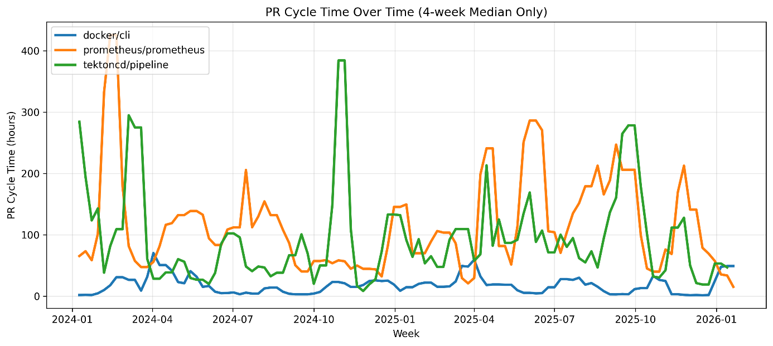
Figur 5. PR cycle time over time across repositories.
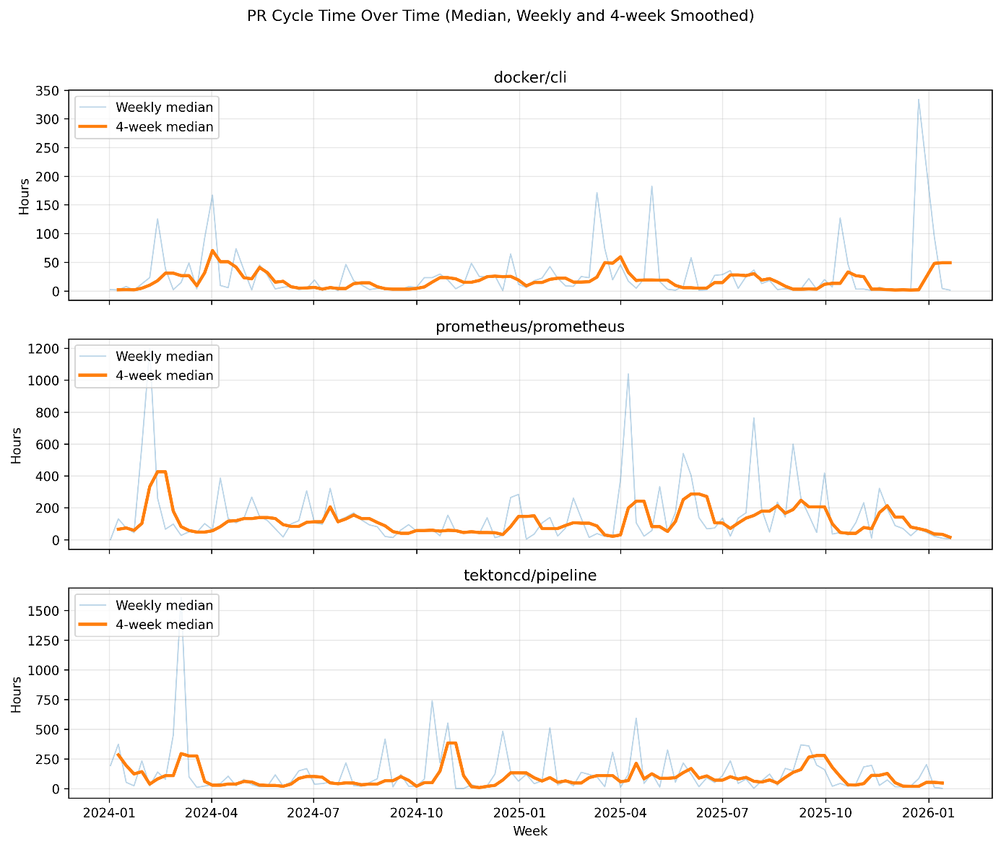
Figur 6. PR cycle time over time per repository

Review Latency
Review latency measures the time between pull request creation and the first review activity and reflects how quickly review processes are initiated. As illustrated in Figures 8 and 9, the repositories exhibit clear differences in both level and temporal behavior.
Docker/cli consistently exhibits low review latency, with values remaining close to zero for most of the observation period, indicating rapid and consistent review initiation. Prometheus/prometheus shows higher latency levels and noticeable temporal variation, including multiple periods where review initiation is delayed. Tektoncd/pipeline demonstrates the highest variability, with frequent spikes indicating that some pull requests experience substantial waiting time before receiving initial review.
The distribution of review latency (Figure 8) reinforces these patterns. Docker/cli shows a low median and a narrow spread, whereas prometheus/prometheus and tektoncd/pipeline exhibit higher medians and broader distributions, indicating that review initiation is both slower and more unevenly distributed across pull requests.
Taken together, these results show that review responsiveness is consistently high in docker/cli, while prometheus/prometheus and tektoncd/pipeline exhibit slower and more variable review initiation.

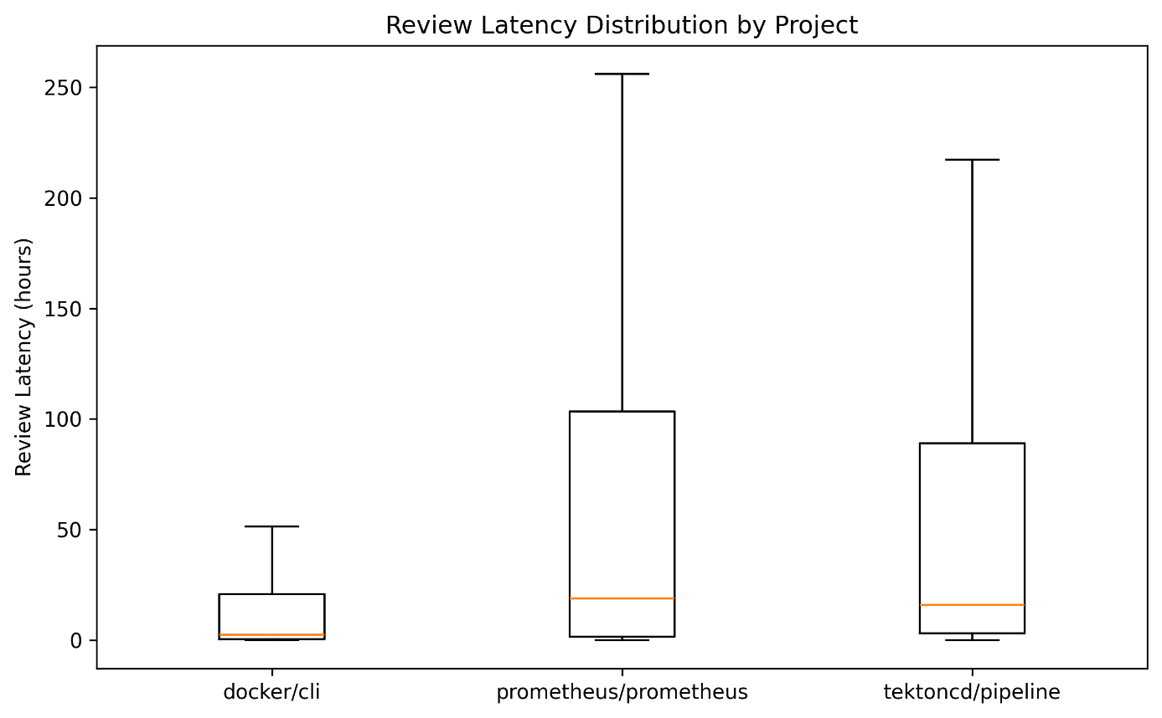
Figur 7. Review latency distribution across repositories.
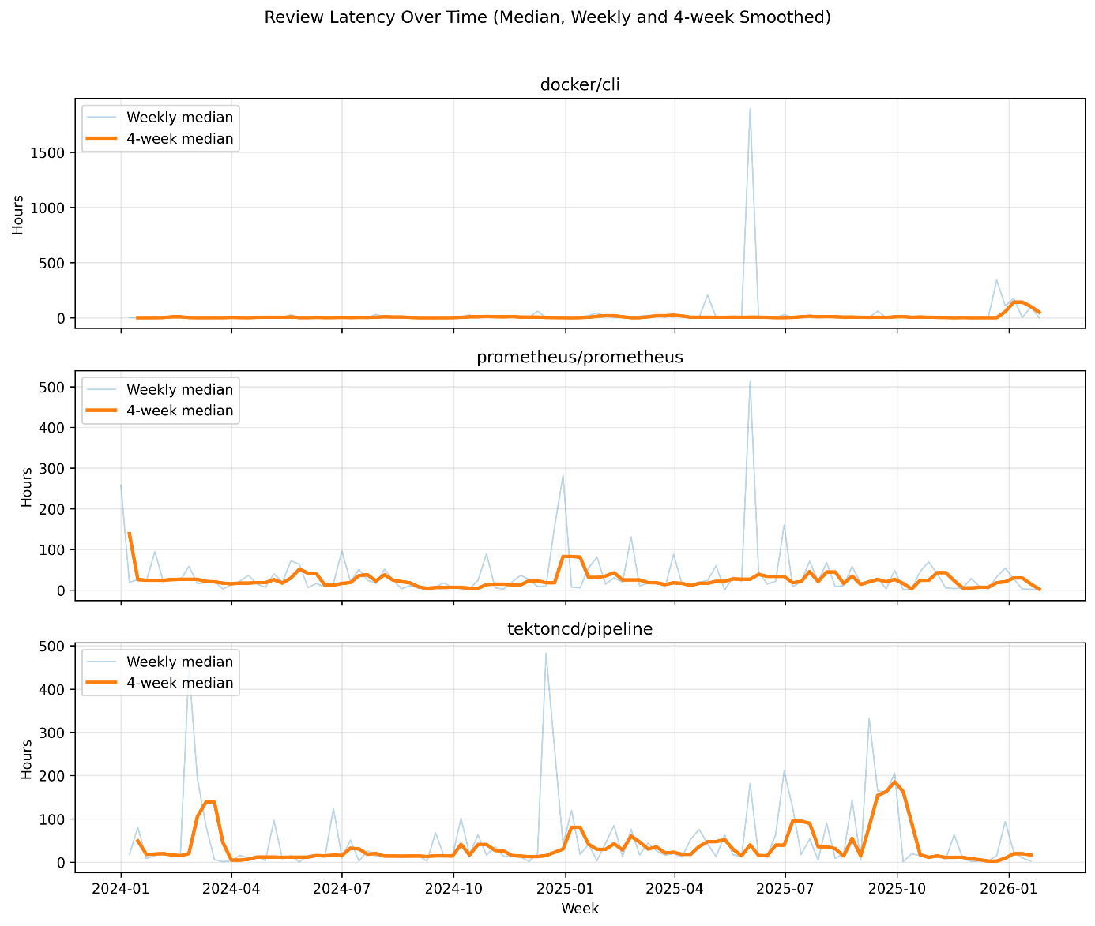
Figur 8. Review latency over time across repositories.
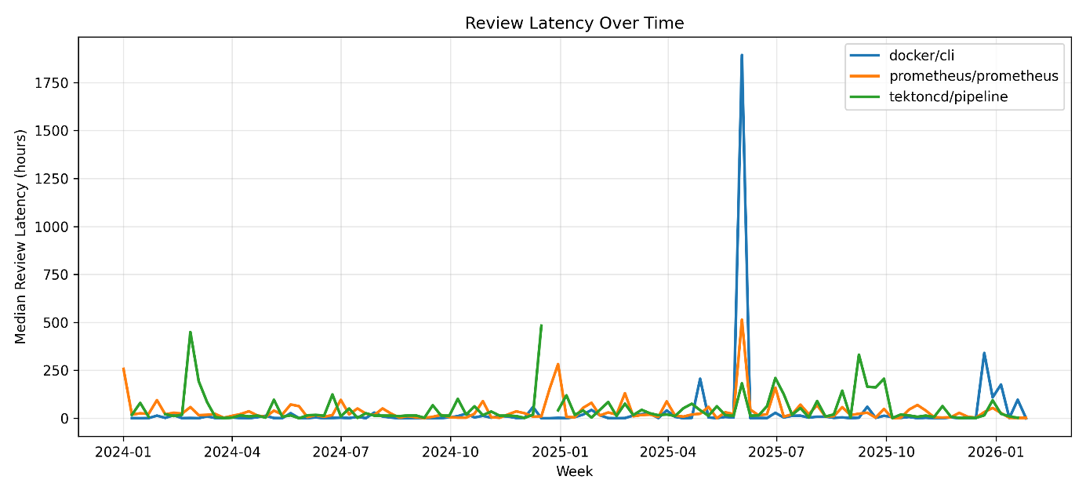
Figur 9. Review latency over time per repository.

Review Duration
Review duration captures the time between the first review activity and pull request completion, representing the processing phase of the review workflow. As shown in Figures 10 and 11, the repositories exhibit substantial differences in both level and variability.
Docker/cli maintains consistently low review duration, indicating that pull requests are processed and completed with limited review overhead. Prometheus/prometheus exhibits higher and more variable durations, including periods where review activity extends significantly, suggesting repeated iterations or coordination effort before completion. Tektoncd/pipeline shows the most pronounced fluctuations, with frequent spikes indicating substantial variation in review duration across pull requests.
Taken together, these patterns show that, beyond differences in review initiation, repositories also differ in how long pull requests remain in the review phase. Docker/cli maintains a consistently short processing phase, while tektoncd/pipeline exhibits the least predictable behavior.

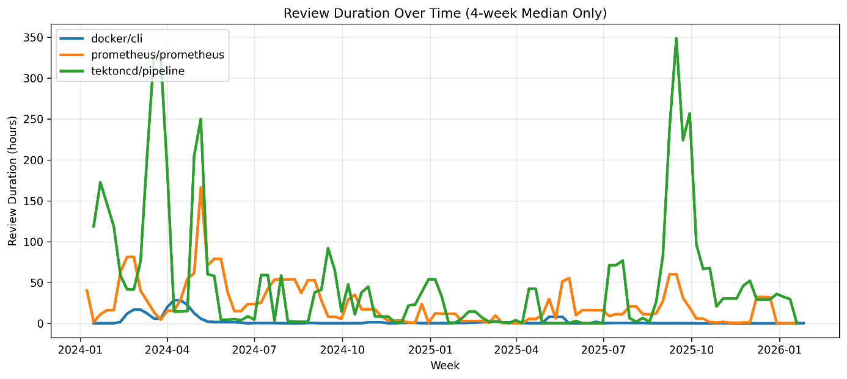
Figur 10. Review duration over time across repositories (4-week median).
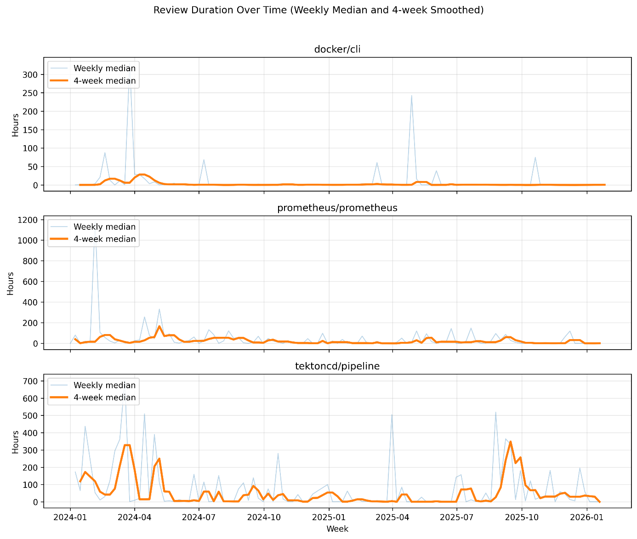
Figur 11. Review duration over time per repository (weekly median and 4-week median).

Merge Frequency
Merge frequency captures the number of pull requests merged per week and reflects integration throughput over time. As shown in Figures 12 and 13, the repositories differ in both the level and temporal consistency of merge activity.
Prometheus/prometheus maintains the highest merge frequency across large parts of the observation period, with extended intervals of elevated integration activity. Docker/cli exhibits a moderate but relatively stable merge rate, interrupted by a distinct increase in activity during late 2025. Tektoncd/pipeline shows consistently lower merge frequency, with only brief periods of increased activity.
Taken together, these results show that repository differences extend beyond integration speed to overall throughput. Prometheus/prometheus operates at a higher and more sustained level of integration activity, while tektoncd/pipeline maintains a lower and less consistent integration volume.

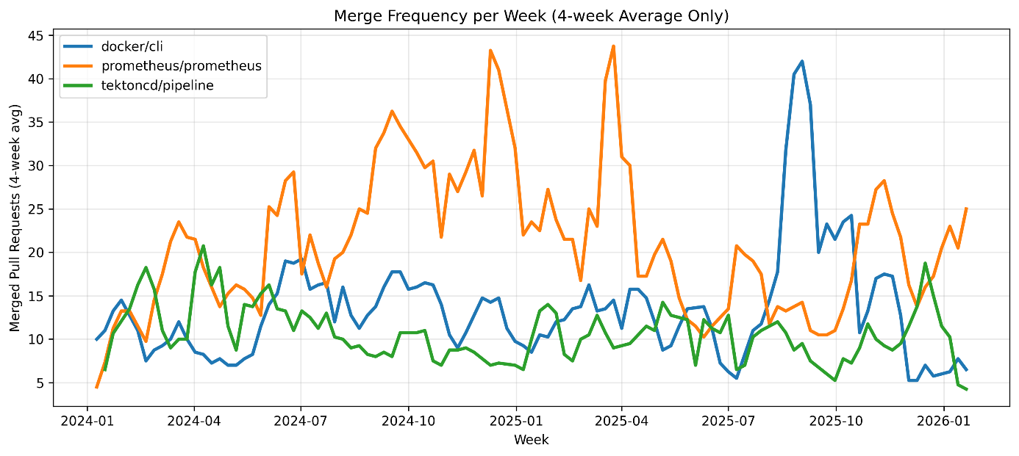
Figur 12. Merge frequency over time across repositories (4-week average).

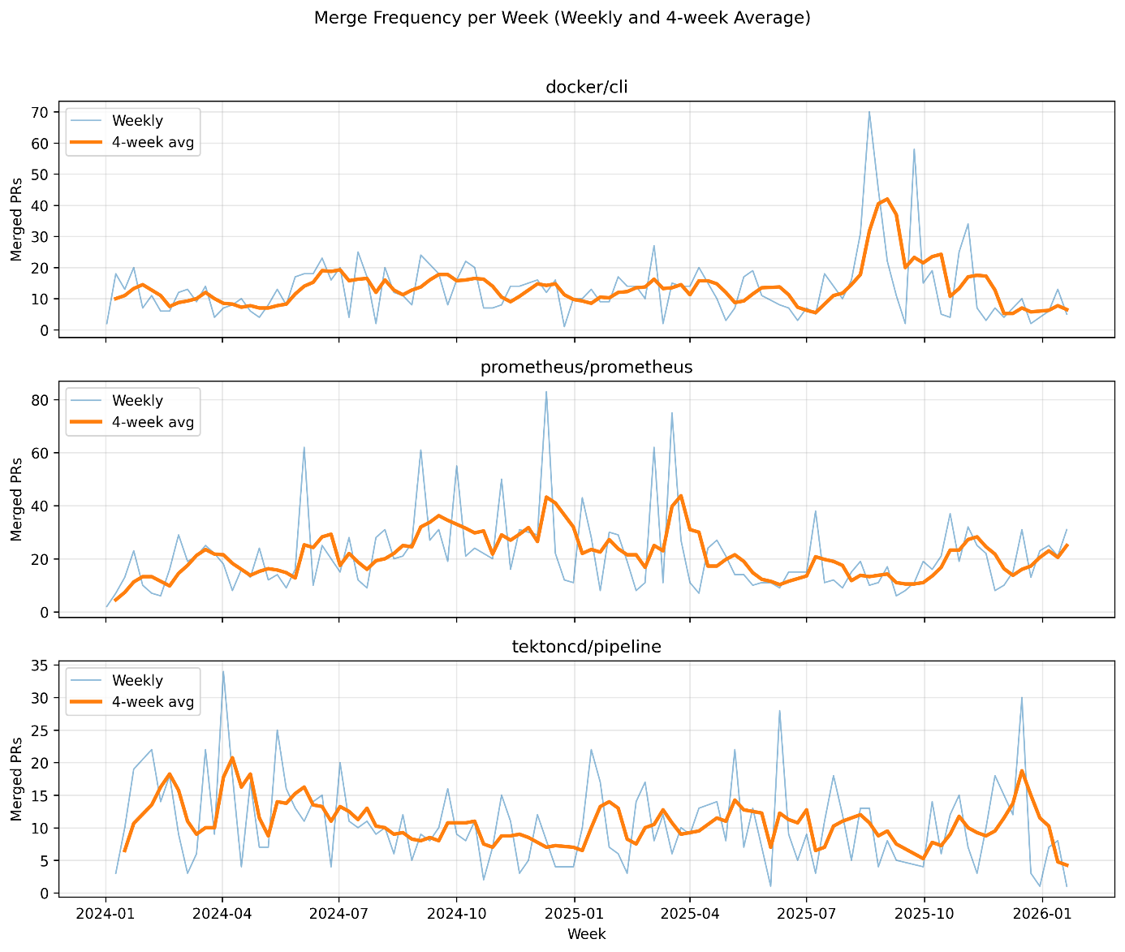
Figur 13. Merge frequency over time per repository (weekly and 4-week average).

5.1.2 CI Pipeline Behavior Over Time
This subsection examines the temporal behavior of CI pipeline performance across the repositories. The analysis focuses on indicators related to pipeline reliability, execution stability, and rerun-related behavior.
The following CI-related metrics are analyzed:

CI Failure Rate
CI failure rate is computed as the proportion of failed CI runs per week, defined as the number of runs with failure-related outcomes divided by the total number of CI runs in the same period. Failures include runs with conclusions of failure, cancelled, or timed_out. For example, a failure rate of 0.20 indicates that 20% of CI runs failed during a given week.
The analysis is based on 64,798 CI runs across the three repositories over a period of approximately 14 months, after filtering out 3,262 outliers exceeding six hours in duration.
Tektoncd/pipeline consistently exhibits the lowest failure rate, typically ranging between 0.03 and 0.12, corresponding to approximately 3–12% of CI runs failing per week. The variation over time is relatively limited, indicating a stable CI process.
Docker/cli shows higher failure rates, generally ranging between 0.10 and 0.25, with several peaks exceeding 0.30, corresponding to roughly 10–30% of CI runs failing during certain periods. The variation is more pronounced, particularly during mid to late 2025.
Prometheus/prometheus demonstrates substantial temporal variation, with failure rates fluctuating between approximately 0.10 and 0.25. The repository exhibits distinct phases of both lower and higher failure levels, indicating comparatively less stable CI behavior.

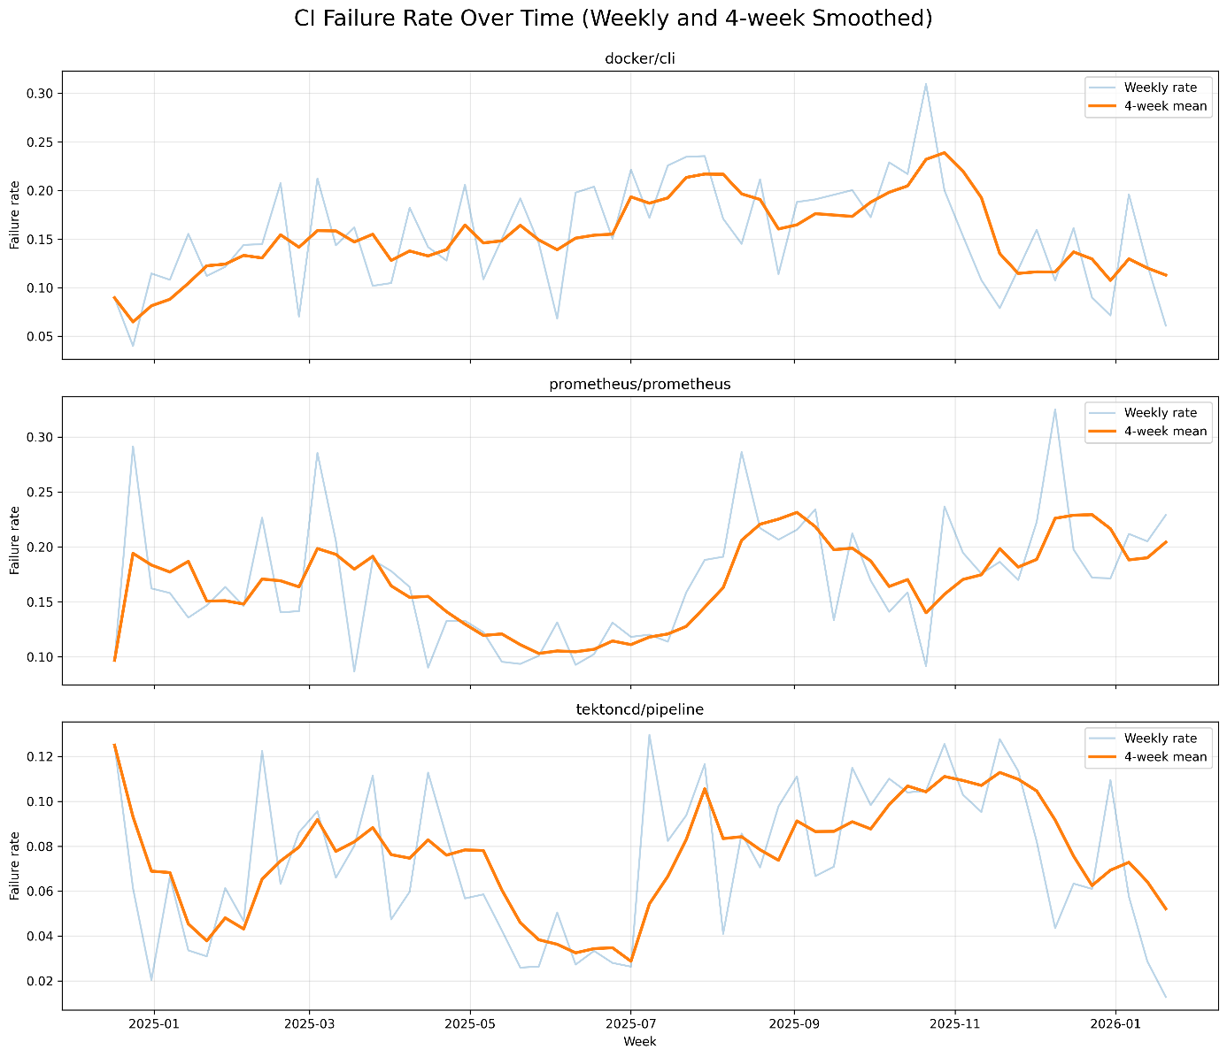
Figur 14. CI failure rate over time per repository (weekly values and 4-week smoothed mean).

CI Duration
CI duration is computed as the execution time of each CI run in minutes, measured as the time difference between the start and completion of a workflow run. Weekly values are aggregated using the median to reduce the influence of extreme values, and a 4-week rolling median is applied to capture the overall trend over time.
As shown in Figure 15, the repositories exhibit clear differences in execution time. Docker/cli maintains relatively stable CI durations, typically around 1.7–2.1 minutes, with only minor fluctuations over time, indicating a consistent and predictable pipeline execution profile.
Tektoncd/pipeline exhibits the lowest CI duration overall, generally ranging between 0.3 and 0.8 minutes. The values remain stable overall, although occasional spikes are observed. Despite these fluctuations, execution time stays consistently low compared to the other repositories.
Prometheus/prometheus shows a markedly different pattern. In the early part of the observation period, CI duration varies substantially, with several spikes exceeding 10 minutes and reaching above 20 minutes. After this initial phase, the duration stabilizes at a much lower level, typically around 0.5–1.0 minutes, and remains relatively consistent for the remainder of the period. This reflects a clear shift from highly variable to more stable pipeline execution behavior.

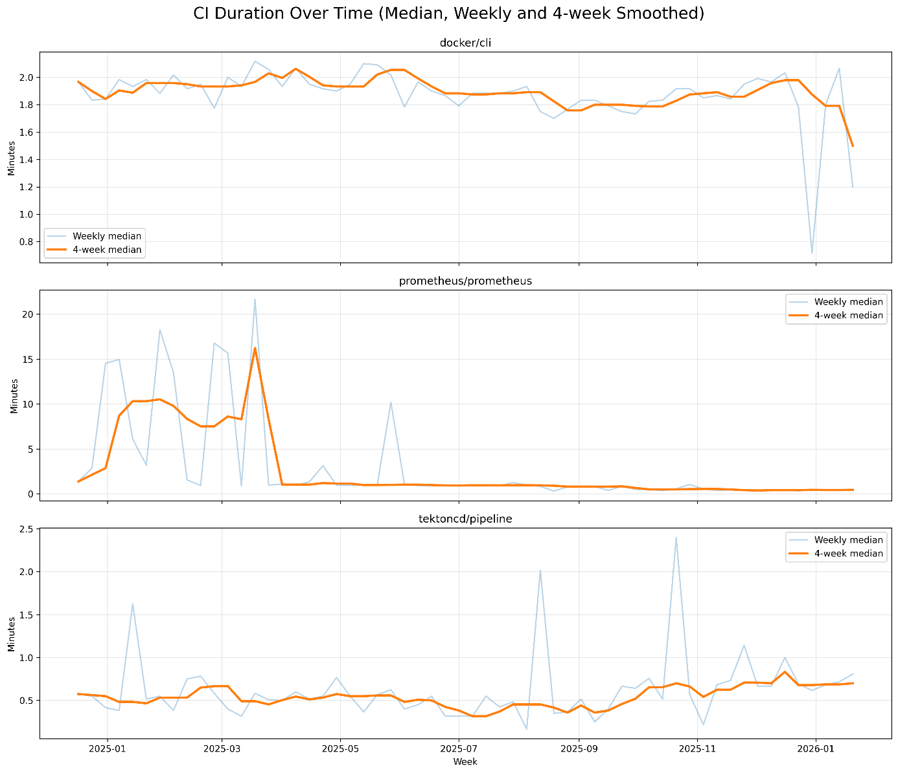
Figur 15. CI duration over time per repository (weekly median and 4-week smoothed median).

CI Flakiness
CI flakiness is approximated using a retry-based proxy, defined as the proportion of workflow executions that are repeated for the same commit, workflow, and event. Specifically, runs are grouped by commit identifier, workflow name, and event type, and a retry is identified when multiple runs occur for the same combination. The weekly flakiness value is computed as the share of such cases relative to the total number of workflow executions. A 4-week rolling mean is applied to capture the overall trend over time.
As shown in Figures 16 and 17 (combined and per-repository views), the repositories exhibit distinct patterns in retry behavior. Docker/cli maintains a moderate level of flakiness, typically around 0.08–0.12, followed by a pronounced increase toward the end of the observation period, where values exceed 0.20, indicating periods with a higher share of repeated executions.
Prometheus/prometheus generally shows lower flakiness levels, typically ranging between 0.02 and 0.10, and remains comparatively stable throughout most of the period.
Tektoncd/pipeline demonstrates a clear upward trend over time, increasing from approximately 0.03–0.06 to around 0.13–0.17, reflecting a growing proportion of workflow executions requiring retries.
A retry in this context may indicate transient failures, infrastructure instability, or non-deterministic test behavior. This interpretation is supported by the distribution of runs per workflow execution, where the median is 1 across all repositories, while higher percentiles reveal repeated executions. In particular, tektoncd/pipeline exhibits substantially higher extreme values, indicating occasional bursts of repeated runs.

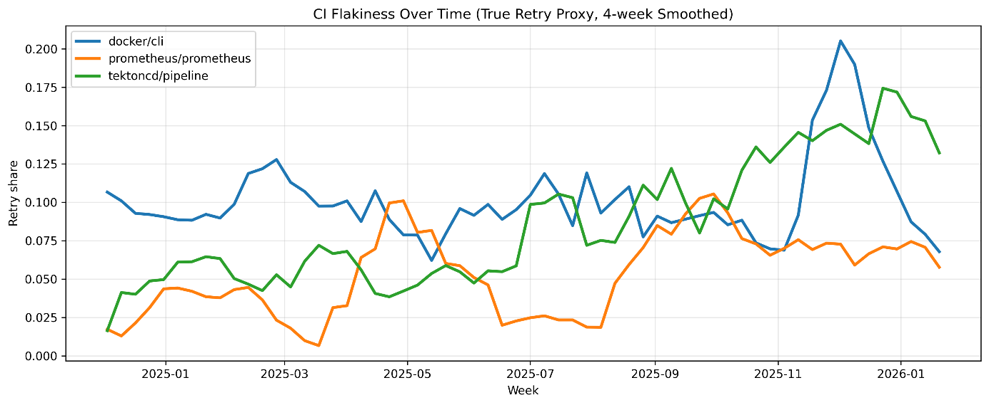
Figur 16. CI flakiness over time (retry share, weekly values and 4-week smoothed mean).
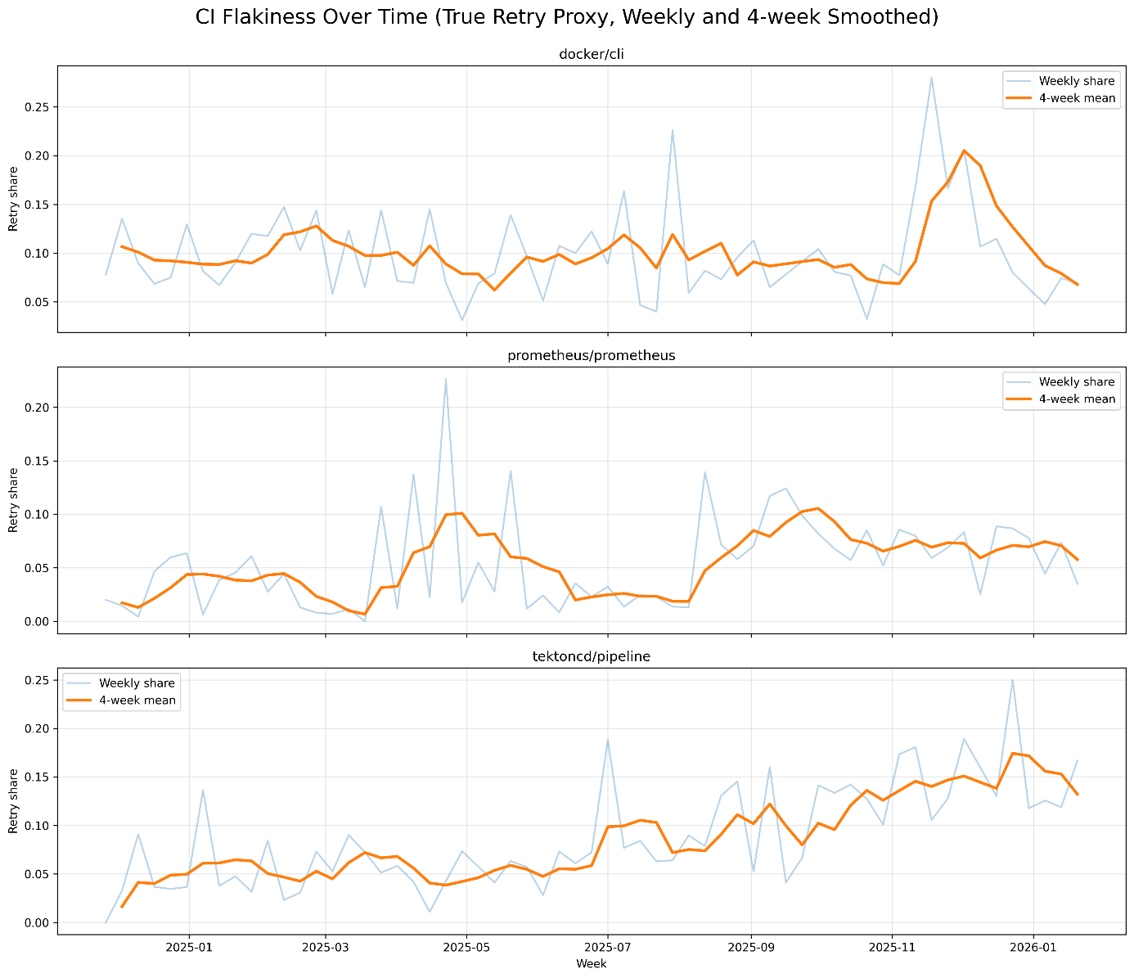
Figur 17. CI flakiness over time per repository (retry share, weekly values and 4-week smoothed mean).

CI Failure Volatility
CI failure volatility is computed as the rolling standard deviation of the weekly CI failure rate over an 8-week window. This metric captures the temporal variability of failure rates, where higher values indicate greater fluctuations in CI reliability and lower values reflect more stable behavior over time.
As shown in Figures 18 and 19 (combined and per-repository views), the repositories exhibit distinct patterns in failure rate variability. Docker/cli shows moderate volatility for most of the observation period, typically ranging between 0.03 and 0.05, followed by a pronounced increase toward late 2025, where values approach 0.08. This indicates periods of substantial fluctuation in CI reliability.
Prometheus/prometheus demonstrates high volatility in the early phase, with values around 0.06–0.08, followed by a marked decrease to approximately 0.02 during mid-2025. Toward the end of the observation period, volatility increases again to around 0.04–0.06, indicating alternating periods of stability and instability.
Tektoncd/pipeline shows a distinct pattern with initially high volatility, followed by a rapid decline to lower levels (approximately 0.01–0.03). For most of the remaining period, volatility remains comparatively low, indicating a more stable failure rate despite occasional fluctuations.
Overall, this metric highlights differences not only in failure levels but in the consistency of CI behavior over time, revealing periods where reliability is either stable or subject to significant variation.
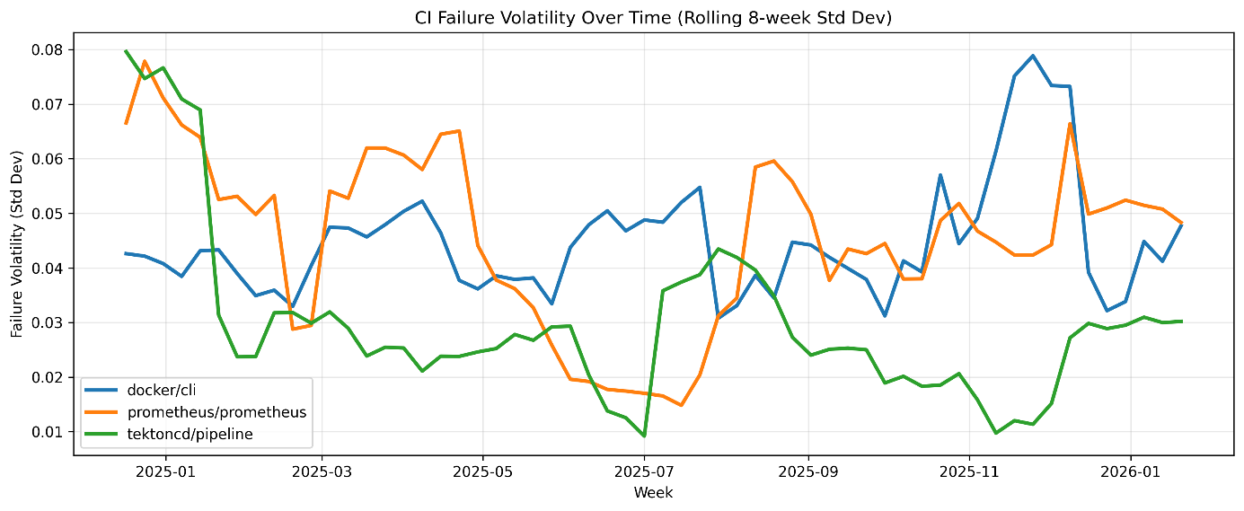
Figur 18. CI failure volatility over time (8-week rolling standard deviation, comparison across repositories)
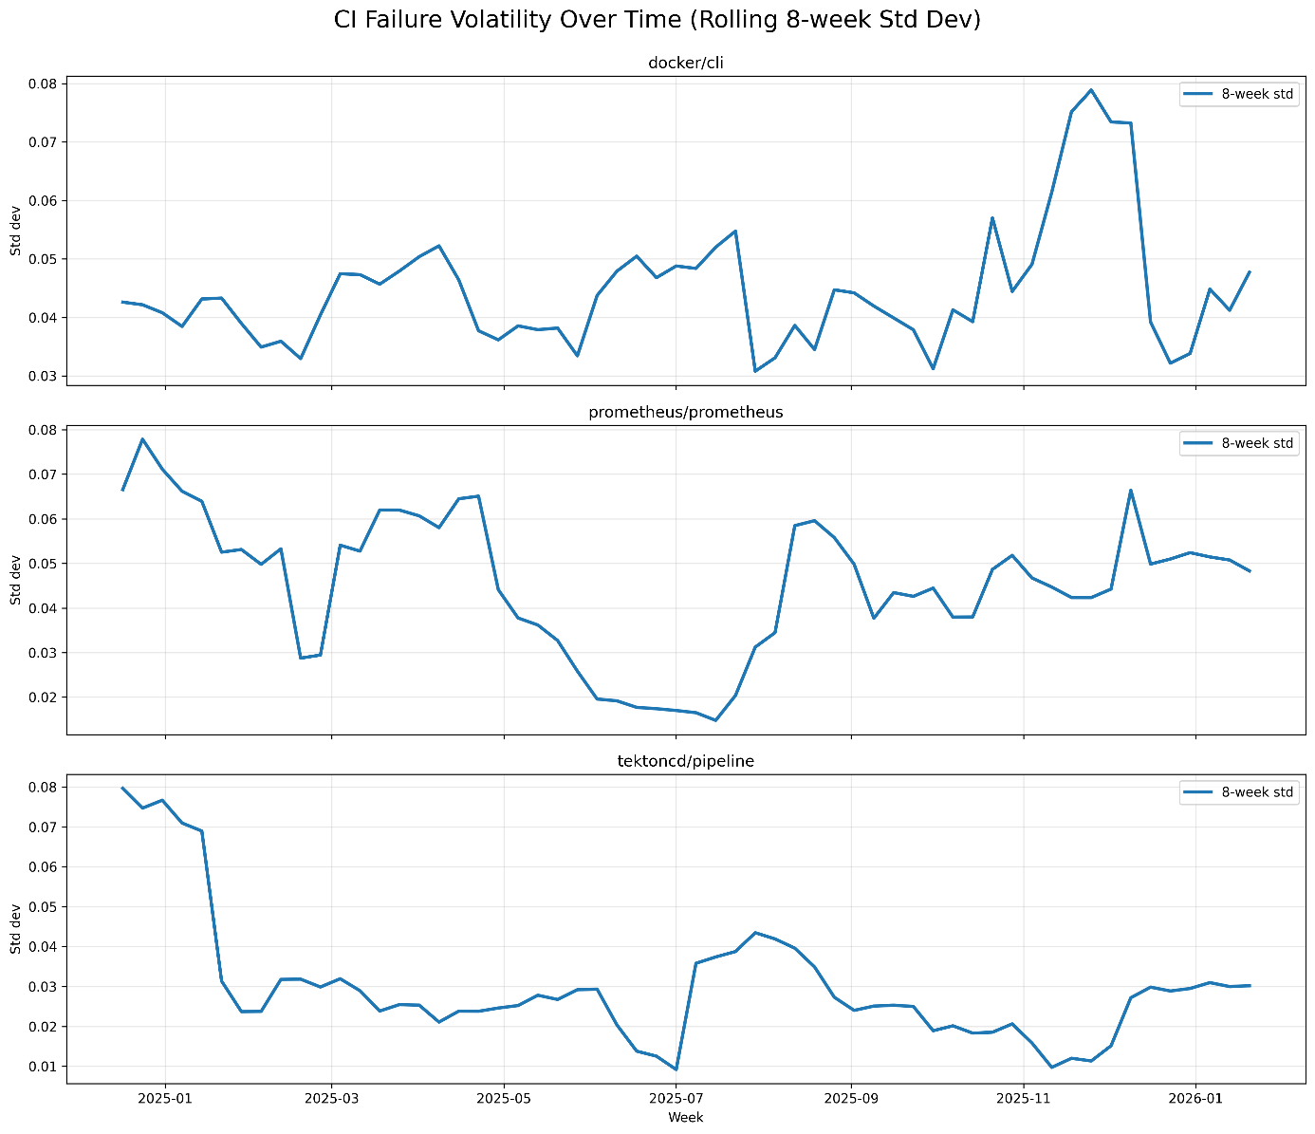
Figur 19. CI failure volatility over time per repository (8-week rolling standard deviation)

5.1.3 Delivery Activity Over Time
These metrics capture delivery activity by quantifying release frequency, the time required for changes to reach production, and the extent to which automated deployment workflows are used.
The following indicators are analyzed:
Release Frequency
Release frequency is computed as the number of releases per repository per month, based on release timestamps extracted from the release dataset. For each release, the publication timestamp was used when available; otherwise, the creation timestamp was used as a fallback. Monthly release frequency was then calculated by grouping releases by repository and calendar month and counting the number of release entries in each period .
Release frequency data was available for prometheus/prometheus and tektoncd/pipeline, but not for docker/cli in the analyzed dataset. As a result, this part of the analysis is limited to the two repositories for which release records were available.
As shown in Figure 20, the two repositories exhibit different temporal patterns in release activity. Tektoncd/pipeline shows relatively high release frequency during much of 2024, with several months reaching between 4 and 6 releases. However, release activity declines noticeably during 2025, with multiple months showing only 1–2 releases.
Prometheus/prometheus exhibits a more irregular release pattern across the observation period. Monthly release counts typically range between 1 and 6, with repeated fluctuations rather than a stable cadence. Several local peaks are visible, but these are interspersed with months of lower release activity, indicating a less consistent release rhythm over time.
Taken together, the results show that release cadence differs not only in magnitude but also in temporal development. Tektoncd/pipeline exhibits a clear shift from higher to lower release activity, while prometheus/prometheus maintains a more irregular release pattern over time.

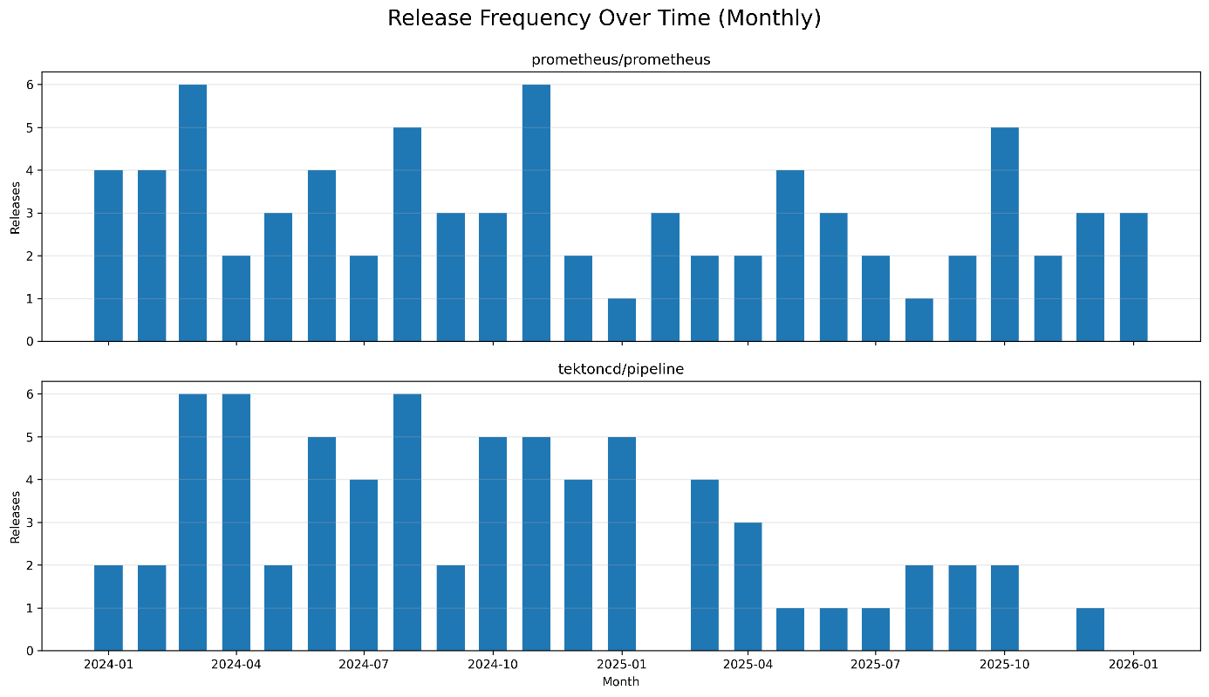
Figur 20. Monthly release frequency per repository.

Time-to-Release
Time-to-Release was computed as the elapsed time between the merge timestamp of a pull request and the timestamp of the next release in the same repository. For release timestamps, the publication time was used when available; otherwise, the release creation time was used. The metric was then aggregated monthly using the median in order to reduce the influence of extreme values. Repositories without release events in the dataset were excluded from the analysis; accordingly, docker/cli is not computable for this metric.
As shown in Figures 21 and 22, prometheus/prometheus and tektoncd/pipeline exhibit clearly different temporal patterns. Prometheus/prometheus maintains a relatively moderate and stable Time-to-Release, with monthly median values generally falling between approximately 2 and 10 days, despite one pronounced peak around January 2025 reaching nearly 20 days. This suggests that merged changes in prometheus/prometheus are typically incorporated into releases within a relatively short time frame, although occasional longer delays occur.
Tektoncd/pipeline shows substantially higher variability. While some months exhibit short median times of around 1–5 days, several periods display much longer release delays, including peaks above 15 days and one extreme value exceeding 30 days around late 2024. During much of 2025, the repository remains at a consistently higher level than prometheus/prometheus, often around 10–20 days, indicating a less stable and less predictable path from merge to release.
Taken together, these results show that prometheus/prometheus follows a more consistent release path once changes are merged, whereas tektoncd/pipeline exhibits stronger month-to-month variation and more frequent periods of delayed release incorporation. In this dataset, Time-to-Release could not be assessed for docker/cli because no release events were available for matching merged pull requests to subsequent releases.
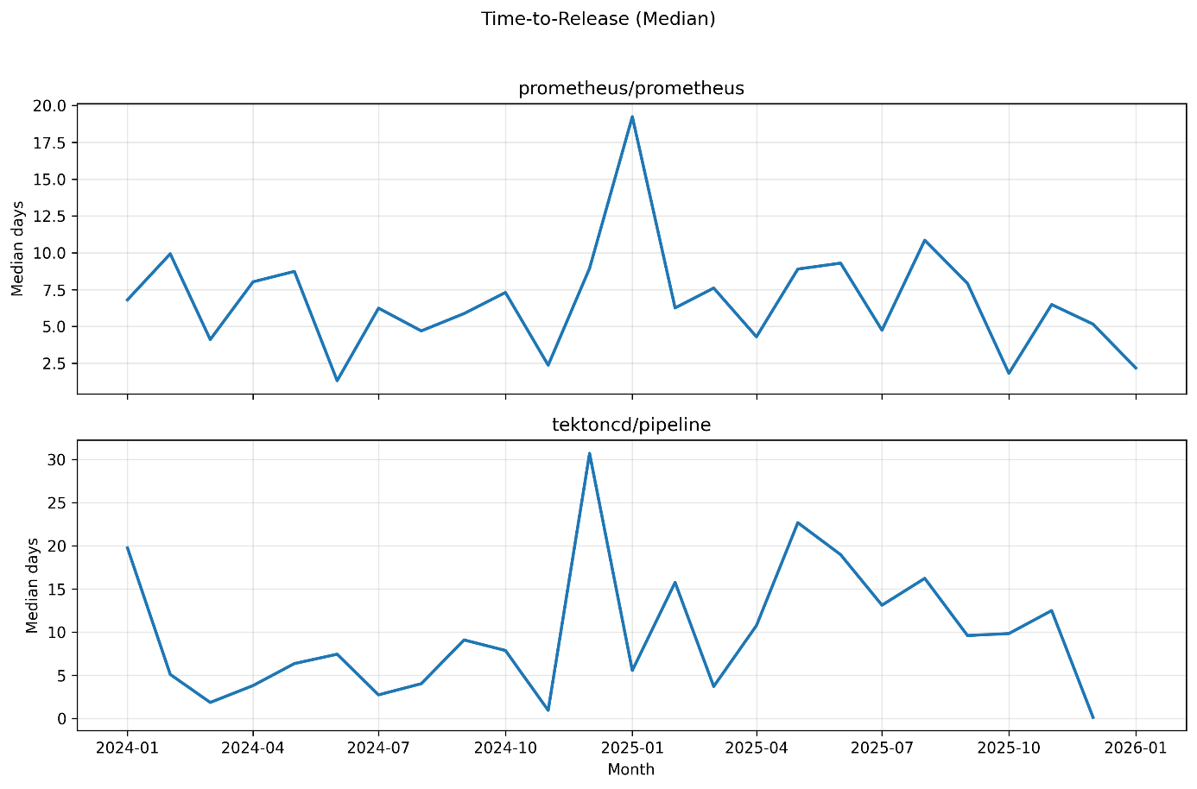
Figur 21. Median monthly Time-to-Release per repository.

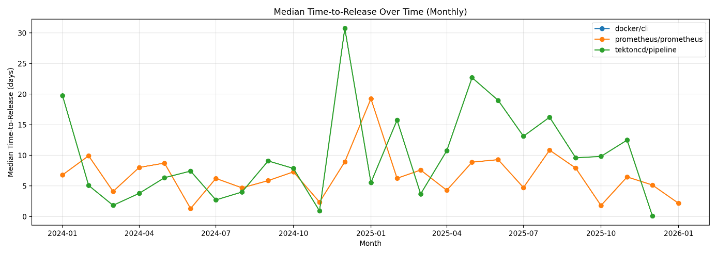
Figur 22. Median Time-to-Release over time for repositories with available release data..

CD Workflow Presence / Success
CD workflow success rate is computed as the proportion of successful workflow executions among workflows identified as deployment-related. CD workflows are approximated using a name-based filtering approach, where workflow names containing terms such as “deploy”, “release”, “publish”, “delivery”, or “cd” are classified as delivery workflows. The success rate is calculated as one minus the proportion of runs with failure-related outcomes (failure, cancelled, or timed_out).
This proxy-based approach enables the identification of delivery-related automation in the absence of explicit deployment metadata. However, it relies on naming conventions and may therefore not capture all deployment workflows or may include workflows that are not strictly related to production deployment.
As shown in Figure 23, CD workflow activity is only observed for prometheus/prometheus in the analyzed dataset. No workflows in docker/cli or tektoncd/pipeline matched the CD-related naming patterns, and these repositories are therefore excluded from this part of the analysis.
For prometheus/prometheus, the CD workflow success rate varies over time, typically ranging between approximately 0.55 and 1.00. Several periods exhibit high success rates above 0.80, indicating that most deployment-related workflows complete successfully. However, there are also intervals where the success rate drops to around 0.60, reflecting a non-negligible proportion of failed or interrupted workflow executions.
The temporal variation suggests that the reliability of deployment-related workflows is not constant over time. Periods of lower success rates indicate reduced stability in delivery automation.
Overall, the results show that observable CD activity is limited to a single repository in this dataset and that even within this repository, delivery pipeline reliability varies over time rather than remaining consistently high. These findings should therefore be interpreted with caution due to the limited coverage of CD-related workflows across repositories.

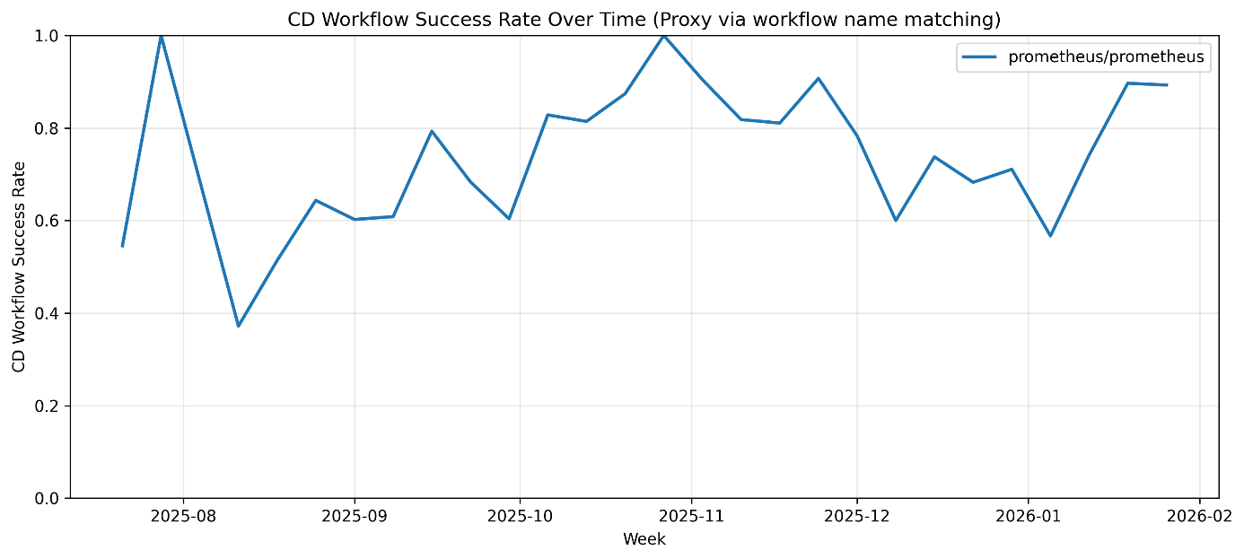
Figur 23. CD workflow success rate over time (weekly).

5.1.4 Summary of RQ1 Results
The results show that the temporal evolution of software delivery performance is reflected through multiple complementary indicators spanning development workflow, CI pipeline behavior, and delivery activity. Across the analyzed repositories, CI/CD performance emerges as a multi-dimensional phenomenon: pull-request metrics reflect integration responsiveness and workflow efficiency, CI metrics capture pipeline reliability and execution stability, while delivery metrics reflect release cadence and the delay between code integration and release availability.
Docker/cli exhibits the most stable development workflow, with consistently low pull request cycle time, short review latency, and limited review overhead. However, this workflow stability is not fully reflected in the CI layer, where higher failure rates, increasing flakiness, and rising failure volatility indicate periods of reduced pipeline reliability. In addition, the absence of release and CD workflow data means that delivery activity cannot be directly observed for this repository within the analyzed dataset.
Prometheus/prometheus shows a different pattern, combining comparatively slower and more variable workflow behavior with high merge throughput. Its CI results reveal substantial temporal variation, including periods of instability followed by more stable execution patterns, while delivery activity remains observable but irregular. Release frequency fluctuates across the period, time-to-release remains moderate but not constant, and CD workflow success varies over time. Together, these observations characterize a repository with sustained delivery activity but without a consistently stable release rhythm or uniformly reliable delivery automation.
Tektoncd/pipeline displays the strongest temporal variability across workflow and delivery dimensions. Pull-request metrics fluctuate considerably, merge throughput remains relatively low, and both release frequency and time-to-release indicate an inconsistent delivery process. At the same time, CI failure rate remains comparatively low, indicating relatively stable failure proportions. However, increasing flakiness and retry behavior point to variability in execution stability despite low failure frequency.
Taken together, the results highlight that development workflow behavior, CI pipeline characteristics, and delivery activity evolve differently over time across repositories. The observed patterns indicate that these dimensions do not necessarily change in a synchronized manner, but instead exhibit partially independent temporal dynamics.

5.2 Results for RQ2: Cross-Project Comparison of Workflow, CI/CD Behavior, and Code Quality
This section presents the results for RQ2, focusing on cross-project differences at an aggregated level. Unlike the temporal analysis in RQ1, this section examines the structural characteristics of each repository by comparing their overall workflow efficiency, CI/CD performance, and code quality indicators. The objective is to identify systematic differences between the projects and to assess whether variations in delivery performance proxies are reflected in corresponding differences in technical debt indicators derived from static analysis.

5.2.1 Cross-Project Workflow and CI/CD Comparison
This subsection compares the repositories using aggregated workflow and CI/CD metrics, capturing their overall development and integration characteristics. The analysis focuses on differences in integration efficiency, coordination effort, pipeline execution behavior, and pipeline reliability across the projects. To provide a structured comparison, the metrics are grouped into two categories: workflow-related indicators and CI/CD performance indicators. Workflow metrics reflect how efficiently changes are integrated and reviewed, while CI/CD metrics capture the behavior and stability of automated pipelines.

Workflow efficiency and coordination
This subsection examines workflow efficiency and coordination across the repositories using aggregated pull-request-based metrics. The analysis focuses on integration responsiveness, review behavior, and change characteristics, as reflected in pull request cycle time, review overhead, and pull request churn.
Tables 2 and 3 present aggregated workflow-related metrics across the three repositories. Together, these tables highlight differences in how efficiently changes are integrated and reviewed, as well as in the consistency of change size across the projects. The analysis is based on data collected between January 2024 and January 2026. The interquartile range (IQR) represents the spread of the middle 50% of the data and is used to capture variability while reducing the influence of extreme values.

Tabell 2. Aggregated workflow efficiency and review metrics.
Repository | PR Cycle |  |  | Review Overhead
 | Time (h) | IQR (h) | N | (h) | IQR (h) | N
docker/cli | 6.87 | 44.21 | 1422 | 2.48 | 20.42 | 1482
prometheus/prometheus | 51.16 | 201.77 | 2291 | 18.80 | 101.92 | 2465
tektoncd/pipeline | 36.85 | 149.94 | 1091 | 15.88 | 85.74 | 921

Tabell 3. Aggregated pull request churn across repositories
Repository | PR Churn
 | lines | IQR (lines) | N
docker/cli | 27 | 109 | 1592
prometheus/prometheus | 31 | 121 | 3336
tektoncd/pipeline | 33 | 299 | 1405

Median Pull Request Cycle Time
As shown in Table 2, the repositories exhibit substantial differences in pull request cycle time, indicating clear cross-project variation in integration responsiveness. docker/cli shows the lowest median cycle time (6.87 hours), whereas prometheus/prometheus shows the highest (51.16 hours), with tektoncd/pipeline occupying an intermediate position (36.85 hours). This indicates that pull requests are integrated significantly faster in docker/cli than in the other two repositories.
The dispersion results reinforce this difference. docker/cli exhibits a comparatively narrow interquartile range (44.21 hours), while prometheus/prometheus and tektoncd/pipeline show much wider spreads (201.77 and 149.94 hours, respectively). This indicates that pull request processing is not only slower on average in these repositories, but also substantially less consistent.
Taken together, these results indicate that the repositories differ both in integration speed and in the predictability of the integration process. docker/cli combines fast and relatively stable integration, whereas prometheus/prometheus and tektoncd/pipeline exhibit slower and more variable processing of pull requests.
These differences should, however, be interpreted with caution. The repositories differ in scale, contribution patterns, and development practices, all of which can influence pull request complexity and coordination requirements. In particular, prometheus/prometheus includes a substantially larger number of merged pull requests, which likely reflects a broader diversity of contribution types. Accordingly, the observed differences represent variations in integration behavior within the analyzed dataset rather than direct indicators of overall workflow quality.

Review Overhead
As shown in Table 2, the repositories differ substantially in review overhead, indicating clear differences in how quickly pull requests receive initial review attention. docker/cli exhibits the lowest median review overhead (2.48 hours), suggesting that pull requests are typically reviewed shortly after submission. In contrast, prometheus/prometheus shows the highest median value (18.80 hours), while tektoncd/pipeline presents slightly lower values (15.88 hours), but still substantially higher than docker/cli.
The dispersion of review overhead further reinforces these differences. prometheus/prometheus and tektoncd/pipeline exhibit much higher interquartile ranges (101.92 and 85.74 hours, respectively) compared to docker/cli (20.42 hours), indicating that the time to initial review is considerably more variable in these repositories.
Taken together, these results show that the repositories differ not only in the speed of review initiation, but also in the consistency of that response. docker/cli combines the shortest review delay with the lowest variability, whereas prometheus/prometheus and tektoncd/pipeline exhibit both slower and less predictable review initiation. This suggests that review coordination is more responsive and stable in docker/cli, while being more variable in the other two repositories.

Pull Request Churn
Pull request churn refers to the amount of code modification associated with a pull request, typically measured as the total number of lines added and deleted. In empirical software engineering research, it is commonly used as a proxy for change size and development effort.
As shown in Table 2, the median pull request churn values are similar across the repositories, with docker/cli exhibiting the lowest median (27 lines), followed by prometheus/prometheus (31 lines) and tektoncd/pipeline (33 lines). This indicates that the typical size of changes introduced through pull requests is broadly comparable across the projects.
The primary difference between the repositories lies in the variability of churn rather than in its central tendency. tektoncd/pipeline exhibits a substantially higher interquartile range (299 lines) than prometheus/prometheus (121) and docker/cli (109), indicating that change size is considerably less consistent in this repository. In other words, tektoncd/pipeline is characterized not by larger typical changes, but by a much wider spectrum of pull request sizes.
This suggests that development practices differ in how changes are structured and integrated. A wider dispersion of churn may reflect a mix of small incremental updates and larger, more complex contributions, whereas lower variability indicates more consistent decomposition of changes into similarly sized units.
Churn should not be interpreted as a direct indicator of quality or efficiency. Larger changes are not inherently problematic, but may require increased review effort and coordination. Accordingly, the observed differences are best understood as variations in change characteristics rather than as indicators of superior or inferior development practices.
This variability is further illustrated in Figure 24, which presents the distribution of pull request churn across repositories on a logarithmic scale. The y-axis represents the total number of lines added and deleted per pull request. The logarithmic scale highlights the strongly right-skewed distribution, where most pull requests are relatively small, while a limited number of large changes contribute disproportionately to overall churn.
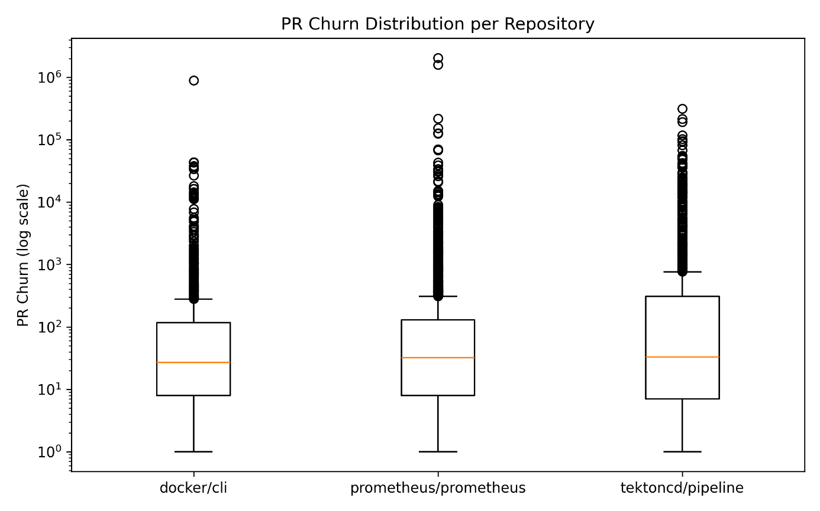
Figur 24. Distribution of pull request churn across repositories (logarithmic scale).

CI/CD performance and stability
The following analysis shifts focus from development workflow characteristics to the behavior of CI/CD pipelines. While the previous metrics capture how changes are integrated and reviewed, the following indicators reflect the execution efficiency, reliability, and stability of automated pipeline processes across the repositories.
Table 4 presents aggregated CI/CD performance and stability metrics across the three repositories, including pipeline execution duration, failure rates, and flakiness indicators. Together, these metrics provide a multi-dimensional view of pipeline behavior and execution characteristics within the analyzed projects.

Tabell 4. Aggregated cross-project comparison of CI/CD performance and stability metrics.
Repository | Median CI Duration (min) | CI Failure Rate | CI Flakiness (runs/SHA)
docker/cli | 1.93 | 0.15 | 6.84
prometheus/prometheus | 0.94 | 0.17 | 3.89
tektoncd/pipeline | 0.55 | 0.07 | 7.82

Median CI Duration
As shown in Table 4, the repositories differ in median CI duration, although the magnitude of this difference is modest compared to the variability observed in workflow metrics. tektoncd/pipeline exhibits the shortest median CI duration (0.55 minutes), followed by prometheus/prometheus (0.94 minutes), while docker/cli shows the longest duration (1.93 minutes). Thus, CI execution is fastest in tektoncd/pipeline and slowest in docker/cli within the analyzed dataset.
Importantly, CI duration does not align directly with the other CI indicators. While tektoncd/pipeline has the shortest execution time, it does not exhibit the lowest overall instability across all CI dimensions. Similarly, docker/cli has the longest duration, but not the highest failure rate. This indicates that execution speed captures a different aspect of pipeline behavior than failure frequency or retry-related instability.
Accordingly, the observed differences should be interpreted as variations in pipeline execution characteristics rather than as direct indicators of superior or inferior CI/CD performance.

CI Failure Rate
As shown in Table 4, the repositories exhibit clear differences in CI failure rates, reflecting variations in pipeline reliability and execution outcomes. tektoncd/pipeline shows the lowest failure rate (0.07), indicating that CI runs in this repository are less likely to result in failure. In contrast, prometheus/prometheus exhibits the highest failure rate (0.17), while docker/cli occupies an intermediate position (0.15).
These differences indicate that pipeline reliability varies across the repositories. Lower failure rates may reflect more stable execution environments or fewer detected issues, whereas higher failure rates may indicate more comprehensive test coverage or a greater ability to detect faults during integration.
However, failure rate should not be interpreted as a direct indicator of pipeline quality or project maturity. A higher failure rate does not necessarily imply poorer performance, as it may also indicate that the pipeline is more effective at identifying defects early in the development process.
A key observation is that the failure-rate ranking does not align with the flakiness results. tektoncd/pipeline shows the lowest failure rate but does not exhibit the lowest flakiness, while prometheus/prometheus shows the highest failure rate despite having the lowest flakiness. This demonstrates that failure frequency and retry-related instability capture different dimensions of CI behavior and should not be treated as interchangeable indicators of pipeline reliability.

CI Flakiness
CI flakiness reflects the extent to which the same code changes trigger multiple CI runs, typically due to retries caused by unstable or non-deterministic behavior in the pipeline. As shown in Table 4, the repositories differ substantially in their flakiness levels. tektoncd/pipeline exhibits the highest flakiness (7.82 runs per SHA), followed by docker/cli (6.84), while prometheus/prometheus shows considerably lower values (3.89).
These results indicate that pipeline stability varies significantly across the repositories. Higher flakiness values suggest that pipelines more frequently require repeated executions for the same commit, which may be associated with flaky tests, infrastructure instability, or non-deterministic execution environments. Lower values indicate more stable and reproducible pipeline behavior.
However, flakiness should be interpreted with caution. Higher retry counts do not necessarily imply poor engineering practices, as they may reflect deliberate mechanisms designed to mitigate transient failures. Conversely, lower flakiness values may indicate more stable pipelines, but could also result from fewer retry mechanisms being employed.
When interpreted together with the failure-rate results, the flakiness findings reinforce that CI instability is multi-dimensional. A repository may fail relatively infrequently while still requiring repeated executions for the same commit, as observed for tektoncd/pipeline, or it may fail more often while exhibiting fewer retries, as observed for prometheus/prometheus. The repositories therefore differ not only in how often pipelines fail, but also in how deterministically they execute.

5.2.2 SonarQube-Based Code Quality Comparison
This subsection compares static code quality indicators derived from SonarQube analysis across the three repositories. These indicators provide insight into structural maintainability and broader static quality characteristics by capturing maintainability-related issues, code duplication, reliability issues, and security issues. Unlike the workflow and CI/CD metrics presented earlier, these measures reflect structural properties of the codebase rather than development process behavior.
Figure 25 provides an overview of the SonarQube-based comparison of the analyzed repositories. The results show that the repositories differ substantially in their static quality profiles, even where some of the overall ratings appear superficially similar.

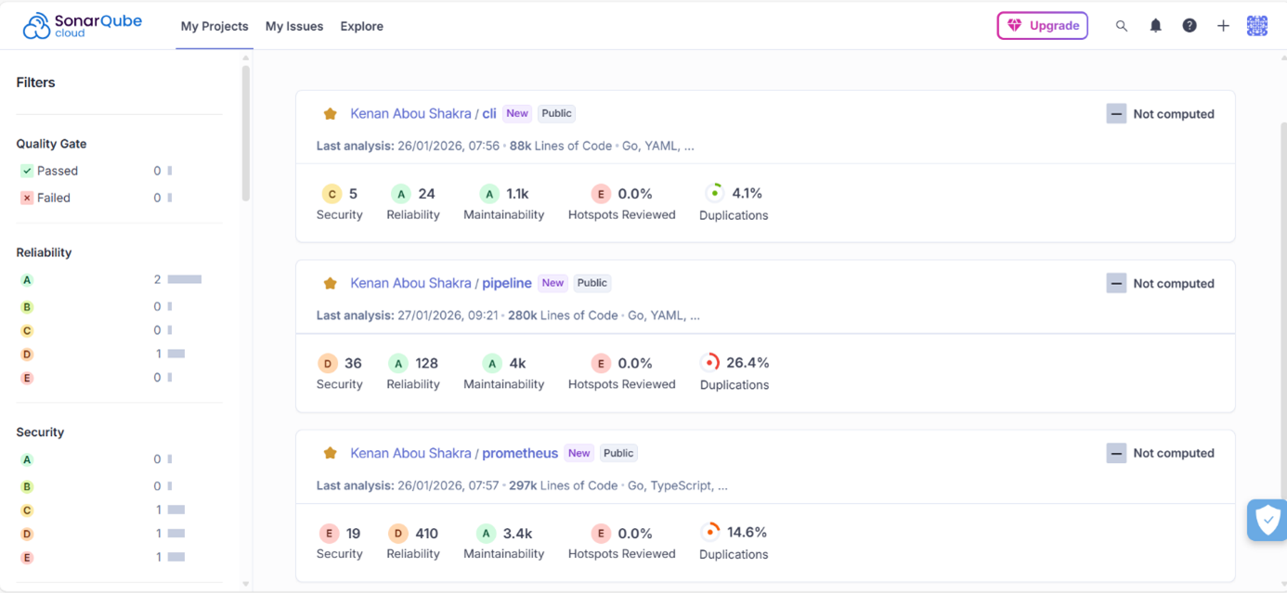
Figur 25. SonarQube-Based Code Quality Comparison.

Maintainability and Code Smells
With respect to maintainability, all three repositories receive a maintainability rating of A. At first glance, this suggests a broadly similar level of structural maintainability. However, the issue counts reveal much clearer differences. docker/cli shows approximately 1.1k maintainability-related issues, whereas prometheus/prometheus and tektoncd/pipeline show substantially higher counts, with approximately 3.4k and 4.0k issues, respectively.
This indicates that maintainability rating alone does not fully capture the differences between the repositories. Although all three projects satisfy the threshold for the highest maintainability grade, the absolute number of maintainability issues varies considerably. In SonarQube terms, these issues are directly relevant to technical debt, since they represent code-level maintainability concerns that may increase future modification effort and reduce structural clarity. Accordingly, the repositories appear similar in rating-based terms, but differ meaningfully in their maintainability-related debt burden.

Code Duplication
The duplication results reveal particularly strong cross-project differences. docker/cli shows the lowest duplication level at 4.1%, indicating comparatively limited structural repetition in the codebase. prometheus/prometheus occupies an intermediate position with 14.6% duplication, while tektoncd/pipeline shows the highest duplication level by a substantial margin at 26.4%.
Code duplication emerges as a key distinguishing factor between the repositories. In particular, the very high duplication observed in tektoncd/pipeline points to a greater degree of repeated implementation, which may increase maintenance effort and make future modifications more difficult to manage consistently. In this sense, duplication represents an important technical-debt-related characteristic, because repeated code can amplify the cost of future changes and hinder maintainability. Compared with the other repositories, docker/cli appears structurally more compact and less affected by repeated code fragments.

Reliability
The reliability results also reveal clear differences. docker/cli and tektoncd/pipeline both receive a reliability rating of A, with 24 and 128 reliability issues, respectively. In contrast, prometheus/prometheus receives a reliability rating of D and exhibits by far the highest number of reliability issues (410).
This indicates that prometheus/prometheus differs substantially from the other two repositories in terms of fault-related static quality concerns. While tektoncd/pipeline shows more reliability issues than docker/cli, both remain within the highest rating category. prometheus/prometheus, by contrast, combines a much larger issue count with a clearly weaker rating, suggesting a structurally less robust static reliability profile.
This contrast highlights a clear separation between prometheus/prometheus and the other repositories in terms of static reliability characteristics.

Security
The security indicators show a different pattern. docker/cli receives a security rating of C with 5 issues, tektoncd/pipeline receives D with 36 issues, and prometheus/prometheus receives E with 19 issues.
These results suggest that the repositories differ not only in the number of security-related issues, but also in their severity profile as reflected in the ratings. Although tektoncd/pipeline shows a higher number of security issues than prometheus/prometheus, its rating is less severe. Conversely, prometheus/prometheus exhibits fewer security issues than tektoncd/pipeline, yet receives the weakest rating (E). This indicates that issue counts alone are insufficient for interpreting static security quality, and that issue severity also matters.

Overall Cross-Project Pattern
Taken together, the SonarQube results show that the repositories do not share a uniform static quality profile. docker/cli appears strongest overall, combining low duplication, few reliability issues, and comparatively limited security concerns. tektoncd/pipeline presents a mixed profile, with strong reliability rating but high maintainability issue counts and very high duplication. prometheus/prometheus shows the weakest static quality profile overall, particularly due to its poor reliability and security ratings and its high number of reliability issues.
An important result is that the different static indicators do not all point in the same direction. For example, all repositories receive the same maintainability rating, yet differ strongly in issue counts and duplication. This suggests that static code quality is multi-dimensional and cannot be adequately captured through a single summary indicator. From a technical debt perspective, the clearest cross-project differences are observed in maintainability-related issues and duplication, where the repositories vary substantially in the likely structural maintenance burden associated with the codebase.

5.2.3 Alignment Between Delivery Performance Proxies and Code Quality Indicators
This subsection examines the relationship between delivery performance proxies—captured through workflow efficiency and CI/CD behavior—and static code quality indicators derived from SonarQube analysis. The objective is to assess whether repositories characterized by efficient and stable development processes also exhibit lower levels of structural quality concerns, particularly with respect to maintainability-related issues and code duplication.
The results indicate that alignment between delivery performance and static code quality is uneven and repository-specific rather than systematic.
docker/cli represents the clearest case of alignment between process performance and structural code quality. The repository exhibits the lowest pull request cycle time (6.87 hours), the lowest review overhead (2.48 hours), and relatively stable CI behavior. These characteristics coincide with the strongest static quality profile among the three repositories, including the lowest duplication level (4.1%), the lowest number of maintainability-related issues (~1.1k), and comparatively few reliability issues (24). This reflects a consistent pattern in which efficient integration and responsive review processes are associated with a lower structural maintenance burden.
prometheus/prometheus exhibits a more complex pattern, where weaker delivery performance aligns only partially with static quality concerns. The repository shows the highest pull request cycle time (51.16 hours) and review overhead (18.80 hours), indicating slower and less predictable integration processes, and also exhibits the highest CI failure rate (0.17). These characteristics correspond to a weaker static quality profile, particularly in terms of reliability, where the repository shows both the lowest rating (D) and the highest number of reliability issues (410). However, this alignment is not consistent across all indicators. Despite weaker workflow and CI failure performance, prometheus/prometheus exhibits the lowest CI flakiness (3.89 runs per SHA), indicating comparatively stable pipeline execution. This demonstrates that different dimensions of delivery performance—such as failure frequency and execution stability—do not align uniformly with structural quality.
tektoncd/pipeline presents the most pronounced mismatch between delivery performance proxies and static code quality indicators. While the repository shows strong CI performance in terms of execution speed (0.55 minutes) and the lowest failure rate (0.07), it also exhibits substantial variability in workflow behavior, including wide dispersion in pull request cycle time (IQR 149.94 hours) and the highest variability in pull request churn (IQR 299). These characteristics are reflected in its static quality profile, particularly in its very high duplication level (26.4%) and the highest number of maintainability-related issues (~4.0k). In addition, the repository exhibits the highest CI flakiness (7.82 runs per SHA), indicating unstable execution despite low failure frequency. This combination shows that strong performance in individual CI metrics does not necessarily translate into lower structural complexity or reduced maintenance-related concerns.
Across the repositories, no single delivery performance metric consistently predicts static code quality outcomes. Instead, different aspects of workflow and CI/CD behavior relate to different structural properties of the codebase. Workflow efficiency metrics, such as cycle time and review overhead, appear more closely associated with maintainability-related indicators and duplication, whereas CI metrics such as failure rate and flakiness capture distinct aspects of pipeline behavior that do not align consistently with static quality measures.
Overall, the findings indicate that delivery performance and static code quality should be interpreted as multi-dimensional constructs. While efficient workflows and stable pipelines may coincide with lower structural complexity in some cases, as observed in docker/cli, this relationship is not generalizable. Rather, the interaction between development processes and code quality appears to be context-dependent and shaped by project-specific characteristics.

5.2.4 Summary of RQ2 Results
This subsection synthesizes the main findings from the cross-project comparison of workflow efficiency, CI/CD performance, and static code quality.
The results reveal clear structural differences between the repositories across all examined dimensions. docker/cli exhibits the strongest overall profile, characterized by fast and predictable pull request processing, low review overhead, moderate CI failure rates, and comparatively stable pipeline behavior. This is reflected in its static code quality results, where the repository shows the lowest duplication (4.1%), the lowest number of maintainability-related issues (~1.1k), and relatively few reliability issues. Taken together, docker/cli represents a case where efficient development processes coincide with a comparatively low structural maintenance burden.
In contrast, prometheus/prometheus demonstrates the weakest overall profile. The repository combines slow and highly variable workflow behavior with the highest CI failure rate. This aligns with its static quality results, particularly in terms of reliability, where it shows both the lowest rating (D) and the highest number of reliability issues (410). However, this pattern is not consistent across all CI indicators, as the repository exhibits the lowest flakiness, indicating more deterministic execution despite frequent failures. This highlights that different CI metrics capture distinct aspects of pipeline performance.
tektoncd/pipeline presents a mixed profile across both delivery performance and static code quality. The repository combines fast CI execution and low failure rate with high workflow variability and the highest level of CI flakiness. In terms of static code quality, it exhibits the highest duplication (26.4%) and the largest number of maintainability-related issues (~4.0k), indicating a substantial structural maintenance burden despite strong performance in selected CI metrics.
Across all repositories, both delivery performance and static code quality emerge as inherently multi-dimensional. Workflow efficiency, pipeline reliability, and structural code characteristics do not align consistently across projects, and no single metric is sufficient to explain overall performance. In particular, low CI failure rates or fast execution times do not necessarily correspond to lower maintainability-related concerns or reduced duplication.
Overall, the findings indicate that the relationship between delivery performance and structural code quality is complex and context-dependent. While some repositories exhibit partial alignment between efficient processes and stronger code quality, others demonstrate clear mismatches, underscoring the need to evaluate these dimensions jointly rather than in isolation.

Chapter 6
This chapter interprets the empirical findings in relation to the theoretical perspectives introduced earlier, with particular emphasis on DevOps-oriented delivery models, DORA-inspired performance metrics, and repository-based analyses of workflow and code quality. Rather than restating the observed results, the discussion focuses on how these findings support, refine, or challenge existing assumptions about software delivery performance in contemporary development environments.
Prior research has emphasized delivery performance through metrics such as lead time and deployment frequency, often operationalized using repository and pipeline data. At the same time, studies of pull-request-based workflows and CI/CD automation have examined coordination efficiency and pipeline reliability as separate analytical concerns. Static analysis approaches, including SonarQube-based assessments, have further introduced structural perspectives on maintainability and technical debt. However, these dimensions are typically studied in isolation.
By examining these aspects jointly, the findings of this study reveal that delivery performance cannot be understood as a single, unified construct. Instead, they indicate that workflow dynamics, pipeline behavior, and structural code quality interact in complex and only partially aligned ways. This challenges simplified interpretations of DevOps performance in which improvements in automation or workflow efficiency are assumed to produce uniformly positive outcomes across all dimensions of software quality and delivery.
From a theoretical perspective, the results support a socio-technical view of software delivery, where coordination processes, automation infrastructure, and codebase characteristics co-evolve but are not tightly coupled. The following sections elaborate on these relationships by examining how different dimensions of delivery performance relate to one another and how they align with structural code quality indicators.

6.1 Synthesis of the Findings
The findings can be interpreted through a layered perspective on software delivery performance, where workflow efficiency, CI/CD pipeline behavior, and structural code quality represent distinct but interacting dimensions. This perspective aligns with DevOps literature that emphasizes the integration of development and operations practices, while also revealing that such integration does not result in a single, coherent performance dimension.
A key implication concerns the interpretation of DORA-inspired delivery metrics. While metrics such as lead time and deployment frequency are commonly used as indicators of delivery performance, the results suggest that these outcome-level measures do not fully capture the underlying dynamics of development processes. Instead, they reflect aggregated effects of coordination efficiency, pipeline execution behavior, and codebase characteristics. This indicates that DORA-style metrics should be interpreted as high-level proxies rather than comprehensive representations of system performance.
The observed workflow patterns provide insight into coordination mechanisms within pull-request-based development. Faster and more consistent integration processes suggest efficient coordination among contributors, but these improvements do not necessarily translate into stable pipeline behavior. This indicates that coordination efficiency operates largely independently of execution stability, suggesting that improvements in review and integration processes alone are insufficient to ensure reliable delivery outcomes.
Similarly, the analysis of CI/CD behavior shows that different indicators capture different aspects of pipeline performance. Failure rate reflects the frequency of unsuccessful executions, whereas flakiness captures instability in repeated runs. The lack of alignment between these metrics indicates that pipeline reliability is not a single property, but a combination of distinct characteristics that must be interpreted together. This challenges common practices that rely on single indicators, such as failure rate, as proxies for overall pipeline health.
When considered in relation to structural code quality, the findings further suggest that technical debt—operationalized through maintainability issues, duplication, and related static indicators—does not follow directly from workflow efficiency or CI/CD maturity. While some patterns of alignment are observed, particularly where efficient workflows coincide with lower structural complexity, these relationships are not consistent across repositories. This indicates that structural code quality reflects longer-term accumulation processes that are influenced by factors beyond immediate development performance.
Taken together, these findings challenge linear interpretations of DevOps performance in which improvements in workflow speed or pipeline execution are expected to produce corresponding improvements in code quality. Instead, they support a non-linear and context-dependent view, where different dimensions of software delivery evolve along partially independent trajectories. From a theoretical standpoint, this reinforces the need to treat delivery performance as a multi-dimensional construct, where outcome metrics, process indicators, and structural properties each provide complementary but incomplete perspectives.

6.2 Interpreting Workflow and CI/CD Dynamics (RQ1)
The RQ1 findings indicate that workflow dynamics and CI/CD behavior should not be interpreted as parallel manifestations of a single delivery-performance trajectory, but as partially decoupled dimensions of the software delivery system. Across Figures 4–22, the repositories do not exhibit synchronized movement between pull-request responsiveness, pipeline reliability, and delivery-related activity. Instead, the temporal evolution of DevOps-oriented development is characterized by layered variation, where coordination processes, automation behavior, and delivery cadence evolve at different rates and according to different patterns.
This observation aligns with the theoretical foundation established in Chapters 2 and 3, which conceptualizes pull-request workflows as coordination mechanisms, CI/CD pipelines as execution infrastructure, and release-related indicators as observable delivery proxies. The temporal results support this layered view, as each metric family captures a distinct aspect of the system rather than a redundant representation of the same phenomenon. Crucially, the lack of synchronized evolution across these dimensions indicates that DevOps performance is structurally multi-dimensional rather than operationally uniform.
The docker/cli case demonstrates that workflow efficiency alone is insufficient to infer delivery-system stability. The repository exhibits consistently fast and predictable integration behavior, yet this stability is not reflected at the CI layer. Increased failure rates, rising flakiness, and higher failure volatility indicate that efficient coordination can coexist with reduced execution stability. This highlights a key theoretical distinction: integration responsiveness and pipeline reliability are governed by different mechanisms and should not be treated as interchangeable constructs.
Prometheus/prometheus illustrates a different configuration, where high integration throughput coexists with slower and more variable workflow behavior. This indicates that throughput and responsiveness capture distinct aspects of process performance. The repository sustains a high volume of merged changes despite greater coordination overhead, suggesting a development process shaped by scale and contributor heterogeneity. At the same time, its CI behavior shifts over time, moving from early instability toward partial stabilization. Rather than indicating simple improvement or deterioration, this pattern reflects reconfiguration across dimensions, where workflow, pipeline behavior, and delivery activity evolve unevenly. This supports a socio-technical interpretation of DevOps environments as systems that mature asynchronously.
Tektoncd/pipeline provides the strongest evidence against a linear interpretation of CI/CD performance. While it exhibits relatively strong performance in terms of failure rate, its workflow dynamics are highly unstable and its flakiness increases over time. This indicates that low failure frequency does not necessarily imply stable execution. Instead, pipeline “success” may occur under conditions of repeated execution and retry-driven instability. This finding is analytically significant because it shows that reliability cannot be reduced to failure incidence alone. Metrics such as flakiness and volatility capture forms of instability that remain invisible in failure-rate-based interpretations.
These results refine the interpretation of DORA-aligned delivery proxies. Indicators such as release frequency and time-to-release approximate observable delivery outcomes, but do not explain the mechanisms that produce them. Workflow and CI/CD metrics therefore function as decomposition indicators, revealing how coordination processes and pipeline behavior jointly shape delivery performance. In this sense, the findings do not contradict DORA-based approaches, but demonstrate their limitations when used in isolation.
A further implication is that temporal variation itself carries analytical meaning. The observed fluctuations, spikes, and shifts across workflow and CI/CD metrics indicate that development systems cannot be adequately described using average values alone. Instead, instability phases and uneven temporal trajectories reflect the adaptive nature of open-source DevOps projects, where coordination load, contributor activity, and pipeline conditions change over time. This supports a dynamic interpretation of repository-based data as traces of evolving socio-technical processes.
Taken together, the RQ1 findings show that workflow dynamics and CI/CD behavior should be understood as related but analytically distinct dimensions of software delivery. Efficient coordination may coexist with unstable automation, high throughput may coexist with slow responsiveness, and low failure rates may coexist with execution instability. Consequently, meaningful evaluation of DevOps performance requires a layered analytical perspective in which workflow efficiency, pipeline behavior, and delivery outcomes are examined jointly, but not collapsed into a single performance dimension.

6.3 Interpreting the Relationship Between Process and Code Quality (RQ2)
The RQ2 findings indicate that the relationship between process performance and structural code quality is not direct or uniform. Instead, it is partial, context-dependent, and varies across repositories. The results do not support a deterministic interpretation in which faster workflows, lower CI failure rates, or shorter execution times automatically correspond to lower technical debt or stronger maintainability. Rather, workflow metrics, pipeline metrics, and SonarQube-based indicators capture distinct but complementary aspects of project condition.
This distinction follows from the layered nature of the system under study. Workflow efficiency reflects coordination and integration processes, CI/CD metrics capture execution behavior and automation stability, and static analysis indicators describe structural properties of the codebase. Because these dimensions operate at different levels, strong performance in one does not imply strong performance in the others. The cross-project comparison empirically confirms this separation.
Docker/cli provides the clearest example of partial alignment between process efficiency and code quality. The repository combines fast and predictable pull-request processing with relatively stable CI behavior, and this profile coincides with low duplication, fewer maintainability issues, and limited reliability concerns. This suggests that efficient coordination processes can align with a lower structural maintenance burden. However, this alignment remains partial rather than universal. As shown in the temporal analysis, docker/cli also exhibits periods of CI instability, indicating that workflow efficiency alone does not ensure consistent pipeline reliability. The case therefore supports alignment, but not full convergence across dimensions.
Prometheus/prometheus exhibits a more complex configuration. It shows higher workflow burden and elevated CI failure rates, which correspond to weaker results in the static reliability dimension. At first glance, this appears to support a stronger process–quality relationship. However, the presence of low flakiness complicates this interpretation. While failures occur frequently, they do so in a relatively stable and predictable manner rather than through repeated unstable reruns. This indicates that CI behavior is internally differentiated: different metrics capture different aspects of execution quality. As a result, even when process and structural weaknesses appear aligned, the relationship is not consistent across all indicators. Some metrics reinforce the connection, while others qualify it.
Tektoncd/pipeline provides the strongest counterexample to simplified assumptions. It combines fast execution and low failure rates with high workflow variability, high flakiness, and substantial structural issues, including high duplication and a large number of maintainability problems. This configuration demonstrates that favorable CI indicators can coexist with a significant structural maintenance burden. In other words, operational efficiency at the pipeline level does not necessarily reflect underlying code quality. The repository is able to execute quickly and fail infrequently, yet still exhibits characteristics associated with accumulated technical debt. This mismatch provides strong evidence that process performance and code quality evolve along only partially overlapping trajectories.
Duplication plays a particularly important role in this interpretation. It emerges as a clear differentiator between repositories, with low levels in docker/cli and very high levels in tektoncd/pipeline. Because duplication is directly linked to maintenance effort, change propagation, and refactoring complexity, its divergence from CI success indicators highlights a key limitation of pipeline-based metrics. Efficient execution does not guarantee maintainable structure. A system may perform well operationally while still accumulating structural complexity that increases long-term maintenance cost. This illustrates why static analysis provides analytical value beyond workflow and pipeline telemetry.
The findings also clarify the role of technical debt in this study. Technical debt is operationalized primarily through SonarQube-based maintainability indicators and duplication, while reliability and security are treated as complementary dimensions. The results show that these structural indicators are not directly inferable from process metrics. Workflow and CI indicators may provide indirect signals under certain conditions, but they do not substitute for direct code-level measurements. This supports the conceptual distinction between process performance and structural quality established in the theoretical foundation.
From a theoretical perspective, the RQ2 findings reinforce a layered and non-reductionist view of DevOps performance. Workflow efficiency appears more closely associated with maintainability and structural simplicity, while CI/CD metrics capture execution-level characteristics related to automation and infrastructure behavior. These dimensions interact, but they do not collapse into a single performance construct. This distinction explains why alignment is observed in some cases but not in others.
A final implication is methodological. Evaluating code quality solely through static analysis would overlook important aspects of coordination efficiency and pipeline behavior. Conversely, relying only on workflow or CI metrics could obscure substantial structural debt in the codebase. The results therefore justify the integrated analytical design of the study. By combining workflow metrics, CI/CD indicators, delivery proxies, and static analysis measures, the study captures both the outcomes and the underlying mechanisms of software delivery.
Taken together, the RQ2 findings show that the relationship between process behavior and code quality is multi-dimensional and context-dependent. Efficient workflows may coincide with lower structural maintenance burden, but strong CI performance alone does not imply a healthy codebase. Consequently, process metrics and code quality indicators must be interpreted jointly, without assuming that one can be directly inferred from the other.

6.4 Theoretical Implications
The findings of this study have several implications for how software delivery performance is conceptualized in DevOps-oriented software engineering research. A central implication is that delivery performance cannot be treated as a unitary construct. While the DORA framework provides an important outcome-oriented perspective on delivery capability, the results show that DORA-aligned proxies alone are insufficient for explaining how delivery performance is produced in repository-based environments. Instead, workflow coordination, CI/CD pipeline behavior, and structural code quality emerge as analytically distinct dimensions, each contributing differently to observed delivery outcomes.
A second implication concerns the theoretical role of workflow metrics. Prior research has often treated pull-request-based workflows as implementation details of collaborative development. The findings challenge this view by showing that workflow behavior constitutes a core component of delivery performance. Metrics capturing integration responsiveness and review processes reflect underlying coordination efficiency and process friction, which directly shape how changes progress through the system. This suggests that delivery performance should not be understood solely through outcome metrics, but also through the structure and efficiency of the integration process itself.
A third implication relates to the interpretation of CI/CD pipeline metrics. The results demonstrate that pipeline performance cannot be adequately captured through single indicators such as failure rate. Instead, metrics such as flakiness, volatility, and execution duration reveal different and sometimes diverging aspects of automation behavior. These challenges simplified conceptualizations of CI/CD performance as a binary distinction between stable and unstable pipelines. From a theoretical perspective, CI/CD should therefore be understood as an internally differentiated domain, where reliability, stability, and execution characteristics represent separate but interacting dimensions of automation infrastructure.
A fourth implication concerns the role of technical debt in DevOps environments. While the theoretical foundation acknowledges that technical debt extends beyond code-level characteristics, the empirical results show that static analysis indicators—particularly maintainability issues and duplication—capture structural properties that are not directly observable through process metrics. This supports a layered interpretation of technical debt, in which process inefficiencies and code-level issues interact but remain analytically distinct. Consequently, process-based indicators may signal potential quality concerns, but they cannot substitute for direct measurement of structural properties within the codebase.
Taken together, these implications support a socio-technical and multi-layered conceptualization of DevOps performance. The findings suggest that software delivery should be understood as the interaction between coordination processes, automation infrastructure, and codebase characteristics, rather than as a single measurable capability. In this sense, the study does not reject DORA-based or process-oriented perspectives, but refines them by demonstrating that their explanatory power is strengthened when combined with workflow decomposition metrics and static code-quality indicators.

6.5 Practical Implications for DevOps Practice
The findings indicate that engineering performance should be monitored using a balanced set of complementary indicators rather than relying on a single headline metric. Delivery-oriented metrics alone provide a limited view of project health. Even when release activity appears frequent or CI execution is fast, underlying frictions may still exist in pull-request workflows or in the structural properties of the codebase. Teams that rely solely on high-level delivery indicators risk overlooking the mechanisms that generate instability, delay, or long-term maintenance burden.
Workflow metrics provide practical value as early indicators of coordination efficiency. Measures capturing integration responsiveness and review processes can help identify whether bottlenecks originate in collaboration practices rather than in the automation layer. This implies that performance improvement efforts should not focus exclusively on pipeline optimization, but also on how changes are reviewed, coordinated, and integrated. Where workflow overhead remains high, interventions such as improved task decomposition, clearer review practices, or better contributor coordination may be as important as improving CI performance.
CI/CD monitoring should extend beyond basic success rates. The findings show that low failure rates do not necessarily indicate a stable pipeline. Indicators such as flakiness and volatility reveal forms of execution instability that remain invisible when monitoring is limited to pass/fail outcomes. Pipelines that succeed frequently but require repeated or unstable execution can still impose coordination overhead and reduce engineering efficiency. Effective monitoring therefore requires combining failure-based indicators with measures of execution consistency.
Static code-quality monitoring remains essential even in mature DevOps settings. Strong workflow or CI performance does not guarantee low maintainability burden or limited duplication. Structural indicators provide visibility into longer-term maintenance risks that are not captured by short-term delivery or pipeline metrics. For sustained delivery performance, teams should therefore combine process-level monitoring with code-level quality analysis.
More broadly, the findings support a layered monitoring strategy in which different metric families serve distinct decision purposes. Delivery indicators reflect release rhythm, workflow metrics reveal coordination efficiency, CI/CD metrics capture execution behavior, and static analysis exposes structural complexity and maintenance risk. The practical implication is not to maximize the number of metrics, but to select a coherent set of complementary indicators that together provide a balanced view of the delivery system. This is particularly relevant in environments where access to full production telemetry is limited.

6.6 Limitations
6.6 Limitations
Several limitations should be considered when interpreting the findings of this study.
The empirical analysis is based on three open-source repositories. While the selected cases provide meaningful variation in workflow and CI/CD behavior and support comparative analysis, the number of cases remains limited. The findings therefore provide analytical insight into patterns rather than supporting broad statistical generalization across all DevOps projects.
The study relies on repository artefacts and GitHub Actions workflow data as its primary empirical sources, which introduces a platform boundary. The observed patterns reflect development and automation behavior within GitHub-based ecosystems and may not transfer directly to environments using other toolchains such as GitLab CI/CD, Jenkins, Azure DevOps, or hybrid enterprise platforms. The results should therefore be interpreted as ecosystem-specific rather than universally representative.
Software delivery performance is examined through repository-based proxies aligned with DORA concepts rather than through complete operational DORA measurement. While release frequency and time-to-release provide meaningful approximations of delivery activity and aspects of lead time, key operational indicators such as change failure rate and mean time to restore service are not directly observable in the dataset. As a result, the findings reflect repository-visible delivery behavior rather than full end-to-end operational performance.
Technical debt is operationalized primarily through SonarQube-based static indicators. This enables consistent cross-project comparison but captures only a subset of the broader technical debt concept. Architectural, infrastructure, build-system, and organizational forms of debt are not directly measured. The study therefore provides a code-level perspective on technical debt rather than a comprehensive view across the full software delivery system.
Finally, the study design is descriptive and comparative rather than causal. The observed relationships between workflow behavior, CI/CD metrics, and code-quality indicators are analytically meaningful, but they do not establish causal direction. For example, co-occurrence between high flakiness and high duplication cannot be interpreted as a causal relationship, as both may arise from underlying project characteristics or evolve differently over time.
Taken together, these limitations define the scope of the study without undermining its contribution. The results provide a theoretically informed and empirically grounded interpretation of workflow dynamics, CI/CD behavior, and static code quality within repository-based DevOps environments.

6.7 Future Research
The limitations of this study point to several directions for future research.
One important direction is cross-platform replication. Since the analysis focuses on GitHub repositories and GitHub Actions workflows, future studies should examine whether similar relationships appear in ecosystems based on GitLab CI/CD, Jenkins, Azure DevOps, CircleCI, or mixed enterprise toolchains. Such comparisons would help distinguish platform-specific effects from more general characteristics of DevOps-oriented software delivery.
Another direction concerns the integration of richer operational telemetry. The present study relies on repository-visible proxies, which means that key operational indicators such as change failure rate, rollback behavior, service incidents, and mean time to restore service are not directly observable. Future research could combine repository mining with deployment logs, observability platforms, and incident management data to establish stronger links between development processes and production outcomes. This would enable a more complete DORA-oriented assessment of delivery performance.
Further work is also needed to expand the measurement of technical debt. This study operationalizes technical debt primarily through SonarQube-based code-level indicators. Future research could incorporate additional dimensions such as architectural debt, dependency-related risk, vulnerability exposure, and build-system or pipeline-related debt. This is particularly relevant in DevOps environments, where instability may arise not only from application code, but also from testing infrastructure and delivery configuration.
A methodological extension involves moving from pattern identification to explanation. While the present study identifies alignment and divergence across metric families, it does not explain the underlying mechanisms. Future studies could combine longitudinal repository analysis with qualitative methods, such as developer interviews or case studies, to better understand how workflow practices, automation changes, and refactoring decisions shape delivery performance over time.
Finally, future research could explore how integrated metric frameworks can support practical decision-making. Since no single metric family is sufficient to characterize project health, an important next step is to design and evaluate monitoring approaches that combine delivery proxies, workflow metrics, CI/CD indicators, and code-quality measures into coherent decision-support tools. Such frameworks could help translate multi-dimensional performance insights into actionable engineering practices.

6.8 Conclusion
This thesis investigated how workflow metrics, CI/CD pipeline indicators, DORA-aligned delivery proxies, and SonarQube-based code-quality measures can be combined to analyze software delivery performance in open-source DevOps projects. The results show that no single metric family provides a sufficient basis for understanding project behavior. Workflow efficiency, pipeline characteristics, delivery activity, and structural code quality capture different aspects of the system and do not align consistently across repositories.
A central contribution of the study is the demonstration that repository-based DevOps analysis becomes more informative when these dimensions are interpreted jointly. Workflow metrics provide insight into coordination efficiency, CI/CD indicators reveal execution behavior, delivery proxies approximate release outcomes, and static analysis exposes structural maintenance concerns. Considered together, these perspectives make it possible to identify patterns that would remain hidden if each metric family were analyzed in isolation.
The findings further show that the relationship between process performance and code quality is neither uniform nor directly predictable. Efficient workflows may coincide with lower structural maintenance burden in some cases, while strong CI performance may coexist with substantial duplication and maintainability issues in others. This supports a multi-dimensional and context-dependent interpretation of software delivery performance and technical debt.
Within the scope of repository mining and static analysis, the thesis therefore provides an empirically grounded perspective on how coordination processes, automation behavior, and code structure interact in DevOps-oriented development. The main conclusion is that meaningful evaluation of software delivery performance requires a layered analytical approach in which process, pipeline, delivery, and code quality are assessed together rather than through isolated indicators.

References
Li, Z., Avgeriou, P., & Liang, P. (2020). A systematic mapping study on technical debt and its management. Journal of Systems and Software, 101, 193–220. https://doi.org/10.1016/j.jss.2014.12.027
Shahin, M., Babar, M. A., & Zhu, L. (2017).
Continuous integration, delivery and deployment: A systematic review on approaches, tools, challenges and practices.
IEEE Access, 5, 3909–3943.
https://doi.org/10.1109/ACCESS.2017.2685629
Hilton, M., Tunnell, T., Huang, K., Marinov, D., & Dig, D. (2016).
Usage, costs, and benefits of continuous integration in open-source projects.
In Proceedings of the 31st IEEE/ACM International Conference on Automated Software Engineering (pp. 426–437).
https://doi.org/10.1145/2970276.2970358

GitHub. (2023).
GitHub Actions documentation.
https://docs.github.com/en/actions
SonarSource. (2023).
SonarQube documentation.
https://docs.sonarsource.com/sonarqube/
Microsoft. (2023).
Azure Pipelines documentation.
https://learn.microsoft.com/en-us/azure/devops/pipelines/
GitLab. (2023). GitLab CI/CD documentation. GitLab.
https://docs.gitlab.com/ee/ci/
Jenkins. (2023). Jenkins documentation. Jenkins Project.
https://www.jenkins.io/doc/

Aldaeej, A., Nguyen-Duc, A., & Gupta, V. (2023). A lean approach of managing technical debt in agile software projects – A proposal and empirical evaluation. In C. J. Stettina et al. (Eds.), XP 2023 (Lecture Notes in Business Information Processing, Vol. 475, pp. 67–76). Springer. doi:10.1007/978-3-031-33976-9_5
Avgeriou, P., Kruchten, P., Ozkaya, I., Seaman, C., Lichtenthaler, E., & Liang, P. (2021). An overview and comparison of technical debt measurement tools. IEEE Software, 38(3), 61–71.
Gousios, G., & Spinellis, D. (2017). Mining software engineering data from GitHub. In 2017 IEEE/ACM 39th International Conference on Software Engineering Companion (ICSE-C) (pp. 501–502). IEEE. doi:10.1109/ICSE-C.2017.164
Kalliamvakou, E., Gousios, G., Blincoe, K., Singer, L., German, D. M., & Damian, D. (2014). The promises and perils of mining GitHub. In Proceedings of the 11th Working Conference on Mining Software Repositories (pp. 92–101). ACM. doi:10.1145/2597073.2597074
Kalliamvakou, E., Gousios, G., Blincoe, K., Singer, L., German, D. M., & Damian, D. (2016). An in-depth study of the promises and perils of mining GitHub. Empirical Software Engineering, 21(5), 2035–2071. doi:10.1007/s10664-015-9393-5
Kansab, S., Hanania, M., Bordeleau, F., & Tizghadam, A. (2025). Analyzing DevOps practices through merge request data: A case study in a networking software company. arXiv.
Sallin, M., Kropp, M., Anslow, C., & Meier, A. (2021). Measuring software delivery performance using the Four Key Metrics of DevOps. In Agile Processes in Software Engineering and Extreme Programming (pp. 44–58). Springer. doi:10.1007/978-3-030-78098-2_7
Santos, J., Costa, D. A., McIntosh, S., & Kulesza, U. (2024). On the need to monitor continuous integration practices: An empirical study. arXiv.
Stochel, M. G., Chołda, P., & Wawrowski, M. R. (2022). Adopting DevOps paradigm in technical debt prioritization and mitigation. In 2022 48th Euromicro Conference on Software Engineering and Advanced Applications (SEAA) (pp. 306–313). IEEE. doi:10.1109/SEAA56994.2022.00055
Wessel, M., Vargovich, J., Gerosa, M. A., & Treude, C. (2023). GitHub Actions: The impact on the pull request process. Empirical Software Engineering, 28, Article 141. doi:10.1007/s10664-023-10369-w
Yu, Y., Wang, H., Filkov, V., Godfrey, M. W., & Hassan, A. E. (2015). Wait for it: Determinants of pull request evaluation latency on GitHub. In 2015 IEEE/ACM 12th Working Conference on Mining Software Repositories (pp. 367–371). IEEE. doi:10.1109/MSR.2015.42
Zhang, X., Yu, Y., Wang, T., Rastogi, A., & Wang, H. (2022). Pull request latency explained: An empirical overview. Empirical Software Engineering, 27, Article 131. doi:10.1007/s10664-022-10143-4
Forsgren, N., Humble, J., & Kim, G. (2018).
Accelerate: The science of lean software and DevOps: Building and scaling high performing technology organizations.
IT Revolution Press.
Kruchten, P., Nord, R. L., & Ozkaya, I. (2012).
Technical debt: From metaphor to theory and practice.
IEEE Software, 29(6), 18–21.
Lenarduzzi, V., et al. (2020).
Does removing code smells improve software quality?
Journal of Systems and Software, 160, 110442.

