CI/CD Performance, Engineering Velocity and Technical Debt, in DevOps
An Empirical Analysis Study of Open-Source DevOps Projects Using Engineering Velocity, Pipeline, and Static Analysis Metrics
“DevOps integrates collaboration, automation, and continuous improvement, enhancing agility, reducing time to market, and ensuring consistent software releases.” (Kansaba et al., n.d., p. 1)
Abstract:
This study examines pull request, workflow, release, and static analysis data collected from three large-scale open-source DevOps repositories: prometheus/prometheus, docker/cli, and tektoncd/pipeline. The dataset covers about tow years observation period and includes 64,798 GitHub Actions workflow runs, comprehensive pull request metadata, release events, and SonarQube-based maintainability and technical debt indicators.
By combining workflow-level CI/CD telemetry with repository mining and static code analysis, the study enables a multi-dimensional analysis of engineering velocity, pipeline stability, delivery cadence, and code-level technical debt.
The empirical dataset consists of pull request metadata (prs.csv), GitHub Actions workflow execution logs (workflow_runs.csv), and release metadata (releases.csv), collected via the GitHub GraphQL and REST APIs. In total, 64,798 workflow executions were analyzed across the three repositories during the observation window.
Static code analysis snapshots were obtained using SonarQube to measure maintainability, code smells, duplication density, reliability, and security issues.
The selected repositories vary in CI/CD maturity and architectural complexity, enabling comparative analysis across heterogeneous DevOps contexts.

Research Objective
The objective of this research is to investigate how Engineering Velocity and CI/CD-related metrics derived from GitHub repository data can be used to analyze DevOps delivery performance and engineering workflow characteristics in open-source projects. In particular, the study examines how these workflow and pipeline measures relate to delivery performance proxies aligned with the Four Key Metrics of DevOps and to code-level technical debt indicators measured using SonarQube static analysis.

Research Questions
- RQ1: How do pull request workflow dynamics and CI/CD pipeline performance evolve over time in open-source DevOps projects?
- RQ2: How do differences in workflow structure and CI/CD automation across projects influence Engineering Velocity and DevOps delivery performance, and how do these differences align with SonarQube-based maintainability and technical debt indicators?

Metric Categories in this Study
The empirical analysis in this study combines three categories of metrics:
- DevOps delivery performance metrics aligned with the Four Key Metrics (deployment frequency proxies, lead time proxies, and change failure rate proxies).
- Engineering Velocity metrics derived from pull request workflows, including PR cycle time, review latency, review duration, and merge frequency.
- Code-level technical debt indicators derived from SonarQube static analysis, including maintainability rating, code smells, duplication density, reliability issues, and security issues.

Relation to the Four Key Metrics of DevOps (DORA Metrics)
The Four Key Metrics of DevOps—deployment frequency, lead time for change, time to restore service, and change failure rate—are widely used indicators for assessing DevOps delivery performance and are commonly referred to as the DORA metrics. In the context of open-source GitHub repositories, not all FKM dimensions are directly observable. Therefore, this study partially operationalizes the Four Key Metrics using repository artefacts and extends them with Engineering Velocity metrics and static analysis–based technical debt indicators to better capture the mechanisms that influence delivery performance.
In this study:
- Deployment Frequency is approximated using Release Frequency and delivery-related GitHub Actions workflows where available.
- Lead Time for Change is approximated using PR Cycle Time and Time-to-Release (when release signals are available).
- Change Failure Rate is approximated using CI Failure Rate and complemented by CI flakiness and failure volatility metrics to capture pipeline instability beyond binary build failures.
- Time to Restore Service (MTTR) cannot be measured because incident and recovery data are not available through GitHub repository metadata alone.
This extension is necessary because the Four Key Metrics primarily capture delivery performance outcomes, while workflow dynamics and technical debt indicators provide insight into the underlying engineering mechanisms that influence delivery speed, integration stability, and CI/CD reliability.

Results

RQ1
RQ1 investigates how pull request workflow metrics and CI/CD pipeline performance indicators evolve over the selected observation period in order to identify temporal trends and cross-project differences.

Motivation
In modern open-source DevOps environments, pull requests and CI/CD pipelines form the backbone of collaborative development and automated delivery. Over time, workflow dynamics may evolve due to project growth, increased contributor activity, or changes in automation practices. Understanding how pull request cycle time, review latency, and CI pipeline stability evolve provides insight into DevOps delivery efficiency and workflow maturity.
This research question investigates whether workflow and CI/CD performance indicators exhibit stabilization, volatility, or improvement over the observation period.

Approach
To address this research question, we analyze GitHub-derived metrics over a 425-day observation period. The analysis is conducted at a weekly granularity.
The analysis focuses on three analytical dimensions:
• Workflow efficiency: measured using PR cycle time, review latency, review duration, and merge frequency.
• CI/CD performance: measured using CI duration, CI failure rate, CI volatility, and CI flakiness indicators.
• Delivery behavior: measured using release frequency and CD workflow triggers where applicable.
For each metric, we compute median and variability statistics per week and analyze temporal trends across the three selected repositories.
These measures partially operationalize the Four Key Metrics of DevOps (DORA metrics). Release frequency approximates deployment frequency, PR cycle time and time-to-release approximate the DORA metric lead time for change, and CI failure rate serves as a proxy for change failure rate. Time to restore service (MTTR) cannot be observed using GitHub repository data alone.

Results
PR cycle time exhibits clear differences in workflow efficiency across the three analyzed repositories over the observation period. Docker/cli maintains relatively short and stable cycle times throughout the observation period, indicating efficient integration flow and rapid feedback. In contrast, prometheus/prometheus demonstrates higher variability and occasional spikes, suggesting more complex coordination and review dynamics.
Review latency and review duration reveal structural differences in feedback processes. Docker/cli consistently shows faster initial review response and shorter review completion times compared to prometheus, indicating lower coordination overhead. These findings reflect differences in contributor structure, architectural complexity, and review practices.
Merge frequency highlights variations in integration throughput and delivery cadence. Docker/cli demonstrates steady integration throughput, while prometheus shows greater fluctuation across months, potentially influenced by release cycles and project scale.
CI-related metrics further differentiate repository behavior and provide insight into change failure risk within the CI pipeline. Prometheus and docker/cli exhibit moderate but persistent CI failure rates, with periodic spikes indicating temporary instability. Tektoncd/pipeline shows comparatively lower baseline failure rates but occasional volatility linked to infrastructure-heavy workflows.
CI flakiness and failure volatility complement the change failure rate proxy by capturing instability beyond binary failure outcomes. These metrics indicate that pipeline reliability evolves differently across repositories and is not solely determined by code-level changes.
Continuous Delivery–related workflows were observed primarily in prometheus/prometheus, while docker/cli and tektoncd/pipeline relied primarily on CI-oriented automation within the analyzed dataset.

Summary
RQ1 demonstrates that delivery performance and workflow stability evolve differently across repositories. FKM-aligned indicators such as lead time for change (approximated by PR cycle time and time-to-release) and change failure rate (approximated by CI failure rate) show repository-specific temporal patterns. Complementary workflow and pipeline stability metrics reveal that variations in review dynamics and CI reliability contribute to differences in observed delivery performance. These findings suggest that delivery outcomes are shaped not only by integration speed, but also by feedback efficiency and automation stability.

RQ2
To address RQ2, we compared workflow structure and CI/CD automation characteristics across projects and examined how these differences align with SonarQube-based maintainability and technical debt indicators.

Motivation
Beyond temporal evolution, structural differences across repositories may shape workflow efficiency and delivery performance. Projects differ in contributor base, review practices, CI/CD automation maturity, and release management strategies.
At the same time, code-level technical debt, measured through SonarQube static analysis, reflects structural maintainability characteristics such as code smells, duplication, reliability, and security ratings.
In this research question, we investigate whether observable workflow and automation differences across repositories align with variations in SonarQube-based technical debt indicators.

Approach
We compare repositories along two dimensions:
• Workflow and CI/CD structure: PR cycle time, review overhead, CI duration, CI failure rate, and CD automation presence.
• Code-level technical debt: SonarQube maintainability rating, duplication percentage, code smells count, reliability and security ratings.
We analyze cross-project differences using median values and descriptive statistics, focusing on alignment patterns rather than causal inference.
In addition, cross-project differences are interpreted through the lens of the Four Key Metrics, focusing on lead time for change (PR cycle time), change failure rate (CI failure rate), and deployment frequency (release frequency where observable), before examining their alignment with SonarQube-based maintainability indicators.

Results
The cross-project comparison aims to reveal how differences in workflow structure and CI/CD automation relate to engineering velocity, delivery performance proxies, and SonarQube-based technical debt indicators. Prometheus demonstrates a higher duplication percentage and a larger number of code smells compared to docker/cli. These structural characteristics coincide with longer PR cycle times and higher CI volatility, suggesting a potential association between architectural complexity, extended lead time, and increased integration instability.

Docker/cli maintains strong maintainability ratings and lower duplication percentages, alongside shorter median PR cycle times and more stable CI duration, indicating more efficient workflow dynamics and stable change integration.
Tekton exhibits elevated CI flakiness and failure rate despite comparable SonarQube maintainability ratings. This indicates that change failure rate proxies may be influenced by infrastructure and pipeline architecture rather than code-level technical debt alone, highlighting the multi-dimensional nature of DevOps performance.
Overall, the findings suggest partial alignment between FKM-aligned delivery proxies (lead time and change failure rate) and static maintainability indicators. While certain repositories show co-variation between duplication density and review overhead, pipeline instability does not consistently correspond to code-level technical debt, underscoring the importance of analyzing workflow, automation, and structural quality jointly.

RQ2 Summary
RQ2 reveals partial alignment between delivery performance proxies and static technical debt indicators. While repositories with higher duplication and code smell density tend to exhibit longer review durations and extended lead time, CI instability is not consistently explained by maintainability metrics alone. These findings suggest that improving DevOps performance requires simultaneous attention to workflow efficiency, automation stability, and structural code quality. By identifying whether bottlenecks originate from review processes, pipeline reliability, or codebase complexity, organizations can better prioritize refactoring, CI stabilization, and process improvements.

Use of GitHub Data in This Study
This study relies on data mined from GitHub repositories to empirically analyze delivery performance, engineering workflow dynamics, and CI/CD pipeline behavior in open-source DevOps projects. In addition, the study examines how these GitHub-based measures relate to code-level technical debt and maintainability indicators measured using SonarQube static analysis snapshots.
GitHub was selected as the primary data source because it provides rich, structured, and publicly accessible information about software development practices, including pull requests, code reviews, CI/CD pipelines, and releases. These artefacts capture workflow and delivery behavior rather than direct technical debt measures.

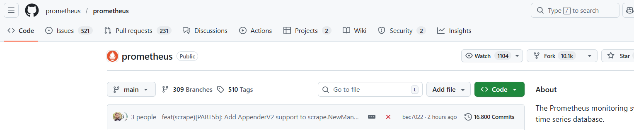

The following subsections describe which GitHub artefacts were collected and how each was used to measure workflow dynamics and CI/CD performance.

1. Pull Requests (PRs)
Data collected
From the Pull Requests section of GitHub repositories, the following information was extracted:
- PR creation timestamp
- PR merge and close timestamps
- PR state (merged, closed, open)
- Number of code additions and deletions
- Number of commits and changed files
- Review events and review timestamps
- Number of reviewers and review comments
Purpose in the study
Pull request data constitutes the primary source for analyzing engineering velocity and process-based technical debt indicators.
Specifically, PR data was used to compute:
- PR Cycle Time (time from creation to merge/closure)
- Review Latency (time from PR creation to first review)
- Review Duration (time from first review to merge)
- Merge Frequency (number of merged PRs per week)
- PR Churn (additions + deletions), used as a proxy for rework and code instability
- Review Overhead, capturing coordination and cognitive load in the review process
These metrics provide insight into development flow, feedback speed, and collaboration efficiency, which are central concepts in both Engineering Velocity and Technical Debt theory.

2. Code Review Information
Data collected
From PR review metadata, the study extracted:
- Review timestamps
- Review counts per PR
- Sequence of review events
Purpose in the study
Review data was used to analyze feedback mechanisms and coordination costs in the development process.
Review-related metrics support:
- the assessment of Fast Feedback capabilities (Accelerate model),
- the identification of review overhead as a form of socio-technical debt,
- the evaluation of how review practices influence overall PR cycle time.

3. GitHub Actions – Workflow Runs (CI/CD Pipelines)
Data collected
From the Actions section of GitHub, metadata for workflow runs was collected, including:
- Workflow name
- Triggering event
- Run start and completion timestamps
- Execution duration
- Run conclusion (success, failure, cancelled, timed out)
- Associated commit SHA (head_sha)
Purpose in the study
Workflow run data was used to evaluate Continuous Integration (CI) and Continuous Delivery (CD) performance.
For CI, this data enabled the computation of:
- CI Duration (median pipeline execution time)
- CI Failure Rate
- CI Flakiness, measured through retry patterns per commit SHA
- Failure Volatility, capturing temporal instability in CI outcomes
For CD, workflow runs were filtered using naming conventions (e.g., “deploy”, “release”) to identify delivery-related pipelines. These were used to compute:
- CD Workflow Success Rate
- CD Pipeline Duration (as a proxy)
These metrics reflect pipeline reliability, automation quality, and operational stability.

4. Releases and Tags
Data collected
From the Releases section of GitHub repositories, the following data was extracted:
- Release creation and publication timestamps
- Release tags and identifiers
Purpose in the study
Release data was used as a proxy for Continuous Delivery, particularly in open-source projects where direct deployment telemetry is unavailable.
Release-based metrics include:
- Release Frequency (number of releases per month)
- Time-to-Release, defined as the time between a PR merge and the subsequent release
These metrics approximate delivery cadence and the speed at which integrated changes reach end users.

5. Repository Metadata
Data collected
General repository metadata was also considered, such as:
- Number of branches and tags
- Commit history size
- Activity indicators (issues, pull requests, contributors)
Purpose in the study
Repository metadata was primarily used for:
- contextualizing the scale and maturity of each project,
- supporting case selection and comparative analysis,
- interpreting observed metric values relative to project size and complexity.

Case Study Projects
Repository Selection and Study Strength
This study analyzes CI/CD performance and engineering velocity across three large open-source projects: prometheus/prometheus, docker/cli, and tektoncd/pipeline. The repositories were selected using a purposeful sampling strategy to ensure variation in CI/CD adoption patterns, pipeline architectures, and automation maturity, while maintaining comparability in terms of project scale, activity level, and industrial relevance.

The prometheus/prometheus repository represents a project that employs GitHub Actions for both Continuous Integration and post-merge automation workflows triggered by push events. These workflows operate beyond pull-request validation and are therefore treated as Continuous Delivery–related automation within the scope of this study. As such, Prometheus serves as a reference case for repositories that integrate CI and CD practices directly within GitHub Actions.

In contrast, the docker/cli repository relies exclusively on pull-request–triggered workflows for build and validation purposes. All observed workflows in this repository correspond to pre-merge Continuous Integration activities, with no evidence of post-merge or release-oriented automation implemented via GitHub Actions. This repository thus functions as a CI-only case, enabling the study to contrast CI performance and stability in the absence of CD practices.

The tektoncd/pipeline repository introduces a third, qualitatively different CI/CD configuration. Rather than focusing on application-level CI or deployment workflows, Tekton represents a cloud-native pipeline framework whose development itself depends on complex, long-running CI pipelines, including scheduled workflows and infrastructure-intensive automation. Although Tekton does not implement Continuous Delivery through GitHub Actions, its pipelines exhibit higher execution times, greater architectural complexity, and stronger dependence on cloud infrastructure compared to the other repositories.

Including tektoncd/pipeline strengthens the study by expanding the empirical scope beyond traditional GitHub Actions–based CI pipelines. It enables the analysis of CI stability, flakiness, and retry behavior in a cloud-native context, where failures may arise from infrastructure and environment-related factors rather than code changes alone. This variation allows the study to capture distinct failure modes and performance characteristics that are not observable in simpler, pull-request–centric CI pipelines.

Overall, the selection of these three repositories enhances the robustness of the study by covering a spectrum of DevOps maturity and pipeline architectures: (1) CI combined with CD automation, (2) CI-only workflows, and (3) advanced, infrastructure-heavy CI pipelines. The observed absence of CD workflows in some repositories is treated as an empirical finding rather than a limitation, reflecting heterogeneous CI/CD adoption patterns in contemporary open-source projects. This diversity strengthens the external validity of the results and supports more nuanced conclusions regarding the relationship between CI/CD practices, pipeline stability, and engineering velocity.

1. Prometheus
Repository:
https://github.com/prometheus/prometheus
Project description:
Prometheus is a widely used open-source monitoring and alerting system and a core project within the Cloud Native Computing Foundation (CNCF). It is designed to collect, store, and query time-series metrics and is extensively adopted in cloud-native, DevOps, and Site Reliability Engineering (SRE) environments.
Relevance to this study:
Prometheus represents a large-scale, mature open-source DevOps project with a long development history and a high level of community engagement. The project employs a pull-request-based development workflow, systematic code reviews, and automated CI pipelines through GitHub Actions. Additionally, Prometheus follows a regular release process, enabling longitudinal analysis of both development and delivery activities.
These characteristics make Prometheus particularly suitable for this study, as it provides rich empirical data for:
- analyzing Engineering Velocity metrics, such as pull request cycle time, review latency, review duration, and merge frequency;
- evaluating CI/CD performance, including pipeline duration, failure rates, execution stability, and feedback speed;
- examining delivery flow and workflow dynamics in a large, production-grade open-source system.
Due to its size and architectural complexity, Prometheus serves as a representative example of a complex DevOps project, enabling a detailed analysis of how CI/CD performance and engineering workflow characteristics evolve over time in large-scale open-source environments.
Due to its size and architectural complexity, Prometheus also serves as a representative example of a complex DevOps system, allowing the study of how technical debt and CI/CD performance evolve in large, production-grade open-source projects.

2. Docker CLI
Repository:
https://github.com/docker/cli
Project description:
Docker CLI is the command-line interface for the Docker platform and constitutes a central component of the Docker ecosystem. It enables users to manage containers, images, volumes, and registries, and plays a critical role in container-based development and deployment workflows commonly used in DevOps practices.
Relevance to this study:
Docker CLI represents a production-critical open-source DevOps tool with a comparatively more focused scope than Prometheus, while still exhibiting a high degree of development activity. The project employs structured pull-request workflows, automated CI pipelines, and frequent releases to maintain stability and backward compatibility.
This makes Docker CLI well suited for this study, as it provides empirical data for:
- assessing CI/CD performance metrics, including CI duration, failure rates, pipeline stability, and release frequency;
- analyzing continuous delivery characteristics, such as time-to-release and release workflow success rates;
- examining engineering workflow efficiency and feedback dynamics through pull request and review activity.
Docker CLI provides a valuable contrast to Prometheus in terms of project size, architectural complexity, and development dynamics, thereby supporting a comparative analysis of CI/CD performance and engineering workflow characteristics across heterogeneous open-source DevOps projects.

3. TektonCD Pipeline
Repository:
https://github.com/tektoncd/pipeline
Project description
Tekton Pipelines is an open-source, cloud-native framework for building, running, and managing Continuous Integration and Continuous Delivery pipelines on Kubernetes. As a core component of the Tekton project under the Continuous Delivery Foundation (CDF), Tekton Pipelines provides declarative, extensible primitives for defining CI/CD workflows as Kubernetes custom resources. The project is widely used in cloud-native DevOps environments and serves as a foundational technology for modern CI/CD systems.
Relevance to this study
TektonCD Pipeline represents a mature and infrastructure-intensive open-source DevOps project whose primary purpose is the development of CI/CD pipeline technology itself. Unlike application-focused repositories, Tekton Pipelines is characterized by complex build and test workflows that validate a distributed, Kubernetes-native system. The project employs automated CI pipelines, including pull-request–triggered workflows, scheduled executions, and auxiliary automation implemented through GitHub Actions.
The inclusion of TektonCD Pipeline strengthens this study by introducing a cloud-native CI context with significantly different pipeline characteristics compared to traditional application repositories. In particular, Tekton pipelines exhibit longer execution times, higher environmental complexity, and stronger dependence on shared infrastructure resources. These properties enable the empirical analysis of CI stability, flakiness, and retry behavior in scenarios where failures may arise from infrastructure and orchestration factors rather than code changes alone.
TektonCD Pipeline provides rich empirical data for:
- analyzing CI pipeline performance in long-running and infrastructure-heavy workflows, including execution time variance and failure frequency;
- examining retry behavior and execution instability in cloud-native CI environments;
- comparing scheduled and event-driven pipeline executions to assess differences in feedback timeliness and reliability;
- investigating how advanced automation and pipeline complexity influence engineering velocity and workflow stability.
By complementing application-centric repositories such as Prometheus and docker/cli, TektonCD Pipeline enables a broader and more nuanced analysis of CI/CD practices across heterogeneous DevOps architectures. Its inclusion allows the study to move beyond conventional CI pipelines and capture failure modes, performance characteristics, and stability challenges that are specific to cloud-native and infrastructure-oriented development contexts. Consequently, TektonCD Pipeline enhances the methodological strength and external validity of the study by expanding the empirical scope to include advanced CI systems that operate under substantially different operational constraints.

Scripts
1. Graph QL
Pull request data was collected using the GitHub GraphQL API. A custom GraphQL query was used to retrieve pull request metadata, review events, and size-related attributes. Pagination was handled using cursor-based traversal to ensure complete data retrieval within the defined time window.

2. Data_Collection.py
The analysis pipeline is organized as a reproducible workflow with three stages:
- Raw data collection (GitHub)
  - GitHub Pull Request and review data are collected and stored as CSV files.
  - GitHub Actions workflow run data are collected as CI/CD execution logs (metadata).
  - GitHub Releases data are collected as a proxy for delivery cadence (CD).
- Metric computation (per-metric scripts)
Each metric is computed by an independent script under scripts/metrics/.
This structure improves reproducibility and isolates metric definitions.
- Visualization scripts
Selected derived datasets are visualized using Matplotlib and saved as publication-quality figures.
All scripts assume a consistent folder structure:
- data/raw/ contains raw datasets (PRs, workflow runs, releases)
- data/derived/ contains computed metric tables
- figures/ contains exported plots used in the Results chapter

Script Catalogue
Metrics were computed using a modular script-based pipeline. Pull request and review data were used to derive engineering velocity measures such as PR cycle time, review latency, review duration, and merge frequency. GitHub Actions workflow run metadata were used to compute CI performance (duration, failure rate) and CI flakiness proxies (retries per commit SHA and failure volatility). Continuous Delivery was operationalized through release-based proxies (release frequency and time-to-release) and through deployment/release workflow success rates inferred from workflow naming patterns. Technical debt was assessed using both process-based proxies (PR churn, review overhead, CI flakiness).
Below is a script-by-script explanation.

Engineering Velocity (PR / Review Flow)
Engineering Velocity refers to the ability of a software team to deliver changes continuously and sustainably through efficient development flow, fast feedback, and stable automation. Unlike traditional productivity measures, Engineering Velocity emphasizes process efficiency and learning speed rather than output volume.
PR_Cycle.py
Category: Engineering Velocity
Goal: Measure PR cycle time (time from PR creation to completion).
Typical definition:
- PR Cycle Time = done_at − created_at
where done_at is merged_at if merged, otherwise closed_at.
Raw inputs: data/raw/prs.csv
Outputs: data/derived/pr_cycle_*.csv (your naming)

Review_Latency.py
Category: Engineering Velocity (also used in TD Review Overhead)
Goal: Measure time to first review (feedback speed).
Definition:
- Review Latency = first_review_at − created_at
Inputs: data/raw/prs.csv
Outputs: data/derived/review_latency_*.csv

review_duration.py
Category: Engineering Velocity (also used in TD Review Overhead)
Goal: Measure time from first review until PR completion.
Definition:
- Review Duration = done_at − first_review_at
Inputs: data/raw/prs.csv
Outputs: data/derived/review_duration_*.csv

merge_frequency_weekly.py
Category: Engineering Velocity / Delivery Flow
Goal: Compute merge throughput per week.
Definition:
- Merge Frequency (weekly) = count(merged PRs in week)
Inputs: data/raw/prs.csv
Outputs: data/derived/merge_frequency_weekly.csv

CI Metrics (Pipeline Performance)
CI_Duration-Failure-Rate.py
Category: CI
Goal: Measure CI runtime and CI failure rate over time.
Definitions (weekly):
- CI Duration (median) = median(updated_at − run_started_at)
- CI Failure Rate = failed_runs / all_runs
Inputs: data/raw/workflow_runs.csv
Outputs: typically:
- data/derived/ci_duration_weekly.csv
- data/derived/ci_failure_rate_weekly.csv

ci_flakiness_retry_weekly.py
Category: CI + Technical Debt (pipeline/test debt proxy)
Goal: Estimate CI flakiness using retry behaviour per commit SHA.
Definition (weekly):
- group by head_sha → count runs per SHA
- avg_runs_per_sha and/or p95_runs_per_sha
Interpretation: values > 1.0 indicate reruns for the same commit, often due to flaky tests or unstable pipelines.
Inputs: data/raw/workflow_runs.csv
Outputs: data/derived/ci_flakiness_retry_weekly.csv

ci_failure_volatility_weekly.py
Category: CI + Technical Debt (pipeline/test debt proxy)
Goal: Measure instability in CI failure rate over time.
Definition:
- compute weekly failure rate
- compute volatility via rolling standard deviation (e.g., 8-week window)
Inputs: data/raw/workflow_runs.csv
Outputs: data/derived/ci_failure_volatility_weekly.csv

CD Metrics (Proxies)
Because most open-source projects do not expose production deployment telemetry, CD is approximated using:
- GitHub Releases (delivery events)
- “deploy/release/publish” workflow runs (workflow-name proxy)
release_frequency_monthly.py
Category: CD (proxy)
Goal: Measure how often releases are published.
Definition:
- Release Frequency (monthly) = count(releases per month)
Inputs: data/raw/releases.csv
Outputs: data/derived/release_frequency_monthly.csv

time_to_release_monthly.py
Category: CD (proxy)
Goal: Measure how quickly merged work reaches a release.
Definition:
For each merged PR, find the next release timestamp:
- Time-to-Release = release_time − merged_at
Aggregated monthly (median).
Inputs: data/raw/prs.csv + data/raw/releases.csv
Outputs: data/derived/time_to_release_monthly.csv

cd_workflow_success_weekly.py
Category: CD (proxy)
Goal: Estimate release/deployment pipeline reliability.
Method: Identify CD-related workflows by name patterns (e.g., “deploy”, “release”, “publish”, “cd”) and compute weekly success rate.
Definition:
- CD Success Rate = 1 − CD Failure Rate
Inputs: data/raw/workflow_runs.csv
Outputs: data/derived/cd_workflow_success_weekly.csv
Thesis limitation note: this CD classification depends on naming conventions and is therefore an approximation.

Technical Debt Metrics (Strong TD Package)
pr_churn.py
Category: Technical Debt (proxy)
Goal: Use change volume as a rework/complexity indicator.
Definition:
- PR Churn = additions + deletions
Inputs: data/raw/prs.csv
Outputs: data/derived/pr_churn_*.csv

review_overhead_weekly.py
Category: Technical Debt (proxy) + Engineering Velocity
Goal: Quantify review burden as a potential debt signal.
Typical weekly outputs:
- median review latency
- median review duration
- median review count
Inputs: data/raw/prs.csv
Outputs: data/derived/review_overhead_weekly.csv

Accelerate / Capability Mapping & Research Design Figures
These scripts support your Accelerate operationalization and your thesis visuals.
Capabilities.py
Category: Accelerate Operationalization
Goal: Defines the mapping between metrics and Accelerate capabilities (e.g., CI capability ↔ CI duration/failure; fast feedback ↔ review latency; trunk-based ↔ merge frequency).
Output: typically a table/CSV or constants used by other scripts.

Observability_of_capabilities.py
Category: Accelerate Discussion
Goal: Create the “observability score” figure/table showing which Accelerate capabilities are observable via GitHub
Output: figures/Observability_of_capabilities.png (or similar)

Research_Design.py
Category: Methodology Figure
Goal: Generate the research design diagram (data sources → metrics → capability analysis).
Output: research design figure for your Methodology chapter.

plot_ci_flakiness.py
Category: Visualization
Goal: Plot ci_flakiness_retry_weekly.csv (or similar) as a time series.

Quick Mapping Table (CI vs CD vs TD)
CI
- CI_Duration-Failure-Rate.py
- ci_flakiness_retry_weekly.py
- ci_failure_volatility_weekly.py
CD (proxies)
- release_frequency_monthly.py
- time_to_release_monthly.py
- cd_workflow_success_weekly.py
Technical Debt
- pr_churn.py
- review_overhead_weekly.py
- ci_flakiness_retry_weekly.py (proxy for test/pipeline debt)
- ci_failure_volatility_weekly.py (proxy for pipeline instability)
- sonar_snapshots_tidy.py (direct/static TD measures)
Engineering Velocity / Flow
- PR_Cycle.py
- Review_Latency.py
- review_duration.py
- merge_frequency_weekly.py
Accelerate Operationalization / Thesis Figures
- Capabilities.py
- Observability_of_capabilities.py
- Research_Design.py

Figurs:
Accelerate Operationalization / Thesis Figures

  - Research_Design.py

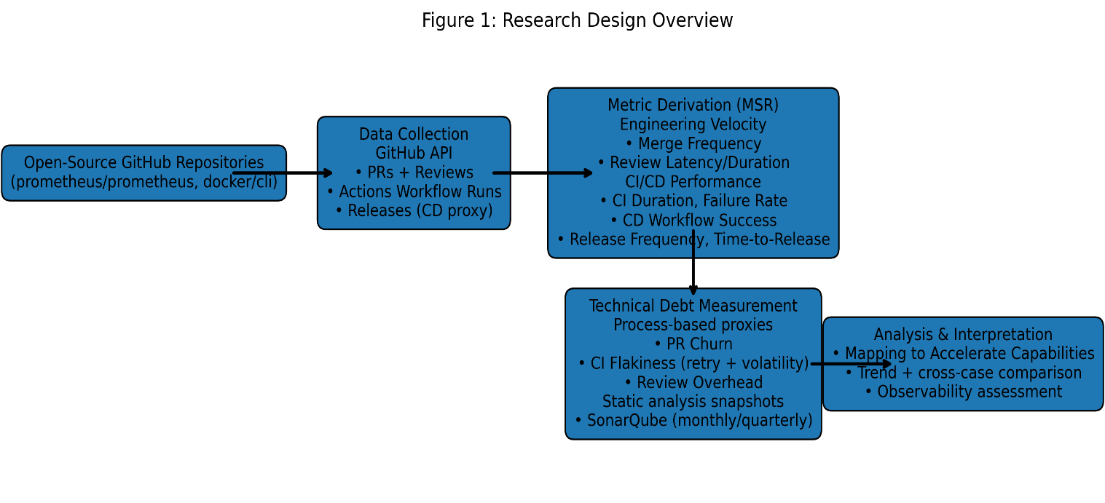

  - Observability_of_capabilities.py

Observability of Accelerate Capabilities via GitHub Data
Figure 6 summarizes the extent to which key Accelerate capabilities can be observed and operationalized using publicly available GitHub data. Each bar represents an observability score on a 0–5 scale, where higher values indicate stronger and more direct measurability through repository artifacts such as pull requests, commits, workflows, and releases.
Capabilities related to Continuous Integration and Fast Feedback achieve the highest observability scores, reflecting the availability of rich and reliable signals in GitHub Actions data, including CI execution times, failure rates, and retry behavior. Trunk-based Development and Automated Testing are also highly observable, as they can be inferred from pull request practices, merge frequency, test execution in CI pipelines, and review dynamics.
In contrast, Observability and Lean Management receive lower scores, as these capabilities are only partially reflected in GitHub metadata and often require contextual or organizational information that is not directly encoded in repository activity. Culture exhibits the lowest observability, highlighting a fundamental limitation of repository-mining approaches: cultural and social factors central to high-performing teams cannot be reliably inferred from GitHub data alone.
Overall, the figure illustrates both the strengths and limitations of Mining Software Repositories (MSR) for studying the Accelerate model. While technical and process-oriented capabilities are highly measurable, organizational and cultural capabilities remain largely opaque when relying solely on GitHub-based metrics.
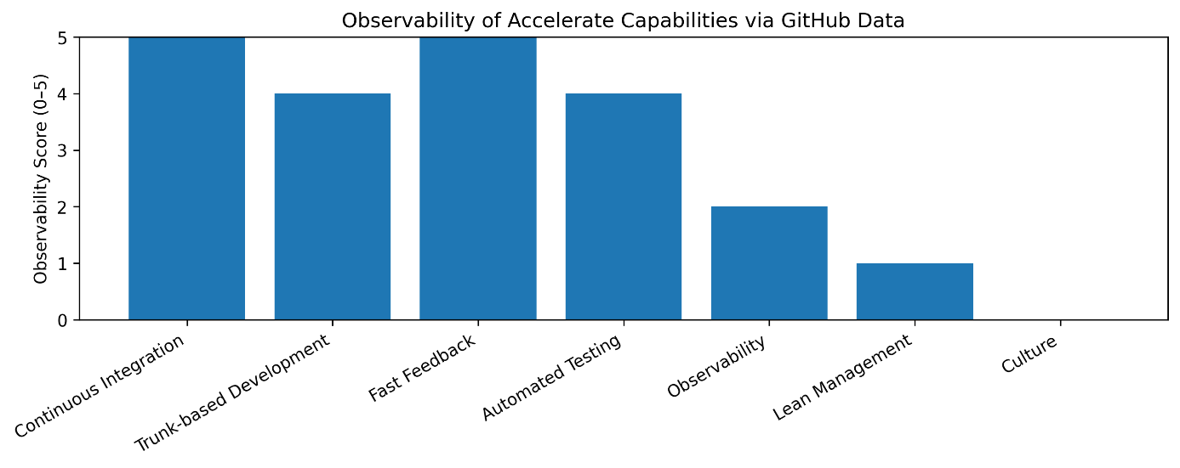

  - Capabilities.py
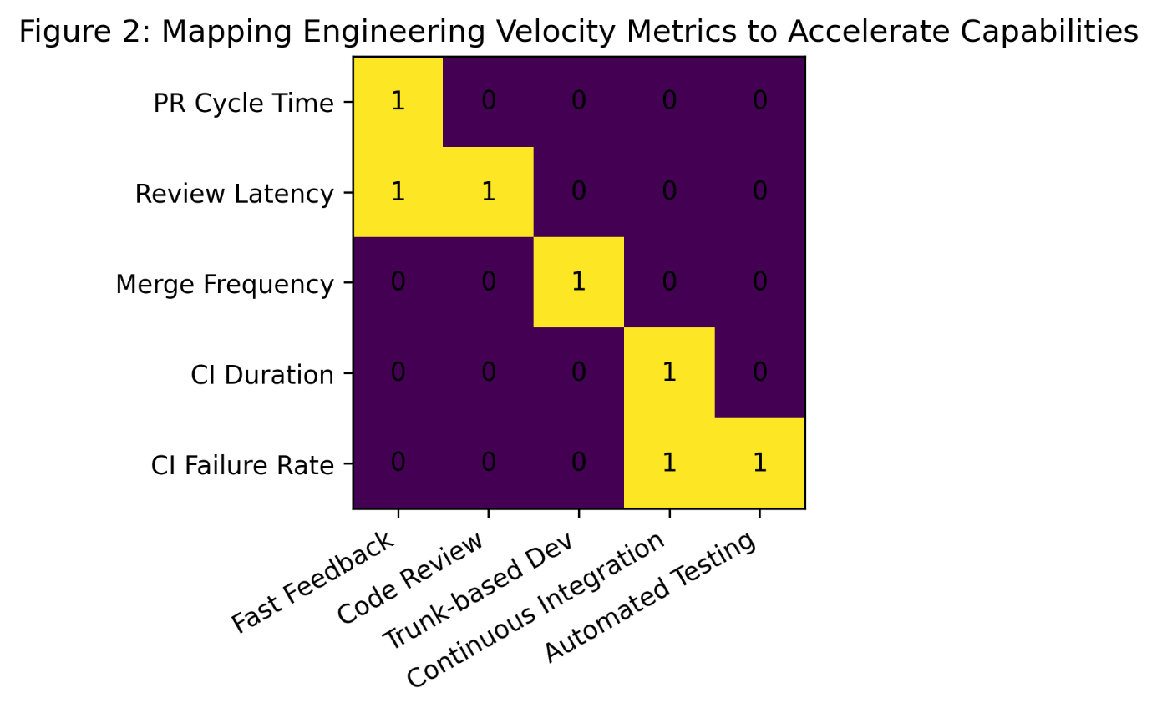

CI
  - CI_Duration-Failure-Rate.py.
The figure illustrates the weekly CI failure rate for docker/cli and prometheus/prometheus. Both projects exhibit persistent CI failures, typically ranging between 5% and 25%, highlighting the ongoing challenges of maintaining reliable CI pipelines in large open-source systems. While docker/cli demonstrates relatively stable behavior, prometheus/prometheus shows higher volatility with several pronounced spikes, likely reflecting periods of increased change activity or infrastructure instability.
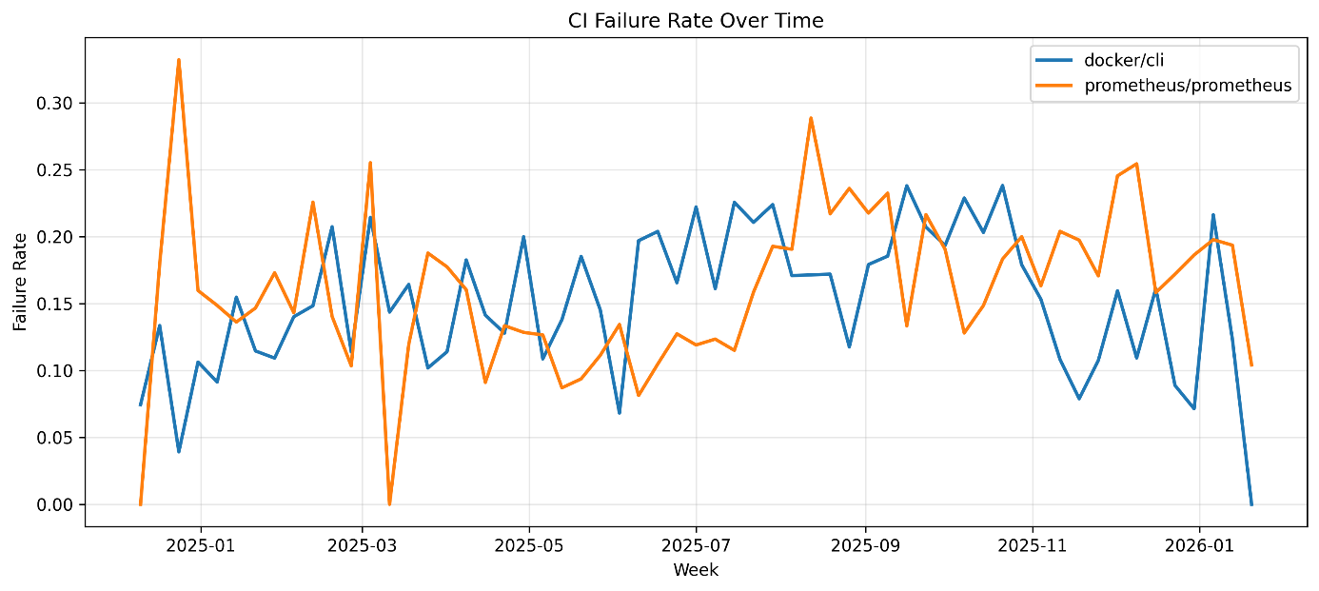
The figure shows the median CI duration per week for docker/cli and prometheus/prometheus. The results indicate that docker/cli maintains a consistently low and stable CI duration throughout the observation period, whereas prometheus/prometheus exhibits higher variability and longer CI execution times in earlier periods, followed by a gradual stabilization.

Time span: Min: 2024-11-26 21:47:24+00:00 Max: 2026-01-26 17:21:34+00:00 Days: 425 Rows: 64798 Repos: ['prometheus/prometheus' 'docker/cli' 'tektoncd/pipeline'] Outlier filter: removed 3262 rows using MAX_CI_MINUTES=360

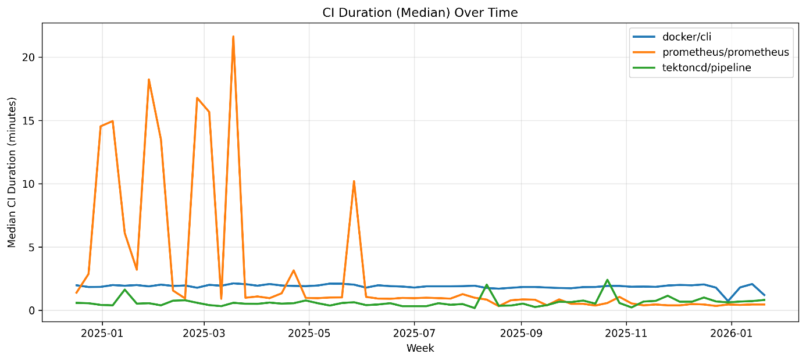

  - ci_flakiness_retry_weekly.py
CI flakiness represents a form of pipeline-level technical debt, where intermittent failures reduce the reliability of automated feedback and increase developer waiting time.
Sanity check summary (overall):
docker/cli {'count': 15241.0, 'mean': 1.2324650613476806, 'std': 0.9119135762671765, 'min': 1.0, '50%': 1.0, '90%': 1.0, '95%': 3.0, '99%': 6.0, 'max': 13.0}
prometheus/prometheus {'count': 25135.0, 'mean': 1.08116172667595, 'std': 0.4420068096728035, 'min': 1.0, '50%': 1.0, '90%': 1.0, '95%': 2.0, '99%': 3.0, 'max': 18.0}
tektoncd/pipeline {'count': 11514.0, 'mean': 1.6361820392565571, 'std': 3.960556049098804, 'min': 1.0, '50%': 1.0, '90%': 1.0, '95%': 3.0, '99%': 17.0, 'max': 109.0}
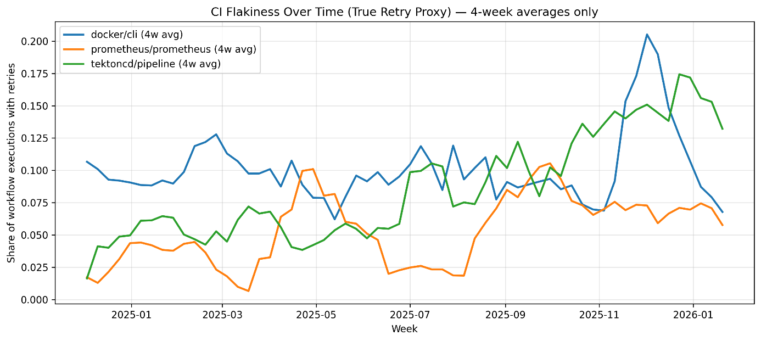
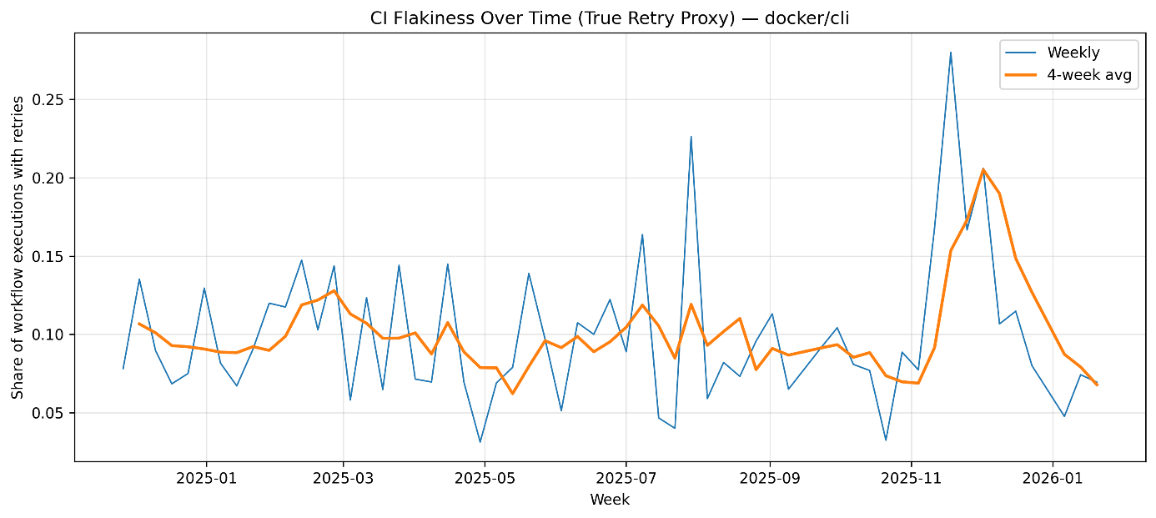
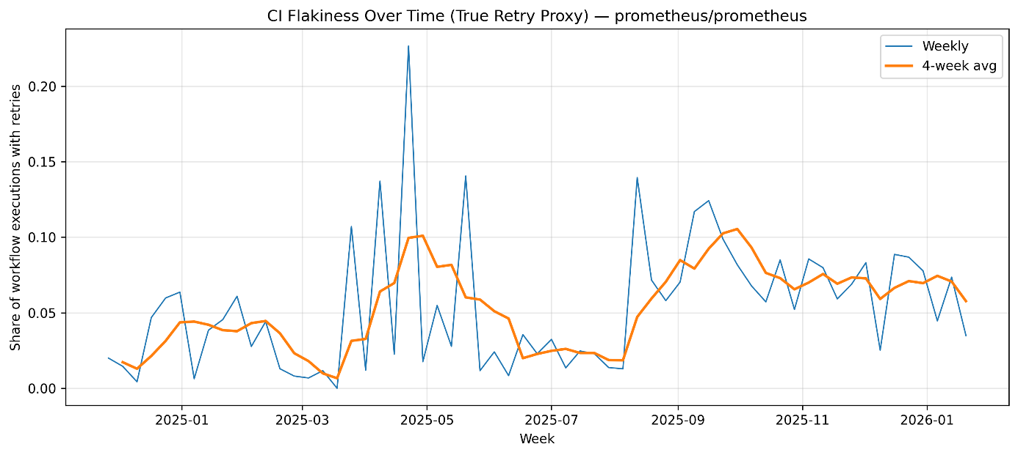
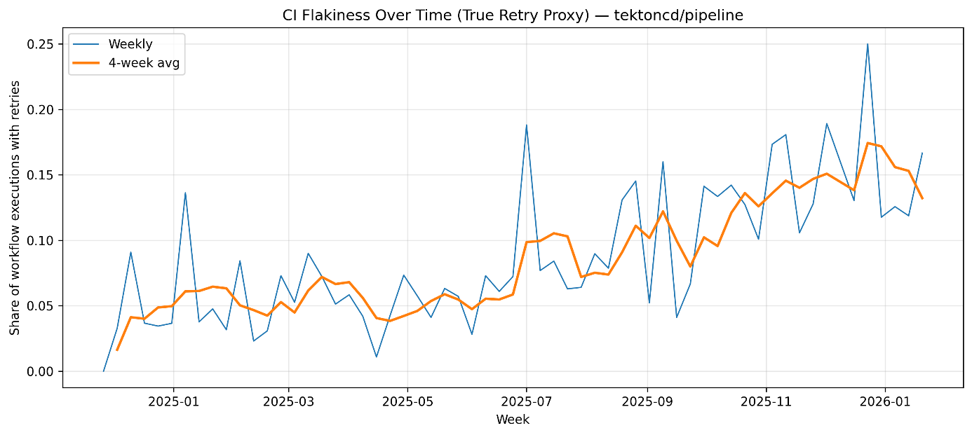

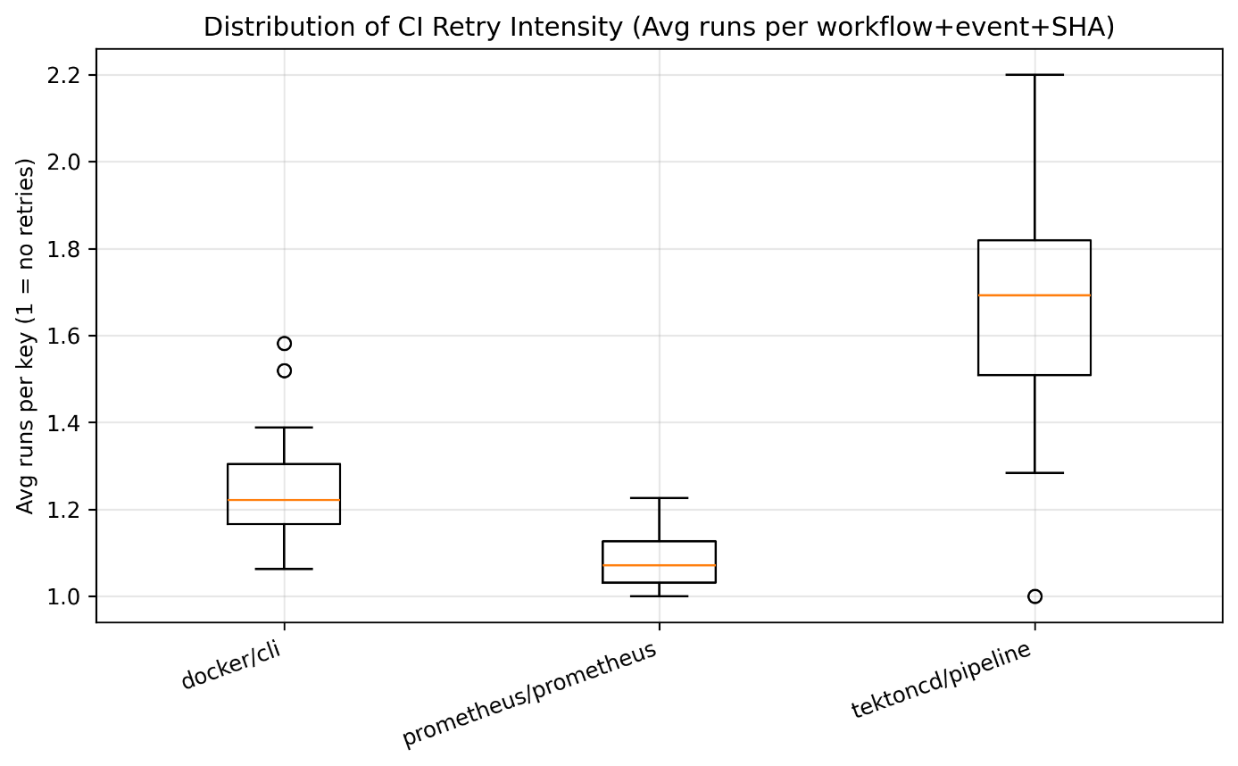

  - ci_failure_volatility_weekly.py
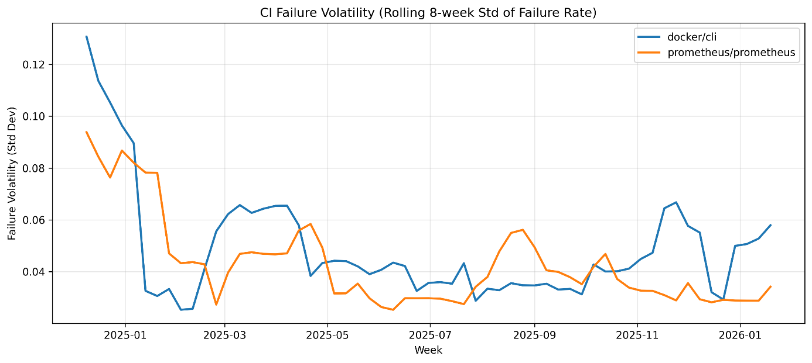

CD (proxies)
In this study, Continuous Delivery (CD) workflows were identified using an event-based proxy derived from GitHub Actions metadata. Specifically, workflows triggered by post-merge events—such as push, release, or workflow_dispatch—were classified as CD-related, as they represent automation executed after code integration and are commonly associated with delivery or deployment activities.

Using this definition, CD data were observed exclusively for the prometheus repository, while no CD workflows were detected for docker/cli and tektoncd/pipeline within the analyzed dataset. This outcome is attributable to substantive differences in CI/CD practices across the studied repositories rather than limitations of the data collection or analysis approach.

The prometheus/prometheus repository includes GitHub Actions workflows triggered by push events on the main branch. These workflows are executed after code integration and perform repository-level automation tasks, such as security checks and post-merge validation. From a DevOps and CI/CD perspective, such workflows qualify as Continuous Delivery–related automation, as they operate beyond pull-request validation and contribute to post-merge pipeline reliability and release readiness.

In contrast, the docker/cli repository relies exclusively on workflows triggered by pull_request events, such as build and validation pipelines. These workflows are confined to pre-merge verification and represent Continuous Integration (CI) activities only. No workflows triggered by post-merge events (e.g., push or release) were observed in the dataset, indicating that CD practices are either not implemented via GitHub Actions for this repository or are managed through external release infrastructure outside the scope of the collected data.

Similarly, the tektoncd/pipeline repository primarily employs workflows triggered by schedule and issue_comment events, corresponding to nightly builds and tooling automation. While these workflows support maintenance and continuous testing, they do not constitute Continuous Delivery in the strict sense, as they are not directly associated with post-merge delivery or release execution. Consequently, they were excluded from the CD classification in this study.

Overall, the presence of CD data for only one repository reflects heterogeneous CI/CD adoption patterns across open-source projects. While some repositories integrate delivery-oriented automation directly within GitHub Actions, others restrict GitHub Actions usage to CI or auxiliary automation, delegating CD responsibilities to alternative tooling or organizational processes. This heterogeneity represents an empirical finding of the study and highlights the importance of repository-specific CI/CD architectures when analyzing delivery performance metrics.
  - release_frequency_monthly.py
the figure shows the weekly and monthly merge frequency for the studied projects. The results indicate that docker/cli maintains a relatively stable and high merge throughput, while prometheus/prometheus exhibits greater variability. The rolling average highlights longer-term trends and mitigates short-term fluctuations caused by release cycles or contributor activity.

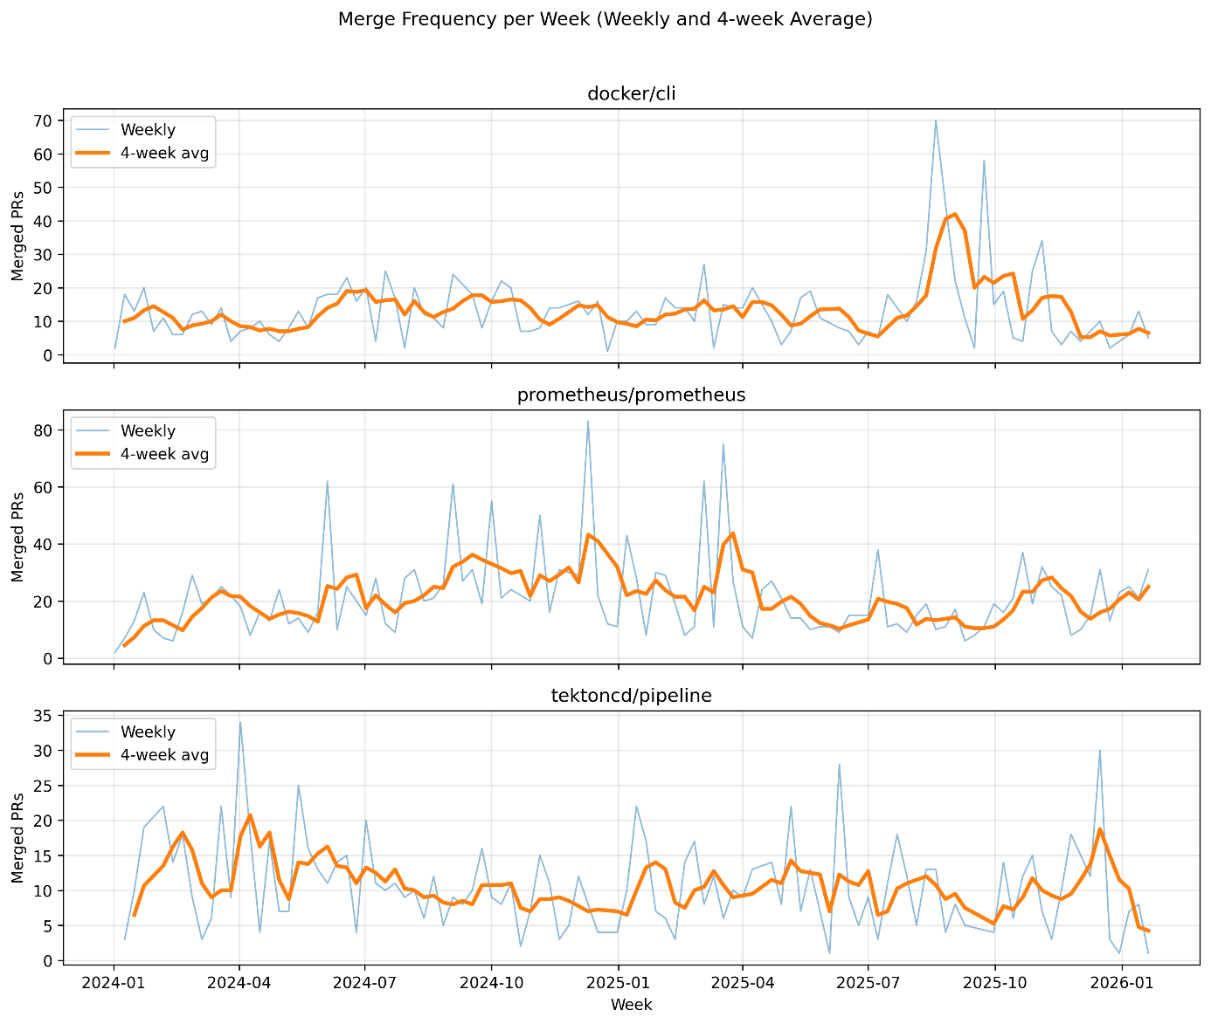
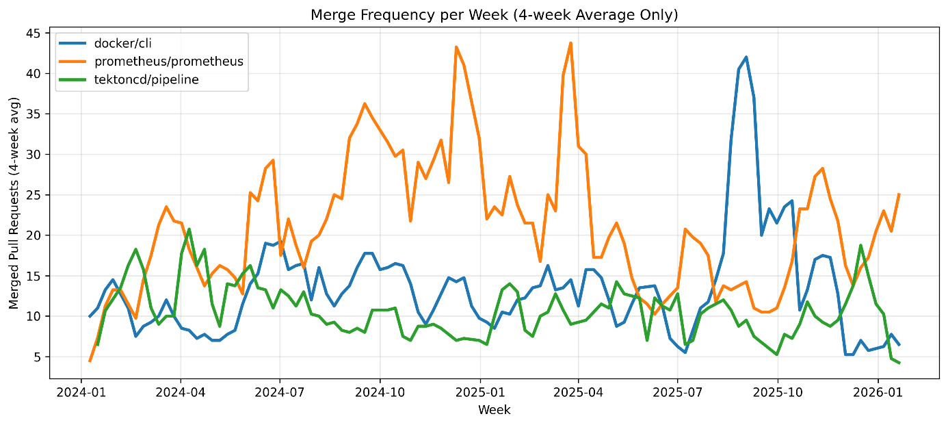
  - time_to_release_monthly.py
Time-to-Release was computed as the elapsed time between the merge date of a pull request and the publication date of the subsequent GitHub release in which the change was included. This metric relies exclusively on pull request and release metadata and does not require the presence of automated CD workflows.
Repositories exposing regular release signals, such as prometheus/prometheus and tektoncd/pipeline, were therefore eligible for Time-to-Release analysis, whereas repositories without a stable release cadence were excluded from this metric.
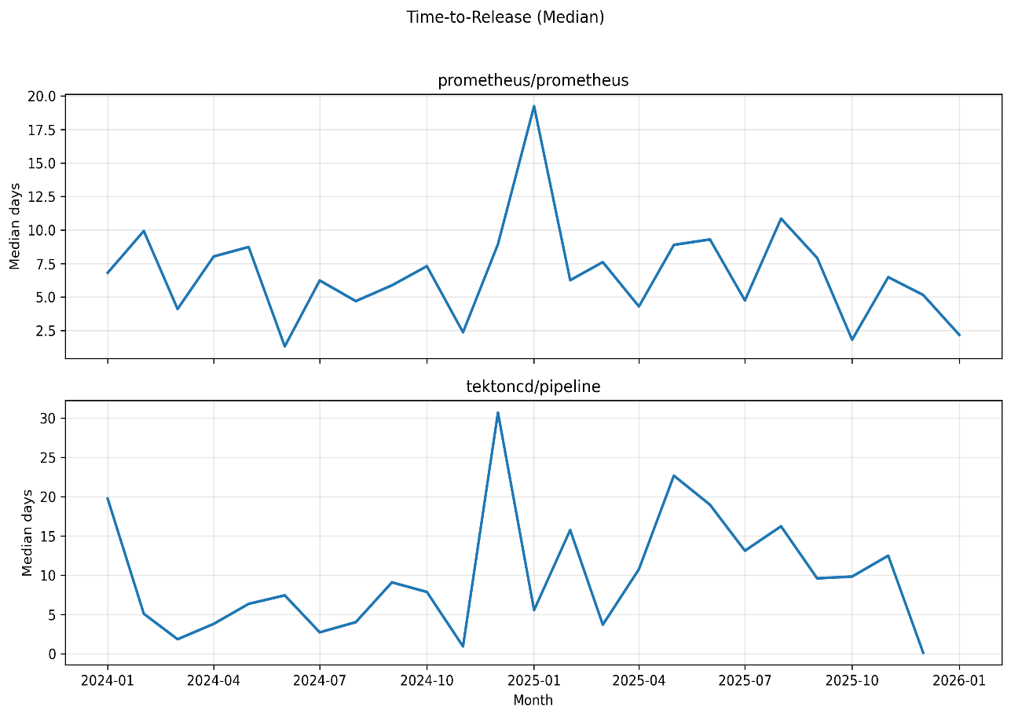
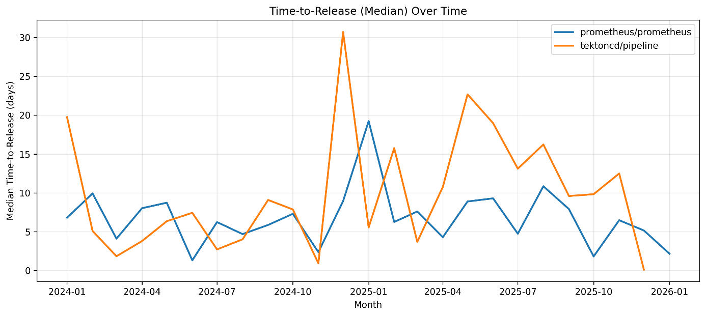
  - cd_workflow_success_weekly.py
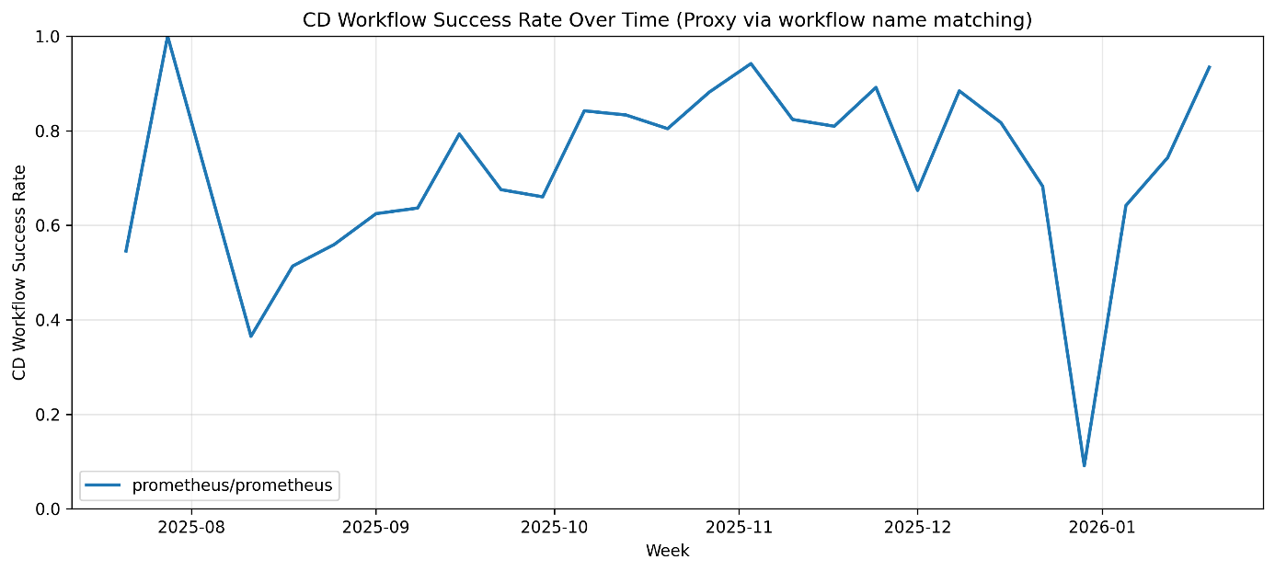

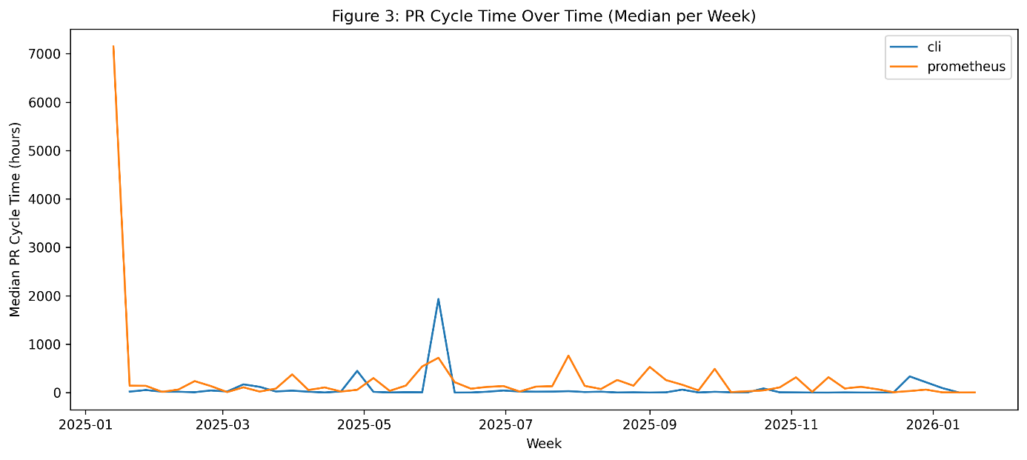

Technical Debt
1.pr_churn.py
Figur 10 viser median Pull Request (PR) cycle time per uke for docker/cli og prometheus/prometheus.
Over tid har docker/cli generelt lav og stabil PR cycle time, noe som indikerer rask feedback og effektiv gjennomstrømning. Enkelte ekstreme topper (f.eks. midten av 2025) skyldes trolig enkelt-PR-er som har vært åpne over lang tid, og påvirker medianen i uker med få PR-er.
prometheus/prometheus viser høyere variabilitet og flere perioder med forhøyet PR cycle time, noe som kan indikere mer komplekse endringer, strengere review-prosesser eller høyere koordinasjonskostnader. Samlet sett illustrerer figuren tydelige forskjeller i utviklingsflyt mellom prosjektene, til tross for at begge følger moderne DevOps-praksiser.
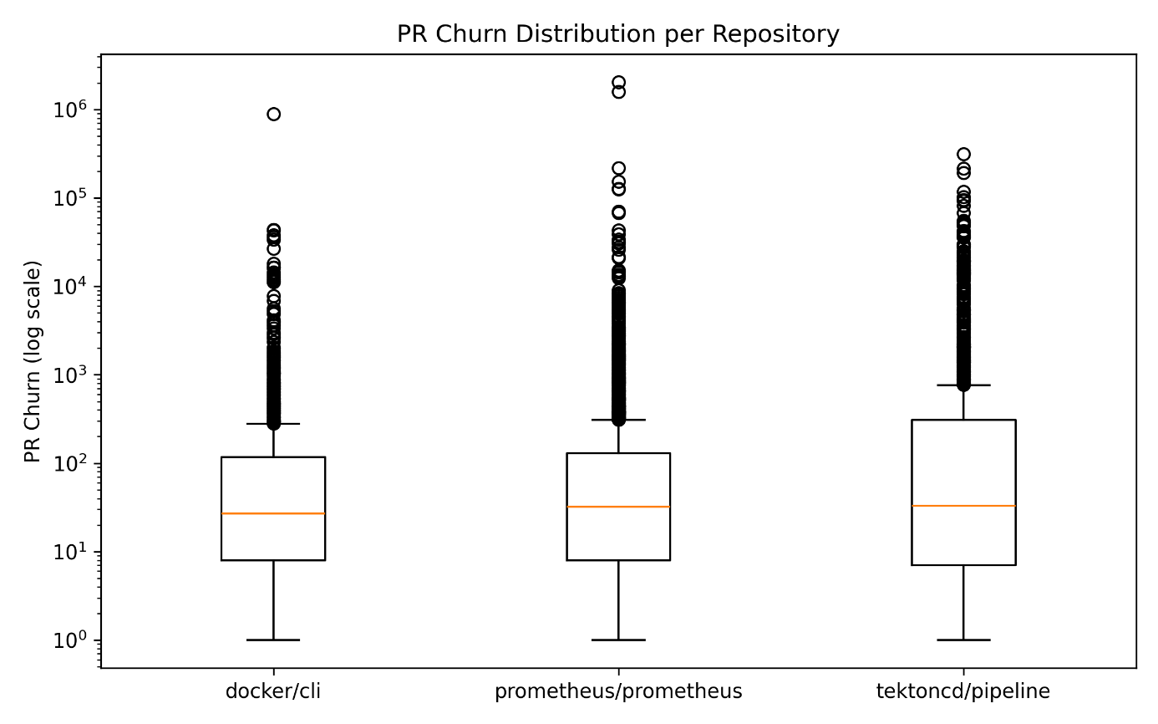
  - review_overhead_weekly.py
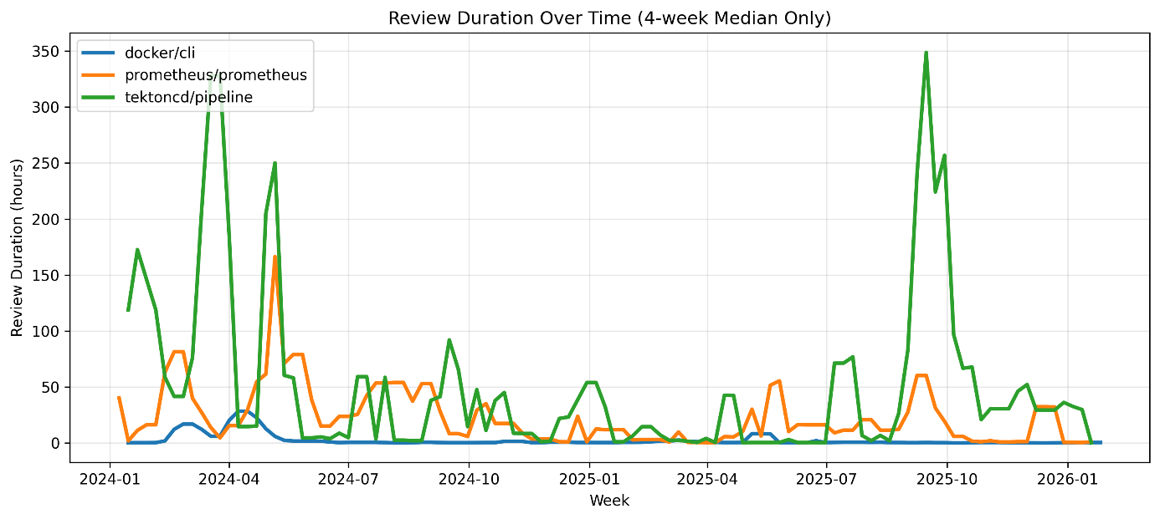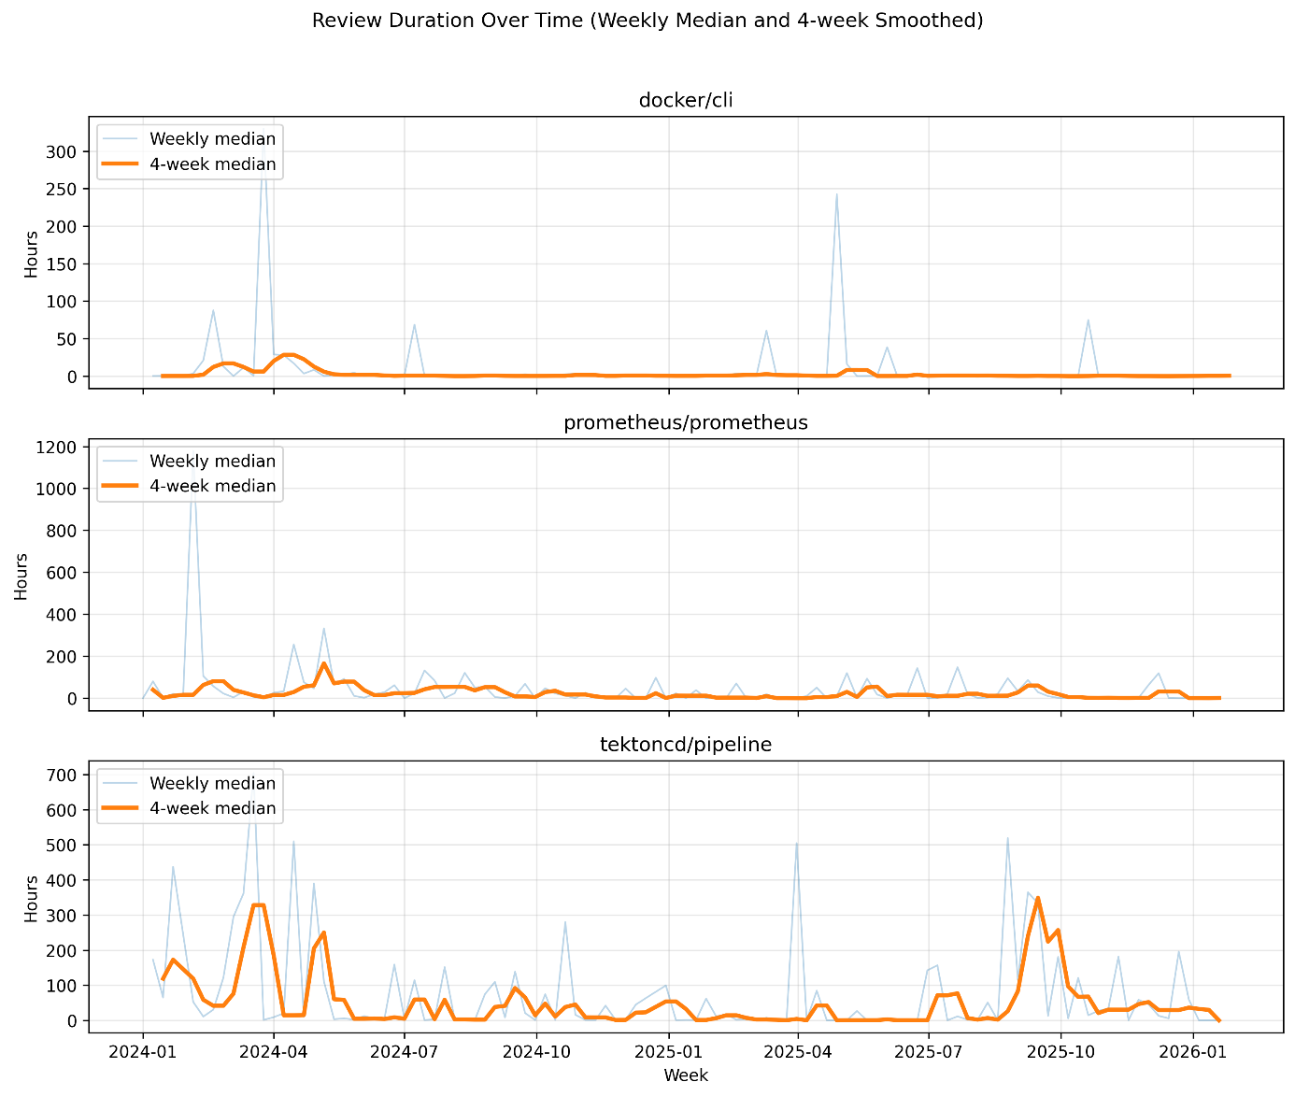
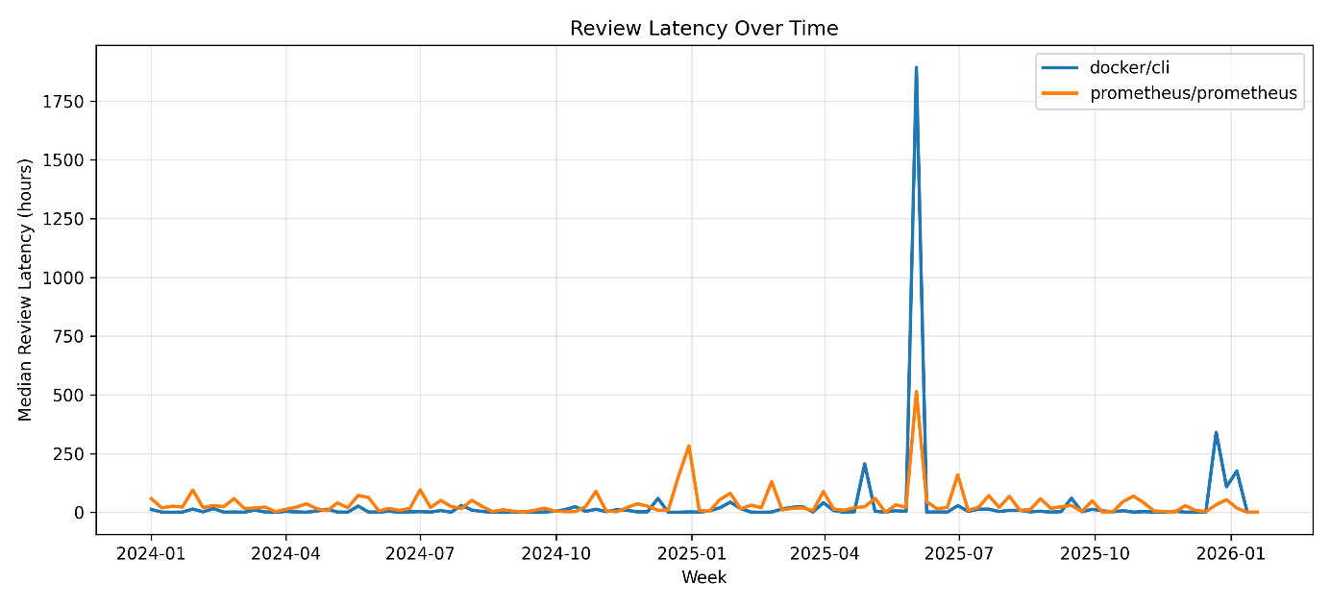
  - ci_flakiness_retry_weekly.py (proxy for test/pipeline debt)
  - ci_failure_volatility_weekly.py (proxy for pipeline instability)
  - sonar_snapshots_tidy.py (direct/static TD measures)
????
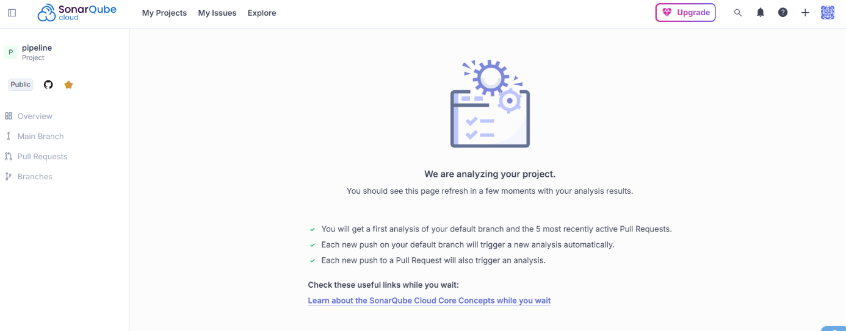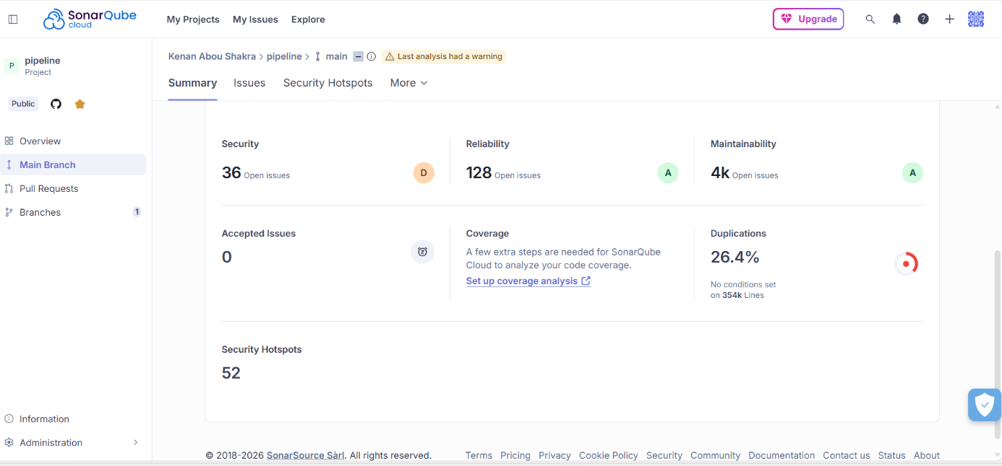
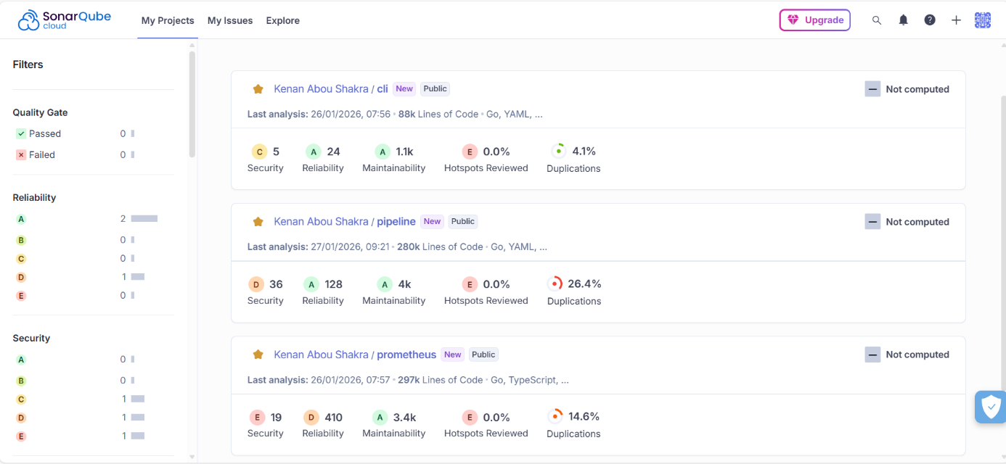
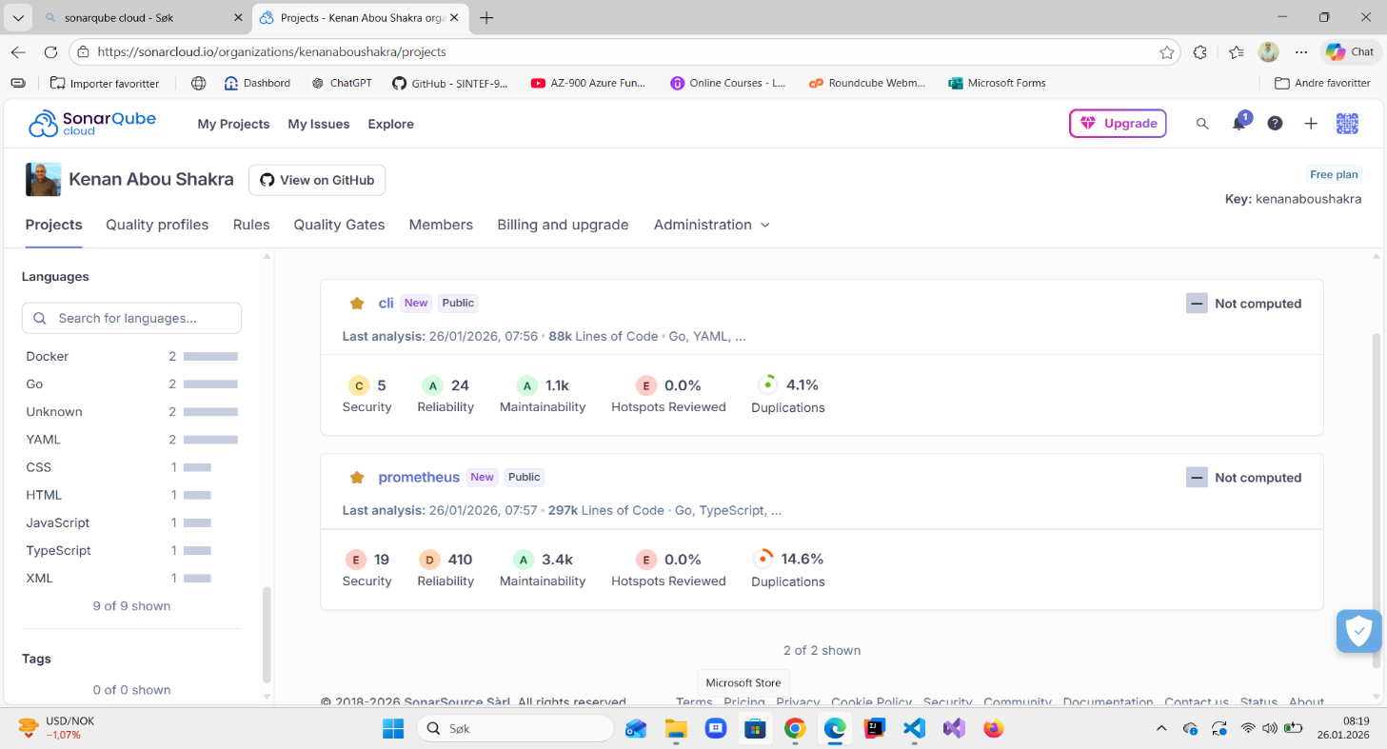
Project 1: Docker CLI (docker/cli)
Last analysis: 26 January 2026
Lines of Code (LoC): ~88,000
Languages: Go, YAML
- Maintainability: A
  - Approximately 1,100 code smells, representing code-level technical debt as estimated by SonarQube.
- Reliability: A
  - 24 reliability-related issues (bugs).
- Security: C
  - 5 security-related issues.
- Code Duplications: 4.1%
Interpretation:
The Docker CLI project exhibits low to moderate code-level technical debt, with a strong maintainability rating and relatively low duplication density. The results suggest that, despite its size, the project maintains a generally healthy codebase with manageable technical debt.

Project 2: Prometheus (prometheus/prometheus)
Last analysis: 26 January 2026
Lines of Code (LoC): ~297,000
Languages: Go, TypeScript
- Maintainability: A
  - Approximately 3,400 code smells, indicating a higher absolute volume of technical debt compared to Docker CLI.
- Reliability: D
  - 410 reliability-related issues (bugs).
- Security: E
  - 19 security-related issues.
- Code Duplications: 14.6%
Interpretation:
Although Prometheus achieves a high maintainability rating, the project shows substantially higher levels of code duplication and reliability issues. This suggests a more complex and heterogeneous codebase, where technical debt accumulates at a larger scale, likely influenced by project size, architectural complexity, and long-term evolution.

Cross-Project Comparison
- Both projects achieve Maintainability grade A, indicating acceptable overall maintainability according to SonarQube.
- Prometheus exhibits significantly higher technical debt volume in absolute terms (code smells and duplication), which correlates with its larger size and complexity.
- Docker CLI demonstrates lower duplication and fewer reliability issues, suggesting more stable internal structure relative to its size.

Engineering Velocity / Flow
- PR_Cycle.py
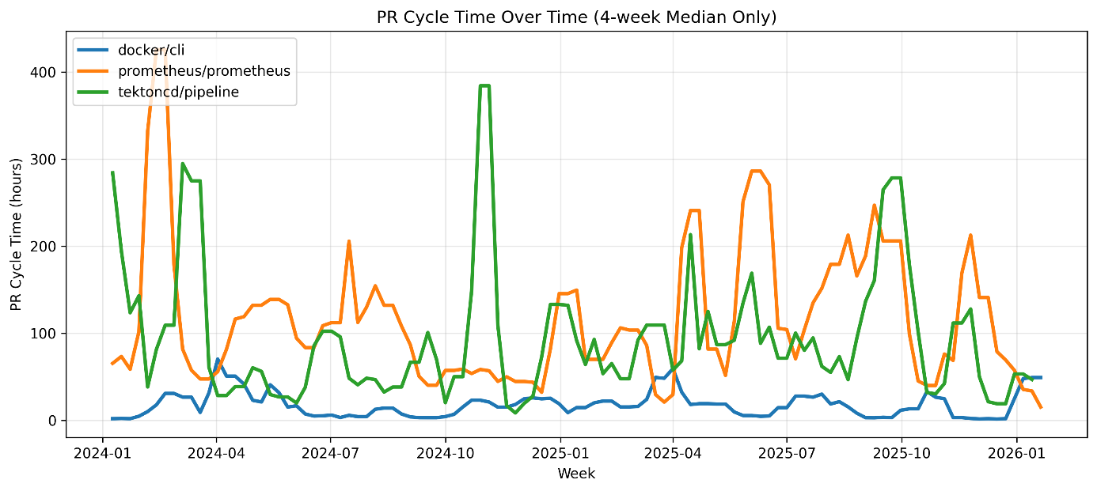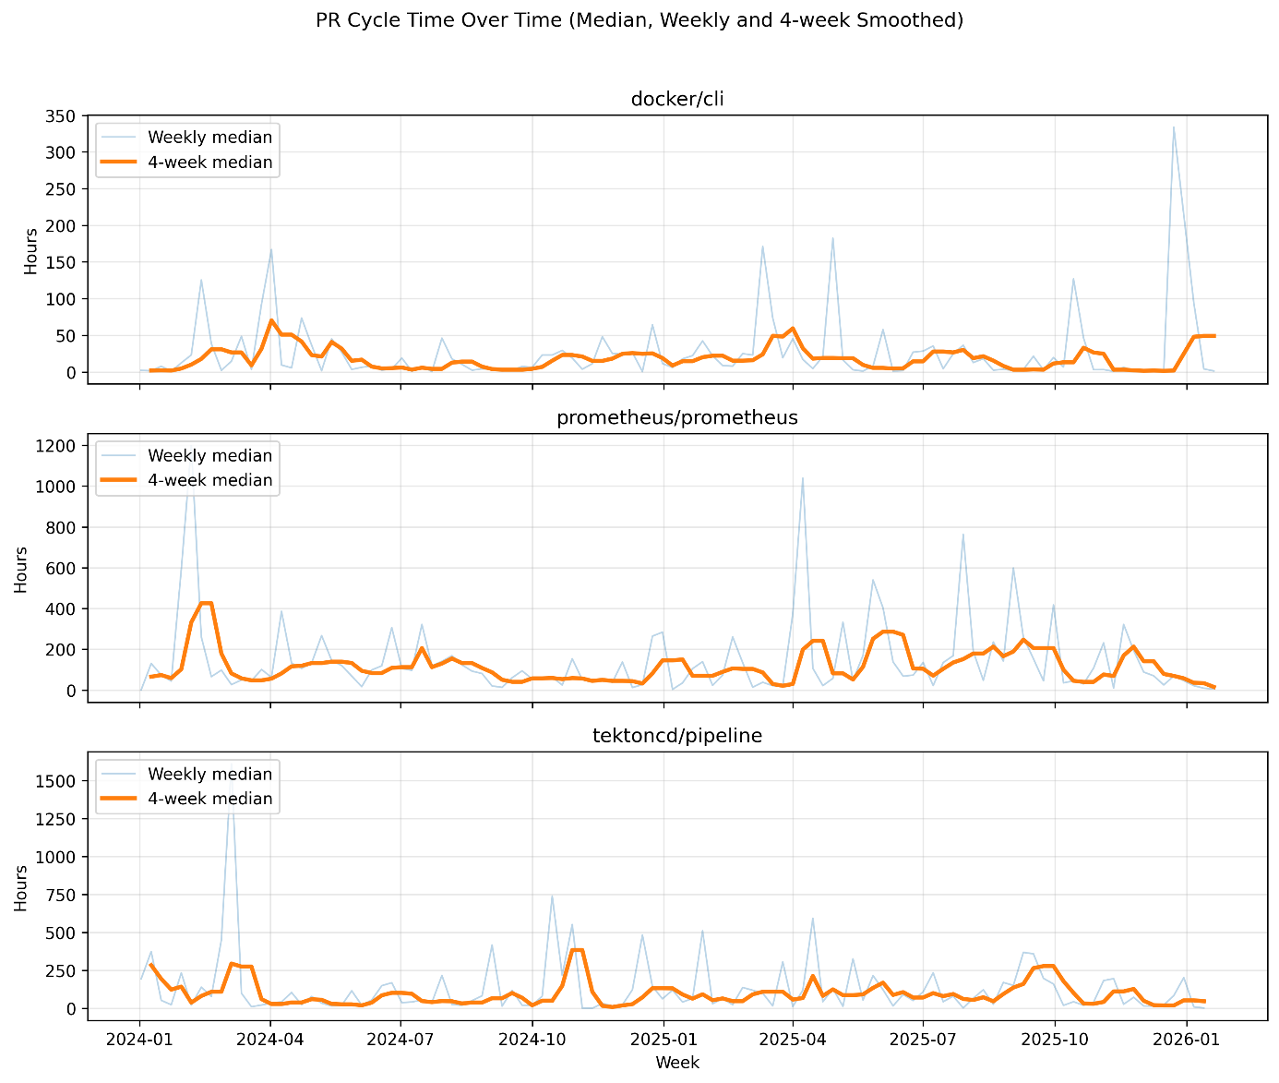

- Review_Latency.py
Review Latency Distribution by Project
This figure shows the distribution of pull request review latency (time from PR creation to first review) for docker/cli and prometheus/prometheus. The results indicate a clear difference in review dynamics between the two projects. docker/cli exhibits a consistently low review latency with a narrow interquartile range, suggesting fast and predictable reviewer feedback. In contrast, prometheus/prometheus shows substantially higher median review latency and a much wider distribution, indicating greater variability and longer delays before reviews occur. This suggests differences in project scale, reviewer availability, and review processes, which directly impact feedback speed and engineering velocity.
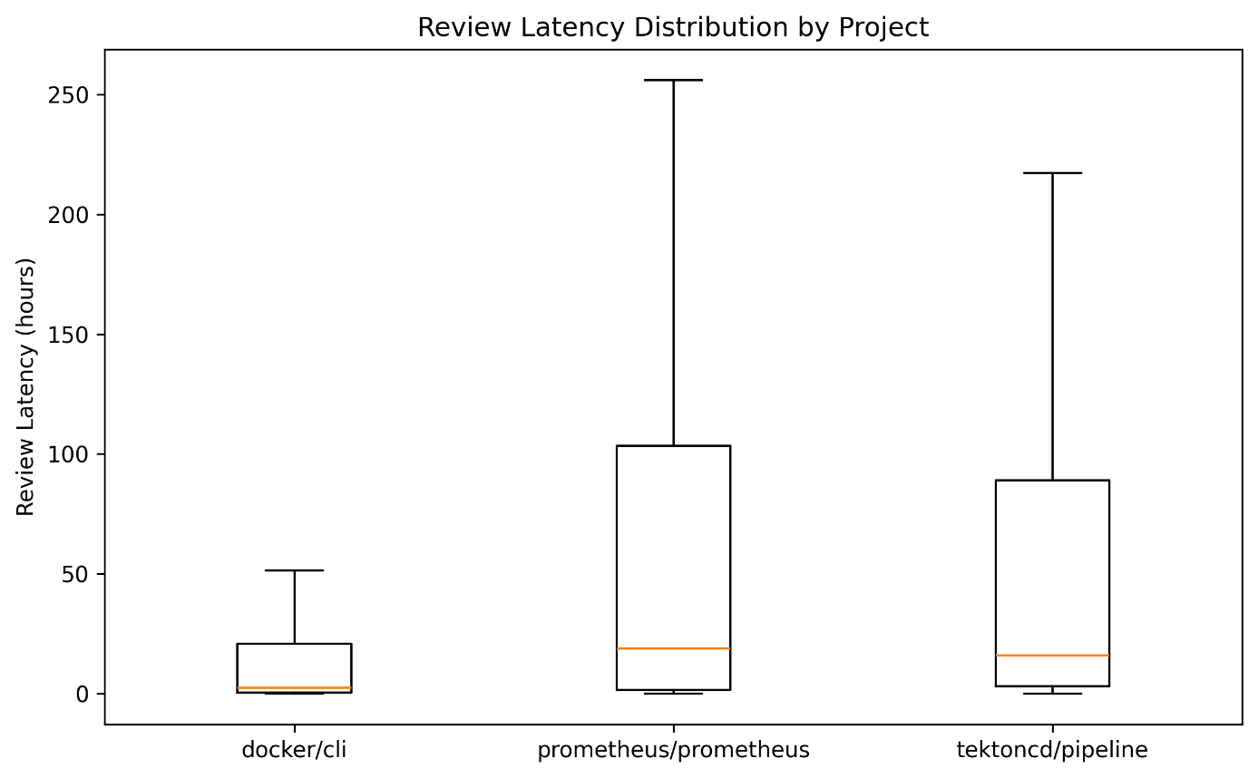
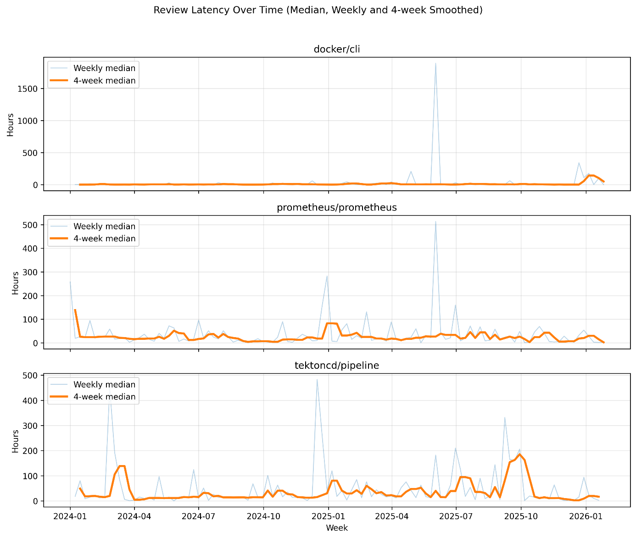
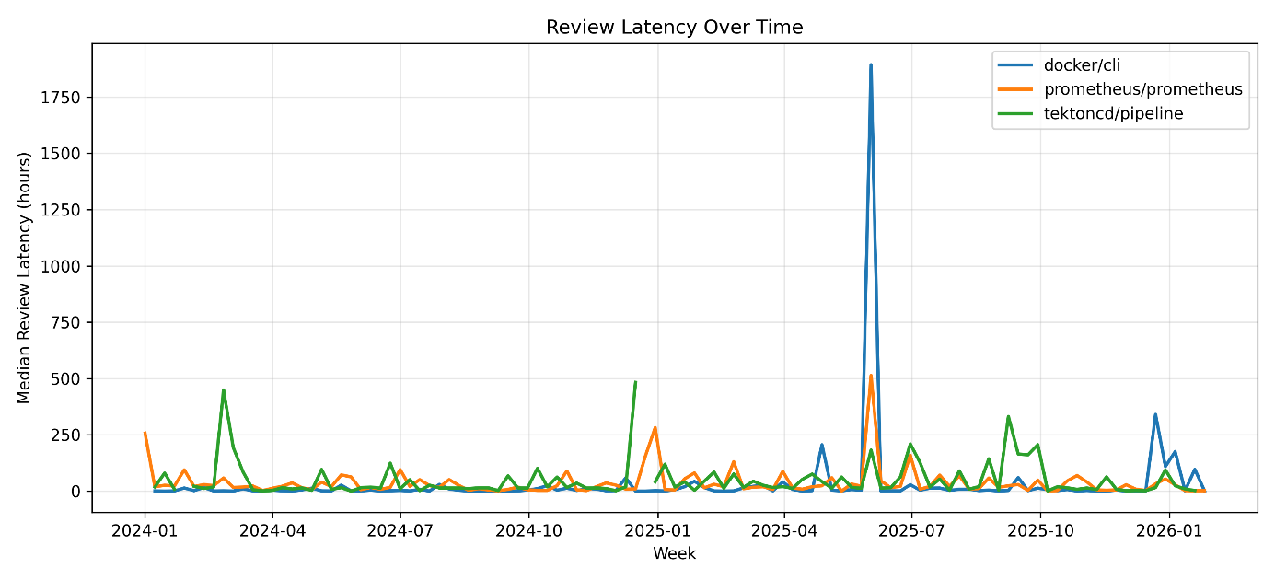
- review_duration.py
- merge_frequency_weekly.py
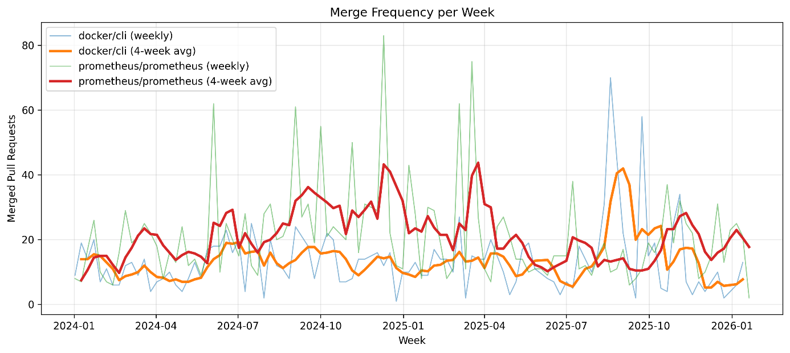

10.
PR churn was used as a proxy for rework and potential technical debt. It was computed as the sum of added and deleted lines per pull request. Weekly median PR churn values were analyzed to identify long-term trends and differences across repositories.

12
Review Duration (Methods)
Review duration was calculated as the time between the first code review and the completion of the pull request. To reduce noise and outliers, weekly median values were used in the analysis.

13
Release Frequency (Results)
Release frequency was measured as the number of GitHub releases per month. The results indicate differences in release cadence across the analyzed repositories.

15.
The review overhead metrics reveal substantial differences in feedback dynamics over time. While review latency reflects how quickly feedback is initiated, review duration captures the overall effort and coordination required to complete the review process. Periods of increased review duration and churn indicate higher coordination costs and may suggest growing technical debt or architectural complexity.

Table A preview:
Repository Median CI Duration (min) Median Failure Rate Median PR Cycle (h)
docker/cli 1.933333 0.149254 7.827222
prometheus/prometheus 0.941667 0.173946 82.031250
tektoncd/pipeline 0.554167 0.073788 61.196250

Repository | Median CI Duration (min), | Median Failure Rate | Median PR Cycle (h)
docker/cli | 1.93333 | 0.151308 | 7.842083
prometheus | 0.94583 | 0.160318 | 82.93194

Repo | Churn (median | CI Flakiness (avg runs/SHA) | Review Overhead (median hours)
docker/cli | 27.0 | 6.849064 | 2.895000
prometheus | 31.0 | 3.834382 | 19.693403

Measuring Software Delivery Performance using the Four Key Metrics of DevOps
(Marc Sallin et al., 2021)
The study by Sallin et al. (2021) investigates how software delivery performance in DevOps environments can be measured using the Four Key Metrics of DevOps (FKM):
- deployment frequency,
- lead time for change,
- time to restore service, and
- change failure rate.
While these metrics are widely adopted in industry—primarily through survey-based approaches such as the State of DevOps reports—the authors argue that surveys provide limited, subjective, and non-continuous insights.
To address these limitations, the study explores how the Four Key Metrics can be automatically measured using development toolchain data, including version control systems, CI/CD pipelines, deployment logs, and incident management systems. The authors conduct a multivocal literature review to identify existing definitions and measurement approaches, followed by the implementation of a prototype that collects and aggregates delivery-related data from an industrial DevOps toolchain.
The prototype is evaluated through an industrial case study at Swiss Post, where practitioners used the automatically collected metrics over several weeks. The results show that automated measurement of delivery performance metrics is feasible, practical, and perceived as valuable by development teams. In particular, velocity-related metrics such as deployment frequency and lead time for change were found to be easier to define and automate than stability-related metrics.

Future work
While this study focused on engineering workflow and CI/CD performance using GitHub repository artefacts and GitHub Actions pipeline data, future work could improve generalizability by replicating the analysis across other industrial DevOps toolchains and CI/CD platforms. In particular, Azure DevOps and Azure Pipelines could be used to collect comparable pipeline execution data (e.g., build and release logs) and evaluate whether the observed patterns remain consistent beyond GitHub-hosted ecosystems.
Future work may also expand the metric set by incorporating deployment- and operations-oriented signals that are typically not available through GitHub alone. Examples include deployment telemetry (deployment frequency, rollback rate, change failure rate), infrastructure/runtime metrics (availability, incident frequency, MTTR), and observability traces from monitoring stacks (e.g., Azure Monitor/Application Insights or OpenTelemetry-based instrumentation). Such data would enable a stronger linkage between CI behavior and downstream delivery outcomes, moving closer to end-to-end delivery performance.
Finally, the study could be extended by integrating additional quality and risk signals, such as dependency/security alerts (e.g., Dependabot-style vulnerability signals) and broader static analysis coverage (e.g., extending SonarCloud snapshots over longer periods or complementing with other analyzers). This would support richer triangulation between workflow dynamics, pipeline stability, and codebase characteristics.

python .\time_to_release_monthly.py
PR repos: 3 ['prometheus/prometheus' 'docker/cli' 'tektoncd/pipeline']
Release repos: 2 ['prometheus/prometheus' 'tektoncd/pipeline']
Merged PR rows: 4804
Release rows: 148
[WARN] No releases for docker/cli -> skipping
Matched PR->Release rows: 3299
[INFO] Missing repos in Time-to-Release output: ['docker/cli']

