
COMPUTER ENGINEERING DEPARTMENT

CSE464 – Introduction to Data Science & Big Data Analytics
Case Study 1
Where Did April 2011 Sales Go?
A Descriptive Review of Monthly Net Sales for a UK Online Gift Retailer
Selected issue 1(b)(ii): Sales figures / company KPIs below targeted rates

Student | Kenan Saleh
Student number | 20220702115
Course | CSE464 – Introduction to Data Science & Big Data Analytics
Semester | Fall 2026
Dataset | UCI Online Retail (ID 352), DOI 10.24432/C5BW33
Analysis notebook | CSE464_Case_Study_1.ipynb (Google Colab; Python, NumPy, pandas, matplotlib)

I. Executive Summary/Abstract
Challenge. Management reports that sales and company KPIs are far below target and needs a decision within three weeks. The real targets are not available, so this study uses the preceding complete month as a historical benchmark and asks: “Across complete calendar months, when did net invoiced sales fall most, which countries accounted for the change, and what should management investigate first?”
Finding. Using the company's own 541,909 invoice lines (UCI Online Retail), the largest month-to-month fall in net invoiced merchandise sales was March → April 2011: −⁠£197,681 (−⁠29.0%), from £680,582 to £482,901, the lowest of the 12 complete months. April had six fewer days with recorded invoices (21 against 27). Valued at March's net sales per invoice day (£25,207), those six days correspond arithmetically to −⁠£151,241, about 77% of the decline; the records do not show why no invoices were recorded on them. On the same two bases (denominators: 27 March and 21 April invoice days), UK net sales fell 22.7% for the whole month but 0.6% per invoice day, while international net sales fell 59.7% for the whole month and 48.2% per invoice day. A few large accounts in the Netherlands, Australia, EIRE and France ordered less in April (−⁠£57,255 together). The typical order did not shrink (median £295 → £300); there were fewer orders and fewer very large ones.
Outcome and proposed action. The records point first to the missing invoice days and to lower international orders; they do not show why either happened. Management should (1) have Finance confirm the April 2011 trading calendar, then (2) have the Head of Sales review the international wholesale accounts that ordered less in April, following the proposed three-week timeline. The KPI to monitor is net invoiced sales per invoice day, split UK vs international. All results come from the executed notebook CSE464_Case_Study_1.ipynb.
II. Background/Introduction
- About the Client/Company: The client is an unnamed UK-based, registered, non-store online retailer that mainly sells unique all-occasion gifts. Many of its customers are wholesalers [1]. Chen, Sain and Guo describe it as a small business with some 80 staff [2]. Management gave me, as the company's data scientist, its transaction log for 1 December 2010 – 9 December 2011: 541,909 invoice lines on 25,900 invoice numbers from customers in 38 countries [1]. The log also contains Amazon fee lines, which shows that some sales go through the Amazon marketplace.
- Industry Context: Online gift retail sells to both small shops (wholesale) and consumers. Demand is seasonal and builds before Christmas: in this data, monthly net sales rose from £702,584 in August to £1,432,735 in November 2011. Wholesale buying is lumpy: the top 5% of orders (above £1,506) bring 36.3% of order value, so a change in one account's orders can move a whole month.
- Goals and Objectives: The company wants to bring sales back toward its targets. The objectives of this study are to (1) build a reliable monthly net-sales KPI from the raw records, (2) find the largest fall between complete months, (3) show where that fall came from, and (4) recommend what management should investigate first.
III. Challenge/Problem Statement
A. The Problem
Sales are reported to be far below target, but management does not know when the shortfall happened or where. KPI: monthly net invoiced merchandise sales in GBP (positive sales minus credit notes). Period: the 12 complete calendar months from December 2010 to November 2011; December 2011 stops on 9 December and is treated as partial. Benchmark: the preceding complete month (a historical comparison, not a management target). Decision: which issue management should investigate first within the three-week deadline.
B. Why It Matters
If a calendar effect is read as a demand problem, or the other way round, the company will act on the wrong thing. It might redesign products or cut prices when the decline is concentrated in a few accounts that ordered less. Time and budget should go where sales were actually lower. The records can show when sales fell, by how much, in which countries and accounts, and whether the cause was fewer orders, smaller orders or more credits. They cannot show targets, costs, margins or profit, or why customers changed their behaviour. Those questions need input from the sales team and from the customers.
IV. Solution/Approach
Why a descriptive analytics approach
The question is about what already happened, and the data are one year of historical invoices with no outcome variable to predict. Descriptive analytics (cleaning, aggregation, summary statistics and charts) answers it directly and gives results that executives can check by hand. A predictive model would need several years of data to learn seasonality, and a two-month comparison would not support it. Descriptive results also fit the three-week deadline.
C. Proposed Solution
A reproducible notebook (CSE464_Case_Study_1.ipynb) follows the nine steps of the course hand-out. Rows are cleaned with three explicit eligibility rules (Table 1), monthly net sales (Y) are built, and three descriptive methods are applied:
- A. Time-series comparison of adjacent complete months, in GBP (for ranking) and % (change ÷ previous month). It was chosen because the question is about change over time. Invoice days are counted to check coverage.
- B. Distribution analysis of order values (median, quartiles, 95th percentile). It was chosen because it separates 'fewer orders' from 'smaller orders' and is not distorted by a few very large wholesale invoices.
- C. Country contribution analysis: each country's signed GBP change between the two months. It was chosen because the contributions add up exactly to the total, which shows where the money moved.
Table 1. Row eligibility and reconciliation (notebook Step 3)
Rule | Invoice lines | Reason
R1 zero or negative unit price | 2,517 | Stock adjustments and 2 bad-debt entries; not sales
R2 quantity sign ≠ invoice type | 0 | Guard rule; no line breaks it after R1
R3 non-merchandise code | 2,927 | Postage, carriage, Amazon/bank fees, manual, discount, samples, vouchers
Retained (eligible) | 536,465 | Includes 8,704 credit lines and 131,586 lines without a CustomerID
Total = raw rows | 541,909 | 536,465 retained + 5,444 excluded

D. Key Features/Technologies
Tools: Google Colab with Python 3; the official ucimlrepo import fetch_ucirepo(id=352) with UCI's Excel workbook as a documented fallback; pandas for parsing, filtering, groupby/pivot_table aggregation and calendar periods; NumPy for rule logic (np.select), quantiles and reconciliation checks (np.isclose); matplotlib for all charts. Features kept: InvoiceDate (month, day), Quantity × UnitPrice (signed line value), InvoiceNo and its 'C' prefix (sales vs credits, order grouping), Country (UK vs international), CustomerID (drill-down only) and StockCode (scope filter). Description was not needed.
E. Implementation Process
Steps 1–2 load the data (541,909 rows, 8 columns) and profile types and missing values. UCI's metadata says there are no missing values, but 135,080 CustomerIDs and 1,454 descriptions are blank. Step 3 parses dates and numbers, keeps InvoiceNo and StockCode as text, and applies rules R1–R3. It keeps credit notes (so returns reduce sales once), lines without a CustomerID (the sale is still valid) and 5,268 identical repeated lines (no line number exists to prove they are errors). Step 4 builds Y and checks that positive sales − credits = net sales for every month and that the monthly totals equal the sum of eligible line values. Steps 5–6 plot X and Y and run methods A–C. Step 6A re-runs the ranking under three other cleaning scopes. Steps 7–9 write the summary, problem and plan. The notebook runs top to bottom in a fresh runtime with relative paths and saves every figure and number used here.
V. Results/Outcomes
F. Quantifiable Results
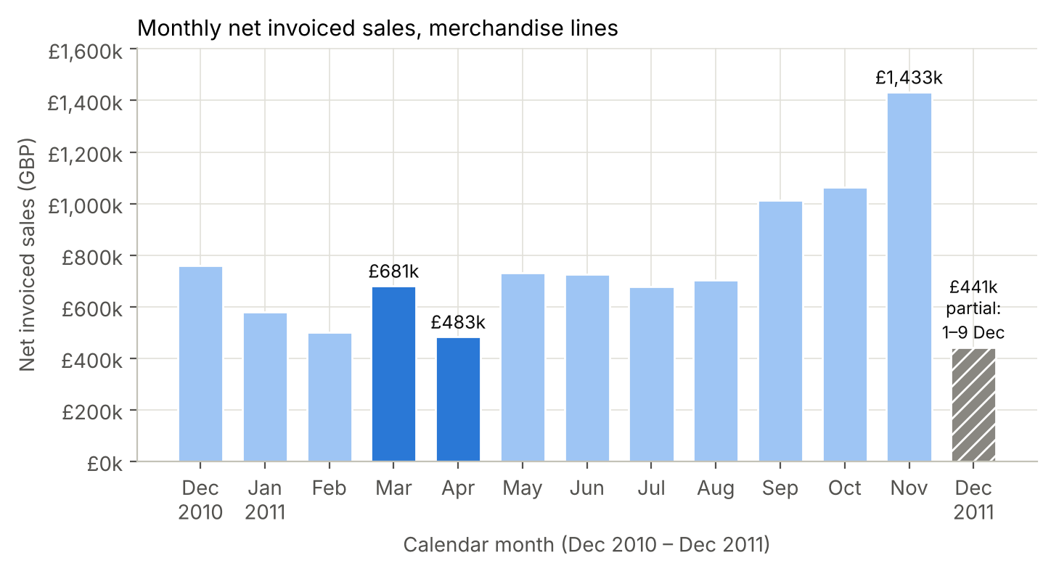
Figure 1. Monthly net invoiced sales (GBP, merchandise lines), December 2010 – December 2011. December 2011 covers 1–9 December only (hatched) and is not ranked. Source: notebook Step 5.
Method A – time series. Of 11 comparisons between adjacent complete months, 5 were declines. The largest was March → April 2011, −⁠£197,681 (−⁠29.0%), ahead of December 2010 → January 2011 (−⁠£179,917, −⁠23.7%), the post-Christmas fall. April had 21 days with recorded invoices against 27: none is dated 22–25 April or 29–30 April. These dates coincide with the 2011 Easter weekend and the 29 April royal-wedding bank holiday [3], but the records do not show whether the business was closed. Net sales per invoice day fell 8.8% (£25,207 → £22,995). Valuing the six missing days at March's daily rate gives −⁠£151,241 (about 77% of the decline, arithmetic only); lower sales per invoice day account for the other −⁠£46,441. The ranking stays the same when repeated rows are removed or only lines with a CustomerID are used. When postage and fee codes are added back, January comes within £1,103 of April. For partial December 2011, the like-for-like 1–9 December comparison is +9.7% against 2010.
Table 2. March vs April 2011, all values in GBP unless stated. Per-invoice-day values divide by all invoice days in the month (27 and 21).
Measure (notebook Steps 4 and 6) | March 2011 | April 2011 | Change
Net invoiced sales (Y) | £680,582 | £482,901 | −⁠£197,681 (−⁠29.0%)
Positive sales | £691,258 | £516,218 | −⁠£175,039
Credit magnitude (returns) | £10,675 | £33,317 | +£22,642
Invoice days | 27 | 21 | −⁠6
Net sales per invoice day | £25,207 | £22,995 | −⁠8.8%
Sales invoices (orders) | 1,440 | 1,235 | −⁠205
Median order value | £295 | £300 | +£6
Orders above 12-month P95 (£1,506) | 71 | 42 | −⁠29
UK net sales, whole month | £563,152 | £435,592 | −⁠22.7%
UK net sales per invoice day | £20,857 | £20,742 | −⁠0.6%
International net sales, whole month | £117,431 | £47,309 | −⁠59.7%
International net sales per invoice day | £4,349 | £2,253 | −⁠48.2%

Method B – order values. Across 18,957 sales invoices in the complete months, the median order was £303 and half of all orders lay between £153 and £484. The mean (£509) sits above the median because of the long upper tail. Figure 2 shows that the typical order in April was the same as in March. The fall came from 205 fewer orders and from large orders: their value fell by £116k (£232,009 → £115,550).
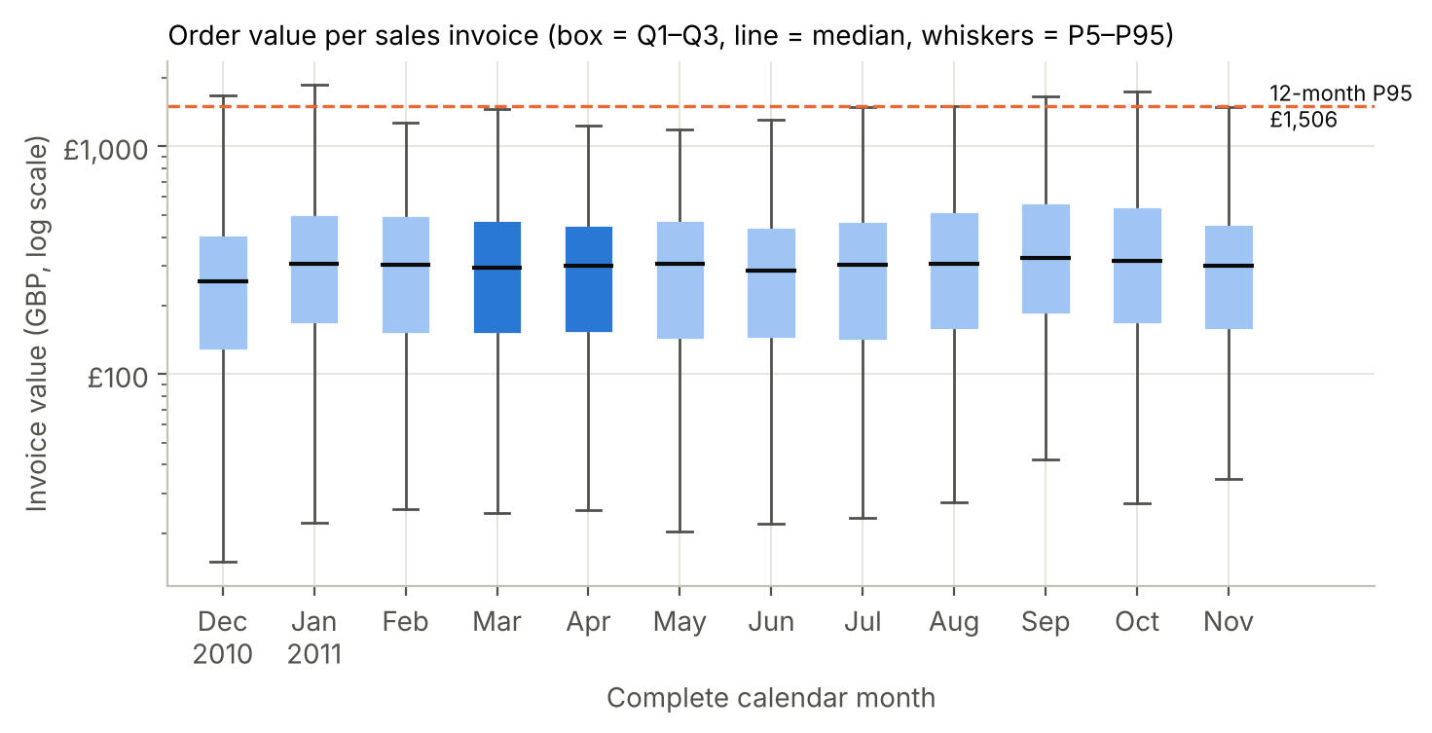
Figure 2. Value per sales invoice by complete month (GBP, log scale; box = Q1–Q3, line = median, whiskers = 5th–95th percentile; dashed line = 12-month P95). March and April 2011 are dark blue. Source: notebook Step 6B.
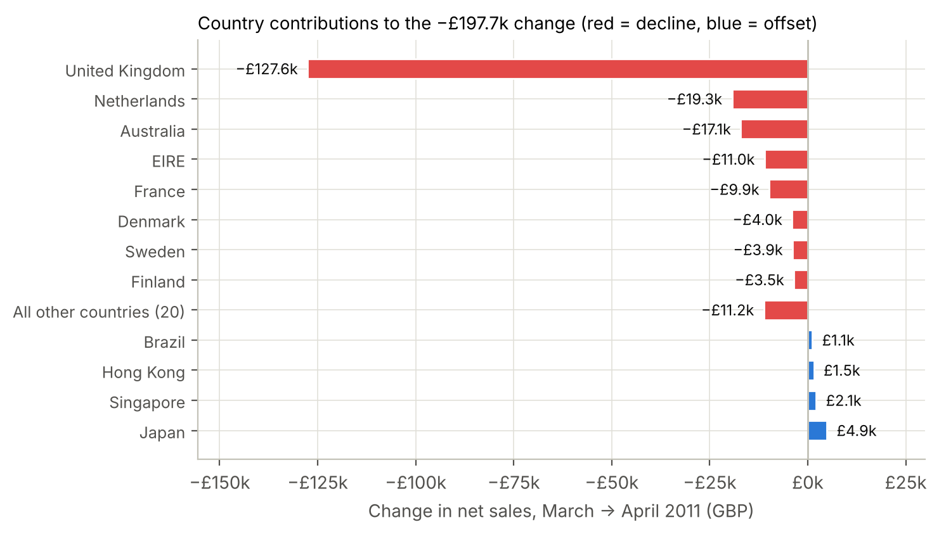
Figure 3. Country contributions to the −⁠£197,681 change, March → April 2011 (GBP; red = decline, blue = offset). The 32 contributions sum exactly to the total. Source: notebook Step 6C.
Method C – countries. The United Kingdom contributed −⁠£127,560 (65% of the fall): its whole-month net sales fell 22.7%, but per invoice day they changed by only −⁠0.6% (£20,857 → £20,742). International customers made up only 17% of March sales, yet they contributed −⁠£70,122 (35%): 59.7% for the whole month and 48.2% per invoice day. The Netherlands (−⁠£19,320), Australia (−⁠£17,072), EIRE (−⁠£11,013) and France (−⁠£9,851) explain −⁠£57,255. Most of these decreases come from a few accounts that ordered less in April: Netherlands customer 14646 (£21,327 → £2,887) and Australia customer 12415 (£16,558 → −⁠£425, net of a credit). Japan (+£4,866), Singapore (+£2,119) and Hong Kong (+£1,540) were small offsets. Countries present in only one month are included with zero for the other month.
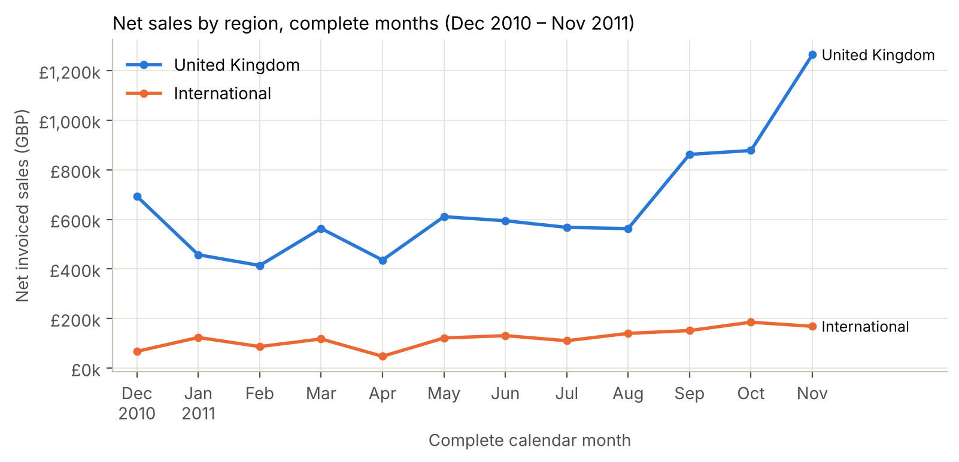
Figure 4. Net invoiced sales by region (GBP), complete months December 2010 – November 2011. Source: notebook Step 5.
Figure 4 puts April in context. International net sales reached their lowest complete month in April 2011 (£47,309, 9.8% of net sales against an average share of 15.8%) and were higher again in May. The UK line dips in April; per invoice day it changed by −⁠0.6%. Over the 12 complete months, the number of sales invoices and net sales move together closely (r = 0.97): the KPI tracks order volume more closely than order size.
Table 3. The three descriptive methods: reason, result and limitation (notebook Step 6)
Method | Why it was chosen | Computed result | One limitation
A. Time-series comparison | The question asks when sales fell between adjacent complete months | Mar → Apr 2011 −⁠£197,681 (−⁠29.0%); per invoice day −⁠8.8% | One year of data: cannot separate seasonality from a real problem
B. Distribution analysis | Separates fewer orders from smaller orders; median is robust to outliers | Median order £295 → £300; orders 1,440 → 1,235; large orders 71 → 42 | An invoice is not a customer; credits are not matched to the order they reverse
C. Country contribution | Shows where the change came from; contributions sum exactly to the total | UK −⁠£127,560 (month −⁠22.7%; per invoice day −⁠0.6%); international −⁠£70,122 (month −⁠59.7%; per invoice day −⁠48.2%) | Shows where, not why; one large account can dominate a country

G. Qualitative Impact
Management can now see that the worst month of the year coincides with six fewer days with recorded invoices and with lower orders from a short list of international wholesale accounts that can be named and contacted. UK net sales per invoice day changed little, although the records cannot show whether UK demand itself changed. This turns a general worry about low KPIs into a specific, checkable list of questions. The cleaned and reconciled KPI also gives a common, auditable definition of 'sales' for future reviews, and partial months and calendar gaps can be separated from performance changes before decisions are made. No customer feedback, satisfaction, savings or revenue gain was measured. These are possible future benefits of the proposed action, not results of this study.
VI. Recommendations
Priority recommendation. The Head of Sales and the international account managers should review the international wholesale accounts that ordered less in April 2011, starting with the four largest country contributors in Figure 3 (Netherlands, Australia, EIRE and France). Before that, Finance should confirm the trading calendar, so that the review starts from a calendar-adjusted baseline. Table 4 gives a proposed three-week management timeline. This is a proposed business action; its benefits have not been measured and must be tracked with the KPI in Table 4.
Table 4. Proposed implementation timeline and metric to monitor
When | Who | What to investigate | Output
Week 1 | Finance and sales operations | Were 22–25 and 29–30 April 2011 non-trading days? Why did credits rise from £10,675 to £33,317? | Calendar-adjusted April baseline
Week 2 | Head of Sales, account managers | Contact accounts NL 14646, AU 12415, EIRE 14156 and 14911, and the main French accounts. Why were their April orders lower (stock, price, timing, other)? | Reasons, account by account
Week 3 | Executive management | Decide recovery actions per account; approve the KPI | Decision memo
Monthly | Sales operations | Net sales per invoice day, UK vs international; credits as % of positive sales | KPI review on 1st working day

H. Key Takeaways
- Normalise before comparing. Always compare complete months and also check sales per invoice day. Valued at March's daily rate, April's six fewer days with recorded invoices correspond arithmetically to about 77% of the fall.
- Large accounts carry concentrated risk. The top 5% of orders bring 36% of value, and four international countries explain 29% of the worst fall. Because the median order did not change, account-level order counts are the first thing to check.
- Contributions must add up. A signed country breakdown that reconciles to the total shows clearly where the money moved, and it is easy for executives to audit.
I. Challenges Overcome
- Credits and adjustments: the raw data contained 9,288 credit-note lines. 8,704 met the merchandise eligibility rules and were kept, each counted once as a negative value (Table 1); the other 584 were excluded by R3 because they carry non-merchandise codes. 2,517 zero- or negative-price adjustment lines were excluded by R1. Two huge orders (74,215 and 80,995 units) were each cancelled within minutes and net to zero in their month.
- Hidden scope problems: non-merchandise codes (e.g., Amazon fees up to £17,836 per line) were removed. The effect of this choice and of the 5,268 repeated rows was tested, and the conclusion did not change.
Table 5. Sensitivity of the main result to cleaning decisions
Cleaning scope (notebook Step 6A) | Lines | Largest decline | Change | Gap to 2nd (Dec → Jan)
Main scope (R1–R3) | 536,465 | Mar → Apr 2011 | −⁠£197,681 (−⁠29.0%) | £17,764
Main scope, repeated rows removed | 531,208 | Mar → Apr 2011 | −⁠£197,267 (−⁠29.0%) | £18,032
Non-merchandise codes included | 539,392 | Mar → Apr 2011 | −⁠£190,060 (−⁠27.8%) | £1,103
Only lines with a CustomerID | 404,879 | Mar → Apr 2011 | −⁠£152,573 (−⁠26.6%) | £75,221

- Wrong metadata and partial periods: UCI says there are no missing values, yet 135,080 CustomerIDs are blank. These lines were kept for totals. December 2011 was compared only like-for-like.
- Data access: the notebook uses the official UCI import and automatically falls back to UCI's own workbook. Both routes were run and gave identical results.
References
[1] Chen, D. (2015). Online Retail [Dataset]. UCI Machine Learning Repository. https://doi.org/10.24432/C5BW33
[2] Chen, D., Sain, S. L., & Guo, K. (2012). Data mining for the online retail industry: A case study of RFM model-based customer segmentation using data mining. Journal of Database Marketing & Customer Strategy Management, 19(3), 197–208. https://doi.org/10.1057/dbm.2012.17
[3] GOV.UK (2010). PM welcomes announcement of date for Royal Wedding. https://www.gov.uk/government/news/pm-welcomes-announcement-of-date-for-royal-wedding
[4] Saleh, K. (2026). CSE464_Case_Study_1.ipynb – executed analysis notebook submitted with this report.

