MemePlain Site Plan

Luke Blackburn

WDD 130

Overview

Purpose
A simple yet efficient meme site

Audience
Individuals needing a quick laugh on any device

Branding

Website Logo


Style Guide

Color Palette
Primary | Secondary | Accent 1 | Accent 2
#E3DFFF | #D3C0CD | #B19994 | #937666

Typography

Heading Font: Rubik Spray Paint

Paragraph Font: Unkempt

Navigation
Home Page2 Page3

Content

Fill with random memes.

It will be static, so I don’t expect the favorites to actually work, just put a few with hearts or like red border over

For the memes themselves, make it so if you click them, they will open up over top of the page and expand to be full size. Not in a new tab

The contact us page doesn’t have to work, but make it so it EITHER shows a nice display for an email to send the memes to OR a name and email field that they can be reached at to send them

The about us and mission can be anything, doesn’t matter too much

Prioritize speed and efficiency for the site, so nothing too crazy with animations and such.

Wireframes

Home
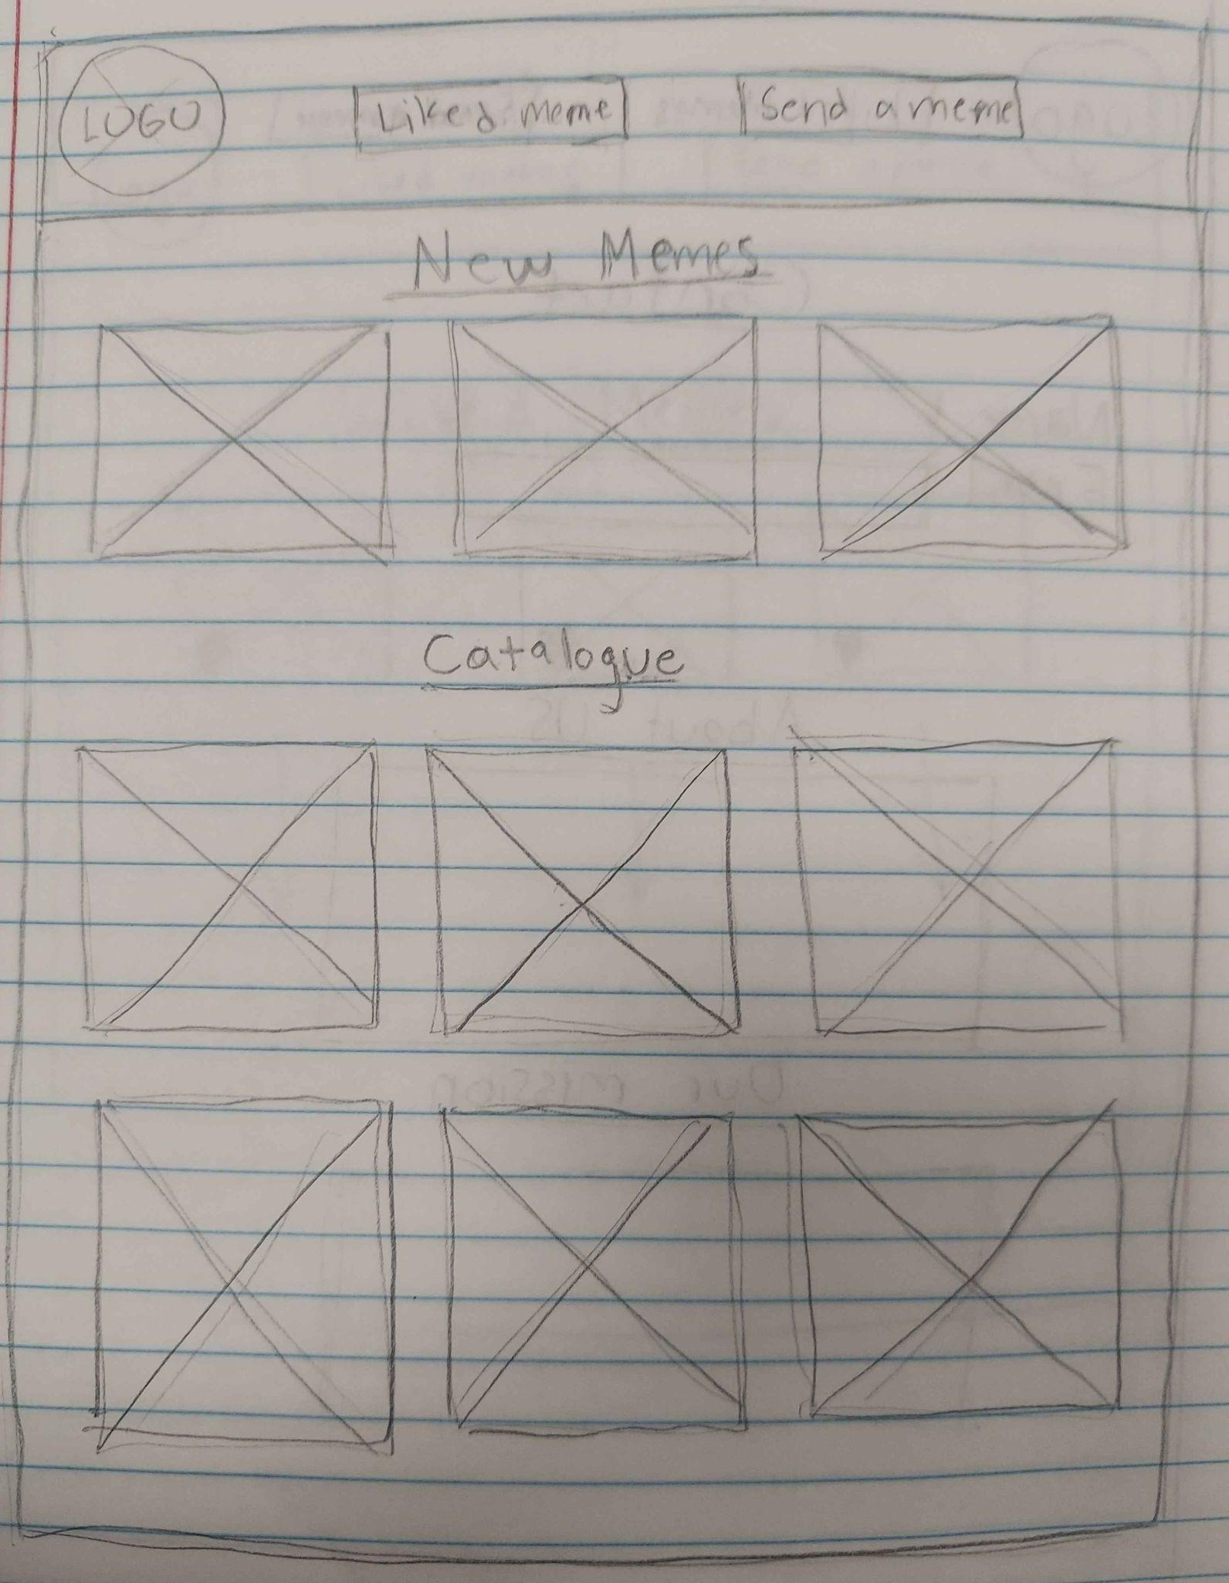

Liked

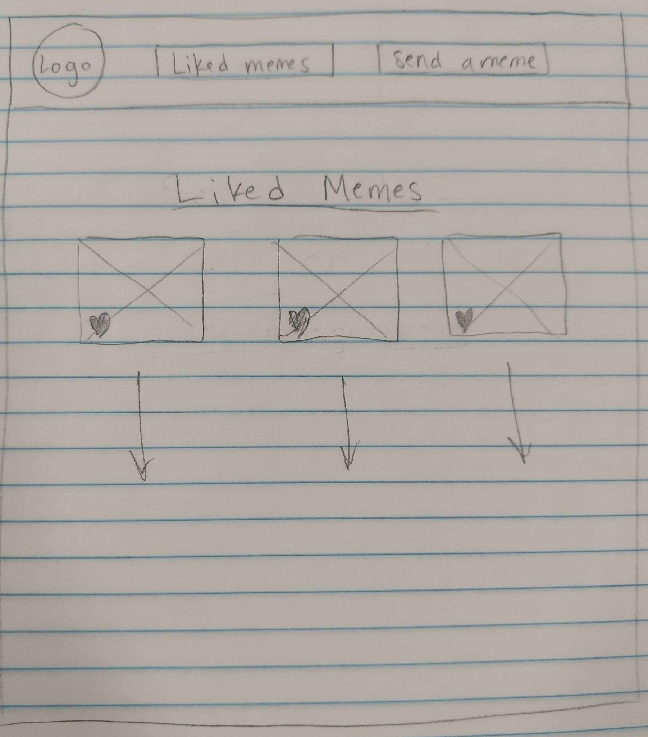

Contact
