Project 5 handoff for Adam – delete this page before submitting
Due Friday, November 6, 2026. Everything in yellow is a working note or a value still to fill in. None of it is report text, so write the final prose in our own words (honor code) and remove the yellow.
Where things stand
Item | Status | Owner (proposed)
Circuit choice: MAJ3 (12T), ONEHOT3 (20T) | Pass at ss, tt, ff (pre-layout) | Kendaro
Layout column order (Table 2.1) | Planned, not drawn | Adam
Spectre script logic_char.py | Ran on Spectre, all 56 transitions pass | Kendaro
Library kendaro_p5 (sky130_fd_pr_main) | Created | Kendaro
Schematics, symbols, LOGIC_tb | Done, screenshots not yet added | Kendaro
Layout, DRC, LVS, extraction | Not started | Adam
Abstract views and LEF | Not started | Adam
Post-extraction simulation | Not started | Kendaro
Cover table, disclosure, final report | Not started | Both

Before you start layout
1. Confirm this split works for you. It follows Project 4, but we have not agreed it yet.
2. The sizes in Tables 1.3 and 1.4 are final: the pre-layout runs passed at ss, tt and ff, so layout can start.
3. Read the 9T cell height, site width and pin conventions from /data/PDK/sky130a/stdcells/sky130_scl_9T/lef/sky130_scl_9T.lef. We have not checked them yet.
4. Keep the cell names MAJ3 and ONEHOT3 and the pins A, B, C, Y, VDD, GND. The script is case-sensitive. Run it with /usr/bin/python3, because plain python3 fails after the Cadence setup.
5. Ask Rohit what the spec means by “a few entries” for synthesis and place-and-route. LEF is assumed; a Liberty entry may also be expected.
6. The bonus wording does not say how area and power combine or how two cells are scored, so the cover table lists area, worst-case power and their product.
Sent with this file: logic_char.py (usage is at the top of the file). The design suggestions and scripts came from Claude, so they go in Section 6 with the session log.

ECE 4540/5545
Project 5
Kendaro Duong and Adam Mawloud

Summary of Results
Measurement (TT, 25 °C, 1.80 V, pre-layout – update after extraction) | MAJ3 | ONEHOT3
Transistor count | 12 | 20
Delay, Y rise, worst | 102 ps | 242.7 ps
Delay, Y rise, average | 98.83 ps | 187.3 ps
Delay, Y fall, worst | 204.6 ps | 258.5 ps
Delay, Y fall, average | 190.5 ps | 200 ps
Dynamic power, Y L→H, worst | 11.25 µW | 20.13 µW
Dynamic power, Y H→L, worst | 8.078 µW | 7.522 µW
Dynamic power, worst transition | 11.25 µW | 20.13 µW
Static power, average of 8 input states | 0.5354 nW | 0.6805 nW
Static power, worst input state | 1.038 nW | 1.083 nW
Cell boundary area | TBD | TBD
Bonus: area × worst dynamic power | TBD | TBD

[Kendaro: these are pre-layout numbers from a 2 ns input period, with delays for single-input changes. Replace them from results.txt after the post-extraction runs, then remove the pre-layout label from the table heading.]
1. General Description
[Kendaro: write in your own words. Cover: FAIL's request for Majority and One Hot cells for the 9T library; each cell is a logic stage plus an output inverter because Y is non-inverted; the shared stage produces the inverted majority, MN; sky130_fd_pr 1.8 V devices; pins A, B, C, Y, VDD, GND; bulks tied to VDD and GND.]
Table 1.1 – Truth tables
A B C | MAJ3 Y | ONEHOT3 Y
0 0 0 | 0 | 0
0 0 1 | 0 | 1
0 1 0 | 0 | 1
0 1 1 | 1 | 0
1 0 0 | 0 | 1
1 0 1 | 1 | 0
1 1 0 | 1 | 0
1 1 1 | 1 | 0

Table 1.2 – Logic functions
Node | Function | Implementation
MN | NOT(AB + C(A + B)) | 10T mirror stage
MAJ3 Y | AB + C(A + B) | MN + inverter
YB | NOT((A + B + C) · MN) | OAI31, 8T
ONEHOT3 Y | (A + B + C) · MN | MN + OAI31 + inverter

[Kendaro: explain the sizing choice in your own words: the bonus scores area and dynamic power, not delay, and cell width depends on poly columns rather than W. The 0.42 µm logic-stage pMOS sizes passed at the ss, tt and ff corners.]
Table 1.3 – MAJ3 transistor sizes and connections
Instance | Type | W | L | Gate | Drain | Source
NM0 | nfet_01v8 | 0.42 µm | 0.15 µm | C | MN | N1
NM1 | nfet_01v8 | 0.42 µm | 0.15 µm | B | MN | N2
NM2 | nfet_01v8 | 0.42 µm | 0.15 µm | A | N2 | GND
NM3 | nfet_01v8 | 0.42 µm | 0.15 µm | A | N1 | GND
NM4 | nfet_01v8 | 0.42 µm | 0.15 µm | B | N1 | GND
NM5 | nfet_01v8 | 0.42 µm | 0.15 µm | MN | Y | GND
PM0 | pfet_01v8 | 0.42 µm | 0.15 µm | C | MN | P1
PM1 | pfet_01v8 | 0.42 µm | 0.15 µm | B | MN | P2
PM2 | pfet_01v8 | 0.42 µm | 0.15 µm | A | P2 | VDD
PM3 | pfet_01v8 | 0.42 µm | 0.15 µm | A | P1 | VDD
PM4 | pfet_01v8 | 0.42 µm | 0.15 µm | B | P1 | VDD
PM5 | pfet_01v8 | 0.84 µm | 0.15 µm | MN | Y | VDD

Table 1.4 – ONEHOT3 transistor sizes and connections
Instance | Type | W | L | Gate | Drain | Source
NM0 | nfet_01v8 | 0.42 µm | 0.15 µm | C | MN | N1
NM1 | nfet_01v8 | 0.42 µm | 0.15 µm | B | MN | N2
NM2 | nfet_01v8 | 0.42 µm | 0.15 µm | A | N2 | GND
NM3 | nfet_01v8 | 0.42 µm | 0.15 µm | A | N1 | GND
NM4 | nfet_01v8 | 0.42 µm | 0.15 µm | B | N1 | GND
NM5 | nfet_01v8 | 0.42 µm | 0.15 µm | YB | Y | GND
PM0 | pfet_01v8 | 0.42 µm | 0.15 µm | C | MN | P1
PM1 | pfet_01v8 | 0.42 µm | 0.15 µm | B | MN | P2
PM2 | pfet_01v8 | 0.42 µm | 0.15 µm | A | P2 | VDD
PM3 | pfet_01v8 | 0.42 µm | 0.15 µm | A | P1 | VDD
PM4 | pfet_01v8 | 0.42 µm | 0.15 µm | B | P1 | VDD
PM5 | pfet_01v8 | 0.84 µm | 0.15 µm | YB | Y | VDD
NM6 | nfet_01v8 | 0.42 µm | 0.15 µm | A | YB | N3
NM7 | nfet_01v8 | 0.42 µm | 0.15 µm | B | YB | N3
NM8 | nfet_01v8 | 0.42 µm | 0.15 µm | C | YB | N3
NM9 | nfet_01v8 | 0.42 µm | 0.15 µm | MN | N3 | GND
PM6 | pfet_01v8 | 0.42 µm | 0.15 µm | A | P3 | VDD
PM7 | pfet_01v8 | 0.42 µm | 0.15 µm | B | P4 | P3
PM8 | pfet_01v8 | 0.42 µm | 0.15 µm | C | YB | P4
PM9 | pfet_01v8 | 0.42 µm | 0.15 µm | MN | YB | VDD

The bulk terminals of all pMOS transistors are connected to VDD, and the bulk terminals of all nMOS transistors are connected to GND.
Figure 1.1 – MAJ3 transistor-level schematic
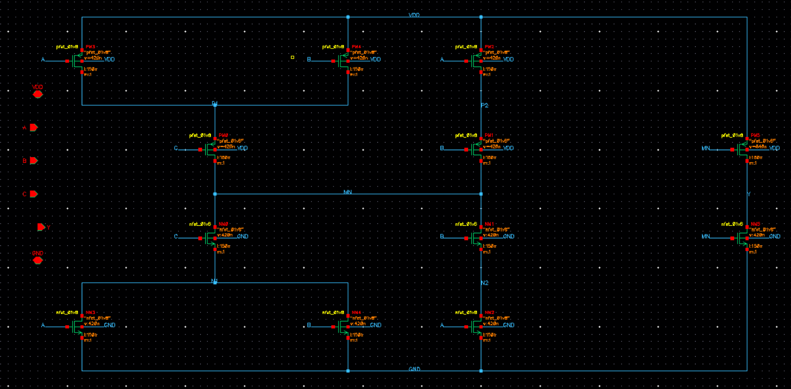
Figure 1.2 – MAJ3 symbol
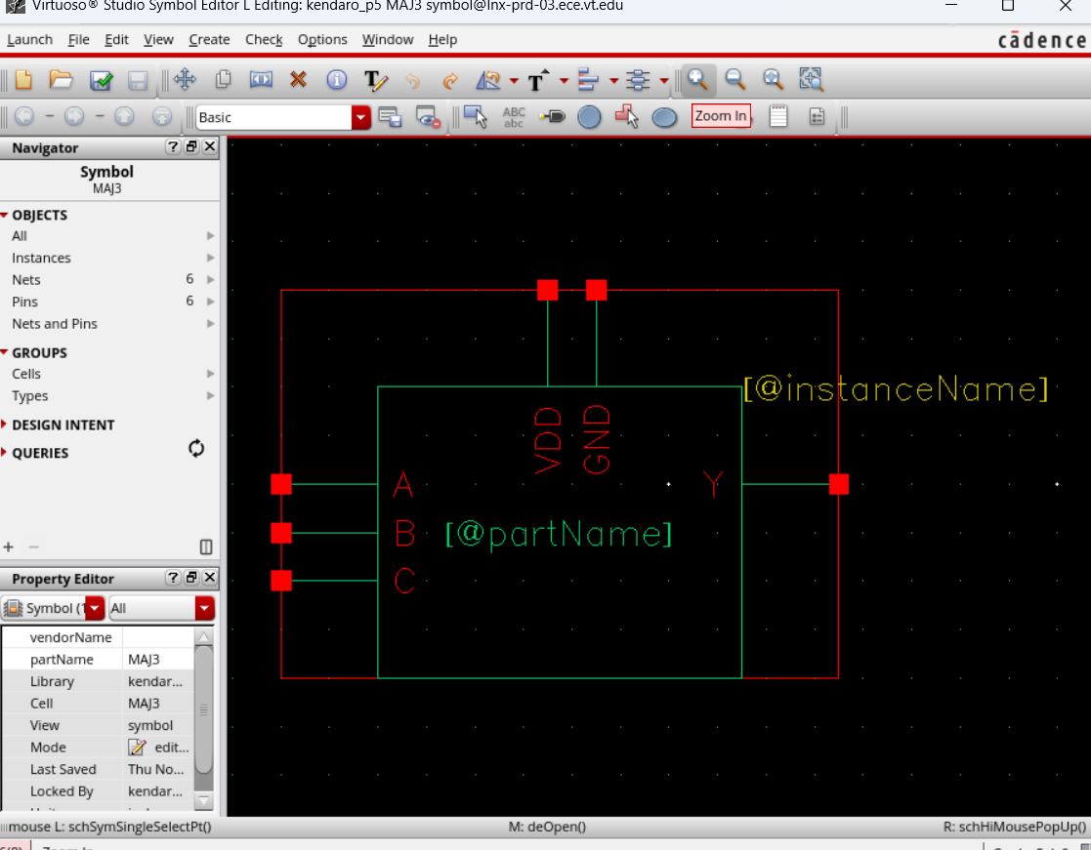
Figure 1.3 – ONEHOT3 transistor-level schematic
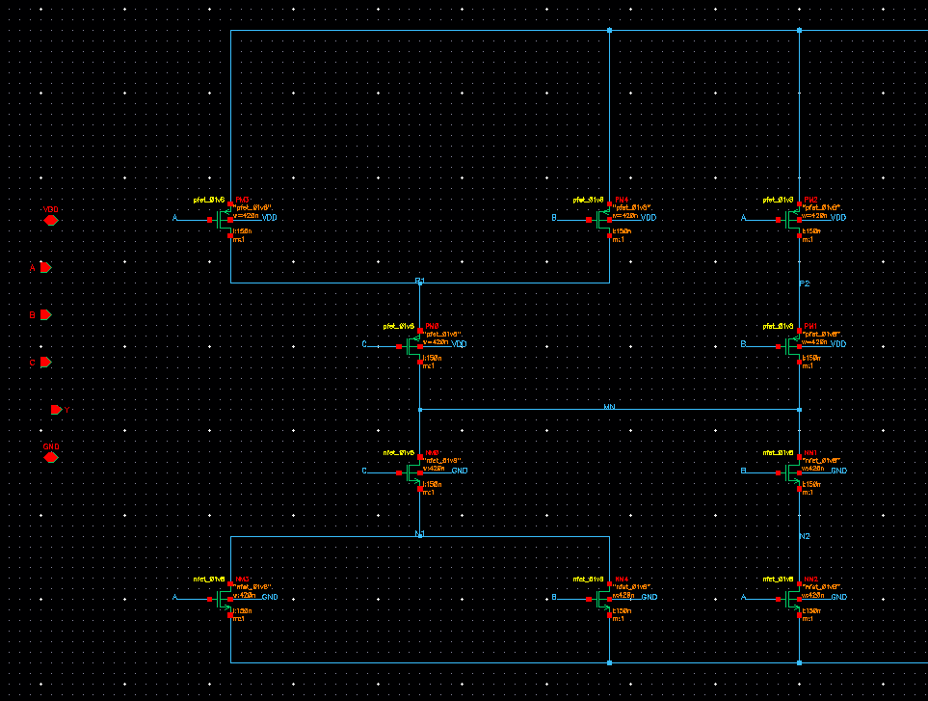
(a) Mirror stage and pins
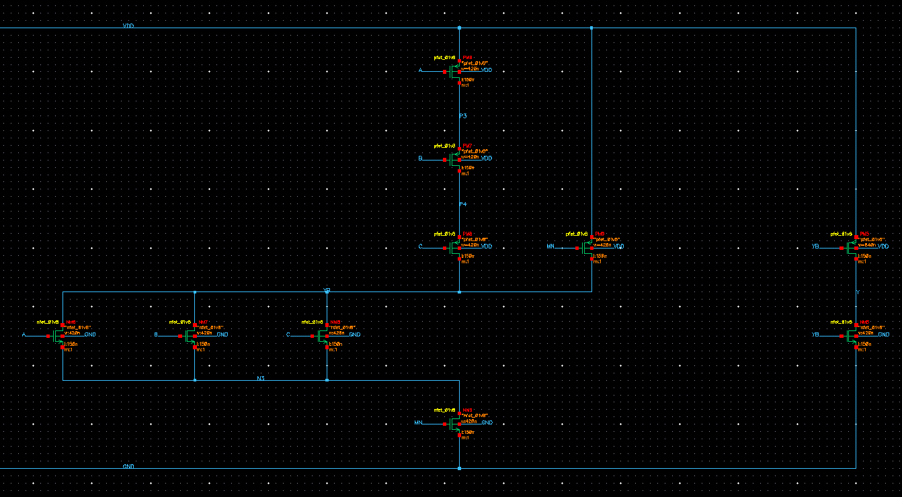
(b) OAI31 stage and output inverter
Figure 1.4 – ONEHOT3 symbol
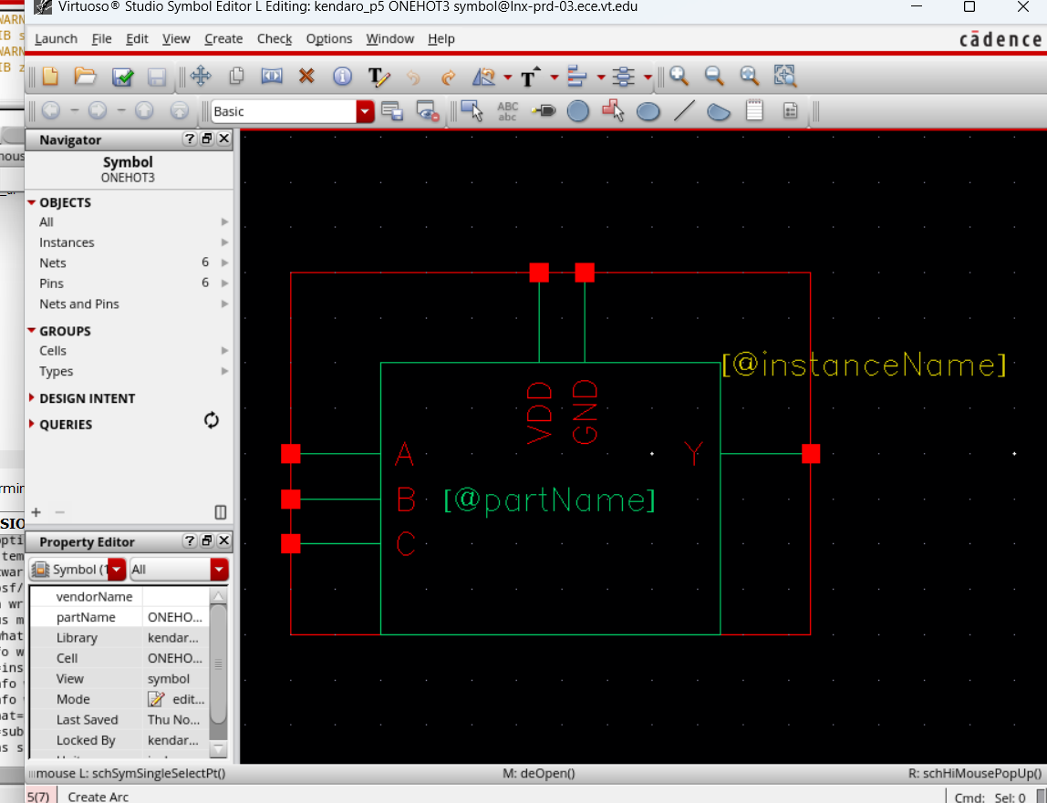
2. Layout
[Adam: write a short intro: placement of the pMOS and nMOS rows, shared diffusion, routing layers, and how each cell matches the sky130_scl_9T height and site pitch.]
Table 2.1 – Planned poly column order and diffusion regions (left to right)
Cell / row | Sequence
MAJ3 poly columns | C B A A B MN
MAJ3 nMOS diffusion | N1 MN N2 GND N1 GND Y
MAJ3 pMOS diffusion | P1 MN P2 VDD P1 VDD Y
ONEHOT3 poly columns | C B A A B A B C MN YB
ONEHOT3 nMOS diffusion | N1 MN N2 GND N1 GND | YB N3 YB N3 GND Y
ONEHOT3 pMOS diffusion | P1 MN P2 VDD P1 VDD P3 P4 YB VDD Y

[Adam: this order is a starting point checked against Tables 1.3 and 1.4 and not yet drawn. MAJ3 needs no diffusion breaks. ONEHOT3 needs one nMOS break, marked |, while the pMOS row stays continuous. Each row uses one diffusion name per region, so tie repeated names together: N1 and P1 in both cells, plus YB and N3 in ONEHOT3. Keep this table in the report only if you follow this order.]
2.1 Cell Layout
Figure 2.1 – MAJ3 layout
[Adam: insert screenshot]
Figure 2.2 – ONEHOT3 layout
[Adam: insert screenshot]
2.2 Layout Measurements
[Adam: describe how the measurements were taken and compare them to the 9T library cell height and site width.]
Figure 2.3 – MAJ3 layout with ruler measurements
[Adam: insert screenshot]
Figure 2.4 – ONEHOT3 layout with ruler measurements
[Adam: insert screenshot]
Table 2.2 – Cell dimensions
Quantity | MAJ3 | ONEHOT3 | sky130_scl_9T reference
Cell height | TBD | TBD | TBD
Cell width | TBD | TBD | TBD
Width in sites | TBD | TBD | –
Cell boundary area | TBD | TBD | –

2.3 Design Rule Check (DRC)
[Adam: tool, rule deck and result for each cell.]
Figure 2.5 – MAJ3 DRC clean result
[Adam: insert screenshot]
Figure 2.6 – ONEHOT3 DRC clean result
[Adam: insert screenshot]
2.4 Layout vs. Schematic (LVS)
[Adam: LVS against kendaro_p5 schematics and the match result for each cell.]
Figure 2.7 – MAJ3 LVS match result
[Adam: insert screenshot]
Figure 2.8 – ONEHOT3 LVS match result
[Adam: insert screenshot]
2.5 Parasitic Extraction
[Adam: extraction tool and settings, extracted view name, and parasitic R/C count.]
Figure 2.9 – MAJ3 extracted view
[Adam: insert screenshot]
Figure 2.10 – ONEHOT3 extracted view
[Adam: insert screenshot]
2.6 Abstract View
[Adam: Abstract Generator steps (Core bin, pins, power and ground, SITE) and result.]
Figure 2.11 – MAJ3 abstract view
[Adam: insert screenshot]
Figure 2.12 – ONEHOT3 abstract view
[Adam: insert screenshot]
2.7 LEF
[Adam: explain how each LEF macro was exported and how it follows the sky130_scl_9T.lef format (CLASS CORE, SIZE, SITE, PIN, OBS). Add any other synthesis or place-and-route entries Rohit confirms.]
[Adam: paste MAJ3 and ONEHOT3 LEF here]
3. Simulation Setup
3.1 Testbench
[Kendaro: describe the testbench in your own words (LOGIC_tb holds both cells, each with its own 5 fF load), and describe how the script walks through all 56 ordered transitions in one transient.]
Figure 3.1 – LOGIC_tb testbench schematic
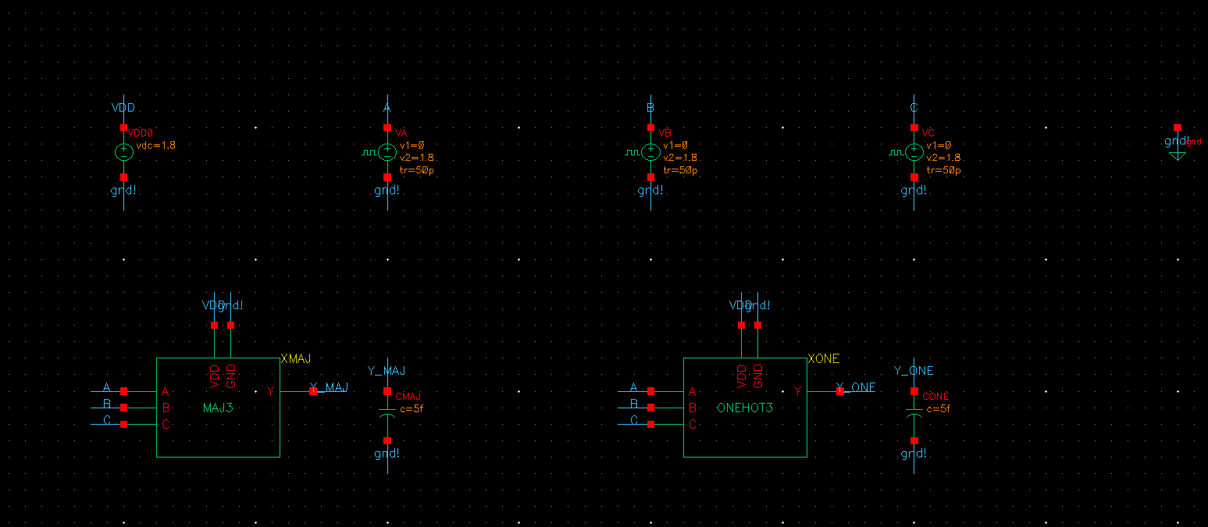
Table 3.1 – Stimulus and load
Quantity | ADE functional check | logic_char.py
Output load on Y | 5 fF | 5 fF
Input rise and fall time | 50 ps | 50 ps
Input pattern | A, B, C pulses, periods 8, 4, 2 ns | All 56 ordered transitions
Time per input state | 2 ns | 2 ns
Static power | – | 8 held input states

3.2 Measurement Definitions
Table 3.2 – Measurement definitions
Measurement | Definition used by logic_char.py
Delay | Input 50% to the last Y crossing of VDD/2 in that period
Dynamic power | Supply energy over one period ÷ period
Glitch | Peak Y deviation while Y should hold, as % of VDD
Static power | Average supply power, 2–3 ns after start, inputs held

Table 3.3 – Transitions covered by each cell
Transitions | MAJ3 | ONEHOT3
All ordered transitions | 56 | 56
Y changes, any inputs | 32 | 30
Y changes, single input | 12 | 18

3.3 Process Corners
[Kendaro: the Project 5 spec requires no corners, only TT for the bonus. Tables 4.1–4.6 report all three, so keep this table unless we drop them.]
Table 3.4 – Simulation corners
Corner | Model section | Temperature | VDD
ss | ss | 125 °C | 1.62 V
tt | tt | 25 °C | 1.80 V
ff | ff | 0 °C | 1.98 V

4. Simulation Results
[Kendaro: Tables 4.1–4.6 are pre-layout results from logic_char.py. All 56 transitions matched the truth table and settled at all three corners. The final results must be post-extraction (Table 4.7), so check that the results.txt header says POST-LAYOUT. Describe the results in your own words, including which transition is worst and why.]
4.1 Delay (Pre-Layout)
Table 4.1 – MAJ3 delay in ps, with input change (ABC)
Measurement | ss 125 °C, 1.62 V | tt 25 °C, 1.80 V | ff 0 °C, 1.98 V
Y rise, worst, single input | 189 (010→110) | 102 (001→101) | 67.22 (001→101)
Y rise, average, single input | 181.6 | 98.83 | 64.96
Y rise, worst, any inputs | 195.4 (000→110) | 105.2 (000→110) | 70.28 (000→110)
Y fall, worst, single input | 390.5 (101→001) | 204.6 (101→001) | 124.9 (101→001)
Y fall, average, single input | 369.2 | 190.5 | 116.2
Y fall, worst, any inputs | 402.4 (111→001) | 208.8 (111→001) | 128.1 (111→001)

Table 4.2 – ONEHOT3 delay in ps, with input change (ABC)
Measurement | ss 125 °C, 1.62 V | tt 25 °C, 1.80 V | ff 0 °C, 1.98 V
Y rise, worst, single input | 458.3 (110→010) | 242.7 (110→010) | 151.4 (110→010)
Y rise, average, single input | 355.3 | 187.3 | 117.3
Y rise, worst, any inputs | 458.3 (110→010) | 242.7 (110→010) | 151.4 (110→010)
Y fall, worst, single input | 517.4 (100→000) | 258.5 (100→000) | 150 (100→000)
Y fall, average, single input | 393.7 | 200 | 123.7
Y fall, worst, any inputs | 517.4 (100→000) | 258.5 (100→000) | 150 (100→000)

4.2 Dynamic Power (Pre-Layout)
Table 4.3 – MAJ3 dynamic power in µW at a 2 ns input period, with input change (ABC)
Measurement | ss 125 °C, 1.62 V | tt 25 °C, 1.80 V | ff 0 °C, 1.98 V
Y L→H, worst | 9.355 (100→101) | 11.25 (100→101) | 13.47 (100→101)
Y L→H, average | 8.431 | 10.1 | 12.03
Y H→L, worst | 6.755 (111→001) | 8.078 (111→001) | 9.953 (111→001)
Y H→L, average | 5.214 | 6.243 | 7.678
Y unchanged, worst | 1.514 (010→001) | 1.837 (010→001) | 2.468 (010→001)
Y unchanged, average | 0.3417 | 0.3985 | 0.5168
Worst transition energy (fJ) | 18.71 | 22.51 | 26.94

Table 4.4 – ONEHOT3 dynamic power in µW at a 2 ns input period, with input change (ABC)
Measurement | ss 125 °C, 1.62 V | tt 25 °C, 1.80 V | ff 0 °C, 1.98 V
Y L→H, worst | 16.62 (111→001) | 20.13 (111→001) | 24.48 (111→001)
Y L→H, average | 13.54 | 16.34 | 19.77
Y H→L, worst | 6.292 (100→110) | 7.522 (100→110) | 9.245 (100→110)
Y H→L, average | 5.168 | 6.156 | 7.505
Y unchanged, worst | 7.182 (111→000) | 8.718 (111→000) | 10.8 (111→000)
Y unchanged, average | 1.651 | 2.061 | 2.872
Worst transition energy (fJ) | 33.24 | 40.26 | 48.95

4.3 Static Power (Pre-Layout)
Table 4.5 – Static power by input state in nW
A B C | MAJ3 ss | MAJ3 tt | MAJ3 ff | ONEHOT3 ss | ONEHOT3 tt | ONEHOT3 ff
0 0 0 | 2.056 | 1.037 | 17.23 | 2.093 | 1.038 | 17.24
0 0 1 | 2.09 | 1.038 | 17.24 | 0.1261 | 0.046 | 1.409
0 1 0 | 2.078 | 1.038 | 17.24 | 0.1339 | 0.03921 | 1.221
0 1 1 | 0.0675 | 0.04569 | 1.408 | 2.165 | 1.083 | 18.64
1 0 0 | 2.056 | 1.038 | 17.24 | 0.1352 | 0.0387 | 1.201
1 0 1 | 0.0872 | 0.03894 | 1.22 | 2.185 | 1.076 | 18.45
1 1 0 | 0.1042 | 0.0361 | 1.086 | 2.202 | 1.074 | 18.32
1 1 1 | 0.0563 | 0.01195 | 0.2467 | 2.154 | 1.049 | 17.48
Average | 1.074 | 0.5354 | 9.113 | 1.399 | 0.6805 | 11.75
Worst | 2.09 | 1.038 | 17.24 | 2.202 | 1.083 | 18.64

4.4 Glitches (Pre-Layout)
Table 4.6 – Largest Y disturbance while Y should hold, in % of VDD
Cell (input change, ABC) | ss 125 °C, 1.62 V | tt 25 °C, 1.80 V | ff 0 °C, 1.98 V
MAJ3 (010→001) | 0.6888 | 0.4878 | 0.3928
ONEHOT3 (000→101) | 12.22 | 14.36 | 26.71

[Kendaro: explain the ONEHOT3 glitch in your own words. It stays below VDD/2 and happens when two inputs rise together, because the OAI31 sees a high input before MN falls. Recheck it after extraction. Spectre also showed the internal node P4 reaching 2.314 V at TT; mention it if we can explain it.]
4.5 Post-Extraction Results
[Kendaro: rerun both cells through the extracted views with --area, fill in this table and the cover table, and describe how the results changed from pre-layout in your own words.]
Table 4.7 – Post-extraction results, TT
Measurement | MAJ3 | ONEHOT3
Delay, Y rise, worst, single input | TBD | TBD
Delay, Y rise, average, single input | TBD | TBD
Delay, Y fall, worst, single input | TBD | TBD
Delay, Y fall, average, single input | TBD | TBD
Dynamic power, Y L→H, worst | TBD | TBD
Dynamic power, Y H→L, worst | TBD | TBD
Dynamic power, worst transition | TBD | TBD
Static power, average | TBD | TBD
Static power, worst | TBD | TBD
Largest glitch, Y unchanged | TBD | TBD

Figure 4.1 – MAJ3 post-extraction transient, TT
[Kendaro: insert screenshot]
Figure 4.2 – ONEHOT3 post-extraction transient, TT
[Kendaro: insert screenshot]
5. Extracted Netlist
[Adam: paste the MAJ3 extracted netlist here. logic_char.py saves the subcircuit it used as netlist.scs; use that only if its header said POST-LAYOUT.]
[Adam: paste the ONEHOT3 extracted netlist here.]
6. AI Usage Disclosure
[Both: state what AI was used for and reference the session logs submitted with this report. Kendaro: Claude suggested the transistor-level circuits and sizing, planned the layout order, wrote logic_char.py, p5_cells.il and p5_finish.il, gave the Virtuoso walkthrough and built this document's tables. Adam: fill in.]
Appendix A. All Transition Results
[Kendaro: paste the “All transitions” tables from results.txt for each cell, or summarize them.]

