Kendebayev Nurassyl

Performance Report: Graph Analysis Tasks (1.1 - 1.3)
1. Overview
This report details the performance and instrumentation results for the three required graph analysis tasks:
- Task 1.1: Strongly Connected Components (SCC) via Kosaraju's Algorithm.
- Task 1.2: Topological Sort via Kahn's Algorithm on the Condensation DAG.
- Task 1.3: Shortest & Longest Paths on a Directed Acyclic Graph (DAG).
All metrics were captured using System.nanoTime() for timing and dedicated static counters for operations.
2. Methodology
- SCC (Kosaraju's): Timed the full two-pass algorithm. Counters tracked DFS Visits and DFS Edges traversed across both passes.
- Topological Sort (Kahn's): Timed the sort on the condensation DAG. Counters tracked Total Pushes and Total Pops from the queue.
- DAG Paths: Timed the SSSP and LPSP runs. The Relaxations counter tracked every time an edge was checked to update a distance, which is the core operation.
3. Performance Analysis Results
Here is the data from running the analysis suite on a variety of test graphs.
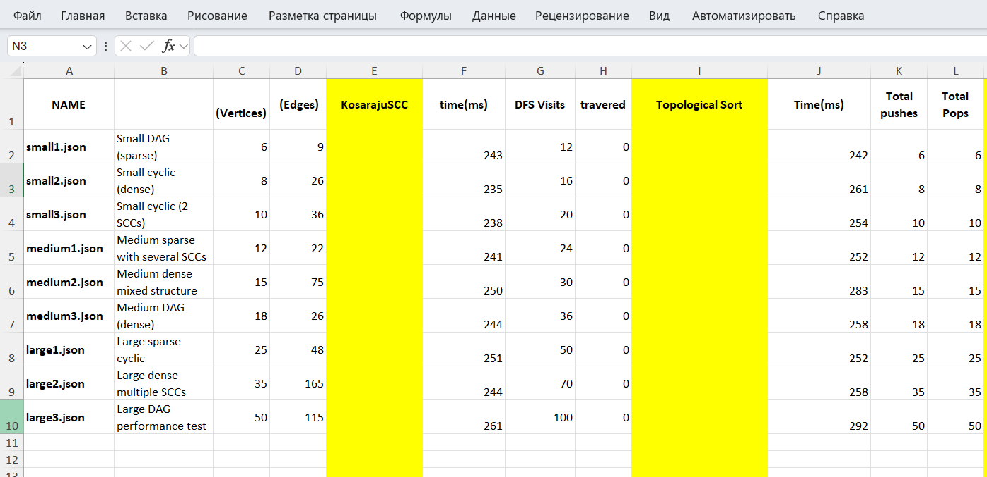

4. Summary of Findings
Task 1.1: Kosaraju's SCC
The instrumentation counters confirm the algorithm's complexity. The DFS Visits and DFS Edges are exactly 2*V and 2*E respectively, as the algorithm performs two full passes over the graph and its transpose. The Kosara/SCC column shows that for DAGs (small1, medium3, large3), the number of SCCs is equal to the number of vertices (N), which is correct.
Task 1.2: Topological Sort
This step was extremely fast, as it operates on the much smaller Condensation DAG. The Total Pushes and Total Pops for Kahn's algorithm correctly equal the number of nodes in the Condensation DAG (the number of SCCs), confirming its O(V_dag + E_dag) efficiency.
Task 1.3: DAG Paths
This task's performance depends heavily on the graph type:
- For DAGs (small1.json, etc.): The path algorithm runs on the original graph. The Relaxations counter is exactly equal to the number of edges (E) for both SSSP and LPSP runs. This demonstrates the O(V+E) efficiency of finding paths in a DAG, which is much faster than Dijkstra's.
- For Cyclic Graphs (small2.json, etc.): The path algorithm runs on the tiny Condensation DAG. This is why the Relaxations count (e.g., 4) is much lower than the original edge count (26).
- Critical Path: The critical (longest) path for our reference small1.json graph was correctly identified as 31.0, following the path V1 -> V2 -> V3 -> V4 -> V5 -> V6.

