# List of operators used in JavaScript

|  |  |  |
| --- | --- | --- |
| [**Previous Page**](http://oer.nios.ac.in/wiki/index.php/Variables_in_Java_Script) | [**Home Page**](http://oer.nios.ac.in/wiki/index.php/ICT-Application) | [**Next Page**](http://oer.nios.ac.in/wiki/index.php/Looping_Constructs) |

**ICT Applications**

### **Operators**

An operator is used to transform one or more values into a single resultant value. In JavaScript, operators are used in expressions to store or return a value.

JavaScript operators are classified as:

**\* Arithmetic**

**\* Logical**

**\* Comparison**

**\* String**

An operator operates on operands or operands. The combination of one or more operators is referred to as an expression.

For example: netPayment=netPrice+salesTax

In this example “+” operator operates on operand netPrice and sales Tax and its result is assigned to variable net Payment.

The following table shows the list of operators used in JavaScript:

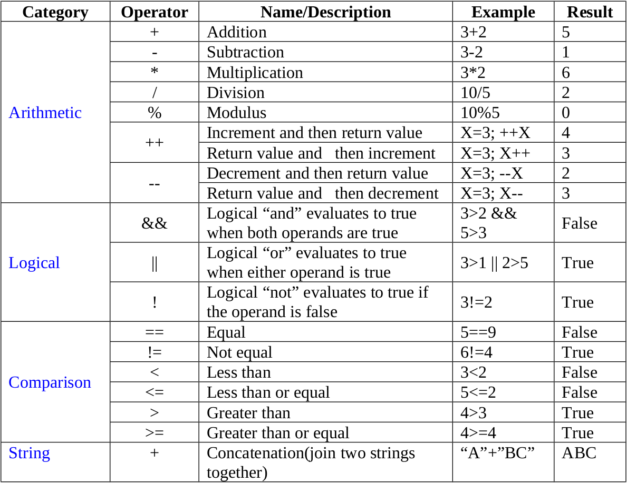

### **Expressions**

An expression is a part of a statement that is evaluated as value.An expression can be any combination of variables, operators and other expressions. In JavaScript there are four types of expressions:

* Assignment expression
* Arithmetic expression
* String expression
* Logical expression
* Assignment expression

This expression is used to assign a value to a variable.Example: avgMarks=55, the value 55 has been assigned to the variable avgMarks using assignment operator (=)

#### **Arithmetic Expressions**

Expressions in which arithmetic operations are performed are called arithmetic expression.Example: netPrice=1200+12

#### **String Expression**

Expressions in which operations are performed on string arecalled string expression.Example: mesg= "Hello," + "Mr. Rakesh", Here "+" string operator concatenate two strings "Hello, " and "Mr. Rakesh" results "Hello,Mr. Rakesh" that is assigned to variable mesg.

#### **Logical Expression**

These expressions evaluate to a Boolean (true or false) value.Example:

|  |
| --- |
|  |