A Super Cool Study - Take 2
Josephine Student
John J. Curtin
2024-03-11
Abstract
This study found some pretty cool results that have both high impact and important clinical implications. For example …

Introduction
You can write your text using markdown.
- Top level section headings use ## because # is reserved for the manuscript title.
- APA (and other?) formats support ##, ###, and #### at least.

Sub-heading - level 3
This is the ### level

Sub-heading - level 4
This is the #### level

Sub-heading - level 5
This is the ##### level

Symbols and Equations
You can use quarto inline or display math equations as needed. Quarto provides details on the use of these equations.
For example $x$ and $y$ are two variables. And here is an important formula:
$$p\left(x\right)=\frac{e^{−λ}λ^{x}}{x!}$$

Citations & References
We can use cite relevant research in multiple formats. The two most common are:
- Knuth (1984) concluded something.
- These are the conclusions(Knuth 1984).
Article references are stored in a .bib file using betterbibtex (BBT) format. We create these references in Zotero collections.
Although we don’t do this regularly I think, if needed you can reference figures elsewhere using the @ symbol. Here is a reference to Figure 1

Methods
This is the methods section.

Results
Results include
- Markdown text
- Figures from data
- Figures from images (maybe included table images)
- Analysis output (i.e. statistics)
We demonstrate each (other than markdown text, which you should know!) below

Data Figures
Figures are also generally created in separate notebooks and embedded into your manuscript.
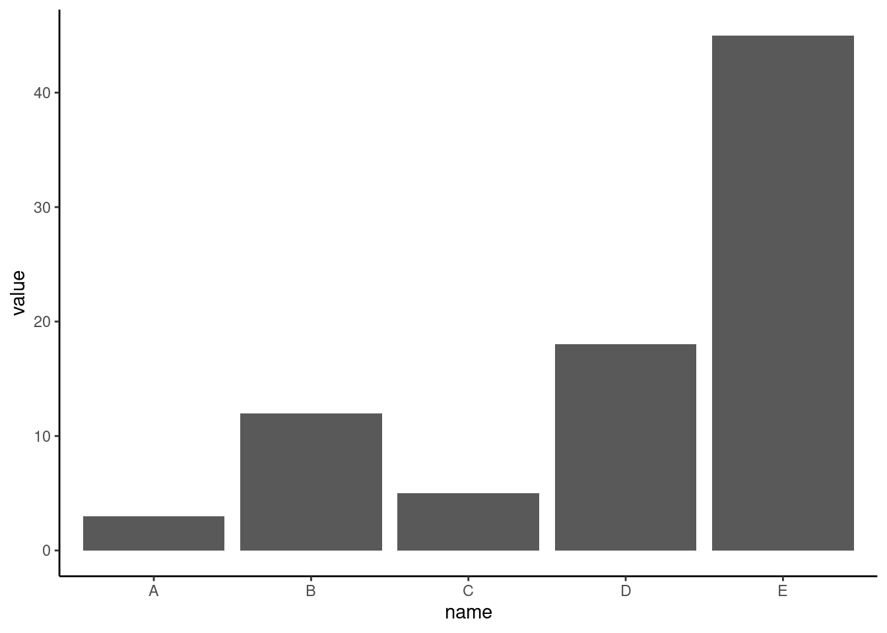
Figure 1: A Basic Barplot Figure
_{Source: Figure 1}

Figures from images
Images from figures can be included using the standard code to insert image files. These images should generally be saved in the image folder at the root of the study template by convention. The quarto website provides additional details

Figure 2: Arc Logo

Tables
We create tables using the kableExtra package. We are working on the optimal method to embed these from notebooks. It may be to save the tables as high res image files and then embed those images. Stay tuned.
Alternatively, this is an example of a simple table that is hard-coded using markdown table format. We don’t recommend this for tables built from data. Tables values should come directly from data so they don’t need to be typed in and will update if your data change. However, you may have other uses for simple tables where this method is helpful.
Table 1: Recent historic eruptions on La Palma
Name | Year
Current | 2021
Teneguía | 1971
Nambroque | 1949
El Charco | 1712
Volcán San Antonio | 1677
Volcán San Martin | 1646
Tajuya near El Paso | 1585
Montaña Quemada | 1492

Analysis Results
To add results that are not figures or tables, you will need to open the objects you saved from these analyses. See lm.qmd as an example. Generally you will open csv files that contain tidied results. For example
_{Source: Article Notebook}
A significant effect of speed was observed ($β$ = 3.9, t = 9.46, p = 0.000).
NOTES:
- We should write a function that works with tidied coeffs tables and takes the row, column, and number of decimal places to make this code simpler.
- This table doesnt contain df. Need to add that to table when saving in lm

Discussion

References
Knuth, Donald E. 1984. “Literate Programming.” Comput. J. 27 (2): 97–111. https://doi.org/10.1093/comjnl/27.2.97.

