WESTERN PROVINCE
RUSIZI DISTRICT
GIHEKE TSS
TERM I
ACADEMIC YEAR: 2026-2027
SECTOR ICT and Multimedia
TRADE: NETWORK AND INTERNET TECKNOLOGY
TVET LEVEL:
EXAMINATION TITLE: INSTALL VOIP SYSTEM & NETWORK FUNDAMENTAL

DATE: sunday,/20/9/2026, Duration:8:30AM-11:30
MARKS: ….
INSTRUCTIONS TO CANDIDATES:

SECTION A: Attempt All questions Marks

01 | Which device converts analog voice into digital packets?  A. Modem  B. Gateway  C. Switch  D. Router  Which VoIP component routes and manages internal calls?  A. PBX  B. Switch  C. Firewall  D. UPS  Which of the following is required for VoIP installation?  A. Electric saw  B. Ethernet switch  C. Aluminum sheet  D. Radio antenna  Which material is used to connect VoIP phones to the network?  A. Wood  B. CAT6 cable  C. PVC pipe  D. USB stick | 4marks
02 | TRUE OR FALSE  - Analog phones can work directly on a VoIP network without any additional equipment  A cable tester is used to check if network cables are properly connected.. | 2marks
03 | Fill in the blank the following statement(Lower cost of calls / Cost efficiency, RTP (Real-Time Transport Protocol, POE (Power over Ethernet, lines)  - One of the main advantages of VoIP is ____________________, which reduces communication costs significantly.  - The protocol used to transmit audio and video in real time over the internet is ____________________.  - he technology that allows network cables to carry electrical power along with data is called ____________________.  - . The full form of PSTN is ____________________  A ____________________ is a telephone that uses Internet Protocol to make calls instead of traditional PSTN | 5marks
04 | Match Column A with Column B  COLUMN A  - VoIP  - PBX  - Hosted VoIP  - In-house VoIP  COLUMN B  - On-site phone system  B. Cloud-based phone service  C. Uses internet for calls  D.Private call routing system | 4marks
05 | Which of the following is a type of VoIP service?  A. In-house VoIP  B. Hosted VoIP  C. Hybrid VoIP  D. All of the above | 4marks
06 | Which device converts analog voice into digital packets?  A. Modem  B. Gateway  C. Switch  D. Router  Which VoIP component routes and manages internal calls?  A. PBX  B. Switch  C. Firewall  D. UPS  Which of the following is required for VoIP installation?  A. Electric saw  B. Ethernet switch  C. Aluminum sheet  D. Radio antenna  Which material is used to connect VoIP phones to the network?  A. Wood  B. CAT6 cable  C. PVC pipe  D. USB stick | 4marks
07 | Fill in the blank the following questions.  - The device that provides backup power in case of power failure is called ____________________  - A ____________________ is a telephone that uses Internet Protocol to make calls instead of traditional PSTN  - The technology that allows network cables to carry electrical power along with data is called ____________________.  - The server responsible for call routing in a VoIP system is called ____________________.  A VoIP deployment that combines on-premises and cloud solutions is called ____________________. | 5marks
08
09
10
11
12
13
14
 | SECTION B ATTEMPT ANY 3 QUATION
15 | with the following types of VoIP services explain one by one  A)Inhouse VoIP Systems  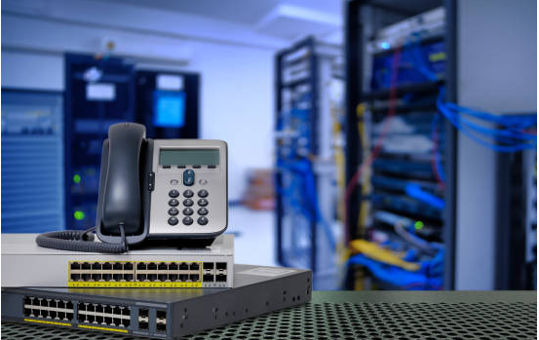  B) Hosted VoIP systems  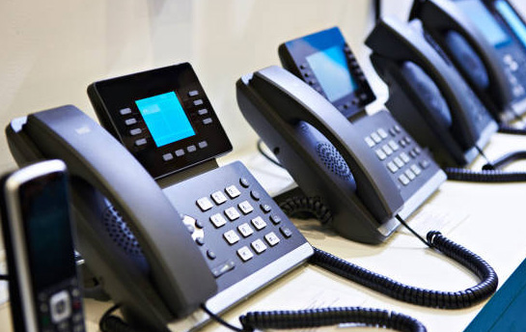  C) hybrid VoIP system | 10mk
16 | Name 4 essential tools that are used in the installation of a VoIP system and explain their purpose
17
18
19
 | SECTION C ATTEMPT ONE QUATION
20 | A company called ABC Ltd wants to install a new computer network in its office. The office has three floors and contains departments such as HR, Finance, ICT, and Administration. Before installing network cables, switches, wireless access points, and other equipment, the ICT team is asked to conduct a physical site  - What is a physical site survey, and why is it important before installing a VoIP system  - As a member of the ICT team, identify four things you would inspect or record during the physical site survey at ABC Ltd.
21

