**2.3.4: Configure inter VLAN routing**

Inter-VLAN routing is the process of forwarding packets between different Virtual Local Area Networks (VLANs). VLANs allow network administrators to segment a single physical network into multiple logical networks, improving security and performance

**Types/methods of inter_vlan routing**

**Router-on-a-Stick**: A single physical router interface is configured to handle multiple VLANs using sub-interfaces, each corresponding to a VLAN.

**Layer 3 Switches**: These switches have built-in routing capabilities and can route traffic between VLANs without needing a separate router

**Traditional inter-VLAN Routing**: Traditional inter-VLAN routing is a method for forwarding traffic between different VLANs using a router with multiple interfaces. It's also known as "Legacy" inter-VLAN routing.

**A router sub-interface** is a virtual interface created on a physical router interface to allow for routing between different VLANs. This technique is commonly used in inter-VLAN routing, especially in a "router-on-a-stick" configuration. Sub-interfaces are not physical interfaces but virtual ones created within a physical interface on the router. Each sub-interface can handle traffic from a different VLAN

**Router interface and sub-interface comparison:** Router Interfaces are physical connections that serve as endpoints for network communication. while Sub-Interfaces are virtual constructs that allow a single physical interface to manage multiple VLANs, enhancing the router's capability to handle inter-VLAN traffic without needing additional physical ports.

Here is comparison table that help us to get more detailed information about router interface and sub-interface.

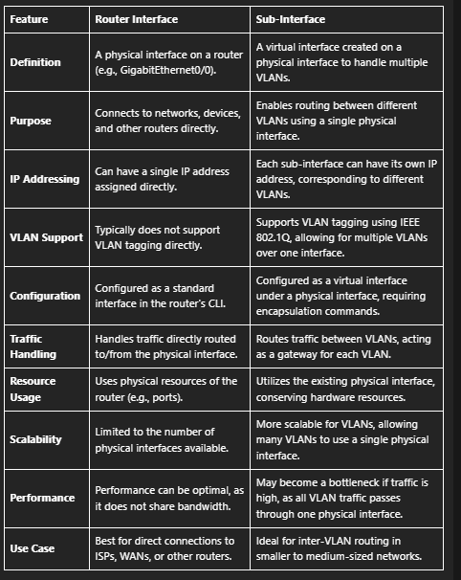

**2.3.4.1 Configure traditional inter VLAN Routing**

**2.3.4.1.1 Configure router on-a-stick inter-VLAN routing.**

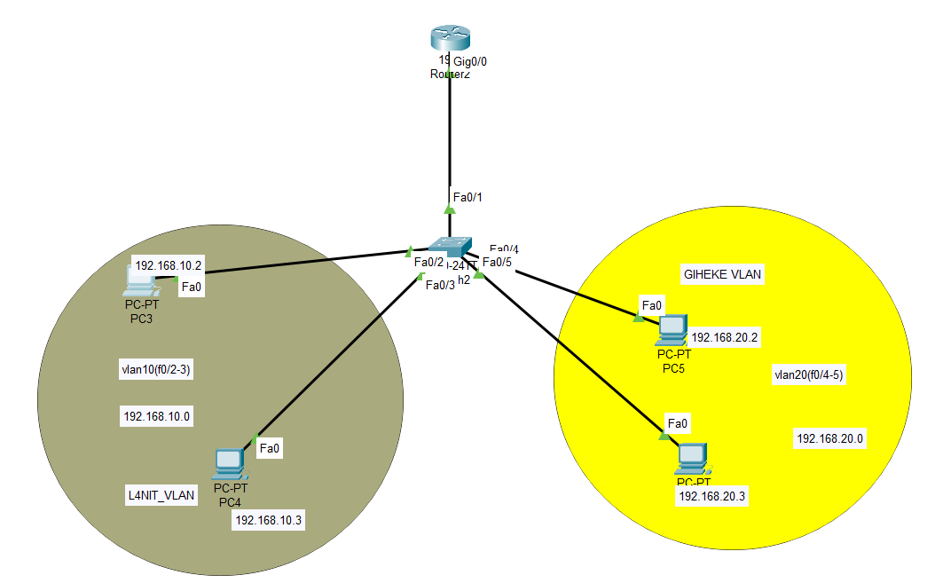

**Vlan 10creation**

Switch>enable

Switch#configure terminal

Switch(config)#vlan 10

Switch(config-vlan)#name LNIT

Switch(config-vlan)#exit

Switch(config)#interface range fastEthernet 0/2-3

Switch(config-if-range)#switchport mode access

Switch(config-if-range)#switchport access vlan 10

**Vlan 20creation**

Switch#configure terminal

Switch(config)#vlan 20

Switch(config-vlan)#name GIHEKE

Switch(config-vlan)#exit

Switch(config)#interface range fastEthernet 0/4-5

Switch(config-if-range)#switchport mode access

Switch(config-if-range)#switchport access vlan 20

**Configure Trunk port**

Switch(config)#interface fastEthernet 0/1

Switch(config-if)#switchport mode trunk

**Turn on Router Interfaces**

Router#configure terminal

Router(config)#interface gigabitEthernet 0/0

Router(config-if)#no shutdown

#before configure inter_vlan routing give your computers Ip address either statically or dynamically#

**Configure inter_vlan routing in router**

Router(config)#interface gigabitEthernet 0/0.10

Router(config-subif)#encapsulation dot1Q 10

Router(config-subif)#ip address 192.168.10.1 255.255.255.0

Router(config)#interface gigabitEthernet 0/0.20

Router(config-subif)#encapsulation dot1Q 20

Router(config-subif)#ip address 192.168.20.1 255.255.255.0

**Check Ip connectivity between the host from different Vlan by using ping command**

**Ex: ping 192.168.20.2**

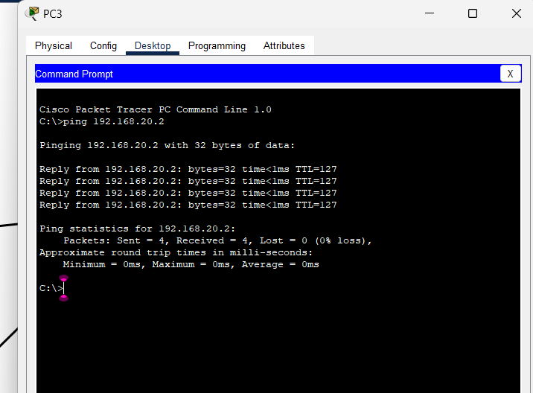

**2.3.4.1.2 Configure traditional inter VLAN Routing/Legacy**

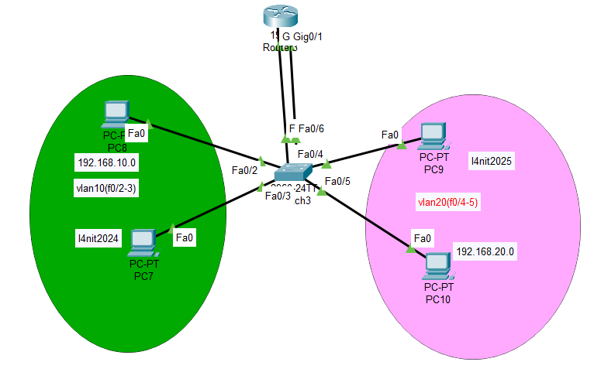

**Creation of Vlans**

Switch>enable

Switch#configure terminal

Switch(config)#vlan 10

Switch(config-vlan)#name L4NIT2024

Switch(config-vlan)#exit

Switch(config)#interface range fastEthernet 0/2-3

Switch(config-if-range)#switchport mode access

Switch(config-if-range)#switchport access vlan 10

**Creation of Vlan20**

Switch(config)#vlan 20

Switch(config-vlan)#name L4NIT2025

Switch(config)#interface range fastEthernet 0/4-5

Switch(config-if-range)#switchport mode access

Switch(config-if-range)#switchport access vlan 20

**Configuration of Access ports**

Switch(config)#interface fastEthernet 0/1

Switch(config-if)#switchport mode access

Switch(config-if)#switchport access vlan 10

Switch(config)#interface fastEthernet 0/6

Switch(config-if)#switchport mode access

Switch(config-if)#switchport access vlan 20

**Turn on Router Interfaces**

Router>enable

Router#configure terminal

Router(config)#interface gigabitEthernet 0/0

Router(config-if)#no shutdown

Router(config-if)#interface gigabitEthernet 0/1

Router(config-if)#no shutdown

**Perform routing between different Vlan**

Router(config)#interface gigabitEthernet 0/0

Router(config-if)#ip address 192.168.10.1 255.255.255.0

Router(config)#interface gigabitEthernet 0/1

Router(config-if)#ip address 192.168.20.1 255.255.255.0

**Verify Interconnectivity between different hosts in different Vlan by using ping command**

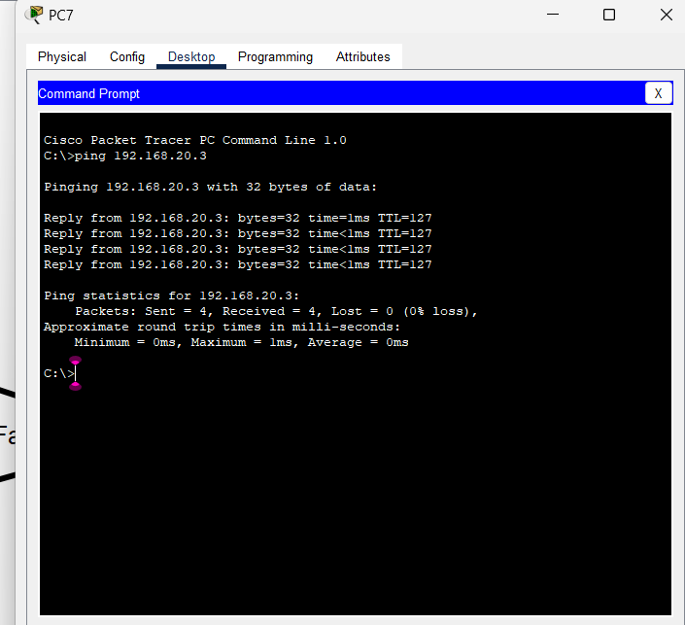

**2.3.4.1.2 Layer 3 switch inter-VLAN Routing (SVI)**

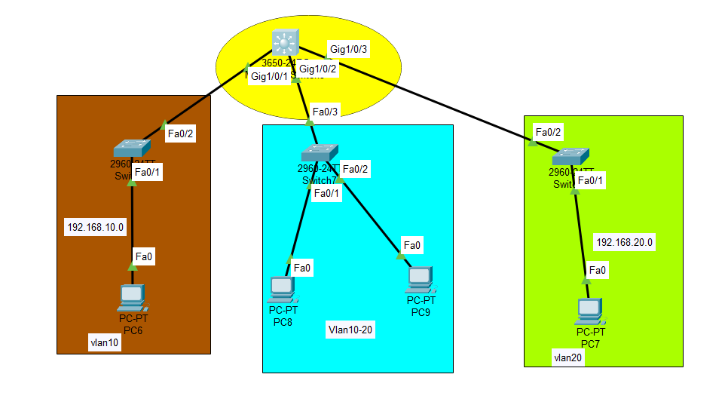

***Creating Vlan20***

Switch>enable

Switch#configure terminal

Switch(config)#vlan 20

Switch(config-vlan)#name GIHEKE

Switch(config)#interface fastEthernet 0/1

Switch(config-if)#switchport mode access

Switch(config-if)#switchport access vlan 20

**Creating vlan10-20**

Switch>enable

Switch#configure terminal

Switch(config)#vlan 10

Switch(config-vlan)#name Cap

Switch(config-vlan)#exit

Switch(config)#vlan 20

Switch(config-vlan)#name Jz

Switch(config)#interface fastEthernet 0/1

Switch(config-if)#switchport mode access

Switch(config-if)#switchport access vlan 10

Switch(config)#interface fastEthernet 0/2

Switch(config-if)#switchport mode access

Switch(config-if)#switchport access vlan 20

**Creating Vlan10**

Switch>enable

Switch#configure terminal

Switch(config)#vlan 10

Switch(config-vlan)#name Welcome

Switch(config-vlan)#exit

Switch(config)#interface fastEthernet 0/1

Switch(config-if)#switchport mode access

Switch(config-if)#switchport access vlan 10

**Configuring Trunk ports**

**On vlan10**

Switch(config-if)#interface fastEthernet 0/2

Switch(config-if)#switchport mode trunk

**On Vlan 10 and 20**

Switch(config)#interface fastEthernet 0/3

Switch(config-if)#switchport mode trunk

**On Vlan 20**

Switch(config)#interface fastEthernet 0/2

Switch(config-if)#switchport mode trunk

**On Multilayer switch**

Switch>enable

Switch#configure terminal

Switch(config)#interface gigabitEthernet 1/0/1

Switch(config-if)#switchport mode trunk

Switch(config)#interface gigabitEthernet 1/0/2

Switch(config-if)#switchport mode trunk

Switch(config)#interface gigabitEthernet 1/0/3

Switch(config-if)#switchport mode trunk

Switch(config-if)#

Switch(config-if)#ip address 192.168.10.1 255.255.255.0

Switch(config)#interface vlan 20

Switch(config-if)#ip address 192.168.20.1 255.255.255.0

Switch(config)#ip routing

After check interconnectivity by running ping command

**2.5 Configure Spanning Tree Protocol**

**2.5.1 Introduction to STP:** Spanning Tree Protocol (STP) is a network protocol designed to prevent loops in Ethernet networks. It is particularly important in environments with redundant paths, which can lead to broadcast storms and network instability.

* **Purpose of STP**

Loop Prevention: STP prevents loops that can occur in a network with multiple interconnected switches.

Redundancy: It allows for redundant links in a network, providing fault tolerance and increased availability without creating loops.

* **Benefits**

STP ensures that there is only one active path between two network devices, which improves communication and prevents traffic from becoming stuck in loops. It also allows networks to include backup links in case an active link fails.

**Redundancy** :in Spanning Tree Protocol (STP) refers to the provision of multiple network paths to ensure reliability and availability while preventing loops in a network topology. Here’s a breakdown of what redundancy means in the context of STP, its importance, and how it is implemented

**Importance of Redundancy**

Fault Tolerance: Redundant links provide alternative paths for data flow, reducing the risk of network outages caused by link failures.

Increased Availability: By maintaining multiple communication paths, STP helps ensure that the network remains operational and responsive.

Load Balancing: While STP primarily blocks redundant paths to prevent loops, it can also be configured in a way (e.g., using Multiple Spanning Tree Protocol, MSTP) to allow some load balancing across different links