Github Link:

https://github.com/KendrickBaker/csd-340

Errors:   
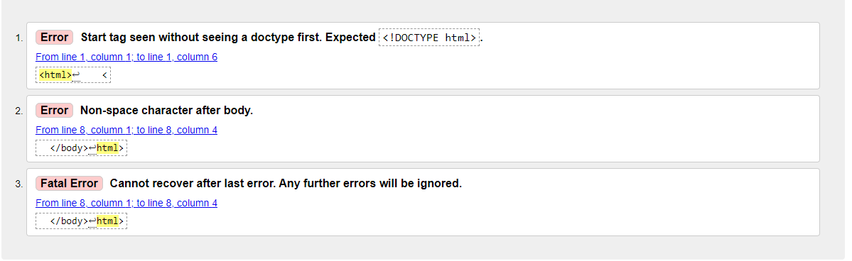

No Errors:   
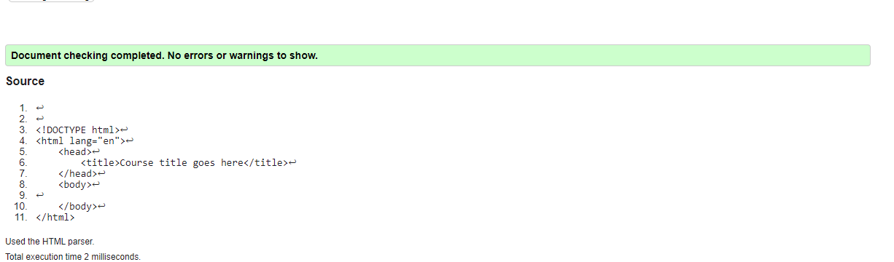

No Errors:   
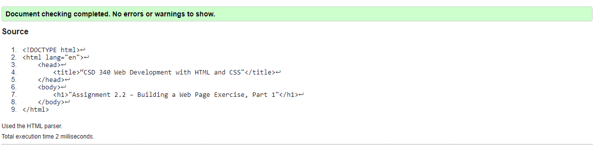

Webpage:

