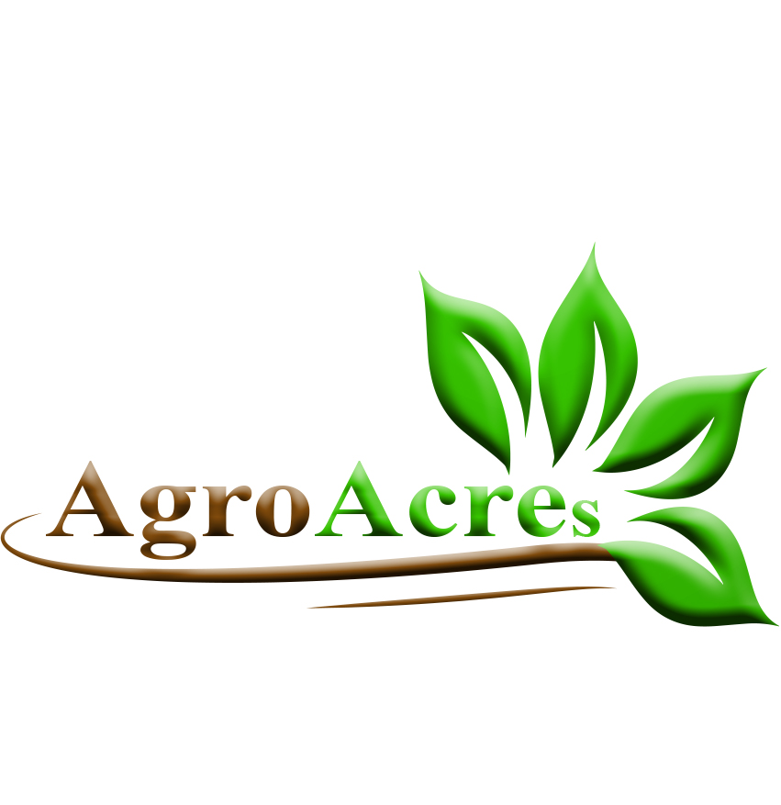February xx, 2020

xxxxxxxxxx

Manager

xxxxxxxxxxx Restaurants,

xxxxxxxxxxxxxxxxxxxxxxxxxx.

Dear Mr xxxxxxxxxxxxxxx,

We love the xxxxxxxxxx Restaurant in xxxxxxx, xxxxxxxxxxx, and we’ve visited two of the other four in xxxxxxxxx, too. The homey atmosphere and emphasis on healthy foods in your restaurants fits perfectly into our community values in this region.

However, we noticed that you purchase your products for as high as xxxxxxxxx. Perhaps you’ve never realized that our 100% organic, family-owned Agro Acres Farm can supply many of your meat and produce needs, at an even cheaper rate.

The partnership of Agro Acres Farm and xxxxxxxxxxxx Restaurants seems to us like a natural pairing. We’re sure that after reading this proposal, you’ll agree.

Please call to schedule a face-to-face meeting to discuss more details and set up a relationship that will benefit xxxxxxxxxxxxxxxxx Restaurants, Agro Acres Farm, and all your customers. We can’t wait to meet you in person.

Sincerely,

Ubesie Kenechukwu (+234 901 312 8268) Obi-Nwosu Chris (+234 706 761 8147)

Product Sales C.E.O

Agro Acres Farm, Enugu.

Drive 5 Prince and Princess Estate, Kaura District, Abuja.

(ltdagroacres@gmail.com)



Agro Acres Farm, xxxxxxxxxxxxx, Abuja

ltdagroaccres@gmail.com

**Proposal**

**Supplying Organic Products to xxxxxxxxxxx Restaurants**

Prepared for: xxxxxxxxxxxxxxxxxxx (Manager)

Prepared by: Ubesie Kenechukwu (Product Sales)

February xx, 2020

**Description**

The 100% organic meat and produce available from Agro Acres Farm, would be a great pairing with the xxxxxxxxx Restaurant. We can decrease your food costs while also increasing the quality of food presented to your customers.

**Opportunities**

The xxxxxxxxxx Restaurants chain has a number of opportunities to benefit from purchasing products and forming a relationship with Agro Acres Farm.

We’re neighbours! Like you, we take pride in our community and in promoting local businesses.

We know that right now xxxxxxxxxx has produce shipped in from others states as a financial rate significantly higher than what we offer. But you should know that most of the items you currently use are available from Agro Acres Farm, can be supplied more cheaply, and will arrive in the freshest condition possible. The “Buy Local” trend is big with the patrons of your restaurants, and so is the attraction of organic foods. We meet both those criteria, and you would benefit from cashing in on that.

**Your customers value healthy food, and we are a 100% organic farm.**

You won’t find a more wholesome, community-minded company than Agro Acres Farm. Our reputation will help promote your restaurants. It’s a natural relationship. The money you spend with us stays in our community.

**Your customers value protecting the environment, and we can help you reduce your carbon imprint.**

By buying locally, not only do you save money in transportation costs and guarantee fresher produce, but you’ll be helping to protect the environment. We are committed to running a sustainable business.

**Summary**

We believe that all of the points cited above are marketing themes that your customers will appreciate. Contracting with Agro Acres Farm for your produce needs is a win-win proposition.

**Products**

Agro Acres Farms is proud to offer xxxxxxxxxx Restaurants the following products:

**Organic poultry and eggs**

Agro Acres Farm raises quite the eye-raising flock of birds. All these birds are allowed to wander freely in large pens, leading healthy lives in open-air environments, and feeding on organic grains, proteins, and greens. As well as providing all cuts of fresh free-range, antibiotic-free poultry, we regularly package and supply fresh chicken eggs to our many customers. If desired, we can add turkey and quail to our poultry stock.

**Garden fresh produce**

In season, we can supply the following fresh produce to your restaurants: lettuce, peppers, tomatoes, corn, green beans, green onions, garlic. We can also supply fresh flowers in the summer if desired.

We take great pride in picking crops only when they are ripe and ready for harvest. Farming has its seasons, and not all products are available at all times of year. Although our seasons fluctuate somewhat each year due to variable weather conditions, due to our enviable supply chain, we’d be able to meet any and all agricultural produce supply needs that might arise.

**Summary**

We frequently add new varieties to our list of produce, so this list may change from year to year. We can grow crops on demand as well, so if you do not see an item on our list that you’d like to have, just ask.

**Delivery Details**

Both Agro Acres Farm and xxxxxxxxxx Restaurants place a high value on the freshness of produce. So you’ll be happy to know that we can provide delivery service directly to your restaurants.

**Benefits of Our Service**

The biggest benefit of our service is farm-to-table freshness! Although we can freeze meat products if you desire, we typically deliver fresh or frozen chicken, and poultry products in our refrigerated trucks so you can advertise that your meals contain ingredients that have “never been frozen.”

**Costs**

The cost of delivery varies by the amount of produce ordered, and should you want a special delivery on days other than Monday or Friday, we must charge extra for that. If you typically order a variety of products on our regular delivery days, we think you’ll be pleasantly surprised at how inexpensive our delivery service is.

Call us for details. We are confident in our ability to work out an arrangement that will suit every budget and meet every establishment’s needs.

Ubesie Kenechukwu (+234 901 312 8268) Obi-Nwosu Chris (+234 706 761 8147)

Product Sales C.E.O

Agro Acres Farm, Enugu.

Drive 5 Prince and Princess Estate, Kaura District, Abuja.

(ltdagroacres@gmail.com)