Fireline Parallelisation Using Java Fork/Join
Introduction
This report evaluates the parallelisation of the Fireline simulation using Java's Fork/Join framework. The workload is a grid-based stencil computation in which cells are updated from their current state and neighbouring cells. The objective is to determine whether dividing the grid into independent rectangular regions provides a useful performance benefit while preserving the behaviour of the serial implementation. The parallel implementation uses recursive spatial decomposition. A task represents a rectangular part of the grid and recursively splits the longer dimension until the region is small enough to be processed sequentially. A sequential cutoff therefore controls the trade-off between available parallelism and Fork/Join task-management overhead.
Measurement protocol
Seven executions were made for every combination of grid size and sequential cutoff. The first two executions were treated as JVM/system warm-up and excluded from the reported statistic. All reported timings and speedups therefore use the arithmetic mean of runs 3–7. Image generation and file writing were excluded from the measured core simulation time.
Experimental Platform Laptop:11th Gen Intel(R) Core(TM) i5-1135G7 @ 2.40 GHz, 4 physical cores and 8 logical processors. The departmental server, was also used as a second architecture for comparison. The repeated-run methodology improves reliability by reducing the effect of startup and transient execution effects. Nevertheless, measurements can vary because of JVM JIT compilation, operating system scheduling, background processes and thermal behaviour. A shared server such as nightmare can additionally experience contention from other users and processes, so larger timing spikes would be expected there than on an otherwise lightly loaded laptop.
Procedure
For each grid size in Table 1 below, (e.g. 400 x 400), the serial code was run 7 times. The first two executions were treated as JVM/system warm-up and excluded, the mean of the other 5 were recorded below. This was also done for the parallel code, however, all 7 runs were made for each sequential cutoff (1 000, 5 000, 10 000, 20 000, 30 000, 40 000, 50 000, 60 000, 70 000, 80 000, 90 000,100 000).
Results
Table 1 reports the best measured cutoff for each grid size. The best cutoff is the cutoff producing the smallest mean parallel execution time among the tested values. Speedup is calculated as serial mean time / parallel mean time.
Grid | Best Cutoff | Serial mean (ms) | Parallel mean (ms) | Speedup
100 x 100 | 40,000 | 127.0 | 178.0 | 0.714x
200 x 200 | 5,000 | 771.8 | 609.9 | 1.265x
300 x 300 | 5,000 | 3,420.6 | 1,335.7 | 2.561x
400 x 400 | 10,000 | 7,554.9 | 2,551.7 | 2.961x
500 x 500 | 50,000 | 14,492.2 | 4,623.5 | 3.134x
600 x 600 | 70,000 | 29,805.3 | 8,774.7 | 3.397x
700 x 700 | 100,000 | 39,706.1 | 14,702.0 | 2.701x
800 x 800 | 100,000 | 44,632.4 | 22,240.2 | 2.007x
900 x 900 | 70,000 | 64,687.7 | 44,485.7 | 1.454x
1000 x 1000 | 80,000 | 119,833.7 | 54,031.3 | 2.218x
Table 1. Mean of runs 3–7 at the best measured cutoff for each grid.
The maximum measured laptop speedup is 3.397x, obtained for the 600 x 600 grid at a 70,000-cell sequential cutoff. The smallest workload, 100 x 100, produced a speedup of only 0.714x, meaning that the parallel version was slower than serial execution. This is consistent with parallel overhead dominating when there is insufficient computational work. Speedup increases substantially from 200 x 200 through 600 x 600. The strongest measured region is approximately 300 x 300–700 x 700, with the maximum at 600×600. Speedup then falls at 700–900 before recovering to 2.218x at 1000×1000. This non-monotonic behaviour shows that grid size alone does not determine performance: task granularity, cutoff selection and memory-system behaviour also matter.
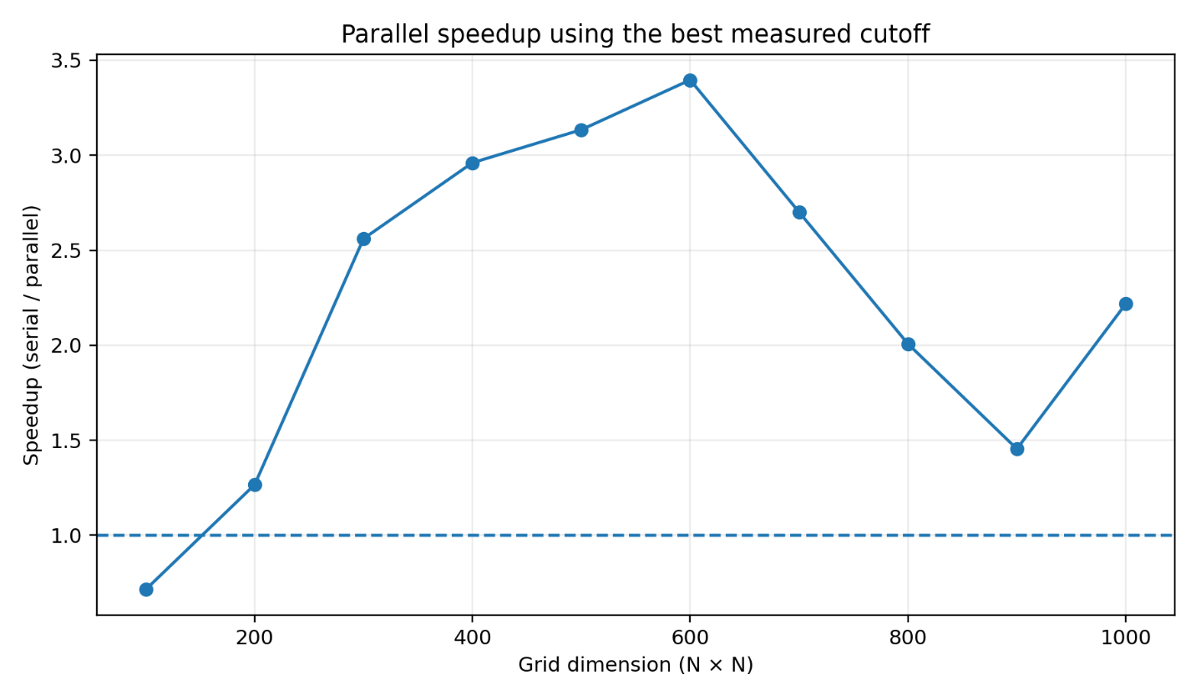
Figure 1. Speedup at the best measured cutoff for each grid size.

Sequential Cutoff Analysis
If the cutoff is too small, the program creates many fine-grained tasks, increasing task creation, scheduling and join overhead. If it is too large, each task contains more sequential work and there may be insufficient parallel work to keep the available cores busy. The results therefore exhibit a workload-dependent optimum.
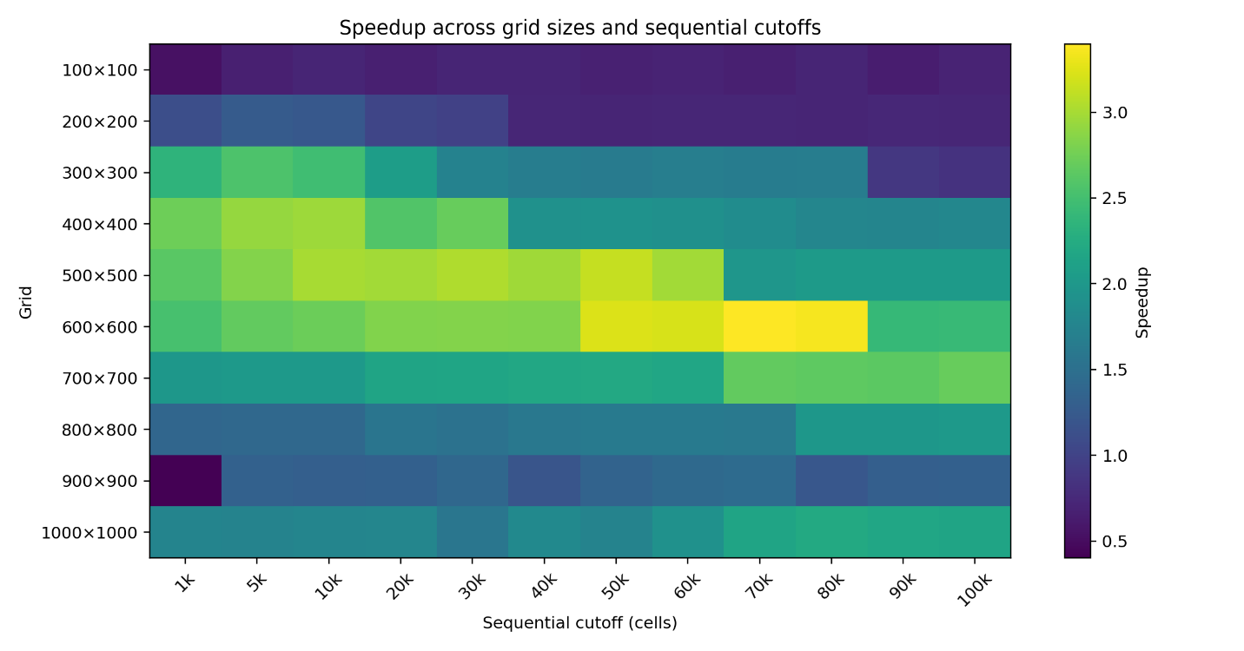
Figure 2. Speedup across the tested grid sizes and sequential cutoffs.
Maximum Speedup and Ideal Scaling: The laptop's maximum observed speedup of 3.397× can be compared with a four-physical-core reference of 4×. It therefore achieves approximately 84.9% of the ideal four-core linear speedup. If all eight logical processors are treated as a reference, the nominal 8× ideal gives approximately 42.5% of ideal. The four-core comparison is more informative for a CPU-bound workload because logical processors from simultaneous multithreading do not provide the same throughput as additional physical cores. Perfect linear scaling is not expected. The simulation retains serial control and convergence work, while Fork/Join introduces task creation, scheduling and join overhead. The stencil update also performs substantial array memory traffic, so memory bandwidth and cache behaviour can become limiting factors before the theoretical core count is fully exploited.
Measurement Reliability and Anomalies
Using five post-warm-up observations for each configuration makes the results substantially more reliable than a single timing. However, the data contain clear anomalies. The most prominent is the 900×900, 1,000-cell-cutoff configuration, where one post-warm-up run was approximately 614 seconds while the other repetitions are around tens of seconds. These can arise from operating-system scheduling, JVM activity, memory pressure and thermal effects. On a shared server, contention from other users would provide an additional source of variability.
Architecture Comparison: The laptop results demonstrate that the algorithm can achieve substantial acceleration, but the magnitude depends strongly on workload size and cutoff. The peak of 3.397x is close to the four-physical-core ideal. A second architecture such as nightmare is valuable because it tests whether the observed benefit is specific to the laptop or is a robust property of the algorithm. The maximum speedup on nightmare was only 1.97x. This is below the laptop's 3.397x peak; shared-server contention and architectural differences may be plausible explanations.
Workload Range Where Parallelisation Is Beneficial: The 100×100 experiment is the clearest evidence that parallelisation is not universally beneficial. Its 0.714x speedup means the parallel implementation costs more than it saves. From 200x200 onward, the best measured configuration produces speedup greater than one, and the strongest range is around 300×300–700×700. At these sizes, there is enough computational work to amortise task-management overhead while the grid is still small enough for the chosen decomposition to expose useful concurrency without excessive memory-system pressure. The decline after the 600×600 peak should not be interpreted as evidence that larger problems cannot benefit from parallelisation. Instead, it indicates that the tested cutoff and execution environment interact with the workload. The recovery to 2.218× at 1000×1000 reinforces this interpretation.
Conclusion
For the laptop architecture, the evidence supports using Java multithreading for sufficiently large Fireline workloads. The best measured configuration achieved 3.397× speedup, approximately 84.9% of the ideal four-physical-core scaling reference. The result demonstrates that the computational region can be parallelised effectively, but the benefit depends strongly on workload size and sequential cutoff. Parallelisation is not worthwhile for every input: at 100×100 the parallel implementation is slower because Fork/Join overhead dominates. The practical benefit begins as the grid becomes large enough to amortise this overhead, with the strongest measured performance occurring around 600×600. The cutoff must also be tuned to the workload rather than treated as a fixed constant. Nightmare as a busy shared server showed greater timing variability and lower observed speedup because competing workloads reduce the resources available to the simulation. The multi-run methodology makes such effects visible rather than hiding them behind a single timing.

AI Declaration
The java files submitted to automaker were generated with the assistance of GPT 5.6 Terra.

