
SCHOOL OF COMPUTING AND INFORMATICS
DEPARTMENT OF INFORMATION TECHNOLOGY
Mobile Application Development
WEEKLY PRACTICAL LOGBOOK

Student Details
Student Name | AMOS MRAMBA KENGA
Admission Number | BIT/2024/47083
Course/Class | BACHELOR’S OF SCIENCE IN INFORMATION TECHNOLOGY
Unit Code
Unit Name | Mobile Application Development
Semester/Academic Year | MAY - AUGUST 2026

Project Details
Project Title | Competency-Based Education (CBE) Assessment Application
Selected Technologies | Android Studio, Java, XML, SQLite

Online Portfolio / Version Control
GitHub Repository Link | https://github.com/Kenga-dev/BIT4107-Mobile-Applications-Development

TABLE OF CONTENTS
Contents
Student Details 1
Project Details 1
Online Portfolio / Version Control 1
Week 1: Android Environment Setup 3
Title: Installation and Configuration of Android Studio 3
Required Evidence 3
Student Reflection 3
Week 2: XML Layouts and GUI Design 4
Title: Native Android UI Planning and XML Implementation 4
Required Evidence 4
Student Reflection 4
Week 3: Java Logic and SQLite Backend 5
Title: Event Handling, Intent Navigation, and Database Integration 5
Required Evidence 5
Student Reflection 5

Week 1: Android Environment Setup

Title: Installation and Configuration of Android Studio

Evidence
Fig 1: Android Studio Installation Success
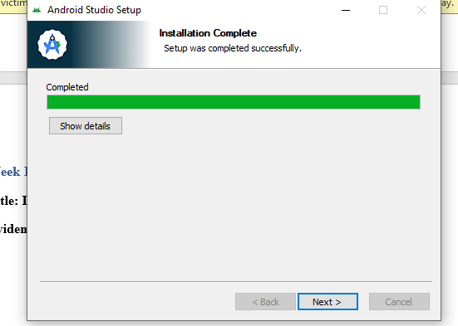

Fig 2: SDK Manager showing installed SDKs/Build Tools
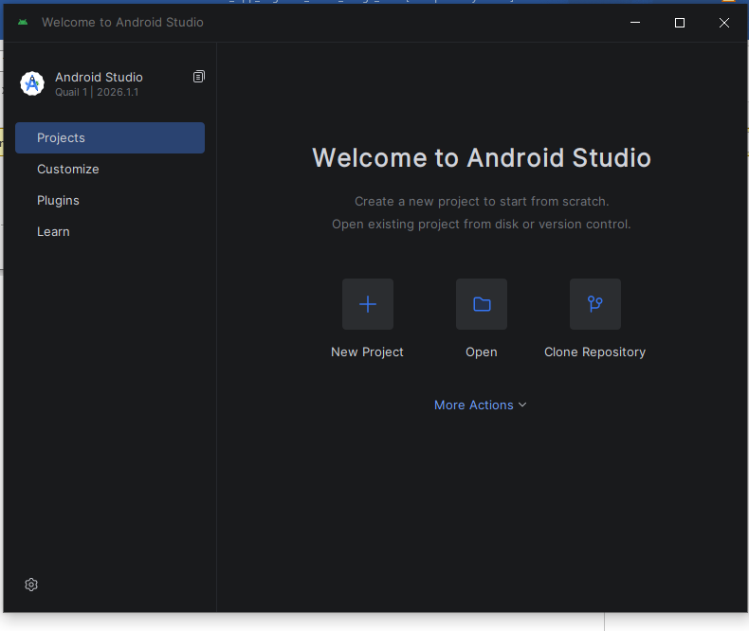

Fig 3: Project Initialization (Empty Views Activity)
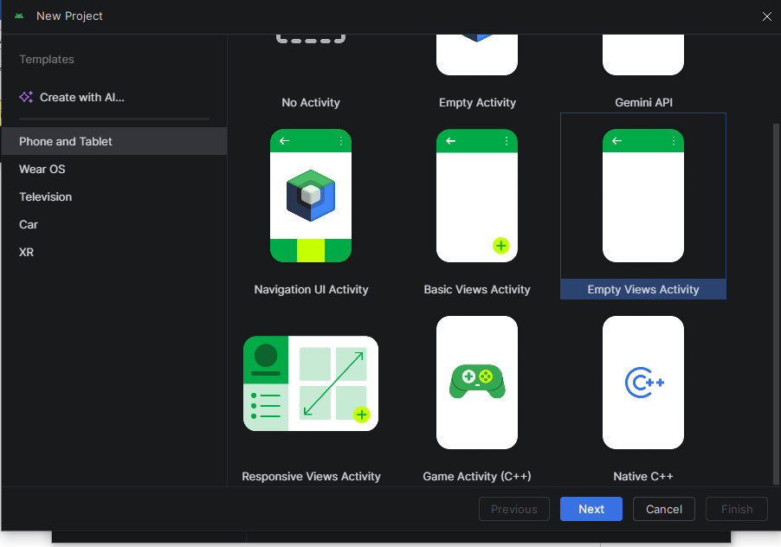

Fig 5: AndroidManifest.xml configuration structure
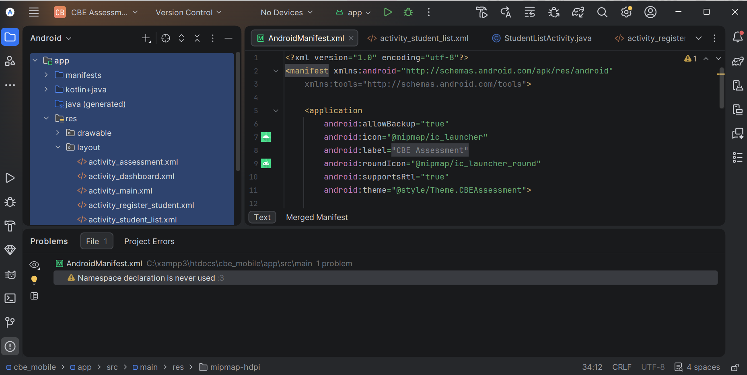

Student Reflection
This week focused on preparing the Android development environment. I successfully installed Android Studio and configured the necessary SDK components targeting Android 7.0 (Nougat) for maximum compatibility. Fig 4 demonstrates the successful compilation and deployment of the initial 'Hello World' build onto a physical device. Overcoming initial gradle sync issues ensured the project was correctly set up for native Java and XML development.

Week 2: XML Layouts and GUI Design

Title: Native Android UI Planning and XML Implementation

Evidence
Fig 1: Wireframe / UI Concept
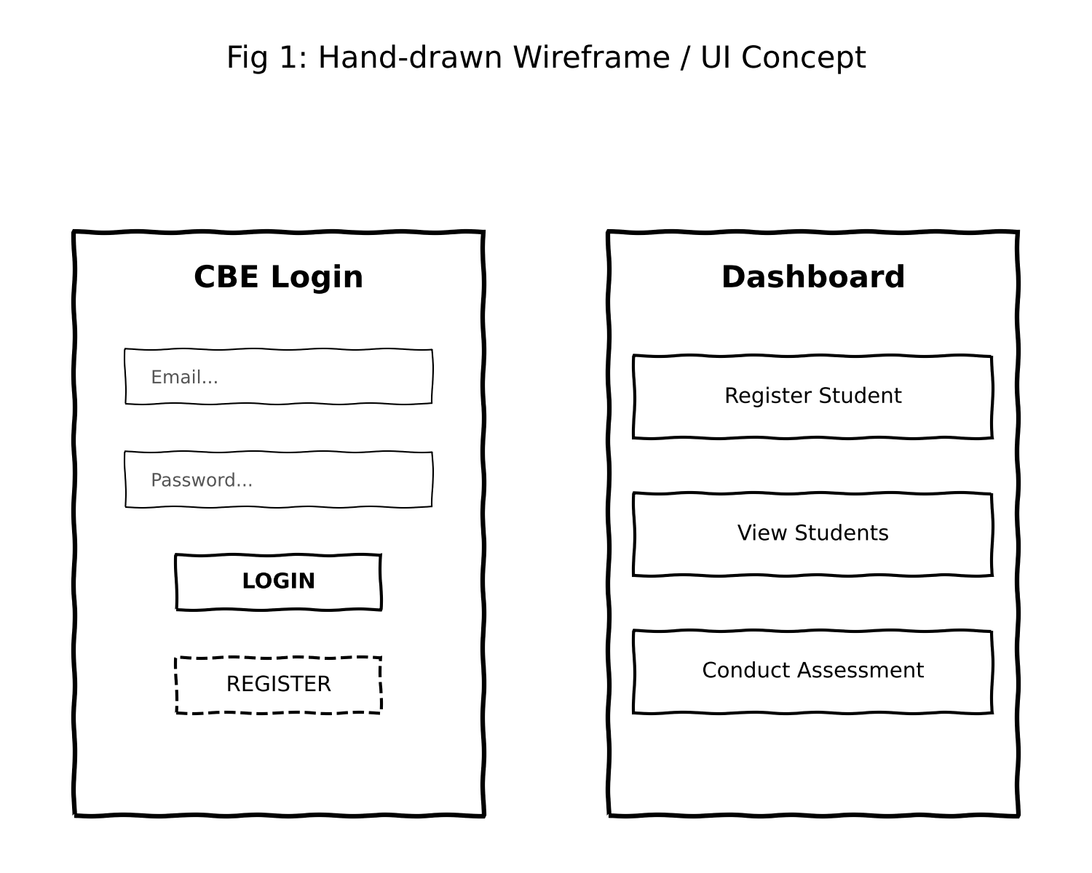

Fig 2: MainActivity.xml (Login UI) implementation
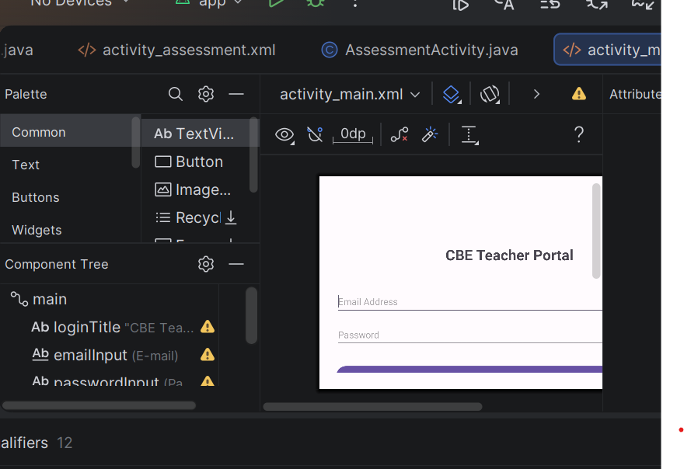

Fig 3: DashboardActivity.xml Layout Design
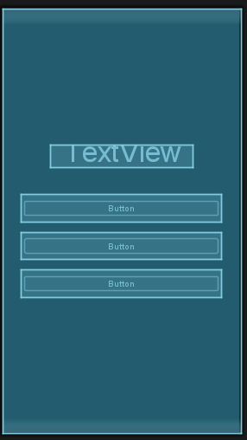

Fig 4: CBE Checklist Layout structure
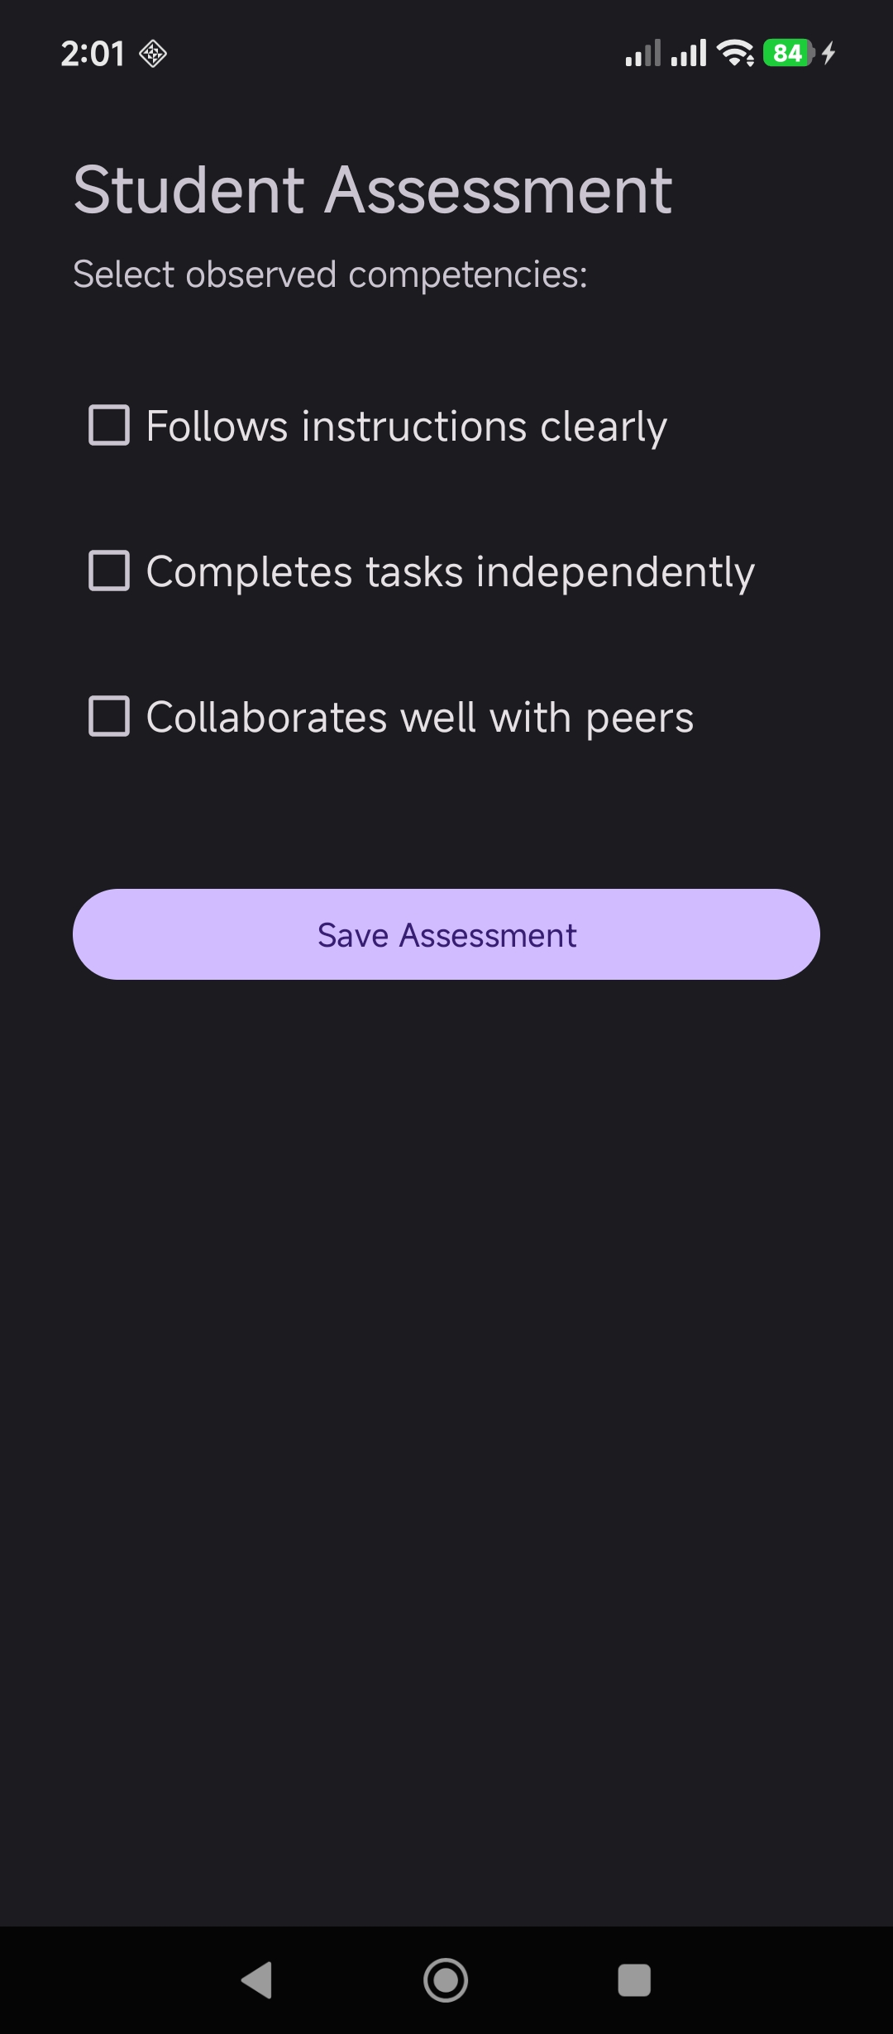

Student Reflection
The design phase centered on constructing responsive native interfaces using XML. I utilized LinearLayout structures with specific padding and gravity attributes to create a clean, user-friendly login portal and dashboard. Fig 3 shows the dashboard layout, which acts as a central hub. Crucially, I assigned unique resource IDs (e.g., @+id/btnRegisterStudent) to all interactive elements to ensure they could be properly bound to the Java backend in the subsequent development phases.

Week 3: Java Logic and SQLite Backend

Title: Event Handling, Intent Navigation, and Database Integration

Evidence
Fig 1: Java findViewById variable binding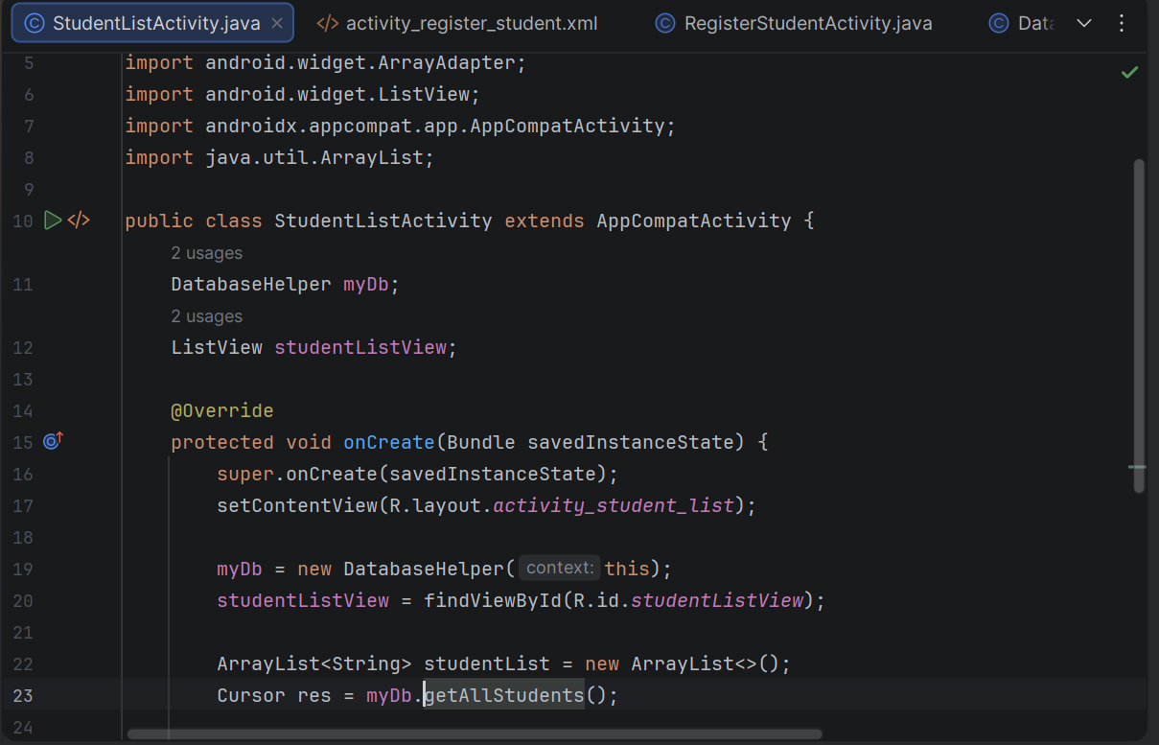

Fig 2: OnClickListener and Intent navigation setup 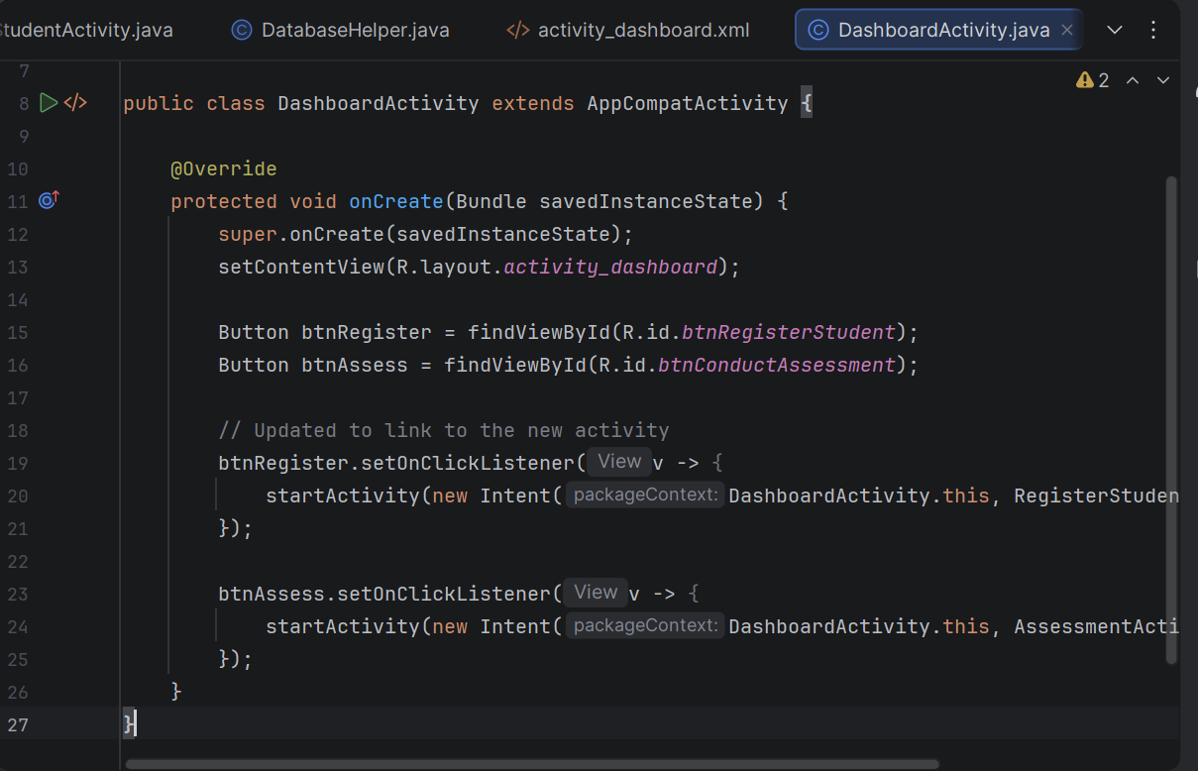

Fig 3: DatabaseHelper.java (SQLiteOpenHelper setup)

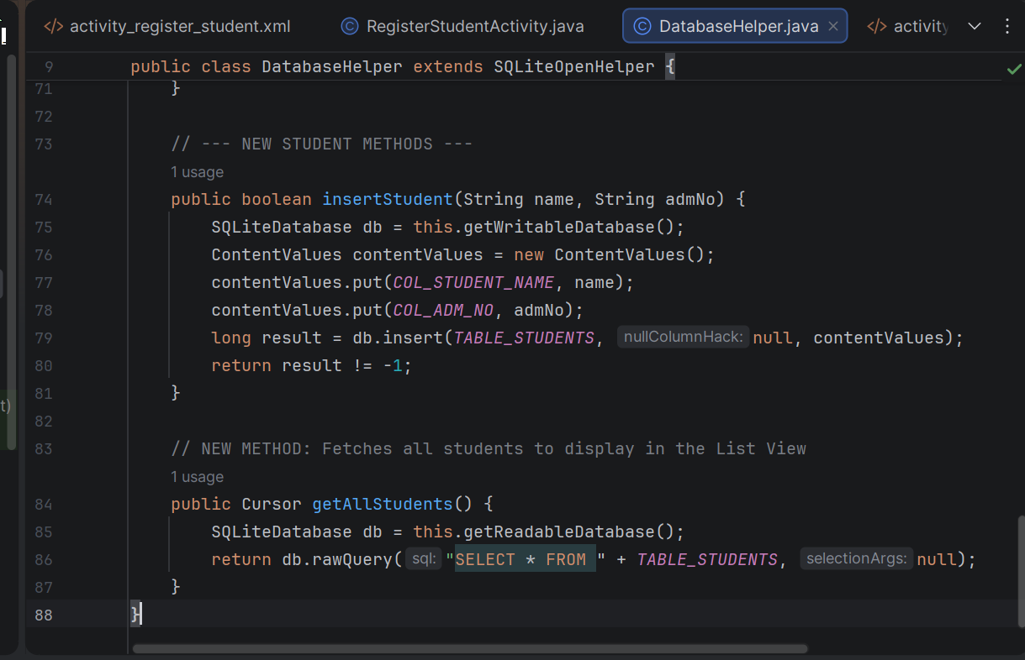

Fig 5: Successful Login/Registration Toast notification
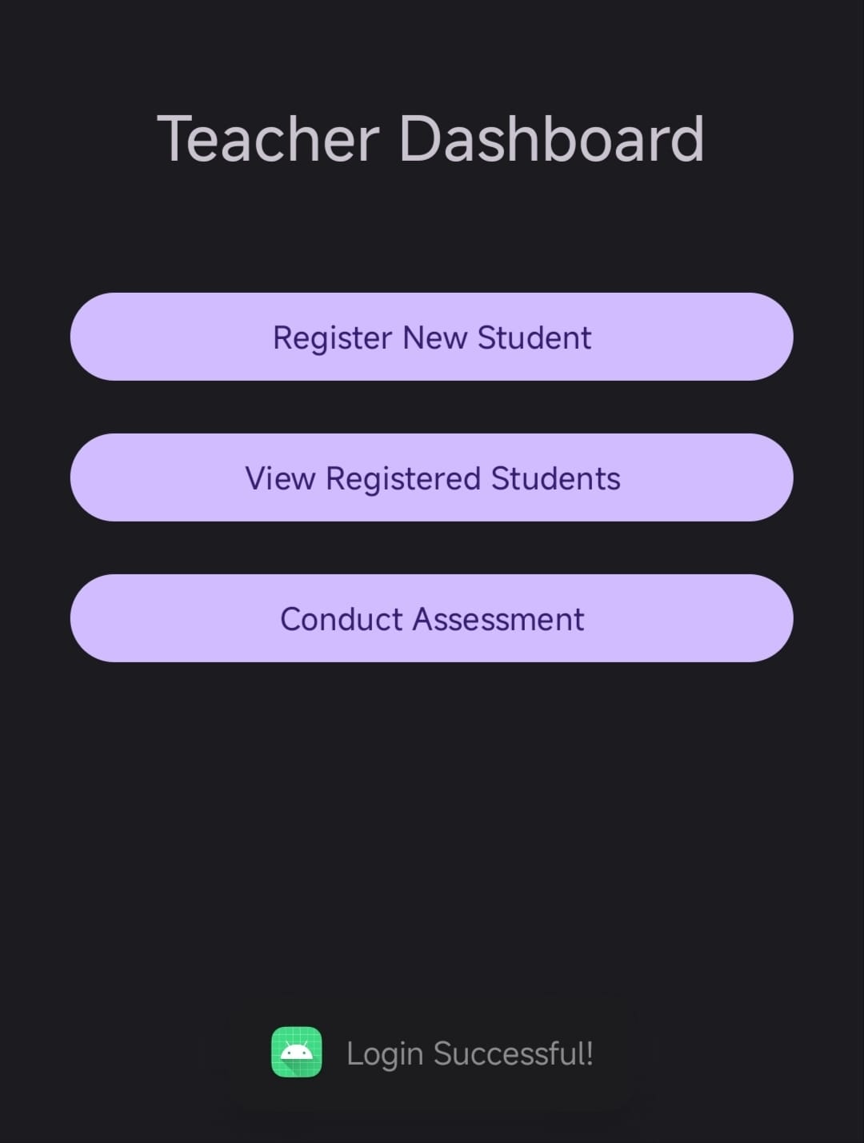

Student Reflection
This week bridged the XML frontend with the Java backend. I implemented View.OnClickListener methods to capture user input and Intents to navigate between screens. Fig 3 illustrates the creation of the DatabaseHelper class, which extends SQLiteOpenHelper to provide offline storage. The integration enabled the secure creation of local user accounts and verification of credentials. Fig 5 demonstrates the successful execution of this logic, triggering a Toast message upon a verified login.

