**Step 1** - Login to your EDAS account at <https://edas.info/>

**Step 2** – Register

For authors with accepted papers, click on the **Registration** icon of the corresponding paper.

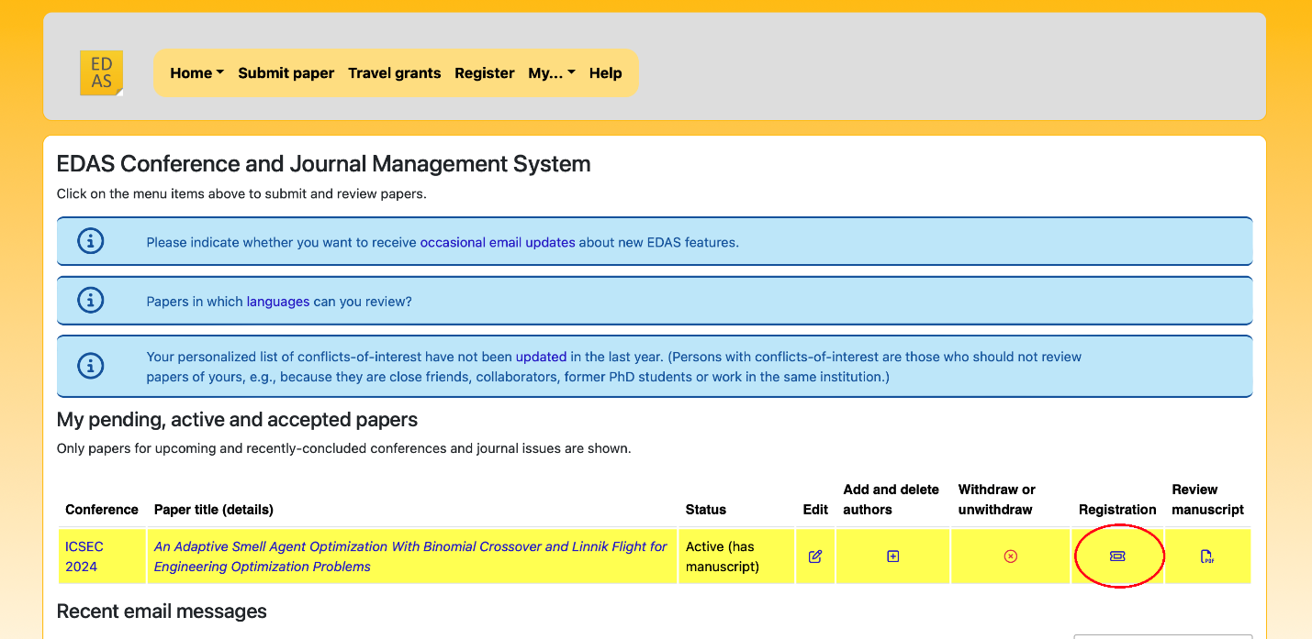

For participants, click on **Register** tab and search for *“ICSEC”*. Then click on the ticket icon under **Register self**.

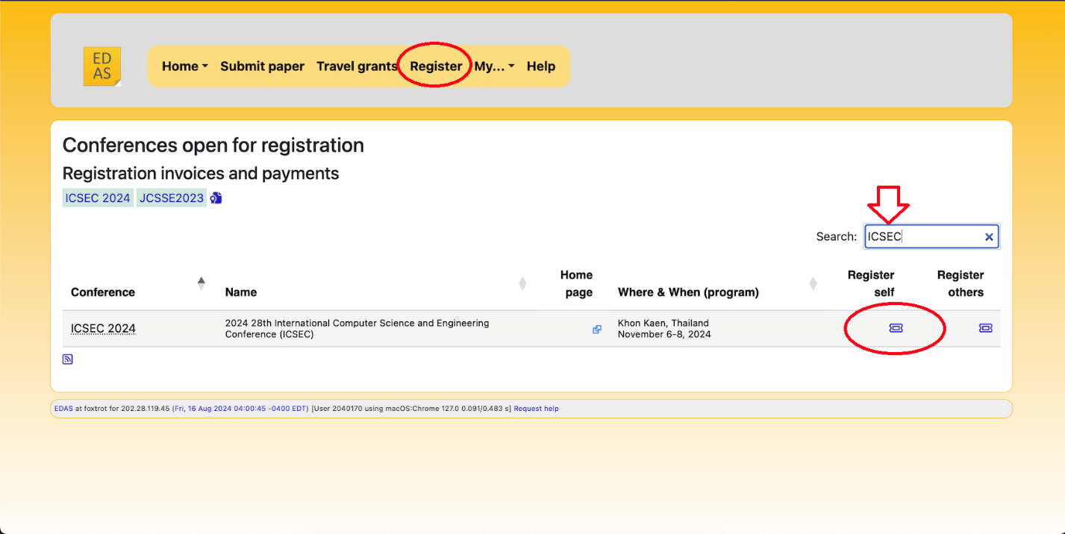

**Step 3** – Click on the **Cart** icon of the registration type that applies to you. The conference has the right to cancel your registration if an incorrect information or an invalid registration option was registered. Please contact our admin for any questions. Registration fees are non-refundable.

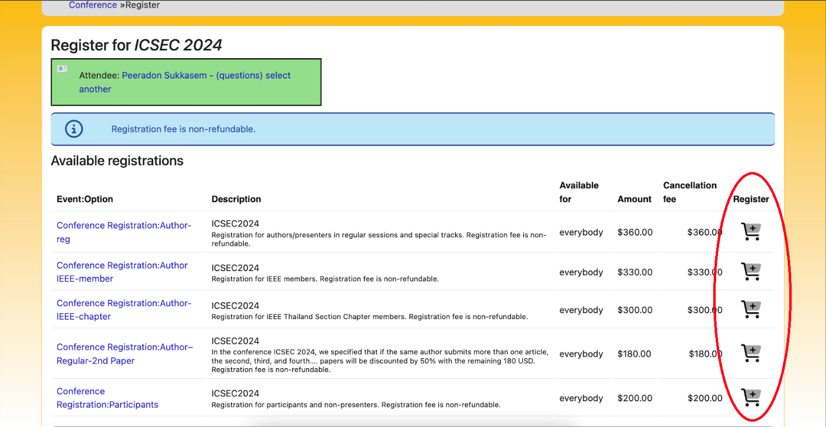

**Step 4** – On the next page, click on “answer the registration questions” at the bottom.

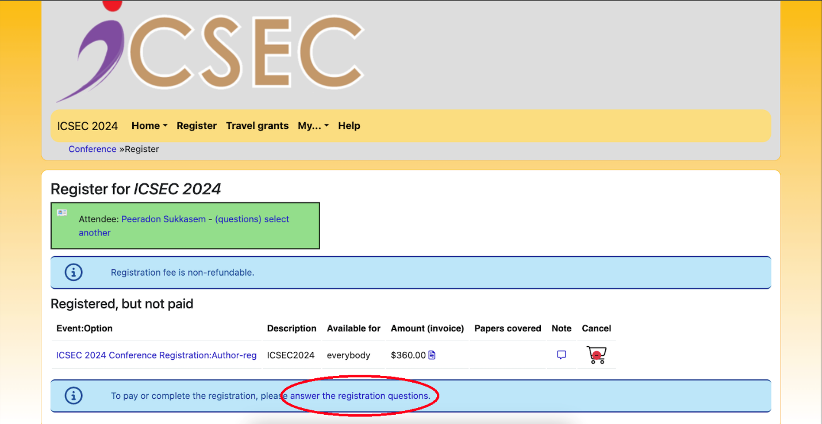

**Step 5** – Check the checkbox if Participate Online**. Leave the box unchecked if participate Onsite**, then click Submit.

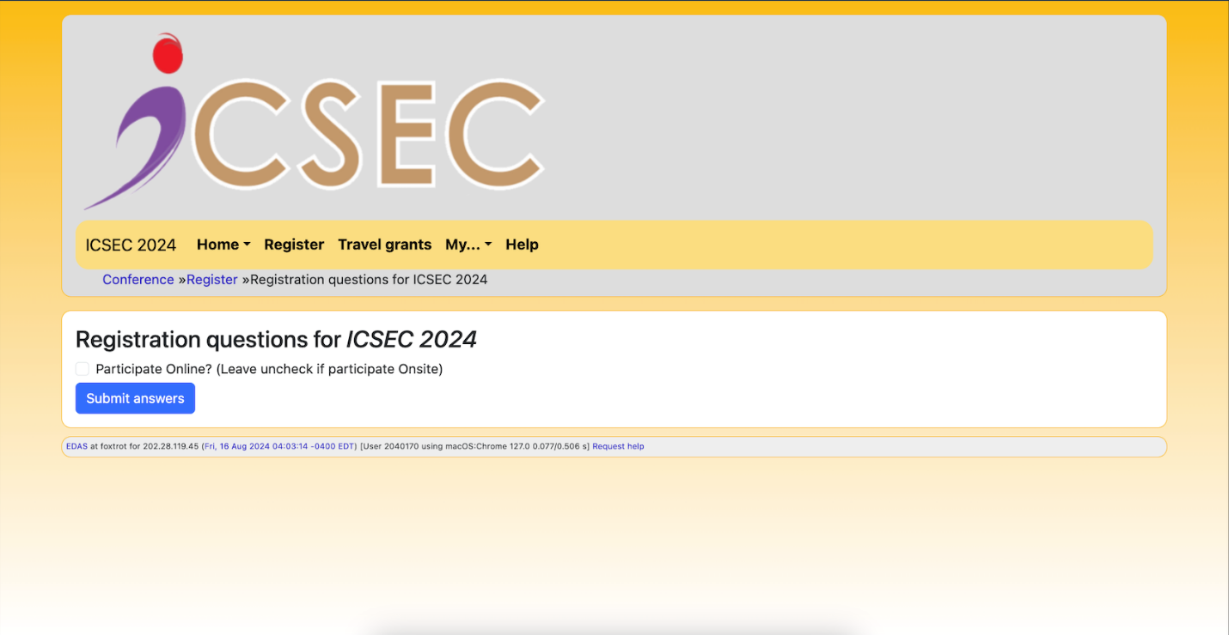

**Step 6 – Payment:** Choose pay by credit card at the bottom (The amount will be charged in US dollar only).

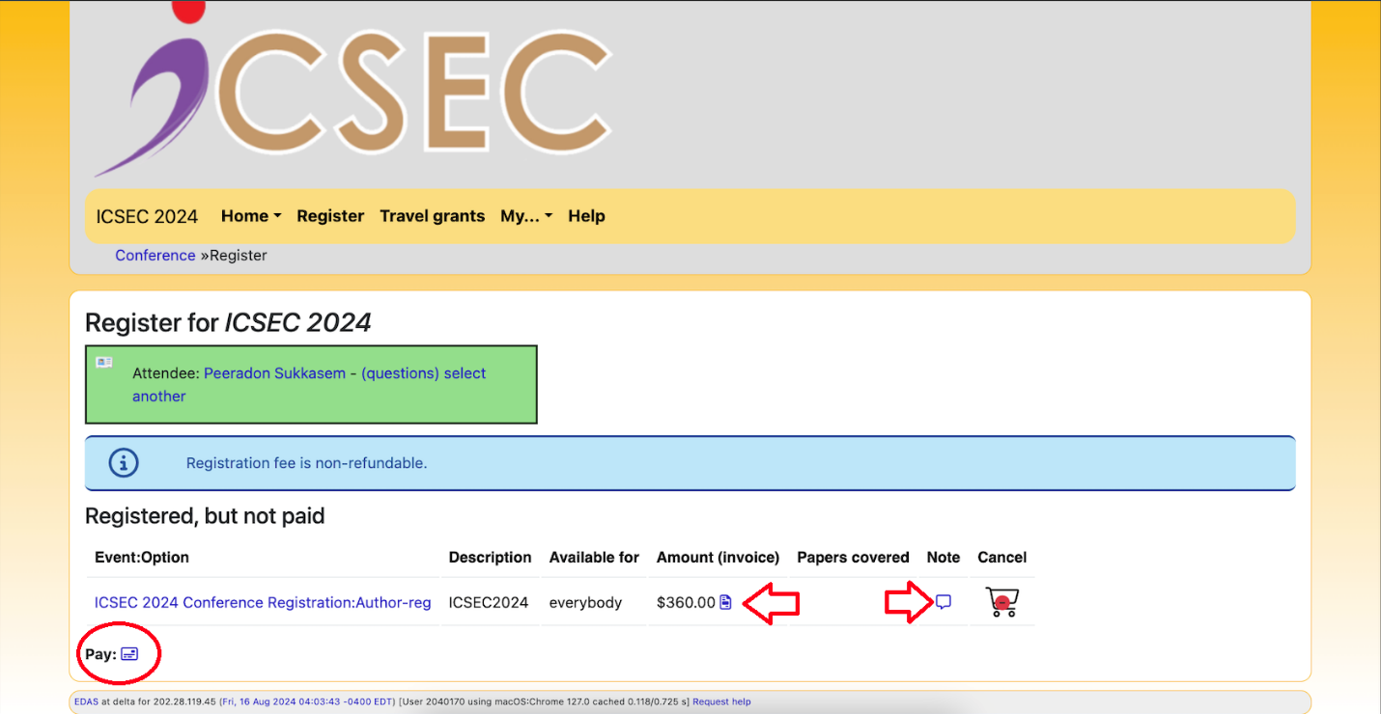

**Step 7 – Payment:** Enter valid card details and click Pay button. After payment please check the invoice if the information is correct.

