**Research on Customer Satisfaction at Tim Hortons**

**MKTG 749-004**

**Group-6**

**Uday Tej Kakumanu - 301222115**

**Kenil Gondaliya- 301329798**

**Ishika Bedi- 301243899**

**Rahul Balvantbhai Lad- 301333400**

## Supervisor- Savita Seharawat

## Date of Submission: 8th November 2023

**Project Abstract:**

**Context:**

In the bustling Greater Toronto Area (GTA), the coffee industry is a competitive arena, and Tim Hortons, a beloved Canadian brand, faces the challenge of catering to post-secondary students' diverse tastes and preferences. This research project delves into the world of Tim Hortons, with a specific focus on Centennial College students, to understand how customer ratings and recommendations, drawn from both qualitative and quantitative user-generated content, can be harnessed to tailor offerings and experiences to this crucial demographic.

**Problem Statement:**

This research seeks to address the following key questions:

1. What are the factors that influence the customer ratings and recommendations for Tim Hortons among post-secondary students in the GTA, specifically those attending Centennial College?
2. How can a combination of qualitative insights (from reviews and comments) and quantitative data (ratings and rankings) be utilized to decipher this target demographic's unique preferences and expectations?
3. What actionable strategies can Tim Hortons employ to enhance customer satisfaction, loyalty, and engagement within the Centennial College student community?

**Type of Survey:**

Our study will adopt a mixed-methods research approach, amalgamating qualitative and quantitative data collection methods. We will collect and analyze user-generated content in the form of online reviews, ratings, and comments from Centennial College students who have frequented Tim Hortons locations in the GTA. This approach will enable us to uncover both the sentiment and specific aspects that influence their perceptions.

**Keywords:**

Text mining, Sentiment analysis, Topic modeling, Machine learning, Customer intelligence, Voice of the customer (VOC), Customer relationship management (CRM), Recommendation systems, Personalization, User experience (UX), User interface (UI)

**Techniques and Tools:**

To address the research questions, we propose the following techniques and tools:

1. **Topic Modeling**: Qualitative insights will be extracted through topic modelling algorithms, helping identify recurring themes and issues raised by customers.
2. **Statistical Analysis**: Quantitative data, including ratings and rankings, will be statistically analyzed to uncover patterns and correlations.
3. **Surveys**: Structured surveys will be conducted to gather additional quantitative data on customer preferences and demographic information.
4. **Focus Groups**: Qualitative insights will be enriched by conducting focus group discussions with Centennial College students to explore in-depth opinions and suggestions.

Through this research, we aim to provide Tim Hortons with actionable insights that can be leveraged to better serve the unique needs and expectations of Centennial College students in the GTA. By combining qualitative and quantitative methods, we seek to provide a comprehensive understanding of the factors driving customer ratings and recommendations, ultimately enhancing the coffeehouse experience for this demographic.

**Literature Review**

Our study is focused on how branding of Tim Hortons influences consumer behaviour, how the preferences contribute to customer satisfaction, and how the business relate to other cultures. As, our study aims to deploy all the necessary tools and techniques to uncover the rationale for consumer behaviour, we have reviewed all the possible studies that some way relates to our research objective.

**Branding's Influence on Consumer Experiences and Loyalty**

Keller (1993) and Aaker (1997) discussed how branding and brand loyalty influences consumer experiences. Their key highlights were that branding plays a pivotal role in shaping consumer experiences and fostering brand loyalty. Their study emphasized the importance of creating a strong connection between consumers and brands.

**Sensory Rituals in Coffee Consumption**

Carlsen et al. (2018) have shed light on the fact that, the act of enjoying coffee often involves engaging sensory rituals that enhance the overall experience. Their research unravels the journey associated with coffee consumption, encompassing taste, touch, smell, and visual elements with respect to rituals as they enrich the overall enjoyment of the coffee-drinking experience.

**Brand Associations in Cultural Contexts**

Holt's typology (Holt, 2004) study was based on understanding brand associations within diverse cultural contexts. Holt's research highlights the significance of cultural factors in shaping brand perceptions, emphasizing the need for global brand management to consider these cultural distinctions.

**Consumer Adaptation and Personalization for Effective Brand Management**

Firat and Venkatesh (1993) and Schau et al. (2009) highlighted the requirement of a deep understanding of how consumers shape and personalize their interactions with a brand for successful brand management. Consumers' ability to adapt and personalize their experiences is important in maintaining brand relevance and resonance.

**Shift in Coffee Consumption Trends in India**

Singh and Saluja (2013) conducted a study focusing on the transition from tea to coffee consumption in particularly in the context of Barista outlets in Delhi, India. They employed research methods such as ANOVA and frequency analysis to measure customer satisfaction, finding that most participants had positive experiences. Their research reflects the nationwide trend of increasing coffee consumption and favorable customer opinions.

**Factors Impacting Customer Satisfaction in Coffee Shops**

Lee, Moon, and Song (2018) investigated the elements such as ambiance, employee demeanor, IT service, and coffee quality that impact customer contentment in coffee shops. They discovered strong connection between customer satisfaction and brand loyalty, underlining the significance of these factors in shaping the overall customer experience.

**Branding, Sensory Experiences, and National Identity**

Cormack's research (2008) studied the relation between branding, sensory experiences, and national identity, focusing on Tim Hortons' 'True Stories' ads in the Canadian context. The study demonstrated how these advertisements link the brand to Canadian culture through sensory experiences and understanding the complex relationship between brands and national identity.

These topics have already been covered in other study, but we wish to bring something fresh. We might use the same procedures as the earlier research but in a different setting, or we might investigate a topic that hasn't received much attention before. Even while some portions of the studies we read are comparable, each one provides us with unique information because it was conducted in a unique manner or location. The information we already have will be use in our research to either validate what we already know or to uncover fresh theories. This enhances the value of our research.

**Survey Questions**

**Introduction**  
  
Tim Hortons is a popular Canadian fast-food chain that is known for its coffee, Timbits, and other food items. Centennial College is a large community college in Toronto, Canada, with over 27,000 students.  
  
This questionnaire is designed to assess the customer satisfaction of Tim Hortons among Centennial College students. The results of this questionnaire will be used to identify areas where Tim Hortons can improve its customer service and offerings for Centennial College students. Please take a few minutes to complete this questionnaire. Your feedback is important to us.

Thank you for your participation!

Q1 Are you a centennial student?

* Yes
* No

Q2 On average, how many times do you visit Tim Hortons per week?

* Once a week
* 2-3 times a week
* 4-5 times a week
* Daily
* Never

Q3 On average, how much money do you spend on a typical visit to Tim Horton's?

* Less than $5
* $5 - $10
* $10 - $15
* More than $15

Q4 Do you have a preferred beverage you like to order at Tim Hortons?

* Yes
* No

Q5 Which of the following beverages did you select for yourself?

* Hot Beverage
* Cold Beverage
* Both

Q6 Which of the following cold beverages did you order for yourself?

* Vanilla Cream Cold Brew
* Vanilla Coconut Cold Brew with Espresso-Infused Foam
* Roasted Hazelnut Cold Brew with Espresso Cold Foam
* Pumpkin Spice Cold Brew
* Redeye Iced Coffee
* Iced Latte
* Redeye Iced Capp
* Mocha Iced Capp
* Caramel Iced Capp
* Vanilla Iced Capp
* Chocolate Creamy Chill
* Vanilla Creamy Chill
* Milk
* Classic Lemonade
* Strawberry Frozen Lemonade
* Strawberry Watermelon Quenchers

Q7 Which of the following hot beverages did you order for yourself?

* Redeye Original Blend
* Latte
* Cappuccino
* Americano
* Brewed Coffee
* Dark Roast Brewed Coffee
* Steeped Tea
* Specialty Tea
* French Vanilla
* Hot Chocolate
* White Hot Chocolate
* London Fog
* Espresso
* Take Twelve

Q8 How satisfied were you with the overall

|  |  |  |  |  |  |
| --- | --- | --- | --- | --- | --- |
|  | Highly Dissatisfied | Dissatisfied | Somewhat Satisfied | Satisfied | Highly Satisfied |
| Taste |  |  |  |  |  |
| Portion size |  |  |  |  |  |
| Accuracy of order |  |  |  |  |  |
| Aroma |  |  |  |  |  |
| Temperature |  |  |  |  |  |
| Packaging |  |  |  |  |  |
| Value for money |  |  |  |  |  |

Q9 Could you provide specific reasons why you were not satisfied with the beverage?

________________________________________________________________

Q10 Do you have any preferred food items you like to order at Tim Hortons?

* Yes
* No

Q11 Which of the following food items did you select for yourself?

* Bagels
* Wraps/Sandwich
* Donuts
* Muffins
* Timbits
* Cookies

Q12 How satisfied were you with the overall

|  |  |  |  |  |  |
| --- | --- | --- | --- | --- | --- |
|  | Highly Dissatisfied | Somewhat Dissatisfied | Neither satisfied nor dissatisfied | Somewhat satisfied | Highly Satisfied |
| Taste |  |  |  |  |  |
| Quality |  |  |  |  |  |
| Freshness |  |  |  |  |  |
| Variety |  |  |  |  |  |
| Customization options |  |  |  |  |  |
| Presentation |  |  |  |  |  |

Q13 Could you provide specific reasons why you were not satisfied with the food?

________________________________________________________________

Q14 What method did you use to order?

* Front counter
* Mobile APP
* Drive-thru

Q15 What do you like/dislike the most about Tim Horton's app?

|  |  |  |  |  |  |
| --- | --- | --- | --- | --- | --- |
|  | Strongly Dislike | Dislike | Neutral | Like | Strongly Like |
| Convenient |  |  |  |  |  |
| Deals and promotions |  |  |  |  |  |
| User interface |  |  |  |  |  |
| Loyalty points |  |  |  |  |  |
| Search function |  |  |  |  |  |
| Customization options |  |  |  |  |  |

Q16 What is the main reason for your dissatisfaction with the Tim Horton's app.

________________________________________________________________

Q17 How satisfied were you with

|  |  |  |  |  |  |
| --- | --- | --- | --- | --- | --- |
|  | Highly dissatisfied | Somewhat dissatisfied | Neither satisfied nor dissatisfied | Somewhat satisfied | Highly satisfied |
| Waiting time |  |  |  |  |  |
| Friendliness of staff |  |  |  |  |  |
| Cleanliness and hygiene |  |  |  |  |  |

Q18 What was the main reason for your dissatisfaction during your visit?

________________________________________________________________

Q19 Which payment method do you prefer to use for your transactions?

* Student Card
* Cash
* Credit/Debit card

Q20 How satisfied are you with the payment options provided by Tim Hortons?

* Extremely dissatisfied
* Somewhat dissatisfied
* Neither satisfied nor dissatisfied
* Somewhat satisfied
* Extremely satisfied

Q21 We appreciate your engagement. Would you like to participate in a focus group session as part of our research, where you'll have the chance to share your insights? As a token of our gratitude for your participation, we're offering a $100 gift card. Your input would be highly valuable to our study.

* Yes
* No

Q22 Please, provide your email id

________________________________________________________________

# **Methodology:**

# **Hypothesis**

**1. Frequency of Visits and Satisfaction Hypothesis:**

**Null Hypothesis (Ho):** There is no statistically significant relationship between the frequency of visits to Tim Hortons and overall customer satisfaction.

**Alternative Hypothesis (Ha):** There is a statistically significant relationship between the frequency of visits to Tim Hortons and overall customer satisfaction.

**2. Average Spending and Satisfaction Hypothesis:**

**Null Hypothesis (Ho):** There is no statistically significant relationship between the amount of money spent on a typical visit to Tim Hortons and overall customer satisfaction.

**Alternative Hypothesis (Ha):** There is a statistically significant relationship between the amount of money spent on a typical visit to Tim Hortons and overall customer satisfaction.

**3.Preferred Beverage and Satisfaction Hypothesis:**

**Null Hypothesis (Ho):** There is no statistically significant relationship between having a preferred beverage and overall satisfaction with Tim Hortons' beverages.

**Alternative Hypothesis (Ha):** There is a statistically significant relationship between having a preferred beverage and overall satisfaction with Tim Hortons' beverages.

**4.Preferred Food Items and Satisfaction Hypothesis:**

**Null Hypothesis (Ho):** There is no statistically significant relationship between having preferred food items and overall satisfaction with Tim Hortons' food.

**Alternative Hypothesis (Ha):** There is a statistically significant relationship between having preferred food items and overall satisfaction with Tim Hortons' food.

**5.Ordering Method and Satisfaction Hypothesis:**

**Null Hypothesis (Ho):** There is no statistically significant relationship between the method used to place an order and overall customer satisfaction.

**Alternative Hypothesis (Ha):** There is a statistically significant relationship between the method used to place an order and overall customer satisfaction.

**Responses and Distribution of answers**

**Q1 - Are you a centennial student?**



Majority of the respondents (90%) are centennial students.

**Q2 - On average, how many times do you visit Tim Hortons per week?**

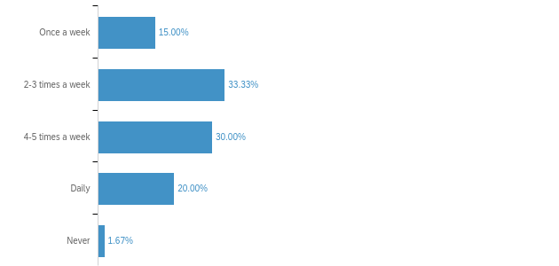

Approximately one-third (33%) respondents visit Tim Hortons 2-3 times a week, while 30% frequent the establishment 4-5 times a week. Additionally, 20% of participants are daily patrons, with 15% choosing to indulge once a week.

**Q3 - On average, how much money do you spend on a typical visit to Tim Horton's?**

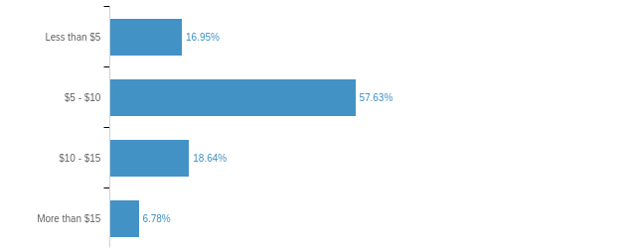

Roughly 17% spend less than $5, a majority of 58% allocate $5-$10, while 19% opt for the $5-$10 range, and the remaining 7% invest more than $15 in their purchase.

**Q4 - Do you have a preferred beverage you like to order at Tim Hortons?**

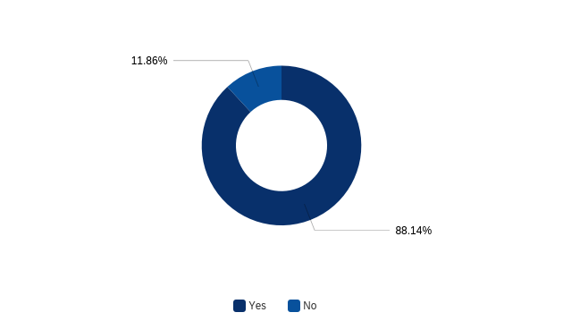

Approximately 88% of the respondents have a preferred beverage at Tim Hortons, while the remaining 12% do not have a favoured drink of choice.

**Q5 - Which of the following beverages did you select for yourself?**

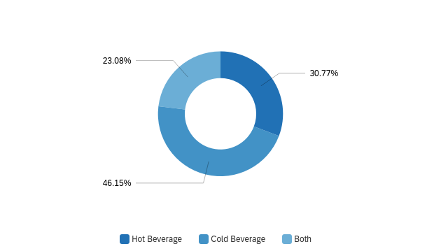

Approximately 46% prefer cold beverages, 31% opt for hot beverages, and 25% have a preference for both hot and cold options.

**Q6 - Which of the following cold beverages did you order for yourself?**

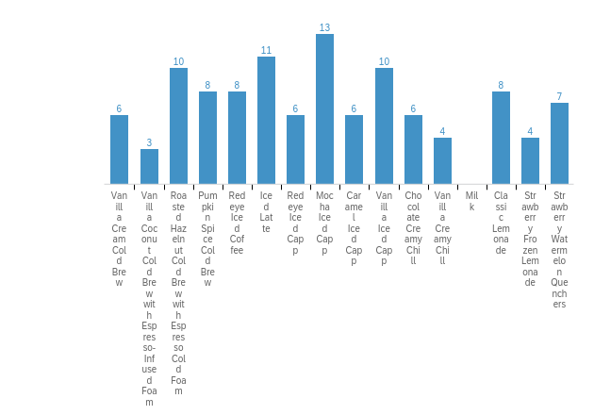

In cold beverages, the top choices among respondents were Mocha Iced Capp, Roasted Hazelnut Cold Brew, Iced Latte and Vanilla Iced Capp. Following closely were Pumpkin Spiced Cold Brew, Redeye Iced Coffee, Classic Lemonade and Strawberry Watermelon Quencher.

**Q7 - Which of the following hot beverages did you order for yourself?**

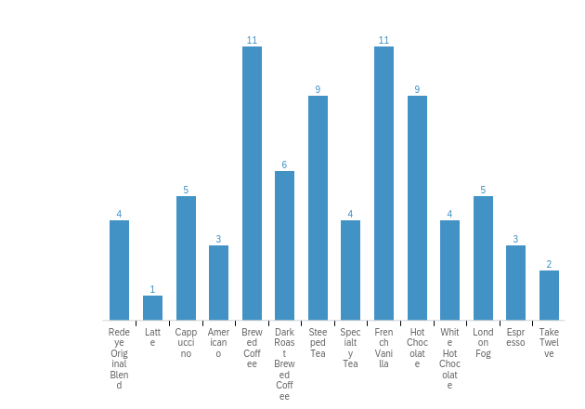

In hot beverages, the top choices among respondents were Brewed Coffee, French Vanilla, Steeped Tea, and Hot Chocolate. Following closely were Dark Roast brewed coffee, Cappuccino, and London Fog.

**Q8 - How satisfied were you with the overall**

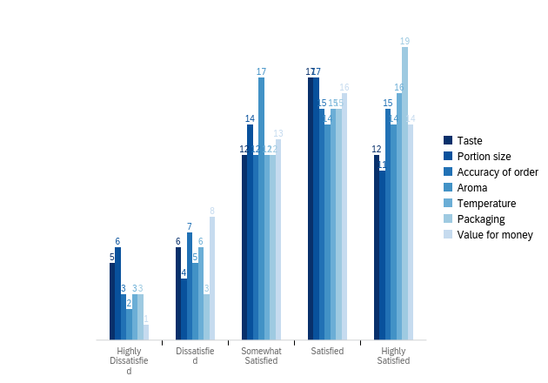

Most of the respondents indicated satisfaction with the packaging, value for money and temperature while expressing dissatisfaction with the taste, portion size and order accuracy.

**Q9 - Could you provide specific reasons why you were not satisfied with the beverage?**

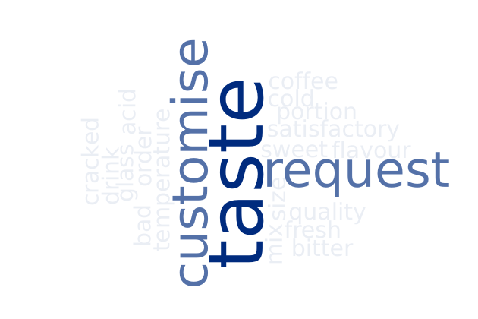

Respondents expressed dissatisfaction with the taste, quality and freshness of the products offered. They also stated that their orders were not customized according to their preferences.

**Q10 - Do you have any preferred food items you like to order at Tim Hortons?**

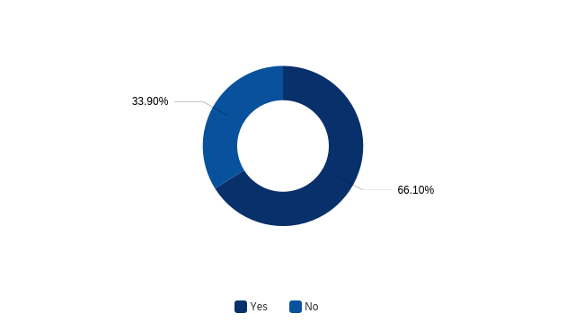

Approximately 66% of the respondents have a preferred food item at Tim Hortons, while the remaining 34% do not have a favoured food item of choice.

**Q11 - Which of the following food items did you select for yourself?**

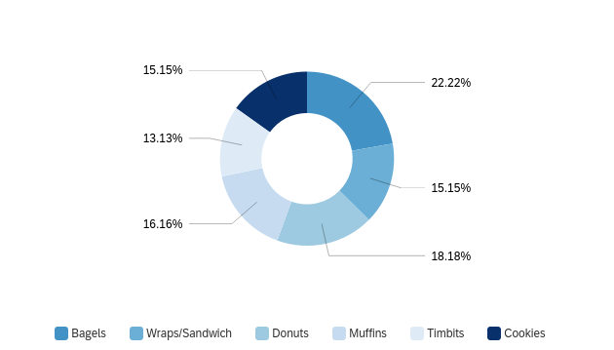

Approximately 22.22% prefer Bagels, 18.18% opt donuts, 16.16% prefer Muffins, and 15.15% have a preference for Wraps/Sandwich and cookies.

**Q12 - How satisfied were you with the overall**

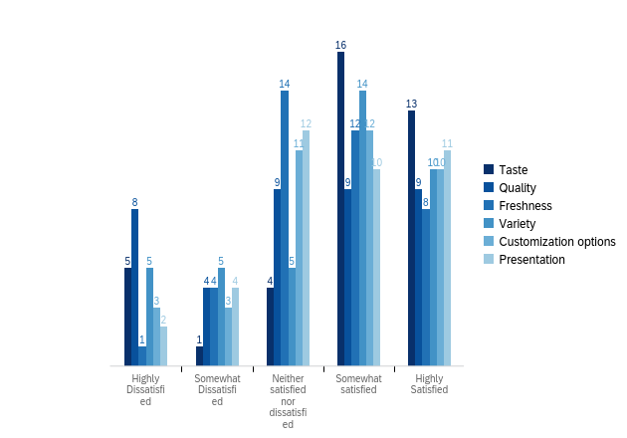

Most of the respondents indicated satisfaction with the taste, variety and presentation while expressing dissatisfaction with the quality, freshness and customization options offered by the company.

**Q13 - Could you provide specific reasons why you were not satisfied with the food?**

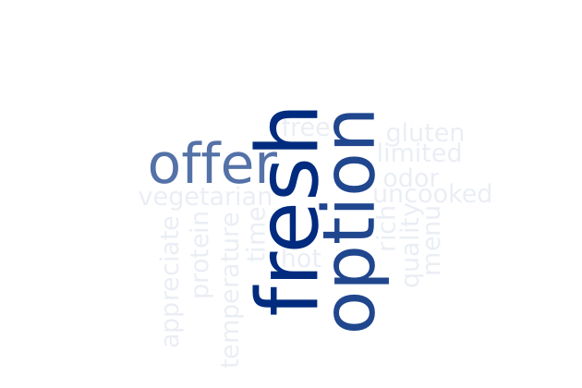

Respondents expressed dissatisfaction with freshness and quality of the products offered and suggested expanding the menu to include options such as gluten-free and vegetable choices.

**Q14 - What method did you use to order?**

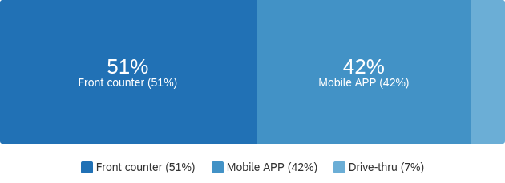

Approximately 51% of the prefer to place orders at front counter, whereas 42% prefer to use the mobile app.

**Q15 - What do you like/dislike the most about Tim Horton's app?**

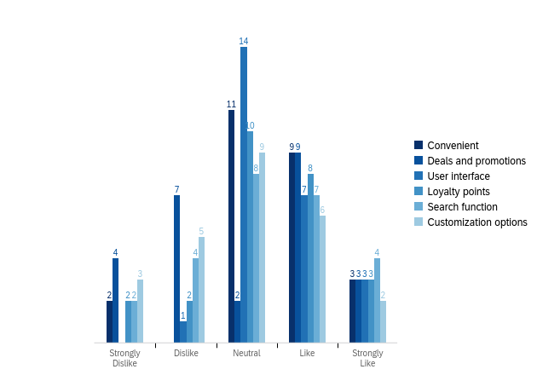

The majority of the respondents favoured the app’s user interface and appreciated the deals and promotions it provides. However, they found the app’s convenience lacking and were dissatisfied with the customization options it offered.

**Q16 - What is the main reason for your dislike with the Tim Horton's app**

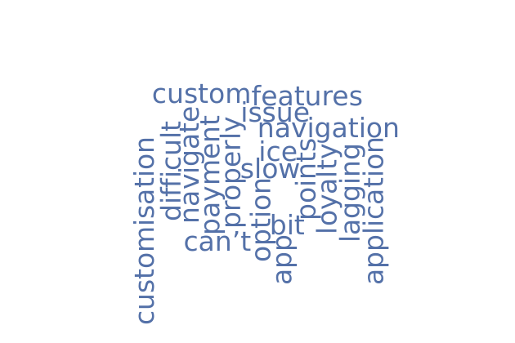Respondents expressed dissatisfaction with the app’s food and beverage customization options , the Tim points system and found it challenging to navigate.

**Q17 - How satisfied were you with**

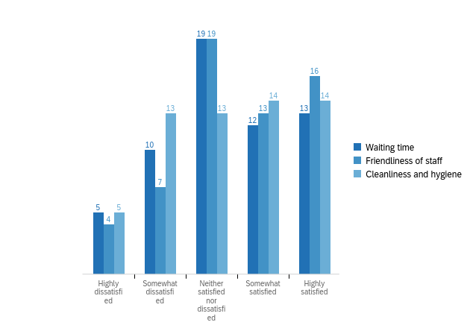

Respondents expressed that they were satisfied with the friendliness of the staff and waiting times for the orders but were dissatisfied with the cleanliness and hygiene of the place.

**Q18 - What was the main reason for your dissatisfaction during your visit?**



The respondents stated that they were dissatisfied with the long waiting times, quality of the products and overall cleanliness of the store.

**Q19 - Which payment method do you prefer to use for your transactions?**

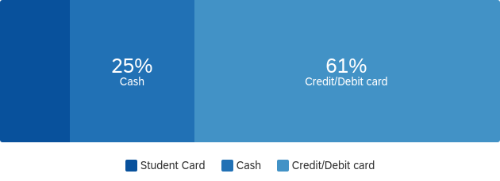

Cash/Debit card are the most preferred payment by respondents accounting to 61%, whereas 25% prefer to pay with cash.

**Q20 - How satisfied are you with the payment options provided by Tim Hortons?**

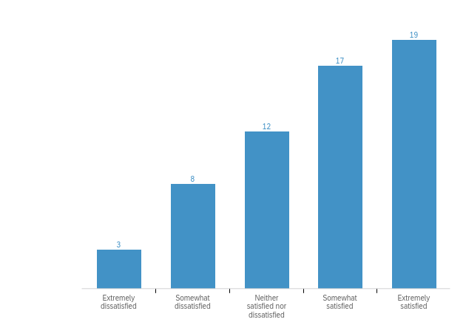

From the graph above, we can analyse that majority of the respondents are satisfied by the payment options offered by Tim Hortons.

**Q21 - We appreciate your engagement. Would you like to participate in a focus group session as part of our research, where you'll have the chance to share your insights? As a token of our gratitude for your participation, we're offering a $100 gift card. Your input would be highly valuable to our study.**

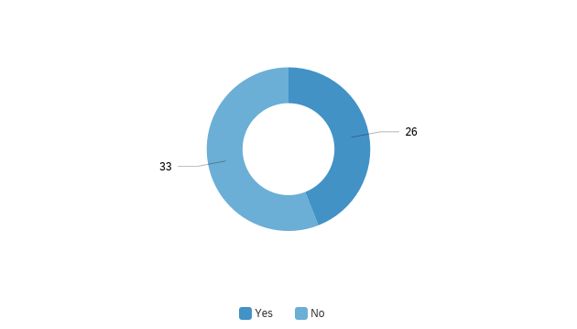

Only 26% of the respondents expressed their interest in participating for the focus group sessions.

**Q22 - Please, provide your email id**

|  |
| --- |
| Please, provide your email id |
| manthantejani8@gmail.com |
| Shetadarshan05@gmail.com |
| pratikkhunt1610@gmail.com |
| karmeshpatel123@gmail.com |
| Hardik1710baria@gmail.com |
| haranniro@gmail.com |
| meghasaluja99@gmail.com |
| parikh.paulomi09@gmail.com |
| mansirpatel7068@gmail.com |
| jenil20498@gmail.com |
| Harshmore8347@gmail.com |
| dsompura@my.centennialcollege.ca |
| duggadisha@gmail.com |
| ibedi1@my.centennialcollege.ca |
| desairuturaj98@gmail.com |
| teju.chowdhary123@gmail.com |
| (^_^) |
| aditi20.ca@gmail.com |
| Tanyatewatia1314@gmail.com |
| Jayhb246@gmail.com |

**Cross- Tabulation and Chi Square Test:**

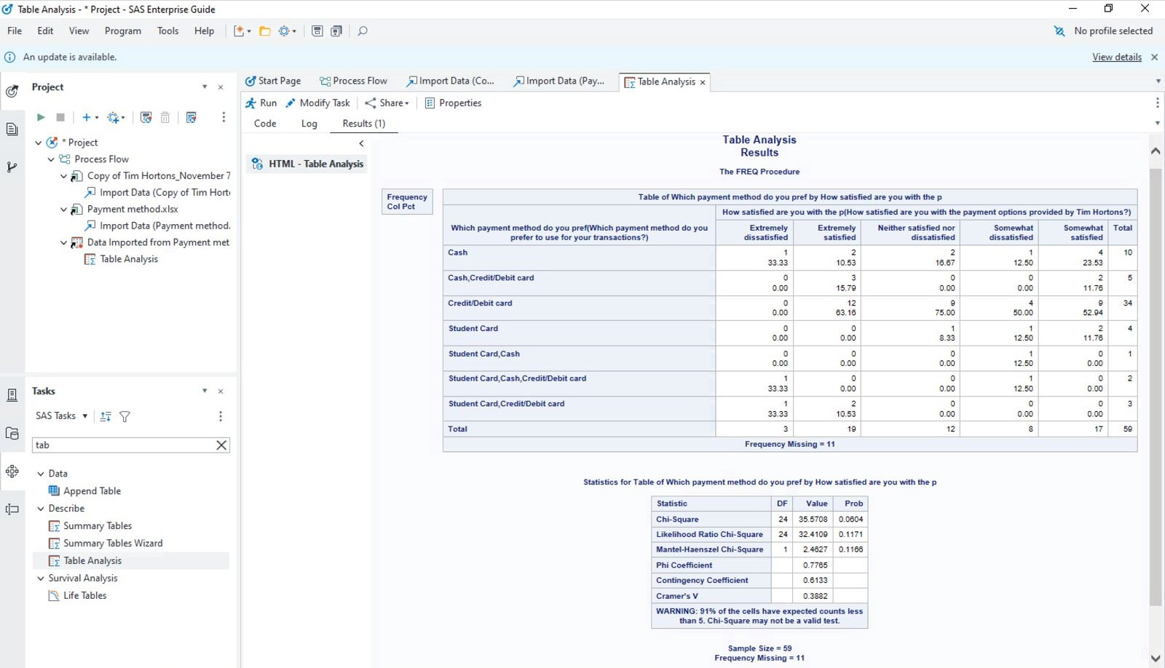

Ho: There is a significant association between payment options and satisfaction level of payment Options.

Ha: There is no significant association between payment options and satisfaction level of payment Options.

This is a statistical test that determines if there is a significant association between two categorical variables.

The value we have is **35.5708** with **24 degrees of freedom (DF)**, and a **p-value (Prob) of 0.0604**. This p-value is slightly above the common alpha level of 0.05, suggesting that the association is not statistically significant at the 5% level. both the Chi-Square and the Likelihood Ratio Chi-Square tests have p-values greater than 0.05, suggesting that there is not a significant association between the variables being tested.

Top of Form

**Regression Analysis**

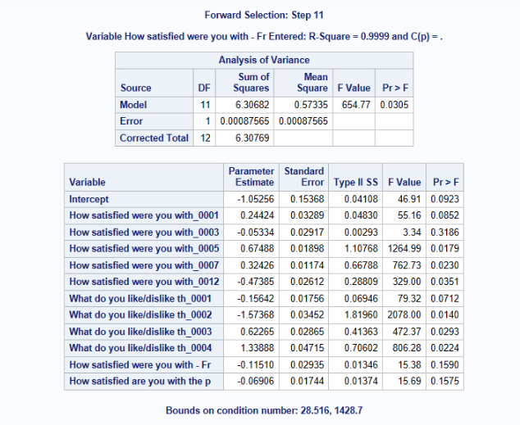

**References**

Dimensions of brand personality - Jennifer L. Aaker, 1997 - *sage journals*. (n.d.). [https://journals.sagepub.com/doi/abs/10.1177/002224379703400304](https://journals.sagepub.com/doi/abs/10.1177/002224379703400304%20)

Carlsen, J., et al. (2018). Enhancing the Consumption Experience: *A Sensory Perspective. Journal of Consumer Marketing, 35*(2), 130-141.

Cormack, P. (2008). 'True Stories' of Canada: Tim Hortons and the Branding of National Identity. *Canadian Journal of Communication, 33*(3), 415-438. <https://journals.sagepub.com/doi/abs/10.1177/1749975508095617>

Firat, A. F., & Venkatesh, A. (1993). Postmodernity: The Age of Marketing. *International* *Journal of Research in Marketing, 10*(3), 227-249.<https://www.sciencedirect.com/science/article/abs/pii/016781169390009N>

Holt, D. B. (2004). How Brands Become Icons: The Principles of Cultural Branding. *Harvard Business Press*.

Keller, K. L. (1993). Conceptualizing, measuring, and managing customer-based brand equity. *Journal of Marketing, 57*(1), 1-22.<https://journals.sagepub.com/doi/abs/10.1177/002224299305700101>

Lee, W. S., Moon, J., & Song, M. (2018). Attributes of the coffee shop business related to customer satisfaction. *Journal of Travel & Tourism Marketing, 35*(3), 296-311.<https://www.tandfonline.com/doi/abs/10.1080/15378020.2018.1524227>

Nambiar, A., & Narasimhan, T. (2018). Customer Satisfaction Study of Barista Coffee. *International Journal of Business and Management Invention, 7*(5), 2319-8028.<https://www.academia.edu/download/33367555/ARTICLE__1_JUNE_2013.pdf>

Raghav, P., & Singh, S. (2019). Customer Satisfaction Study of Coffee Outlet. International *Journal of Recent Technology and Engineering, 8(*1S2), 379-384