🌐 Lab: Network Load Balancer (NLB)
Google Cloud Associate Cloud Engineer | GSP007

Overview
Set up a passthrough Network Load Balancer (NLB) on Google Cloud Platform using 3 Compute Engine VMs running Apache. A Layer 4 NLB routes traffic based on IP addresses and port numbers and does not inspect the content of the traffic.

Objectives
- Configure the default region and zone for resources
- Create multiple web server instances
- Configure a load balancing service
- Configure a forwarding rule to distribute traffic

Task 1 — Set Default Region & Zone
Set the default region and zone so all resources are created in the correct location.

gcloud config set compute/region [YOUR-REGION]
gcloud config set compute/zone [YOUR-ZONE]

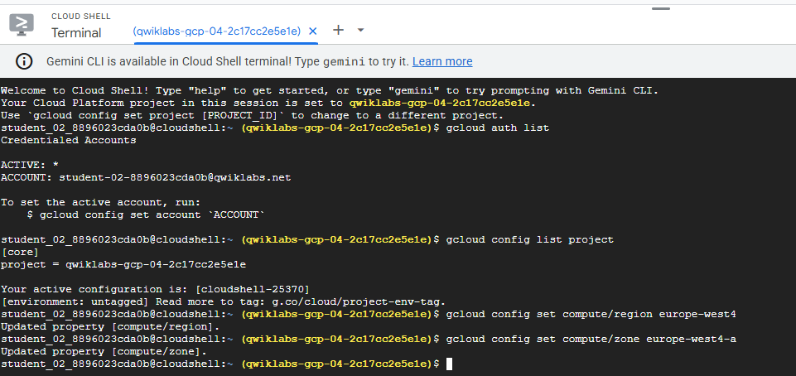

Task 2 — Create Web Server Instances
Created 3 Compute Engine VMs (www1, www2, www3) with Apache installed via startup script. Each VM gets a unique homepage. A firewall rule allows HTTP traffic on port 80.

gcloud compute instances create www1 --zone=[ZONE] --tags=network-lb-tag --machine-type=e2-small --image-family=debian-11 --image-project=debian-cloud
gcloud compute instances create www2 --zone=[ZONE] --tags=network-lb-tag --machine-type=e2-small --image-family=debian-11 --image-project=debian-cloud
gcloud compute instances create www3 --zone=[ZONE] --tags=network-lb-tag --machine-type=e2-small --image-family=debian-11 --image-project=debian-cloud
gcloud compute firewall-rules create www-firewall-network-lb --target-tags network-lb-tag --allow tcp:80

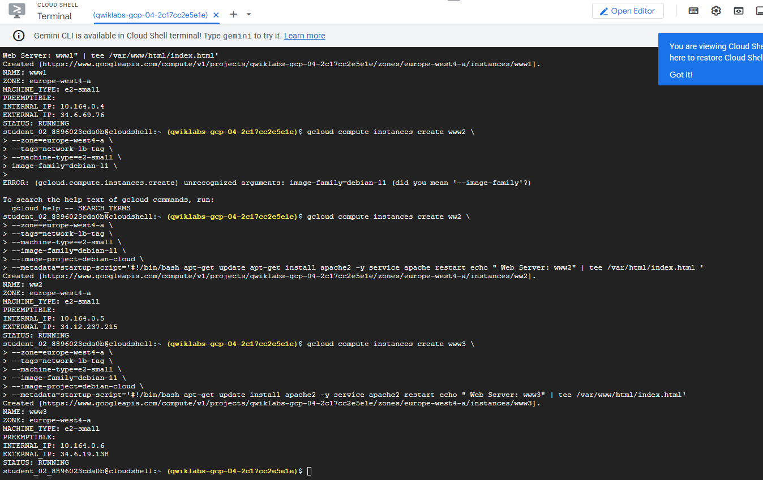

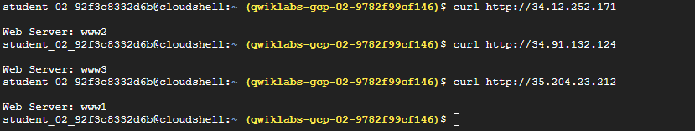

Task 3 — Configure the Load Balancing Service
Created a static external IP address for the load balancer and added a legacy HTTP health check to monitor instance health.

gcloud compute addresses create network-lb-ip-1 --region [REGION]
gcloud compute http-health-checks create basic-check

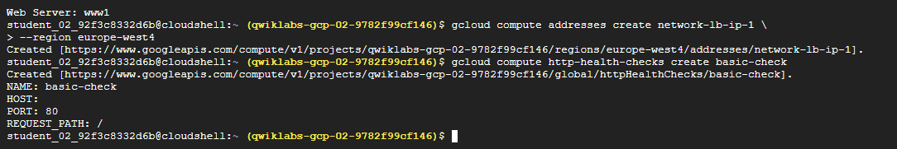

Task 4 — Create Target Pool & Forwarding Rule
A target pool groups the 3 backend VMs. The forwarding rule routes incoming traffic from the static IP to the target pool on port 80.

gcloud compute target-pools create www-pool --region [REGION] --http-health-check basic-check
gcloud compute target-pools add-instances www-pool --instances www1,www2,www3
gcloud compute forwarding-rules create www-rule --region [REGION] --ports 80 --address network-lb-ip-1 --target-pool www-pool

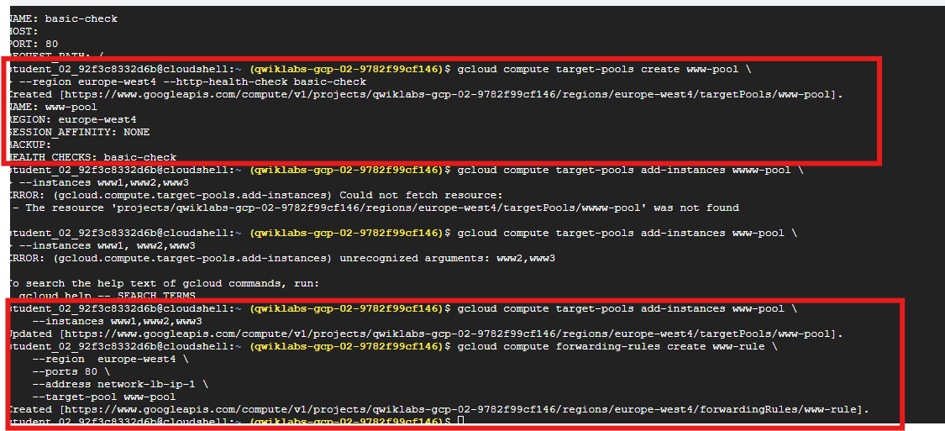

Task 5 — Send Traffic to Instances
Used curl in a loop to send repeated requests to the load balancer external IP. The responses rotated between www1, www2, and www3 confirming traffic distribution is working.

IPADDRESS=$(gcloud compute forwarding-rules describe www-rule --region [REGION] --format="json" | jq -r .IPAddress)
while true; do curl -m1 $IPADDRESS; done

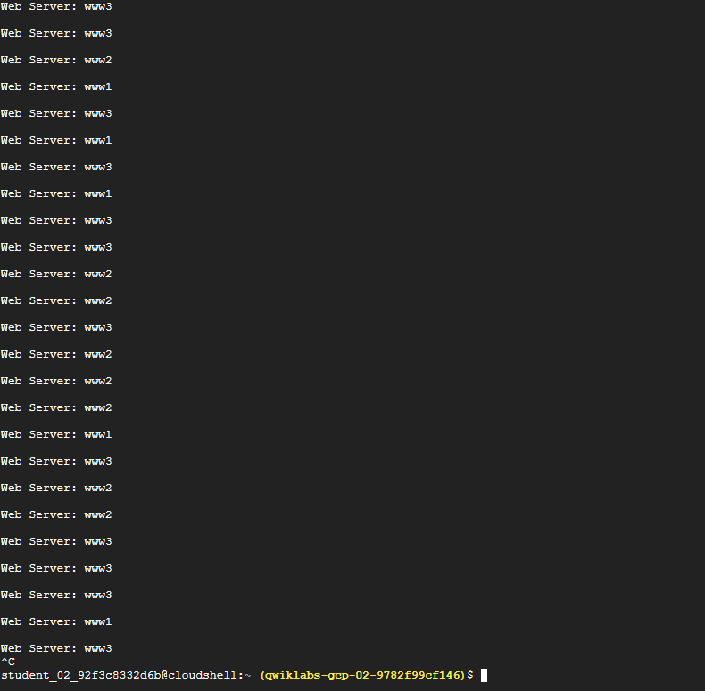

What I Learned
- A Layer 4 NLB routes traffic based on IP/port — it does not inspect content
- Target pools group backend instances that receive incoming traffic
- Forwarding rules direct traffic from a static IP to a target pool
- Health checks automatically remove unhealthy instances from rotation
- All backend instances in a target pool must be in the same region

Challenges & How I Solved Them
- Typos in curl command (Task 2) — Mistyped the IP address (confused 1 and l, w errors) which caused curl to fail when verifying VMs were responding. Fixed by carefully re-reading the external IP from gcloud compute instances list and retyping it character by character.
- Target pool issues (Task 4) — Same typo problem carried over when setting up the forwarding rule and target pool. Learned to copy/paste IP addresses and resource names directly from the terminal output instead of retyping them to avoid errors.
- Key Lesson — In GCP commands, one wrong character breaks everything. Always copy/paste resource names and IP addresses rather than typing them manually.

Resources
GCP Network Load Balancer Docs: https://cloud.google.com/load-balancing/docs/network
Lab ID: GSP007

