Nightfall Asimov-Silverberg-signed limited edition 296 of 750. Doubleday November 1990. Stated First Edition. No dust jacket but slipcase. As new (never read) hard cover with all 339 pages tightly bound and no marks of any kind. ISBN 0385263414
In quarter cloth and boards with purple tinted top edge, with maroon satin marker ribbon, laid-into a card board slipcase with color plate a-fixed. (339pp.) (6 1/2" X 9 3/4") Asimov's acclaimed short story here expanded to novel length in collaboration with Robert Silverberg.
Nightfall is a 1941 science fiction short story by the American writer Isaac Asimov about the coming of darkness to the people of a planet ordinarily illuminated by sunlight at all times. It was adapted into a novel with Robert Silverberg in 1990. The short story has appeared in many anthologies and six collections of Asimov stories. In 1968, the Science Fiction Writers of America voted "Nightfall" the best science fiction short story written prior to the 1965.
ID 000197 Price $475 Box one
Ebay at $750
BookFinder no results; Via Libri no results; BooksScouter

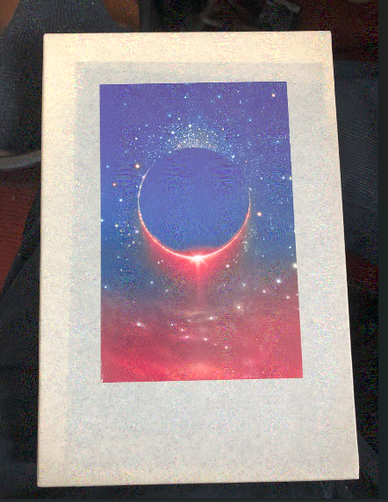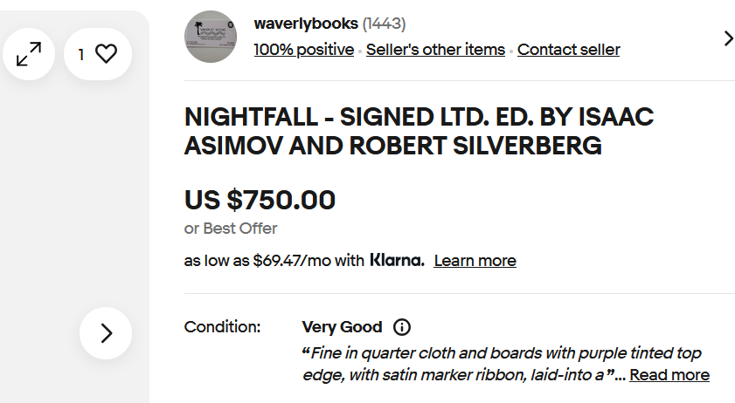
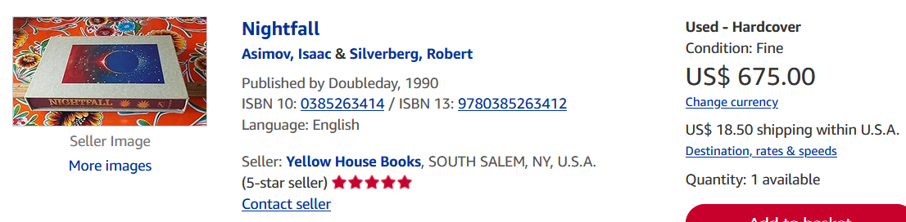
AbeBooks $500, $675 and $750

