Standar Room

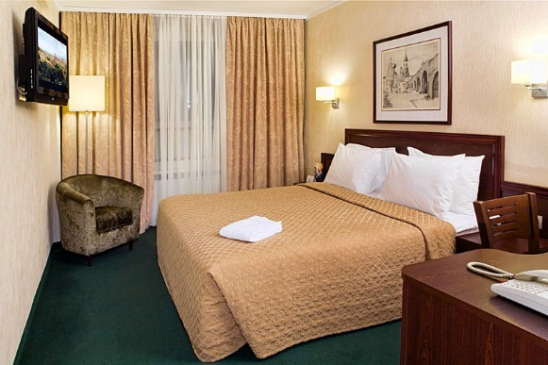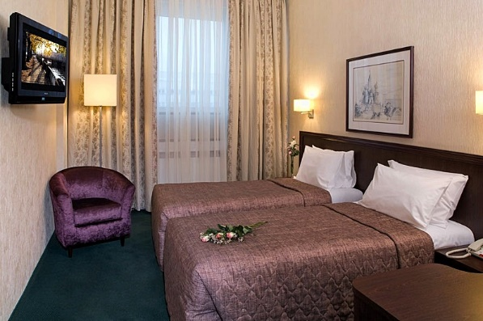

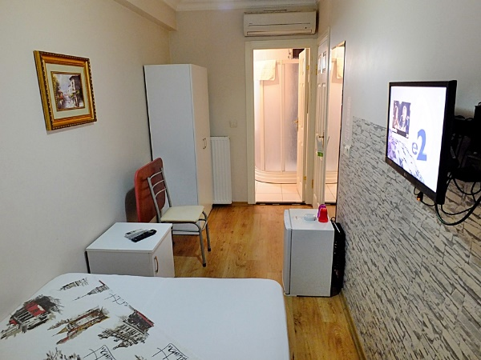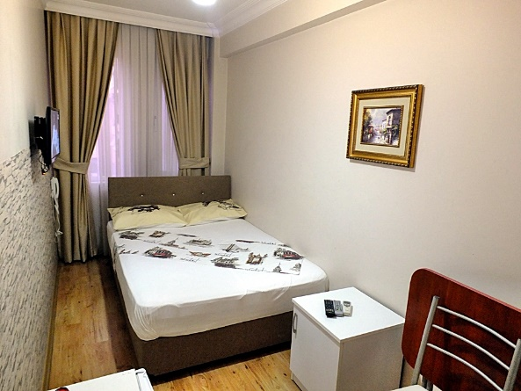

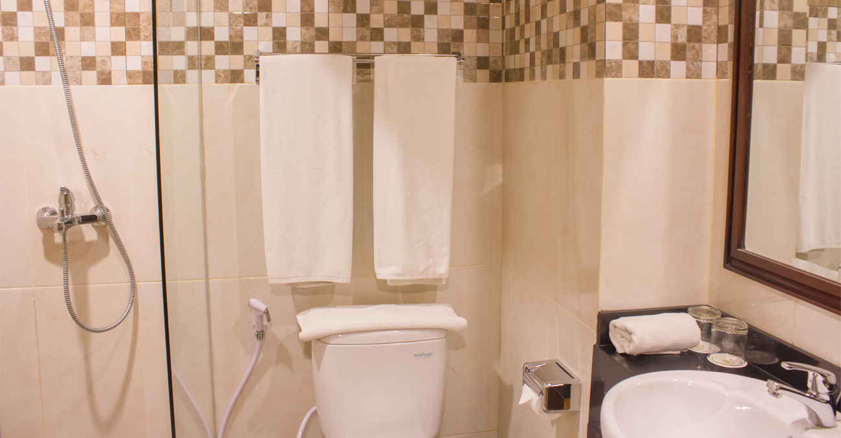

Standard Rooms are relatively compact, but space is maximized using carefully selected furniture and fittings. Decorated in a simple traditional style with fabrics in classic colours, Standard Rooms have either one king-size bed or two twin beds, with other furniture including writing desk with chair, armchair, and large wardrobe.

BATHROOM

En suite bathrooms have bath with shower, wash basin, and WC.

AMENITIES

Communication:

* Dial-up Internet access
* Telephone

Comfort:

* 24-hour room service
* Air-conditioning
* Hairdryer
* Minibar
* Pillow menu

Entertainment:

* Cable /satellite television
* Flat LCD TV
* Pay TV

Security:

* In-room Safe
* Electronic Door Lock

Superior Room

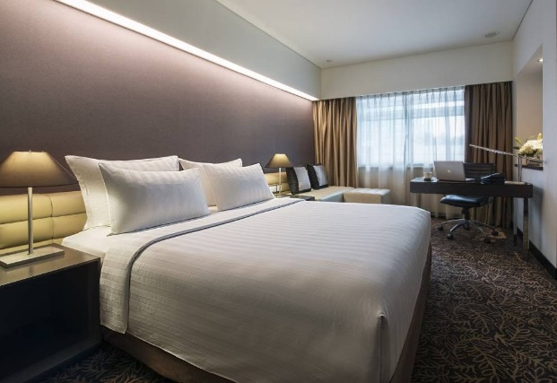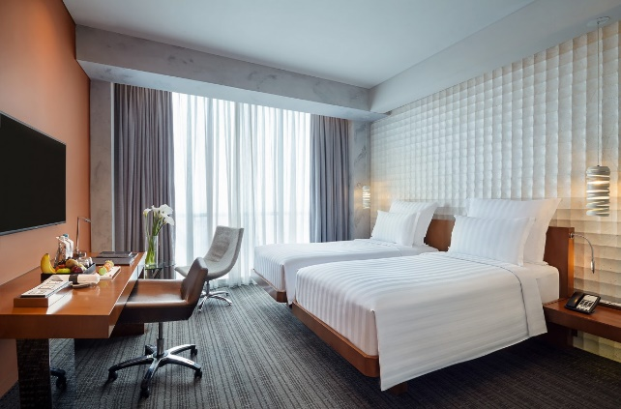

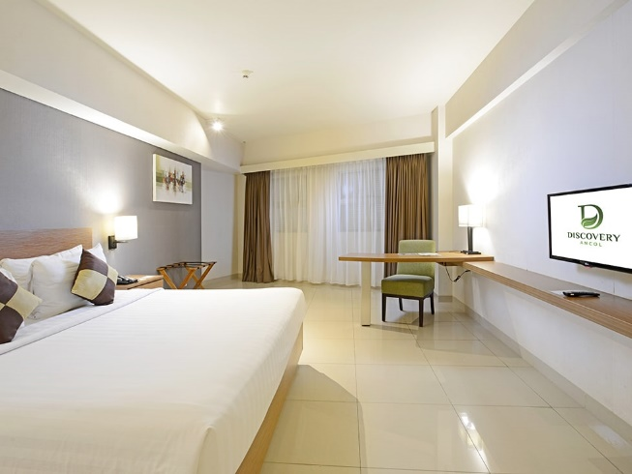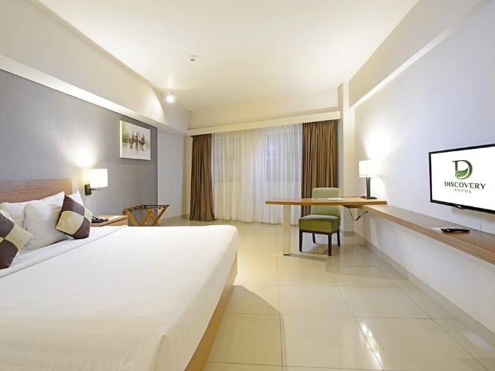

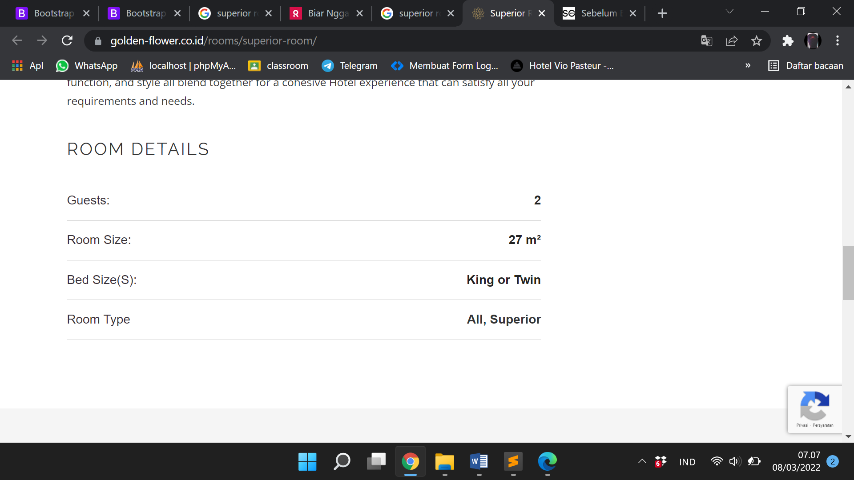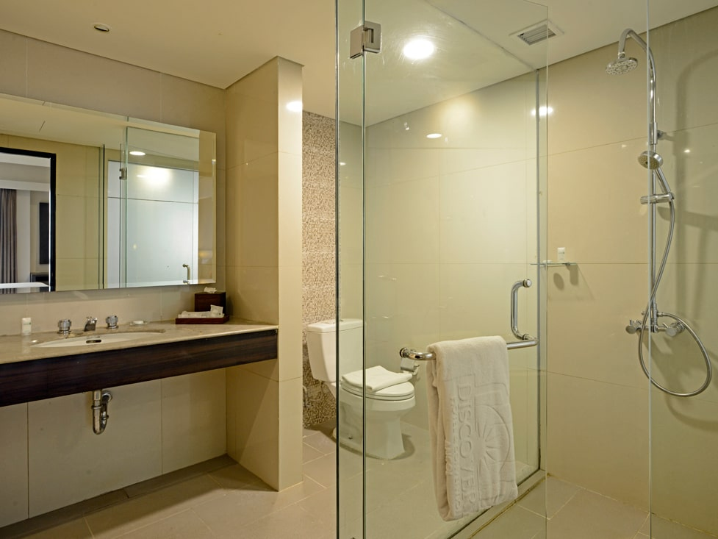

For your comfort

* • 1 queen or 2 single beds
* • Bottled of water
* • AC
* • Rain shower
* • Kimono & slippers
* • Bathroom scale
* • Praying mat
* • Turndown service
* • Iron & ironing board
* • Tea & coffee making facilities

for exclusive comfort and privacy. Features include free local calls, newspapers, 1 time pressing and access to the Executive Lounge with daily...

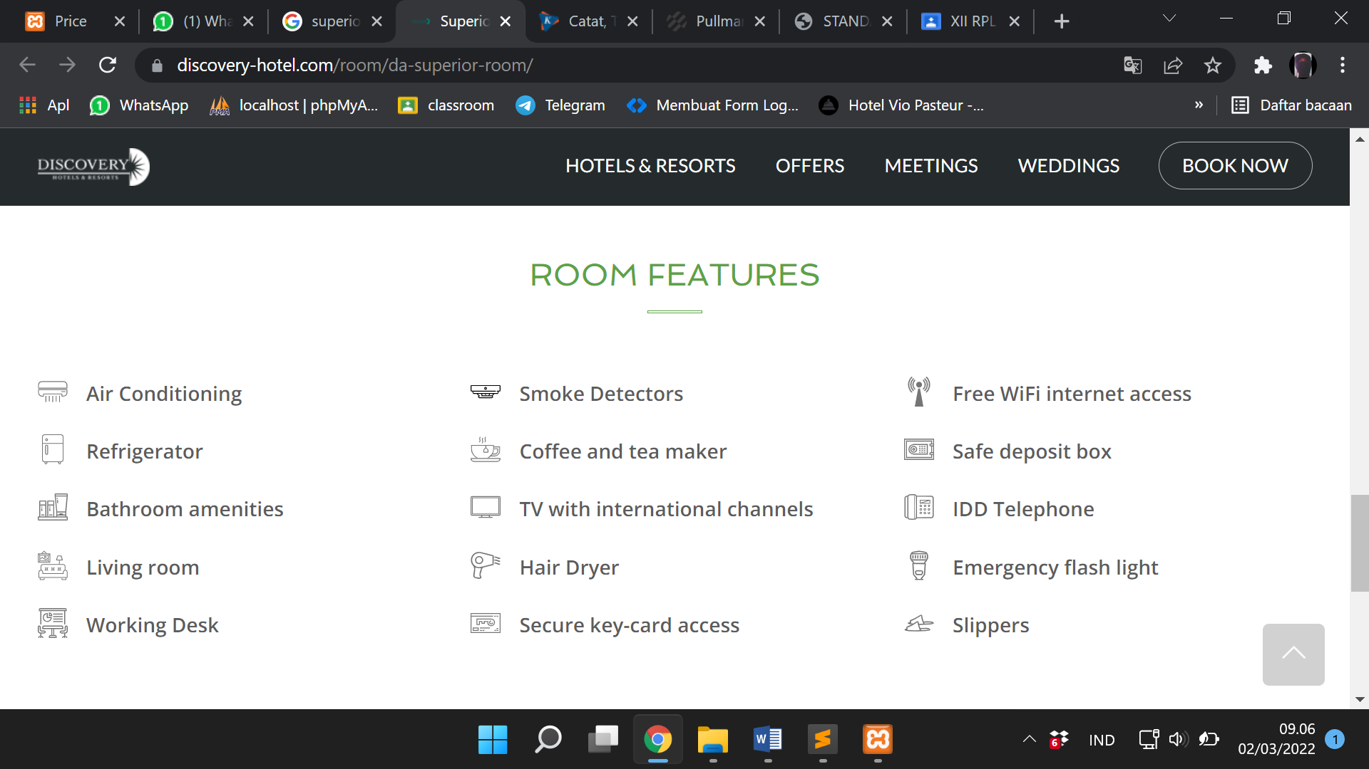

Deluxe Room



 Deluxe Room menyambut Anda dengan kenyamanan modern dan dekorasi elegan. Nikmati pilihan panorama kota, taman, atau pelabuhan dari jendela setinggi langit-langit kami, atau tarik tirai gelap untuk menikmati tidur lelap pada siang atau malam hari. Datang dan bersantailah di lokasi istirahat pribadi di Marina Bay Sands yang tak pernah jauh dari beragam aktivitas dan keseruan.

## Di Dalam Kamar Anda

* Mulai 62 meter persegi
* 1 tempat tidur ukuran King atau 2 ukuran Single
* Kamar mandi dengan shower berdinding kaca
* Fasilitas kamar mandi mewah
* Jubah mandi wafel
* Pengering Rambut
* Televisi layar datar interaktif dengan saluran kabel
* Meja kerja eksekutif
* Brankas dalam kamar
* Setrika dan meja setrika
* Bebas rokok