プログラミングⅢ レポート2

提出日：2019/05/27

2EP3 – 59 宮澤　瑛至

1. **ソースコード**

class ReportClass{

static int counter = 3;

int num ;

String str = "";

ReportClass(String s, int n){

counter++;

for(int i = 0; i < n; i++){

this.str = this.str + s;

}

}

ReportClass(int x, int y){

counter++;

num = x + y;

}

ReportClass(int add){

counter++;

num = counter + add;

}

int getint(){

return num;

}

String getString(){

return str;

}

}

public class Report2{

// main Method-------------------------

public static void main(String[] args){

ReportClass a = new ReportClass("abc", 3);

ReportClass b = new ReportClass(4, 5);

ReportClass c = new ReportClass(5);

System.out.println(a.getint() + " : " + a.getString());

System.out.println(b.getint() + " : " + b.getString());

System.out.println(c.getint() + " : " + c.getString());

}

}

1. 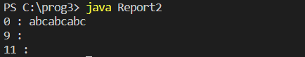出力